Jack Wilburn
Assignment 1

Chapter 1 material
- How many records does this file contain? How many fields are there per record?
  - There are seven records (one for each project) in this file and there are five fields (PROJECT_CODE, PROJECT_MANAGERS, MANAGER_PHONE, MANAGER_ADDRESS, and PROJECT_BID_PRICE) per record
- What problem would you encounter if you wanted to produce a listing by city? How would you solve this problem by introducing additional files (tables)?
  - If you were trying to list by city you’d have to first unpack the address and grab the city. However, that might be a difficult task if the address types aren’t standardized. This would mean you’d need a script or a function. To rectify this, it’d be best to have a table named Addresses with a relational link Projects. Then with a table dedicated for addresses, we’d be able to have each field of the address as a field in the table Addresses. This would make sorting by city far easier and reduces the possibility for redundancy.
- If you wanted to produce a listing of the file contents by last name, area code, city, state, or zip code, how would you alter the file structure?
  - To order by any of these variables, it would be best if they were in their own fields. Therefore, I’d alter the file so that each thing I wanted to sort by is in it’s own column/field. Without this, we’d have to script like I explained above in the previous question.
- What data redundancies do you detect? How could those redundancies lead to problems?
  - There are several data redundancies (repeated data) in this example. Specifically, there are redundancies in the PROJECT_MANAGER, MANAGER_PHONE, and MANAGER_ADDRESS fields. This might lead to data entry issues with typos leading to inaccurate information in the spreadsheet.
- Identify and discuss the serious data redundancy problems exhibited by the file structure shown.
  - In this example there are redundancies in the PROJ_NUM, PROJ_NAME, EMP_NUM, EMP_NAME, JOB_CODE, JOB_CHG_HOUR, and EMP_PHONE fields. These redundancies can lead to problems when copying/entering data in that there may be mistakes. It would make a lot more sense to keep another sheet with the repeated information so that we minimize copying errors. Also, if an employee changes their name or number, we only need to update it in one place not in every row they appear.
- Looking at the EMP_NAME and EMP_PHONE contents in this figure, what change(s) would you recommend to the file structure?
  - I’d recommend that this company put all of their employee information in a separate file/table and use employee id numbers only in this project file. That would allow them to keep only on copy of name and phone number so that if they were to change or be entered incorrectly, they only need be updated in one location.

Chapter 2 material
- Write the business rule(s) that govern the relationship between AGENT and CUSTOMER.
  - A customer only works with one agent.
  - An agent may serve many customers
- Given the business rule(s) you wrote in Problem 1, create the basic crow's foot ERD.
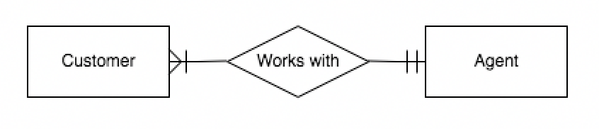
- Identify each relationship type in the figure and write all of the business rules.
  - A course has many classes and each class has one course.
  - A class has many enrolls and each enroll has one class.
  - An enroll has one student but a student may have many enrolls.
- Create the basic crow's foot ERD for Tiny College.
- United Broke Artists (UBA) is a broker for not-so-famous artists. UBA maintains a small database to track painters, paintings, and galleries. A painting is created by a particular artist and then exhibited in a particular gallery. A gallery can exhibit many paintings, but each painting can be exhibited in only one gallery. Similarly, a painting is created by a single painter, but each painter can create many paintings. Using PAINTER, PAINTING, and GALLERY, in terms of a relational database:
  - What tables would you create, and what would the table components be?
    - I would create 3 tables, PAINTER, PAINTING, and GALLERY. The components of the PAINTER table would be first name, last name, birthplace, year of birth, year of death. For PAINTING, the components would be title, year, city, country, style, gallery code, and painter code. For GALLERY, I’d include the city, country, year built, size, revenue, and price.
  - How might the (independent) tables be related to one another?
    - The tables would be related to each other by the gallery and painter codes in the PAINTING table. This would let users find who painted which picture and which gallery it was in. If you were to use a lookup (or join, spoilers) you could extract all this information at once or just a subset.
    - A painter may paints many paintings. One painting is made by one painter. A painting can only be in one gallery but a gallery may have many paintings.
- Create a crow's foot ERD to include the following business rules for the ProdCo company:
  - each sales representative writes many invoices;
  - each invoice is written by one sales representative;
  - each sales representative is assigned to one department;
  - each department has many sales representatives;
  - each customer can generate many invoices;
  - each invoice is generated by one customer.
