Jack Wilburn
Assignment 2

- For each table, identify the primary key and the foreign key(s). If a table does not have a foreign key, write None.
  - EMPLOYEE
    - PK
      - EMP_CODE
    - FK
      - STORE_CODE
  - STORE
    - PK
      - STORE_CODE
    - FK
      - REGION_CODE
  - REGION
    - PK
      - REGION_CODE
    - FK
      - None
- Do the tables exhibit entity integrity? Answer yes or no, and then explain your answer.
  - Yes, these tables do have entity integrity. For each table, the primary key is unique for each row and is never (null).
- Do the tables exhibit referential integrity? Answer yes or no, and then explain your answer.
  - Yes, these tables do have referential integrity. For each table, any foreign key has a matching entry in the related table.
- Describe the type(s) of relationship(s) between STORE and REGION.
  - STORE and REGION have a 1:M relationship. A region may have many stores but each store only has one region.
- Describe the type(s) of relationship(s) between EMPLOYEE and STORE. (Hint: each store employs many employees, one of whom manages the store.)
  - There is a 1:M relationship where each employee works at one store and each store has many employees.
  - There is also a 1:1 relationship where each store has one manager and each manager manages one store.
- Create an ERD to show all relationships involving EMPLOYEE, STORE, and REGION. (ERDPlus is a good, free tool to use for this.)
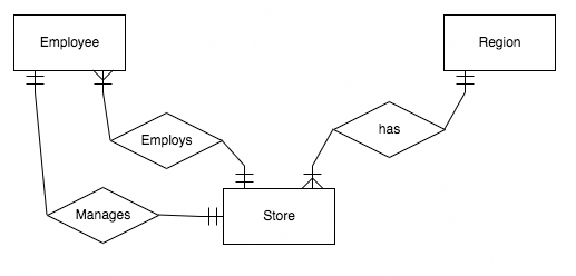
- For each table, identify the primary key and any foreign keys.
  - MACHINE
    - PK
      - MACHINE_NUM is clearly supposed to be the primary key but it is not one since there is a null value
    - FK
      - None
  - ITEM
    - PK
      - ITEM_NUMBER
    - FK
      - None
  - STOCK
    - PK
      - (MACHINE_NUM, ITEM_NUM) is probably supposed to be but they can’t be because ITEM_NUM is (null) for one entry.
    - FK
      - MACHINE_NUM
      - ITEM_NUM
- Do the tables exhibit entity integrity? Why or why not?
  - These tables do not exhibit entity integrity. Both STOCK and MACHINE don’t have primary keys which are required for entity integrity.
- Do the tables exhibit referential integrity? Why or why not?
  - These tables do not exhibit referential integrity. The Stock table has foreign keys that reference a primary key which doesn’t exist. For example, MACHINE_NUM == 6 does not have a matching row in the MACHINE table.
- Describe the types of relationships between MACHINE, ITEM, and STOCK.
  - There is a M:N relationship between MACHINE and STOCK where each machine has many things stocked in it and stock keeps track of many machines.
  - There is an M:N relationship between ITEM and STOCK where each item is stocked multiple times and each machine has many items stocked.
- Create an ERD to show all relationships involving MACHINE, ITEM, and STOCK.
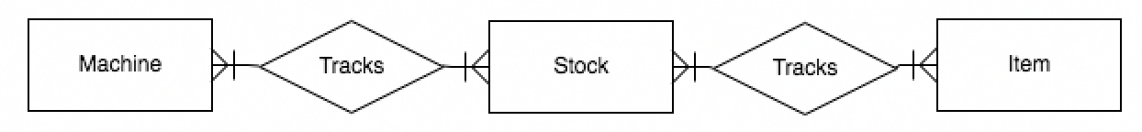
- For each of the following functional dependencies, say whether it is true with the given data. If it is not, give an example where it fails to hold.
  - GAME_TITLE → PUBLISHER_NUM
    - This functional dependency holds.
  - GAME_YEAR → PUBLISHER_NUM
    - This functional dependency does not hold. GAME_YEAR == 2001 yields 2 publisher numbers, 46 and 137
  - GAME_NUM → GAME_TITLE
    - This functional dependency holds.
  - (GAME_NUM, GAME_TITLE) → (GAME_YEAR, PUBLISHER_NUM)
    - This functional dependency holds.

- For each of the dependencies in #12, say whether the determinant does or does not constitute a superkey.
  - GAME_TITLE → PUBLISHER_NUM
    - GAME_TITLE is not a superkey.
  - GAME_YEAR → PUBLISHER_NUM
    - GAME_YEAR is not a superkey
  - GAME_NUM → GAME_TITLE
    - GAME_NUM is a superkey.
  - (GAME_NUM, GAME_TITLE) → (GAME_YEAR, PUBLISHER_NUM)
  - (GAME_NUM, GAME_TITLE) is a superkey.
- List at least three candidate keys for this relation.
  - GAME_NUM
  - (GAME_TITLE, GAME YEAR)
  - (GAME_YEAR, PUBLISHER_NUM)

