Jack Wilburn
Assignment 3

1)
Yellow hand with strap showing. This image uses the slicing render method and a 1d transfer function to map the skin and strap to yellow. I chose these settings because they’re the default, and I was able to get the desired result.
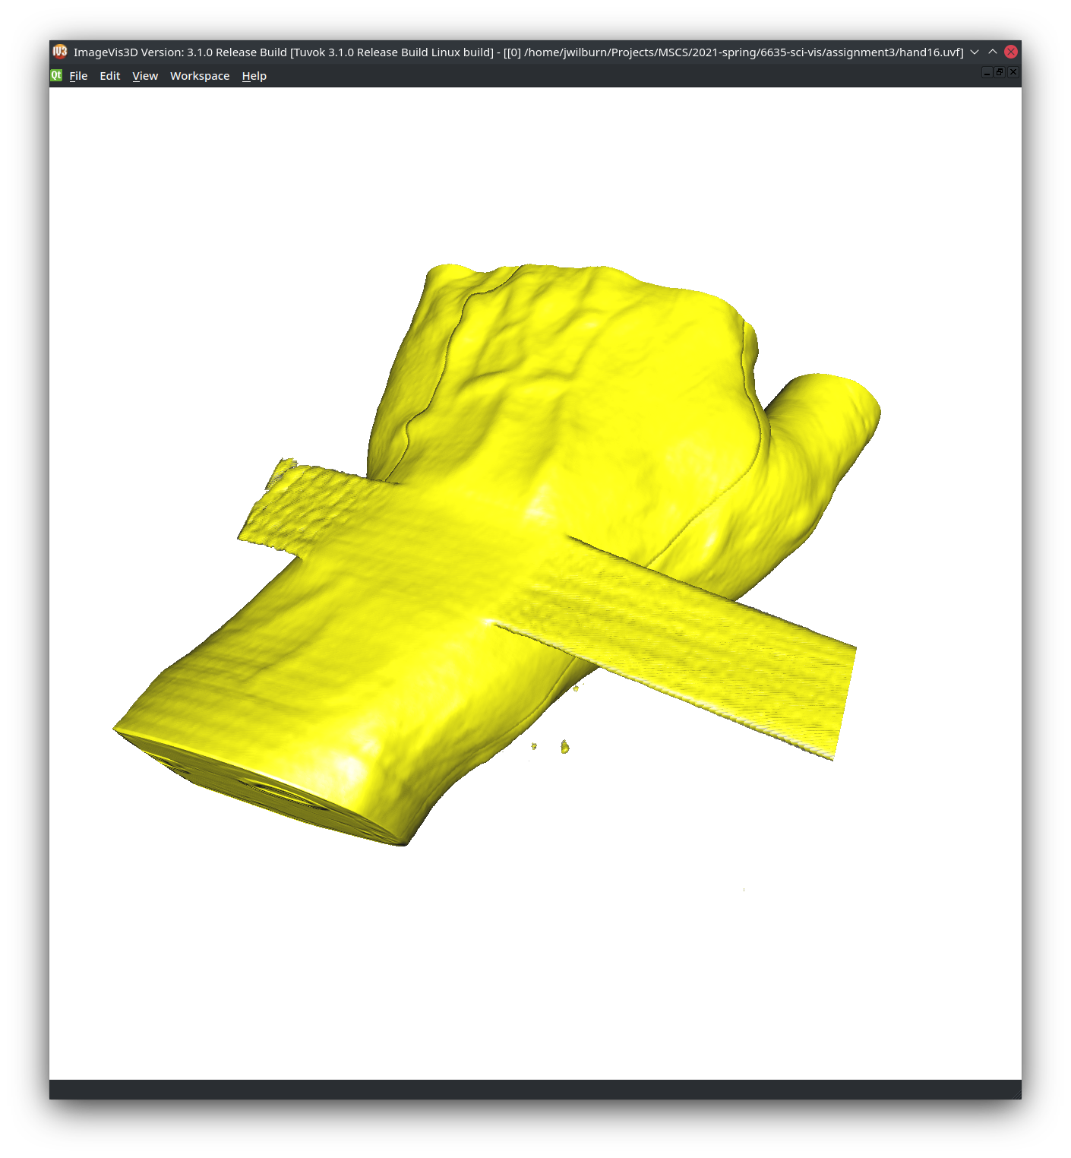
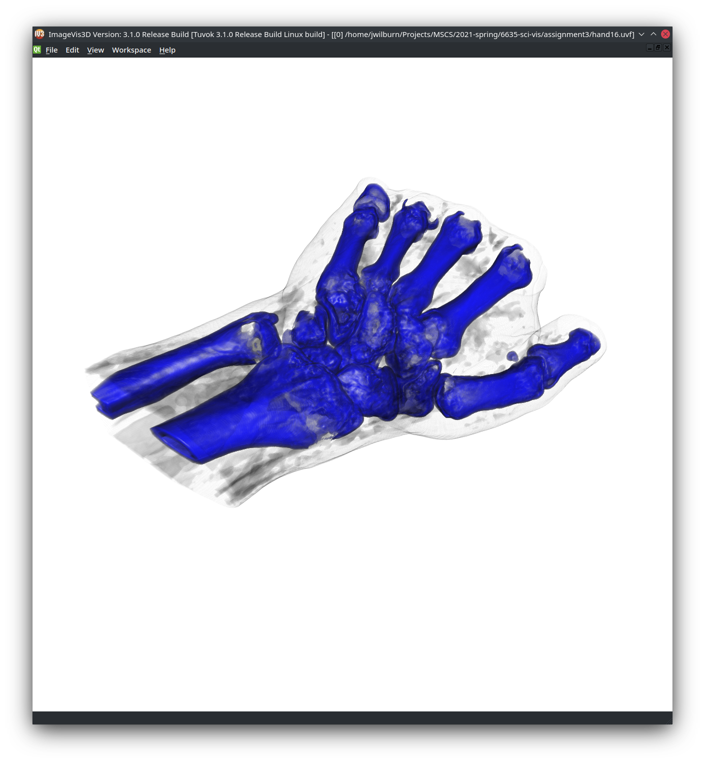
A look inside the skin at the bone structure with the bones in blue. Here I made the skin white and gave it a transparency and I colored the bones with blue using a 1d transfer function. The rendering method was slicing again. I chose these settings because they’re the default, and I was able to get the desired result.
A look inside the hand with accurate colors for bones, and veins. Black background where there is emptiness. I used the slicing render method and a 1d transfer function to map the empty space to black, the blood vessels to red and the bone to a typical bone color. I chose these settings because they’re the default, and I was best able to get the desired result.
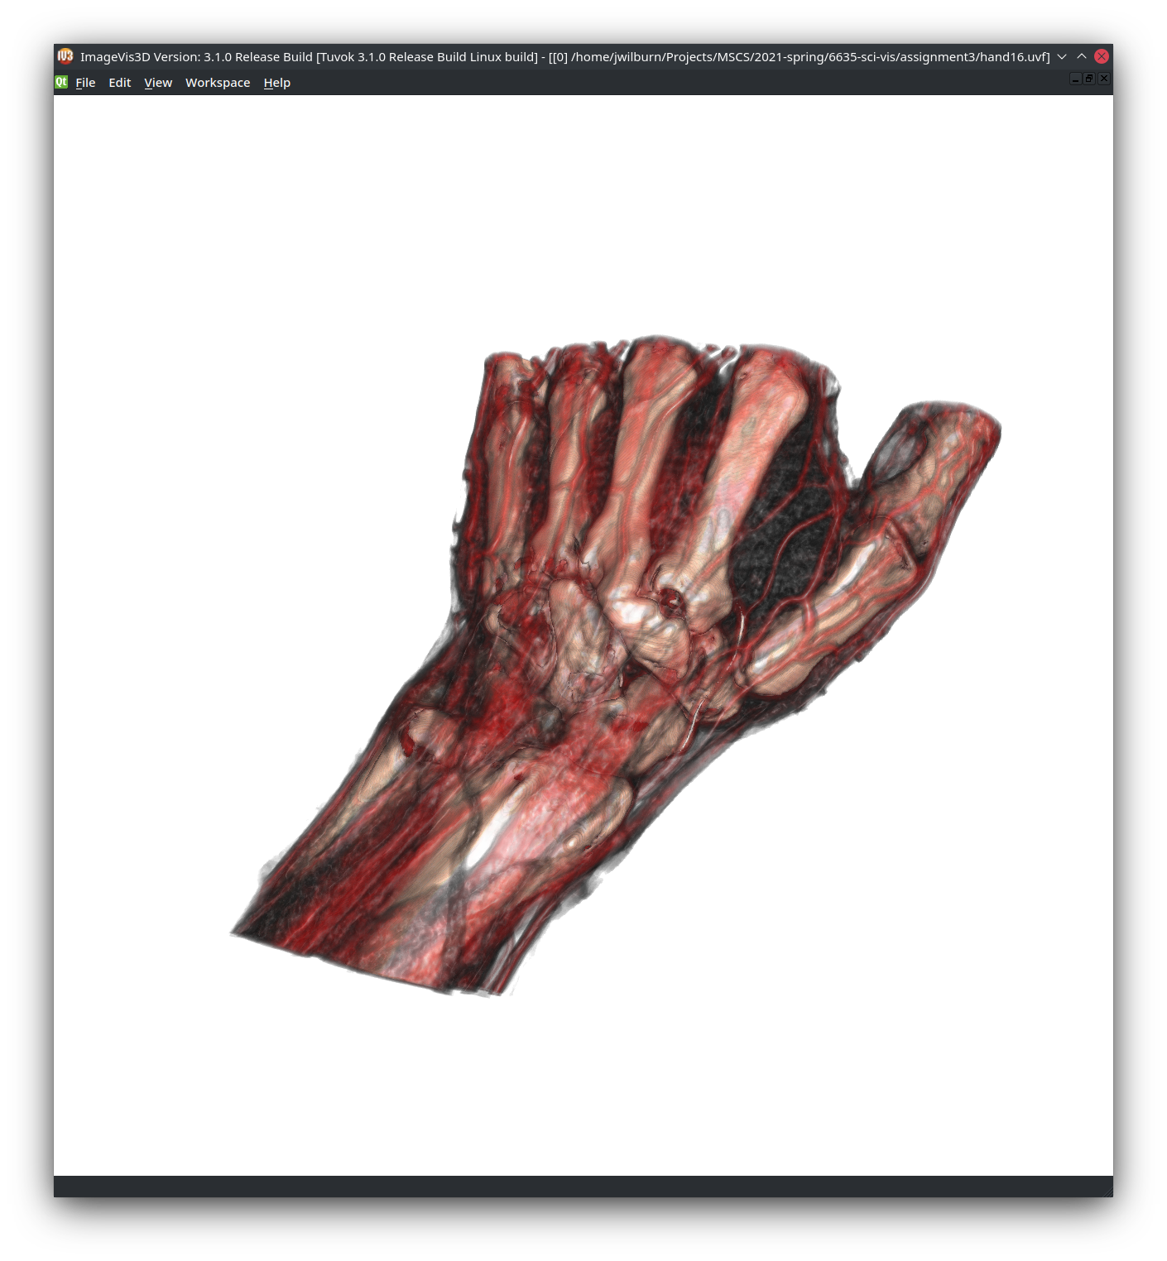

The isovalue that captures the bone well is: 1400 (anything between 1400-2600)

The isovalue that corresponds to skin is: 800 (anything between 200-900)
2) All of the following images where created using the volume rendering option in paraview and the colors were added by tweaking a 1d transfer function to get the correct images. I found working with paraview’s 1d transfer function much more finicky than 3dimagevis, even though I didn’t particularly like the transfer function UI in imagevis3d either. The ability to enter values instead of clicking and dragging was nice , though.

Yellow hand and strap. The opacity and the yellow chosen makes this a little hard to see
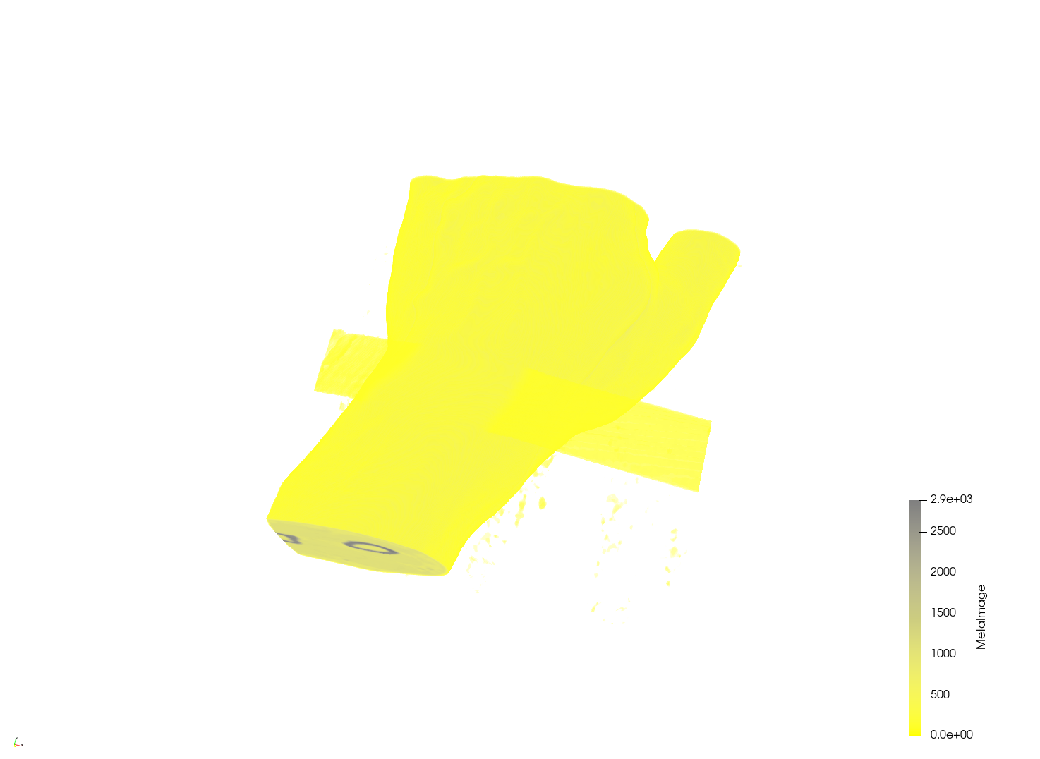
The blue bones with the transparent grey skin. I used a step transfer function to separate bone from skin and then played with the transparency to get this image.
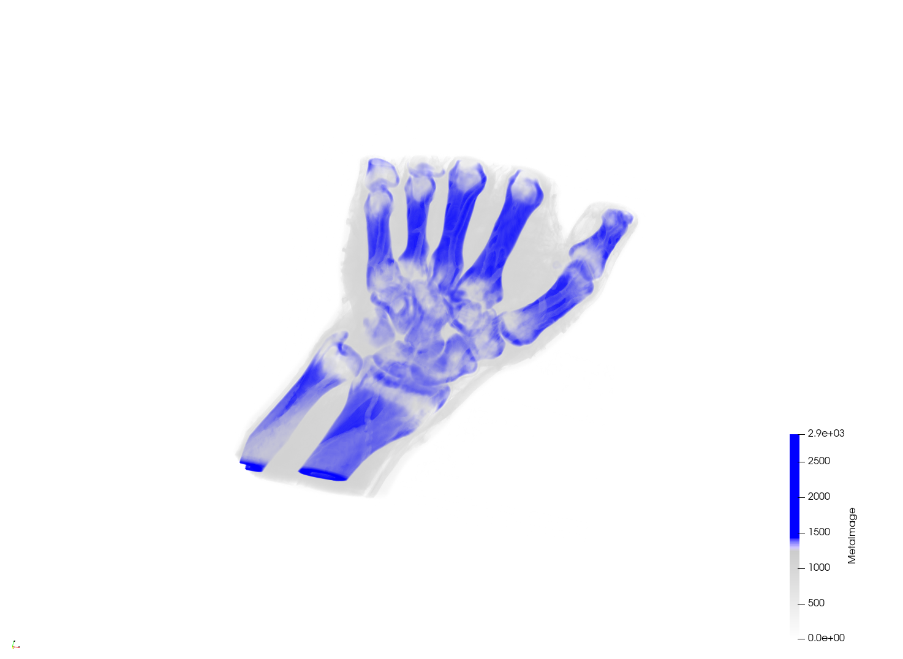

I used a bunch of different values here for skin, blood vessels, and bone. You can see in the legend that it’s a bit crazy. I then played with opacity until I got something decent.
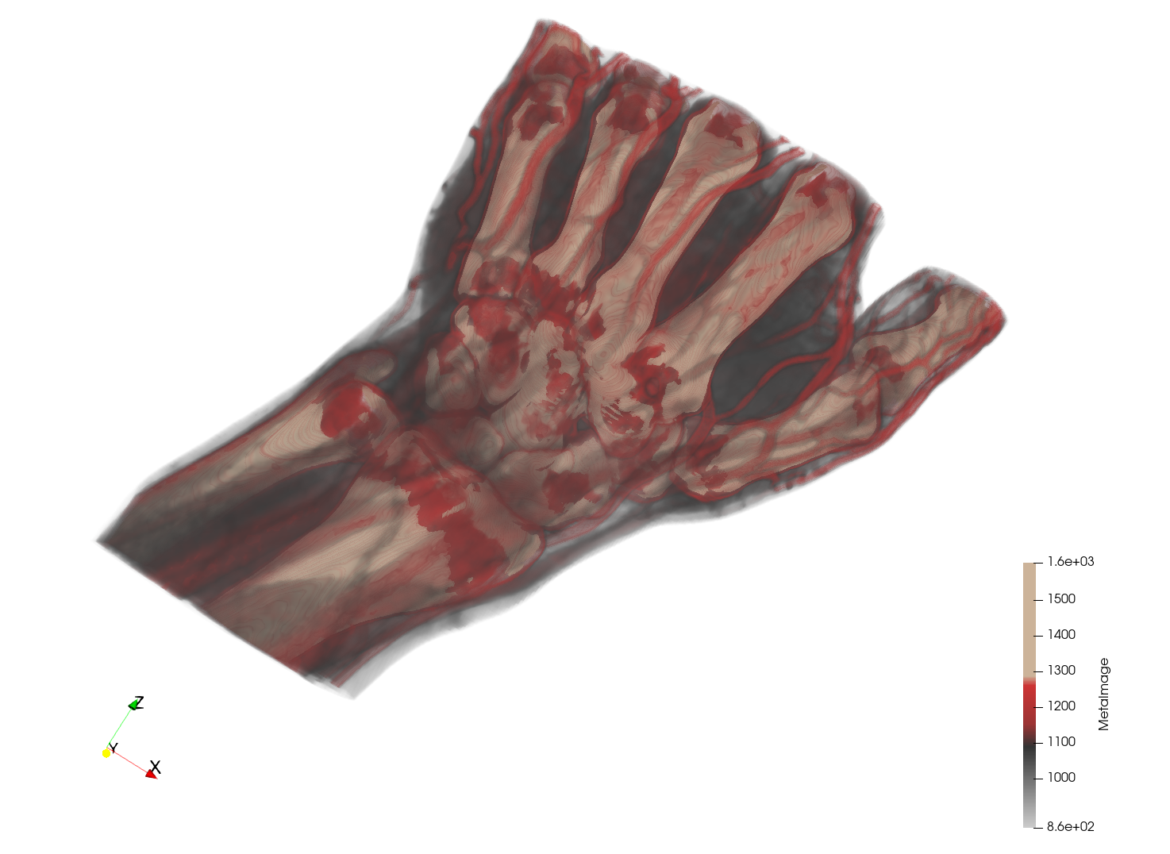
3)
Here we see the outside of the present. It has some decoration: stars and some twine.
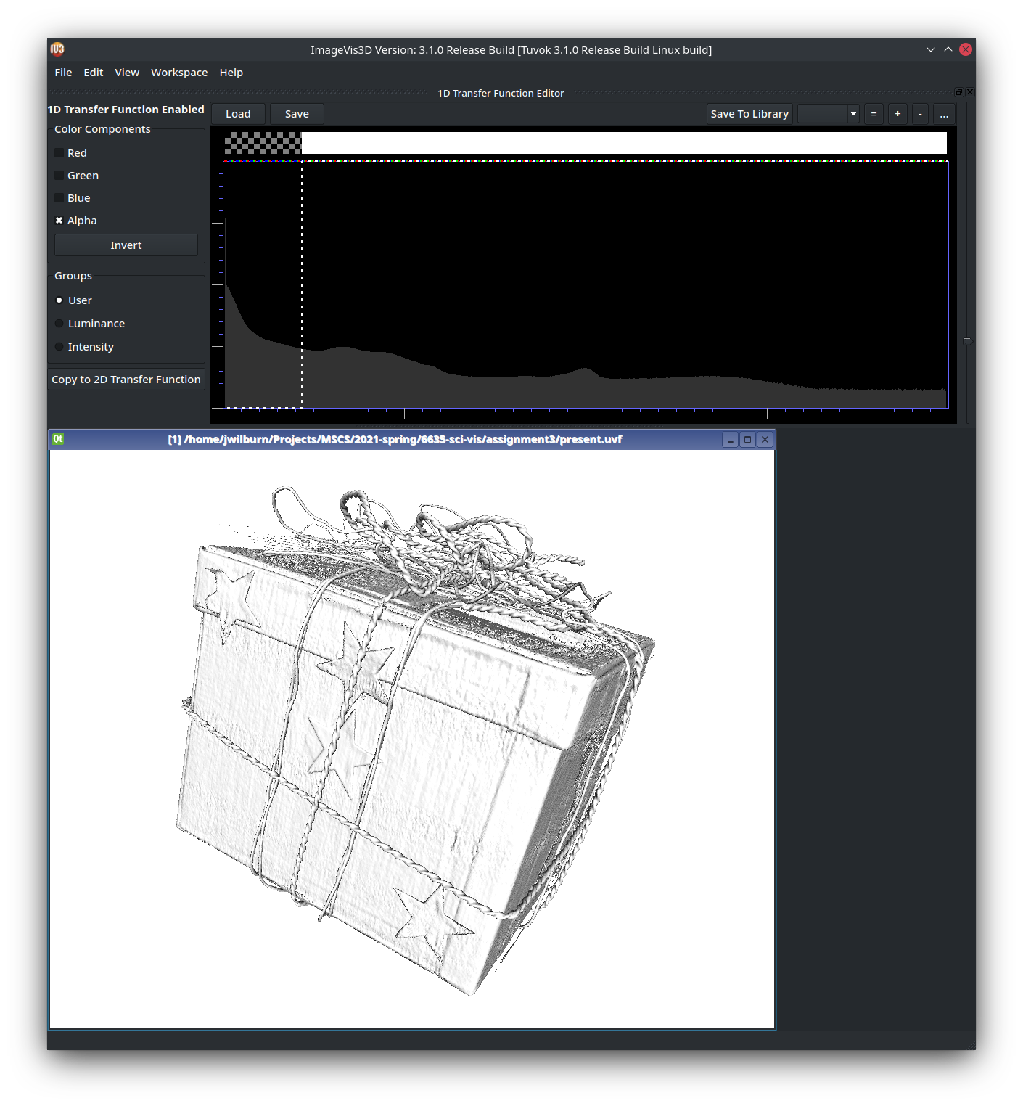

There appears to be a box inside the outer box
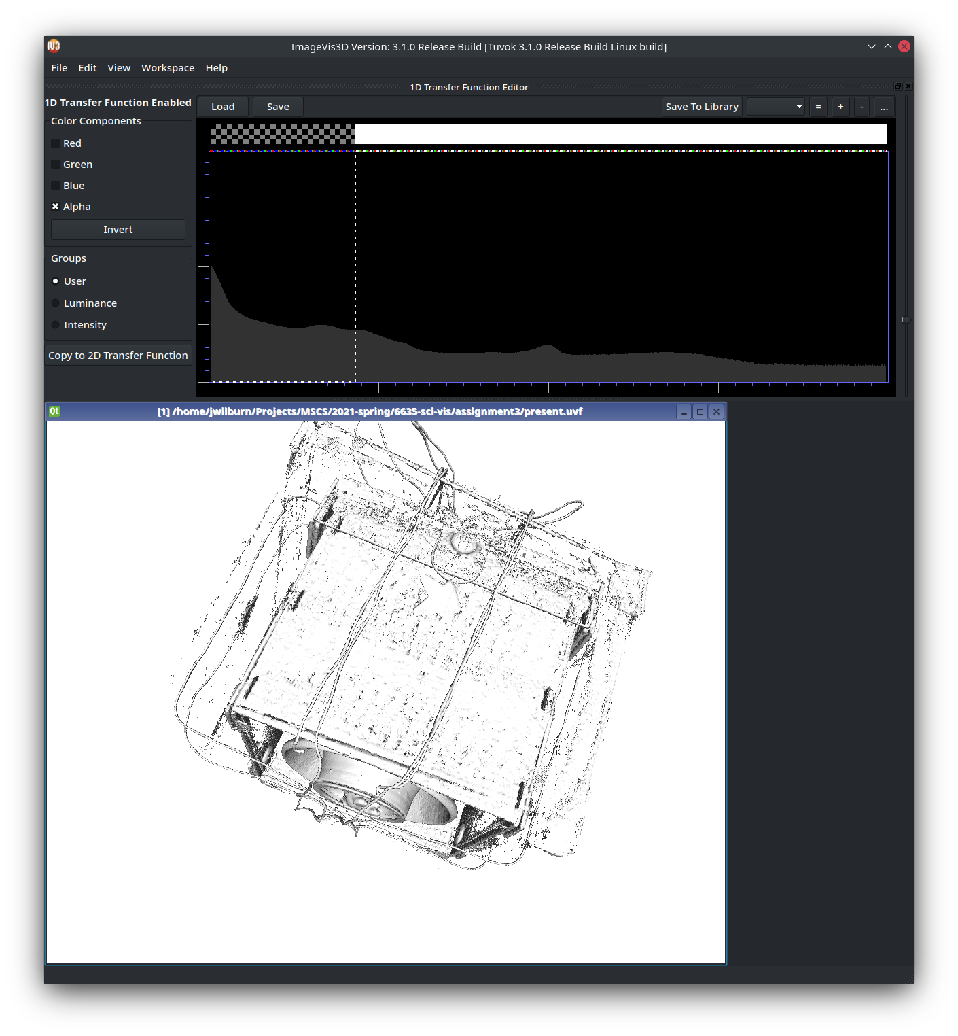

On the inner box there appears to be writing, some like “DIE2EF”. Inside the inner box, there seems to be a pot of some kind.
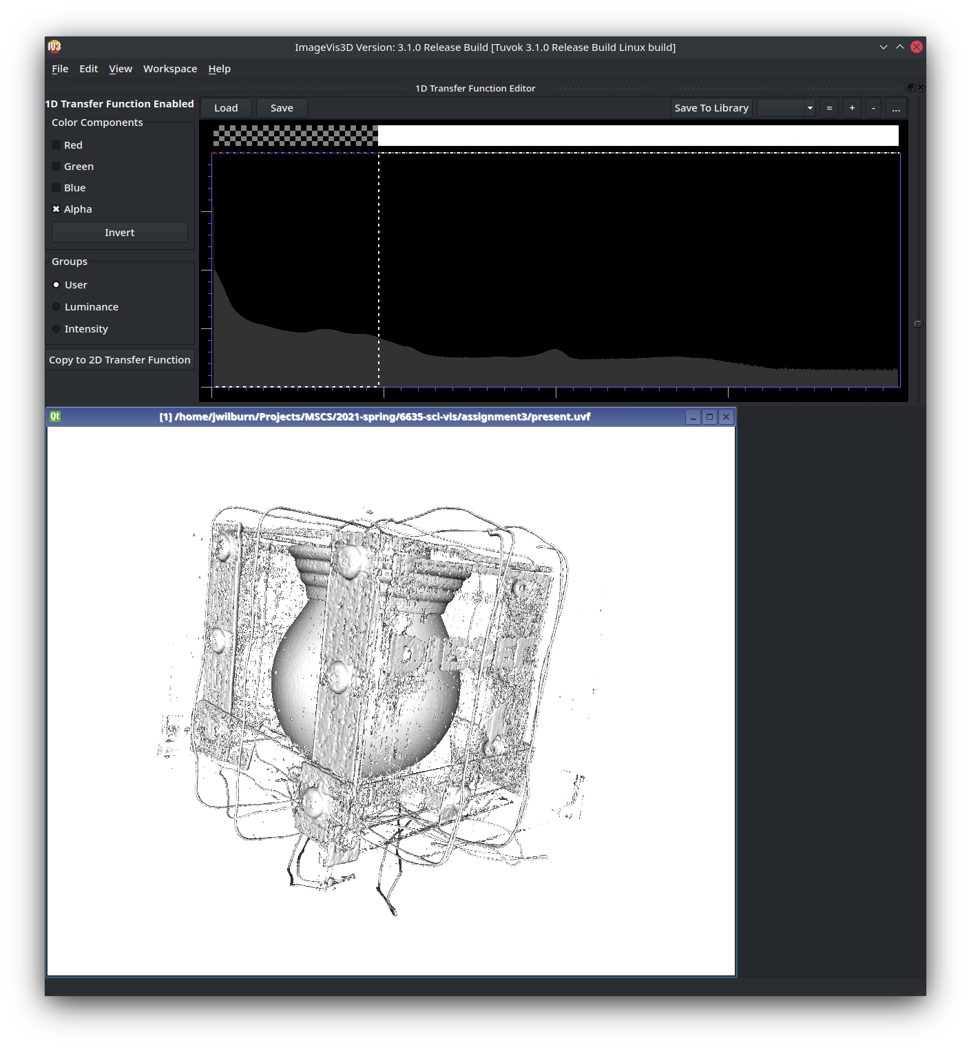

After reducing the visible information some more, a couple things are clear. That inner pot, has some packaging holding the spout end of it that has disappeared. The outer box has some kind of circular objects all over it
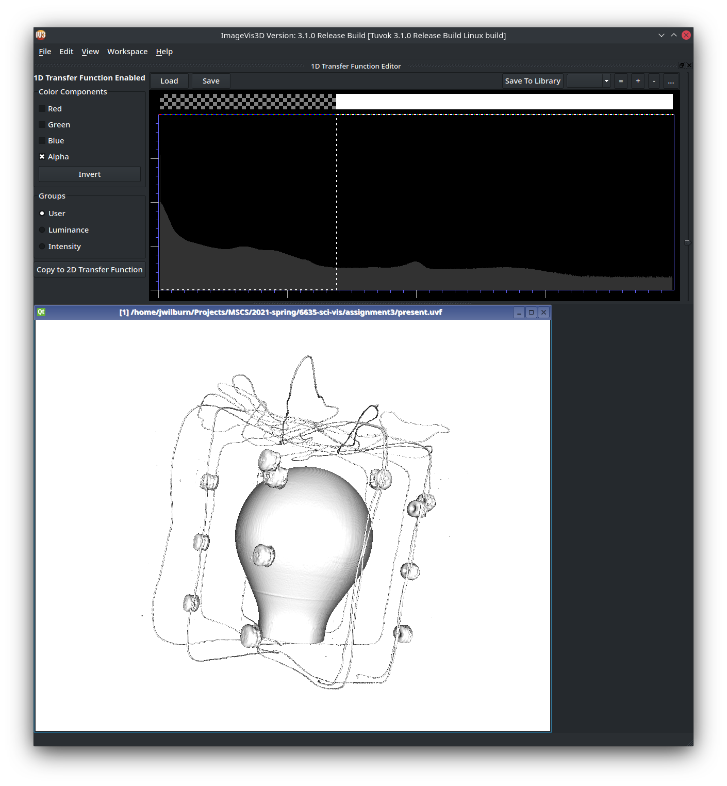

Inside the main object, there appears to be some kind of church/castle
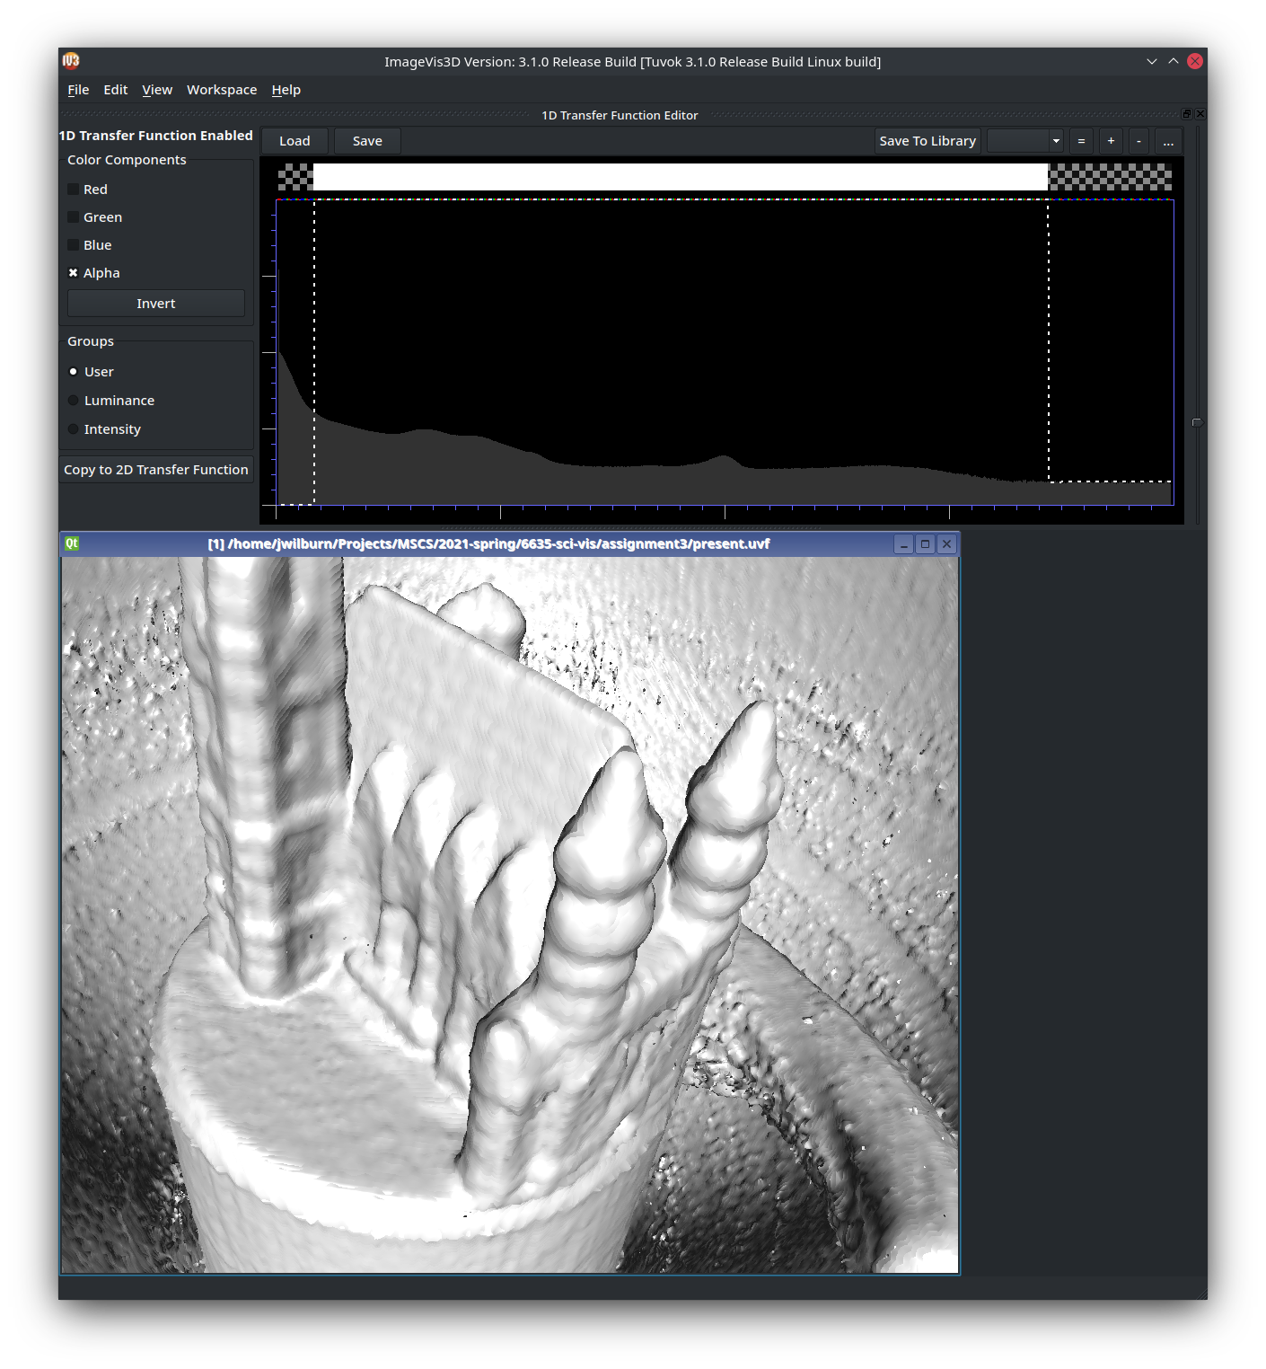

Next to the church, there appears to be some kind of creature swimming. It looks to me like a snake.
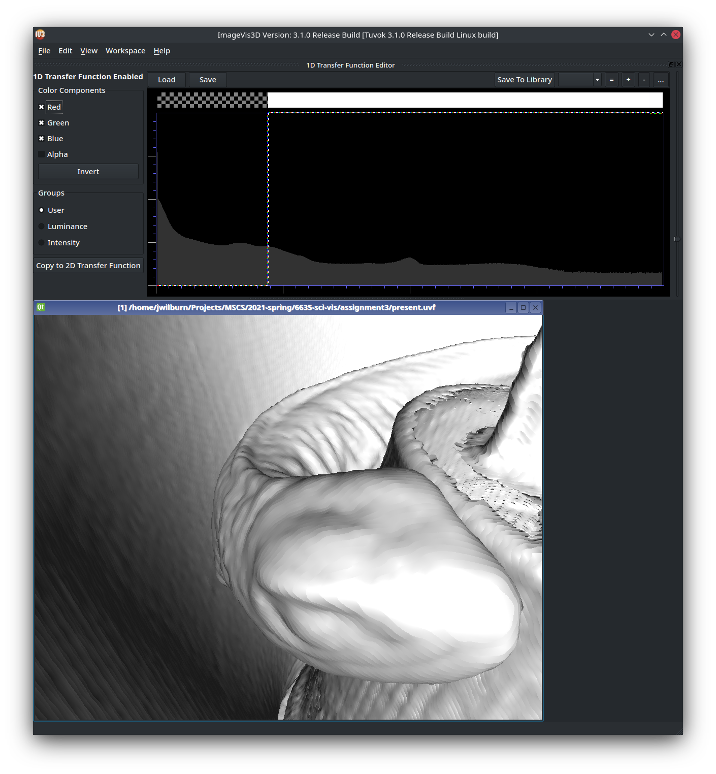
Under the castle, there appears to be a mouse
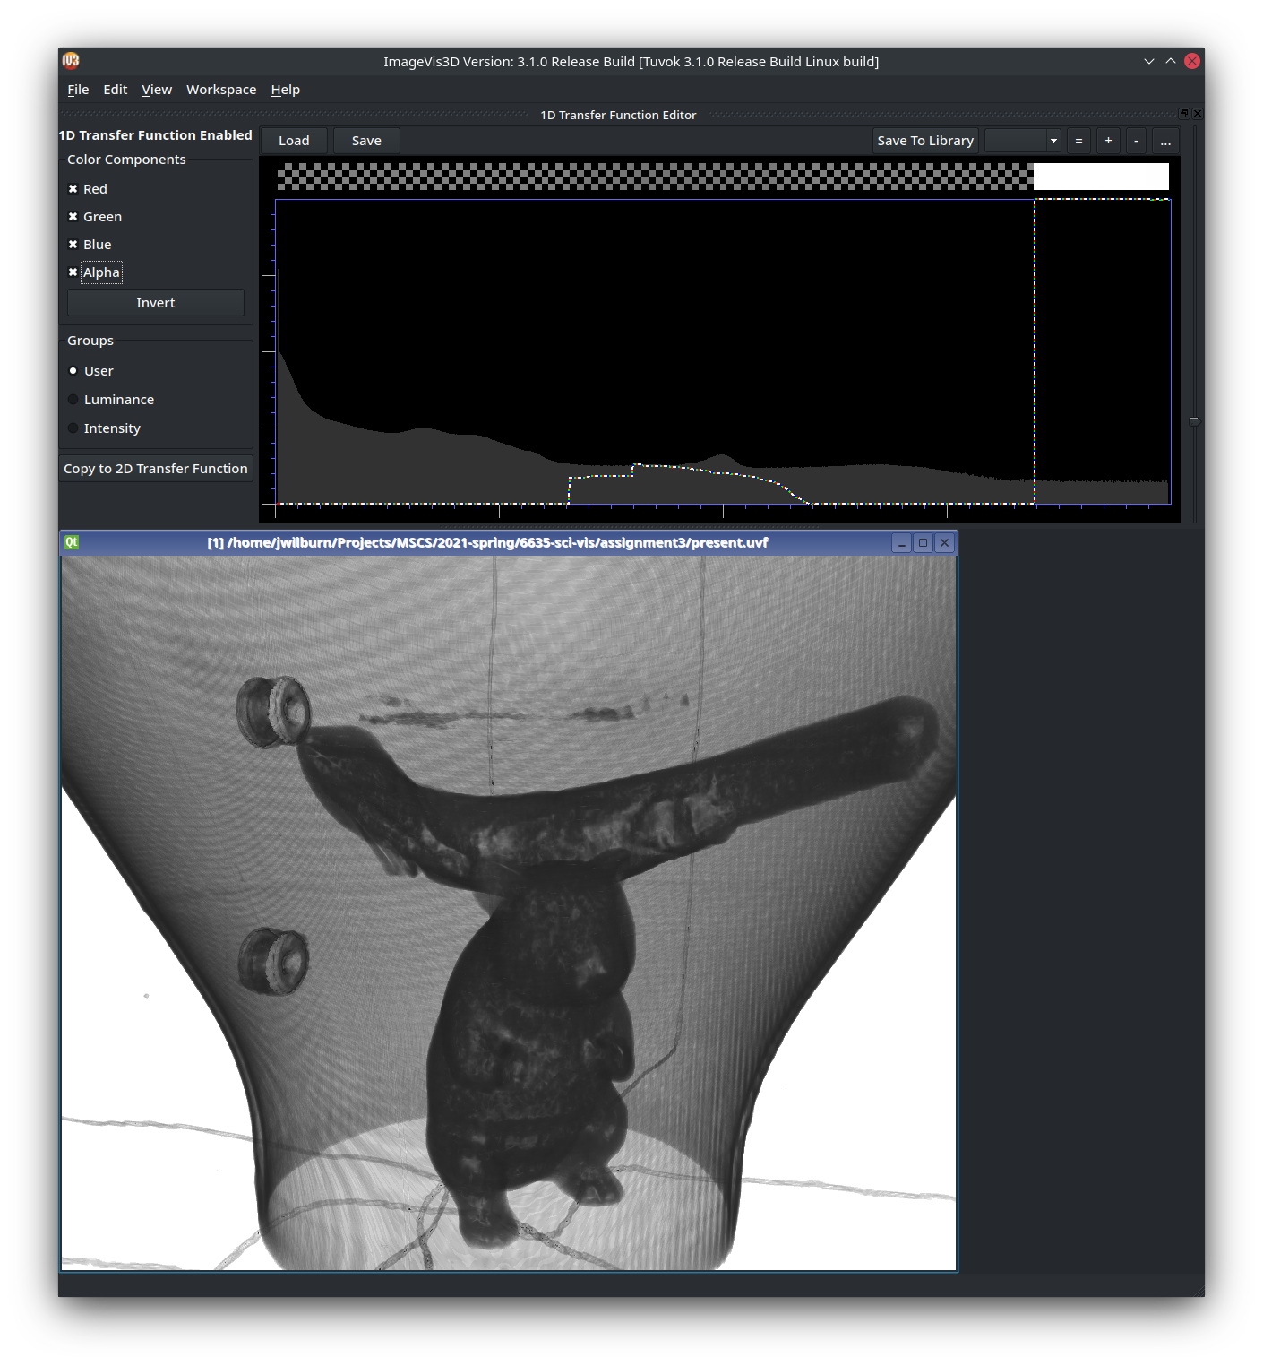
Here’s a top down view.
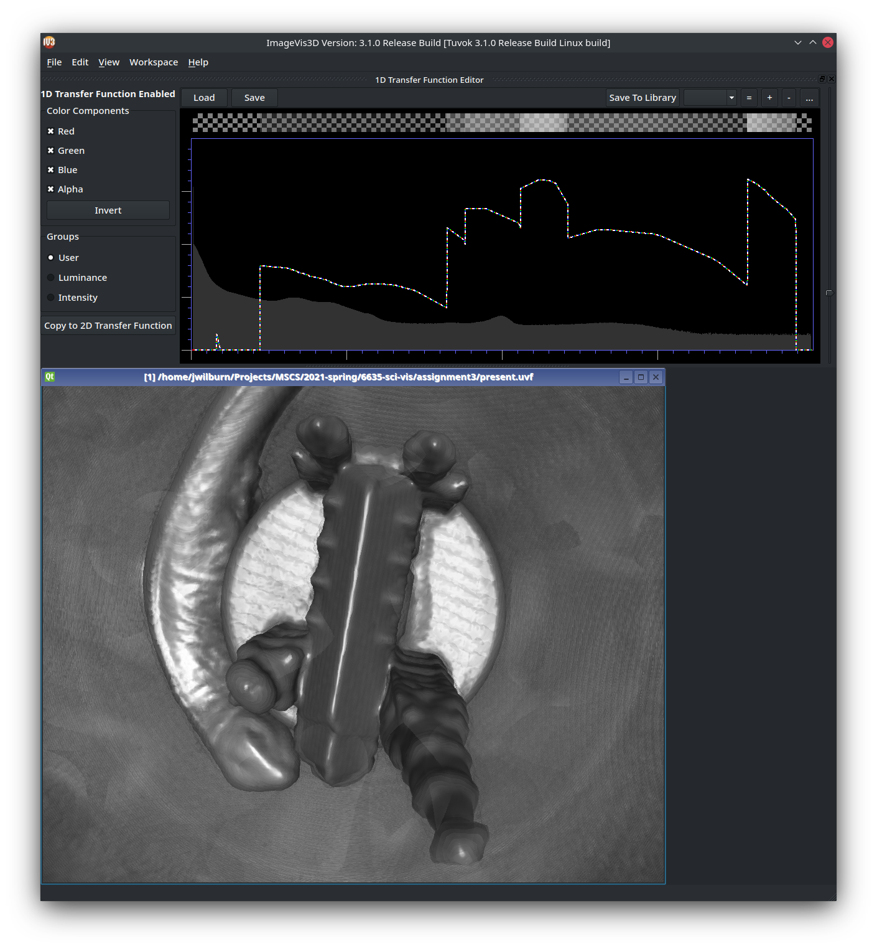
And the same view showing the mouse.
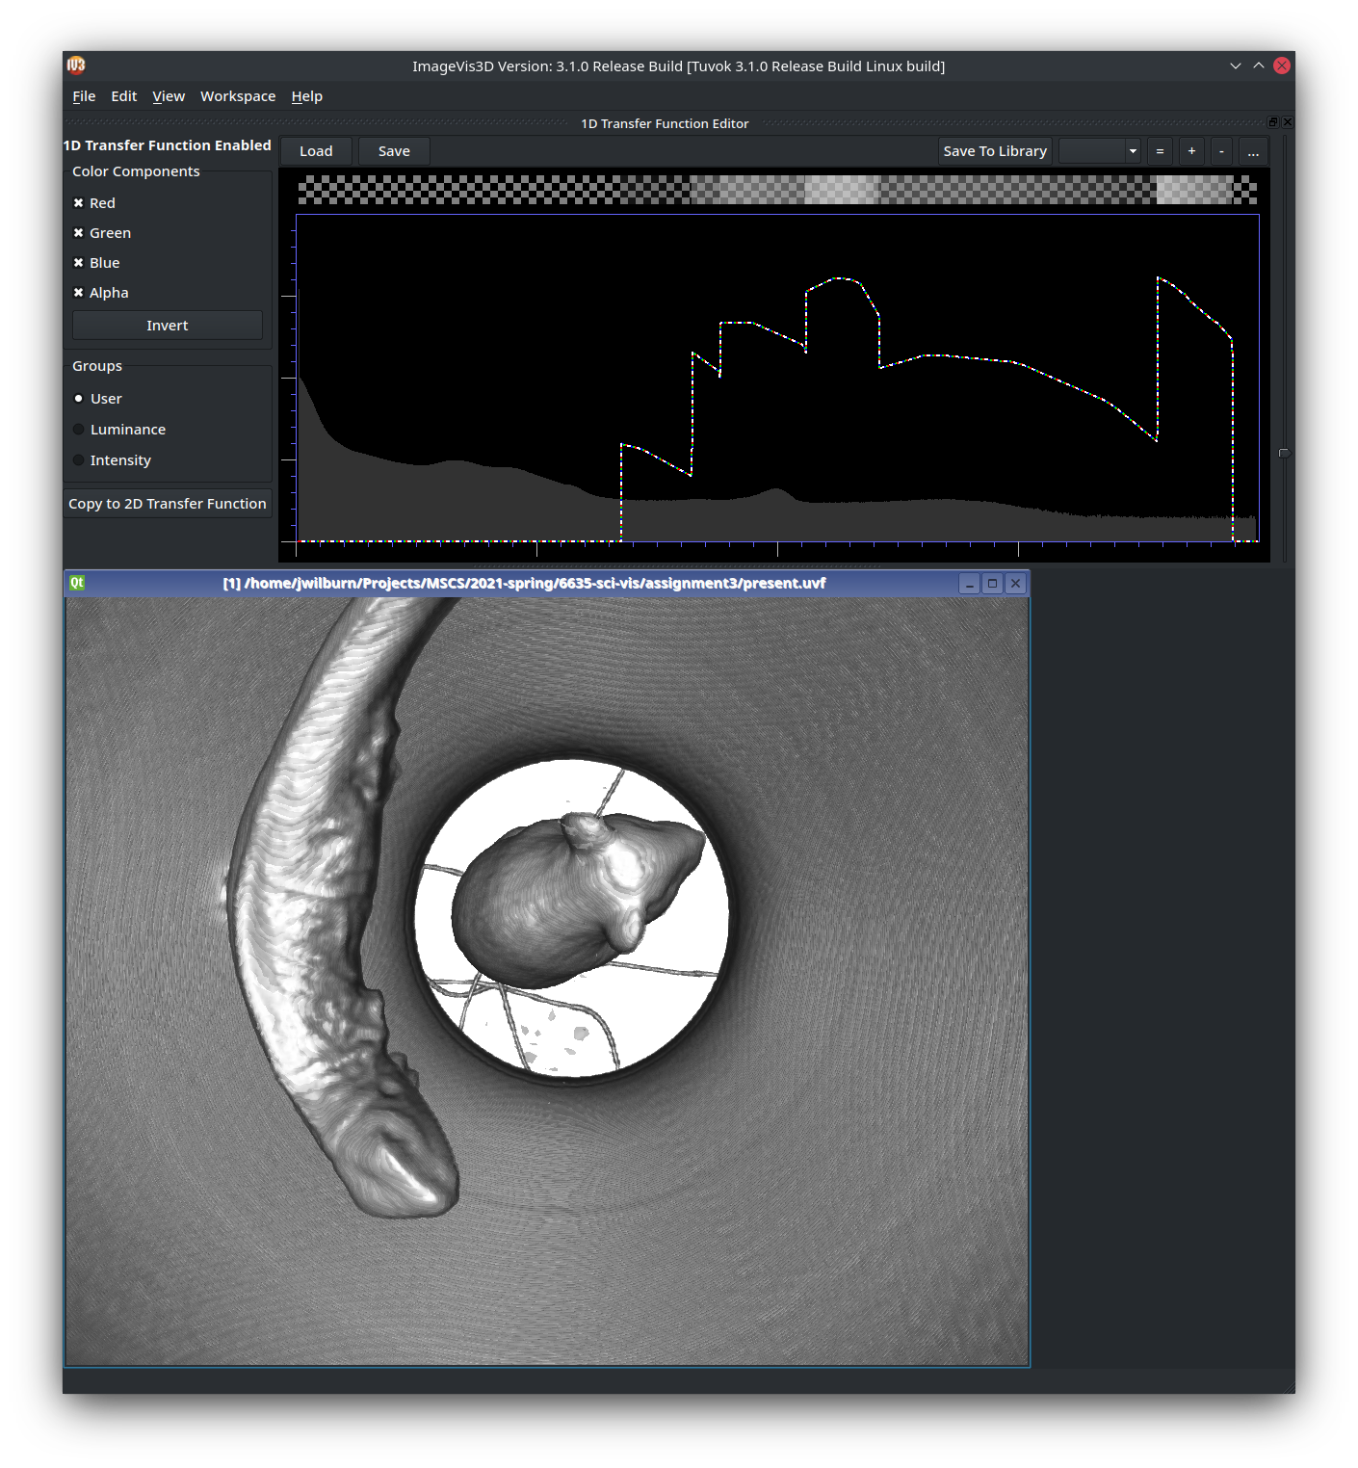
Based on the internals of the mouse and snake, I would guess they are stuffed animals. They don’t seem to have organs.
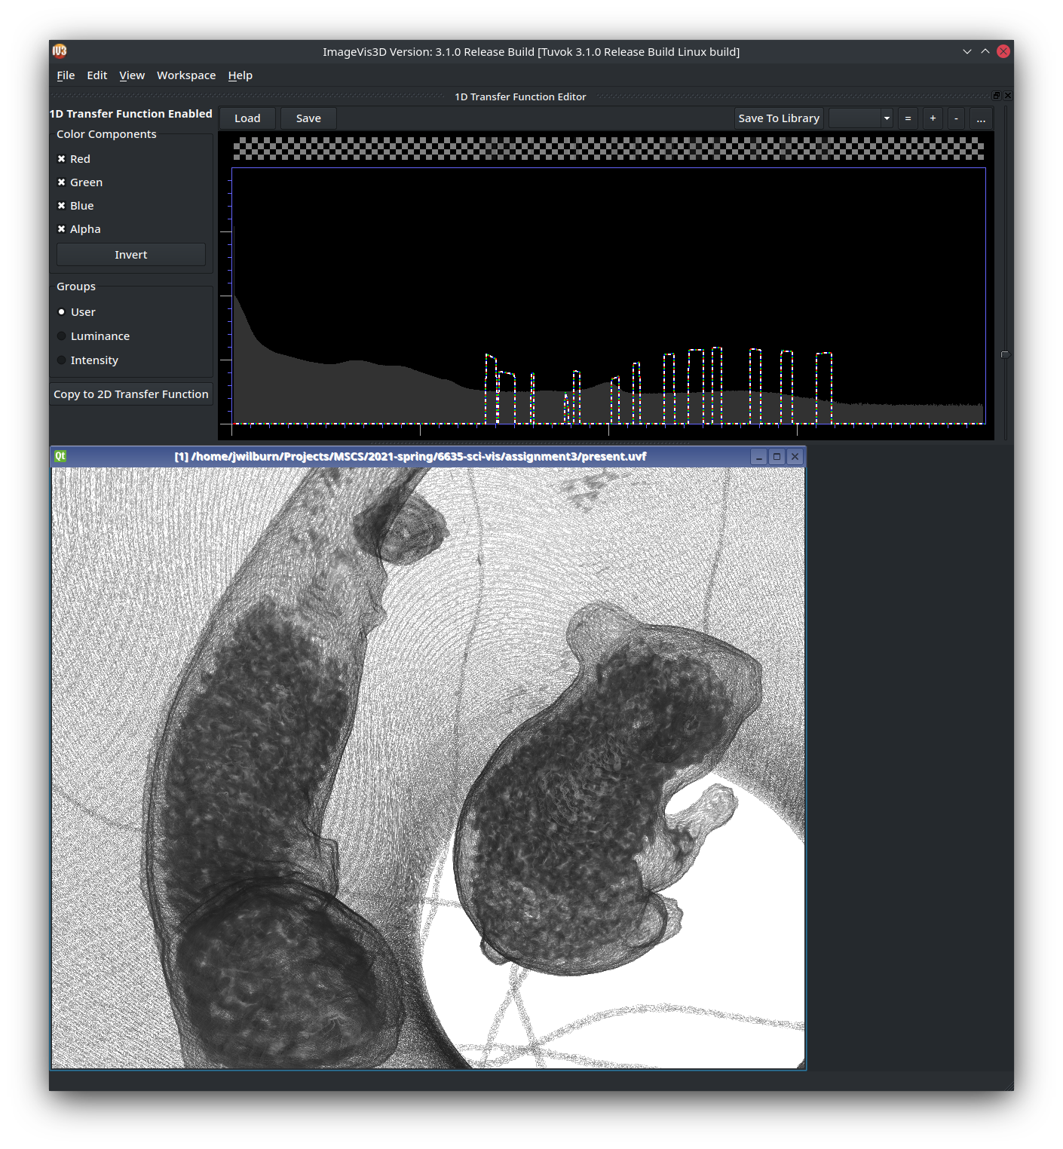

4)
Here’s the outer box with more transparency than with imagevis3d. The nested boxes and inner container are clearly visible though the outside. As are the twine and inner circular spacers
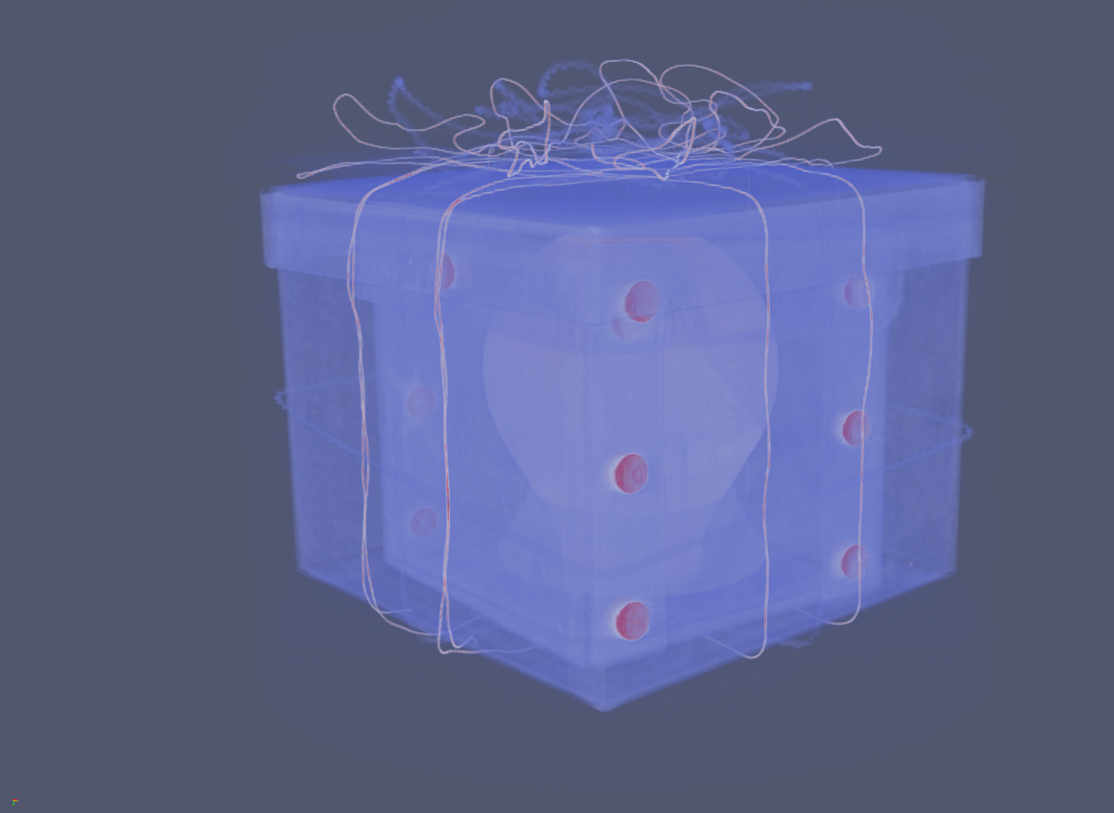

Here’s the inner box and container more clearly
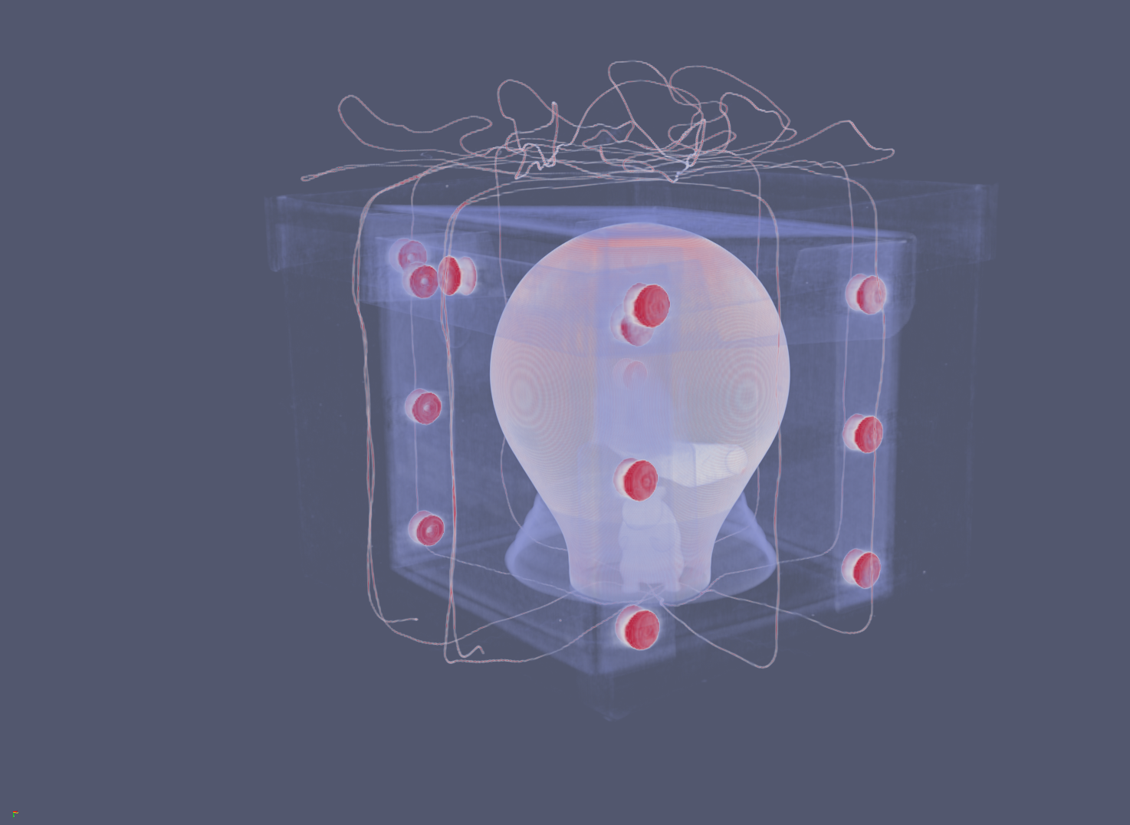

Again, the inner container and the spacers. Here we can see the mouse and snake thanks to the transparency.
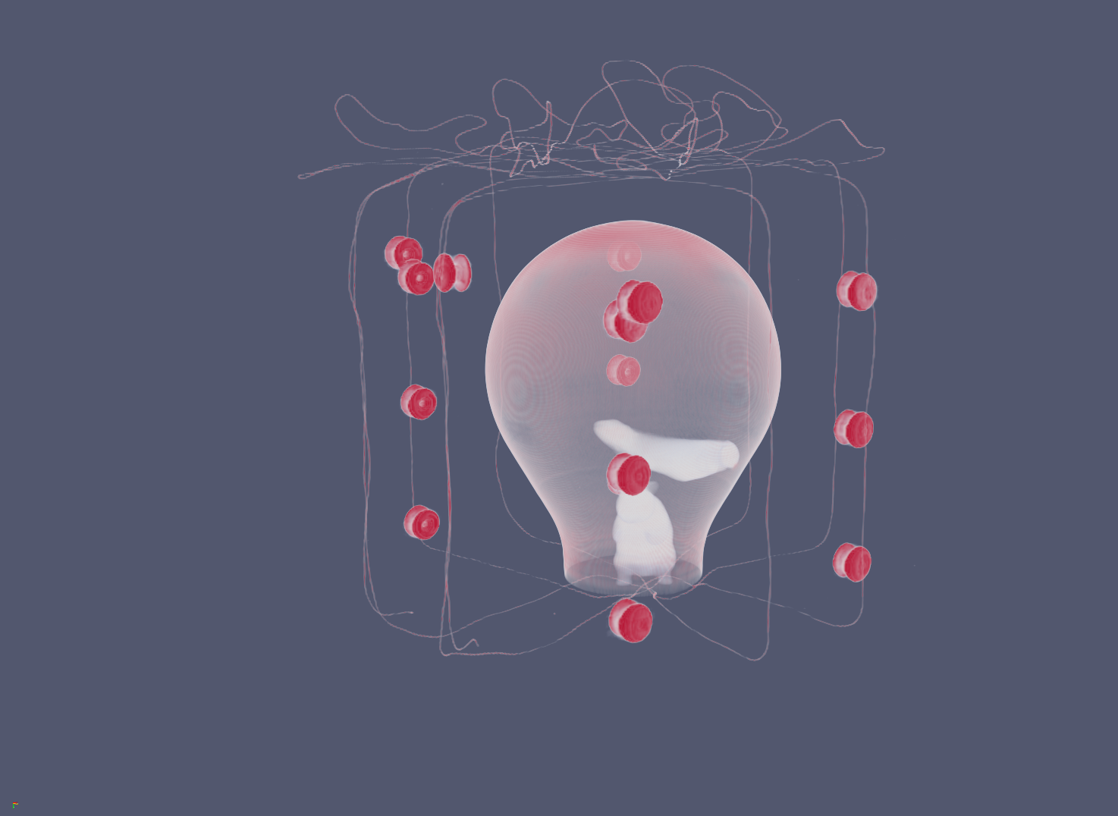

Here we can also see the church/castle through the outside.
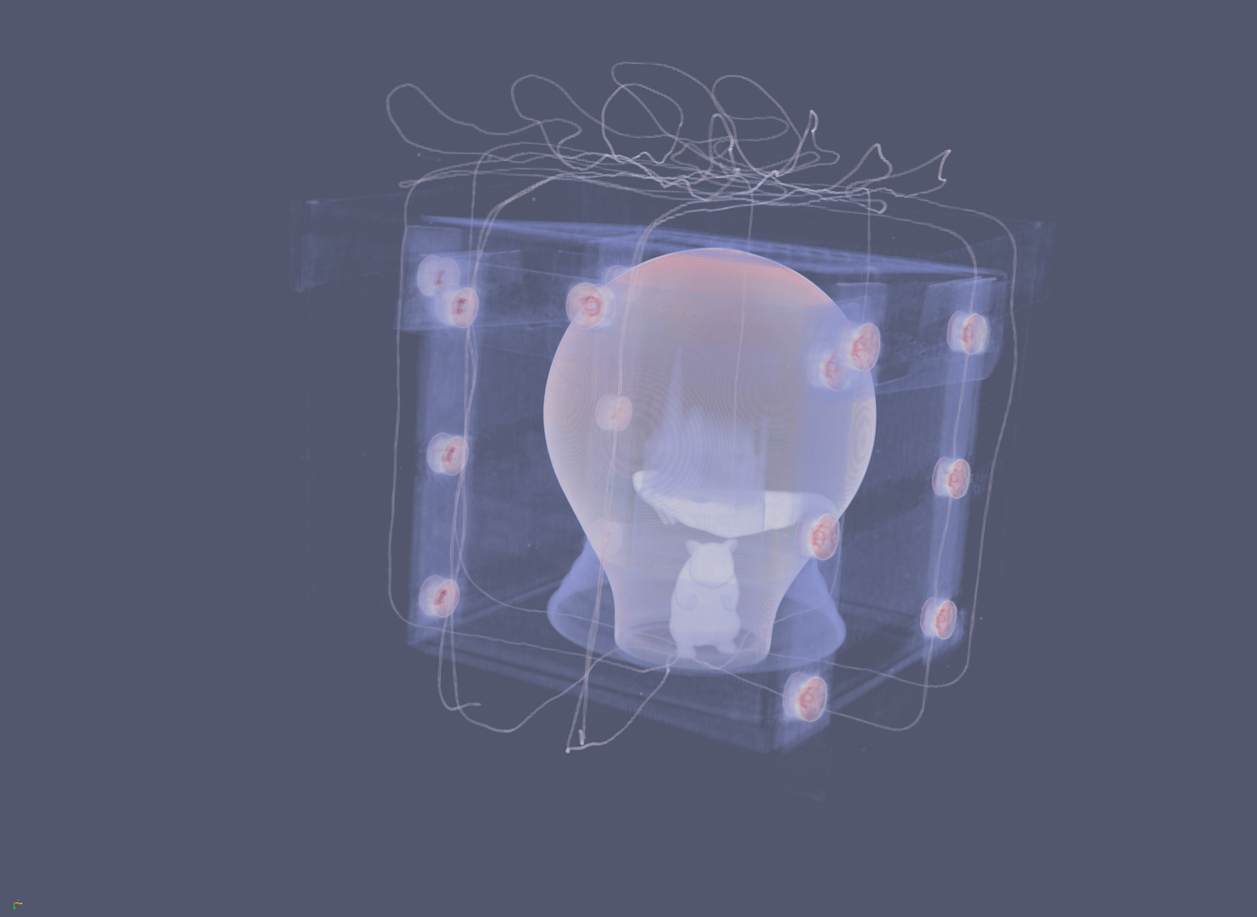

Here’s a look at the mouse in the base of the container

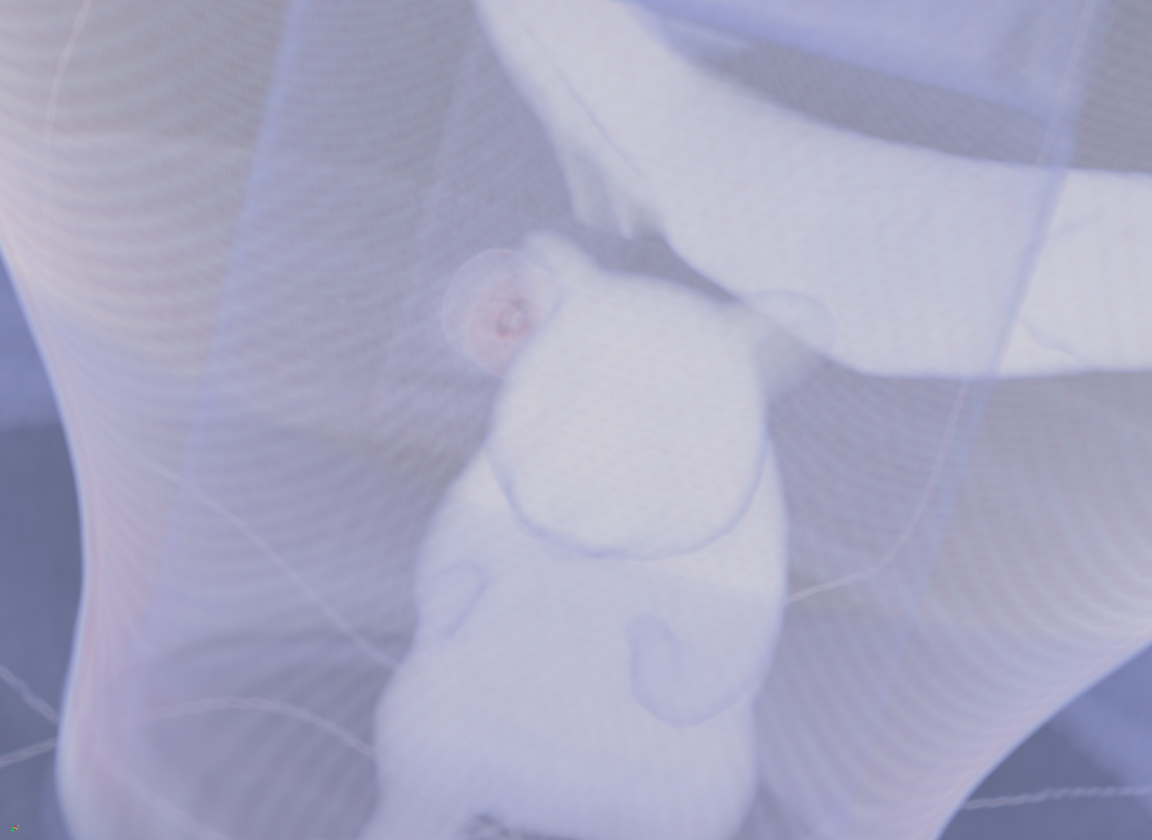

Here is a view of the snake next to the church
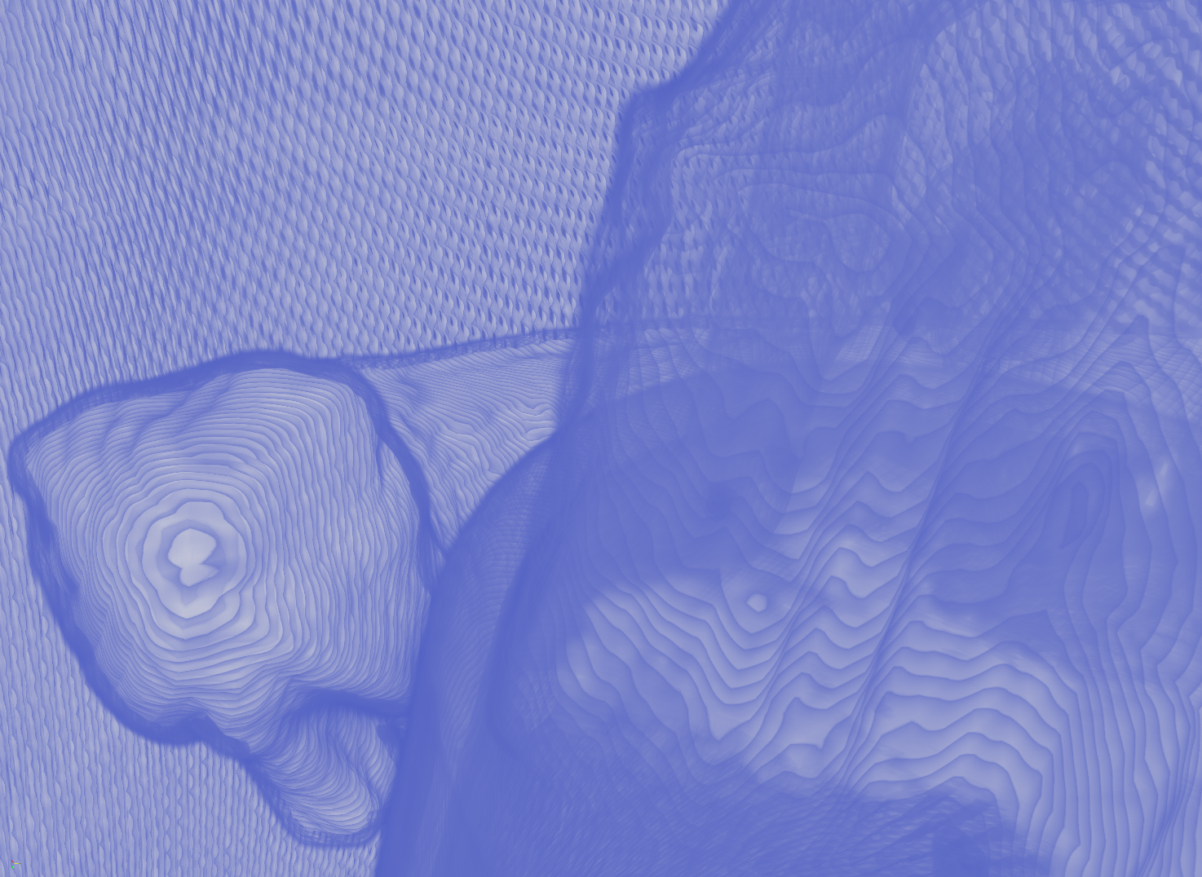

Here’s is a better view of the top of the church looking down.
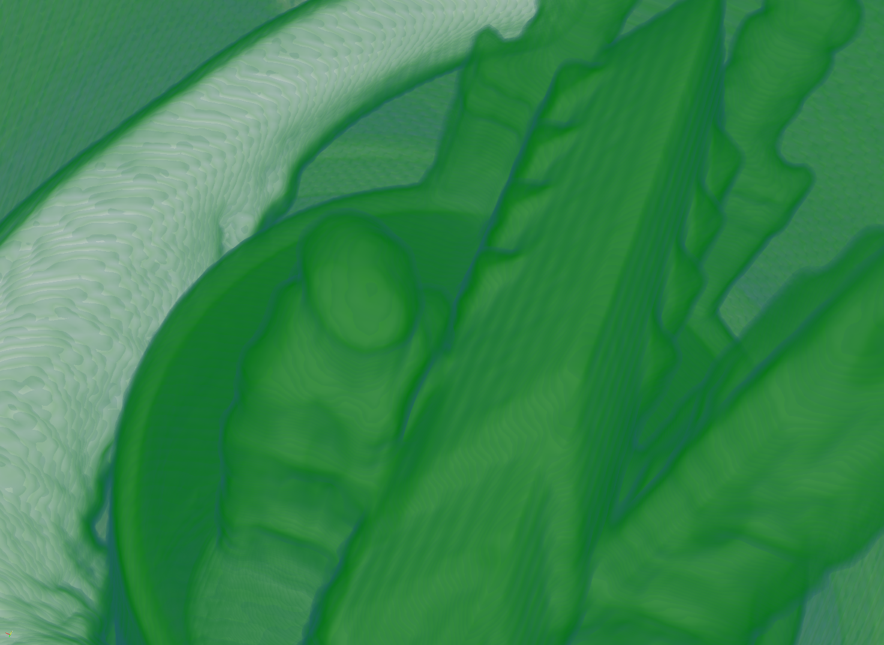
5) After converting this data from dat to raw by stripping of those first bytes, visualizing the beetle was pretty simple. The notable differences between the two data sets is in the resolution and that seems to be affecting the transparency a little. The next shows the top down side by side and you can see that the left has less resolution in the fine details, such as the antennae and that you can see through the shell more easily. In the bottom image, you can see the difference in the antennae again, from a different angle.

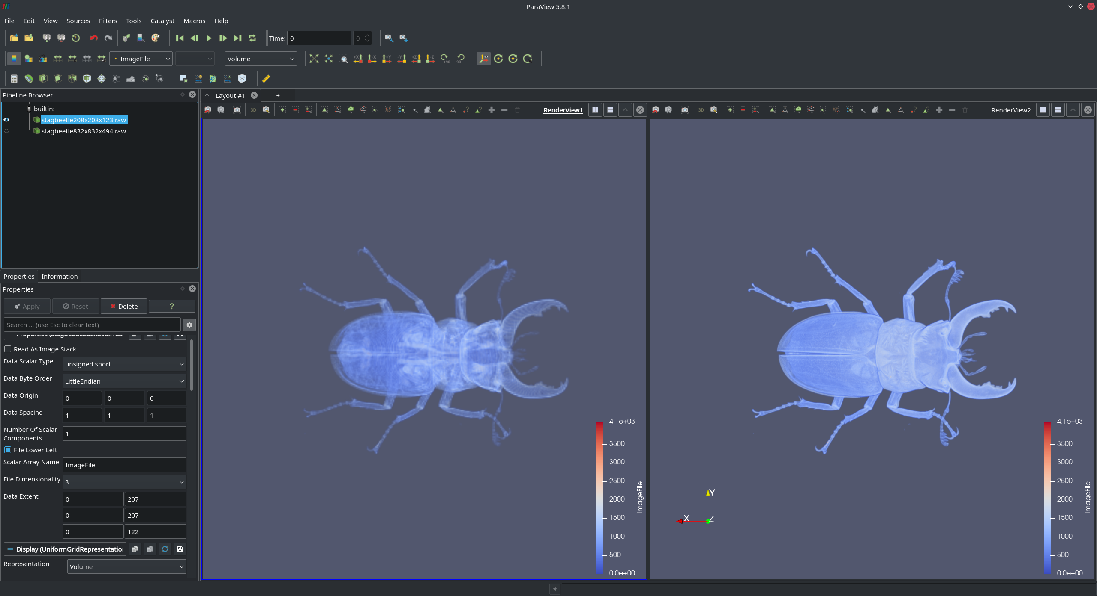
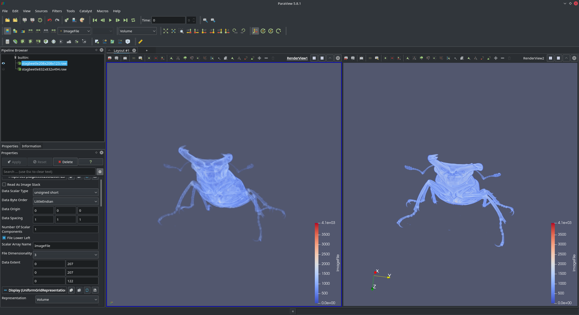
6) For these 8 images I used the importer to convert the raw data to uvf by using unsigned chars and a domain of 256x256x256 for all the files. This data appears to show some kind of gas flow through a hole or created by an object that makes a whole. It appears to be some sort of exit wound based on the frustum shape that is apparent in the first frame. The frames towards the end are hard to understand due to the nature of the chaotic flows that seem to be present. Isosurface rendering didn’t seem to show any other details than what we can see here.


