Jack Wilburn
Assignment 4

Part 1
Visualizing the flow of air above a heated disk using streamlines with tubular surfaces
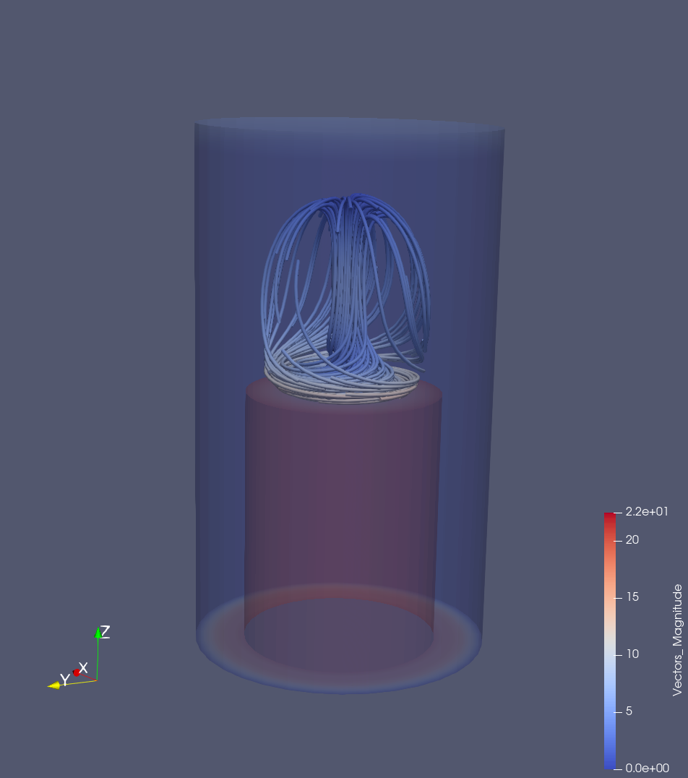
In this first visualization, you can see that the air flow looks like convection, where we’d assume that the middle is hottest and causing the fluid to rise, whereas on the edges, the fluid seems to be falling. Without visualizing the direction of the flow, though, it’s impossible to know if that’s the case.

Fluid flow visualization that shows the direction the fluid is moving using 3d glyphs:
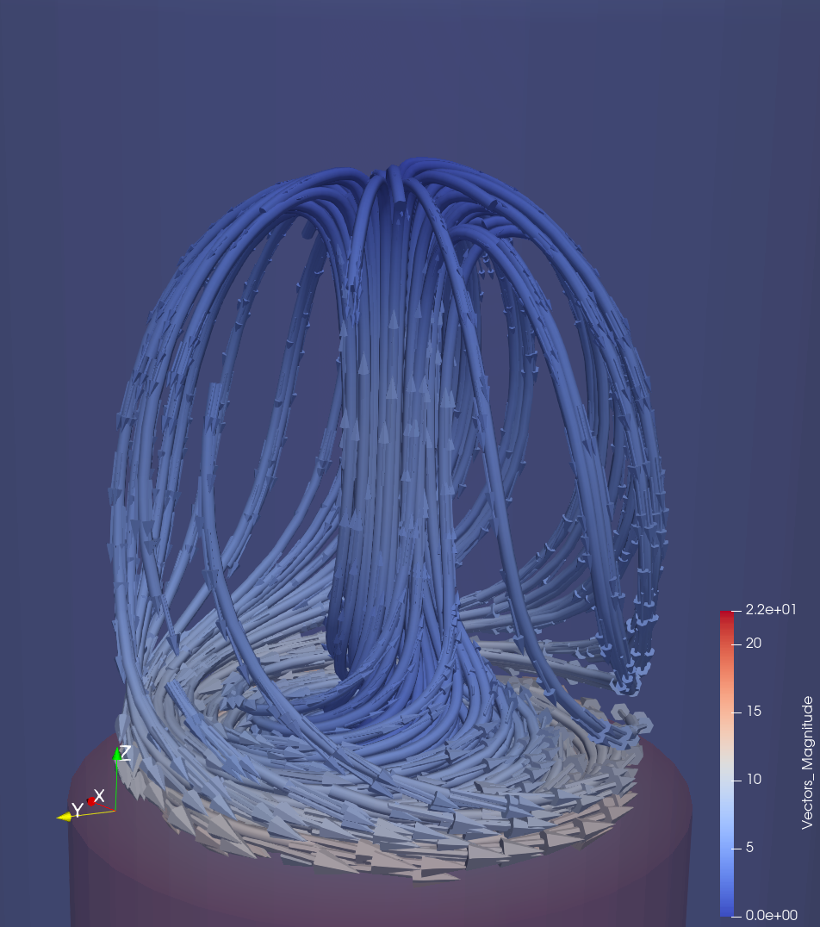
In this visualization we can see that my assumption from before was correct. This looks like convection with the fluid rising from the middle of the heating disc and falling back to the edge of the disc. The fluid appears to be moving fastest near the disc, the whiter area at the bottom.

Part 2
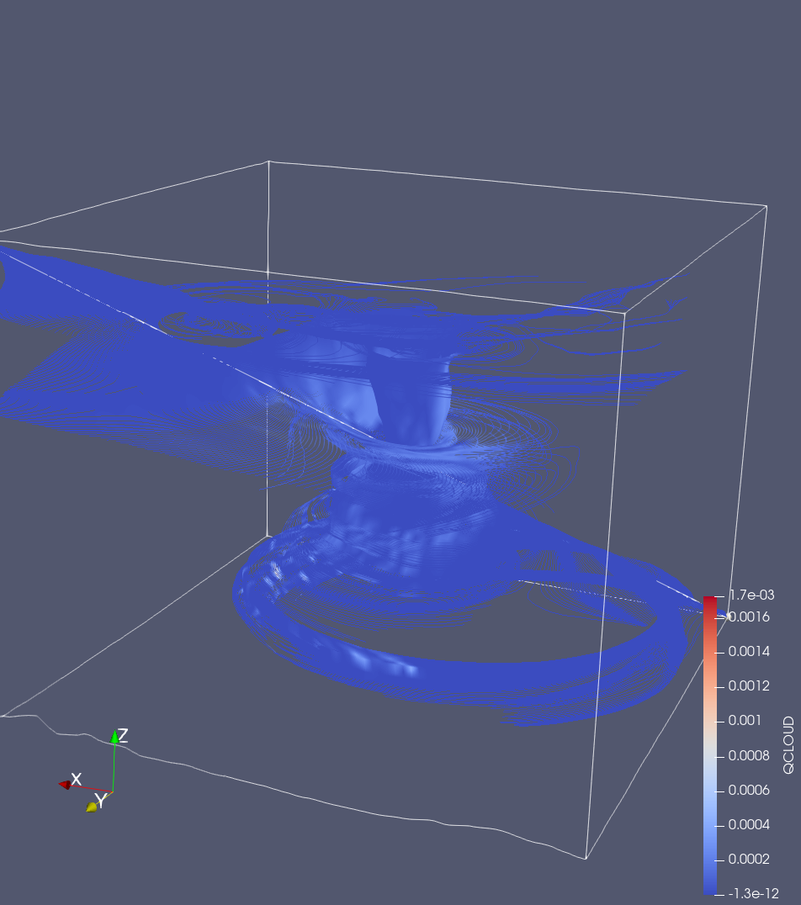
Streamline visualization of hurricane Katrina’s air flow:
From this visualization, you can see that there is one strong central column that the air is moving though and that the air is being pulled towards (or pushed away from) that column over time. The air also seems to be changing locations in the vertical axis in this flow.

Streamline visualization of hurricane Katrina’s air flow with a tubular surface representation:
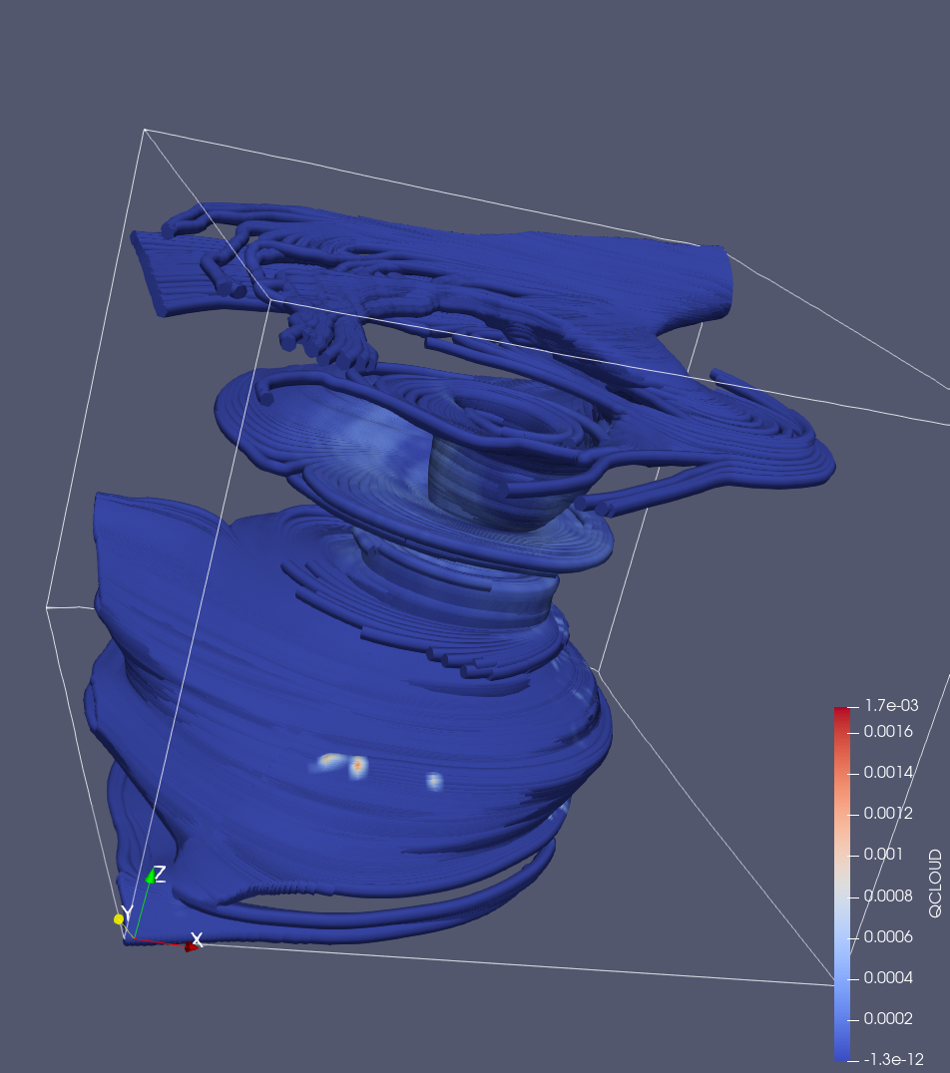
Here we see similar results as before, just the flow is a little easier to pick out. There seems to be a large mass of flowing air at the bottom of the visualization with the air moving through the vertical column of air. It might have made more sense to add a double encoding of the wind speed to the color map, but I was curious about how the flow was interacting with the cloud water mixing ratio.
Visual showing the direction of the flow using cone glyphs to show direction:
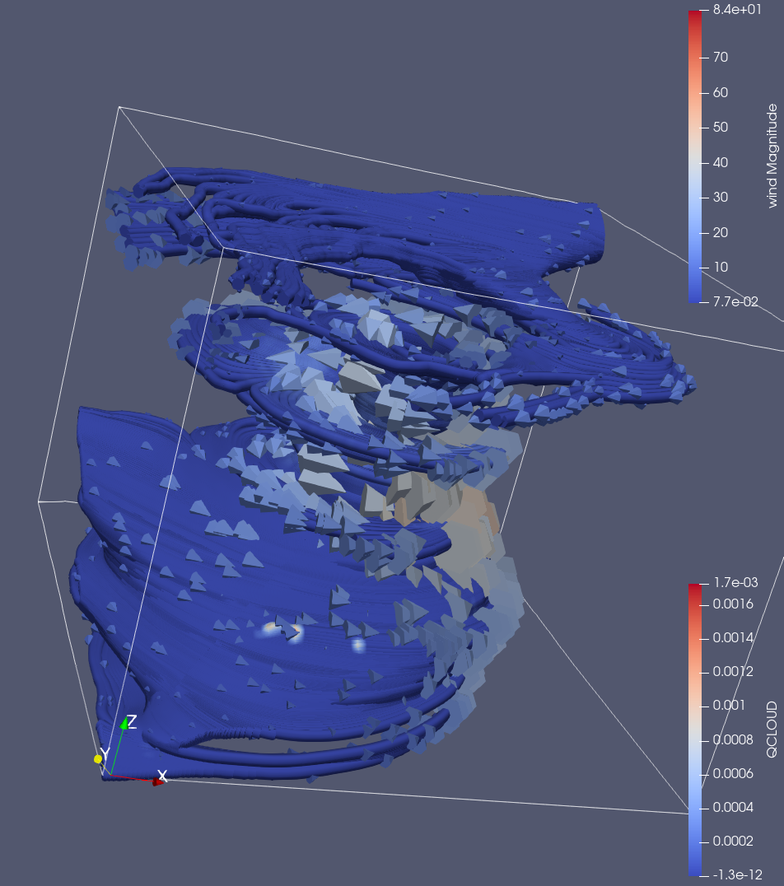
After adding cone glyphs to the visualization, we can see that the flow is wrapping around that central column and the air is being pulled down the column to the large area of airflow at the bottom of the vis. Here we can see that the wall of the eye of the hurricane seems to have the fastest moving winds, denoted by the lighter color of the glyphs.

Left - Visual showing the direction of the flow using cone glyphs to show direction with 2500 random sampled points showing wind direction and strength in other locations
Right - Visual showing 2500 random sampled points showing wind direction and strength in locations across the vis:
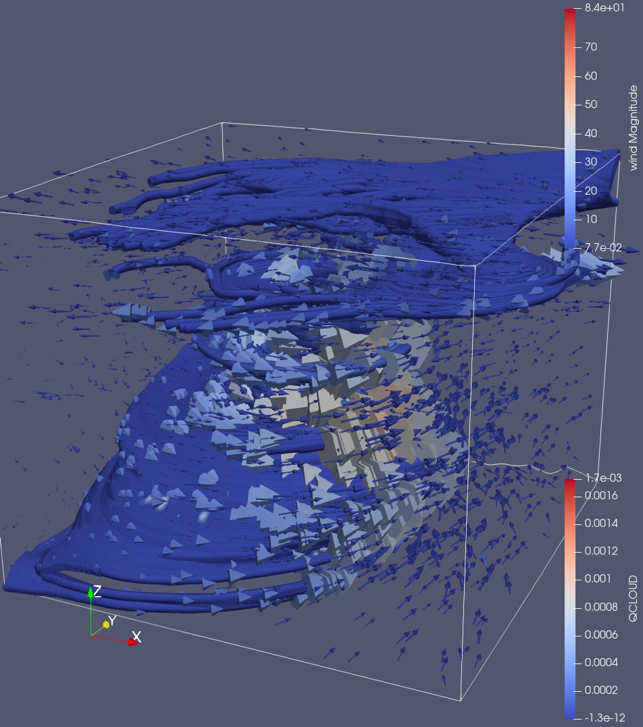
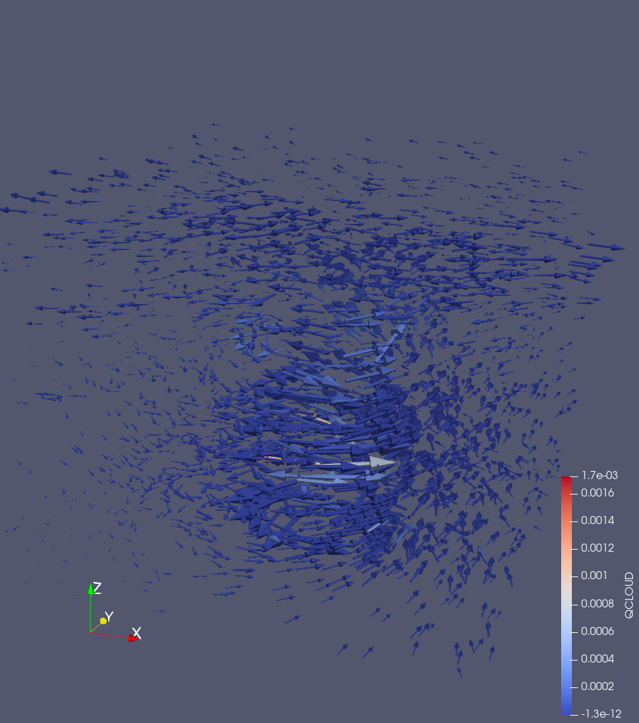
Here I sampled 2500 points from across the vis to show the airflow of other locations inside this data. We can see similar results to what we saw before. The wall of the eye of the hurricane has the highest speed airflow and the other areas have a relatively lower speed. There seems to be a low pressure zone under the central column of air that is pulling down on the air causing a sort of inverse convection style flow.

Part 3
Volume rendering vis of air flow around a car (transfer function, red high magnitude, blue low magnitude)
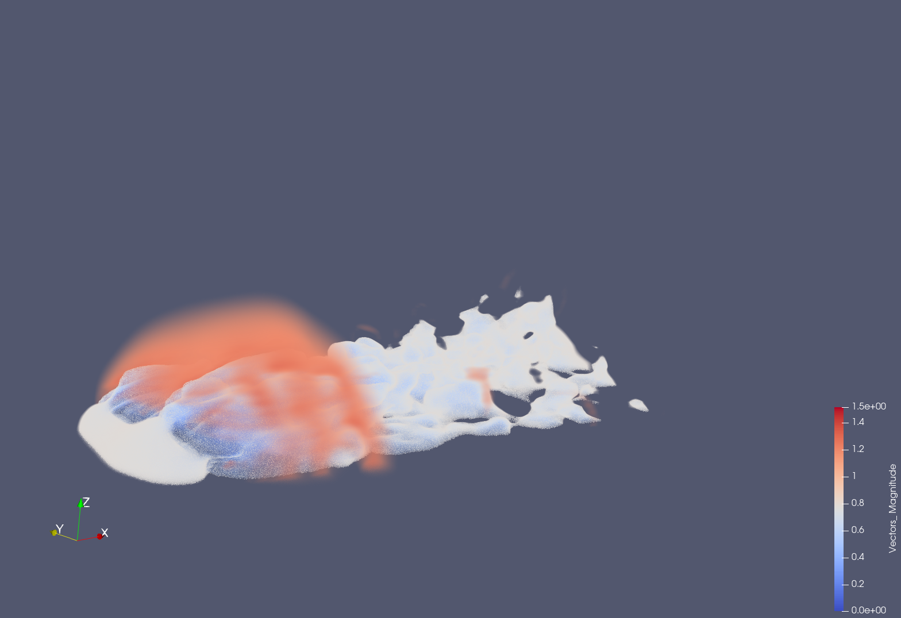
In this visualization we can see that there are area of high magnitude flow around the car and less behind the car. Behind the car, the flow is slower but appears to have more vortices

Adding the stream tracer seeding line:
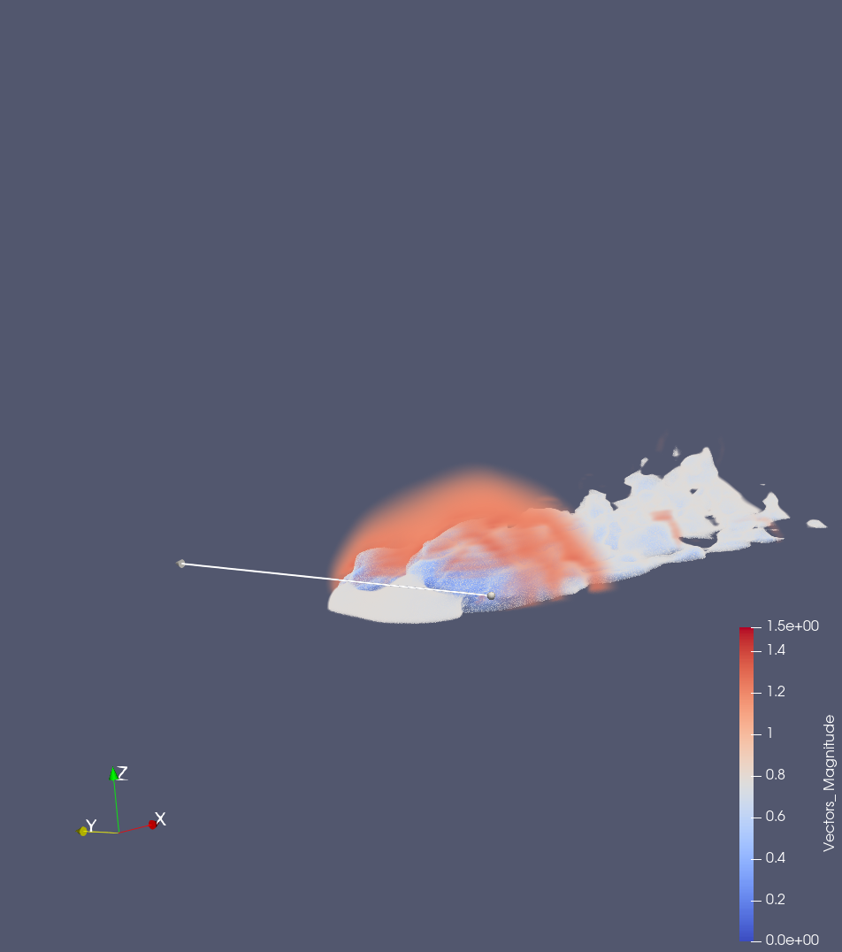

50 samples along the stream tracer with a 0.7 width on the ribbons
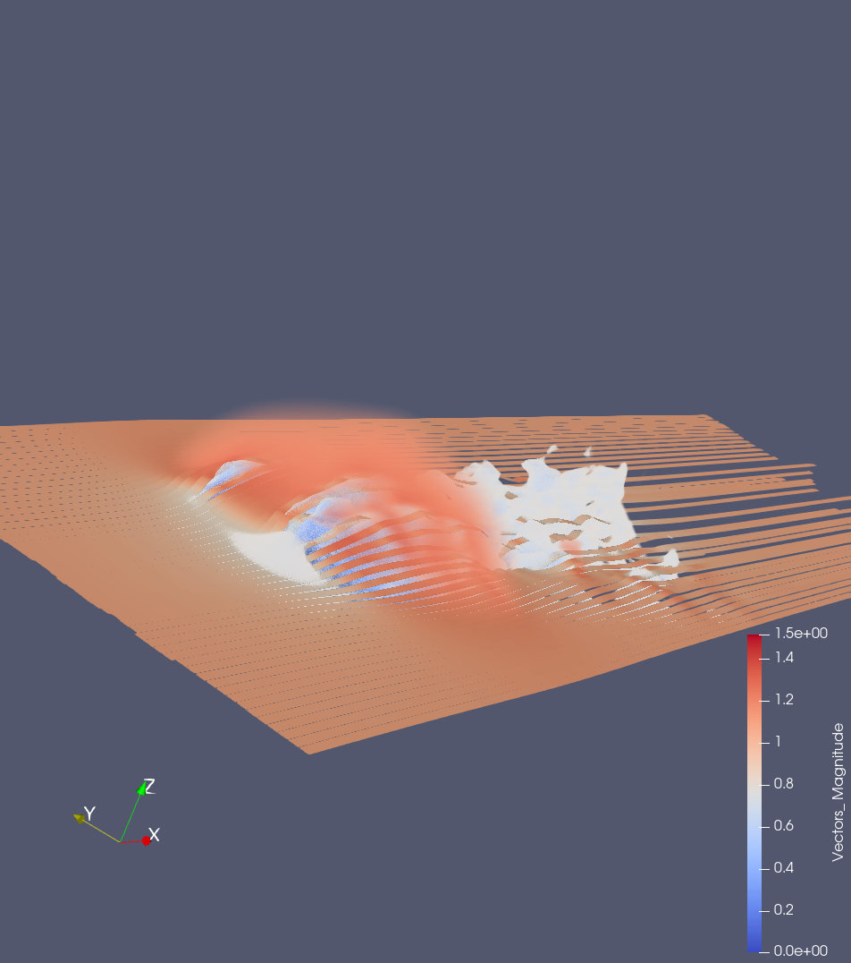
Here you can see the streamlines of the airflow over the car. The flow is relatively smooth over the car and then it becomes more turbulent around the back. This is expected since cars create low pressure zones behind them as they move through a fluid.

Ribbon visualization of the air flow around the car (number 2) smaller line covering just half of the fron of the car
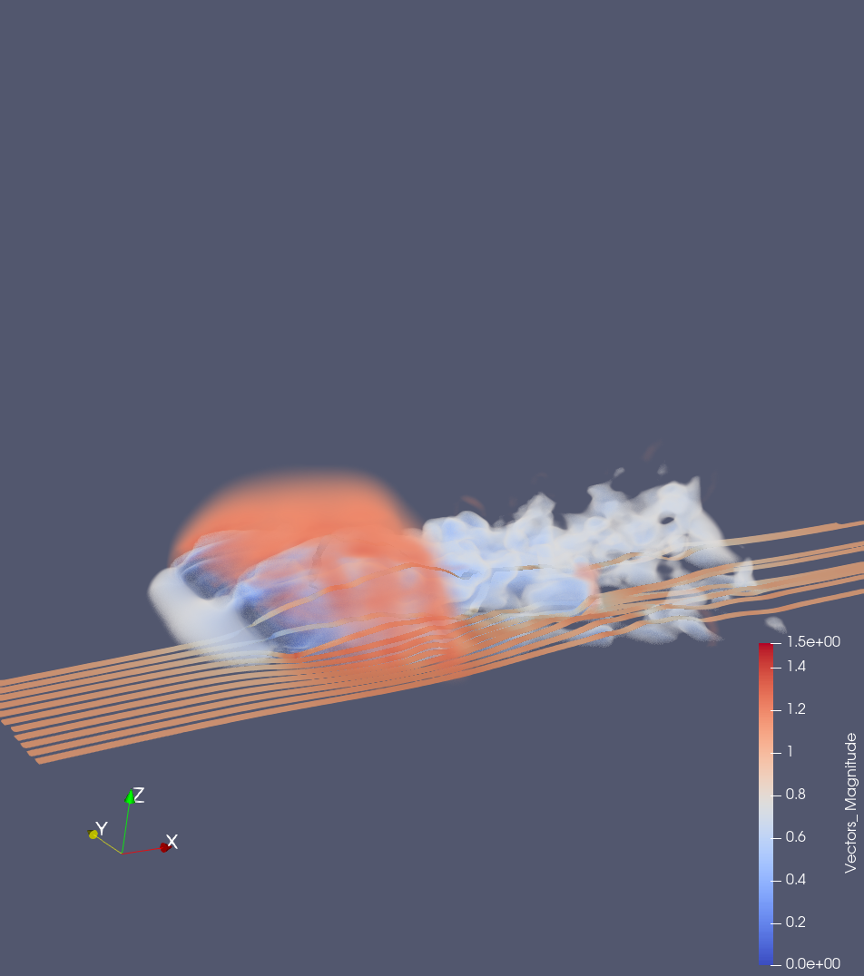
Here we see similar information to before, but it’s slightly easier to see the flow through the vortices behind the car. The ribbons show the twisting more meaning that the air flow behind the car is turbulent.

Sphere source for the streamlines/ribbon visualization on the car
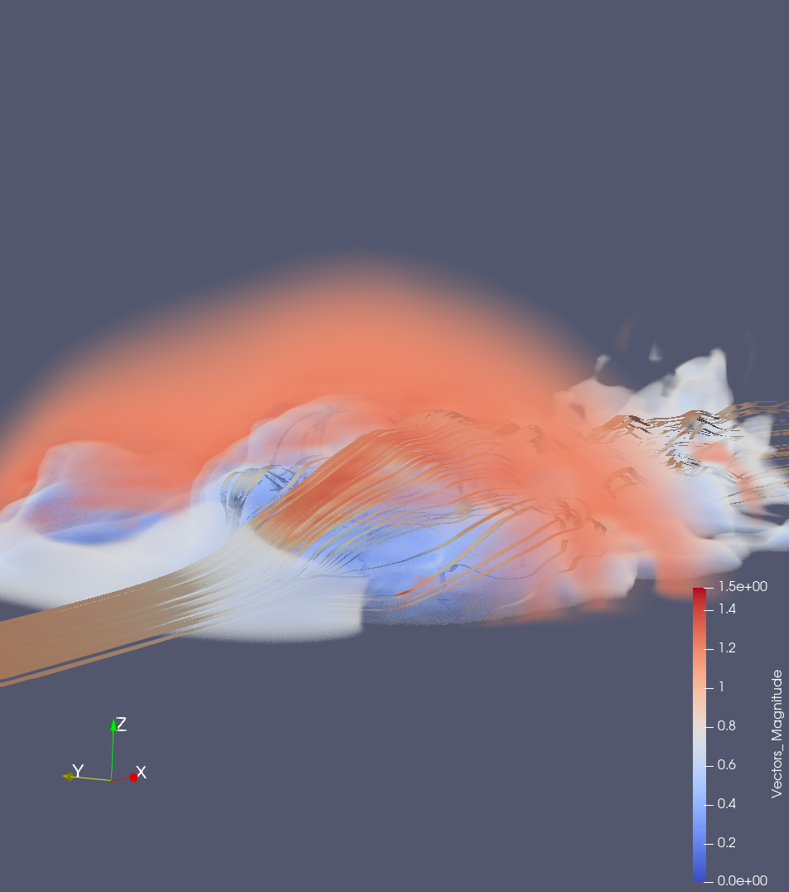
This uses a sphere seed and the ribbons show the airflow over the front corner of the car. You see some ribbons get stuck to the top of the car in the flow and as they get into the vortices at the back, the ribbons start to turn and twist. The sphere point source shows more information about what the air does for a vertical region in front of the car. Basically, it follows a similar pattern to the flow for the orthogonal line.

Part 4
- What are steady and unsteady state flows? What are pathlines and streamlines?
Steady flows are flows that are not dependent on time. A particle in a steady flow follows a consistent path through the vector field regardless of the time component.

Unsteady flows are characterized by their time dependence. In this kind of vector field. The path of a particle is governed by an equation that depends on the time that the particle begins to move. These are significantly harder to model and visualize.

A pathline is an integral curve through the vector field for some specific starting location and time. In a steady flow, the time can be disregarded, a key assumption for the mathematics behind pathlines. We can use a pathline for one instant of an unsteady flow, but if we want to see the path of a particle over time in the vector field, we need to use streamlines.

Streamlines are similar to pathlines, but they show the time dependent nature of the vector fields for unsteady flow by modifying how the line is computed over time. In unsteady flow, we can’t just follow the vector field and one instant, we need to follow the vector field at many different instants to get the resulting streamline over the unsteady flow.

- Briefly describe any three classifications of vector-field visualization techniques.
The three classifications of vector-field visualization are: point-based direct flow visualization, sparse /dense representations of particle tracing, and feature-based visualization.

Point based direct flow traditionally uses glyphs to show the vector at a specific location. This gives a good overview of 2d vector fields but causes lots of occlusion when trying to visualize 3d vector fields. The magnitude and direction can be represented by this type of visualization, but generally it a primitive way to visualize the data. In some circumstances, this is a useful method.

Particle tracing uses pathlines/streamlines to show the path of a particle through a particular vector field. The lines can be through a 2d flow, a 3d flow, or a 2d slice of a 3d flow. This allows for a visualization to focus in on specific details, such as only showing the flow through a small area of the overall data.

Feature based visualizations aim to reduce visual clutter by highlighting the important aspects of the visualization. This can include looking just at critical points and the flows between them, aggregating vectors to reduce the amount of data to visualize, etc. The goal of this feature based visualization is to reduce the analysis burden on the end user by presenting only the most useful information (or at least, less redundant information)

- State any three features for feature-based vector field visualizations. Describe any two features in detail. Why is feature-based visualization important for vector field data?
Three features for feature-based vector field visualization are: critical points, vortices, and aggregated flow

Critical points in a vector field show areas where the flow exhibits some kind of pattern. This pattern might be a saddle point (or others such as a peak or trough) in 3 dimensional space. In 2d space, a critical point may represent a sink or a source, among others. By just displaying the critical points and the way the flow is connected between them, it’s possible to visualize the whole field. This is called topology base visualization.

Vector field clustering, which leads to visualizations of aggregated flow, reduces the resolution of the visualized data so as to remove visual clutter and keep from overwhelming the user. A common strategy for the aggregation is combining multiple vectors from a region of space into one vector, but often this can remove important features such as vortices. Therefore, these algorithms need to be carefully crafted to remove redundant information while leaving behind the intricacies of the flow.

Feature-based visualization is important for vector field data because it reduces the analysis burden on the user of the visualization. Instead of a user having to synthesize all of the features in their head from the visualization, they are instead guided to see the automatically detected patterns in the data, such as critical points, etc. This makes it easier to understand the underlying data and to generate useful analyses.

Conclusion:

Through this work, I learned how to apply my theoretical knowledge of differential equations and calculus to some actual simulation data. This reinforced my understanding of the underlying mathematical concepts such as critical points, line integrals, etc.

References:
Weiskopf, D , Erlebacher, G. Overview of Flow Visualization. The Visualization Handbook. 2005.

