Jack Wilburn
Assignment 6

Part 1)

Box plot of 10,000 random numbers between 0 and 1
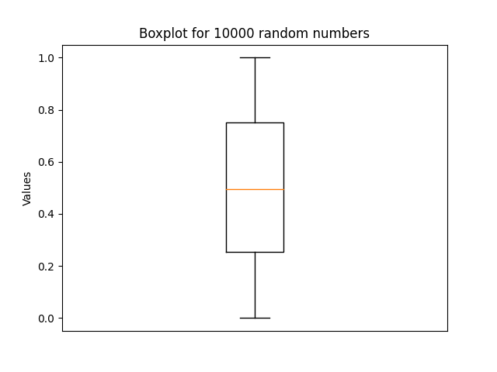
This box plot represents the uncertainty in the data by showing a central 50% of the data and then where data exists but is outlying as whiskers. If we had points outside this range, they would be tracked as dots showing that they are extreme outliers.

  - Completed see images below.
  - Isocontour visualization of variable data to show uncertainty in 3 locations
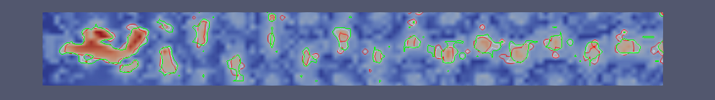
A
B
C
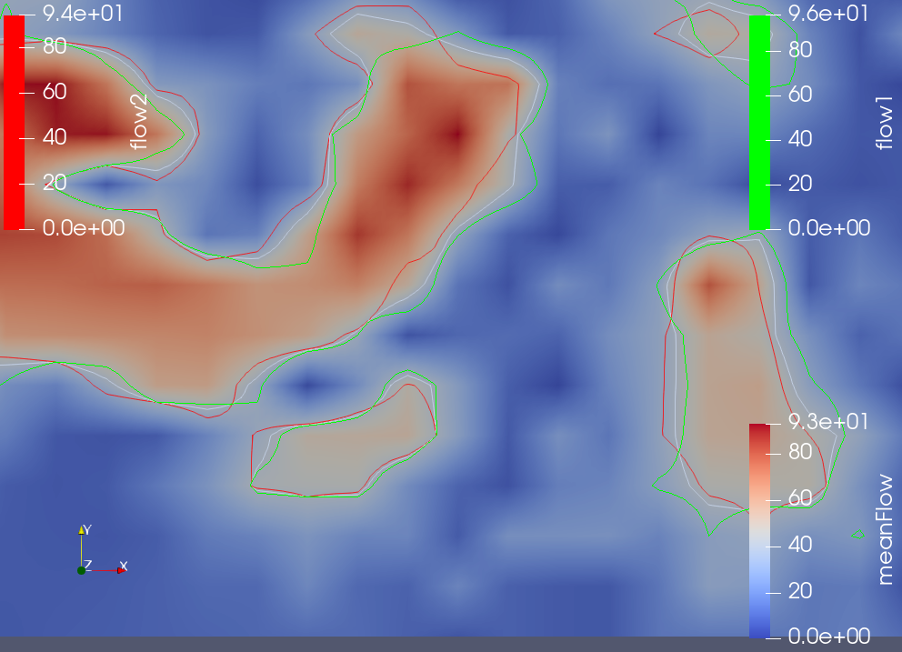
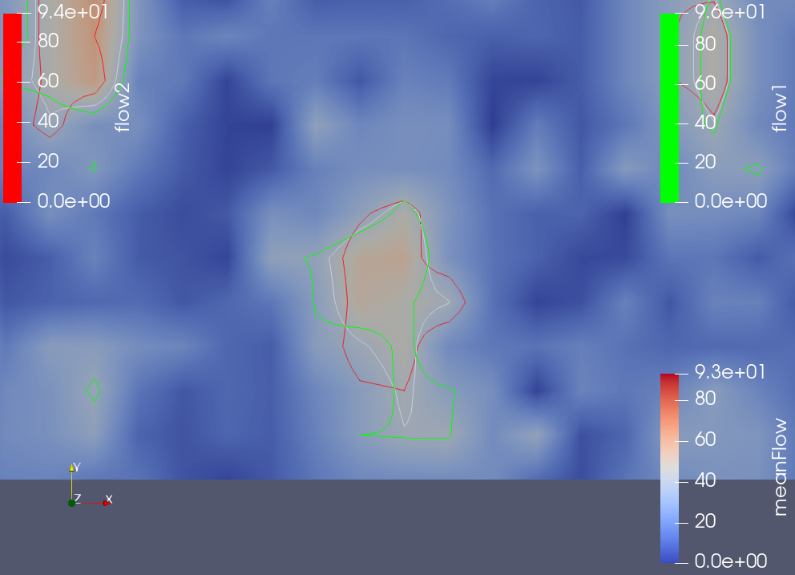
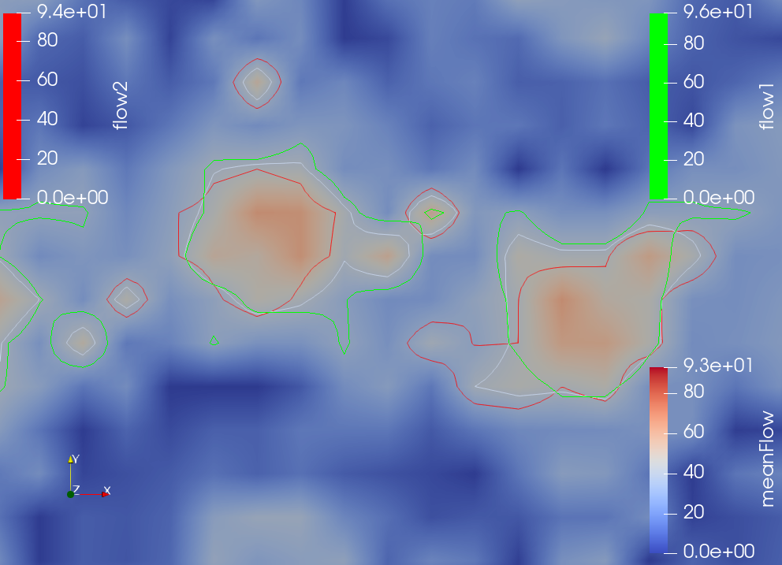
  - A is top left, B is top right, C is bottom. In all three of these data sets, the isocontour boundaries are different. This shows that the data is clearly variable and that the measurements likely have some uncertainty associate with them. In A we see low variability, and the contours seem to line up. In B there is a higher variability and the contours are close but don’t overlap a ton. In C we see more variability still with some region being highlighted in one color and not being selected at all in the other colors (take for example the blob in the top left of the image).

- In your own words, briefly describe contour boxplots, and describe the conceptual similarities and differences between contour box plots and 1D boxplot
Contour box plots take the idea of a 1D boxplot and move them into the 2D realm allowing for the analysis of boundaries using isocontours. Generally when scientist generate data, the uncertainty is trick to visualize and often researchers would use averages or point-wise probability. In the case of contour box plots you see the variability along certain regions and are more easily able to see the uncertainty in the measurement.

- In your own words, discuss the advantages/disadvantages of contour box plots over spaghetti plots for isocontour uncertainty visualization.
Spaghetti plots show similar boundaries for the uncertainty in the visualization with their overlapped lines, but I’d argue that they’re a little busy and don’t leverage preattentive processing as well as contour box plots. In contour box plots, the outliers are specifically drawn attention to with color, but in the spaghetti plots it’s on the viewer to parse through that themselves. The same is true with the median value. Ultimately, contour box plots do a better job overall in this example.

Part 2)

Mean wind glyphs:
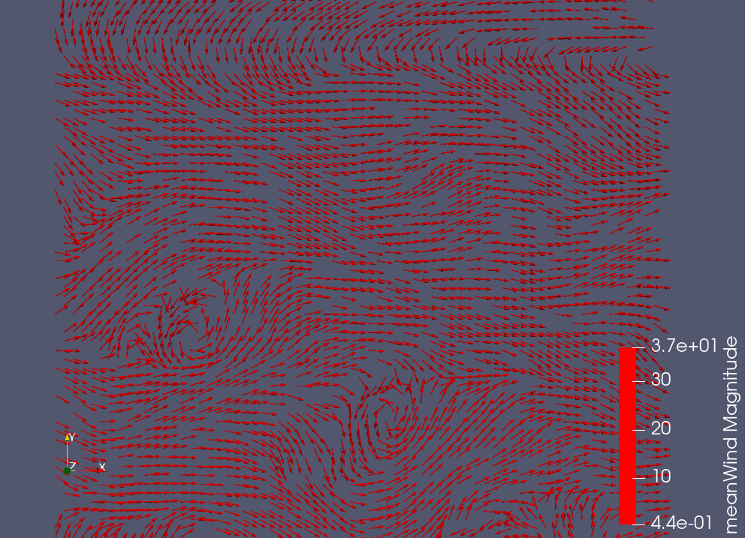
Wind 1 glyphs:
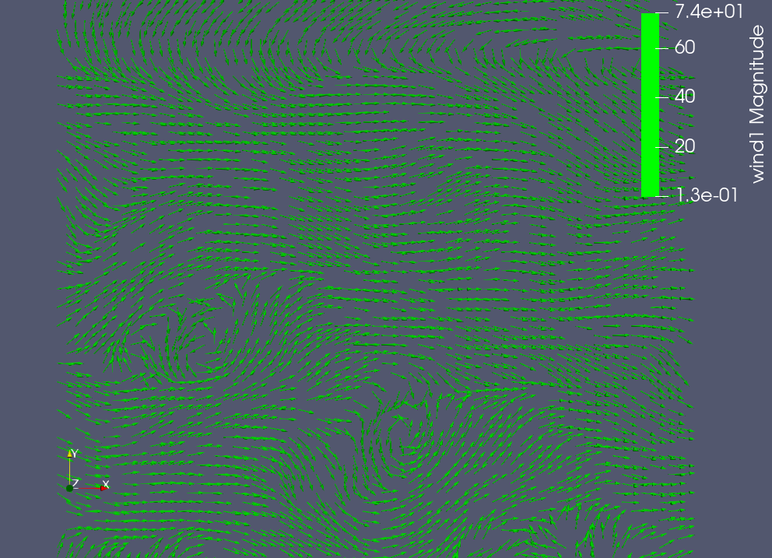
Wind 2 glyphs:
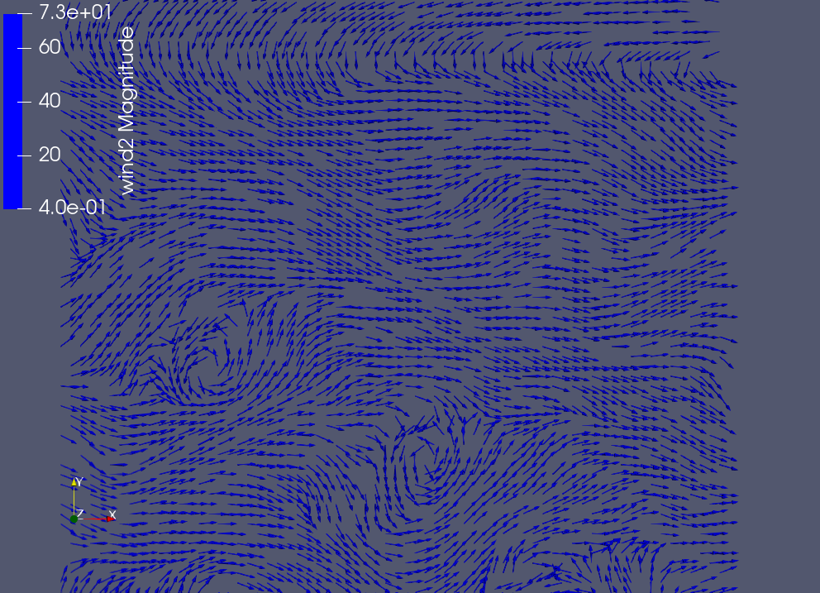

All 3 overlayed:
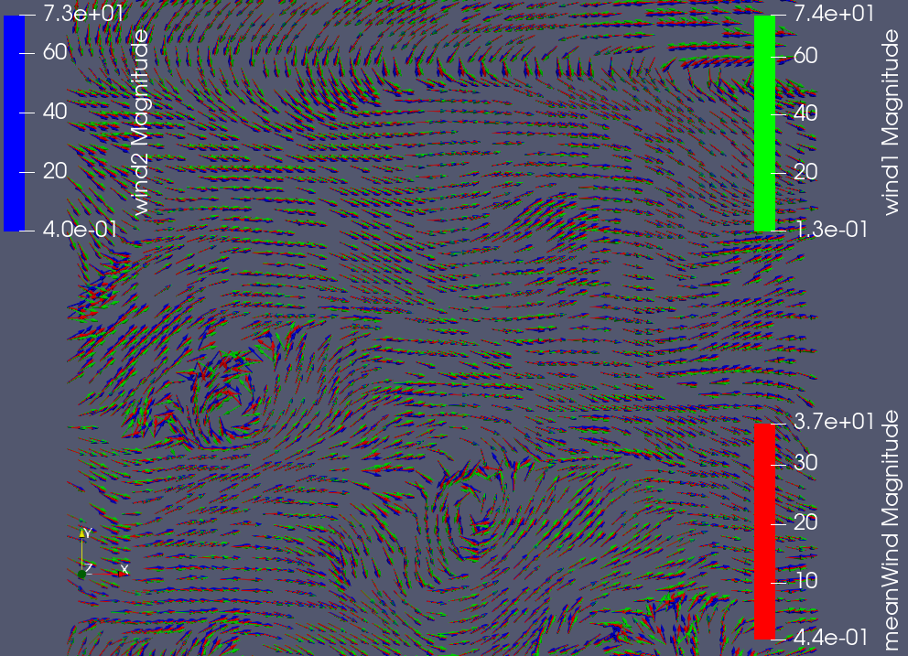
All 3 overlayed, zoom:

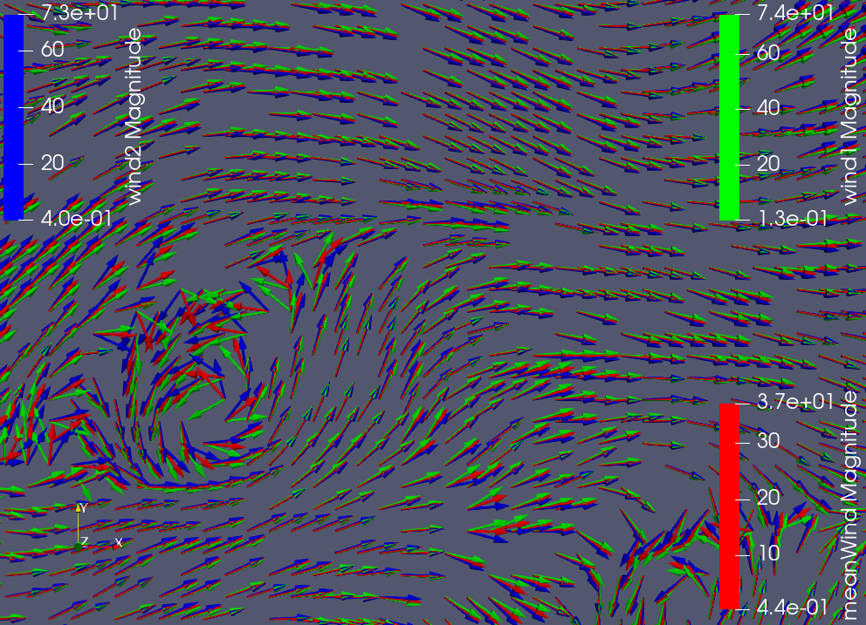
You can clearly see the variability in the zoomed image with the arrows pointing in similar directions, but off by a few degrees, and sometimes as much as 90.
Part 3)
- What is preattentive processing, and why is important? Please answer in your own words.
Preattentive processing is the processing that happens within your brain without your intervention. Ebert claims that this processing happens at a low level in the brain which conjures thoughts of the less recently developed areas that are closer to the brain stem, such as the amygdala, etc.

Preattentive processing is so important because the information that is garnered in this stage of the understanding of the visualization helps you create a foundation for the more complex insights that you might find. In other words, it allows a analyst to understand things about the data subconsciously, preserving the conscious brain for the more complex processing and insight generation.

- What types of preattentively processed features are used in the following two visualizations? Please answer separately each image. Try to identify as many relevant types/classes as possible.
First image (circles): This image uses several features that would be process preattentively, including: size, spatial grouping, color (hue), and (likely) motion to show groupings.

Second image (scatter plot): The scatter plot uses color (hue), size, marks, and x and y position.

- We have created many visualizations in previous assignments. Select one visualization that you have created from a previous assignment that may not be perceptually significant. State what you can do to improve the perceptualization and try to re-visualize it in ParaView. (Images of your previous visualization and the new design should be in your report.)
Not Included.

Part 4)
Cool to warm color map for foot data:
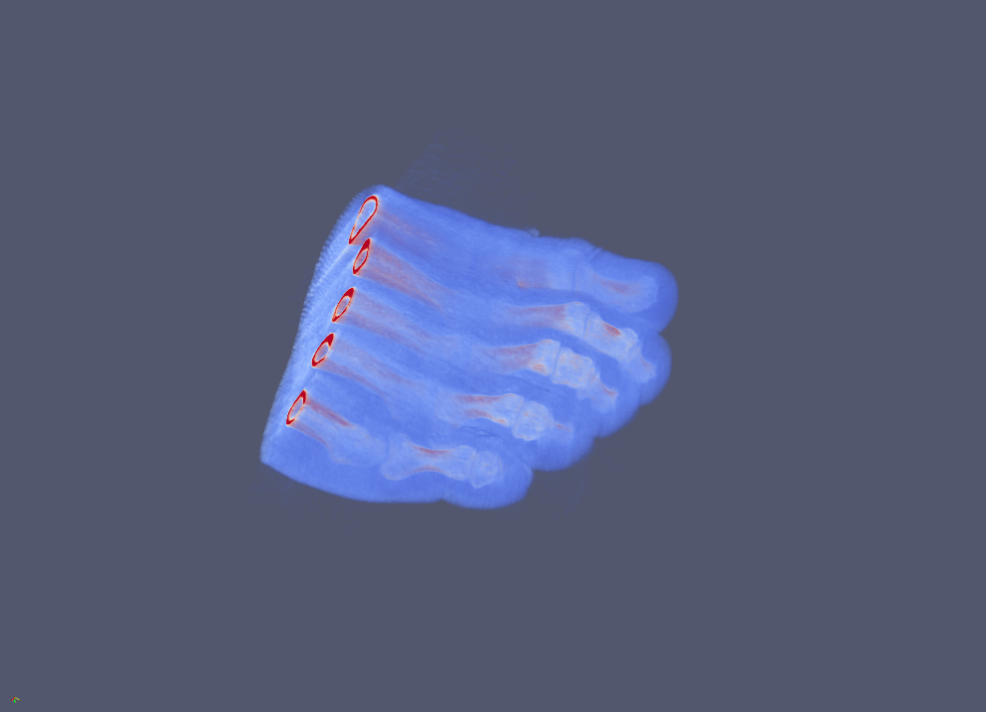
Rainbow desaturated color map for foot data:
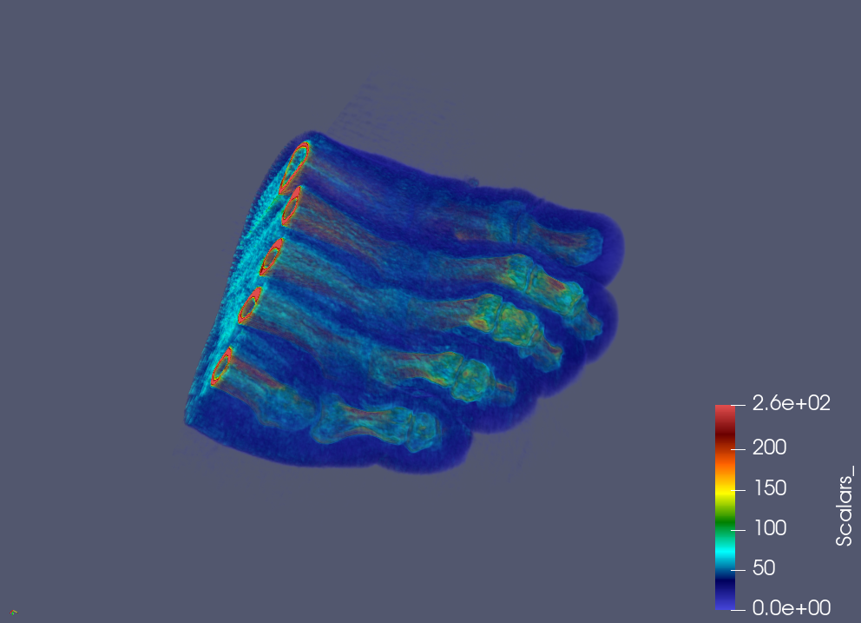

Jet color map for foot data:
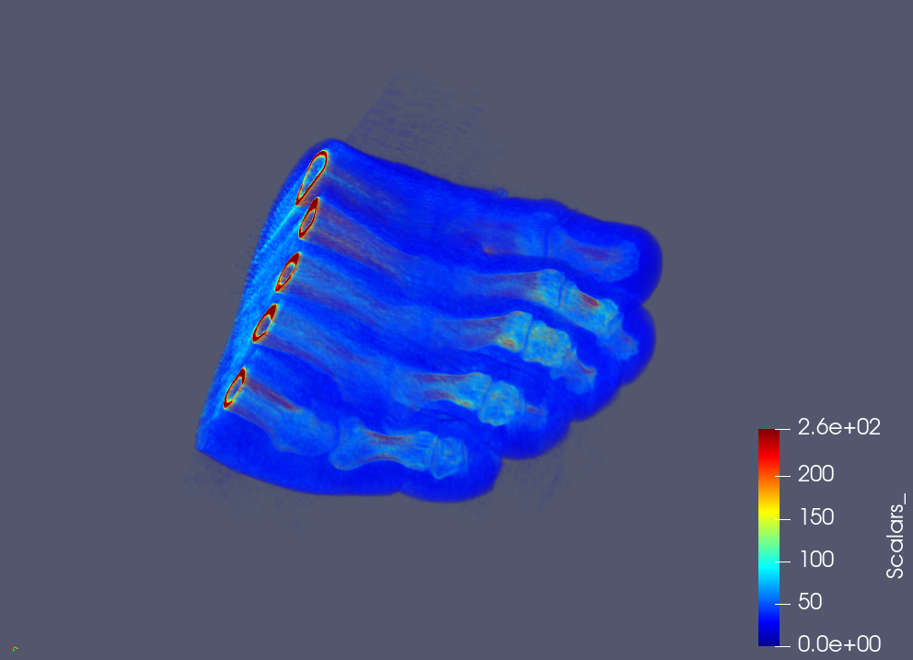

I think rainbow desatured best shows this data. It seems that it has better transparency and highlights the important regions of bone, skin, and muscle more clearly.

