How to hook up DSAMS Apps from GitLab

**Login a) GitLab URL:** [**https://git.apps.dsca.mil**](https://git.apps.dsca.mil)

**b) GitLab** **GitLab from OKTA dashboard**

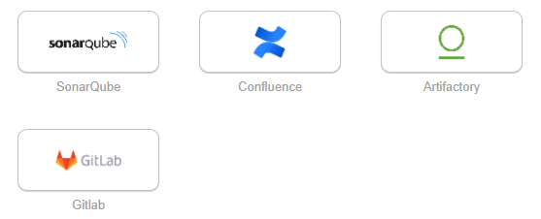

**#1. Create your taken:**

1. Click Settings from your user profile on top right icon.

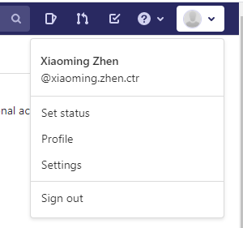

1. **Click Access Tokens on the right side menu**

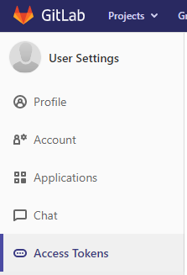

1. **Click personal access token after you fill up the form**

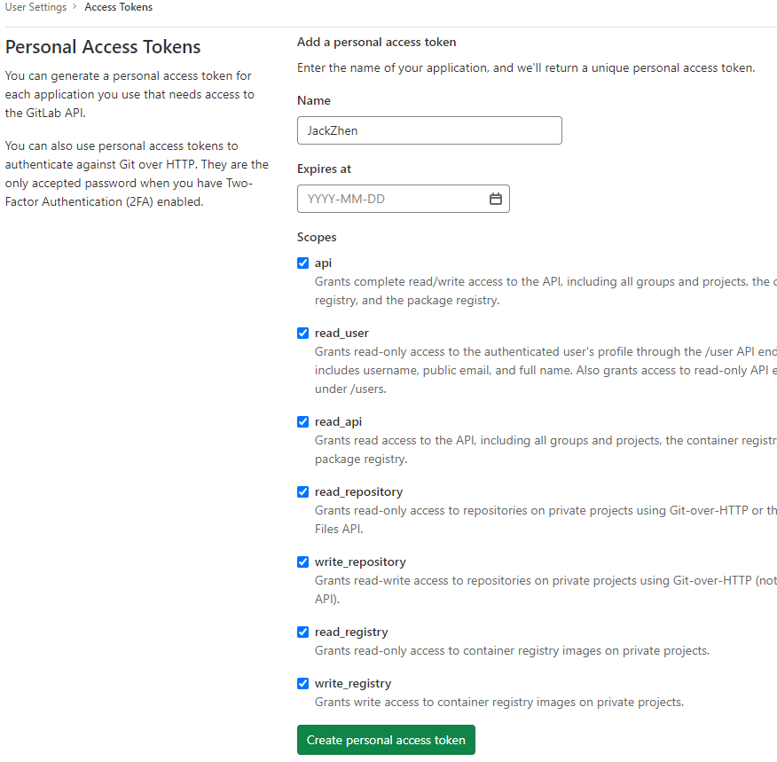

1. **Get the source code(project:dsasm-core-test) from the GIT Bash**

Git clone <https://git.apps.dsca.mil/dsams/dsams-core-test>

Note: Execute this command first if you used the workspace in AWS.

Or you have error: SSL certificate problem: self signed certificate in certificate chain

$ git config --global http.sslBackend schannel

Enter your name and token when you clone or pull from GitLab

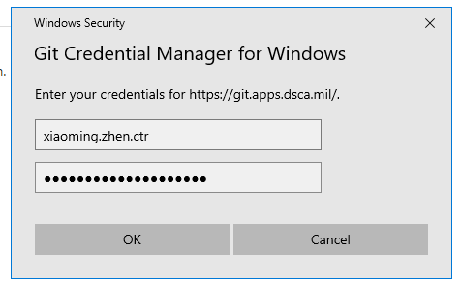

1. **Get the source code(project:dsasm-core-test) from the Git Repository from the Eclipse**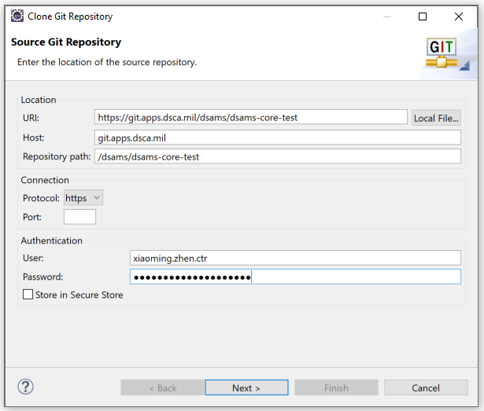

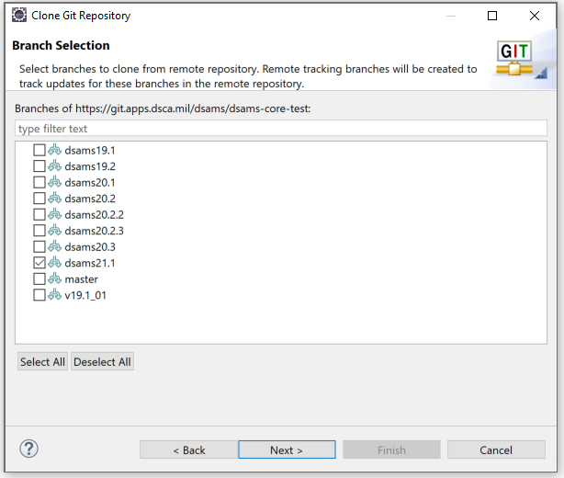

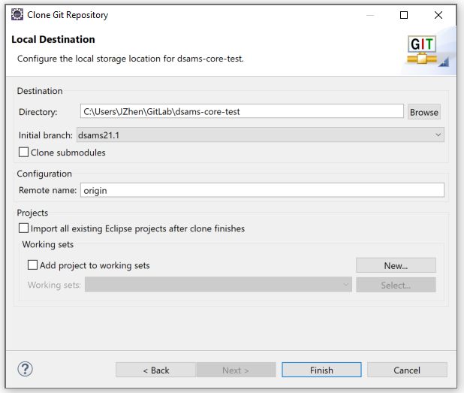

1. **Get the source code from the Version Control from the VCode**

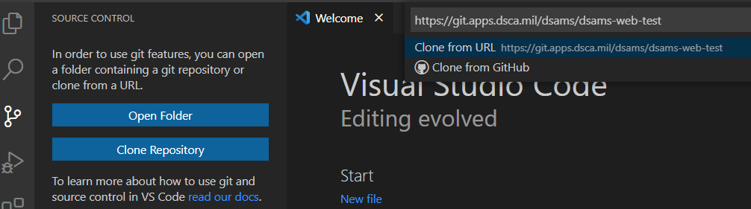

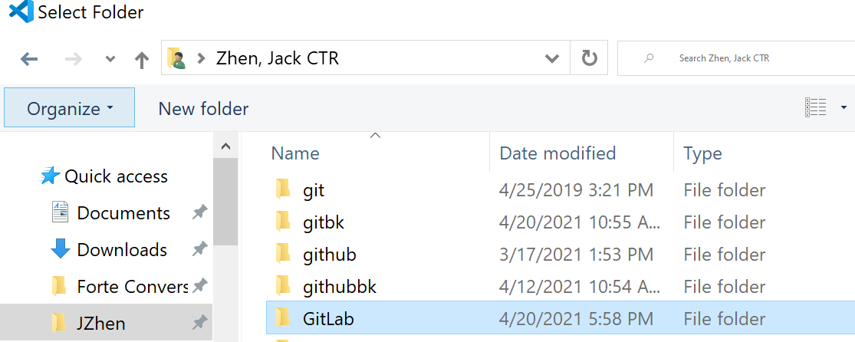

1. **Click the Open button**

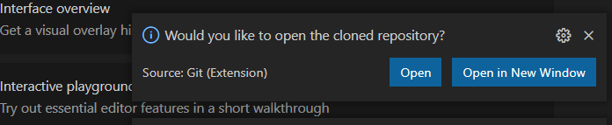

credential manager