--Purpose and Audience—
To inform the audience(young and aspiring game developers) about the purpose and details of game jams, as well as introduce the 2 most infuencial game jams today.

-LOGO-
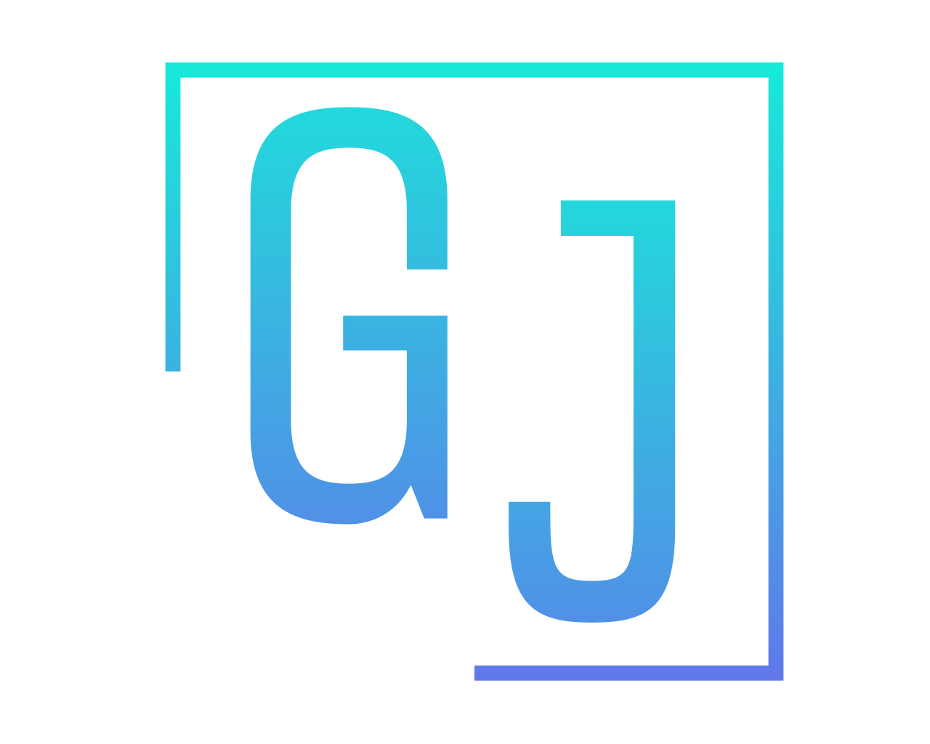

GAME JAM INFO PAGE
--Page 1 paragraph—
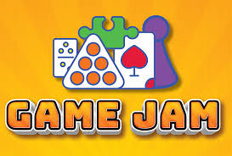
Game Jams are timed events in which a team of game developers work together and collaborate to create small, polished games. A game jam can take as long as a couple months or be as short as a couple of hours, within this time many different individuals or teams compete to make the best game. Only two things remain consistent between game jams, every game jam has a time limit and a theme to direct creative design. Inside each person’s game there is much to be considered, games are typically graded on sound design/music, artistic visuals and effects, gameplay ingenuity, how fun the finished product is and how well the game fits the theme.
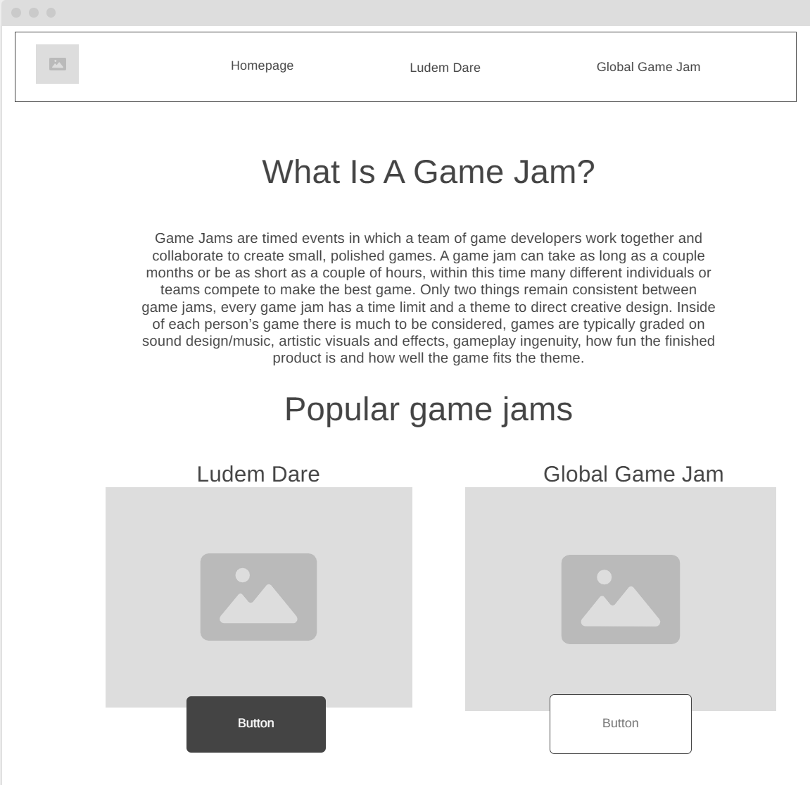

--Ludum Dare—

What?
The Ludum Dare Game Jam is one of the world’s largest game jams. In 2019 alone it amassed over 47,000 participants.
Where?
The ludem dare gamejam can be found at its own website(https://ldjam.com/) or at itch.io(https://itch.io/jams), one of the most popular game jam hosting sites
When?
Typically, it runs 48-72 hours over the weekend.
Why?
The Ludum Dare game jam is one of the longest running game jams to date and inspired many games such as Hollow Knight, Inscription, Loop Hero as well as many others. Having a good standing in a game jam can show you that something in your game jam worked and might be worth pursuing, it can also look great on a resume to place highly in a game jam like this.
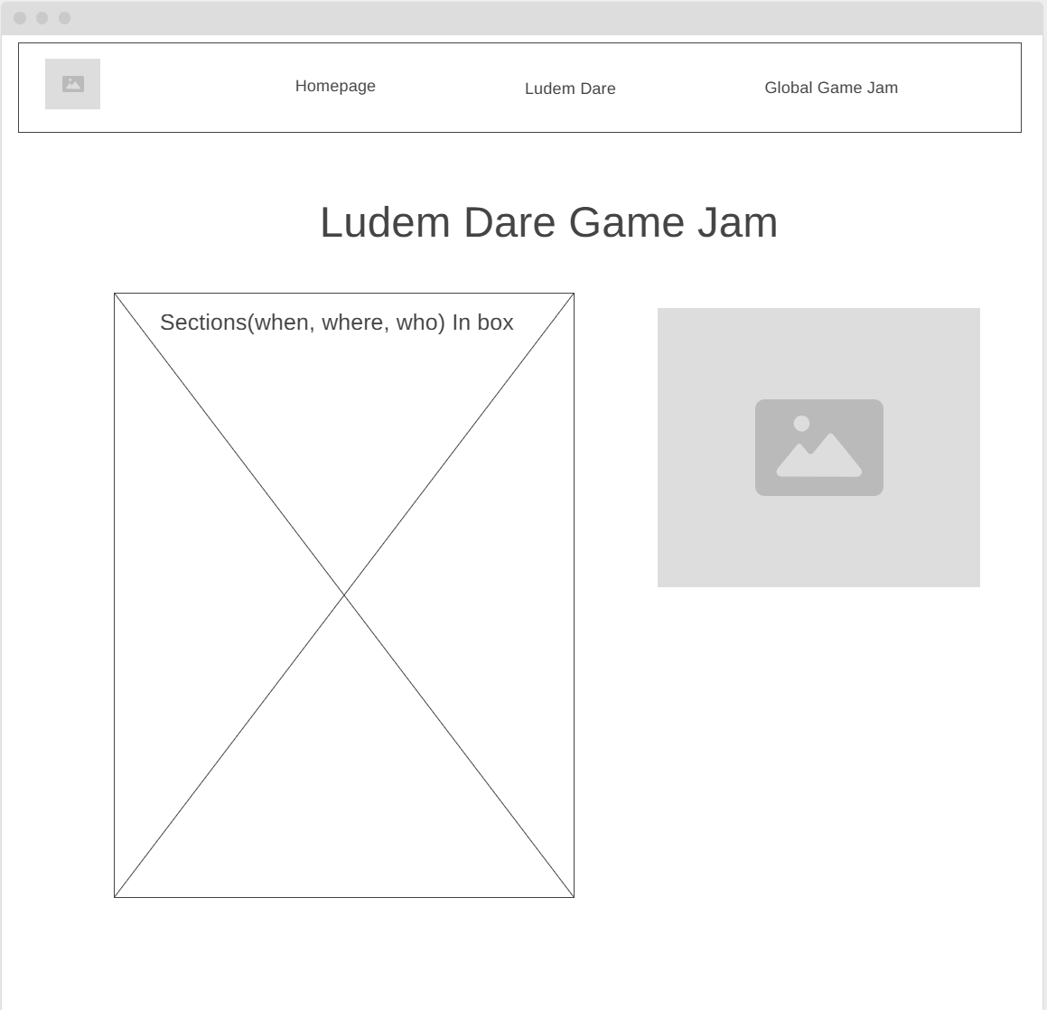

--Global Game Jam—
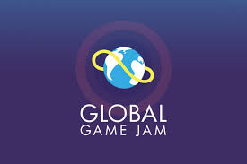
What?
The global Game Jam is the world’s largest game creating event that takes place around the world. There are tens of thousands of participants globally participating virtually and physically.
Where?
The global game jam can be found at its website(https://globalgamejam.org ) or found at a physical location across all 7 continents
When?
The Global Game Jam occurs once a year beginning at the end of Jan and runs for 6 days.

Why?
The Global Game Jam often has cash prizes from sponsors. One notable example was a $50,000 prize pool in 2022 including a $10,000 first prize. There are also many sponsoring companies that scout for developers. Additionally, placing well is a great indicator of a good game idea and an amazing indicator to companies that you are likely a good candidate.

(button link on page)
https://globalgamejam.org/map/2026

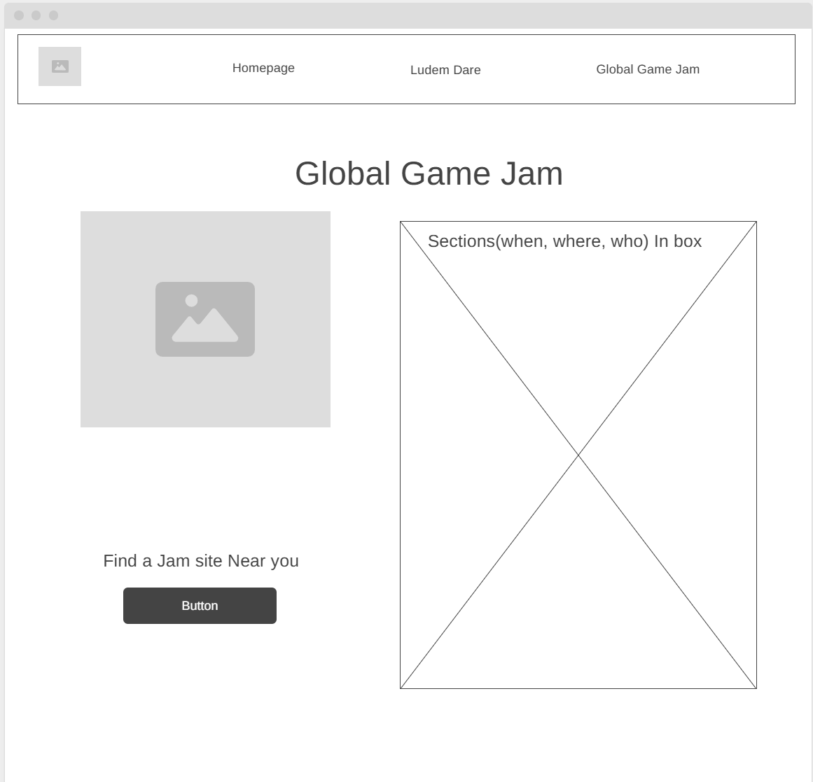
--Main Colors--
Dark Blue (Background) (#1C263E)
Black Accents(#FFFFFF)
Cyan Main Text(#17EAD9)
Blue (#0000EA)

