1. php artisan make:migration create_member_table –create=”member”
2. you can bellow code file: member.php, and command: php artisan migrate
3. Make a Event: php artisan make:event myEvent , then you can touch file on app/Events/myEvent.php , so you can put bellow code :

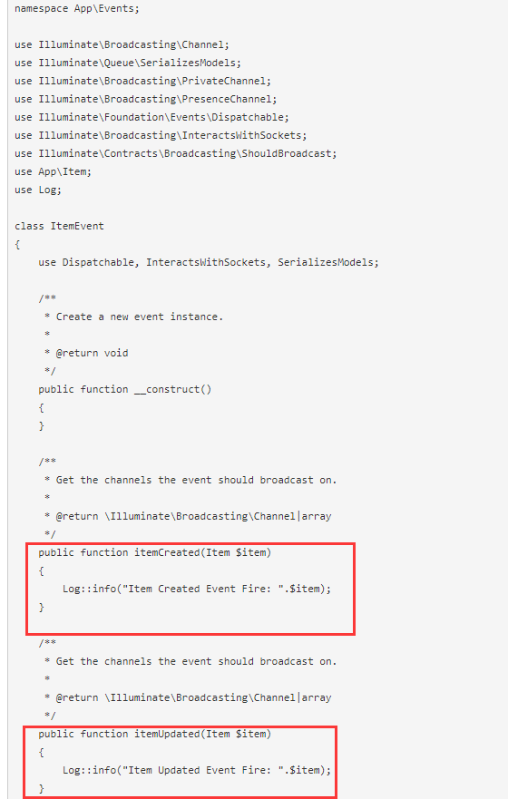

1. you have to register following events on app/Providers/EventServiceProvider.php file, so let`s put like as bellow code :

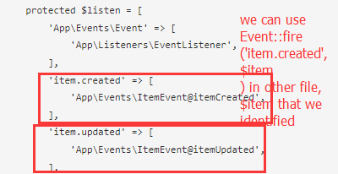

1. Now we can make a model file : php artisan make model myModel , and put like as bellow code:

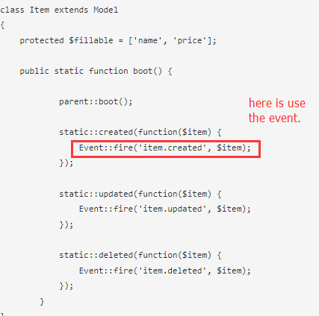

6.when we register event , then we can use Event:fire() in any file.