**The Forest Inventory and Analysis: BIGMAP User Documentation in ESRI products**

**October 16th, 2023**

**Contents**

**Preface**

**Abstract**

**Keywords**

**Authors**

**Background**

In 1928, Congress enacted the McSweeny-McNary Forest Research Act which states that, *“… a comprehensive survey of the present and prospective requirements for timber and other forest products of the United States…*” Thus, began the Forest Inventory and Analysis (FIA) program, which collects Forest health parameters such as condition, volume, growth, and use of trees on the Nations Forest lands. FIA publishes yearly summary reports of the lands they survey, which benefits forest management and policies across the United States.

These reports are constructed with the same information that is publicly available and can be found on the Forest Inventory and Analysis Database (FIADB). Most inventories can be located using this database, some historical information might not be available due to the changes in inventory sampling. As a widespread reach for national consistency, all annual inventories use a common plot design and common data collection procedures. These summary reports, written by Forest Service Personal can be found on the geospatial showcase hub.

The Big Data Mapping and Analytics Platform (BIGMAP) is FIA’s could-based national scale modeling, mapping, and analysis environment for US Forests. The foundation of BIGMAP was established with the use of moderate spatial resolution imagery from MODIS to produce Continuous United States (CONUS) raster data sets on numerous forest attributes. BIGMAP intends to provide users with simple ways to estimate forest attributes (and associated uncertainties), eliminating the need to understand how FIA stores and processes information. BIGMAP allows access to data services that are derived from the integration of FIA data and ancillary predictors are based upon peer-reviewed modeling approaches, these models can be constructed to simultaneously protect plot security and provide reliable estimates of various forest attributes across a range of spatial scales. Lastly, individual forest attributes can be combined easily with other content to provide integrative assessments (developed by the Agency as well as its partners) relevant to resource managers, policymakers, and the interested publics to create associated maps. This report should be used to navigate the geospatial showcase to locate BIGMAP layers and utilize them for further analysis.

**Acknowledgements**

-Partnership with ESRI

**Chapter 1: Introduction**

1. Early stages of BigMAP
   * CONUS ([Characterization and visualization of the accuracy of FIA's CONUS-wide tree species datasets | US Forest Service Research and Development (usda.gov)](https://www.fs.usda.gov/research/treesearch/46519)
2. History of BigMAP development
   * Partnership between ESRI and FS

**Chapter 2: Raster format -Layer Catalog**

Raster images are comprised of pixels each one filled with information that when combined with other pixels create an image. The information that is collected from each pixel is information regarding the color and where it falls on the visible color spectrum, which can be manipulated to and interpretated to match real-time environmental conditions. This is the framework for remote sensing analytics and combined with data collected in the field many things can be harnessed.

BIGMAP uses Landsat imagery where each bucket represents a distribution of attribute values, stored in FIADB, that can be used as a machinery to make pixel-level predictions and maps of Forest resources. Statistical methods such as kNN algorithms and Harmonic Regressions are used to model forest attributes and order tree species along environmental gradients. Parallel processing outputs raster imagery which are stored on image services.

Image services exist for public access of the data. To use an image service, first connect to the GIS server and navigate to your source data. Source data for BIGMAP can be found on the FIA Geospatial Showcase page under FIA BIGMAP General Layer Catalog.

**Chapter 3: Mosaic Dataset**

Mosaic datasets are used to manage collections of raster images stored in the geodatabase. The translation of raster imagery to mosaic dataset allows you to store, manage, view, and query your raster imagery quickly and efficiently. Their advanced raster querying capabilities and processing functions are a result of the referencing of the raster imagery rather than manipulating the source imagery.

A mosaic dataset is created and stored in the geodatabase through the geoprocessing toolbox. At first it is created empty where then the user can add an unlimited amount of raster imagery to the dataset. The images added to a mosaic dataset do not need to be continuous and can be pieced together so long as the coordinate system is the same.

It is best to store the image service layers from the BIGMAP catalog in mosaic datasets because of the ease at which the information can be cataloged and processed. The design at which mosaic datasets can handle varying resolutions all spectrally, spatially, temporarily, and radiometrically. As the mosaic datasets only reference the raster imagery while preforming functions the source pixels are never altered or converted, and the metadata remains intact.

Just like normal spatial layers mosaic datasets have attribute tables that are related to spatial data layers. The attributes associated with mosaic datasets include:

* **ObjectID**
* **Raster**
* **Name**
* **MinPS and MaxPS**
* **LowPS and HighPS**
* **Category**
* **Tag**
* **GroupName**
* **ProductName**
* **CenterX and Century**
* **ZOrder**

The three layers that are created through a mosaic dataset include: boundary, footprint, and image layer. The boundary layer displays the full extent of all the raster imagery added to the mosaic dataset. The footprint layer reflects the extent for each individual raster image added to the mosaic dataset. Each footprint box corresponds to a unique row in the attribute table that can be used to query the data. The image layer is what controls the rendering of the data which can be manipulated through the stretch, RGB band combination, resampling, mosaic method, and other properties.

The seamline layer is another layer that can be added that acts similarly to the footprint layer in mosaicking images together. The functionality of this layer ensures that there is minimal overlap between all the raster images once added to the mosaic dataset. The use of seamlines is recommended when you do not need to view individual mosaic dataset images separately and would like to keep one feature selected throughout the mosaic dataset.

**Chapter 4: Accessing BIGMAP layers**

BIGMAP species layers are stored on an image service that can be located by (How can it be found). There are two ways you can process the data: 1) via ArcGIS online 2) ArcGis pro. Access for the already processed and created mosaic dataset can be found at: [FIA_BIGMAP_2018_Species_Aboveground_Biomass - Overview (arcgis.com)](https://usfs.maps.arcgis.com/home/item.html?id=1e75650439c84a27ab9ff1f1c169f10b)

**Chapter 5: Viewing and manipulating BIGMAP data in AGOL**

**Section 5.1 Accessing**

**~~Map Viewer~~**

1. ~~Through the portal posted in the previous chapter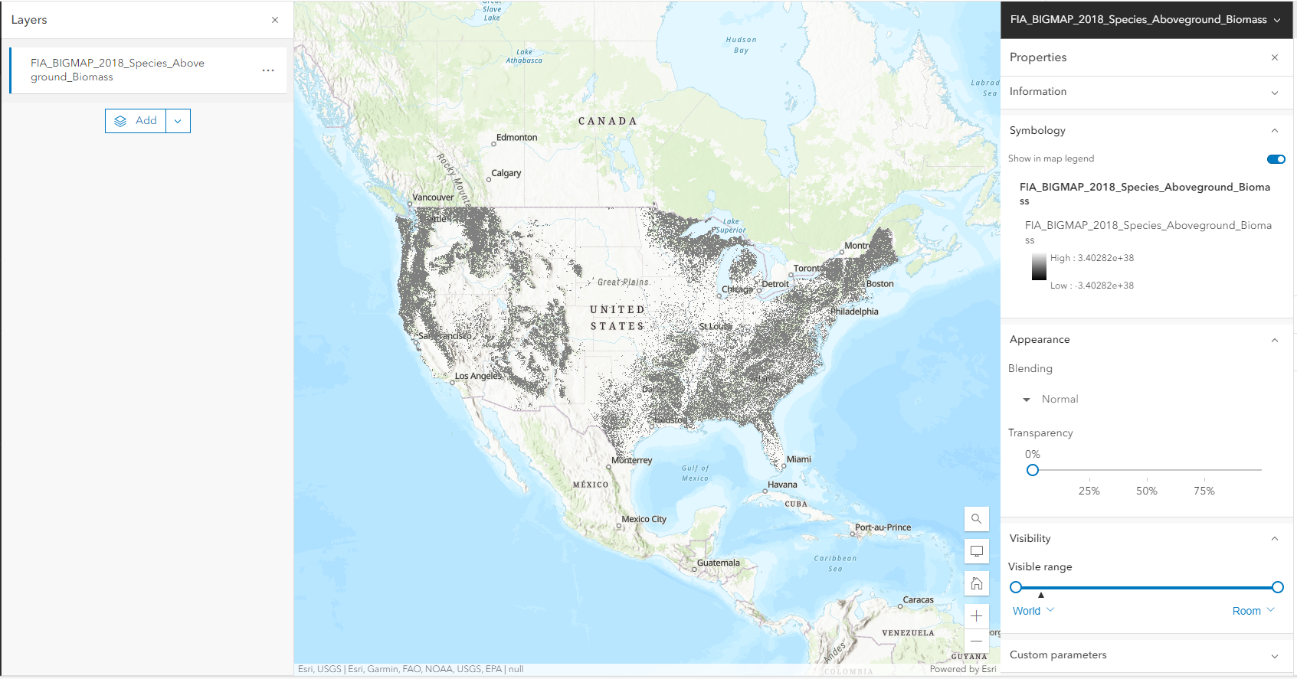 navigate to “Open in Map Viewer.”~~
2. ~~In the layers pane >> click on the layer for the side pane where the filter button is kept~~
3. ~~Filter by species ID which can be found here: Graphical user interface, text, application

   Description automatically generated~~
4. ~~Input species of interest to view, multiple expressions can be viewed at the same time~~

**Map viewer classic**

**Chapter 6: Viewing and manipulating BIGMAP data in ArcGIS Pro**

**6.1 Accessing**

1. In ArcGIS Pro, open a new map window
2. Upload the species data using the URL from the image service: Navigate to Map ribbon >> Layer >> Add Data >> Data From Path >> <https://di-usfsdata.img.arcgis.com/arcgis/rest/services/FIA_BIGMAP_2018_Species_Aboveground_Biomass/ImageServer>
3. There are two ways to filter the layer by species:
   1. Select by Attributes

b) Right click the layer>> navigate to Selection and click on make a layer from the selected attributes

* 1. Definition Query
     1. A definition query is a way to subset the data through defining a set of features to be retrieved from a specified layer.
     2. You can create a definition query via right clicking on the layer of interest >> clicking on properties >> Definition query>> Click on **+** New Definition query >> filter for species of interest via SQL code

* + 1. To deactivate a Definition query, right click on the green checkbox to hide the query or make one visible

**Chapter 7: Creating an Area of Interest**

**Chapter 8: Use Cases – Choose 2 or 3**

* Calculating zonal statistics by fire shed

Pick a fire prone species- species group or maybe a whole genus- genus level ash map

Who is interested in this?

What is needed to study this?

What is a fireshed?

1. Built Colorado state forests using a list of the major tree species: [Colorado's Major Tree Species | Colorado State Forest Service | Colorado State University (colostate.edu)](https://csfs.colostate.edu/colorado-trees/colorados-major-tree-species/#:~:text=Colorado%27s%20major%20tree%20species%20include%20bristlecone%20pine%2C%20Colorado,Rocky%20Mountain%20juniper%2C%20subalpine%20fir%20and%20white%20fir.)
2. Wildfire perimeter data

[Historic Perimeters 2018 | Historic Perimeters 2018 | National Interagency Fire Center (arcgis.com)](https://data-nifc.opendata.arcgis.com/datasets/historic-perimeters-2018/explore?location=39.823697%2C-104.855970%2C6.56)

1. Add shapefiles on colorodo
   1. Firesheds
   2. Wui data
   3. State BOUNDRIES
   4. Select by location
   5. Polygons to raster

Problem Statement: The state of Colorado is interested in the location of Wildfire locations and the correlation it has to density of Aboveground Biomass in trees in 2018 and if there is a specificity in certain firesides. In using FIA BIGMAP layers and publicly available data from the USGS, fireshed source data, and Colorodo state forest inventory we can accurately assess how Aboveground biomass data relates to instances of fires on the landscape.

Steps:

1. Add BIGMAP Species layers from the USFS Geospatial discovery hub. For Colorodo the species that were of interest included ([Colorado's Major Tree Species | Colorado State Forest Service | Colorado State University (colostate.edu)](https://csfs.colostate.edu/colorado-trees/colorados-major-tree-species/#:~:text=Colorado%27s%20major%20tree%20species%20include%20bristlecone%20pine%2C%20Colorado,Rocky%20Mountain%20juniper%2C%20subalpine%20fir%20and%20white%20fir.)):
   * + Blue Spruce *Picea pungens*
     + Boxelder *Acer negundo*
     + Bristlecone pine *Pinus aristate*
     + Chokecherry *Prunus virginiana*
     + Douglas-fir *Pseudotsuga menziesii*
     + Engelmann Spruce *Picea engelmannii*
     + Gambel Oak *Quercus gambelii*
     + Limber Pin *Pinus flexilis*
     + Lodgepole Pine *Pinus Contorta*
     + Narrowleaf Cottonwood *Populus angustifolia*
     + Peachleaf willow *Salix amygdaloides*
     + Pinion Pine *Pinus edulis*
     + Planes Cottonwood *Populus deltoides*
     + Ponderosa Pine *Pinus ponderosa*
     + Quaking Aspen *Populus tremuloides*
     + Rocky Mountain Juniper *Juniperus scopulorum*
     + Rocky Mountain Maple *Acer glabrum*
     + Subalpine Fir *Abies lasiocarpa*
     + Thinleaf Alder *Alnus tenuifolia*
     + White Fir *Abies concolor*
2. Add shapefile of firesheds to the map downloaded from ([Forest Service Research Data Archive (usda.gov)](https://www.fs.usda.gov/rds/archive/Catalog/RDS-2020-0054))
3. Add state boundary level data from:
4. Add Historic Fire Perimeter in 2018 to map
5. Create a mosaic data set using the steps from the previous chapter and add all BIGMAP layers to this mosaic dataset
6. Clip down the mosaic dataset to the extent of the Colorado state boundaries
7. Clip down the fireshed area to the extent of Colorado state boundaries
8. Rasterize the fireshed polygon using the geoprocessing tool: Polygon to raster
9. Use the Raster Function: Zonal Statistics to average the Aboveground Biomass in each fireshed of Colorado
10. Graphical user interface, text, application, email

    Description automatically generated Compare size of the fire to the average density of aboveground biomass in each fireshed

**Chapter 9: Raster functions**

**Input: - FIA_BIGMAP_2018_Species_Aboveground_Biomass**

**-**

|  |  |  |  |
| --- | --- | --- | --- |
| **Function** | **Additional inputs** | **Description** | **Output** |
| **Zonal Statistics** |  |  |  |
|  |  |  |  |

1. Calculate Cell pixel statistics

Zonal statistics as a table

1. Tabulate area
2. Different graphs

**Chapter 10: Validation data**

1. Hex validation
   1. Levels
2. Accuracy Assessment
   1. Reduced major axis regression

**Chapter 11: Common errors/troubleshooting**

1. [Mosaic Dataset Analyzer: Error 70100—ArcMap | Documentation (arcgis.com)](https://desktop.arcgis.com/en/arcmap/latest/manage-data/raster-and-images/mosaic-dataset-analyzer-error-70100.htm)
2. **Error 001491** Cannot process above the size limits of the image service: 'FIA_BIGMAP_2018_Species_Aboveground_Biomass'. The allowed maximum number of rows and columns is 4100 and 15000 respectively. Please adjust the output extent and/or cellsize to fit within the limits.

**Chapter 12: Python functionality**

-CreateMosaicDataset()

-AddRasterstoMosaicDataset()

-RasterCollection()

**Chapter 13: Tool development**

1. Dashboard Mike made.
2. Proposed tools and future development

**Literature Cited**

**Appendix**