Министерство образования Республики Беларусь
Учреждение образования
БЕЛОРУССКИЙ ГОСУДАРСТВЕННЫЙ УНИВЕРСИТЕТ
ИНФОРМАТИКИ И РАДИОЭЛЕКТРОНИКИ

Факультет компьютерных систем и сетей
Кафедра программного обеспечения информационных технологий
Дисциплина: Компьютерные системы и сети

ОТЧЁТ
по лабораторной работе №4

Тема работы: Сервер FTP

Выполнила
студент: гр. 851003 Касач Е.С

Проверил: Красковский П.Н.

Минск 2020

Задание:
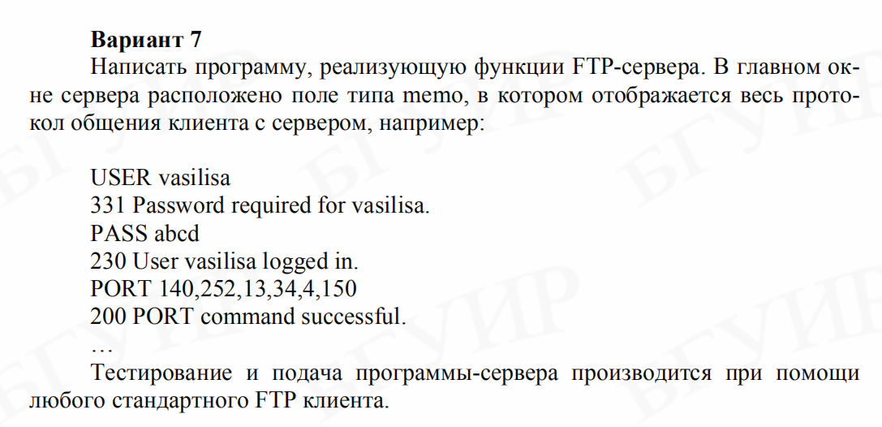
Проверка работы сервера ведётся с применением клиента Filezilla.

Пример работы:

Клиент:
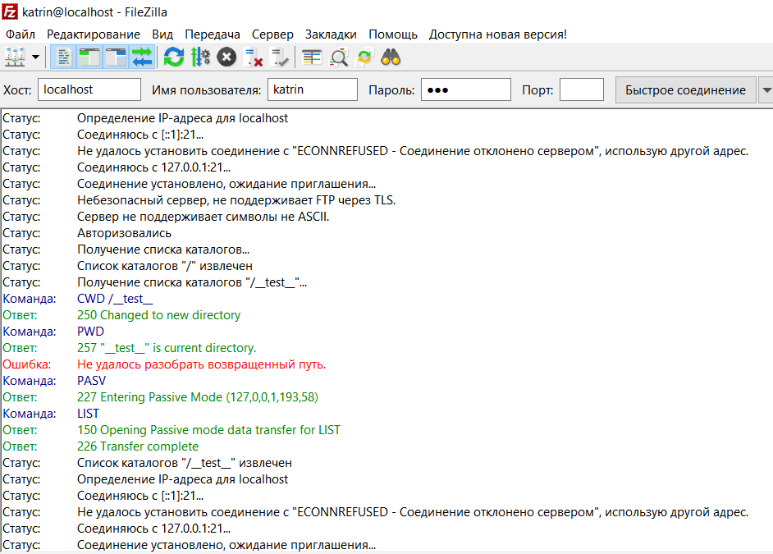
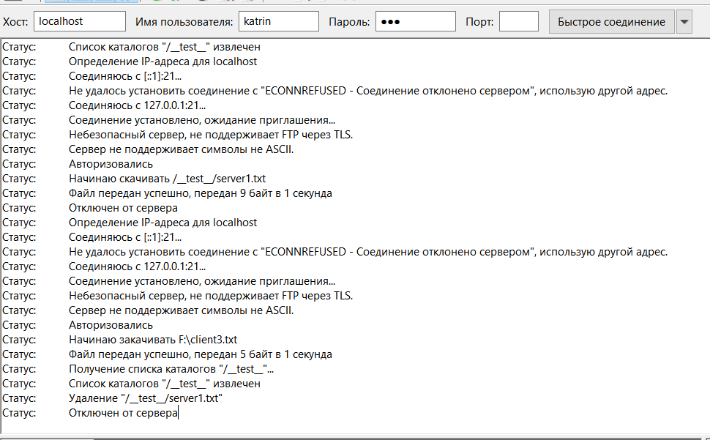

Сервер:
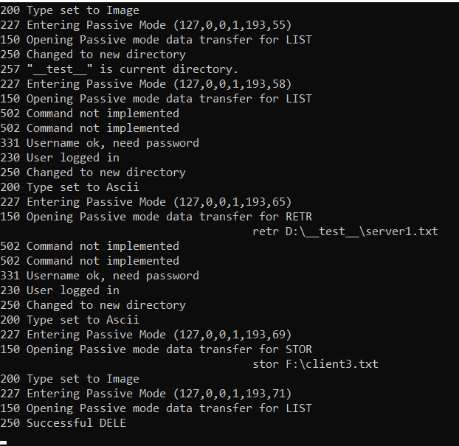

Исходный код (сервер):

Program.cs
namespace SimpleFtpServer
{
using System;

public class Program
{
public static void Main()
{
FtpServer ftpServer = new FtpServer();

ftpServer.Start();

Console.WriteLine("Press any key to stop...");
Console.ReadKey();

ftpServer.Stop();
}
}
}

FtpServer.cs
namespace SimpleFtpServer
{
using System;
using System.Net;
using System.Net.Sockets;
using System.Threading;

/// <summary>
/// Listens for connections from TCP network clients using TcpListtener.
/// </summary>
public class FtpServer
{
/// <summary>
/// Listens for connections from TCP network clients.
/// </summary>
private TcpListener listener;

//public FtpServer()
//{
//}

/// <summary>
/// Starts listening for connections.
/// </summary>
public void Start()
{
const int Port = 21;
this.listener = new TcpListener(IPAddress.Any, Port);
this.listener.Start();

// Begins an asynchronous operation to accept an incoming connection attempt.
this.listener.BeginAcceptTcpClient(this.HandleAcceptTcpClient, this.listener);
}

/// <summary>
/// Stops listening for connections.
/// </summary>
public void Stop()
{
this.listener?.Stop();
}

/// <summary>
/// Called when someone connected.
/// </summary>
/// <param name="result">Represents the status of asynchronous operation.</param>
private void HandleAcceptTcpClient(IAsyncResult result)
{
TcpClient client = this.listener.EndAcceptTcpClient(result);

// Continue listening for more connections.
this.listener.BeginAcceptTcpClient(this.HandleAcceptTcpClient, this.listener);

ClientConnection connection = new ClientConnection(client);

// Creates a new background thread for client (this keeps foreground free).
ThreadPool.QueueUserWorkItem(connection.HandleClient, client);
}
}
}

ClientConnection.cs
namespace SimpleFtpServer
{
using System;
using System.Collections.Generic;
using System.Globalization;
using System.IO;
using System.Net;
using System.Net.Sockets;
using System.Text;

/// <summary>
/// Used for connection of the client to server.
/// </summary>
public class ClientConnection
{
#region Fields

/// <summary>
/// Used to transfer commands.
/// </summary>
private readonly TcpClient controlClient;

/// <summary>
/// Used to transfer files.
/// </summary>
private TcpClient dataClient;

/// <summary>
/// Used for "Control" connection (e.g. to send commands to the server and for the server to send responses back to the client).
/// </summary>
private NetworkStream controlStream;

/// <summary>
/// Reader for "Control" connection (e.g. reads stream from client).
/// </summary>
private readonly StreamReader controlReader;

/// <summary>
/// Writer for "Control" connection (e.g. writes stream to client).
/// </summary>
private readonly StreamWriter controlWriter;

/// <summary>
/// Used to receive data connection in passive mode.
/// </summary>
private TcpListener passiveListener;

/// <summary>
/// Type of transferring data.
/// </summary>
private TransferType connectionType = TransferType.Ascii;

/// <summary>
/// Format control for TransferType.
/// </summary>
private FormatControlType formatControlType;

/// <summary>
/// Type of data connection (passive/active).
/// </summary>
private DataConnectionType dataConnectionType = DataConnectionType.Active;

private string root = @"D:\";
private string currentDirectory = @"D:\";

/// <summary>
/// Used for data connection.
/// </summary>
private IPEndPoint dataEndpoint;

private string username;

#endregion

#region Constructors

/// <summary>
/// Initializes a new instance of the <see cref="ClientConnection"/> class.
/// </summary>
/// <param name="client">The client that will be connected to the server.</param>
public ClientConnection(TcpClient client)
{
this.controlClient = client;

this.controlStream = this.controlClient.GetStream();

this.controlReader = new StreamReader(this.controlStream);
this.controlWriter = new StreamWriter(this.controlStream);
}

#endregion

#region Enums

private enum TransferType
{
Ascii,
Ebcdic,
Image,
Local,
}

private enum FormatControlType
{
NonPrint,
Telnet,
CarriageControl,
}

private enum DataConnectionType
{
Passive,
Active,
}

#endregion

#region Copy Stream Implementations

private static long CopyStream(Stream input, Stream output, int bufferSize)
{
byte[] buffer = new byte[bufferSize];
int count;
long total = 0;

while ((count = input.Read(buffer, 0, buffer.Length)) > 0)
{
output.Write(buffer, 0, count);
total += count;
}

return total;
}

private static long CopyStreamAscii(Stream input, Stream output, int bufferSize)
{
char[] buffer = new char[bufferSize];
long total = 0;

using (StreamReader rdr = new StreamReader(input, Encoding.ASCII))
{
using (StreamWriter wtr = new StreamWriter(output, Encoding.ASCII))
{
int count;

while ((count = rdr.Read(buffer, 0, buffer.Length)) > 0)
{
wtr.Write(buffer, 0, count);
total += count;
}
}
}

return total;
}

private long CopyStream(Stream input, Stream output)
{
Stream limitedStream = output;

if (this.connectionType == TransferType.Image)
{
return CopyStream(input, limitedStream, 4096);
}
else
{
return CopyStreamAscii(input, limitedStream, 4096);
}
}

#endregion

public void HandleClient(object obj)
{
this.controlWriter.WriteLine("220 Service Ready.");

// Sends to client.
this.controlWriter.Flush();

try
{
string line;

while (!string.IsNullOrEmpty(line = this.controlReader.ReadLine()))
{
string response = null;

// Splitting line received from client.
string[] command = line.Split(' ');

// Command is the first "word" in line.
// Coverts to UpperCase according to specification: casing doesn't matter for commands.
string cmd = command[0].ToUpperInvariant();

// Agruments - another "word(s)"
string arguments = command.Length > 1 ? line.Substring(command[0].Length + 1) : null;

if (string.IsNullOrWhiteSpace(arguments))
{
arguments = null;
}

switch (cmd)
{
case "USER":
response = this.User(arguments);
break;
case "PASS":
response = this.Password(arguments);
break;
case "CWD":
response = this.ChangeWorkingDirectory(arguments);
break;
case "CDUP":
response = this.ChangeWorkingDirectory("..");
break;
case "QUIT":
response = "221 Service closing control connection";
break;
case "PORT":
response = this.Port(arguments);
break;
case "PASV":
response = this.Passive();
break;
case "TYPE":
string[] splitArgs = arguments.Split(' ');
response = this.Type(splitArgs[0], splitArgs.Length > 1 ? splitArgs[1] : null);
break;
case "PWD":
response = this.PrintWorkingDirectory();
break;
case "RETR":
response = this.Retrieve(arguments);
break;
case "LIST":
response = this.List(arguments);
break;
case "STOR":
response = this.Store(arguments);
break;
case "DELE":
response = this.Delete(arguments);
break;
default:
response = "502 Command not implemented";
break;
}

Console.WriteLine(response);

if (this.controlClient == null || !this.controlClient.Connected)
{
break;
}
else
{
this.controlWriter.WriteLine(response);
this.controlWriter.Flush();

if (response.StartsWith("221"))
{
break;
}
}
}
}
catch (Exception ex)
{
Console.WriteLine(ex);
}
}

private string PrintWorkingDirectory()
{
string current = this.currentDirectory.Replace(this.root, string.Empty);

if (current.Length == 0)
{
current = "/";
}

return $"257 \"{current}\" is current directory.";
}

private bool IsPathValid(string path)
{
return path.StartsWith(this.root);
}

private string NormalizeFilename(string path)
{
if (path == null)
{
path = string.Empty;
}

if (path == "/")
{
return this.root;
}
else if (path.StartsWith("/"))
{
path = new FileInfo(Path.Combine(this.root, path.Substring(1))).FullName;
}
else
{
path = new FileInfo(Path.Combine(this.currentDirectory, path)).FullName;
}

return this.IsPathValid(path) ? path : null;
}

private string User(string username)
{
this.username = username;

return "331 Username ok, need password";
}

private string Password(string password)
{
return "230 User logged in";
}

private string ChangeWorkingDirectory(string pathname)
{
if (pathname == "/")
{
this.currentDirectory = this.root;
}
else
{
string newDir;

if (pathname.StartsWith("/"))
{
pathname = pathname.Substring(1);
newDir = Path.Combine(this.root, pathname);
}
else
{
newDir = Path.Combine(this.currentDirectory, pathname);
}

if (Directory.Exists(newDir))
{
this.currentDirectory = new DirectoryInfo(newDir).FullName;

if (!this.IsPathValid(this.currentDirectory))
{
this.currentDirectory = this.root;
}
}
else
{
this.currentDirectory = this.root;
}
}

return "250 Changed to new directory";
}

private string Port(string hostPort)
{
this.dataConnectionType = DataConnectionType.Active;

string[] ipAndPort = hostPort.Split(',');

byte[] ipAddress = new byte[4];
byte[] port = new byte[2];

for (int i = 0; i < 4; i++)
{
ipAddress[i] = Convert.ToByte(ipAndPort[i]);
}

for (int i = 4; i < 6; i++)
{
port[i - 4] = Convert.ToByte(ipAndPort[i]);
}

if (BitConverter.IsLittleEndian)
{
Array.Reverse(port);
}

this.dataEndpoint = new IPEndPoint(new IPAddress(ipAddress), BitConverter.ToInt16(port, 0));

return "200 Data Connection Established";
}

private string Passive()
{
this.dataConnectionType = DataConnectionType.Passive;

IPAddress localIp = ((IPEndPoint)this.controlClient.Client.LocalEndPoint).Address;

this.passiveListener = new TcpListener(localIp, 0);
this.passiveListener.Start();

IPEndPoint passiveListenerEndpoint = (IPEndPoint)this.passiveListener.LocalEndpoint;

byte[] address = passiveListenerEndpoint.Address.GetAddressBytes();
short port = (short)passiveListenerEndpoint.Port;

byte[] portArray = BitConverter.GetBytes(port);

if (BitConverter.IsLittleEndian)
{
Array.Reverse(portArray);
}

return $"227 Entering Passive Mode ({address[0]},{address[1]},{address[2]},{address[3]},{portArray[0]},{portArray[1]})";
}

private string Type(string typeCode, string formatControl)
{
switch (typeCode.ToUpperInvariant())
{
case "A":
this.connectionType = TransferType.Ascii;
break;
case "I":
this.connectionType = TransferType.Image;
break;
default:
return "504 Command not implemented for that parameter";
}

if (!string.IsNullOrWhiteSpace(formatControl))
{
switch (formatControl.ToUpperInvariant())
{
case "N":
this.formatControlType = FormatControlType.NonPrint;
break;
default:
return "504 Command not implemented for that parameter";
}
}

return $"200 Type set to {this.connectionType}";
}

private string Retrieve(string pathname)
{
pathname = this.NormalizeFilename(pathname);

if (this.IsPathValid(pathname))
{
if (File.Exists(pathname))
{
if (this.dataConnectionType == DataConnectionType.Active)
{
this.dataClient = new TcpClient();
this.dataClient.BeginConnect(this.dataEndpoint.Address, this.dataEndpoint.Port, this.DoRetrieve, pathname);
}
else
{
this.passiveListener.BeginAcceptTcpClient(this.DoRetrieve, pathname);
}

return $"150 Opening {this.dataConnectionType} mode data transfer for RETR";
}
}

return "550 File Not Found";
}

private void DoRetrieve(IAsyncResult result)
{
if (this.dataConnectionType == DataConnectionType.Active)
{
this.dataClient.EndConnect(result);
}
else
{
this.dataClient = this.passiveListener.EndAcceptTcpClient(result);
}

string pathname = (string)result.AsyncState;
Console.Write($" retr {pathname}\n");

using (NetworkStream dataStream = this.dataClient.GetStream())
using (FileStream fs = new FileStream(pathname, FileMode.Open, FileAccess.Read))
{
this.CopyStream(fs, dataStream);
this.dataClient.Close();
this.dataClient = null;
this.controlWriter.WriteLine("226 Closing data connection, file transfer successful");
this.controlWriter.Flush();
}
}

private string Store(string pathname)
{
pathname = String.Concat(@"F:\", pathname);
if (File.Exists(pathname))
{
if (this.dataConnectionType == DataConnectionType.Active)
{
this.dataClient = new TcpClient();
this.dataClient.BeginConnect(this.dataEndpoint.Address, this.dataEndpoint.Port, this.DoStore, pathname);
}
else
{
this.passiveListener.BeginAcceptTcpClient(this.DoStore, pathname);
}
return $"150 Opening {this.dataConnectionType} mode data transfer for STOR";
}
return "550 File Not Found";
}

private void DoStore(IAsyncResult result)
{
if (this.dataConnectionType == DataConnectionType.Active)
{
this.dataClient.EndConnect(result);
}
else
{
this.dataClient = this.passiveListener.EndAcceptTcpClient(result);
}

string pathname = (string)result.AsyncState;
Console.Write($" stor {pathname}\n");

using (NetworkStream destStream = this.dataClient.GetStream())
using (FileStream fs = new FileStream(pathname, FileMode.Open, FileAccess.ReadWrite))
{
this.CopyStream(destStream, fs);

this.dataClient.Close();
this.dataClient = null;
this.controlWriter.WriteLine("226 Closing data connection, file transfer successful");
this.controlWriter.Flush();
}
}

private string Delete(string pathname)
{
pathname = this.NormalizeFilename(pathname);

if (this.IsPathValid(pathname))
{
if (File.Exists(pathname))
{
File.Delete(pathname);
return $"250 Successful DELE";
}
}

return "550 File Not Found";
}

private string List(string pathname)
{
pathname = this.NormalizeFilename(pathname);

if (pathname != null)
{
if (this.dataConnectionType == DataConnectionType.Active)
{
this.dataClient = new TcpClient();
this.dataClient.BeginConnect(this.dataEndpoint.Address, this.dataEndpoint.Port, this.DoList, pathname);
}
else
{
this.passiveListener.BeginAcceptTcpClient(this.DoList, pathname);
}

return $"150 Opening {this.dataConnectionType} mode data transfer for LIST";
}

return "450 Requested file action not taken";
}

private void DoList(IAsyncResult result)
{
if (this.dataConnectionType == DataConnectionType.Active)
{
this.dataClient.EndConnect(result);
}
else
{
this.dataClient = this.passiveListener.EndAcceptTcpClient(result);
}

string pathname = (string)result.AsyncState;

NetworkStream dataStream = this.dataClient.GetStream();
using (StreamWriter dataWriter = new StreamWriter(dataStream, Encoding.ASCII))
{
IEnumerable<string> directories = Directory.EnumerateDirectories(pathname);

foreach (string dir in directories)
{
DirectoryInfo d = new DirectoryInfo(dir);

string date = d.LastWriteTime < DateTime.Now - TimeSpan.FromDays(180) ?
d.LastWriteTime.ToString("MMM dd yyyy", CultureInfo.CurrentCulture) :
d.LastWriteTime.ToString("MMM dd HH:mm", CultureInfo.CurrentCulture);

string line = string.Format(CultureInfo.CurrentCulture, "drwxr-xr-x {0} {1}", date, d.Name);

dataWriter.WriteLine(line);
dataWriter.Flush();
}

IEnumerable<string> files = Directory.EnumerateFiles(pathname);

foreach (string file in files)
{
FileInfo f = new FileInfo(file);

string date = f.LastWriteTime < DateTime.Now - TimeSpan.FromDays(180) ?
f.LastWriteTime.ToString("MMM dd yyyy", CultureInfo.CurrentCulture) :
f.LastWriteTime.ToString("MMM dd HH:mm", CultureInfo.CurrentCulture);

string line = string.Format(CultureInfo.CurrentCulture, "-rw-r--r-- {0} {1} {2}", f.Length, date, f.Name);

dataWriter.WriteLine(line);
dataWriter.Flush();
}
}

this.dataClient.Close();
this.dataClient = null;

this.controlWriter.WriteLine("226 Transfer complete");
this.controlWriter.Flush();
}
}
}

