1. **ant**

**【ant-1.3】**

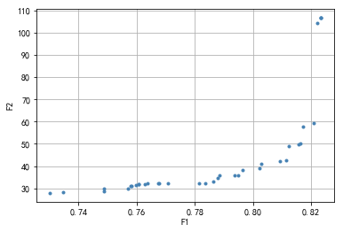

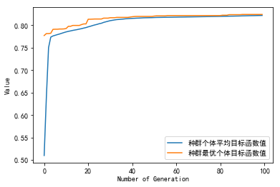

种群信息导出完毕。

多目标的fpa, aae值分别为:

[0.78157576 0.76775758 0.73018182 0.76266667 0.76387879 0.74860606

0.76072727 0.76072727 0.77066667 0.75830303 0.82327273 0.82327273

0.79660606 0.78642424 0.78351515 0.75975758 0.75709091 0.81624242

0.74884848 0.82230303 0.80945455 0.75806061 0.80218182 0.73454545

0.78836364 0.78787879 0.81721212 0.82327273 0.76727273 0.82084848

0.81575758 0.79490909 0.79369697 0.81236364 0.81139394 0.80290909]

[ 32.39669805 32.29279274 27.91604999 31.88139287 32.082781

28.58363312 31.71136888 31.71136888 32.35363077 30.94493259

106.59490812 106.59490812 38.31212178 33.17963899 32.45996682

31.58493449 29.84823265 50.24299608 29.79763109 104.38410642

42.26210784 30.94086944 38.96434227 28.27282966 35.72207234

34.77544649 57.58852654 106.59490812 32.21797517 59.34161916

49.85751021 35.83579851 35.77722957 48.92229659 42.8001758

40.96802218]

多目标的fpa, aae平均值值分别为: 0.785070707070707 44.32543953686894

单目标的fpa, aae值分别为: 0.8242424242424242 6044012.159426598

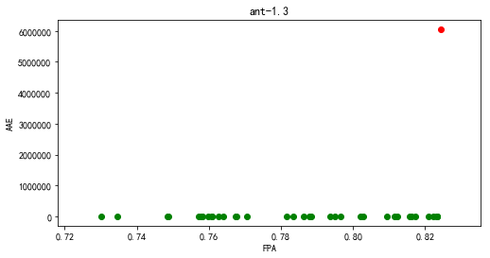

【ant-1.4】

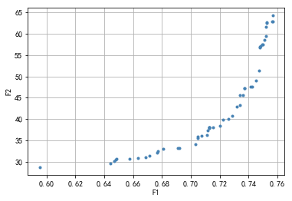

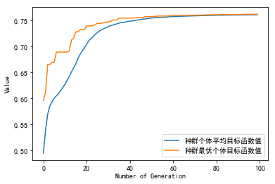

种群信息导出完毕。

多目标的fpa, aae值分别为:

[0.71264643 0.71539565 0.73392302 0.74862539 0.64845804 0.70738704

0.75669376 0.7564547 0.70487688 0.73715037 0.74743007 0.75245039

0.71300502 0.7501793 0.70499641 0.74157303 0.59526656 0.71300502

0.75268946 0.69184796 0.67726512 0.72866364 0.73189099 0.74491991

0.66339947 0.71192924 0.74922305 0.71300502 0.67666746 0.72220894

0.64702367 0.73404255 0.74802773 0.6908917 0.66877839 0.68109013

0.73715037 0.75197227 0.67116902 0.75101602 0.7520918 0.70344251

0.71097299 0.64439398 0.64821898 0.75687306 0.72005738 0.7479082

0.72615348 0.6574229 0.73631365 0.74240975]

[37.83567039 38.0526934 43.24471744 57.12680438 30.57965171 35.95749031

62.95248092 62.93009703 35.53351157 47.17021916 51.3847157 62.54446686

38.00512762 57.48225749 35.84336399 47.50315624 28.67448854 38.00512762

62.66436228 33.13573008 32.51935414 40.6907639 42.84255863 49.02671334

30.87875789 37.39251612 57.41767239 38.00512762 32.10626095 39.74234476

30.16202472 45.64250982 57.01823964 33.12851753 30.91830062 32.93415919

47.17021916 59.51802684 31.39156599 58.64036617 61.72140837 34.04013244

36.2202586 29.60402159 30.43130719 64.29199967 38.43928578 56.83827397

40.08035281 30.61683613 45.65102711 47.50609045]

多目标的fpa, aae平均值值分别为: 0.7140509203920631 43.254098582275965

单目标的fpa, aae值分别为: 0.7622519722687067 70758224.8917498

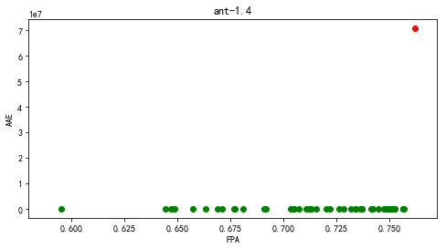

**【ant-1.5】**

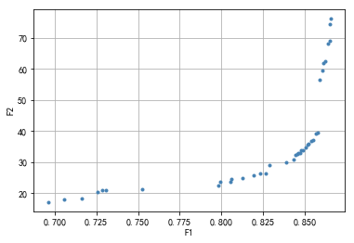

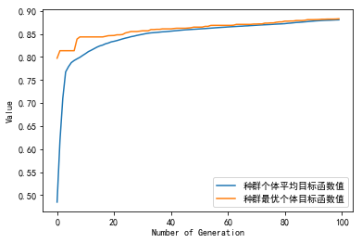

种群信息导出完毕。

多目标的fpa, aae值分别为:

[0.84895173 0.85216967 0.70580205 0.82311068 0.86504144 0.85168211

0.84680644 0.8050707 0.86192101 0.85655778 0.86455388 0.82866894

0.8123842 0.86045831 0.79814725 0.83861531 0.86348123 0.72588981

0.85460751 0.82632862 0.8443686 0.79892735 0.8058508 0.71623598

0.84563627 0.75231594 0.84573379 0.84758654 0.85031692 0.69605071

0.73057045 0.8574354 0.85363237 0.84339347 0.85850804 0.86533398

0.86094588 0.7287177 0.81901511]

[33.93536467 35.7822585 17.91322935 26.19701288 74.35833353 35.69668974

33.01729817 23.78554208 62.53590496 39.18465997 68.96187219 29.15014602

24.9908474 59.56480295 22.42350425 30.00706258 68.15269717 20.39938196

36.97115821 26.25745332 32.19048466 23.75553788 24.66199048 18.33163725

32.53097327 21.25522663 32.79470576 33.9281093 34.66985868 17.10861642

21.06540576 39.46598378 36.64062389 30.75138742 56.34873098 76.11837466

61.93417086 21.0435255 25.80151966]

多目标的fpa, aae平均值值分别为: 0.8207903586743177 36.145694429326404

单目标的fpa, aae值分别为: 0.8827888834714773 99791450.63562259

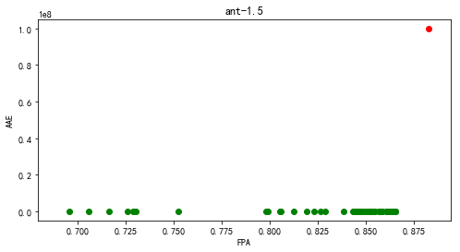

【ant-1.6】

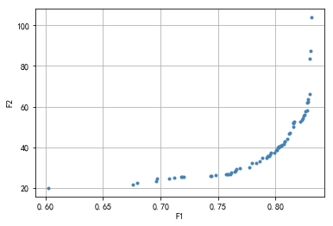

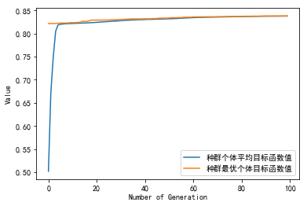

种群信息导出完毕。

多目标的fpa, aae值分别为:

[0.76080763 0.7650192 0.75809798 0.80253623 0.75839217 0.81232194

0.7834603 0.76602564 0.80453363 0.80379041 0.80792456 0.79601759

0.60261055 0.7686269 0.7942989 0.78615447 0.77745262 0.82588567

0.81517094 0.76407469 0.69624055 0.69670507 0.80348074 0.80773876

0.80148334 0.71991515 0.78852347 0.79521244 0.82704695 0.80679425

0.75658058 0.82731017 0.74433296 0.82930757 0.67981234 0.80248978

0.81543416 0.83046885 0.82779016 0.79298278 0.8232844 0.71221974

0.71833581 0.70721851 0.82269602 0.79245634 0.82466246 0.83090239

0.81566642 0.74764648 0.80174656 0.74314072 0.80035303 0.71773195

0.82156571 0.79916078 0.76162827 0.67569367 0.81613093 0.7795584

0.81160969 0.82969466 0.81037099 0.82845596 0.82548309 0.80575684]

[ 26.83645688 28.29204186 26.80487824 40.11079639 26.80538114

47.00471507 32.3390387 29.06720914 40.68196478 40.67811874

42.81462691 37.22046958 19.96147319 29.78548024 35.58180929

33.21135114 29.97432067 57.52112119 50.1199465 27.98470084

23.31148784 24.6471235 40.22945641 42.67086142 38.64784103

25.58291395 34.64872424 36.35316656 58.18902411 41.50172725

26.6311563 62.03704676 25.87664674 66.10548333 22.53050187

39.80408362 51.89491631 87.5381175 62.31332299 35.50808794

54.32475428 25.1913469 25.32547211 24.75311057 53.31010437

34.87895284 55.59780332 103.86950055 52.10994139 26.20897008

39.75635054 25.73479415 38.59702609 25.31889637 52.61656512

37.33972012 27.36144951 21.68752092 52.54527696 32.17125319

46.54853112 83.50238042 44.33030247 63.44248135 55.87351867

41.01815212]

多目标的fpa, aae平均值值分别为: 0.7822124534081055 40.79139038913745

单目标的fpa, aae值分别为: 0.8381023163631859 1051057086.3161651

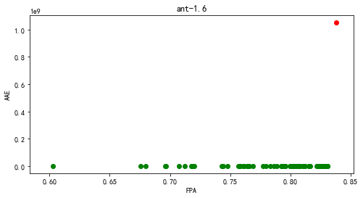

【ant-1.7】

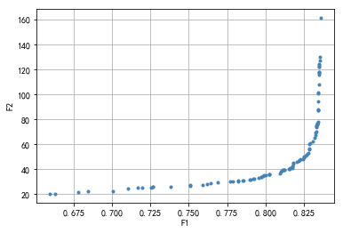

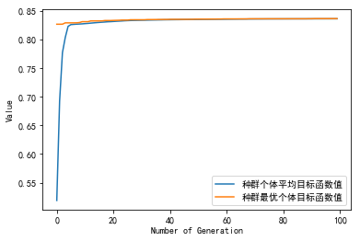

种群信息导出完毕。

多目标的fpa, aae值分别为:

[0.80257734 0.79021683 0.82518963 0.7166157 0.8348199 0.81758866

0.78945634 0.83431158 0.79218458 0.82585283 0.78203804 0.81781105

0.80971169 0.83364441 0.7379691 0.82145268 0.83234979 0.83506215

0.77838847 0.81773559 0.8023073 0.82250109 0.81563878 0.82775902

0.83472459 0.83464517 0.82433184 0.83401771 0.83366427 0.82888686

0.83294945 0.6777213 0.82223105 0.81512648 0.7850006 0.75095906

0.79556809 0.7971129 0.70036933 0.79879274 0.83574123 0.68407529

0.76435408 0.83364441 0.83413288 0.81161987 0.7971129 0.72515786

0.82815615 0.82044399 0.81758866 0.83197252 0.83464914 0.78566777

0.81118701 0.83499464 0.8305111 0.82833088 0.79854652 0.75107422

0.72657559 0.83226639 0.83308844 0.83467694 0.83469282 0.83549104

0.81068266 0.6596402 0.83427584 0.66294428 0.80923315 0.81242206

0.82825146 0.75915174 0.71017434 0.72657559 0.79991263 0.83470474

0.78226441 0.80234701 0.83364044 0.83554267 0.79276041 0.83287796

0.83299313 0.83408522 0.81233073 0.76170923 0.82480442 0.81726699

0.77716929 0.83395417 0.71959414 0.82724276 0.76860728 0.81557921

0.8342679 0.82688138]

[ 35.99410967 32.03325604 50.1491193 25.04642034 122.49097732

42.3943021 31.67926591 101.36964345 32.20517122 51.16090678

30.60005805 45.39199981 38.3505046 76.80969258 26.13614407

46.36362838 69.36191632 124.63472441 30.55546355 44.80024826

35.89197459 47.8646616 40.73906967 53.03304441 121.92884054

107.80437136 48.00764644 87.08959062 76.82810142 60.78094409

73.57422145 21.83288801 47.36791033 40.04913875 31.19094634

26.56747768 33.16501333 33.97661519 22.3679833 35.02842536

161.29170101 22.18159071 28.67607006 76.80969258 88.28642697

39.52552013 33.97661519 25.36077162 55.81685511 45.97862703

42.3943021 65.30391869 115.68757151 31.19552596 39.39248834

123.98509604 62.29556513 60.01739188 34.37193824 27.30508377

26.02967522 67.56215675 74.9056041 117.44283531 118.15807649

127.3049735 38.59958219 20.35511859 100.63332349 20.58814833

36.62436598 39.82597145 56.88221719 27.32937297 24.53023087

26.02967522 35.28639394 118.21046821 31.05389074 35.89612309

76.1754307 129.82221063 32.21228153 69.93704705 74.25302887

87.09874377 39.80752106 28.21841168 49.53461179 41.07578968

29.99954264 77.74410261 25.27956647 52.07457301 29.60461228

40.46406793 94.50681545 51.63057303]

多目标的fpa, aae平均值值分别为: 0.8010094264464055 55.66486022974072

单目标的fpa, aae值分别为: 0.836654620547238 130901523.6265333

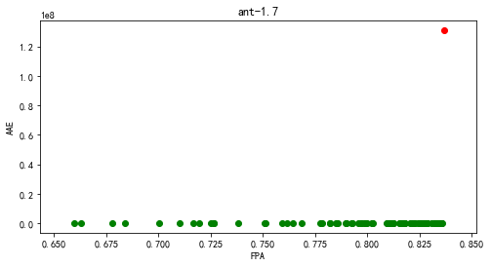

1. camel

【camel-1.0】

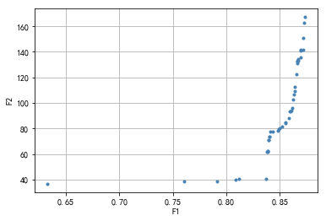

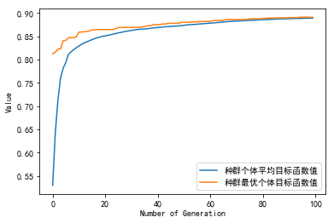

种群信息导出完毕。

多目标的fpa, aae值分别为:

[0.83944374 0.8369153 0.86957438 0.84892541 0.86388538 0.84934682

0.86936367 0.86135693 0.84091867 0.83860093 0.87147071 0.76085124

0.83902233 0.86599241 0.85840708 0.84302571 0.86283186 0.79161399

0.86367467 0.85524652 0.84007585 0.86725664 0.85882849 0.86620312

0.81184155 0.87315634 0.84787189 0.80868099 0.86662453 0.86219975

0.83902233 0.86072482 0.86557101 0.83754741 0.87189212 0.85545723

0.8596713 0.84007585 0.86915297 0.87273493 0.83923304 0.85208597

0.63274336 0.86704593]

[ 70.82132526 40.64650992 141.33812473 79.23440788 112.75120509

79.91206302 141.18127028 96.20097346 77.34821152 61.64778129

141.42889526 38.69509096 62.45149929 130.99421901 88.1354183

77.56579301 106.37600373 38.82111428 109.04699746 84.18646697

73.34486481 134.39549544 93.2553527 132.66175146 40.52778922

167.18789519 78.03912268 40.15787682 132.80598251 102.38761616

62.45149929 94.15786865 122.6045051 61.35801235 151.09253401

84.5300622 93.68359167 73.34486481 135.75893112 162.68663913

70.72623635 81.64024919 36.61479199 132.8120256 ]

多目标的fpa, aae平均值值分别为: 0.845367390721373 94.02293020834696

单目标的fpa, aae值分别为: 0.8910661609776654 48186448.803138666

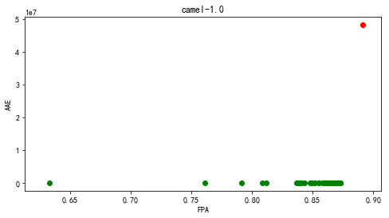

【camel-1.2】

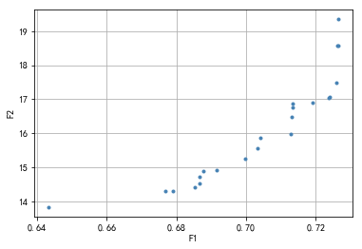

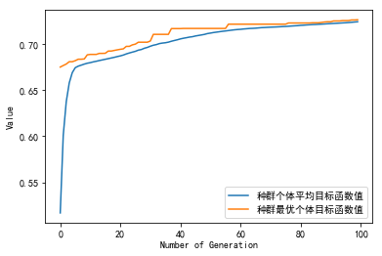

种群信息导出完毕。

多目标的fpa, aae值分别为:

[0.7237488 0.64341979 0.69165595 0.72624111 0.67894863 0.72635927

0.71276656 0.6851479 0.68656105 0.68771426 0.69965435 0.67672729

0.71342981 0.71904618 0.7238449 0.7033298 0.7262868 0.71334001

0.72588507 0.68666818 0.70414902 0.71316514]

[17.0329974 13.83604577 14.92715301 18.56460887 14.29964221 19.34989355

15.96777246 14.41648819 14.54264801 14.89854519 15.24651197 14.29855221

16.86191379 16.9035209 17.05969565 15.57200277 18.57681359 16.75829051

17.4896198 14.72339836 15.86308232 16.49725701]

多目标的fpa, aae平均值值分别为: 0.7030949954398797 16.076656979519836

单目标的fpa, aae值分别为: 0.7265231145392216 36169078.89586636

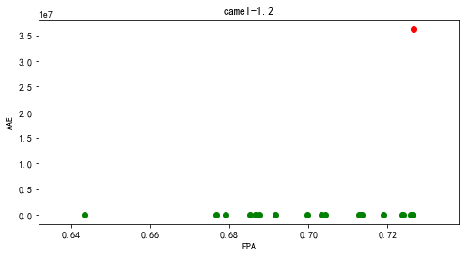

【Camel-1.4】

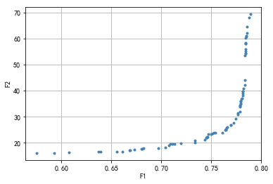

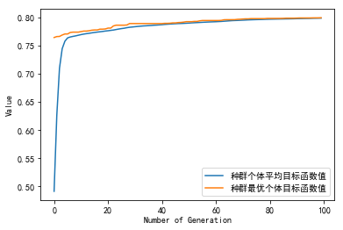

种群信息导出完毕。

多目标的fpa, aae值分别为:

[0.78393468 0.74669143 0.74370807 0.78906956 0.78440538 0.78474599

0.77222374 0.77962823 0.71917363 0.78128851 0.73380118 0.77611256

0.74473504 0.74552581 0.75418664 0.77891962 0.66816035 0.78133644

0.74528618 0.70750034 0.76436054 0.78776188 0.7852766 0.65535054

0.76967685 0.67308983 0.78156922 0.7656648 0.66867041 0.76347391

0.7843489 0.78414693 0.77905313 0.66094242 0.73385766 0.77923456

0.77830001 0.78316103 0.78501643 0.74616425 0.78000137 0.63907641

0.70412844 0.57479803 0.70902027 0.778858 0.78349993 0.74993838

0.77935437 0.7645317 0.78097015 0.75236033 0.78451664 0.68070998

0.71299124 0.76078666 0.78388676 0.69697385 0.6370293 0.68239764

0.78399973 0.7767664 0.60716144 0.78239764 0.78156922 0.78529714

0.68001849 0.77450021 0.76939614 0.71107422 0.59261605 0.77885458

0.76498015 0.78446871 0.78378748 0.75103382]

[54.39652352 23.37802915 21.04783396 69.31092166 58.05619317 60.62401883

27.73316883 36.05263665 19.80308231 38.08487717 20.13379924 30.74069374

21.89023546 22.12300766 23.78678253 34.2084178 17.04447056 38.8390057

22.0183048 18.91122968 25.01466769 68.10736608 61.9805832 16.67373365

26.7899325 17.3714933 39.66909689 26.06712459 17.09329647 24.82376585

58.00597759 55.99460618 34.8759811 16.68185197 20.75630478 35.09672409

31.78698727 42.22704354 61.08664556 22.12879431 36.70324908 16.64410005

18.1976991 16.03634623 19.42920045 34.09968972 43.90913116 23.39413824

35.99311262 25.26501593 36.91248497 23.74543529 60.32828209 17.71553753

19.65188585 23.80793898 54.3197542 17.89607541 16.44668413 17.81210456

55.0313732 31.33666558 16.17463263 40.85977647 39.66909689 64.65084465

17.68910225 29.29335199 26.74400443 19.6097468 16.08995383 33.89887931

25.59307623 58.35224309 53.5603409 23.45321723]

多目标的fpa, aae平均值值分别为: 0.7446487384420246 32.509597106859985

单目标的fpa, aae值分别为: 0.7993153498562234 84775391.62234801

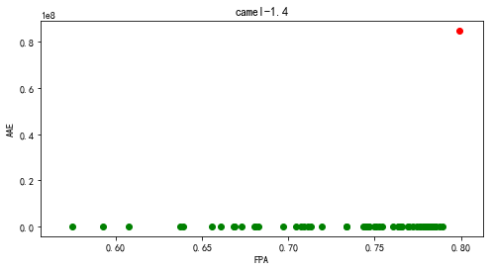

【camel-1.6】

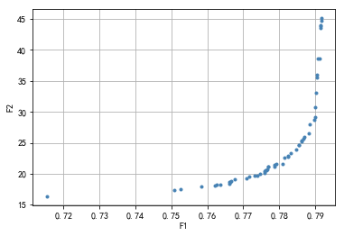

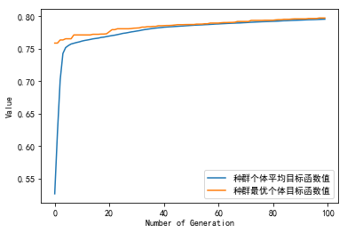

种群信息导出完毕。

多目标的fpa, aae值分别为:

[0.78839793 0.79017409 0.7666114 0.77389016 0.78535959 0.77693057

0.79170155 0.76603731 0.75078756 0.78233575 0.7152829 0.78607876

0.76613472 0.79063627 0.77918756 0.7862487 0.77612228 0.78996062

0.78808497 0.78986632 0.7905513 0.78088497 0.78696373 0.77598549

0.7635772 0.75256788 0.77664663 0.77629845 0.78330984 0.7915658

0.76251606 0.78670881 0.76750259 0.77476477 0.77320622 0.75840311

0.79167047 0.79147565 0.7854114 0.79134715 0.78470052 0.79150674

0.77857617 0.76197927 0.77679171 0.77597306 0.78235855 0.76636891

0.79041865 0.77091192 0.77164974 0.77864767 0.78132021 0.78973057]

[27.96602065 33.01554493 18.82836126 19.75890086 24.60279352 21.08721921

45.11847143 18.44861022 17.43365289 22.71749598 16.3642387 25.26644522

18.68676798 38.57561139 21.58961917 25.39887683 20.58133489 30.81768614

26.55792748 29.133805 35.9418884 21.63495773 26.01040224 20.49355563

18.24514794 17.54374735 20.66318023 20.635843 23.31138333 43.99616047

18.17472629 25.61760309 19.16923455 19.96780007 19.75602233 18.01118427

44.71998714 43.61318874 24.69097148 38.67248858 23.89529433 43.86276922

21.10459839 18.14168471 21.08645896 20.1108467 22.92533876 18.72732589

35.53266377 19.20046792 19.60209516 21.48257058 22.60329175 28.68342296]

多目标的fpa, aae平均值值分别为: 0.7778170408750718 25.18106825422946

单目标的fpa, aae值分别为: 0.7970777202072539 50836133.99187211

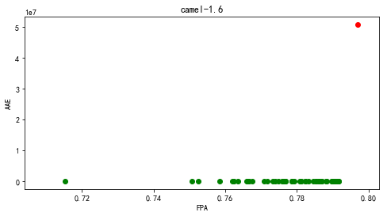

1. ivy

【ivy-1.1】

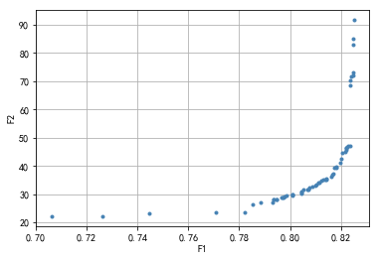

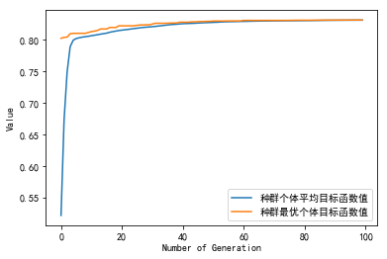

种群信息导出完毕。

多目标的fpa, aae值分别为:

[0.78838495 0.78215984 0.82016781 0.78544639 0.80504968 0.77086958

0.79298612 0.80427638 0.81316939 0.7934501 0.81386537 0.80075784

0.82372501 0.80087384 0.81719058 0.81823454 0.82190774 0.80462437

0.72628852 0.82295171 0.81402003 0.82488497 0.82206241 0.81599196

0.82469164 0.79874725 0.82461431 0.74469319 0.82144376 0.80686695

0.79689131 0.82360902 0.81637861 0.79650466 0.82213974 0.81007617

0.80450837 0.70614391 0.79348877 0.82364768 0.79468739 0.81011484

0.81688126 0.80098983 0.81231876 0.79476472 0.80729227 0.82225573

0.8074856 0.80860689 0.79789661 0.82484631 0.79747129 0.82043846

0.81421335 0.81978115 0.81123613 0.823957 0.81804122 0.81154545

0.82511696]

[27.01375544 23.59599363 42.59488394 26.23384794 31.45934328 23.36465391

27.10232646 30.28602643 35.05564276 27.91914466 35.21089603 29.49809904

70.13644394 29.82104452 39.24405725 39.63248416 45.75507808 30.83361462

22.2749858 46.98477431 35.26060108 85.03189901 46.45414933 36.184766

72.96057497 29.34123653 71.90331234 23.27897366 44.97244025 31.47190674

28.80848021 47.22650156 36.79228562 28.66647867 46.49609862 33.10614943

30.60363111 22.13136325 27.97393712 68.57598112 28.0387399 33.50777184

37.14156165 29.96585677 34.85058253 28.04743121 31.5901315 46.66831284

32.45255161 32.74373331 29.10012743 83.12601937 28.94491829 44.49749088

35.35423992 41.19170614 33.96493079 71.71471353 39.42313416 34.21294253

91.67320544]

多目标的fpa, aae平均值值分别为: 0.8055364870252647 39.33554040037335

单目标的fpa, aae值分别为: 0.8314580675095696 257078664.25080693

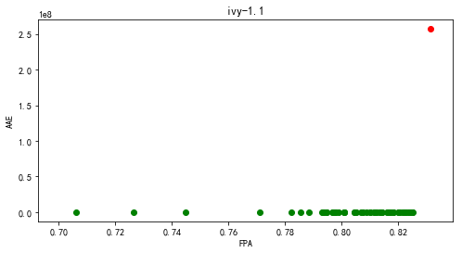

【ivy-1.4】

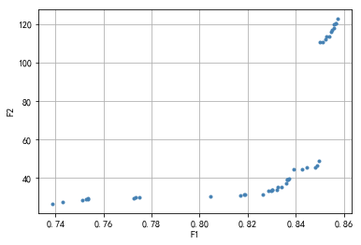

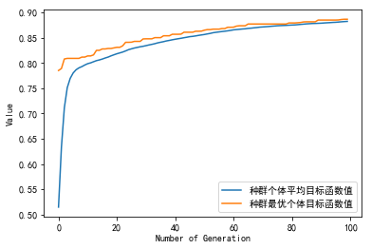

种群信息导出完毕。

多目标的fpa, aae值分别为:

[0.83609959 0.85108345 0.75334255 0.85730751 0.82849239 0.83725219

0.83633011 0.7724758 0.84877824 0.77316736 0.85408022 0.83633011

0.81881051 0.83218073 0.84278469 0.81857999 0.85569387 0.77478101

0.85500231 0.85477178 0.85661595 0.83010604 0.8494698 0.80451821

0.83932688 0.85661595 0.84462886 0.83033656 0.8264177 0.85016136

0.84808668 0.8340249 0.75265099 0.83241125 0.8526971 0.85592439

0.829645 0.83679115 0.75357308 0.74296911 0.75103734 0.81696634

0.73881973 0.85246657]

[ 37.40006809 110.72430461 28.91059922 122.81701518 33.2164577

39.60204906 39.2611356 29.56654995 46.39436997 29.75680477

113.5874184 39.2611356 31.4341855 33.98474422 44.637298

31.41889778 118.2897737 30.0980047 116.95588234 116.23023433

120.41057417 33.5656683 48.66749445 30.39404893 44.2796944

120.41057417 45.63320022 33.74355273 31.55097763 110.62945187

45.70964699 35.17988438 28.80268312 35.02446011 113.5446877

119.81214734 33.48577056 39.38873712 29.3345306 27.55490517

28.44529065 30.97880589 26.54138125 112.01678778]

多目标的fpa, aae平均值值分别为: 0.8232637579110608 57.2420882784618

单目标的fpa, aae值分别为: 0.8863531581373905 73421024.82627028

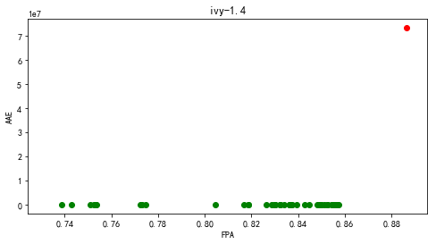

【ivy-2.0】

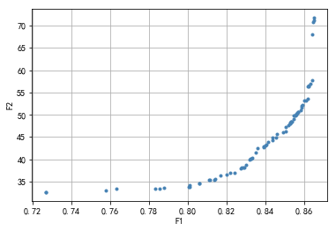

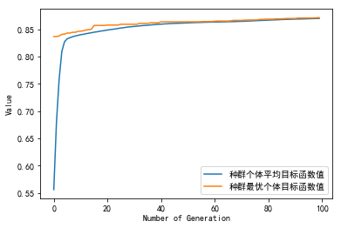

种群信息导出完毕。

多目标的fpa, aae值分别为:

[0.84395292 0.85217127 0.83324878 0.85699067 0.80595576 0.8287845

0.78566356 0.86181006 0.78327922 0.85303369 0.86475244 0.82756696

0.85465706 0.82898742 0.81402192 0.82766843 0.86515828 0.85617898

0.85293222 0.86409294 0.84598214 0.85384537 0.85886769 0.86216518

0.84369927 0.86221591 0.80580357 0.85460633 0.82426948 0.80083198

0.81706575 0.83507508 0.72671469 0.84552557 0.85714286 0.8492289

0.85318588 0.8600345 0.85643263 0.83910816 0.78774351 0.86084619

0.85064935 0.83608969 0.8317776 0.8533888 0.86257102 0.85546875

0.84065544 0.85075081 0.72676542 0.86328125 0.85278003 0.83994521

0.81097808 0.76324067 0.83015422 0.84136567 0.83223417 0.8641944

0.83918425 0.85531656 0.8113332 0.83269075 0.8010349 0.85612825

0.86500609 0.859375 0.8005276 0.81995739 0.82183442 0.85881696

0.8136668 0.85830966 0.75760958]

[44.85503895 47.58826309 40.26854779 50.54894834 34.67795076 38.09693542

33.36732578 53.65306143 33.35425769 48.31822935 70.80106267 37.92895919

49.79974239 38.11152108 35.483107 38.05613494 71.73915273 50.28989647

48.13243513 57.6516659 45.68041547 48.49086982 52.08253608 56.41747749

44.18986245 56.41766256 34.55171401 48.98917516 37.06093969 33.78578271

36.36137496 41.56512153 32.62774623 44.92472373 50.63587879 46.02209732

48.36098375 53.23237274 50.38414614 42.76162528 33.51646985 53.27281394

46.25773555 42.55855196 40.01346029 48.37764142 56.48880591 49.90254638

43.24979819 47.2721831 32.62844162 57.0040386 48.01094978 43.13905601

35.31596561 33.35114724 38.66445679 43.93585745 40.07230164 67.95049314

42.91003237 49.82009548 35.4220794 40.17487344 34.26637206 49.95888606

71.24754669 52.21946984 33.70458768 36.51986818 36.95260766 51.58421764

35.44053019 50.94479561 32.91651949]

多目标的fpa, aae平均值值分别为: 0.8349117288961039 45.09773251025091

单目标的fpa, aae值分别为: 0.871195211038961 239190800.9145959

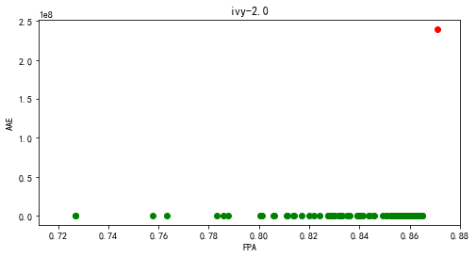

1. jedit

【jedit-3.2】

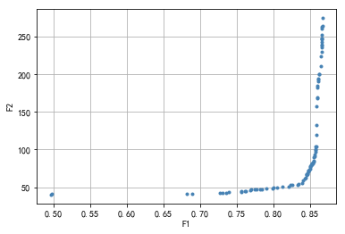

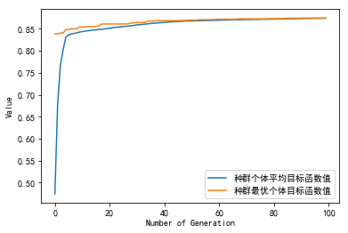

种群信息导出完毕。

多目标的fpa, aae值分别为:

[0.85347051 0.78423352 0.83283608 0.84600208 0.84503003 0.85286418

0.83447221 0.85907184 0.68195642 0.86605905 0.82386626 0.85911996

0.84671427 0.73499577 0.7394133 0.85046774 0.72682476 0.85630005

0.79944949 0.84826378 0.49717047 0.86111218 0.85297005 0.75566869

0.85756083 0.85979366 0.86664613 0.86657877 0.86487527 0.85123768

0.68917462 0.84785956 0.76076956 0.75670812 0.86598206 0.86629004

0.76886357 0.49574607 0.85265245 0.8519595 0.85937019 0.84887974

0.82081537 0.73002002 0.85720473 0.76238643 0.85647328 0.86014975

0.85926432 0.86003426 0.86716585 0.85492378 0.77432053 0.84291269

0.86551047 0.85866762 0.8048872 0.86660764 0.79982484 0.85714698

0.84528988 0.86616492 0.77705382 0.84995765 0.7694699 0.85552048

0.84585771 0.8506506 0.79006583 0.86575108 0.78215468 0.85408646

0.82545427 0.85771481 0.86570296 0.83951532 0.86674238 0.84042963

0.81208616 0.86279643 0.86115068 0.86287342 0.86077533 0.84728211

0.85454843 0.86546235 0.865087 0.84366338]

[ 81.49461399 47.15379508 53.34516834 67.7957382 66.39345473

81.05082522 54.31598146 119.97904203 40.65215643 246.92803744

52.8638449 132.98231998 67.97171576 42.7727512 43.35726576

76.51944516 41.74930939 91.33892147 47.98466671 72.43557517

40.54835643 193.02138316 81.11450343 43.87069083 99.91304717

169.24453748 263.15002325 252.01719533 210.75378318 78.61059201

41.29966982 72.27576547 44.80669467 44.38737061 242.68793044

247.76398445 45.59238928 40.03003801 80.15371066 79.23478143

167.58324796 73.68988882 50.57919362 42.7434963 99.54789133

45.13566622 93.42263384 184.33642587 156.96689419 182.09335757

274.67004457 84.8599535 46.52597854 61.50516619 236.28493486

104.21602127 49.3558662 261.12551612 49.34995322 96.84355128

67.12292909 247.34090415 46.68549928 74.82472311 46.48093855

89.83416811 67.54909035 77.47486356 47.95160052 238.93406934

47.09450062 82.25417297 53.08140072 104.05586415 237.80408553

55.70018579 264.53912893 58.67941282 50.08062121 199.61323541

194.49608785 200.02404906 191.18990398 70.60031984 83.39517158

229.82513724 223.77893492 62.54021828]

多目标的fpa, aae平均值值分别为: 0.8241011808102585 109.92440879484234

单目标的fpa, aae值分别为: 0.8743984832152757 89205208.03716742

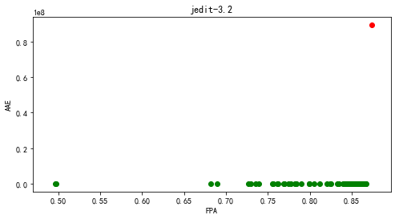

【jedit-4.0】

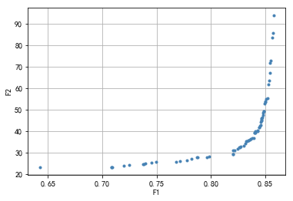

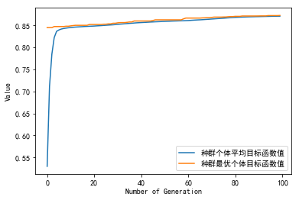

种群信息导出完毕。

多目标的fpa, aae值分别为:

[0.82737579 0.7963445 0.84299265 0.74534386 0.84689687 0.85710567

0.84678119 0.78201458 0.78687316 0.82626236 0.83985482 0.64224362

0.73749205 0.77792238 0.84091041 0.85328822 0.84656429 0.71993753

0.84621725 0.84782231 0.7086153 0.85466192 0.85664295 0.83647117

0.8299786 0.74939268 0.82065186 0.84422176 0.84900804 0.84977442

0.76780034 0.82146162 0.78756724 0.83276939 0.83985482 0.8204928

0.85257967 0.85107583 0.83438892 0.83556018 0.84092487 0.83807623

0.84983226 0.85490774 0.84900804 0.82637804 0.83181503 0.84565331

0.83451906 0.79860027 0.84970212 0.8202759 0.84773555 0.82459946

0.84488692 0.84462664 0.70916479 0.84653537 0.72455029 0.73811383

0.85404014 0.85779976 0.7086153 0.83979698 0.77174793 0.85203019

0.739502 0.83259587 0.84303603 0.84600035]

[32.64881488 27.80184262 39.90280828 25.13005677 46.51613627 85.58350999

45.89182392 26.95225413 27.78224252 32.29781405 39.05793884 23.17413933

24.5062424 26.34527567 39.09943755 63.52294566 45.61997772 23.94093615

44.79881605 48.41965378 23.19917077 71.55261875 83.36166251 36.43290636

33.04721733 25.6248892 30.93669127 41.74009742 49.16257339 53.51213663

25.63827506 31.16326837 27.79887341 35.21362624 39.05793884 29.27647389

61.58548027 55.0166737 35.48995989 36.1386156 39.74411991 36.5525917

53.9040335 72.66954497 49.16257339 32.51964735 34.2844903 42.89296298

35.79153783 28.18137004 52.79815418 29.23846812 47.46033677 31.67205065

42.59128629 41.8197448 23.24942504 44.89571676 24.25475514 24.66583496

67.19617606 93.73267597 23.19917077 36.67739167 25.94142371 55.3112212

24.8782903 35.11223466 40.39517047 44.15398468]

多目标的fpa, aae平均值值分别为: 0.8159754757360171 40.412688566115655

单目标的fpa, aae值分别为: 0.8722742784429406 120351827.35664874

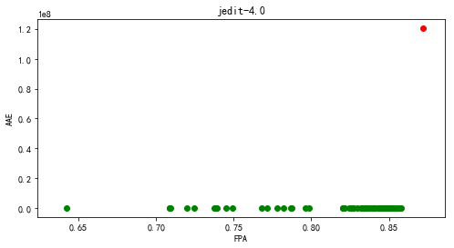

【jedit-4.1】

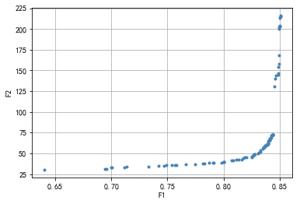

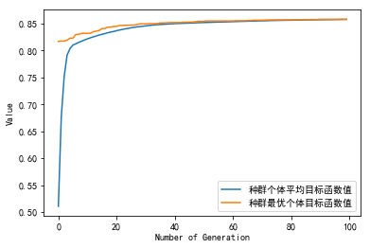

种群信息导出完毕。

多目标的fpa, aae值分别为:

[0.81625901 0.8396402 0.75648411 0.82036512 0.77444464 0.84268285

0.81371854 0.79144511 0.69430167 0.71140553 0.81887333 0.78321813

0.83715881 0.75407657 0.85017133 0.84978731 0.83566702 0.80704242

0.83907893 0.74898086 0.85068829 0.83961066 0.84376108 0.82619934

0.84888633 0.69964847 0.84104337 0.8490488 0.84002422 0.84376108

0.8251802 0.7420241 0.79079523 0.83774962 0.79801784 0.80046969

0.84376108 0.83265391 0.8176031 0.84104337 0.81163594 0.83937434

0.83455926 0.70060853 0.73302907 0.83540116 0.84331797 0.83729174

0.82825239 0.8502895 0.82718894 0.82633227 0.83695203 0.83990606

0.83061562 0.78713222 0.84838414 0.84953622 0.8084899 0.84966915

0.84678896 0.64005081 0.83302316 0.84940328 0.76657214 0.78125369

0.69605932 0.83102919 0.79993797 0.80026291 0.85052582 0.84185572

0.83634645 0.75830084 0.71399031 0.84359861 0.7466324 0.84879771

0.8411763 0.84376108 0.84259423 0.82537221 0.84514947 0.84311119

0.84138308 0.84605045 0.85055536 0.84999409]

[ 42.97096913 62.55728071 35.84418265 45.08875662 36.98657319

71.35627647 42.63166739 38.73878673 31.42409431 33.44399758

45.08500323 37.72821913 59.16865798 35.67320154 203.87927724

202.6367826 57.61610007 41.30914076 60.24986931 35.51931188

215.91888528 62.21937854 72.93622082 47.56448402 153.96085777

33.04907187 66.09507856 157.74222464 64.62182049 72.93622082

45.34371314 34.57883663 38.69207404 59.92889227 39.21428595

39.70810399 72.93622082 52.02568386 44.78877571 66.09507856

42.20407943 61.70645472 55.52182947 33.4013438 34.40953764

56.29672363 72.51856263 59.34071576 49.32481097 213.52673391

48.87976928 47.92748157 58.60915132 63.23288624 50.30111064

38.59402335 145.01170268 200.12454137 41.80049644 201.70083081

144.09153868 30.39766329 53.91960762 167.92285023 36.68652798

37.40808032 31.70667231 50.76868622 39.47248749 39.58765976

215.1410317 68.54268352 57.62996239 36.03672693 34.33455372

72.92341002 35.07241999 146.8493881 66.56781257 72.93622082

68.61171273 46.41589598 131.17182845 71.59677033 68.0232044

140.31843727 215.16107835 202.73219527]

多目标的fpa, aae平均值值分别为: 0.8128217548580452 75.19004486772056

单目标的fpa, aae值分别为: 0.8580142975304266 267477927.62376174

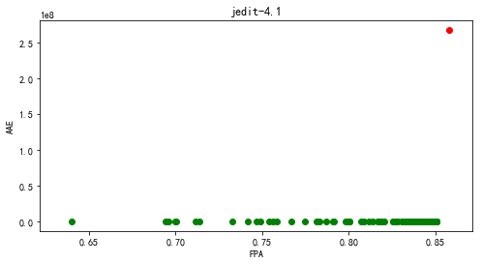

【jedit-4.2】

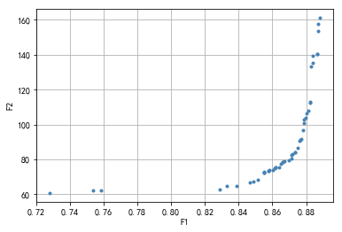

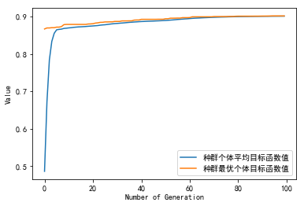

种群信息导出完毕。

多目标的fpa, aae值分别为:

[0.8760475 0.82867205 0.85491748 0.75381728 0.88640687 0.87499357

0.85777081 0.85160146 0.88216544 0.86514832 0.86178089 0.88391342

0.85748805 0.87846383 0.86607372 0.85494319 0.72824019 0.86188371

0.85509742 0.84864531 0.85795075 0.88275667 0.87802684 0.88715233

0.86008431 0.87630456 0.87342553 0.84653745 0.83854301 0.87165184

0.88661251 0.8613953 0.8837849 0.87108632 0.88257673 0.86702483

0.7584443 0.88103439 0.87869518 0.86969822 0.8879235 0.87324559

0.87974911 0.88039175 0.87134338 0.8641458 0.87705002 0.83299059

0.88697239 0.86607372]

[ 90.78972678 62.63245458 72.30774452 62.15195845 140.31280625

86.59848942 73.54337738 68.40281772 112.55683625 77.21571524

75.17519468 139.60484431 73.1014223 100.89431355 78.53695533

72.50643163 60.68667759 75.29835747 72.84658832 67.13314653

73.69721911 133.15177944 96.84745306 157.75670236 73.70090582

91.34203364 84.05749165 66.62694839 64.93406476 83.10663542

140.48042098 74.81204081 135.31000726 80.4049361 112.81803354

78.8315806 62.24909336 108.05092449 102.78906936 79.18884369

161.07163939 83.85135485 103.56722331 106.32197006 82.34397203

75.50331731 91.37281348 64.87171008 153.77351286 78.53695533]

多目标的fpa, aae平均值值分别为: 0.8612148475656778 91.27333021752749

单目标的fpa, aae值分别为: 0.9014703614210067 102217091.16690041

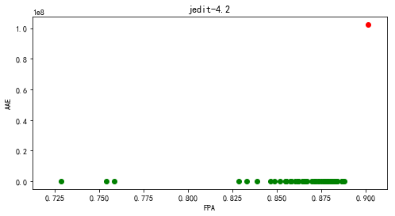

【jedit-4.3】

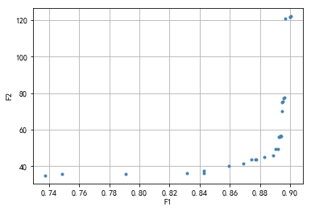

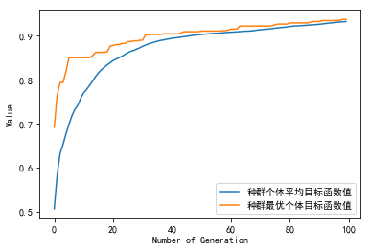

种群信息导出完毕。

多目标的fpa, aae值分别为:

[0.87415312 0.89430894 0.8772019 0.8429878 0.89498645 0.89278455

0.89684959 0.8946477 0.9004065 0.87771003 0.79115854 0.89346206

0.89583333 0.89193767 0.89346206 0.86890244 0.83155488 0.89447832

0.73755081 0.89617209 0.89346206 0.74847561 0.84256436 0.90023713

0.85958672 0.88871951 0.8829607 0.89058266 0.90006775 0.89312331]

[ 43.43863535 56.4890664 43.50947052 37.40909734 75.21824014

55.89952329 120.79837937 75.08378053 122.07489589 43.6249444

35.85783989 56.34375716 77.16971242 49.21127607 56.34375716

41.42859157 36.15017064 69.9658821 34.82413762 77.6898525

56.34375716 35.46703594 36.16643676 121.87027148 40.13866339

45.88462124 44.75284416 49.18764198 121.54644701 56.13004735]

多目标的fpa, aae平均值值分别为: 0.8713442863595303 60.53395922708758

单目标的fpa, aae值分别为: 0.9373306233062331 152761273.9981303

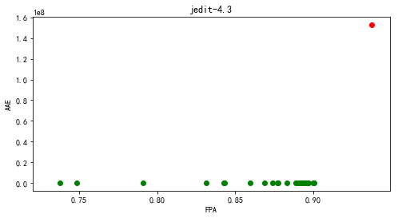

1. log4j

【log4j-1.0】

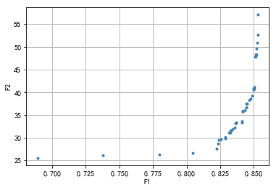

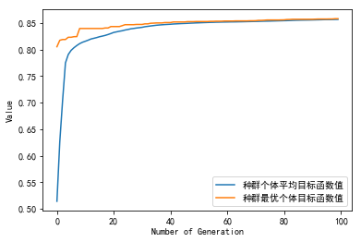

种群信息导出完毕。

多目标的fpa, aae值分别为:

[0.83145112 0.82343655 0.85039466 0.85185185 0.83242259 0.83703704

0.84165149 0.83315118 0.83630844 0.85160899 0.83679417 0.85221615

0.84456588 0.85245902 0.84893746 0.84432301 0.68901032 0.77996357

0.85306618 0.83570128 0.83278689 0.85088039 0.84104432 0.84966606

0.83436551 0.84444444 0.84517304 0.82404372 0.84990893 0.85015179

0.85294475 0.82853673 0.82562234 0.8476017 0.73746205 0.82902247

0.80473588 0.85124469 0.84638737 0.84310868 0.84153005 0.84116576

0.82222222]

[31.06705209 28.7081256 41.21828913 48.41450776 31.14350837 33.38625743

35.89858139 31.67015878 33.14173259 48.39313653 33.38306766 49.69338753

37.51079796 50.84545178 39.32838919 36.68487899 25.55845714 26.38513486

57.06659289 32.26958945 31.56855866 47.78483243 33.42179772 40.45565449

31.90767947 36.77055746 37.57326075 29.49735942 40.83345621 40.91272024

52.6033117 29.77820168 29.66516912 38.63077342 26.1848147 30.14664483

26.71562557 47.92407877 38.22688277 36.0971385 35.8225785 33.65533056

27.62527473]

多目标的fpa, aae平均值值分别为: 0.8330325750836616 36.64113485649257

单目标的fpa, aae值分别为: 0.8581663630843959 95375471.12679906

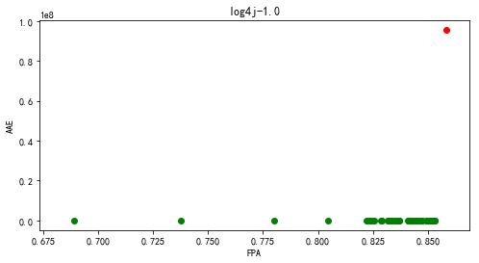

【log4j-1.1】

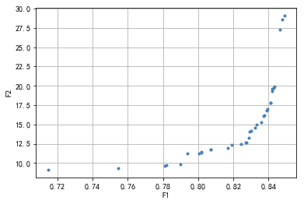

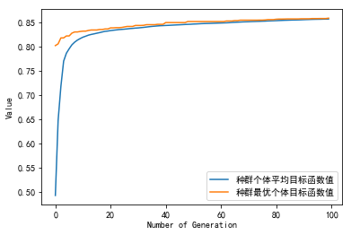

种群信息导出完毕。

多目标的fpa, aae值分别为:

[0.83240879 0.83571581 0.83934286 0.81672712 0.80723277 0.80733945

0.78984425 0.84627694 0.84200981 0.80200555 0.78088329 0.80189887

0.82686153 0.71463623 0.83774269 0.82430126 0.84222317 0.83731598

0.84328995 0.82888841 0.8294218 0.84126307 0.82739492 0.78195007

0.84905057 0.84126307 0.83304886 0.79389802 0.83027523 0.80040538

0.84296992 0.83891615 0.81896736 0.75453382 0.84777043]

[14.57677409 15.30422941 16.9559542 11.90738033 11.73635384 11.79176044

9.85426733 27.29055655 19.27798462 11.45895354 9.63789519 11.30732558

12.63384155 9.13615447 16.14783758 12.42187496 19.58173276 16.12513003

19.89312638 13.29738433 14.07894699 17.7934165 12.69665958 9.68986682

29.07654819 17.7934165 15.01095363 11.20956379 14.15484 11.23285635

19.76358303 16.76371908 12.3353935 9.29771 28.59900347]

多目标的fpa, aae平均值值分别为: 0.819659239842726 15.138085560393

单目标的fpa, aae值分别为: 0.8583315553659057 86626077.71460052

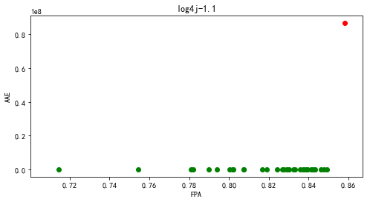

【log4j-1.2】

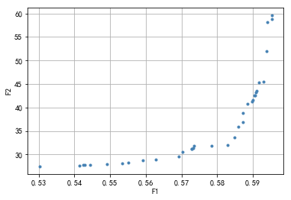

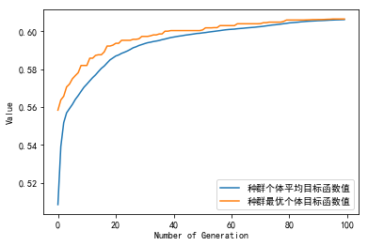

种群信息导出完毕。

多目标的fpa, aae值分别为:

[0.58730532 0.55512783 0.57832305 0.59396611 0.59529827 0.53018905

0.54279557 0.57327848 0.5885885 0.57293565 0.5910765 0.56281712

0.58490548 0.54237438 0.58584582 0.57359193 0.59172299 0.57027133

0.59302576 0.57289646 0.59534724 0.59043001 0.54447057 0.58296601

0.54143403 0.56920364 0.58726614 0.55916348 0.59080223 0.55344304

0.59387795 0.59055735 0.54903517 0.58972475 0.58997943]

[38.77656964 28.28037816 31.92698513 58.07965069 58.84515539 27.48407971

27.83787683 31.30508453 40.75616239 31.24251669 43.53578362 28.88163667

33.63564954 27.71655611 35.87918197 31.79200693 45.31993975 30.50269081

45.45639134 31.17626749 59.5798665 42.55600244 27.87299849 32.01508297

27.61641347 29.58831507 36.898617 28.81083862 43.24999326 28.16086236

51.92015583 42.56022874 27.90981947 41.27457781 41.52187133]

多目标的fpa, aae平均值值分别为: 0.5746867609812069 36.856177335970656

单目标的fpa, aae值分别为: 0.606425702811245 27847538.178632505

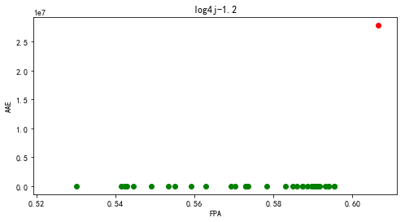

1. lucene

【lucene-2.0】

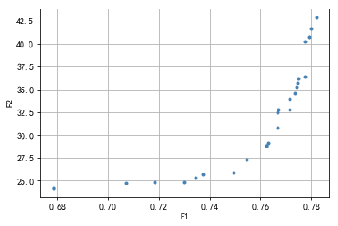

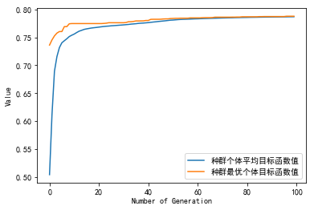

种群信息导出完毕。

多目标的fpa, aae值分别为:

[0.71844623 0.73430922 0.77405281 0.76714504 0.7373517 0.77336395

0.75451588 0.77493303 0.77979334 0.77152698 0.76655186 0.72979334

0.77898967 0.77148871 0.762323 0.67839648 0.74933027 0.76664753

0.77763108 0.67839648 0.763031 0.77921929 0.77462687 0.70715653

0.77755454 0.762323 0.78191734]

[24.84708797 25.32239127 35.23482888 32.78420876 25.68294492 34.64349432

27.28632817 36.22887691 41.66643105 33.96322791 30.83946977 24.88056942

40.77148518 32.83424978 28.7750421 24.18792251 25.87955401 32.49611023

40.27771194 24.18792251 29.10184005 40.7813075 35.76546932 24.77480258

36.43150741 28.7750421 42.90999032]

多目标的fpa, aae平均值值分别为: 0.7552153761108984 31.901104329014302

单目标的fpa, aae值分别为: 0.7880788365862993 43036736.003276944

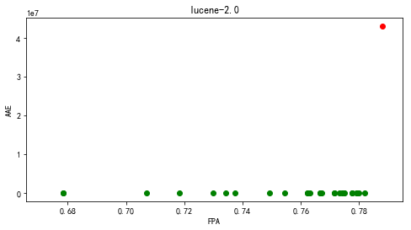

【lucene-2.2】

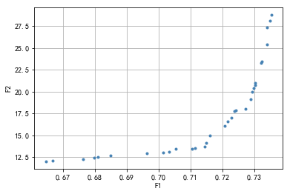

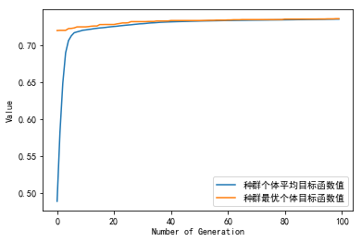

种群信息导出完毕。

多目标的fpa, aae值分别为:

[0.73234368 0.73400614 0.73225078 0.71619824 0.73039762 0.73027049

0.69642473 0.72281875 0.71453578 0.71053609 0.7354339 0.70156858

0.72929257 0.71138688 0.73490583 0.72376733 0.68488529 0.72981087

0.72168437 0.67630894 0.66462282 0.72427585 0.70548026 0.66690137

0.72893074 0.73416261 0.70335817 0.72720961 0.67980989 0.72068689

0.71506386 0.6809345 ]

[23.47297474 25.41629505 23.25096645 14.9650787 21.01646024 20.76372476

12.9457753 16.98850882 13.75702685 13.50278643 28.76853839 13.0427598

19.97986119 13.51982126 28.09219858 17.82181165 12.71250281 20.3971588

16.56855853 12.25249117 12.03917835 17.8891795 13.43766845 12.08408714

19.11707687 27.35289953 13.14584341 18.03742989 12.44259896 16.09064731

14.15383761 12.53920795]

多目标的fpa, aae平均值值分别为: 0.7131332328521973 17.423904828429748

单目标的fpa, aae值分别为: 0.7358348491071603 36673921.7640204

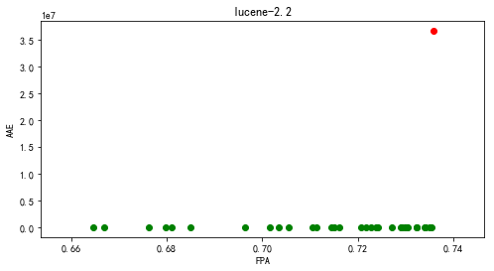

【lucene-2.4】

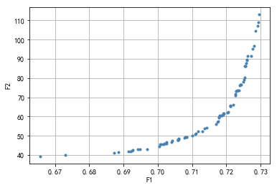

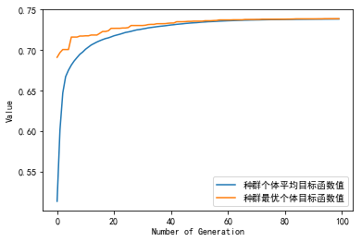

种群信息导出完毕。

多目标的fpa, aae值分别为:

[0.72909531 0.70580324 0.69148827 0.70101917 0.70580324 0.70065153

0.7024153 0.72285462 0.725121 0.70580324 0.70995905 0.72848101

0.71897803 0.71785182 0.69478313 0.70255957 0.71707465 0.7210955

0.71783321 0.72328276 0.7183777 0.7232083 0.7259261 0.72379002

0.72496742 0.72946296 0.72194248 0.72938384 0.7210955 0.71094099

0.72544676 0.72412044 0.72594006 0.71290488 0.71921538 0.72056031

0.69203742 0.70406739 0.72435778 0.72714538 0.70427681 0.71800074

0.70247115 0.71111318 0.69254933 0.70175447 0.69679821 0.72551191

0.70188477 0.69277736 0.7142917 0.7003723 0.69414092 0.68857502

0.72366437 0.70607316 0.72575856 0.72537695 0.72253351 0.66572506

0.72564687 0.70797655 0.72111876 0.70618485 0.67298027 0.7276573

0.71870114 0.70848846 0.72290115 0.71356106 0.70770197 0.708293

0.72400875 0.72810406 0.72034159 0.71748883 0.68732316 0.71182986

0.72268708 0.70580324 0.72614017 0.71903388 0.71767033]

[107.25008645 47.69640772 41.89979695 45.68934748 47.69640772

45.48377971 46.07354172 73.29374074 79.13809379 47.69640772

50.1692599 104.52521584 60.80457694 59.96690778 42.94066185

46.60574555 56.02310064 65.38122624 59.3552703 73.48211366

60.49788819 73.43702316 89.17189569 76.40781105 77.9475773

113.07268514 66.17140106 108.9910717 65.38122624 50.83326779

86.36304172 76.6283154 89.52882632 52.30943919 61.84774986

62.28416247 42.02710191 46.81490944 76.77447025 91.66279471

47.43010378 60.49284104 46.10802421 51.39089447 42.41552213

45.80204519 43.07117846 86.40368413 45.97879763 42.59726815

54.03261636 44.49901644 42.86850873 41.62016355 73.70087967

48.36991736 87.66094702 80.29399212 71.15775965 39.32041169

86.44803865 49.21998872 65.68075508 48.5243601 40.06748491

95.28659381 60.58700916 49.49328012 73.41261663 53.66941804

48.83234706 49.35047947 76.4885997 96.67266866 62.13997995

57.2065853 41.33419028 52.1843262 71.80749935 47.69640772

91.43650106 61.72220049 57.68182287]

多目标的fpa, aae平均值值分别为: 0.7130377896545229 62.66845870396361

单目标的fpa, aae值分别为: 0.7384167907669397 128768766.62015374

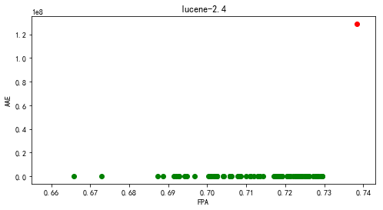

1. poi

【poi-1.5】

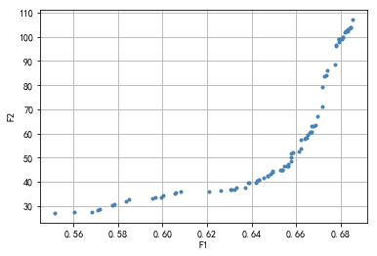

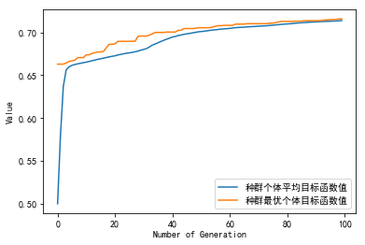

种群信息导出完毕。

多目标的fpa, aae值分别为:

[0.66702445 0.67199028 0.65295976 0.66772152 0.58341353 0.67742493

0.68079305 0.65884472 0.63855578 0.55163225 0.67949145 0.67195327

0.60026032 0.6824216 0.65662398 0.60812545 0.65792558 0.64951761

0.67909665 0.66212648 0.67813433 0.64315148 0.64247909 0.68258198

0.68529622 0.66622252 0.65642658 0.64876502 0.67274286 0.66223752

0.64218916 0.63244874 0.60571347 0.64934488 0.64716115 0.67391492

0.64564364 0.66123819 0.57179781 0.63887655 0.63695808 0.57077997

0.56016976 0.65614282 0.68442026 0.67926321 0.59927332 0.67358798

0.6537987 0.68198978 0.66698127 0.68342093 0.65476102 0.59678733

0.67808498 0.68089175 0.60577516 0.5772448 0.64708713 0.66456313

0.68345794 0.63066598 0.66487157 0.59528216 0.57827498 0.68121252

0.68451896 0.63331236 0.66869001 0.62088854 0.56818911 0.65790707

0.66635206 0.63085104 0.62597774 0.68417351 0.67946061 0.65404545

0.65785772 0.66376736 0.58496805 0.66513682 0.66947961 0.6434229 ]

[ 62.9274628 79.2659682 44.78770062 63.09904146 31.93191788

88.34487174 99.22949484 52.24556641 39.54895548 27.06827926

99.10080852 71.18515515 34.35612174 102.31488958 47.36279403

35.77145349 51.88814541 44.35923177 97.89669238 53.76992986

96.47601851 40.88992842 40.53034745 102.32913288 107.05794212

60.04937092 46.62795619 43.3746011 83.70323869 57.40640259

39.68978722 36.85820823 35.31112434 44.17876482 42.57484214

86.01209561 41.41787439 52.35386321 28.62312553 39.67278348

37.49592393 28.21126075 27.37008961 46.61764167 103.79561675

99.06370632 33.62177106 83.98243546 44.86220457 101.72254902

60.77059531 102.40319433 46.44223029 33.52792659 96.42650814

99.88673822 35.5894745 30.16894243 42.45750939 58.03003949

103.05174384 36.60299552 58.1877014 33.21775593 30.53367718

99.9614053 103.80579416 37.41983749 63.58536607 36.10368271

27.39344796 50.16382322 60.44026133 36.61369561 36.41281878

103.46223186 99.07137082 44.99181242 48.4508792 57.91482607

32.72416559 59.59373949 66.9141127 40.92195138]

多目标的fpa, aae平均值值分别为: 0.6470120742550234 58.709254074726196

单目标的fpa, aae值分别为: 0.7157697337577418 70725780.8233649

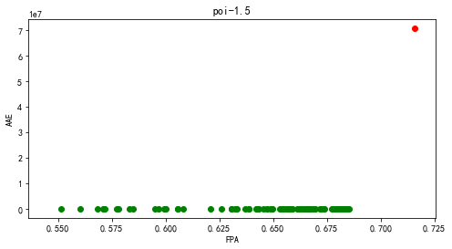

【poi-2.0】

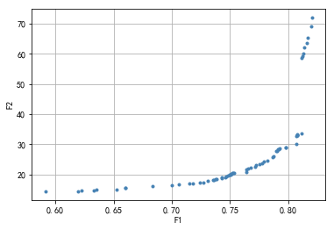

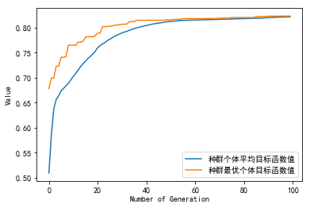

种群信息导出完毕。

多目标的fpa, aae值分别为:

[0.75126572 0.80695737 0.80736567 0.76792422 0.76433121 0.79201372

0.79046219 0.69973869 0.78172464 0.74293647 0.79797485 0.71803038

0.75044913 0.74579455 0.7274212 0.72374653 0.81936959 0.63547281

0.77159889 0.74799935 0.714764 0.73583211 0.80744733 0.62240732

0.78727748 0.75281725 0.81569492 0.79266699 0.8067124 0.66013392

0.78670586 0.73820023 0.59129512 0.76563776 0.70610812 0.77919321

0.81173444 0.65988894 0.61938592 0.73754695 0.77535522 0.7466928

0.65237629 0.74318145 0.75322554 0.77756002 0.77208885 0.80736567

0.81234689 0.73109587 0.80736567 0.8203495 0.75208231 0.76367794

0.73501552 0.79103381 0.81365344 0.8163482 0.79813817 0.75126572

0.74991834 0.81308182 0.78989058 0.81136698 0.63302303 0.74979585

0.68381512]

[20.18251256 32.75757204 32.94875926 22.35228026 21.70861162 28.49046255

27.78509672 16.39817083 24.6248551 18.69476099 28.83289777 17.02759209

20.08669769 19.07455479 17.43552176 17.3739084 69.11008337 14.90343908

22.43848013 19.71067793 17.00829163 18.30096784 33.32213382 14.7294443

25.97316658 20.59369859 63.69579297 28.56085821 30.02036394 15.67794185

25.80991416 18.48145175 14.46048778 21.90653499 16.81934232 24.30484669

58.68917467 15.59728904 14.55789397 18.427484 23.57438519 19.26936649

15.16177552 19.07300203 20.63238502 23.72559888 23.24955676 32.94875926

59.2453024 17.96081601 32.94875926 71.91533335 20.55183748 20.71197166

18.07675559 28.45607208 62.05206042 65.36841121 28.99554293 20.18251256

19.99739019 60.11346404 27.67167676 33.71216408 14.76270655 19.83055701

16.28254781]

多目标的fpa, aae平均值值分别为: 0.753509522451437 26.945443650589073

单目标的fpa, aae值分别为: 0.8230442593499918 43310542.62209206

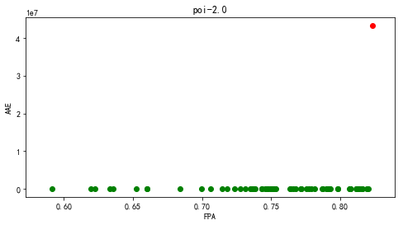

【poi-2.5】

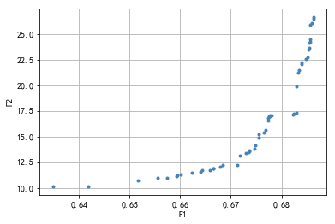

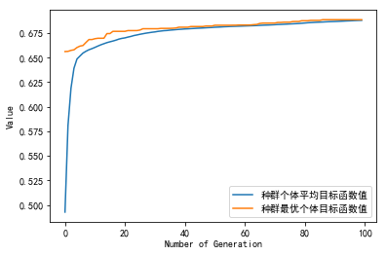

种群信息导出完毕。

多目标的fpa, aae值分别为:

[0.6777545 0.67127933 0.66577294 0.67550272 0.68253037 0.68523775

0.67777021 0.67484814 0.65162338 0.67556033 0.6863296 0.68608347

0.6679645 0.66661081 0.67366988 0.67654744 0.68530582 0.67808965

0.68394952 0.67185274 0.68556242 0.68322162 0.65936322 0.67356514

0.66005446 0.68544198 0.68629294 0.66844365 0.65919564 0.68301739

0.67463343 0.68295978 0.67683284 0.67732509 0.66433808 0.68567763

0.68562526 0.65550377 0.68235756 0.67353372 0.64176267 0.63478215

0.65739422 0.66394009 0.68346774 0.68567239 0.66224864 0.68392857

0.66661081 0.67735913 0.67304671 0.68479786 0.6774822 ]

[16.98531366 12.20416649 11.75639773 14.85289108 17.23704887 22.72913994

17.03228536 14.09347525 10.75073297 15.19511667 26.62387346 26.07238956

12.061879 11.84930236 13.60225023 15.42309575 23.43734176 17.0602678

22.19866477 13.11594276 24.17836029 21.26033288 11.18131543 13.51672292

11.26183239 23.6323174 26.51839945 12.19117065 11.11745837 19.85825077

13.76592996 17.29579356 15.6233976 16.57606706 11.75604124 25.90028142

24.24516152 10.95434975 17.1113746 13.45622919 10.17101517 10.13845975

10.96361122 11.52262564 21.50889702 24.49969803 11.43889246 22.06867323

11.84930236 16.82969505 13.37633185 22.59765362 16.94993807]

多目标的fpa, aae平均值值分别为: 0.6737683383263116 16.596172743298652

单目标的fpa, aae值分别为: 0.6885002094679514 18234621.438408222

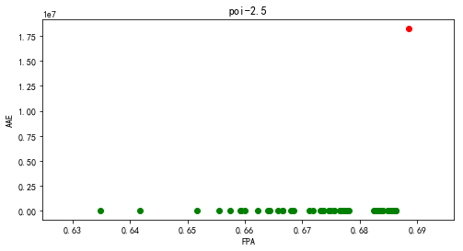

【poi-3.0】

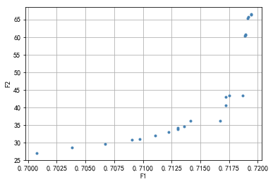

[[ -6.54442416 5.65195186 -16.68180222 ... -14.73019679 15.30345303

-10.23948382]

[-11.9747259 16.78511526 -7.34952055 ... 0.05766595 9.82486772

9.40715803]

[ -2.28644156 5.44841356 -5.89443826 ... 9.80844356 -14.58609352

6.03891522]

...

[ 7.86010995 -6.13403024 -12.89381719 ... -16.42262869 13.05064151

16.85567559]

[ -8.87848884 18.61753875 -0.76260799 ... 4.62367669 -0.02034334

-18.88020589]

[ -7.14026204 -2.72649441 2.47043115 ... -10.88005729 6.31658261

6.61302404]]

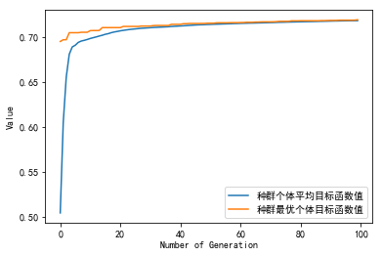

种群信息导出完毕。

多目标的fpa, aae值分别为:

[0.71908371 0.71360181 0.71893665 0.71942308 0.71750679 0.70672398

0.70384163 0.71865611 0.70973756 0.71304072 0.71723077 0.7090724

0.71915837 0.71223529 0.71104525 0.71411312 0.71721267 0.71669683

0.71300452 0.70073303 0.71884389 0.71895928 0.71941403]

[65.39882165 34.54663326 60.4774252 66.46797665 43.33193318 29.68952473

28.52304182 43.46796522 31.09124287 34.23690107 42.91469175 30.89137653

65.63377797 33.0432954 32.04578637 36.14215601 40.56882561 36.27918843

33.76510364 27.02661572 60.3887593 60.74965717 66.33717245]

多目标的fpa, aae平均值值分别为: 0.714272673617942 43.609472695028124

单目标的fpa, aae值分别为: 0.7187918552036199 160515963.42144915

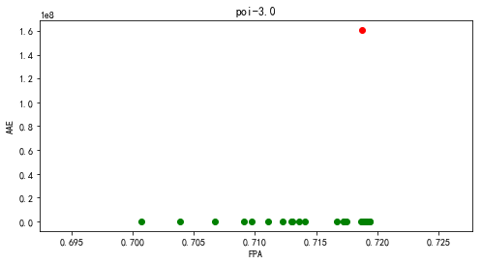

1. synapse

【synapse-1.0】

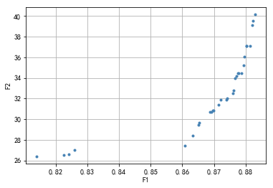

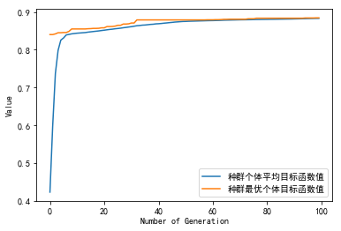

种群信息导出完毕。

多目标的fpa, aae值分别为:

[0.88019412 0.87382469 0.82256597 0.87716106 0.8692751 0.8695784

0.86320898 0.88231726 0.86078253 0.87625114 0.88201395 0.86502881

0.86533212 0.874128 0.8240825 0.87594783 0.8140734 0.87746436

0.87867759 0.88019412 0.87139824 0.88140734 0.87655444 0.8792842

0.82590234 0.86988171 0.86866849 0.8795875 0.87200485 0.87776767

0.88292387]

[37.06758921 31.87816664 26.55254098 34.18742466 30.7308371 30.83006148

28.37816081 39.52672436 27.41158108 32.76811352 39.1283958 29.46936248

29.62997592 32.05243855 26.57818154 32.47738031 26.39843874 34.43958142

34.47365592 37.06758921 31.40947003 37.10739261 33.94123477 35.19846684

27.02311428 30.87257359 30.70320808 36.02659643 31.87602917 34.47133987

40.13471836]

多目标的fpa, aae平均值值分别为: 0.8676607277388045 32.57452721808638

单目标的fpa, aae值分别为: 0.8844404003639672 49993431.49927069

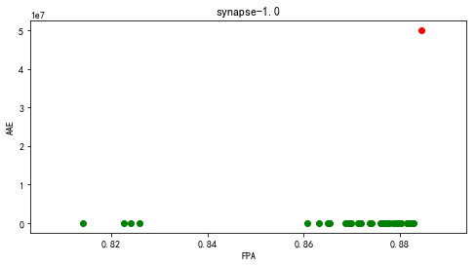

【synapse-1.1】

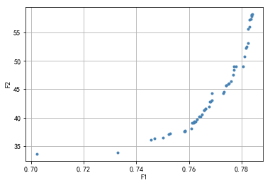

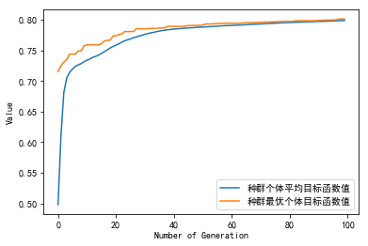

种群信息导出完毕。

多目标的fpa, aae值分别为:

[0.77513878 0.76876877 0.76813177 0.76180726 0.76185276 0.76203476

0.77413777 0.76881427 0.75839476 0.78382928 0.78105378 0.75857676

0.76080626 0.76380926 0.75830376 0.77413777 0.76198926 0.77714078

0.77331877 0.78405678 0.74556375 0.75225225 0.78305578 0.76617527

0.78050778 0.78250978 0.76631177 0.77295477 0.77709528 0.78255528

0.74692875 0.76763127 0.76198926 0.75270725 0.75011375 0.73300573

0.76262626 0.76294476 0.76107926 0.78373828 0.78173628 0.77586678

0.76494676 0.77482027 0.7021567 0.76572027 0.76562927 0.76799527

0.77682228 0.78187278 0.77777778 0.78360178 0.76449176 0.78296478

0.78387478]

[46.10872014 43.092175 42.81517533 39.11564201 39.18726824 39.2867884

45.7196822 44.26030006 37.55658581 58.08637916 50.72077235 37.68489002

38.10747192 40.17225403 37.55001901 45.7196822 39.23926633 48.98807678

44.50962874 58.19318174 36.09690395 37.1141427 57.24097032 41.61603504

49.06519702 53.15042783 41.62655617 44.34921288 48.38101261 55.66216442

36.41253143 41.93589534 39.23926633 37.2151937 36.48210115 33.93957568

39.29911381 39.71731126 39.10855858 57.87048723 52.259789 46.44122943

40.59152955 45.92944526 33.64640372 41.38699422 41.3407958 42.792742

47.49823807 52.5321317 49.00639118 57.29966148 40.18690354 55.9404424

58.13689122]

多目标的fpa, aae平均值值分别为: 0.7676023130568586 44.484112826873854

单目标的fpa, aae值分别为: 0.8013013013013013 224170516.49448746

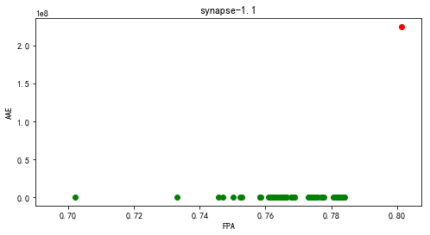

【synapse-1.2】

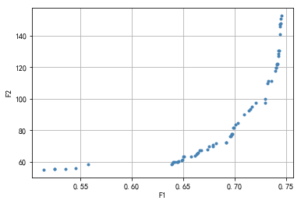

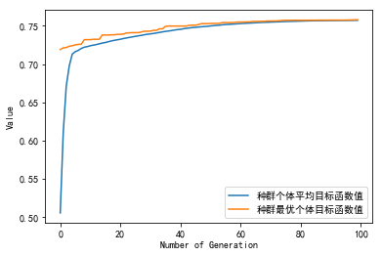

种群信息导出完毕。

多目标的fpa, aae值分别为:

[0.74552802 0.74105603 0.74501616 0.67928341 0.70107759 0.73283944

0.74396552 0.7139278 0.66602909 0.67327586 0.63968211 0.69706358

0.5450431 0.74434267 0.69665948 0.72960668 0.72974138 0.69889547

0.72037985 0.73178879 0.64913793 0.74339978 0.663618 0.66163793

0.74288793 0.74127155 0.66309267 0.64989224 0.64493534 0.74302263

0.69717134 0.74428879 0.71659483 0.70288254 0.73628772 0.74426185

0.7423222 0.52462284 0.74251078 0.74485453 0.64832974 0.6919181

0.67917565 0.71530172 0.64043642 0.69552802 0.64404634 0.52462284

0.63838901 0.69908405 0.64536638 0.74027478 0.53558728 0.68162716

0.70918642 0.73984375 0.66473599 0.74065194 0.65094289 0.69771013

0.65757004 0.66729526 0.67478448 0.55732759 0.69216056 0.51430496

0.64183728]

[152.75619572 121.55075723 150.88821534 70.85587994 83.49912835

111.26826596 141.1689694 92.64082149 67.13548616 67.82303718

58.89217265 77.30782889 55.68400833 147.57499774 76.38250061

97.67916864 99.8426119 81.41610952 97.43757772 109.99475517

61.44149277 130.67542985 65.27896325 63.61320595 128.44145876

121.97676304 64.8395131 63.12701565 60.09897374 130.52212942

77.4661101 147.43221819 94.89564001 84.72995663 111.30588096

145.93833604 122.22263768 55.39165206 127.28356242 147.88477561

60.99303987 72.10633574 69.80617274 93.27453683 59.67975669

76.23578869 59.97309838 55.39165206 58.52113963 81.62422849

60.20958346 119.86358867 55.41237646 71.99034107 90.17853106

117.80121768 65.79766198 119.9530106 63.19046429 77.62320984

63.23475301 67.35428088 69.7864641 58.33138133 72.26612692

54.96987307 59.9076382 ]

多目标的fpa, aae平均值值分别为: 0.6845064816006177 88.68418589369367

单目标的fpa, aae值分别为: 0.7578394396551724 211515269.64793587

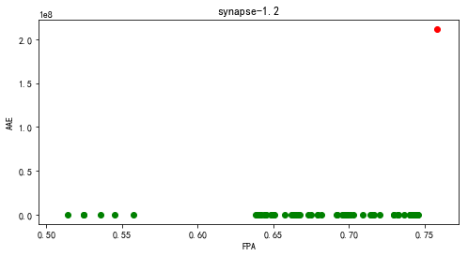

1. velocity

【velocity-1.4】

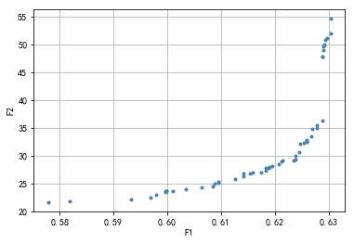

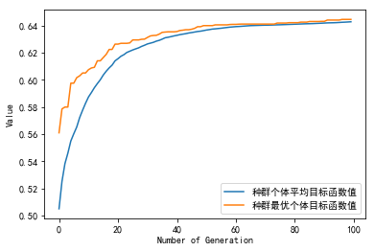

种群信息导出完毕。

多目标的fpa, aae值分别为:

[0.61887755 0.62587464 0.62069971 0.60958455 0.62886297 0.62704082

0.61411565 0.62385811 0.62534014 0.62351798 0.62135569 0.61827017

0.59319728 0.62971331 0.59689018 0.62458698 0.62786686 0.60102041

0.62922741 0.61409135 0.62934888 0.61588921 0.62898445 0.57783042

0.60843052 0.63041788 0.6154033 0.59958698 0.59979349 0.62905734

0.59969631 0.59986638 0.59795918 0.60874636 0.62589893 0.60945092

0.62880224 0.6063654 0.62883868 0.61253644 0.61905977 0.58180272

0.61741983 0.61839164 0.6212585 0.62599611 0.62682216 0.60344995

0.62382167 0.61953353 0.62775753 0.63039359 0.62463557]

[27.84546805 32.44979154 28.51829444 25.26853489 47.90259575 34.77943021

26.74023185 30.04800279 32.31382937 29.22353045 29.20921785 27.24289107

22.09829012 51.22254498 22.51956646 30.58478657 35.44022007 23.68432219

50.03359241 26.38959066 50.76802337 26.91732761 48.97080219 21.66554489

24.49545066 54.62399349 26.74463931 23.48470651 23.59689411 49.74489224

23.57093928 23.62073617 23.01233187 25.05765175 32.73611392 25.10309114

36.35528739 24.37822439 47.76144091 25.86462531 27.94939644 21.76138932

27.00957402 27.78446721 29.00200837 32.75604788 33.45563029 24.03021168

29.33492975 28.0770177 35.02584828 51.9703784 32.1377356 ]

多目标的fpa, aae平均值值分别为: 0.616362973760933 31.552492135286347

单目标的fpa, aae值分别为: 0.6445821185617104 45172709.263429426

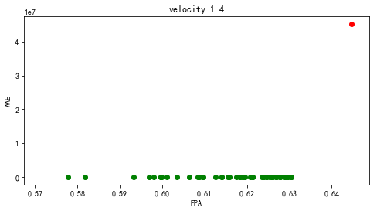

【velocity-1.5】

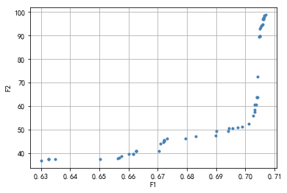

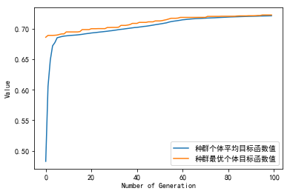

种群信息导出完毕。

多目标的fpa, aae值分别为:

[0.70305221 0.70583336 0.63012113 0.67183838 0.70372985 0.69890166

0.66254906 0.70116046 0.63252111 0.70543807 0.70471807 0.65667617

0.67320072 0.67213485 0.70502866 0.706511 0.70396984 0.63489285

0.67219132 0.69445464 0.70502866 0.65750911 0.67046898 0.70413926

0.69417229 0.66154671 0.7059463 0.65620324 0.7032075 0.67213485

0.66156083 0.70614394 0.70502866 0.70327809 0.70615806 0.68303357

0.70408279 0.70684982 0.6901488 0.70629923 0.69734167 0.70396984

0.70526866 0.67939125 0.70504278 0.65019623 0.63247875 0.66254906

0.70556512 0.63252111 0.66012085 0.70632747 0.68986645 0.69564051

0.6709631 0.66254906 0.70252986 0.70614394 0.67213485]

[57.60079085 94.80760179 36.78967022 44.48357449 60.56407429 51.34234946

40.92317122 52.33853767 37.32964667 94.2980658 89.49044378 38.07864204

46.02942062 45.28582839 89.65051968 98.42019479 63.85923989 37.37989667

45.67143446 50.54439147 89.65051968 38.58343954 40.9504773 72.66693218

49.28819831 39.51620404 96.91708302 37.5540477 58.25566957 45.28582839

39.63228798 96.93603666 89.65051968 60.51486963 97.27770243 47.11905288

63.87078106 98.78257292 49.28079494 97.6815118 50.74537623 63.85923989

93.65804099 46.21180377 92.88527361 37.43416617 37.32898065 40.92317122

94.60443557 37.32964667 39.48008376 97.94455971 47.44518505 50.57693206

43.86219675 40.92317122 55.9344147 96.93603666 45.28582839]

多目标的fpa, aae平均值值分别为: 0.6844485531462197 60.97746723808254

单目标的fpa, aae值分别为: 0.7224496710619194 112934169.32471785

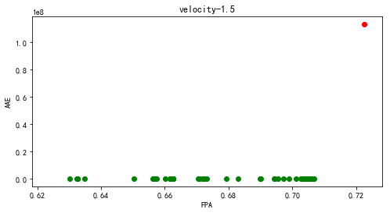

【velocity-1.6】

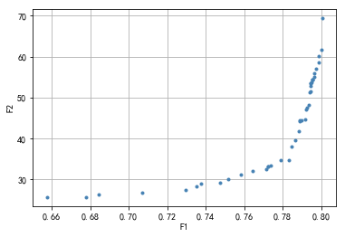

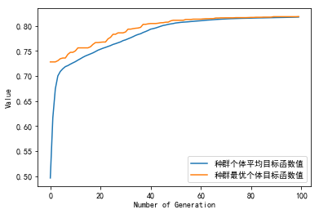

种群信息导出完毕。

多目标的fpa, aae值分别为:

[0.79554125 0.72948747 0.79492071 0.80029878 0.79648357 0.68455527

0.79891979 0.75172374 0.77129396 0.65738911 0.78340611 0.77373018

0.79473684 0.75842335 0.80062055 0.67784417 0.77887842 0.78896805

0.772604 0.79344978 0.7646518 0.78478511 0.73511836 0.79473684

0.7974029 0.78830154 0.79446104 0.79168007 0.79236957 0.73740519

0.78673868 0.7475293 0.70680303 0.79556424 0.77223627 0.78878419

0.79416226 0.78974948 0.79864399 0.79659848 0.79249598 0.7956102

0.79456447]

[54.37532763 27.36897262 53.70939676 61.61513416 54.98844154 26.41283419

60.0112135 29.98177284 32.57117786 25.68631915 34.74304454 33.40547516

53.51616981 31.23577211 69.34052906 25.77512106 34.62593113 44.40937727

33.27763253 48.1286983 32.18180223 38.05379185 28.4171329 53.51616981

57.01934694 41.74236757 51.53043292 44.76095279 47.02497633 28.9544252

39.50346559 29.25057045 26.73842215 54.45910639 33.21538882 44.27578082

51.20961416 44.43542465 58.6720243 55.86665839 47.61194635 54.4746774

52.93577416]

多目标的fpa, aae平均值值分别为: 0.7731085609830405 43.047176589794645

单目标的fpa, aae值分别为: 0.8186393932429327 425804198.32238764

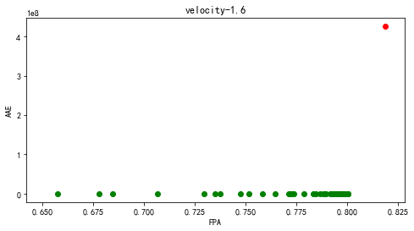

1. xalan

【xalan-2.4】

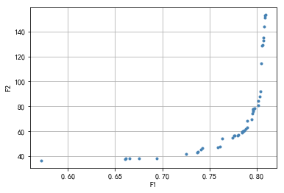

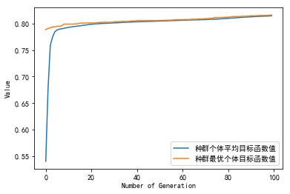

种群信息导出完毕。

多目标的fpa, aae值分别为:

[0.66522148 0.78977373 0.80203568 0.79658297 0.77635032 0.79650317

0.78002092 0.80663723 0.78449835 0.73783559 0.74092102 0.78470227

0.66155974 0.79487179 0.78079228 0.74238394 0.79541263 0.78820442

0.80499699 0.66070859 0.80753272 0.80348087 0.8040217 0.72518353

0.80148597 0.79593574 0.80849026 0.78508352 0.57186048 0.79801929

0.78597014 0.80859666 0.76340568 0.73725928 0.7966007 0.78659964

0.67576338 0.80929709 0.80716034 0.79036777 0.76099408 0.80558215

0.75861794 0.80814448 0.69375288 0.77643012 0.77427563]

[ 38.16276874 63.00768849 84.26931339 77.91383917 56.32217461

77.24147494 56.45346684 128.97708421 58.64152985 43.63458189

45.38264026 59.47303044 38.07028939 69.36992763 56.88568868

46.6657085 74.33754942 61.55042833 114.28948361 37.73591097

134.94920386 88.05882162 91.72267978 41.52120458 80.46524121

76.09333141 151.34481158 60.09555269 36.48120172 78.35715012

60.30595987 152.99012899 54.31353905 43.1702316 77.94297052

60.6448126 38.18718311 153.27665934 132.77229398 68.14610034

47.64603053 128.41633693 46.83893888 143.9572056 38.37018986

56.38991616 54.70527536]

多目标的fpa, aae平均值值分别为: 0.7687218121137075 74.1605861831495

单目标的fpa, aae值分别为: 0.8163102457708267 284598165.8319287

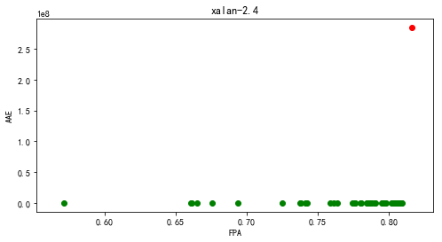

【xalan-2.5】

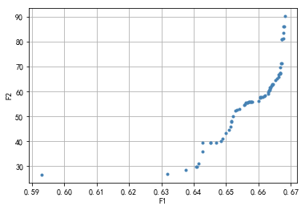

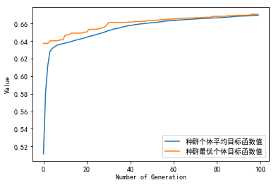

种群信息导出完毕。

多目标的fpa, aae值分别为:

[0.66298696 0.66680738 0.66625625 0.66449262 0.65702064 0.63173645

0.65168753 0.6570652 0.66769389 0.65662194 0.6554669 0.66007416

0.66052445 0.65222694 0.65342771 0.64524511 0.66662328 0.65407265

0.6374448 0.66317458 0.66760711 0.66727409 0.64988403 0.66582472

0.66317224 0.6604752 0.65140141 0.64524511 0.6666995 0.6579775

0.6407903 0.64884039 0.65669934 0.64837603 0.657682 0.65789542

0.66344898 0.66139454 0.66428623 0.6516758 0.66085513 0.66339269

0.59290138 0.64272397 0.66346305 0.65297273 0.65585153 0.65767965

0.66727174 0.66708647 0.66175101 0.66206293 0.64691494 0.66801284

0.64094392 0.64145049 0.64274273 0.66369757 0.66424402 0.66513287

0.66777363 0.66307374 0.65596996 0.66399308 0.66618354 0.66676751

0.66714979 0.66817818 0.65091359]

[59.23983869 69.70875816 66.84666369 63.10734738 55.72117893 26.78348196

48.0303554 55.75930915 83.55975723 55.41730351 54.72145163 56.27847153

57.69277869 50.16244976 52.63470757 39.39310295 67.26034626 52.83843629

28.43636683 60.47459562 81.17009494 81.08167397 43.45635399 65.27148577

60.4550178 57.32641272 45.79112485 39.39310295 67.4008033 55.87922504

29.83336043 41.20539232 55.59225564 40.2434576 55.7784185 55.8026864

61.00867511 57.82024388 62.86572213 47.98040714 57.69992008 60.53666154

26.62787595 35.81705477 61.50687389 52.23441423 54.86738694 55.77813024

80.82212702 71.22690925 58.2261151 58.29747334 39.42079647 86.235311

29.86302163 31.09164898 39.34362446 61.65643566 62.58867171 64.51438311

86.16641413 59.62015823 55.40527973 62.41487477 65.9755906 67.4850581

71.32104006 90.20878223 44.54920001]

多目标的fpa, aae平均值值分别为: 0.6569341164035343 56.53512824594346

单目标的fpa, aae值分别为: 0.6705081931457599 224525593.87330648

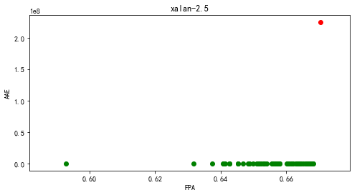

【xalan-2.6】

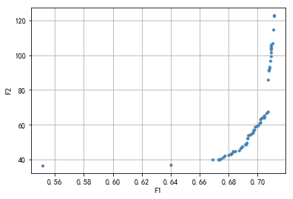

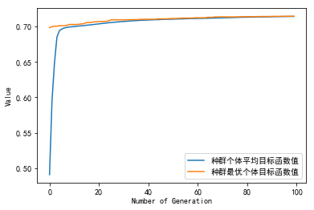

种群信息导出完毕。

多目标的fpa, aae值分别为:

[0.69518373 0.71045966 0.70899797 0.70862644 0.71076158 0.69131028

0.69665898 0.68951322 0.67314983 0.67984452 0.70455503 0.70944542

0.69366508 0.70794847 0.67320588 0.70789062 0.70723525 0.69532203

0.70115977 0.70585311 0.67621785 0.69177401 0.70474215 0.66903955

0.67488452 0.69755571 0.70768994 0.68300113 0.55168723 0.69730621

0.69296904 0.7071539 0.6895304 0.70286825 0.69315977 0.69689944

0.70454508 0.68160723 0.67374644 0.70917695 0.67724836 0.68120407

0.70234124 0.70043119 0.69939797 0.68192633 0.70467435 0.6872

0.71109605 0.7090974 0.69813424 0.69177401 0.68838508 0.68307525

0.69252429 0.70173288 0.63983367 0.70947345 0.7020809 0.7111304

0.70930802 0.70929356 0.68447367 0.70841311]

[ 54.44232558 107.01693308 99.43232092 96.6973856 114.61116954

48.56401631 55.20966059 47.34617381 39.99351703 42.50911962

64.41306417 105.03301615 53.86368693 92.45130082 40.01462594

91.68573269 85.8863561 54.47278198 61.14387393 66.54868512

41.12798656 48.89666142 65.29364288 39.80958956 40.37190272

57.13201725 91.29296554 44.54159881 36.48738959 57.12864889

52.26039821 67.39848378 47.40290771 63.90062569 52.39248506

55.56808627 64.11972374 43.16212937 40.12687666 103.50025391

41.9492774 43.06972681 63.62874605 59.79526657 59.01692145

43.51284241 65.03406303 45.32559821 122.62955869 101.59905553

58.61151568 48.89666142 46.51513377 44.64652574 49.44814658

61.24965822 36.79383068 105.96828463 63.25811685 122.99392035

104.33631099 103.96058114 44.90484284 93.52934582]

多目标的fpa, aae平均值值分别为: 0.6931342372881356 65.06131328761172

单目标的fpa, aae值分别为: 0.7144912994350282 1041604379.2056922

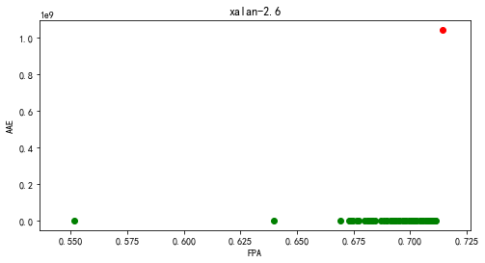

【xalan-2.7】

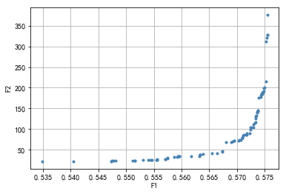

[[ 4.10150115 15.67295355 -19.23095738 ... 13.398974 -1.66370928

-2.70299385]

[ 4.58322844 16.78124141 4.65005497 ... 10.24710331 8.43726896

-16.74743829]

[ 9.18116887 17.77839162 17.2124519 ... 10.26482432 -10.07535806

-11.86413568]

...

[ 19.37612491 11.8985782 -19.13333258 ... 16.36746841 -3.71064598

-0.55751483]

[ -6.11962642 -5.23996485 11.5969565 ... 7.17102146 -12.0524001

-9.27409095]

[ -9.79677064 9.21870555 -1.01068007 ... -5.75345571 -15.84661342

1.31596377]]

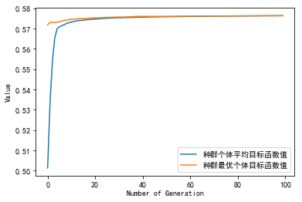

种群信息导出完毕。

多目标的fpa, aae值分别为:

[0.54052404 0.5556272 0.5481314 0.57430368 0.54750698 0.56929287

0.5515723 0.57338269 0.55935561 0.57438984 0.57454356 0.57183682

0.57036305 0.57344572 0.57243993 0.57528317 0.56333976 0.54771421

0.56646052 0.57326161 0.55867178 0.56799868 0.57495758 0.56333432

0.55744288 0.55704111 0.55562539 0.57455399 0.57550128 0.56733707

0.5745413 0.57436626 0.57241 0.53482125 0.57094032 0.57438984

0.54735779 0.57294691 0.55547166 0.57372868 0.55941682 0.57113576

0.55465044 0.5717561 0.57124641 0.5730113 0.55160994 0.57166224

0.57549811 0.57548995 0.5617939 0.57484512 0.57364071 0.5753394

0.56741643 0.57481428 0.55964129 0.5704669 0.57471905 0.57397628

0.5574846 0.57260545 0.57463244 0.5752088 0.55440466 0.56333432

0.56951825 0.55709009 0.57373594 0.55964038 0.57367336 0.57094032

0.57224675 0.56324363 0.57339403 0.5706637 0.56896502 0.55303111

0.5592631 0.57331512 0.56382769 0.55119003 0.56544884 0.55402737

0.57094032 0.56944569 0.57384205]

[ 22.41805152 26.48334552 24.15003238 178.1248996 23.22722362

70.16195552 24.47709655 126.40150039 33.67699283 184.27445284

186.54445813 89.60794768 72.25206772 132.08036584 104.00972629

311.40503679 38.49281838 23.89817831 41.56508641 115.64364342

31.78851393 67.91511424 200.46849404 38.1655333 29.37998895

26.91227911 26.38134924 186.66834733 375.81119953 45.56796024

185.62480159 181.79510097 98.12900046 22.09282366 79.16009533

184.27445284 22.74584125 104.43329447 25.85383718 143.50593095

33.97896419 83.70878441 25.85305676 86.89005395 85.74634

111.17651296 24.50924707 85.92605881 328.13613457 327.51547118

34.09138745 198.64513855 140.2453214 321.49705419 47.17183457

192.07162906 34.06780556 73.86900556 189.76898618 176.07046826

30.93023566 104.31283036 188.83065615 215.15826678 25.54208223

38.1655333 71.76507079 27.09283359 143.75444389 33.99835515

141.75002795 79.16009533 90.67229244 34.40161385 130.2259387

74.41489087 68.03207861 24.77169995 33.29239092 116.49660984

40.22683681 24.18079372 40.87783278 25.16170857 79.16009533

71.38491319 145.07205395]

多目标的fpa, aae平均值值分别为: 0.5661316844745091 98.9119571694463

单目标的fpa, aae值分别为: 0.576415473369266 628577120.3537035

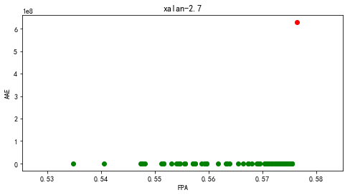

1. xerces

【xerces-init】

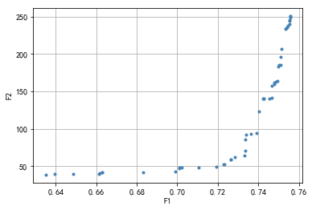

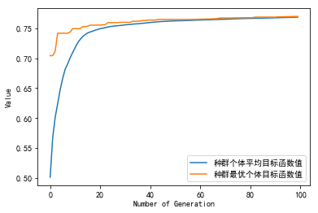

种群信息导出完毕。

多目标的fpa, aae值分别为:

[0.75559991 0.73312634 0.63487839 0.74998152 0.7557108 0.74543506

0.70111629 0.75094256 0.63935093 0.74850299 0.66289643 0.75578473

0.72828417 0.72647298 0.71919125 0.68293044 0.73637909 0.74802247

0.74672876 0.75578473 0.72662083 0.70215125 0.7231463 0.66149183

0.74661788 0.71043099 0.75338212 0.73371775 0.75012937 0.73382864

0.74286612 0.74037111 0.75556295 0.74266282 0.74927922 0.66130702

0.74787462 0.7516079 0.75404746 0.73368079 0.73904044 0.75101649

0.75452798 0.69904635 0.75523028 0.74225623 0.70115325 0.66300732

0.72281363 0.75397353 0.64842537]

[245.14248721 63.86160492 38.45466303 183.78750344 249.04762436

140.74415223 46.95701841 185.89114131 38.93573154 163.16209645

41.32901547 250.71361504 61.89796314 58.7768468 49.01575938

41.44524461 92.84974206 162.1726006 158.08058639 250.71361504

58.89098094 47.91959988 52.78645701 41.04909806 141.08537335

48.2920022 233.45203964 86.09681113 185.56673655 91.97658193

140.65961946 123.34824701 244.46791466 140.61940877 164.27933146

39.40862998 159.85699323 206.90300443 236.31253256 70.77324875

94.25198919 196.63838292 237.66856906 43.13715209 240.49749544

140.28190612 47.90569999 41.43182759 52.61743345 234.41385789

39.10683473]

多目标的fpa, aae平均值值分别为: 0.7260468170412986 125.58185825445658

单目标的fpa, aae值分别为: 0.7697567827308346 137508320.14413065

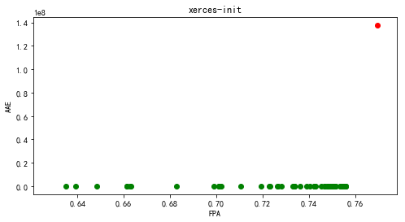

【xerces-1.2】

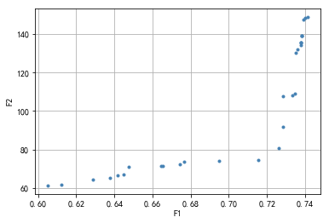

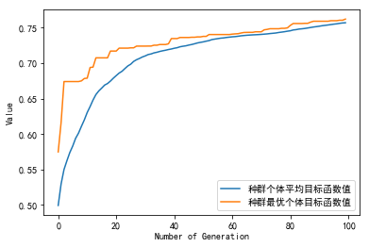

种群信息导出完毕。

多目标的fpa, aae值分别为:

[0.74124506 0.72629447 0.73774704 0.64466403 0.72847826 0.73839921

0.73774704 0.71528656 0.73770751 0.74025692 0.62865613 0.73934783

0.73525692 0.73620553 0.73784585 0.73466403 0.64772727 0.64177866

0.6376087 0.66458498 0.66538538 0.73839921 0.67642292 0.73324111

0.67436759 0.7286166 0.61213439 0.69501976 0.60519763 0.73839921]

[148.72671403 80.74572219 135.43092317 67.14714995 91.91700878

138.89765269 135.43092317 74.64461263 134.04235082 148.30505306

64.28213494 147.52623598 130.24295238 132.16753558 135.55903093

108.83563096 71.18249399 66.73508083 65.31084963 71.56131188

71.627806 138.89765269 73.71656983 108.22348 72.22195711

107.76654738 61.55594014 73.89739095 61.30542325 138.89765269]

多目标的fpa, aae平均值值分别为: 0.7006228590250329 101.89339292120184

单目标的fpa, aae值分别为: 0.7621739130434783 49261959.665993445

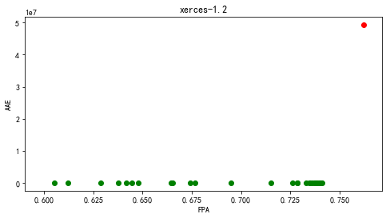

【xerces-1.3】

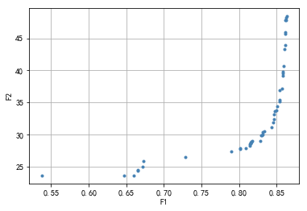

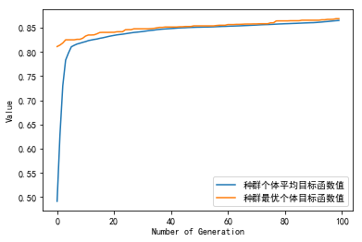

种群信息导出完毕。

多目标的fpa, aae值分别为:

[0.8161594 0.64677052 0.86157911 0.85427032 0.85987487 0.8597319

0.81477542 0.85755299 0.86232257 0.67216827 0.66473367 0.81396333

0.82829496 0.78992096 0.83324755 0.8511821 0.85837079 0.81536447

0.84573768 0.84666415 0.81617084 0.53720162 0.8014446 0.67239703

0.86165917 0.86208238 0.85781606 0.84920335 0.82967894 0.85439614

0.83077697 0.84620664 0.86181359 0.81380892 0.72816228 0.66539135

0.84784225 0.84272953 0.85357261 0.81737753 0.85799334 0.83090279

0.86179643 0.80102712 0.86340917 0.80842741 0.81474682 0.65962095

0.83136602]

[28.83890102 23.64506243 43.91940079 35.37243847 43.27349002 40.70519469

28.69915629 37.16806507 48.15226436 25.05626245 24.41504027 28.55688963

29.06975944 27.42651803 30.50471741 34.41285226 39.834756 28.7799608

31.94597873 33.15587833 28.86174756 23.64302091 27.86675378 25.8982698

45.6340715 47.85078543 39.13605701 33.83320877 29.89064169 36.90002969

29.93430447 32.42564204 47.80407517 28.30264442 26.4686521 24.54631762

33.62225784 31.10567888 35.21046784 29.03111978 39.59878714 30.0707715

45.98565786 27.71539361 48.42221473 27.89480598 28.59020546 23.68234751

30.40902905]

多目标的fpa, aae平均值值分别为: 0.8088103443003665 33.127909094701394

单目标的fpa, aae值分别为: 0.8686591405597685 104290241.22397046

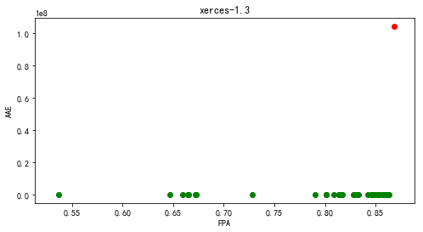

【xerces-1.4】

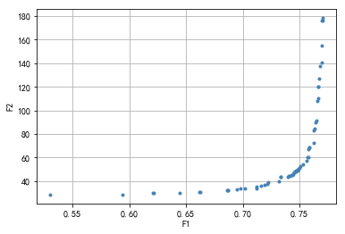

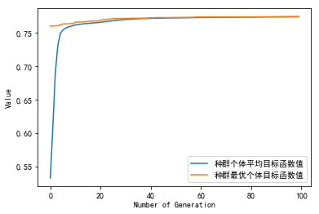

种群信息导出完毕。

多目标的fpa, aae值分别为:

[0.76263203 0.76712615 0.62189487 0.76319412 0.74362991 0.74810751

0.74566358 0.7493388 0.73366345 0.7664154 0.73933026 0.76991053

0.6861808 0.7125243 0.76630884 0.75746445 0.76586343 0.69443912

0.59403238 0.53045241 0.64437507 0.75272418 0.76804575 0.74167881

0.7018034 0.74497681 0.7699734 0.75831319 0.7427103 0.74831797

0.74038412 0.76616925 0.7465752 0.72223075 0.62050321 0.75673186

0.74811018 0.76439504 0.76272313 0.74718578 0.76510899 0.73360698

0.73175125 0.66158967 0.75000959 0.76966971 0.7700709 0.68708335

0.69780105 0.71933341 0.72123069 0.71239216 0.75885291 0.74490009

0.66264567 0.75632214 0.75798446 0.75059353 0.74411369 0.77016894

0.71613611 0.68687663]

[ 72.24723114 127.33208512 29.92150749 84.63761399 45.2037363

49.15769621 48.08410528 50.16969633 43.41491817 120.16362043

43.78647499 155.0814849 32.03339365 35.41869236 120.04583144

60.4699224 107.81800955 33.11910837 28.78110393 28.60741081

29.96454355 54.54314082 137.5818134 44.70468257 33.93663094

47.3324293 175.97530813 68.51767376 45.01755073 49.74430714

44.28355936 110.211383 48.40153417 39.23240753 29.7719361

60.11105375 49.59084409 89.7648727 82.82115293 48.97650442

91.59697312 43.40314005 40.02117898 30.45203351 50.89019155

140.82879165 176.18467167 32.34809122 33.83189112 37.08703855

37.43303752 33.96392267 68.79050384 47.14281691 30.58011289

57.33005073 67.21447426 52.91175502 46.0027908 178.26422675

36.47747217 32.3315605 ]

多目标的fpa, aae平均值值分别为: 0.7295861564570852 64.04941446336105

单目标的fpa, aae值分别为: 0.7745255997135696 225467266.50502107

