RF还是垃圾，调了参数还是过拟合

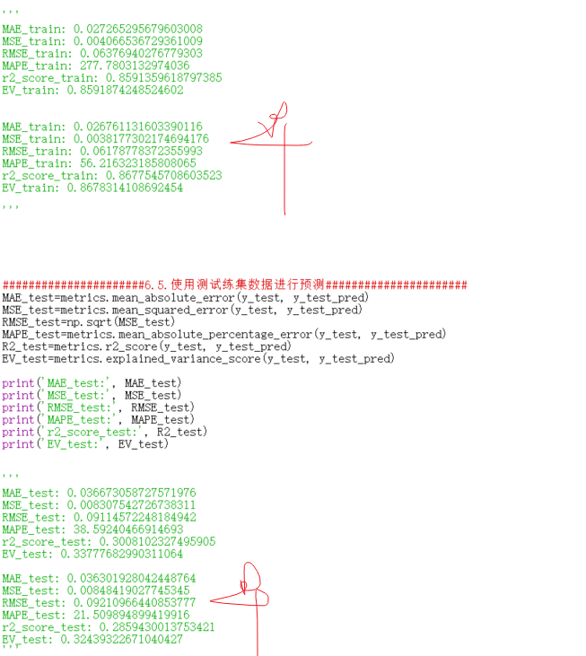

早停法？

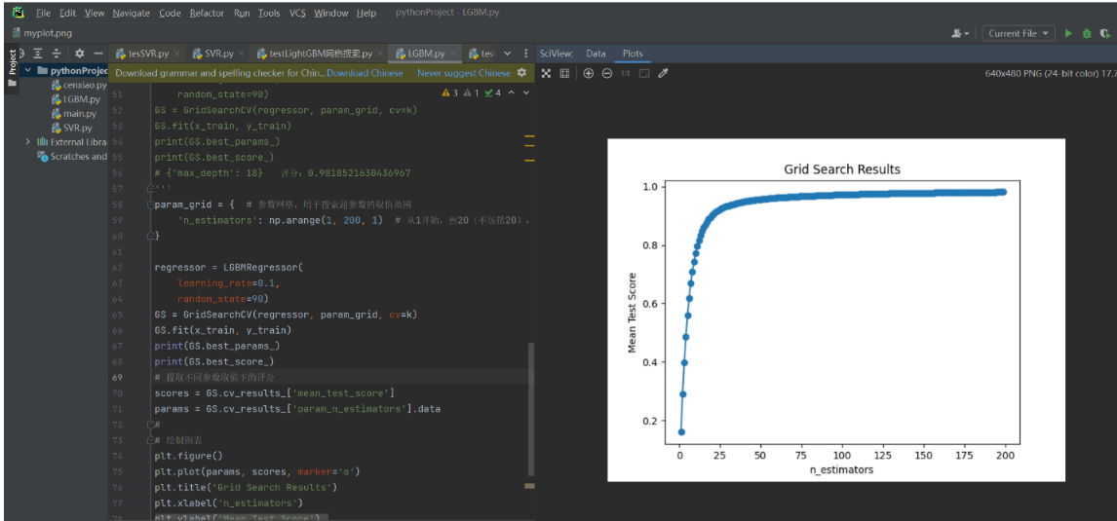

26

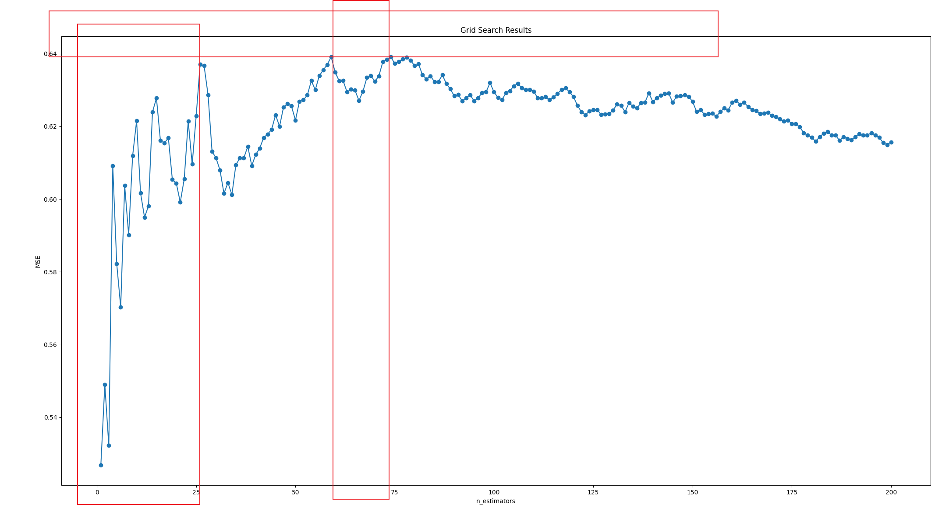

3

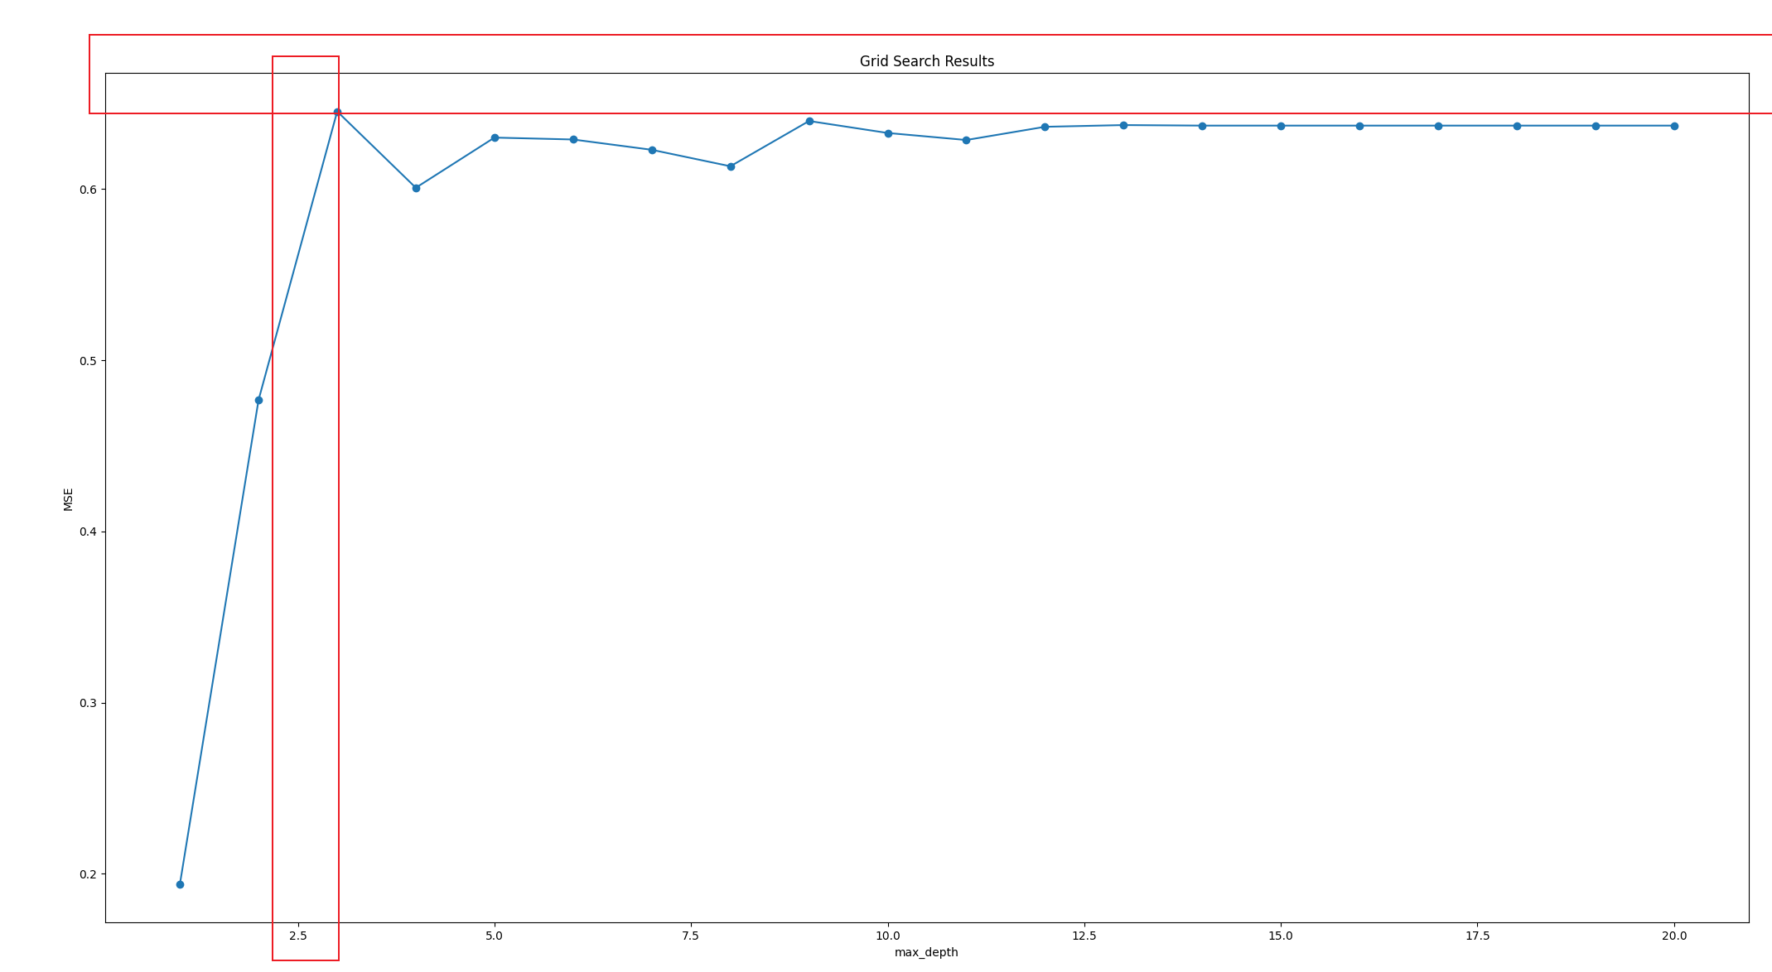

8

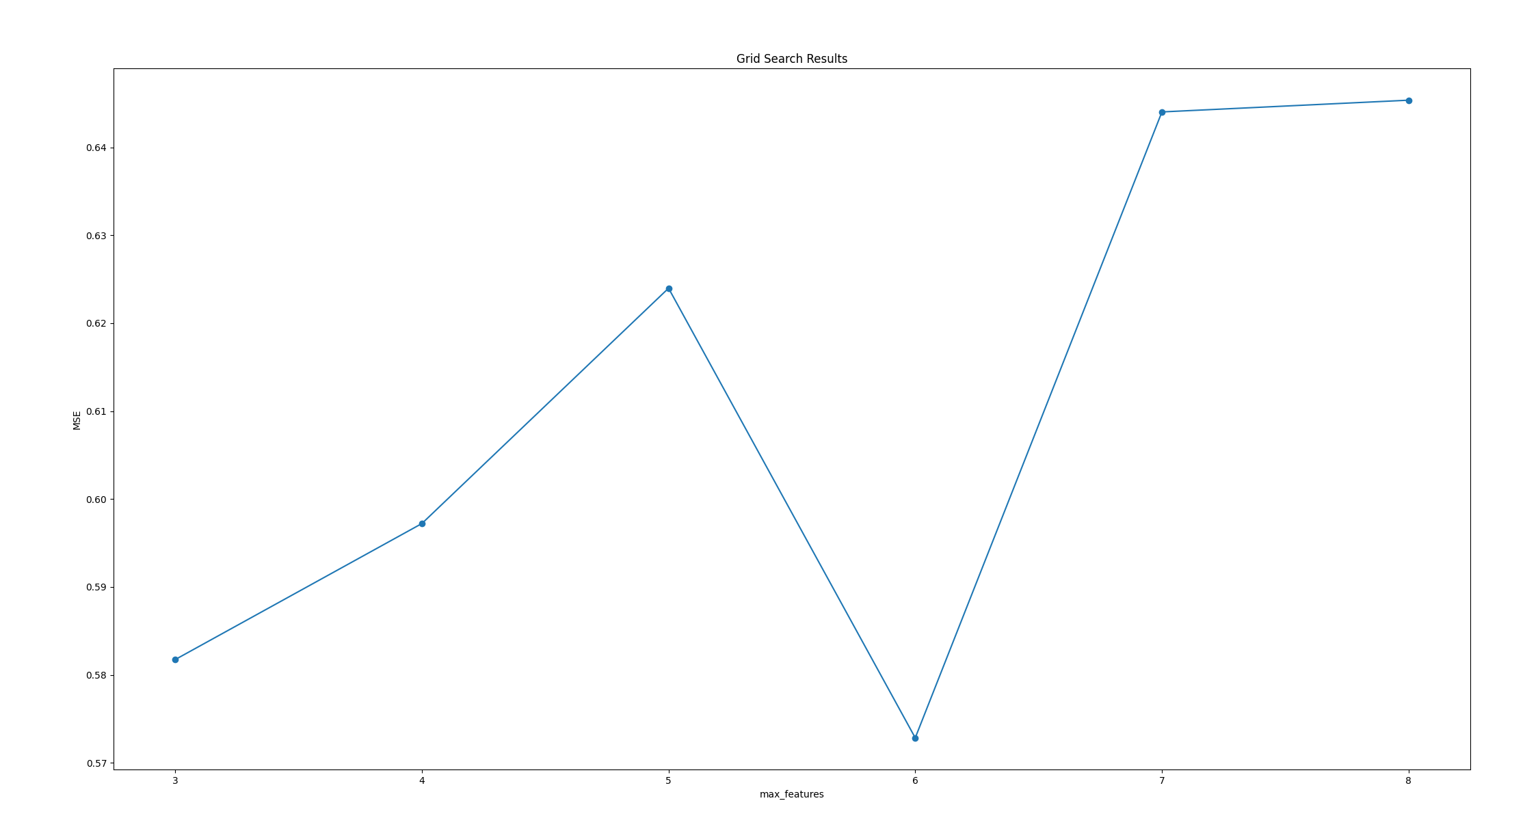

等等 数值是越大越好吗？--y轴GS.cv_results_['mean_test_score']--平均测试分数--是的

1

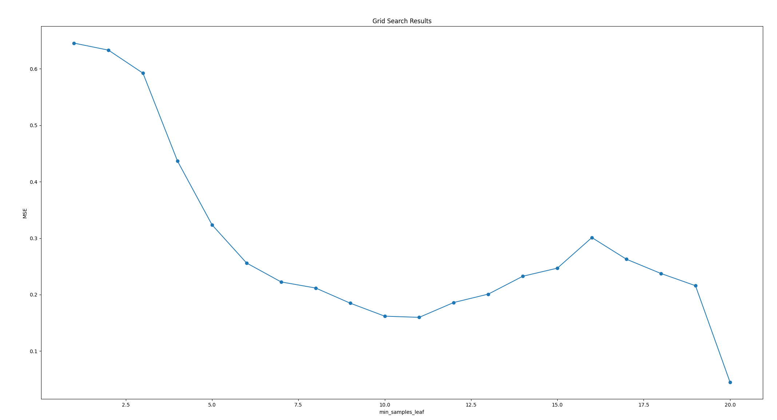

2

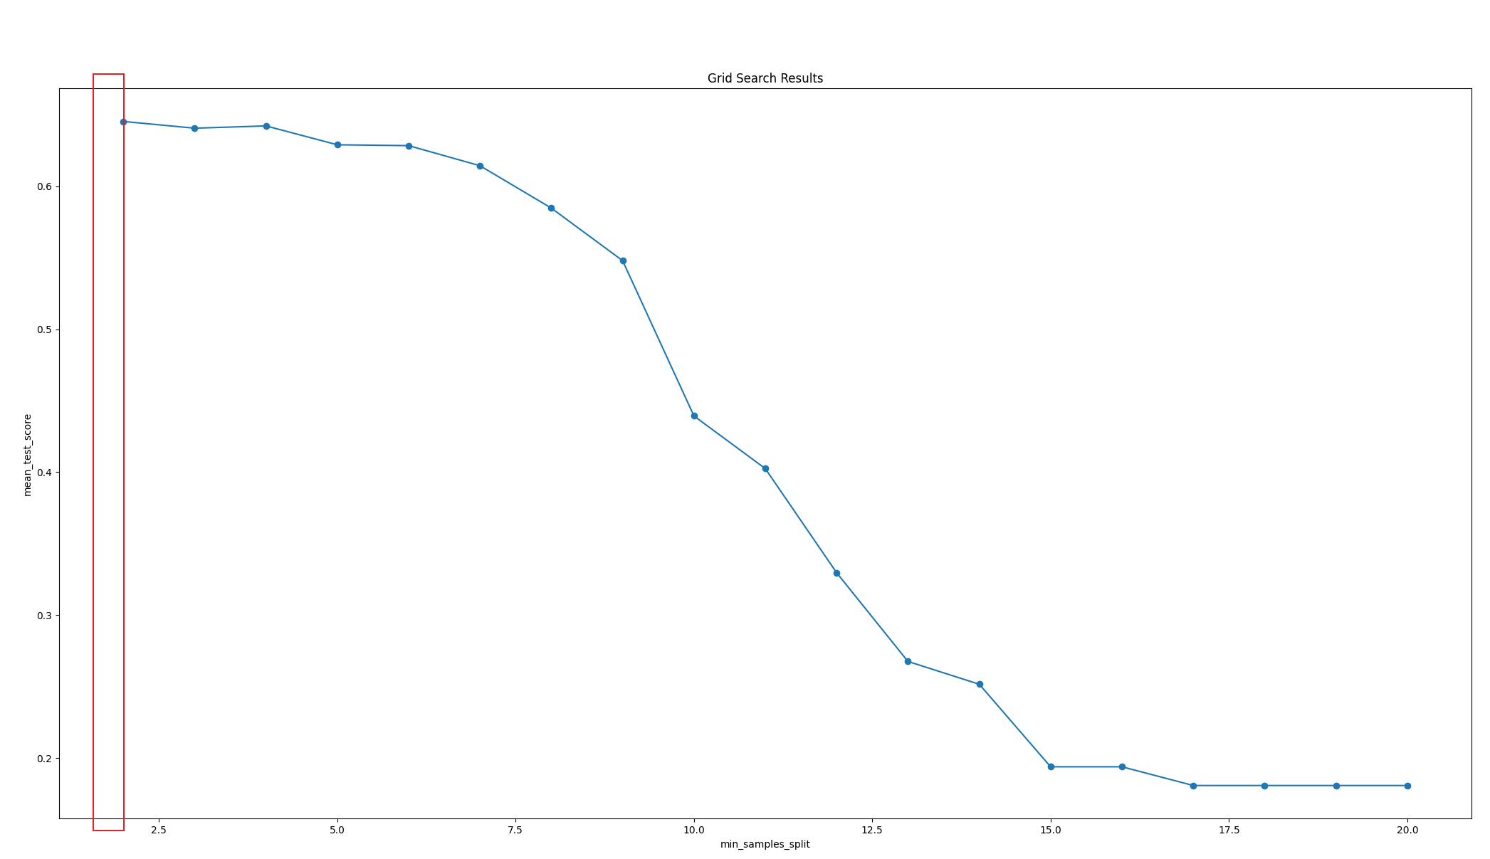

RF性能很差---过拟合---怎么办

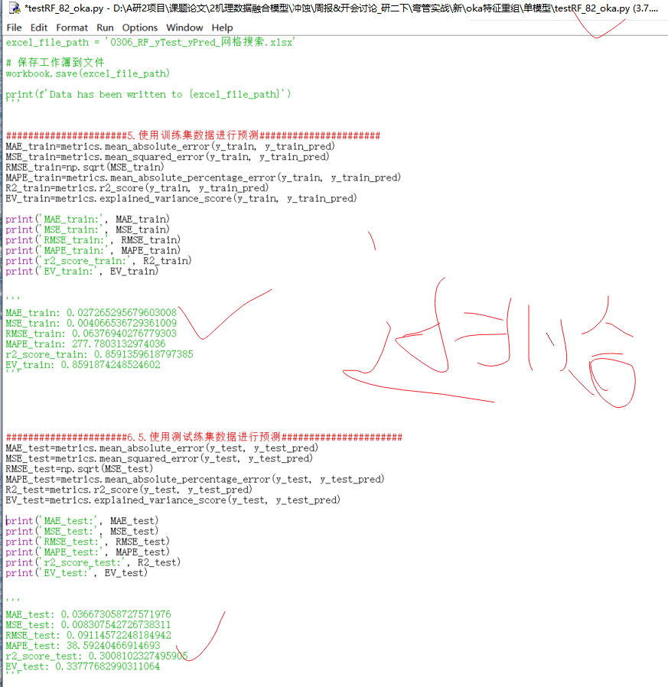

param_grid = {

'n_estimators': np.arange(1,201,1),

}

#{'n_estimators': 74}----0.6391445740407009

param_grid = {

'max_depth': np.arange(1,21,1),

}

{'max_depth': 3}------0.641422802337859

param_grid = {

'max_features': np.arange(3,21,1),

}

#{'max_features': 7}----0.6540027383923165

param_grid = {

'min_samples_leaf': np.arange(1,21,1),

}

#{'min_samples_leaf': 1}-----0.6540027383923165

param_grid = {

'min_samples_split': np.arange(2,21,1),

}

#{'min_samples_split': 4}----0.6626201155894132