1．

#include <stdio.h>

int main()

{

int a,b;

scanf ("%d%d",&a,&b);

printf("%d\n",(a>b)?b:a);

return 0;

}

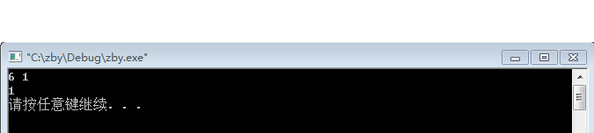

2.

#include<stdio.h>

int main() {

int a,b,c,m,m1,m2;

printf("输入三个整数:\n");

scanf("%d %d %d",&a,&b,&c);

m1 = (a>b)? b : c ;

m2 = (c>a)? a : c ;

m = (m1>m2)? m2 : m1 ;

printf("%d", m);

return 0;

}

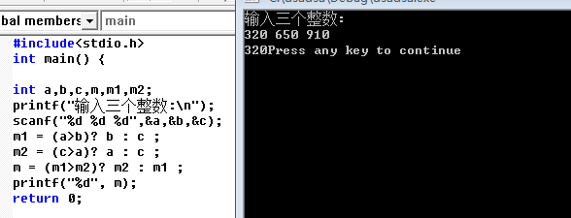

3

{

float score;

char grade;

scanf("%f",&score);

if(score>100||score<0) printf("\ninput error");

else

{

if(score>=90) grade='A';

else if(score>=80) grade='B';

else if(score>=70) grade='C';

else if(score>=60) grade='D';

else grade='E';

}

printf("学生成绩是：%c\n",grade);

}

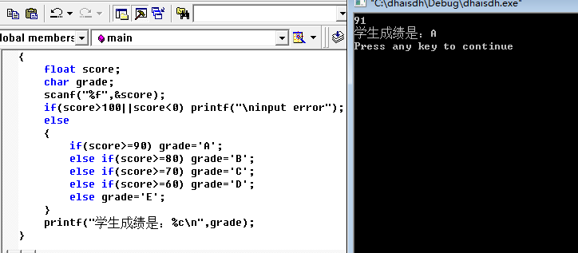

4.

5.

6.