Taylors maturity sampling data visualisation

# *Add in table of contents when I work out how*

* Set up Git
* import data and make tidy
* display data

# Setting up working environments.

## Working directory and folders

In my DATASCHOOL working directory, I created a new folders to organise my work.

I have a folder for my raw data, scripts and figures.

Using the drop down in R studio I have also created files, in which I will do my work.

These files are:

* Create a new project in R studio
* Create a new script file in R
* Create a new markdown file

The advantage of creating a new project in R studio is that I am prompted to create a git repository

## Creating a GIT repository.

When I select create a new project in R studio, I go onto create a new directory and new project, here is a small checkbox ‘create git repository’. Once this is selected I can go to R studio Terminal to double check that I have repository.

In the terminal $git status ## Next step is to go to GitHub log in, and create a new repository.

I selected public

Simply follow the instructions

‘….or push on existing repository from command line’

copy the code and paste in R studio terminal - done!

This part is setting up a repository on Github which allows my work to be pushed from my local computer to Github - Safe and sound!

## Staging, committing and pushing in R studio

Again R studio makes things easy for me!

Git pane has a list of my files.

Checkbox allows me to stage the files and then commit.

Adding a comment on the commit window.

At the end of the day, I can push my files to Github using the push icon in the git window.

# Importing data.

* Import tidyverse and ggplot2 (note tidyverse already had ggplot2)
* Import dplyer
* Import my data using read_csv

library(tidyverse)

## -- Attaching packages ------------------------------------------------------- tidyverse 1.2.1 --

## v ggplot2 3.0.0 v purrr 0.2.5  
## v tibble 1.4.2 v dplyr 0.7.6  
## v tidyr 0.8.1 v stringr 1.3.1  
## v readr 1.1.1 v forcats 0.3.0

## -- Conflicts ---------------------------------------------------------- tidyverse_conflicts() --  
## x dplyr::filter() masks stats::filter()  
## x dplyr::lag() masks stats::lag()

library(dplyr)  
  
maturity_data <- read_csv("Raw_data/Taylors_maturity_2015_2016.csv")

## Warning: Missing column names filled in: 'X19' [19], 'X20' [20],  
## 'X21' [21], 'X22' [22], 'X23' [23], 'X24' [24], 'X25' [25], 'X26' [26],  
## 'X27' [27], 'X28' [28], 'X29' [29], 'X30' [30], 'X31' [31]

## Parsed with column specification:  
## cols(  
## .default = col_character(),  
## Year = col_integer(),  
## `sampling event` = col_integer(),  
## GFV = col_integer(),  
## Sample = col_integer(),  
## `GPS sampling pt ID` = col_integer(),  
## POINT_X = col_double(),  
## POINT_Y = col_double(),  
## pH = col_double(),  
## TA = col_double(),  
## brix = col_double(),  
## `bunch wt` = col_double(),  
## `Mean berry wt` = col_double(),  
## `berries/bunch` = col_integer(),  
## `Colour per berry Wt` = col_double(),  
## `Phenolic per berry Wt` = col_double(),  
## `Colour per berry` = col_double(),  
## `Phenolic per berry` = col_double()  
## )

## See spec(...) for full column specifications.

# Check out what my data looks like

I have a few options here;

*head()

*str()

*View(maturity_data)

*glimps

#str(maturity_data)  
#head(maturity_data)  
#View(maturity_data)  
glimpse(maturity_data)

## Observations: 450  
## Variables: 31  
## $ Year <int> 2015, 2015, 2015, 2015, 2015, 2015, 20...  
## $ `sampling event` <int> 1, 1, 1, 1, 1, 1, 1, 1, 1, 1, 1, 1, 1,...  
## $ `Sampling date` <chr> "14/01/2015", "14/01/2015", "14/01/201...  
## $ GFV <int> 2414, 2414, 2414, 2414, 2414, 2414, 24...  
## $ Sample <int> 1, 2, 3, 4, 5, 6, 7, 8, 9, 10, 11, 12,...  
## $ `GPS sampling pt ID` <int> 101, 102, 103, 104, 105, 106, 107, 108...  
## $ POINT_X <dbl> 286331.7, 286382.4, 286425.7, 286473.1...  
## $ POINT_Y <dbl> 6236797, 6236810, 6236821, 6236833, 62...  
## $ pH <dbl> 2.724, 2.685, 2.789, 2.801, 2.695, 2.7...  
## $ TA <dbl> 16.579, 16.699, 15.729, 15.304, 22.389...  
## $ brix <dbl> 12.1, 12.1, 12.4, 12.4, 10.7, 11.9, 12...  
## $ `bunch wt` <dbl> 121.55, 158.68, 148.42, 143.55, 100.64...  
## $ `Mean berry wt` <dbl> 1.153, 1.139, 1.268, 1.392, 1.023, 0.9...  
## $ `berries/bunch` <int> 105, 139, 117, 103, 98, 99, 107, 106, ...  
## $ `Colour per berry Wt` <dbl> 0.187, 0.204, 0.249, 0.218, 0.109, 0.1...  
## $ `Phenolic per berry Wt` <dbl> 1.156, 1.221, 1.142, 1.111, 1.126, 1.1...  
## $ `Colour per berry` <dbl> 0.214, 0.243, 0.332, 0.293, 0.116, 0.1...  
## $ `Phenolic per berry` <dbl> 1.324, 1.456, 1.523, 1.495, 1.194, 1.1...  
## $ X19 <chr> NA, NA, NA, NA, NA, NA, NA, NA, NA, NA...  
## $ X20 <chr> NA, NA, NA, NA, NA, NA, NA, NA, NA, NA...  
## $ X21 <chr> NA, NA, NA, NA, NA, NA, NA, NA, NA, NA...  
## $ X22 <chr> NA, NA, NA, NA, NA, NA, NA, NA, NA, NA...  
## $ X23 <chr> NA, NA, NA, NA, NA, NA, NA, NA, NA, NA...  
## $ X24 <chr> NA, NA, NA, NA, NA, NA, NA, NA, NA, NA...  
## $ X25 <chr> NA, NA, NA, NA, NA, NA, NA, NA, NA, NA...  
## $ X26 <chr> NA, NA, NA, NA, NA, NA, NA, NA, NA, NA...  
## $ X27 <chr> NA, NA, NA, NA, NA, NA, NA, NA, NA, NA...  
## $ X28 <chr> NA, NA, NA, NA, NA, NA, NA, NA, NA, NA...  
## $ X29 <chr> NA, NA, NA, NA, NA, NA, NA, NA, NA, NA...  
## $ X30 <chr> NA, NA, NA, NA, NA, NA, NA, NA, NA, NA...  
## $ X31 <chr> NA, NA, NA, NA, NA, NA, NA, NA, NA, NA...

# Make my data tidy.

I have a number of problem with my data that needs to be fixed:

1. I have column that need to be removed that have NA
2. I have column headings with white spaces
3. I don’t have a unique ID column
4. My date column is not represented at a date rather a string. I should consider splitting this column out to day, month, year

Consider creating a new data coloumn that has year as factor.

## 1.Select data I want to use / remove the data I don’t want.

mat_tidy1 <- select(maturity_data,c(1:18))  
glimpse(mat_tidy1)

## Observations: 450  
## Variables: 18  
## $ Year <int> 2015, 2015, 2015, 2015, 2015, 2015, 20...  
## $ `sampling event` <int> 1, 1, 1, 1, 1, 1, 1, 1, 1, 1, 1, 1, 1,...  
## $ `Sampling date` <chr> "14/01/2015", "14/01/2015", "14/01/201...  
## $ GFV <int> 2414, 2414, 2414, 2414, 2414, 2414, 24...  
## $ Sample <int> 1, 2, 3, 4, 5, 6, 7, 8, 9, 10, 11, 12,...  
## $ `GPS sampling pt ID` <int> 101, 102, 103, 104, 105, 106, 107, 108...  
## $ POINT_X <dbl> 286331.7, 286382.4, 286425.7, 286473.1...  
## $ POINT_Y <dbl> 6236797, 6236810, 6236821, 6236833, 62...  
## $ pH <dbl> 2.724, 2.685, 2.789, 2.801, 2.695, 2.7...  
## $ TA <dbl> 16.579, 16.699, 15.729, 15.304, 22.389...  
## $ brix <dbl> 12.1, 12.1, 12.4, 12.4, 10.7, 11.9, 12...  
## $ `bunch wt` <dbl> 121.55, 158.68, 148.42, 143.55, 100.64...  
## $ `Mean berry wt` <dbl> 1.153, 1.139, 1.268, 1.392, 1.023, 0.9...  
## $ `berries/bunch` <int> 105, 139, 117, 103, 98, 99, 107, 106, ...  
## $ `Colour per berry Wt` <dbl> 0.187, 0.204, 0.249, 0.218, 0.109, 0.1...  
## $ `Phenolic per berry Wt` <dbl> 1.156, 1.221, 1.142, 1.111, 1.126, 1.1...  
## $ `Colour per berry` <dbl> 0.214, 0.243, 0.332, 0.293, 0.116, 0.1...  
## $ `Phenolic per berry` <dbl> 1.324, 1.456, 1.523, 1.495, 1.194, 1.1...

Note I played around with a number of other option. I was not convinced it worked It looked like this worked when you run head but when you run str you get the orginal list.

#test1_1 <- select(maturity, -starts_with("X"))  
#head(test1_1)

# 2.Remove the white spaces in heading names.

This can be done one at a time using this function.

names(maturity_data_clean)[names(maturity_data_clean) == ‘sampling event’] <- ‘sampling_event’

But much better way is to use this function.

names(mat_tidy1) <-str_replace_all(names(mat_tidy1), c(" " = "_", "/" = "_" ))  
glimpse(mat_tidy1)

## Observations: 450  
## Variables: 18  
## $ Year <int> 2015, 2015, 2015, 2015, 2015, 2015, 2015...  
## $ sampling_event <int> 1, 1, 1, 1, 1, 1, 1, 1, 1, 1, 1, 1, 1, 1...  
## $ Sampling_date <chr> "14/01/2015", "14/01/2015", "14/01/2015"...  
## $ GFV <int> 2414, 2414, 2414, 2414, 2414, 2414, 2414...  
## $ Sample <int> 1, 2, 3, 4, 5, 6, 7, 8, 9, 10, 11, 12, 1...  
## $ GPS_sampling__pt_ID <int> 101, 102, 103, 104, 105, 106, 107, 108, ...  
## $ POINT_X <dbl> 286331.7, 286382.4, 286425.7, 286473.1, ...  
## $ POINT_Y <dbl> 6236797, 6236810, 6236821, 6236833, 6236...  
## $ pH <dbl> 2.724, 2.685, 2.789, 2.801, 2.695, 2.744...  
## $ TA <dbl> 16.579, 16.699, 15.729, 15.304, 22.389, ...  
## $ brix <dbl> 12.1, 12.1, 12.4, 12.4, 10.7, 11.9, 12.0...  
## $ bunch_wt <dbl> 121.55, 158.68, 148.42, 143.55, 100.64, ...  
## $ Mean_berry_wt <dbl> 1.153, 1.139, 1.268, 1.392, 1.023, 0.976...  
## $ berries_bunch <int> 105, 139, 117, 103, 98, 99, 107, 106, 13...  
## $ Colour_per_berry_Wt <dbl> 0.187, 0.204, 0.249, 0.218, 0.109, 0.134...  
## $ Phenolic_per_berry_Wt <dbl> 1.156, 1.221, 1.142, 1.111, 1.126, 1.153...  
## $ Colour_per_berry <dbl> 0.214, 0.243, 0.332, 0.293, 0.116, 0.131...  
## $ Phenolic_per_berry <dbl> 1.324, 1.456, 1.523, 1.495, 1.194, 1.131...

**Help I would like to make a new df with the new headings but I cant get this to work for me**

# 3.Create a unquie ID.

**3a create a new data coloum for year as float**

mat_tidy1 <- mat_tidy1 %>%  
 mutate(Year_a = Year)  
  
mat_tidy1$Year_a <- as.factor(mat_tidy1$Year_a)  
glimpse(mat_tidy1)

## Observations: 450  
## Variables: 19  
## $ Year <int> 2015, 2015, 2015, 2015, 2015, 2015, 2015...  
## $ sampling_event <int> 1, 1, 1, 1, 1, 1, 1, 1, 1, 1, 1, 1, 1, 1...  
## $ Sampling_date <chr> "14/01/2015", "14/01/2015", "14/01/2015"...  
## $ GFV <int> 2414, 2414, 2414, 2414, 2414, 2414, 2414...  
## $ Sample <int> 1, 2, 3, 4, 5, 6, 7, 8, 9, 10, 11, 12, 1...  
## $ GPS_sampling__pt_ID <int> 101, 102, 103, 104, 105, 106, 107, 108, ...  
## $ POINT_X <dbl> 286331.7, 286382.4, 286425.7, 286473.1, ...  
## $ POINT_Y <dbl> 6236797, 6236810, 6236821, 6236833, 6236...  
## $ pH <dbl> 2.724, 2.685, 2.789, 2.801, 2.695, 2.744...  
## $ TA <dbl> 16.579, 16.699, 15.729, 15.304, 22.389, ...  
## $ brix <dbl> 12.1, 12.1, 12.4, 12.4, 10.7, 11.9, 12.0...  
## $ bunch_wt <dbl> 121.55, 158.68, 148.42, 143.55, 100.64, ...  
## $ Mean_berry_wt <dbl> 1.153, 1.139, 1.268, 1.392, 1.023, 0.976...  
## $ berries_bunch <int> 105, 139, 117, 103, 98, 99, 107, 106, 13...  
## $ Colour_per_berry_Wt <dbl> 0.187, 0.204, 0.249, 0.218, 0.109, 0.134...  
## $ Phenolic_per_berry_Wt <dbl> 1.156, 1.221, 1.142, 1.111, 1.126, 1.153...  
## $ Colour_per_berry <dbl> 0.214, 0.243, 0.332, 0.293, 0.116, 0.131...  
## $ Phenolic_per_berry <dbl> 1.324, 1.456, 1.523, 1.495, 1.194, 1.131...  
## $ Year_a <fct> 2015, 2015, 2015, 2015, 2015, 2015, 2015...

**3b create a new data coloum that combines Year and GPS_sampling__pt_ID**

mat_tidy3 <- mat_tidy1 %>%  
 unite(ID, Year, GPS_sampling__pt_ID)  
  
glimpse(mat_tidy3)

## Observations: 450  
## Variables: 18  
## $ ID <chr> "2015_101", "2015_102", "2015_103", "201...  
## $ sampling_event <int> 1, 1, 1, 1, 1, 1, 1, 1, 1, 1, 1, 1, 1, 1...  
## $ Sampling_date <chr> "14/01/2015", "14/01/2015", "14/01/2015"...  
## $ GFV <int> 2414, 2414, 2414, 2414, 2414, 2414, 2414...  
## $ Sample <int> 1, 2, 3, 4, 5, 6, 7, 8, 9, 10, 11, 12, 1...  
## $ POINT_X <dbl> 286331.7, 286382.4, 286425.7, 286473.1, ...  
## $ POINT_Y <dbl> 6236797, 6236810, 6236821, 6236833, 6236...  
## $ pH <dbl> 2.724, 2.685, 2.789, 2.801, 2.695, 2.744...  
## $ TA <dbl> 16.579, 16.699, 15.729, 15.304, 22.389, ...  
## $ brix <dbl> 12.1, 12.1, 12.4, 12.4, 10.7, 11.9, 12.0...  
## $ bunch_wt <dbl> 121.55, 158.68, 148.42, 143.55, 100.64, ...  
## $ Mean_berry_wt <dbl> 1.153, 1.139, 1.268, 1.392, 1.023, 0.976...  
## $ berries_bunch <int> 105, 139, 117, 103, 98, 99, 107, 106, 13...  
## $ Colour_per_berry_Wt <dbl> 0.187, 0.204, 0.249, 0.218, 0.109, 0.134...  
## $ Phenolic_per_berry_Wt <dbl> 1.156, 1.221, 1.142, 1.111, 1.126, 1.153...  
## $ Colour_per_berry <dbl> 0.214, 0.243, 0.332, 0.293, 0.116, 0.131...  
## $ Phenolic_per_berry <dbl> 1.324, 1.456, 1.523, 1.495, 1.194, 1.131...  
## $ Year_a <fct> 2015, 2015, 2015, 2015, 2015, 2015, 2015...

# 4. My date column is not represented at a date rather a string.

I should consider splitting this column out to day, month, year.

mat_tidy4 <- mat_tidy3 %>%  
 separate(Sampling_date, c("Day", "Month", "Year"), sep = '/')  
mat_tidy4

## # A tibble: 450 x 20  
## ID sampling_event Day Month Year GFV Sample POINT_X POINT_Y  
## <chr> <int> <chr> <chr> <chr> <int> <int> <dbl> <dbl>  
## 1 2015~ 1 14 01 2015 2414 1 286332. 6.24e6  
## 2 2015~ 1 14 01 2015 2414 2 286382. 6.24e6  
## 3 2015~ 1 14 01 2015 2414 3 286426. 6.24e6  
## 4 2015~ 1 14 01 2015 2414 4 286473. 6.24e6  
## 5 2015~ 1 14 01 2015 2414 5 286583. 6.24e6  
## 6 2015~ 1 14 01 2015 2414 6 286631. 6.24e6  
## 7 2015~ 1 14 01 2015 2414 7 286667. 6.24e6  
## 8 2015~ 1 14 01 2015 2414 8 286729. 6.24e6  
## 9 2015~ 1 14 01 2015 2414 9 286759. 6.24e6  
## 10 2015~ 1 14 01 2015 2414 10 286779. 6.24e6  
## # ... with 440 more rows, and 11 more variables: pH <dbl>, TA <dbl>,  
## # brix <dbl>, bunch_wt <dbl>, Mean_berry_wt <dbl>, berries_bunch <int>,  
## # Colour_per_berry_Wt <dbl>, Phenolic_per_berry_Wt <dbl>,  
## # Colour_per_berry <dbl>, Phenolic_per_berry <dbl>, Year_a <fct>

head(mat_tidy4)

## # A tibble: 6 x 20  
## ID sampling_event Day Month Year GFV Sample POINT_X POINT_Y pH  
## <chr> <int> <chr> <chr> <chr> <int> <int> <dbl> <dbl> <dbl>  
## 1 2015~ 1 14 01 2015 2414 1 286332. 6.24e6 2.72  
## 2 2015~ 1 14 01 2015 2414 2 286382. 6.24e6 2.68  
## 3 2015~ 1 14 01 2015 2414 3 286426. 6.24e6 2.79  
## 4 2015~ 1 14 01 2015 2414 4 286473. 6.24e6 2.80  
## 5 2015~ 1 14 01 2015 2414 5 286583. 6.24e6 2.70  
## 6 2015~ 1 14 01 2015 2414 6 286631. 6.24e6 2.74  
## # ... with 10 more variables: TA <dbl>, brix <dbl>, bunch_wt <dbl>,  
## # Mean_berry_wt <dbl>, berries_bunch <int>, Colour_per_berry_Wt <dbl>,  
## # Phenolic_per_berry_Wt <dbl>, Colour_per_berry <dbl>,  
## # Phenolic_per_berry <dbl>, Year_a <fct>

These columns are char I want them to be intergers

mat_tidy4$Day <- as.integer(mat_tidy4$Day)  
mat_tidy4$Month <- as.integer(mat_tidy4$Month)  
mat_tidy4$Year <- as.integer(mat_tidy4$Year)  
glimpse(mat_tidy4)

## Observations: 450  
## Variables: 20  
## $ ID <chr> "2015_101", "2015_102", "2015_103", "201...  
## $ sampling_event <int> 1, 1, 1, 1, 1, 1, 1, 1, 1, 1, 1, 1, 1, 1...  
## $ Day <int> 14, 14, 14, 14, 14, 14, 14, 14, 14, 14, ...  
## $ Month <int> 1, 1, 1, 1, 1, 1, 1, 1, 1, 1, 1, 1, 1, 1...  
## $ Year <int> 2015, 2015, 2015, 2015, 2015, 2015, 2015...  
## $ GFV <int> 2414, 2414, 2414, 2414, 2414, 2414, 2414...  
## $ Sample <int> 1, 2, 3, 4, 5, 6, 7, 8, 9, 10, 11, 12, 1...  
## $ POINT_X <dbl> 286331.7, 286382.4, 286425.7, 286473.1, ...  
## $ POINT_Y <dbl> 6236797, 6236810, 6236821, 6236833, 6236...  
## $ pH <dbl> 2.724, 2.685, 2.789, 2.801, 2.695, 2.744...  
## $ TA <dbl> 16.579, 16.699, 15.729, 15.304, 22.389, ...  
## $ brix <dbl> 12.1, 12.1, 12.4, 12.4, 10.7, 11.9, 12.0...  
## $ bunch_wt <dbl> 121.55, 158.68, 148.42, 143.55, 100.64, ...  
## $ Mean_berry_wt <dbl> 1.153, 1.139, 1.268, 1.392, 1.023, 0.976...  
## $ berries_bunch <int> 105, 139, 117, 103, 98, 99, 107, 106, 13...  
## $ Colour_per_berry_Wt <dbl> 0.187, 0.204, 0.249, 0.218, 0.109, 0.134...  
## $ Phenolic_per_berry_Wt <dbl> 1.156, 1.221, 1.142, 1.111, 1.126, 1.153...  
## $ Colour_per_berry <dbl> 0.214, 0.243, 0.332, 0.293, 0.116, 0.131...  
## $ Phenolic_per_berry <dbl> 1.324, 1.456, 1.523, 1.495, 1.194, 1.131...  
## $ Year_a <fct> 2015, 2015, 2015, 2015, 2015, 2015, 2015...

## Plotting data

Make an empty plot

ggplot(data=mat_tidy4, aes(x = sampling_event, y = brix))

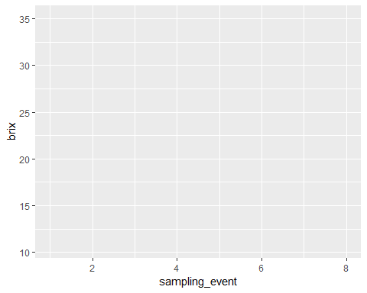 Now fill my plot

ggplot(data=mat_tidy4, aes(x = sampling_event, y = brix, colour = Year_a))+  
 geom_point(alpha = 0.3)

## Warning: Removed 1 rows containing missing values (geom_point).

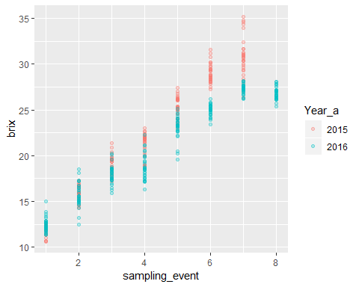 Each year had a number of sampling events which occurred through the season. In 2015 we sampled 30 vines on 7 separate events In 2016 we sampled 30 vines on 8 separate events Plotting by event makes the data points sit onto of each other. Plotting by date (on the x axis) will mean that there is a big gap between years. I have calculated the growing degree days for each year, based on weather data, this could be a way of displaying the x axis.

ggplot(data=mat_tidy4, aes(x = GFV, y = brix, colour = Year_a))+  
 geom_point(alpha = 0.3) +  
 labs(x = "Degree days",y = "Brix",title = ("maturity of grapes"),colour = "Year") +  
 theme(axis.text.x=element_text(), axis.ticks.x = element_blank())

## Warning: Removed 1 rows containing missing values (geom_point).

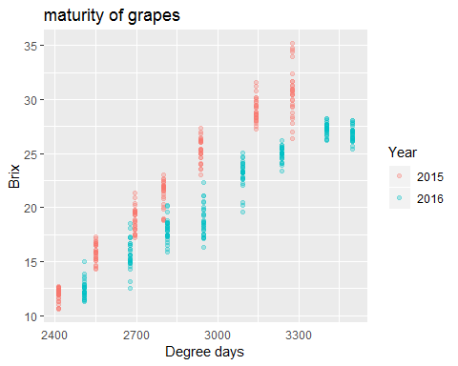

Formatting…

ggplot(data=mat_tidy4, aes(x = GFV, y = brix, colour = Year_a))+  
 geom_point(alpha = 0.3) +  
 labs(x = "Degree days",y = "Brix",title = ("maturity of grapes"),colour = "Year") +  
 theme(panel.grid = element_blank(),  
 axis.text.x=element_text(),   
 axis.ticks.x = element_blank(),  
 panel.background = element_rect(fill = "white",  
 colour = "black"))

## Warning: Removed 1 rows containing missing values (geom_point).

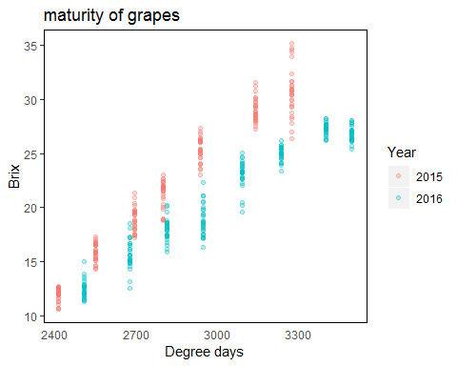 Try all the grape properties…

#X = GFV and Y = pH  
ggplot(data=mat_tidy4, aes(x = GFV, y = pH, colour = Year_a))+  
 geom_point(alpha = 0.3) +  
 labs(x = "Degree days",y = "pH",title = ("maturity of grapes"),colour = "Year") +  
 theme(panel.grid = element_blank(),  
 axis.text.x=element_text(),   
 axis.ticks.x = element_blank(),  
 panel.background = element_rect(fill = "white",  
 colour = "black"))

## Warning: Removed 1 rows containing missing values (geom_point).

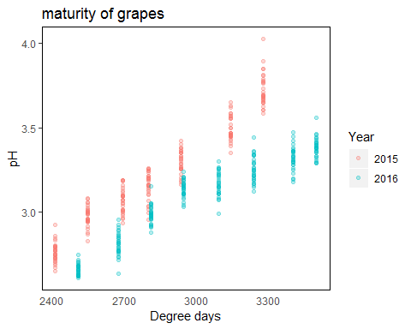

#X = GFV and Y = TA  
ggplot(data=mat_tidy4, aes(x = GFV, y = TA, colour = Year_a))+  
 geom_point(alpha = 0.3) +  
 labs(x = "Degree days",y = "TA",title = ("maturity of grapes"),colour = "Year") +  
 theme(panel.grid = element_blank(),  
 axis.text.x=element_text(),   
 axis.ticks.x = element_blank(),  
 panel.background = element_rect(fill = "white",  
 colour = "black"))

## Warning: Removed 1 rows containing missing values (geom_point).

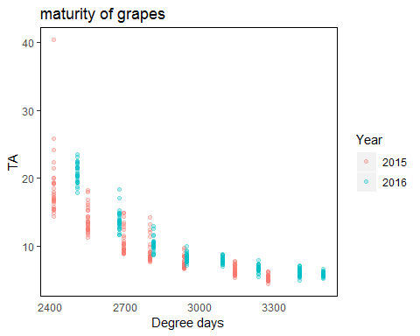

#X = GFV and Y = bunch_wt  
ggplot(data=mat_tidy4, aes(x = GFV, y = bunch_wt, colour = Year_a))+  
 geom_point(alpha = 0.3) +  
 labs(x = "Degree days",y = "Bunch weight",title = ("maturity of grapes"),colour = "Year") +  
 theme(panel.grid = element_blank(),  
 axis.text.x=element_text(),   
 axis.ticks.x = element_blank(),  
 panel.background = element_rect(fill = "white",  
 colour = "black"))

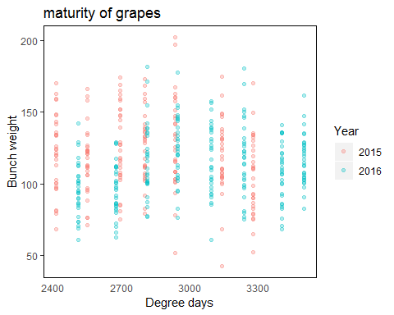

#X = GFV and Y = Mean_berry_wt  
ggplot(data=mat_tidy4, aes(x = GFV, y = Mean_berry_wt, colour = Year_a))+  
 geom_point(alpha = 0.3) +  
 labs(x = "Degree days",y = "Mean berry weight",title = ("maturity of grapes"),colour = "Year") +  
 theme(panel.grid = element_blank(),  
 axis.text.x=element_text(),   
 axis.ticks.x = element_blank(),  
 panel.background = element_rect(fill = "white",  
 colour = "black"))

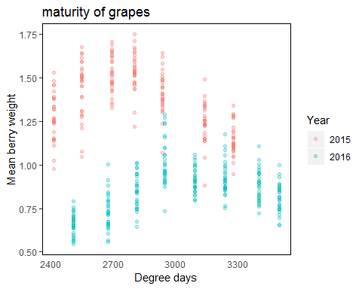

#X = GFV and Y = Colour_per_berry_Wt  
ggplot(data=mat_tidy4, aes(x = GFV, y = Colour_per_berry_Wt, colour = Year_a))+  
 geom_point(alpha = 0.3) +  
 labs(x = "Degree days",y = "Colour per berry weight",title = ("maturity of grapes"),colour = "Year") +  
 theme(panel.grid = element_blank(),  
 axis.text.x=element_text(),   
 axis.ticks.x = element_blank(),  
 panel.background = element_rect(fill = "white",  
 colour = "black"))

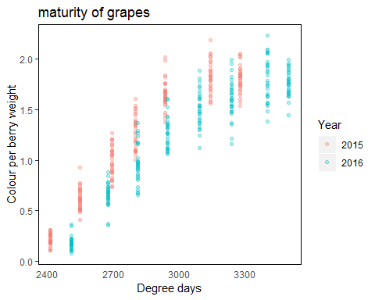

#X = GFV and Y = Phenolic_per_berry_Wt  
ggplot(data=mat_tidy4, aes(x = GFV, y = Phenolic_per_berry_Wt, colour = Year_a))+  
 geom_point(alpha = 0.3) +  
 labs(x = "Degree days",y = "Phenolic per berry weight",title = ("maturity of grapes"),colour = "Year") +  
 theme(panel.grid = element_blank(),  
 axis.text.x=element_text(),   
 axis.ticks.x = element_blank(),  
 panel.background = element_rect(fill = "white",  
 colour = "black"))

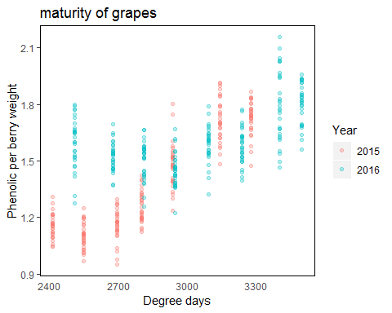

# Grape properties change through the season.

For grape properties such as brix, pH, TA and colour variation over the season seems to be stronger than variation of the 30 vines sampled.

For the other properties, the plots show a huge variation per sampling location, which seems to dominate how the property changes over time.

Can I check this with the grape property Brix?

## Plot brix for each sample point.

ggplot(data=mat_tidy4, aes(x = Sample, y = brix, colour = Year_a))+  
 geom_point(alpha = 0.5) + facet_wrap(~ sampling_event)+  
labs(x = "sample location",y = "Brix",title = ("maturity of grapes"),colour = "Year") +  
 theme(panel.grid = element_blank(),  
 axis.text.x=element_text(),   
 axis.ticks.x = element_blank(),  
 panel.background = element_rect(fill = "white",  
 colour = "black"))

## Warning: Removed 1 rows containing missing values (geom_point).

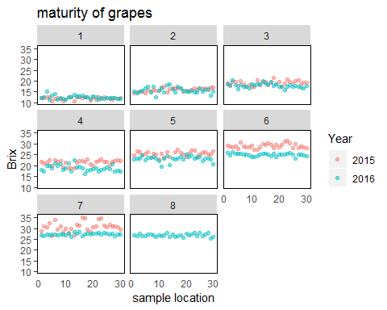 This is saying the early in the season differences between location and year is not as obvious as late in the year. This is quite a broad generalisation.

Need to overlay with something else? Should look at how these sample location were picked. Something to add to my data set!

Perhaps I can see more if I look at what is happening per year?

mat_tidy4 %>%  
 filter(Year_a == "2015") %>%  
 ggplot(aes(x = POINT_X, y = POINT_Y, colour = brix)) +  
 geom_point(size = 2.5) +  
 facet_wrap(~ GFV) +   
 labs(   
 x = "Easting",  
 y = "Northing",  
 title = "2015",  
 colour = "Brix") +  
 theme(panel.grid = element_blank(), #remove panel lines  
 axis.text.x=element_blank(),  
 axis.text.y=element_blank(),  
 panel.background = element_rect(fill = "white",  
 colour = "black"))

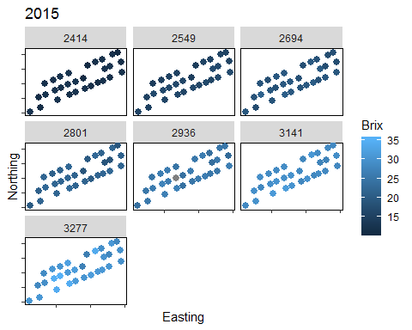

2016

mat_tidy4 %>%  
 filter(Year_a == "2016") %>%  
 ggplot(aes(x = POINT_X, y = POINT_Y, colour = brix)) +  
 geom_point(size = 2.5) +  
 facet_wrap(~ GFV) +   
 labs(   
 x = "Easting",  
 y = "Northing",  
 title = "2016",  
 colour = "Brix") +  
 theme(panel.grid = element_blank(), #remove panel lines  
 axis.text.x=element_blank(),  
 axis.text.y=element_blank(),  
 panel.background = element_rect(fill = "white",  
 colour = "black"))

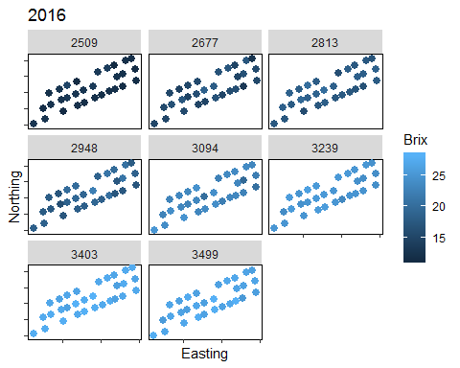

What I really want to see is each pane with its own scale, its hard to remove the effect of time on these graphs.

Harvest sampling is pretty important.

mat_tidy4 %>%  
 filter(GFV == "3277") %>%  
 ggplot(aes(x = POINT_X, y = POINT_Y, colour = brix)) +  
 geom_point(size = 2.5) +  
 labs(   
 x = "Easting",  
 y = "Northing",  
 title = "Harvest 2015",  
 colour = "brix") +  
 theme(panel.grid = element_blank(), #remove panel lines  
 axis.text.x=element_blank(),  
 axis.text.y=element_blank(),  
 panel.background = element_rect(fill = "white",  
 colour = "black"))

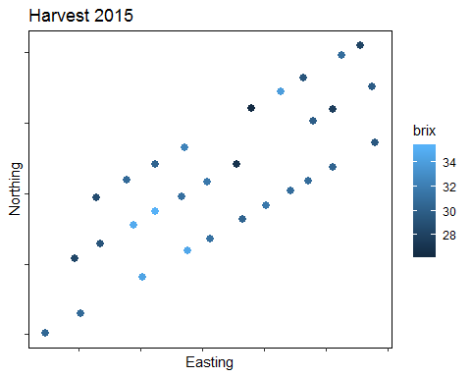

mat_tidy4 %>%  
 filter(GFV == "3499") %>%  
 ggplot(aes(x = POINT_X, y = POINT_Y, colour = brix)) +  
 geom_point(size = 2.5) +  
 labs(   
 x = "Easting",  
 y = "Northing",  
 title = "Harvest 2016",  
 colour = "brix") +  
 theme(panel.grid = element_blank(), #remove panel lines  
 axis.text.x=element_blank(),  
 axis.text.y=element_blank(),  
 panel.background = element_rect(fill = "white",  
 colour = "black"))

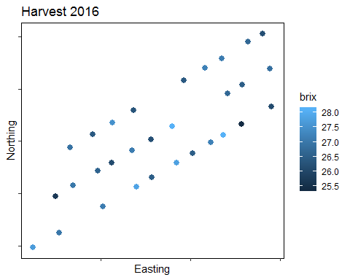

What about some other grape property that is more variable through time?

mat_tidy4 %>%  
 filter(Year_a == "2015") %>%  
 ggplot(aes(x = POINT_X, y = POINT_Y, colour = bunch_wt)) +  
 geom_point(size = 2.5) +  
 facet_wrap(~ GFV) +   
 labs(   
 x = "Easting",  
 y = "Northing",  
 title = "2015",  
 colour = "Bunch weight") +  
 theme(panel.grid = element_blank(), #remove panel lines  
 axis.text.x=element_blank(),  
 axis.text.y=element_blank(),  
 panel.background = element_rect(fill = "white",  
 colour = "black"))

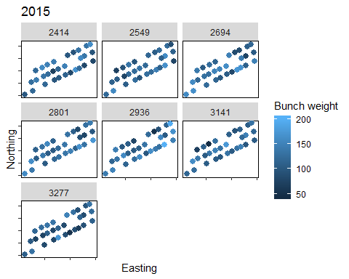 ```

mat_tidy4 %>%  
 filter(Year_a == "2016") %>%  
 ggplot(aes(x = POINT_X, y = POINT_Y, colour = bunch_wt)) +  
 geom_point(size = 2.5) +  
 facet_wrap(~ GFV) +   
 labs(   
 x = "Easting",  
 y = "Northing",  
 title = "2016",  
 colour = "Bunch weight") +  
 theme(panel.grid = element_blank(), #remove panel lines  
 axis.text.x=element_blank(),  
 axis.text.y=element_blank(),  
 panel.background = element_rect(fill = "white",  
 colour = "black"))

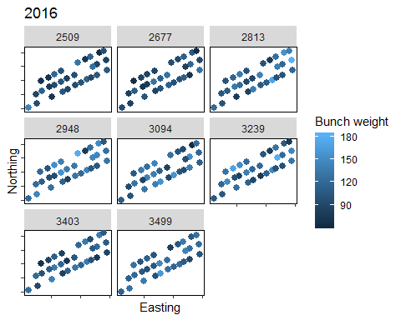

# I think I can see Jesus!

## Plotting grape variable against each other.

#Brix vs pH  
mat_tidy4 %>%  
 ggplot(aes(x = brix, y = pH, colour = GFV, shape = Year_a)) +  
 geom_point(size = 2.5, alpha =0.8) +  
 labs(   
 x = "Brix",  
 y = "pH",  
 title = "",  
 colour = "Degree days",   
 shape = "Year") +  
 theme(panel.grid = element_blank(), #remove panel lines  
 axis.text.x=element_blank(),  
 axis.text.y=element_blank(),  
 panel.background = element_rect(fill = "white",  
 colour = "black"))

## Warning: Removed 1 rows containing missing values (geom_point).

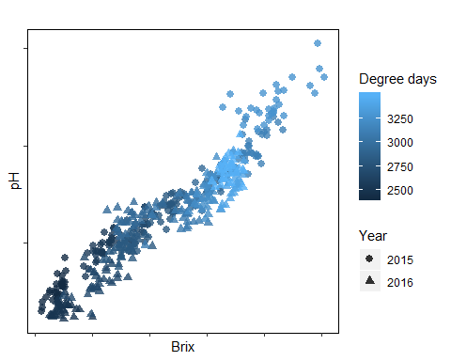

#Brix vs TA  
mat_tidy4 %>%  
 ggplot(aes(x = brix, y = TA, colour = GFV, shape = Year_a)) +  
 geom_point(size = 2.0, alpha =0.8) +  
 labs(   
 x = "Brix",  
 y = "TA",  
 title = "",  
 colour = "Degree days",   
 shape = "Year") +  
 theme(panel.grid = element_blank(), #remove panel lines  
 axis.text.x=element_blank(),  
 axis.text.y=element_blank(),  
 panel.background = element_rect(fill = "white",  
 colour = "black"))

## Warning: Removed 1 rows containing missing values (geom_point).

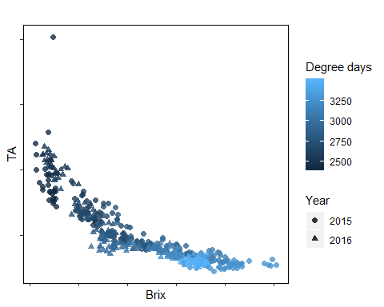

glimpse(mat_tidy4)

## Observations: 450  
## Variables: 20  
## $ ID <chr> "2015_101", "2015_102", "2015_103", "201...  
## $ sampling_event <int> 1, 1, 1, 1, 1, 1, 1, 1, 1, 1, 1, 1, 1, 1...  
## $ Day <int> 14, 14, 14, 14, 14, 14, 14, 14, 14, 14, ...  
## $ Month <int> 1, 1, 1, 1, 1, 1, 1, 1, 1, 1, 1, 1, 1, 1...  
## $ Year <int> 2015, 2015, 2015, 2015, 2015, 2015, 2015...  
## $ GFV <int> 2414, 2414, 2414, 2414, 2414, 2414, 2414...  
## $ Sample <int> 1, 2, 3, 4, 5, 6, 7, 8, 9, 10, 11, 12, 1...  
## $ POINT_X <dbl> 286331.7, 286382.4, 286425.7, 286473.1, ...  
## $ POINT_Y <dbl> 6236797, 6236810, 6236821, 6236833, 6236...  
## $ pH <dbl> 2.724, 2.685, 2.789, 2.801, 2.695, 2.744...  
## $ TA <dbl> 16.579, 16.699, 15.729, 15.304, 22.389, ...  
## $ brix <dbl> 12.1, 12.1, 12.4, 12.4, 10.7, 11.9, 12.0...  
## $ bunch_wt <dbl> 121.55, 158.68, 148.42, 143.55, 100.64, ...  
## $ Mean_berry_wt <dbl> 1.153, 1.139, 1.268, 1.392, 1.023, 0.976...  
## $ berries_bunch <int> 105, 139, 117, 103, 98, 99, 107, 106, 13...  
## $ Colour_per_berry_Wt <dbl> 0.187, 0.204, 0.249, 0.218, 0.109, 0.134...  
## $ Phenolic_per_berry_Wt <dbl> 1.156, 1.221, 1.142, 1.111, 1.126, 1.153...  
## $ Colour_per_berry <dbl> 0.214, 0.243, 0.332, 0.293, 0.116, 0.131...  
## $ Phenolic_per_berry <dbl> 1.324, 1.456, 1.523, 1.495, 1.194, 1.131...  
## $ Year_a <fct> 2015, 2015, 2015, 2015, 2015, 2015, 2015...

#Brix vs bunch_wt  
mat_tidy4 %>%  
 ggplot(aes(x = brix, y = bunch_wt, colour = GFV, shape = Year_a)) +  
 geom_point(size = 2.0, alpha =0.8) +  
 labs(   
 x = "Brix",  
 y = "Bunch weight",  
 title = "",  
 colour = "Degree days",   
 shape = "Year") +  
 theme(panel.grid = element_blank(), #remove panel lines  
 axis.text.x=element_blank(),  
 axis.text.y=element_blank(),  
 panel.background = element_rect(fill = "white",  
 colour = "black"))

## Warning: Removed 1 rows containing missing values (geom_point).

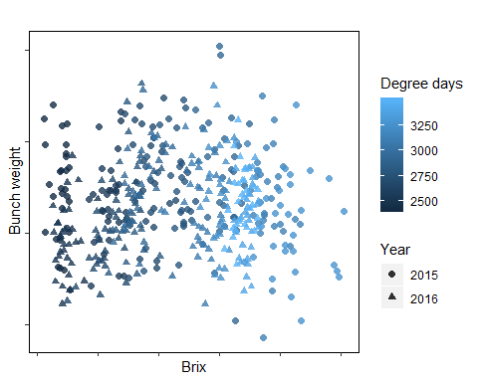

#Brix vs Mean_berry_wt  
mat_tidy4 %>%  
 ggplot(aes(x = brix, y = Mean_berry_wt, colour = GFV, shape = Year_a)) +  
 geom_point(size = 2.0, alpha =0.8) +  
 labs(   
 x = "Brix",  
 y = "Mean berry weight",  
 title = "",  
 colour = "Degree days",   
 shape = "Year") +  
 theme(panel.grid = element_blank(), #remove panel lines  
 axis.text.x=element_blank(),  
 axis.text.y=element_blank(),  
 panel.background = element_rect(fill = "white",  
 colour = "black"))

## Warning: Removed 1 rows containing missing values (geom_point).

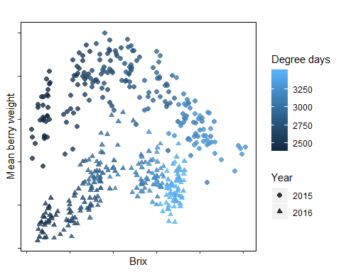

#Brix vs Colour_per_berry_Wt  
mat_tidy4 %>%  
 ggplot(aes(x = brix, y = Colour_per_berry_Wt, colour = GFV, shape = Year_a)) +  
 geom_point(size = 2.0, alpha =0.8) +  
 labs(   
 x = "Brix",  
 y = "Colour per berry weight",  
 title = "",  
 colour = "Degree days",   
 shape = "Year") +  
 theme(panel.grid = element_blank(), #remove panel lines  
 axis.text.x=element_blank(),  
 axis.text.y=element_blank(),  
 panel.background = element_rect(fill = "white",  
 colour = "black"))

## Warning: Removed 1 rows containing missing values (geom_point).

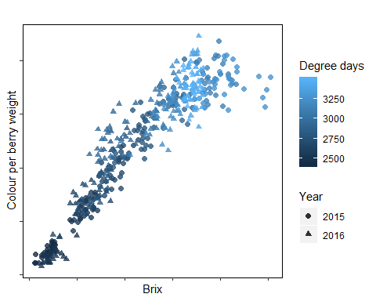

#Phenolic_per_berry_Wt  
mat_tidy4 %>%  
 ggplot(aes(x = brix, y = Phenolic_per_berry_Wt, colour = GFV, shape = Year_a)) +  
 geom_point(size = 2.0, alpha =0.8) +  
 labs(   
 x = "Brix",  
 y = "Phenolic per berry weight",  
 title = "",  
 colour = "Degree days",   
 shape = "Year") +  
 theme(panel.grid = element_blank(), #remove panel lines  
 axis.text.x=element_blank(),  
 axis.text.y=element_blank(),  
 panel.background = element_rect(fill = "white",  
 colour = "black"))

## Warning: Removed 1 rows containing missing values (geom_point).

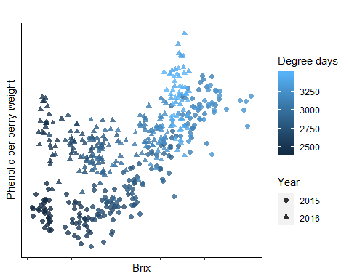

Do pH and TA have relationship?

#pH vs TA  
mat_tidy4 %>%  
 ggplot(aes(x = pH, y = TA, colour = GFV, shape = Year_a)) +  
 geom_point(size = 2.0, alpha =0.8) +  
 labs(   
 x = "pH",  
 y = "TA",  
 title = "",  
 colour = "Degree days",   
 shape = "Year") +  
 theme(panel.grid = element_blank(), #remove panel lines  
 axis.text.x=element_blank(),  
 axis.text.y=element_blank(),  
 panel.background = element_rect(fill = "white",  
 colour = "black"))

## Warning: Removed 1 rows containing missing values (geom_point).

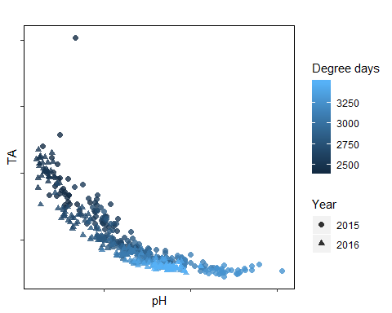

#pH vs colour  
mat_tidy4 %>%  
 ggplot(aes(x = pH, y = Colour_per_berry_Wt, colour = GFV, shape = Year_a)) +  
 geom_point(size = 2.0, alpha =0.8) +  
 labs(   
 x = "pH",  
 y = "Colour per berry Wt",  
 title = "",  
 colour = "Degree days",   
 shape = "Year") +  
 theme(panel.grid = element_blank(), #remove panel lines  
 axis.text.x=element_blank(),  
 axis.text.y=element_blank(),  
 panel.background = element_rect(fill = "white",  
 colour = "black"))

## Warning: Removed 1 rows containing missing values (geom_point).

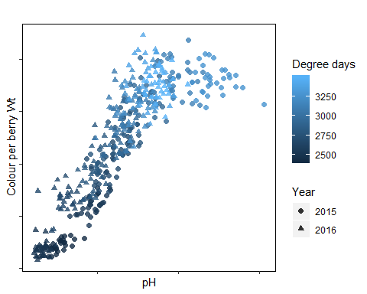

#phenolics vs colour  
mat_tidy4 %>%  
 ggplot(aes(x = Phenolic_per_berry_Wt, y = Colour_per_berry_Wt, colour = GFV, shape = Year_a)) +  
 geom_point(size = 2.0, alpha =0.8) +  
 labs(   
 x = "Phenolic per berry Wt",  
 y = "Colour per berry Wt",  
 title = "",  
 colour = "Degree days",   
 shape = "Year") +  
 theme(panel.grid = element_blank(), #remove panel lines  
 axis.text.x=element_blank(),  
 axis.text.y=element_blank(),  
 panel.background = element_rect(fill = "white",  
 colour = "black"))

