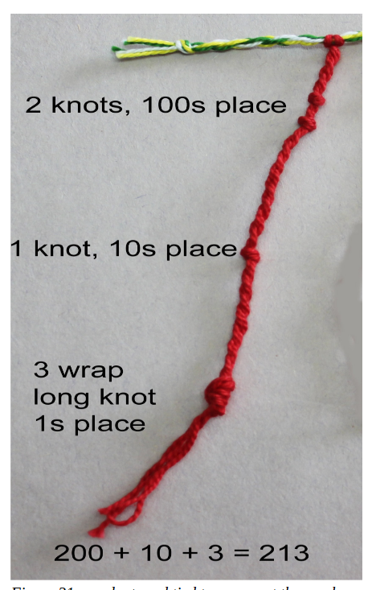

Coding the LED strip
We can’t do different types of knot in the LED strip (well not using electricity anyway), so I’ve just used individual LEDs e.g. 5 LEDs in the tens position = 50. There is one yellow light to separate 10s from ones, ones from 1st decimal place, etc. and 2 yellow lights at the end.

The colour of the lights represents the area e.g. Purple for Liverpool, Green for Wirral

Example:

Y |  |  |  |  | * | * | * | * | * | Y |  |  |  |  |  |  | * | * | * | Y |  |  |  |  |  | * | * | * | * | Y |  |  |  |  |  |  | * | * | * | Y | Y

- Yellow Light
- 5 lights in tens positions = 50
- Yellow Light
- 3 lights in ones positions = 3
- Yellow Light
- 4 lights in first decimal place positions = 0.4
- Yellow Light
- 3 lights in second decimal place positions = 0.03

So number represented is 53.43

Originally I had the data moving along the LED strips, but this made it too difficult to read. I’ve changed it so there is one static copy of the data on the outside part of the strip, and 2 moving copies within the column (the LEDs inside the column don’t need to be read – they represent the digital activity that the non-included households are missing out on, and that they can’t decipher at the moment).

The Data
The data being shown by the LED strips is the percentage of households in the City of Liverpool, and the 5 boroughs of the Liverpool City Region (Halton, Knowsley, St Helens, Sefton, Wirral), which don’t have “the minimum basket of digital goods, services, and skills that households need to live and participate in the digital world” (you can find out more at https://mdls.org.uk/).

Area | Average of Percent Not Meeting Full MDLS (Equipment and skills)
Halton | 40.63%
Knowsley | 40.55%
Liverpool | 38.93%
Sefton | 39.68%
St.Helens | 39.98%
Wirral | 39.98%
Grand Total | 39.71%

The Quipu strings show some of the equipment elements that make up that data.

Row Labels | Average of Overall percent not adequate equipment | Average of Percent not adequate BB | Average of Percent not adequate Smart TV | Average of Percent not adequate number of Large Screen Devices | Average of Percent significantly below MDLS equipment needs
Halton | 12.34% | 5.85% | 1.83% | 2.64% | 2.02%
Knowsley | 12.51% | 6.03% | 1.79% | 2.60% | 2.08%
Liverpool | 14.31% | 5.78% | 2.64% | 3.64% | 2.25%
Sefton | 13.32% | 7.63% | 1.57% | 2.43% | 1.68%
St.Helens | 12.50% | 7.12% | 1.45% | 2.46% | 1.47%
Wirral | 13.29% | 7.89% | 1.40% | 2.53% | 1.48%
Grand Total | 13.36% | 6.76% | 1.89% | 2.86% | 1.86%

The cords are made of 2 colours, one represents the area, and one represents the data being shown. The support structure has 6 sides – one for each area.

