Knot Key (3 Types)
1) Single Knot (for tens, hundreds, thousands)  Used in groups.  Example: 4 tens = 4 single knots in the tens zone.  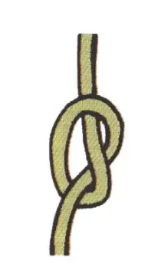 | 2) Figure-of-Eight Knot (for 1 in the ones place)  1 one = 1 figure-of-eight knot  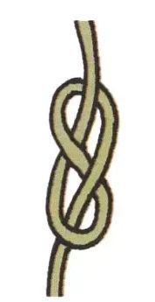
3) Long Knot (for 2–9 in the ones place)  A long knot has loops.  Example:  6 ones = long knot with 6 loops  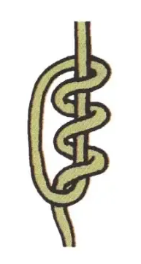 | Rule for Zero  If a place value digit is 0, leave that place blank.  Places after the Decimal Point  I couldn’t find any examples of recording decimal places, so have used the same format as for ones i.e. figure-of-eight and long knots.  Separators  Sometimes it’s difficult to work out what place a knot is in, especially in a number containing zeros. Although the Inca Empire’s Quipucamayocs were obviously able to do without (possibly due to more accurate placing of the knots), I decided to mark the boundaries between place values (and the start and end of each cord) with yellow 3D printed separators.

