Hi everyone!
Below are some instructions on how to use Anaconda Navigator to run the Python code in the Jupyter Notebooks that we used during our workshop at GCC.
I have found videos that can help work you through the installation on Mac and Windows. If you do not have access to a Mac or Windows computer, please let us know as soon as possible.
Mac: https://www.youtube.com/watch?v=pRbaLVAGuEY&ab_channel=99thCloud
Windows: https://www.youtube.com/watch?v=5mDYijMfSzs
A few further notes on the installation that may be confusing in the video:
- You can choose to install for "Just me" if you use a shared computer
- On the "Advanced Options" step, do not check the "Add Anaconda to system PATH environment variable" box.
- You do not need to install "Microsoft VS code"

Once the installation is complete, follow the steps below to complete the assignment.
- Find the Anaconda-Navigator app on your computer and open it. The icon looks like this 
- Scroll through the applications menu to find 'Jupyter Lab'. Click Launch and this will open a tab in your web browser.
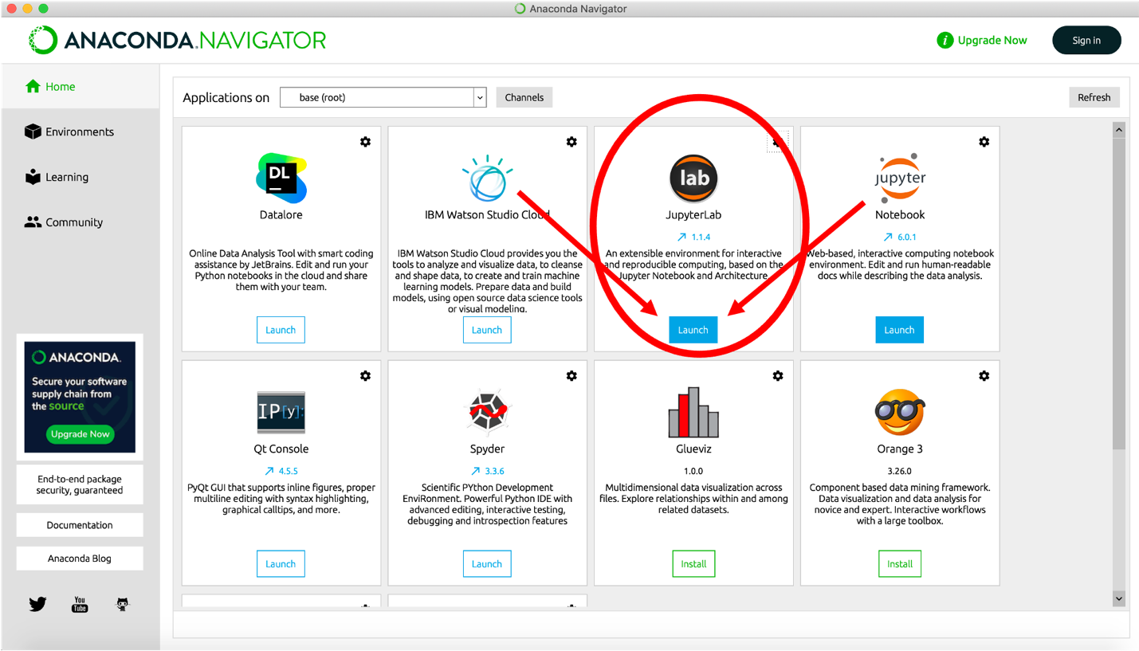
- In this new web browser window, a jupyter “launch pad” will be displayed. Click on "Python 3" under the orange square that reads “Notebook”. This will launch a Jupyter Notebook.
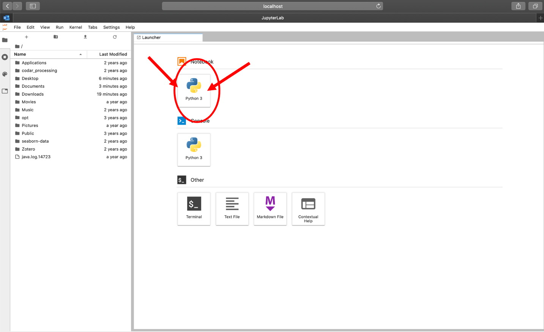
- In the new notebook, click in the empty cell and type the text without the brackets [ print("Hello world!") ]. Then click the play button. Congratulations! You have officially run a line of code!
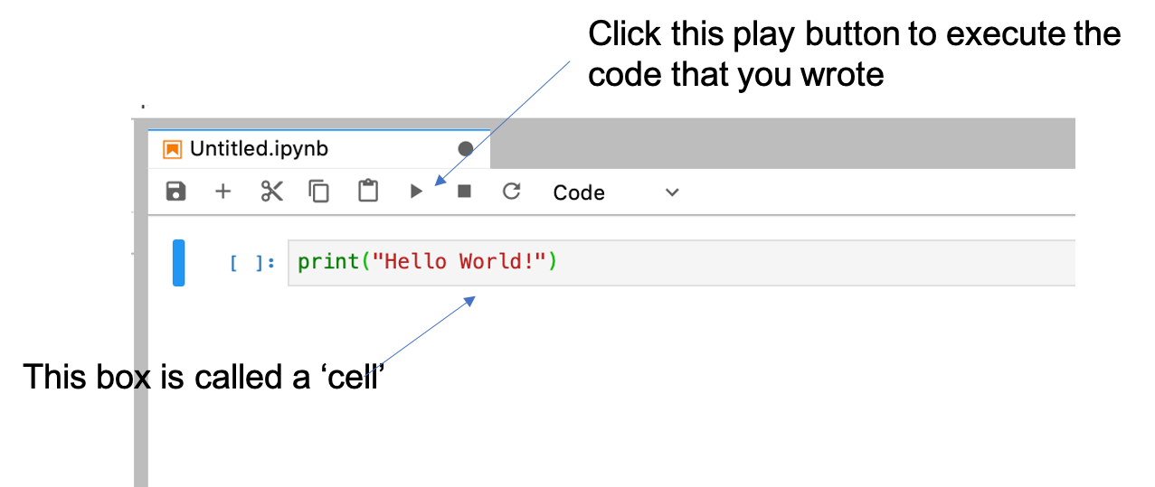
Now you can create your own Jupyter Notebooks!

5. To install the dependencies needed to run the notebooks we used during the GCC workshop, click the + button on the upper left (“New Launcher”) and then select “Terminal”.

6. Once you’ve gotten to the terminal page, run the following:

conda install -c conda-forge numpy xarray scipy cartopy matplotlib

And then

pip install earthaccess

7. Now that your environment is ready to go, you can work on the Jupyter Notebooks that we used during the workshop by (1) downloading them from Jackie’s Github repo then (2) navigating back to Jupyter Notebook and using the file system on the left to navigate to the notebook (double click to open).

8. Happy Coding!

