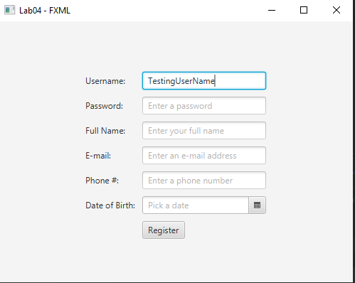

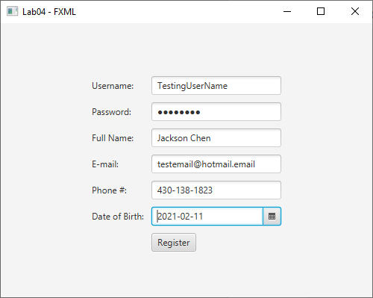

Output when register is clicked

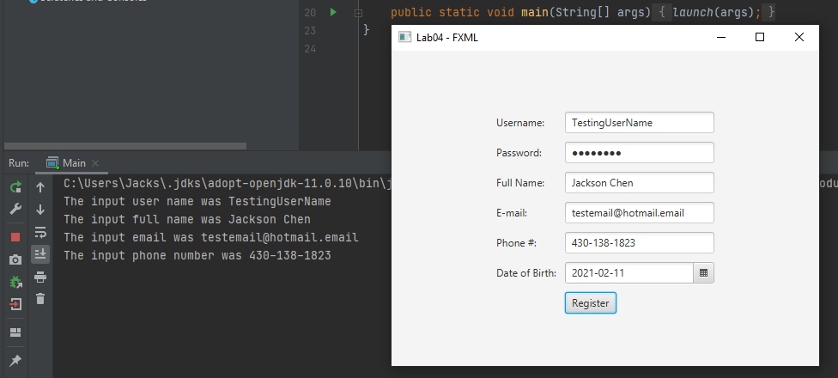

Screenshots for directory and contents

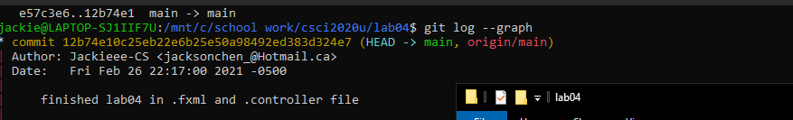

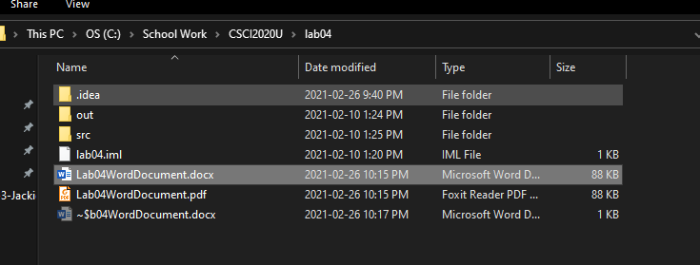

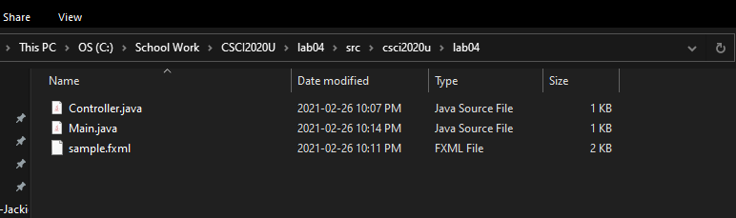

Direct github link = <https://github.com/Jackieee-CS/csci2020u_JacksonChen> under lab 04