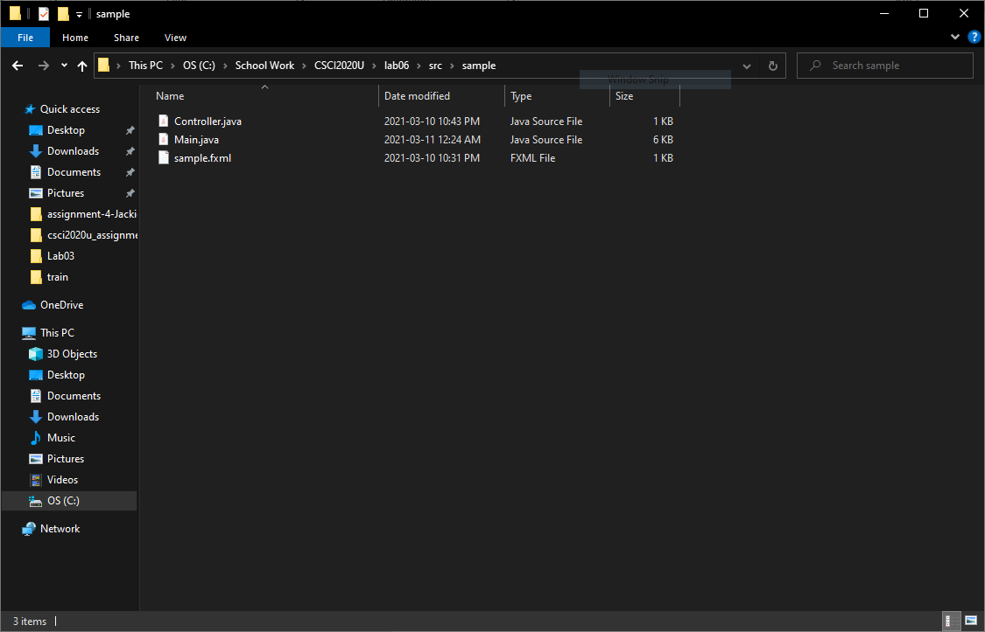

Output

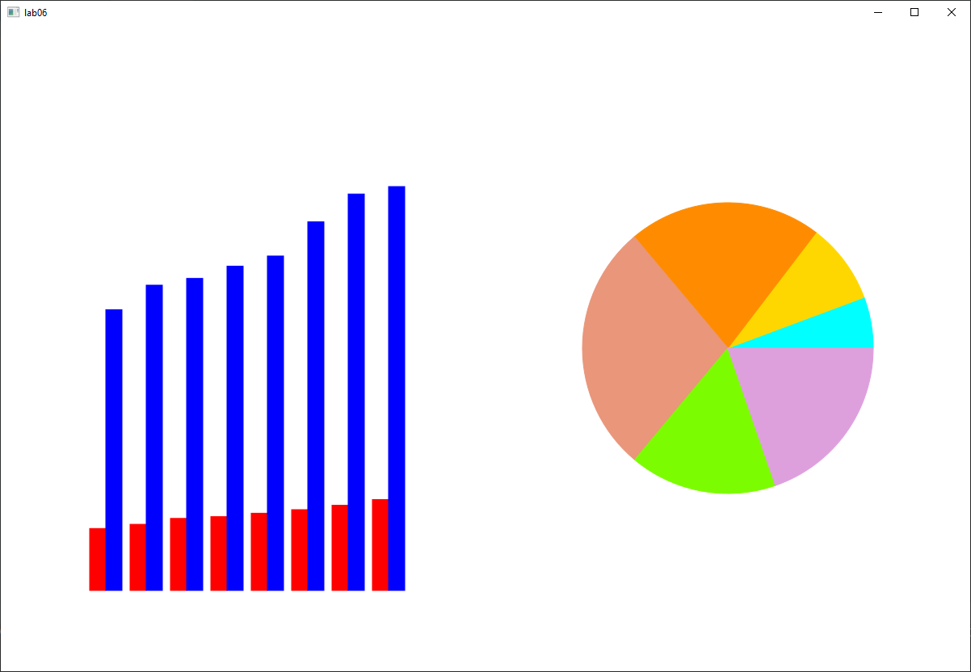

Github will be found at https://github.com/Jackieee-CS/csci2020u_JacksonChen