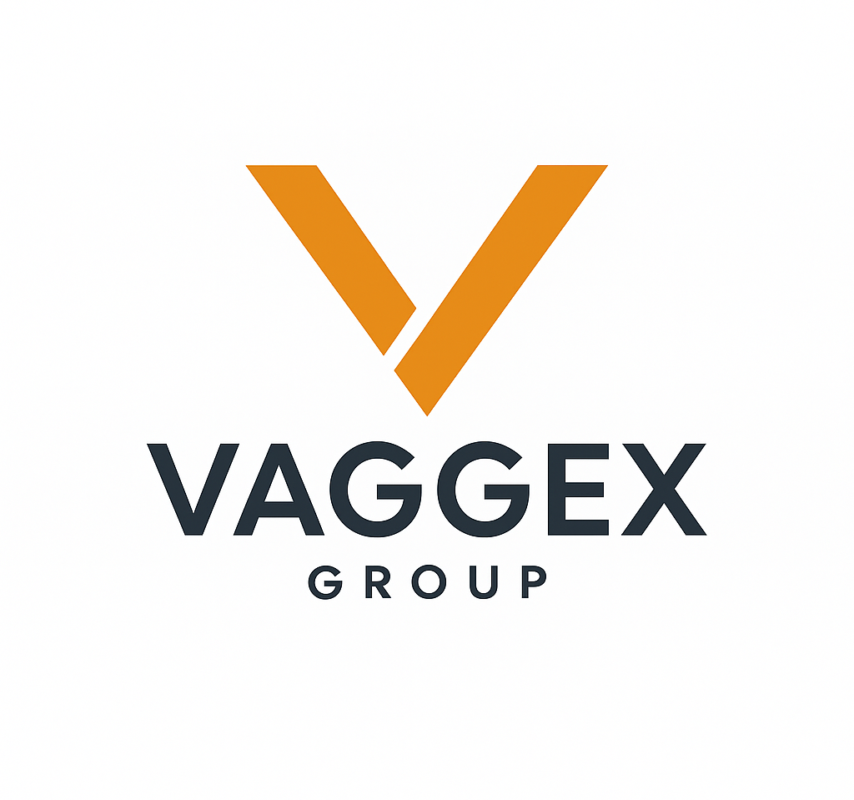

VAGGEX GROUP (Pty) Ltd
Civil & Infrastructure | Residential & Commercial | Rebuild & Maintenance

Company Overview

Vaggex Group is a Botswana-based multi-disciplinary construction firm specializing in civil infrastructure, residential and commercial building, and rebuilding and maintenance solutions. We are committed to delivering top-tier engineering solutions with a focus on quality, safety, and sustainability. Our approach blends local expertise with modern technologies, ensuring efficient, reliable, and future-ready project delivery.

Our Vision
To be Botswana’s most trusted and innovative construction group, transforming skylines and infrastructure with precision and purpose.

Our Mission
- To deliver high-quality construction and infrastructure solutions that exceed client expectations.
- To build with integrity, safety, and sustainability at the core of every project.
- To drive economic and social impact through local employment, skills development, and excellence in delivery.

Our Values

- Integrity: We do what’s right, always.
- Quality: Built to last. Delivered with pride.
- Innovation: Modern methods for modern challenges.
- Collaboration: Strong teams. Strong results.
- Excellence: From foundation to finish.

Core Services

Civil & Infrastructure
- Roads, earthworks, bridges, drainage
- Water and sanitation systems
- Drainage and stormwater systems
-Bridges and culverts

Residential & Commercial Construction
- Housing developments & custom homes
- Office complexes, lodges & retail facilities
- Industrial units & warehouses
-Lodges and tourism facilities

Rebuild & Maintenance Solutions
- Renovations and structural upgrades
-Emergency repairs and site support
- Building refurbishments and extensions
- Long-term maintenance contracts

Why Choose Vaggex?

- Skilled professionals across disciplines
- Transparent project management
- Commitment to deadlines and budget
- Innovation-driven construction solutions

Let’s Build the Future, Together
Whether you’re planning a national infrastructure project, a real estate development, or a commercial build, Vaggex Group is your reliable partner — committed to quality, innovation, and impact.

Contact Information

Email: vaggexgroup@gmail.com
Phone: +267 76 449 256 / 76 345 055
Website: Coming Soon
Address: [business location to be announced]

“Vaggex Group – Building Africa’s Future, One Project at a Time.”

VAGGEX GROUP (Pty) Ltd
Civil & Infrastructure | Residential & Commercial | Rebuild & Maintenance Solutions

Company Overview
Vaggex Group is a citizen-owned, Botswana-based multi-disciplinary construction and infrastructure development firm. We specialize in civil and infrastructure works, residential and commercial projects, as well as rebuild and maintenance solutions. Our goal is to deliver safe, sustainable, and innovative engineering solutions that empower communities and transform the built environment.

Vision
To be a leading construction and infrastructure company in Botswana, recognized for quality, integrity, and innovation.

Mission
To provide sustainable construction and infrastructure solutions with a commitment to safety, reliability, and customer satisfaction.

Core Values
- Integrity and Transparency
- Commitment to Safety
- Innovation and Excellence
- Sustainability
- Client-Centered Service

Our Services

Civil & Infrastructure
- Roads, bridges, and drainage systems
- Water and sanitation infrastructure
- Stormwater management solutions

Residential & Commercial Construction
- Housing developments and custom homes
- Commercial buildings, offices, and retail facilities
- Industrial complexes and warehouses

Rebuild & Maintenance Solutions
- Renovations and structural upgrades
- Building refurbishments and extensions
- Long-term maintenance contracts
- Emergency repairs and support services

Capability Statement
Although Vaggex Group is a newly established entity, our strength lies in the extensive expertise of our leadership team, who collectively bring over three decades of hands-on experience in the construction and civil engineering sectors. We are equipped with the technical knowledge, industry networks, and management capacity to deliver projects of varying scope and scale. Our directors and partners have successfully worked on high-value infrastructure projects across Botswana, including water transfer schemes, residential developments, and government infrastructure initiatives.

Leadership & Management

Mr. Vehonga Kangotui – Director
Mr. Kangotui is an accomplished construction professional with over 30 years of experience in civil works, water infrastructure, and building projects. He has served as a General Foreman and Foreman on major projects including the Palapye–Mmamashia Water Transfer Project, Selebi Phikwe–Serule Water Transfer Scheme, and multiple rehabilitation and infrastructure upgrades across Botswana. His technical background, hands-on management, and industry expertise form a strong foundation for Vaggex Group.

Mr. Albin Mashabe – Partner
Mr. Mashabe holds a Bachelor of Commerce (BCom) in Entrepreneurship and has a strong foundation in business development, financial management, and strategic planning. He has assisted in managing financial operations for institutions such as St Kizito Senior Secondary School and has field experience supporting construction projects. His entrepreneurial drive, combined with administrative and project management skills, complements the technical leadership of the group.

Why Choose Vaggex?
- Citizen-owned and locally registered company
- Leadership team with decades of combined experience
- Strong foundation in civil works, construction, and business management
- Commitment to safety, sustainability, and on-time delivery
- Innovative solutions tailored to client needs

Contact Information
Email: info@vaggexgroup.com
Phone: +267 77814198 | +267 7780693
Address: P.O. Box 10702 Woodhall, Lobatse, Botswana
Website: www.vaggexgroup.com (coming soon)
“Vaggex Group – Building Africa’s Future, One Project at a Time.”
"C:\Users\USER 1\Desktop\MovieBox.lnk"

