Abstract:

Purpose:

To test the uncertainty principle on the human acoustic system : C=4\*pi\*Dt\*Df. In this task, we only test the precision Df, Dt of the uncertainty principle instead of the resolution df, dt

Def:

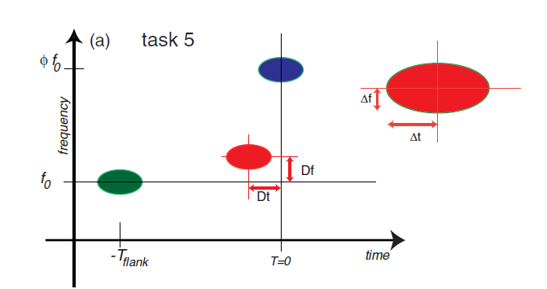

Experiment design:

1. Participants will go through 15 test sections, and the 15 test sections are all the same.
2. In each section, participants will hear three sounds, two flank sound and a test sound. The participant should answer if the test sound comes earlier or later than the second flank sound(blue) and if the test sound comes higher or lower than the first flank sound(green)
3. Participants have only one chance to conduct the experiment, which means they cannot listen to the audio the second time.
4. The experiment will be conducted two times. First time calculates ones rough precision value. Then I will use the uncertainty precision value observed first time to be the start point of the second time.

Ex: first time initial value -> 4\*pi\*Dt\*Df=1 then

second time initial value-> 4\*pi\*Dt\*Df=C ,where C is the precision value observed at first time.

Testing method:

1. Set initial value Dt and Df so that 4\*pi\*Df\*Dt =1
2. Start the test, record the score of Df and Dt with the correctness and incorrectness policy(described below)

Evaluate method:

1. The score that fluctuate between a certain value would be ones uncertainty limit because he/she can’t get a more steady value.

EX:

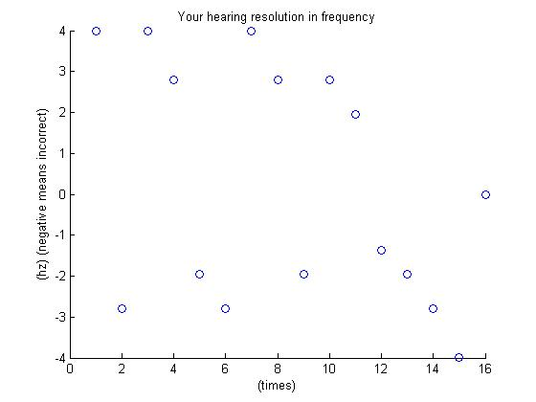

In this example, the precision of frequency will be 2 because the score fluctuates between 2

My result is as below:

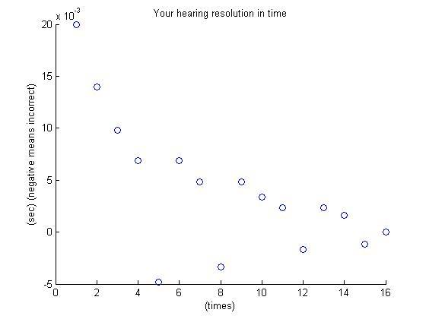

Discussion:

I found I am more sensitive at time precision than frequency precision, and my uncertainty limit is 0.0628 which is under 1, the standard uncertainty limit appeared in the paper. (The result may be incorrect, so I modified some part of the code to test my partner)

I found that participants should perform the test many times some that they are more familiar with what they are doing.

Participants are asked to answer both frequency and time precision but I found that in my case, I can only focus on one of the precision (either frequency or time), and cannot focus on both of them, so I used to listen again when I was asked different question. However I decide not to give participant a second chance since the precision should be precision of the perception of both time and frequency.

After modifying code I have my second test result:

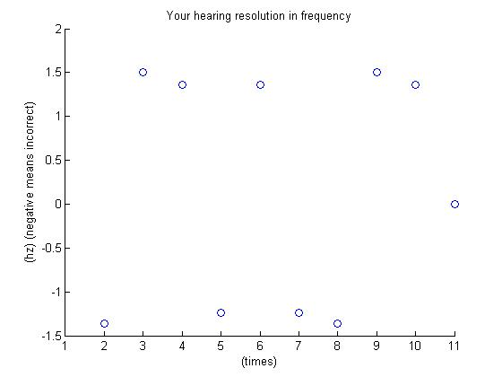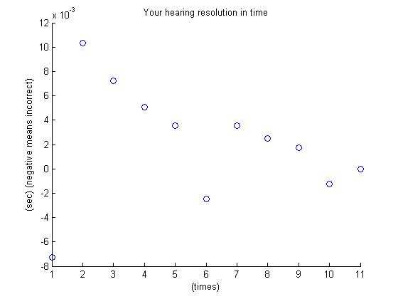

From the plot, I conclude that my limit frequency precision would be 1.5 and my limit time precision would be 0.002 because my scores fluctuates at the two values, not getting farther or closer. As the result, my uncertainty limit is 4\*pi\*0.002\*1.5 = 0.0377

Result of another participant:

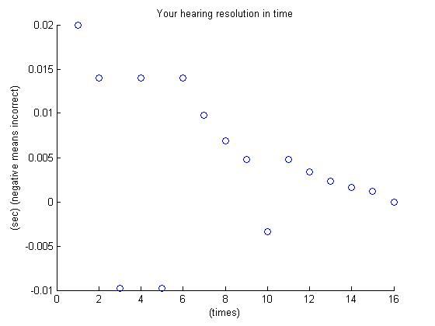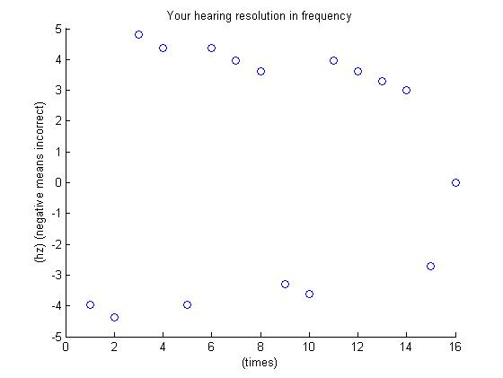

My participant scores well on time precision while her frequency remains at about 3 hz, which determines her uncertainty limit as 0.0377.

This is the second time test for her precision, for I had received her first rough uncertainty precision. Then I tuned the initial value of Dt and Df from

Df = 1.5;

Dt = 1/(4\*pi)/Df;

To

Df = 1.5;

Dt = C/(4\*pi)/Df;

Where C was the value that she got first time.