Sinusoidal sound analysis and synthesis:

Introduction:

The main purpose of the project is to reconstruct the sound by extracting the parameters of original sound file and finally reconstruct the sound with those extracted parameters. By doing this, we first use short time fourier transform to identify the the first few amplitude peaks as our interested signals, after rectifying those parameters with interpolating method, we synthesize back our signal but only remains the interested part. The reconstructed signals will be close to but not same as the original signal.

Method:

We separate our method to three part:

1. step1: find peaks of each spectrum generated by STFT method
   1. in each spectrum, find the peaks 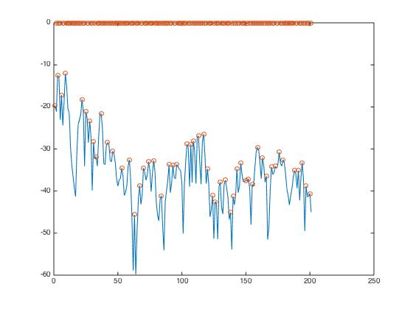
   2. find maxNumPeaks of peaks which is defined by users .
   3. use QI-interpolate to get more accurate peaks and frequencies.
   4. Beware that some frame may have less peaks, then interpolate additional points as peaks.

finally by selecting maxNumPeaks = 10 we have the result: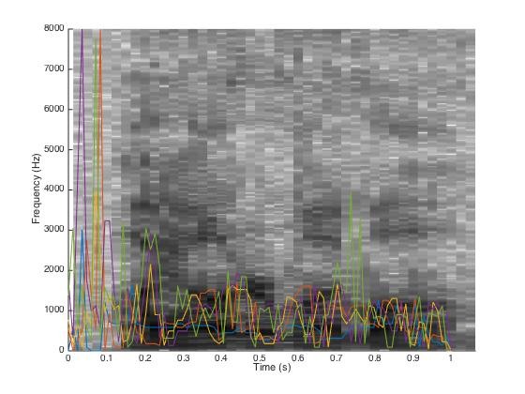

1. step2: Synthesis the signals with the extracted peaks and amplitudes:
   1. As we received the peaks, those peaks stand for the top few peak values of each spectrum. However, we need to interpolate them to form real time signals. In this project, we link each peak values with straight lines 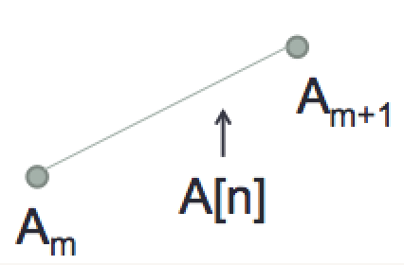

our results shows:

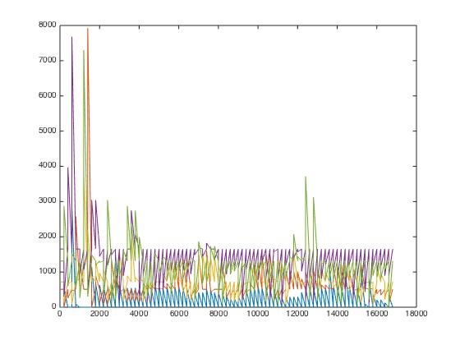

Discussion:

First of all, we interpolate the amplitude under DB scale, because it simulates how human ear perceive the amplitude to the sound.

＃＃伶伶部分：

（引導：去聽聽看其他音檔的效果draw_16.wav, LinearMethod.wav, peaches_16.wav 還有試試一些參數（time expansion factor，how many semitones of pitch shift））

Conclusion:

By extracting and re-synthesize the sound signals, we may recognize the meaning of the spoken words. However, it may sound not natural because we have eliminated the noises, as we perceive in real world.