My method to extract pitch:

1. find peak value:
   1. step1. filter out the frequencies that is bigger than 500 or smaller than 50 hz
   2. step2. find the highest intensity of our signal in frequency domain.

2. Autocorrelation:

a. find the first peak in the autocorrelation function

b. locate the x-axis coordinate, and the first peak x-axis coordinate should be the fundamental period.

c. the pitch value F0 should be 1/T

Window select:

The smaller the window, the more sensitive to noise:

find peak:  
win_len=0.01:

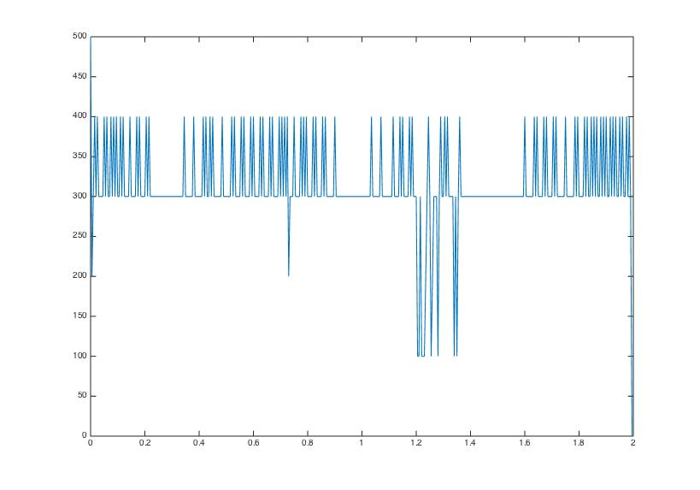

win_len=0.05:

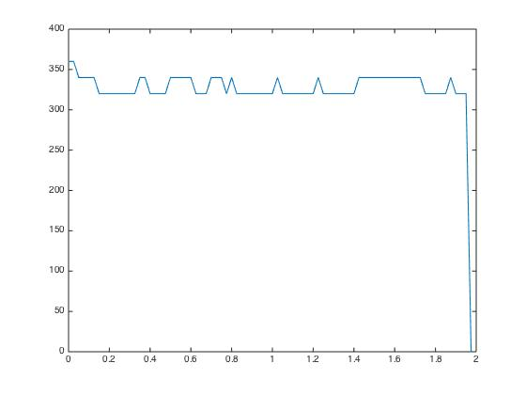

win_len=0.10: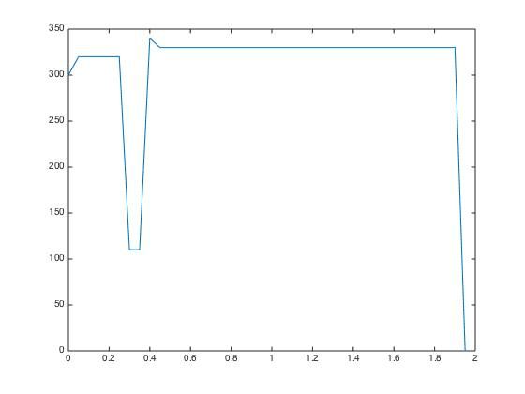

ACF:

win_len=0.01:

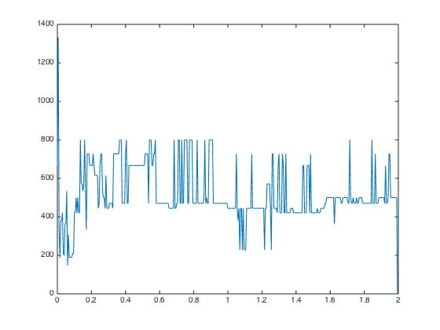

win_len=0.05:

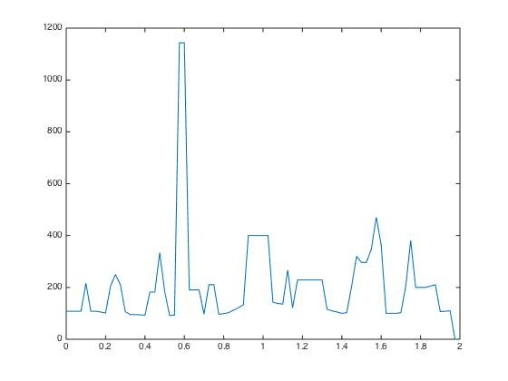

win_len=0.10:

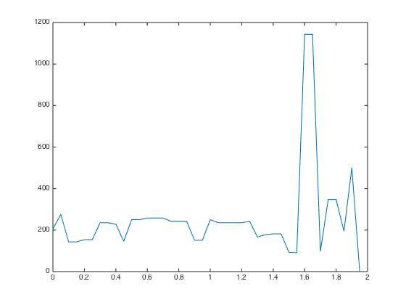

Window selection:

I’ll choose the window with window length 0.10 because I want to get smoother value.

my highest pitch can reach up to, 400 hz i think it’s reasonable because it’s between 50 t0 500.

Denoising on spectrum:

Method:

I used parabolic-interpolation on spectrum with the recursing curve :

cn*x^poly_n+...c1*x^1+c0

where poly_n is the parameter that is tunable, represented as the order of the paranomial.

%***matlab function***/////////

p=polyfit(spectra{ii}(:,1),spectra{ii}(:,2),poly_n); %train parameter p

spectra{ii}(:,2)=polyval(p,spectra{ii}(:,1));% use p to reconstruct spectra

%************************/////////

the effect of this method:

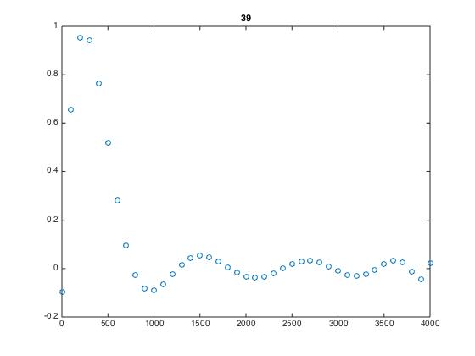

In contrary, the spectrum without parabolic interpolation will be 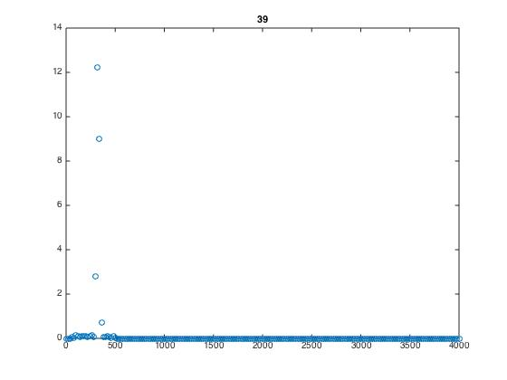

Then I’ll show the final result with and without interpolation:

My voice pitch without interpolation:

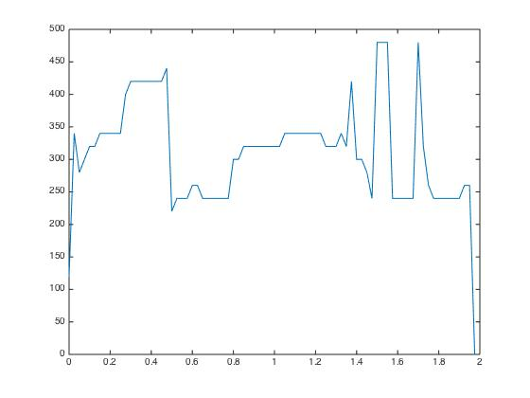

with interpolation, whose poly_n=10:

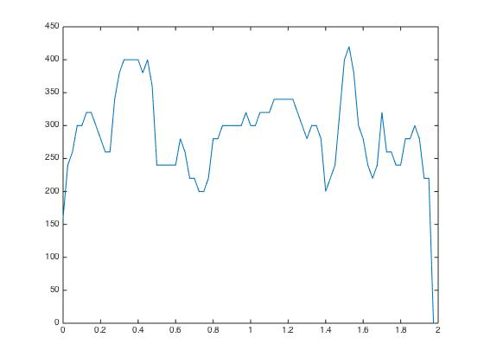

with interpolation, whose poly_n=20:

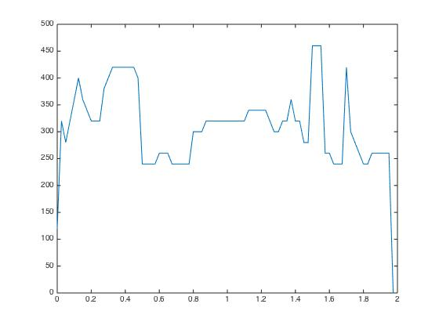

we then get a conclusion that using parabolic interpolation can get a smoother curve