Sizing Report

Giacomo Mastroddi  
16.06.2023

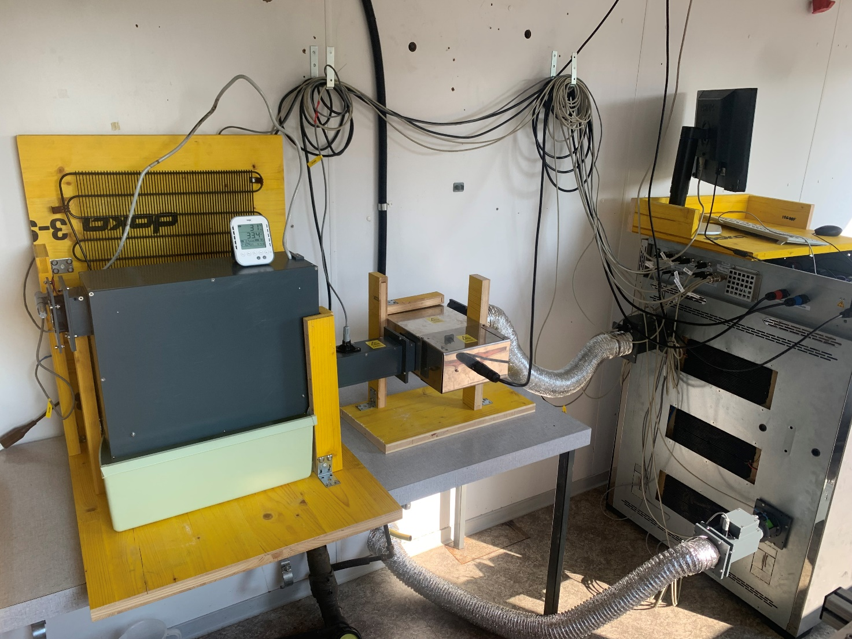

# System Limits

The limits of our system are defined by the specific energy that our actuators can extract or add to the humid air.

## Cooler

The maximal specific energy that our cooler can extract is approximately 17 kJ/kg of dry air. This value is obtained by subtracting the specific enthalpy after the cooler (hcool) from the specific enthalpy of the ambient (hamb). The measurements are taken once the system is running for long time and steady state is ensured.

If we calculate the maximal useful specific energy for our set up, we receive a value of 12 kJ/kg of dry air. This means that 5 kJ/kg of dry air are lost in the tubes.

## Heater

Similar to the cooler, the maximal specific energy of the heater is approximately 23 kJ/kg of dry air. This value is obtained by subtracting the specific enthalpy at the inlet of the climate chamber (hin) from the specific enthalpy of the ambient (hamb).

## System

Therefore, we obtain the feasibility region in green to reach the point at 27°C and 60% rH.

## Fan

The nominal volumetric flow of our fans is 25.2 m3/h as written in the datasheet. Converting this value to SI unit is useful to calculate the power given and extracted with the cooler and the heater, respectively. Additionally, it is useful to estimate the maximal volume of the climate chamber.

# Maximal Climate Chamber Volume

Depending on the time that is needed to exchange the air inside the chamber, it is possible to estimate the maximal volume of the climate chamber. The current value of volume and volumetric flow are the following.

## Example

If we need to exchange the air inside the chamber every 3 minutes, then the maximal volume of the climate chamber is the following.

It is important to mention that the size of the climate chamber in independent from the actuator power in this calculation. In fact, they will always extract or add the same amount of specific energy.