https://stackoverflow.com/questions/41923492/cant-import-moviepy-editor

conda install moviepy

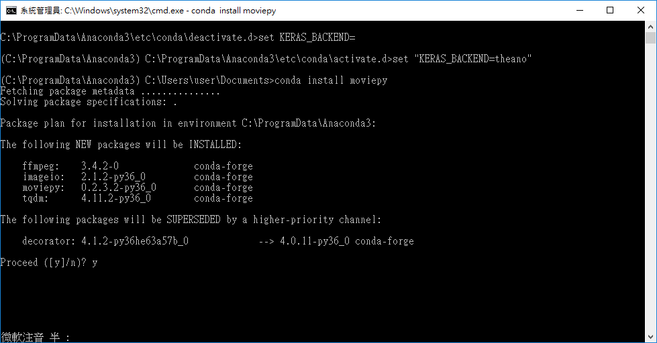

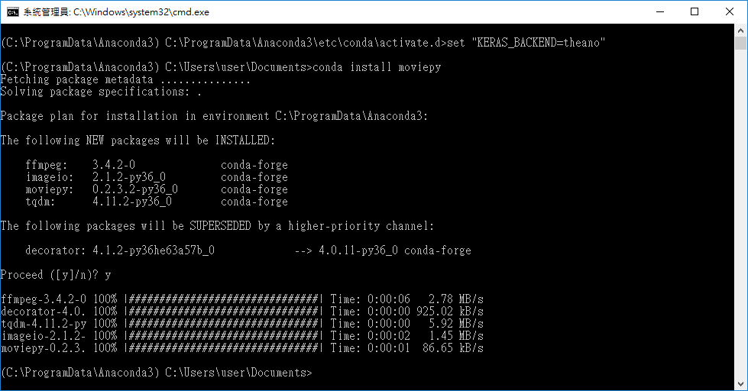

**範例 Object Detection with Tensorflow API**

<https://www.youtube.com/watch?v=_zZe27JYi8Y>

**Code**

<https://github.com/diegocavalca/machine-learning/tree/master/supervisioned/object.detection_tensorflow>