INTRODUCTION TO LARGE LANGUAGE MODELS
TAKE-HOME ASSIGNMENT
Question 1 – Creative Semantic Retrieval
Semantic Movie Retrieval Using Sentence Embeddings
Student: Lakshman Rakesh Pillai
Course: Introduction to Large Language Models
Dataset: User-provided dataset of 100 movies
Embedding Model: all-MiniLM-L6-v2
Similarity: Cosine similarity
Retrieval: Top 5 movies

1. Objective
The objective is to implement a semantic retrieval system that retrieves the five most relevant movies from a dataset of 100 movies for a natural-language query. Movies and queries are represented as embeddings using a pretrained Sentence Transformer, and cosine similarity is used to rank the movies.

2. Dataset
The dataset contains 100 movies across international genres and decades. Each record includes title, director, year, genre, mood and description. These fields are combined into a text representation before embedding.
Total movies: 100

3. Embedding Model
The final implementation uses the pretrained Sentence Transformer model all-MiniLM-L6-v2. The same model converts movie text and the natural-language query into numerical embedding vectors. No model is trained from scratch.

4. Retrieval Methodology
- Convert each of the 100 movie records into a combined text representation.
- Generate an embedding for each movie using all-MiniLM-L6-v2.
- Generate an embedding for the user's natural-language query using the same model.
- Calculate cosine similarity between the query embedding and every movie embedding.
- Sort movies by similarity in descending order and return the top five.
Pipeline:
100 movies → movie text → Sentence Transformer → movie embeddings
Natural-language query → Sentence Transformer → query embedding
Query embedding + movie embeddings → cosine similarity → ranking → top 5

5. Cosine Similarity
Cosine Similarity(A, B) = (A · B) / (||A|| × ||B||)
A is the query embedding and B is a movie embedding. A higher value indicates that the two vectors point in more similar directions in the embedding space. The score measures semantic/text similarity; it does not measure movie quality or personal taste.

6. Implementation
The original CrossEncoder-based scoring was replaced with an embedding-based implementation using SentenceTransformer and scikit-learn cosine similarity. The final program also provides a --demo mode containing five evaluation queries.
from sentence_transformers import SentenceTransformer
from sklearn.metrics.pairwise import cosine_similarity
MODEL_NAME = "all-MiniLM-L6-v2"
For the final submission, insert screenshots from VS Code showing: the model declaration, movie/query embedding code, cosine similarity calculation, ranking/top-five logic, and the terminal output.

7. Five-Query Evaluation

7.1 Query 1
Input: A hopeful story about a prisoner who builds a friendship and finds freedom.
Rank | Movie | Cosine Similarity | Manual Assessment
1 | The Shawshank Redemption | 0.4835 | Highly relevant: directly matches prison, friendship and hope.
2 | Oldboy | 0.3768 | Partially relevant: prison and release overlap, but the tone and intent differ.
3 | The Green Mile | 0.3740 | Relevant: prison setting and a strong inmate relationship overlap.
4 | Forgotten | 0.3478 | Weak/partial: mystery and memory themes, but not the intended prison/freedom story.
5 | Django Unchained | 0.3394 | Related: freedom and oppression overlap, but it is a different genre/story.
Assessment: The Shawshank Redemption is the clearest match. The remaining results show that broad thematic overlap can bring related movies into the top five.

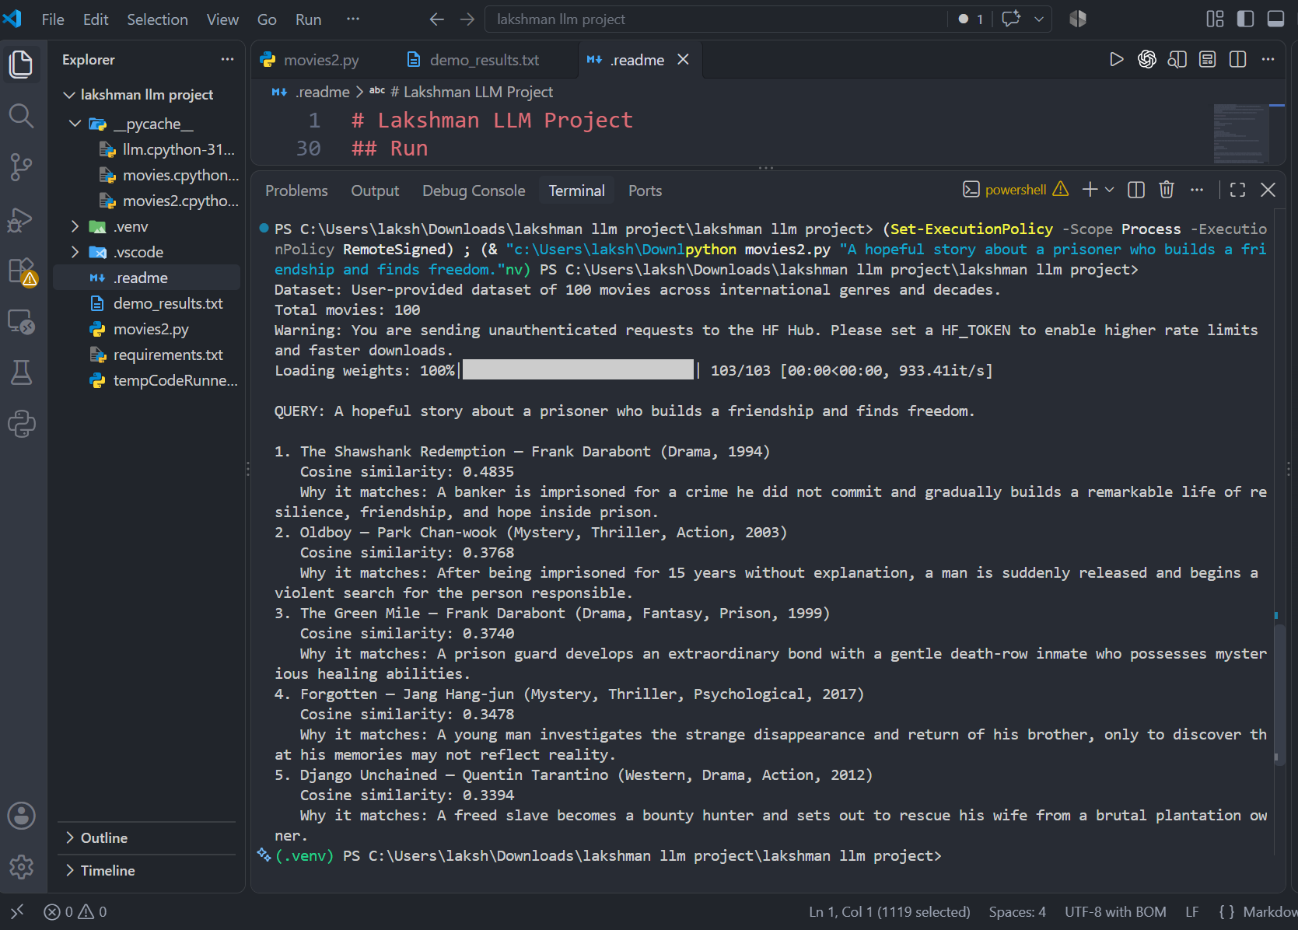

7.2 Query 2
Input: A suspenseful psychological thriller about a detective investigating strange murders.
Rank | Movie | Cosine Similarity | Manual Assessment
1 | Cure | 0.6755 | Highly relevant: detective, psychological themes and unexplained murders.
2 | Memories | 0.6334 | Highly relevant: police investigation and a series of murders.
3 | Memories of Murder | 0.6070 | Highly relevant: detectives investigate a series of murders.
4 | Dies Irae | 0.5459 | Partially relevant: psychological thriller and disturbing elements, but weaker detective/murder overlap.
5 | The Wailing | 0.5281 | Relevant: police investigation, strange incidents and mystery, but not an exact match.
Assessment: Cure, Memories and Memories of Murder are strong matches because they share investigation, murder and suspense concepts.
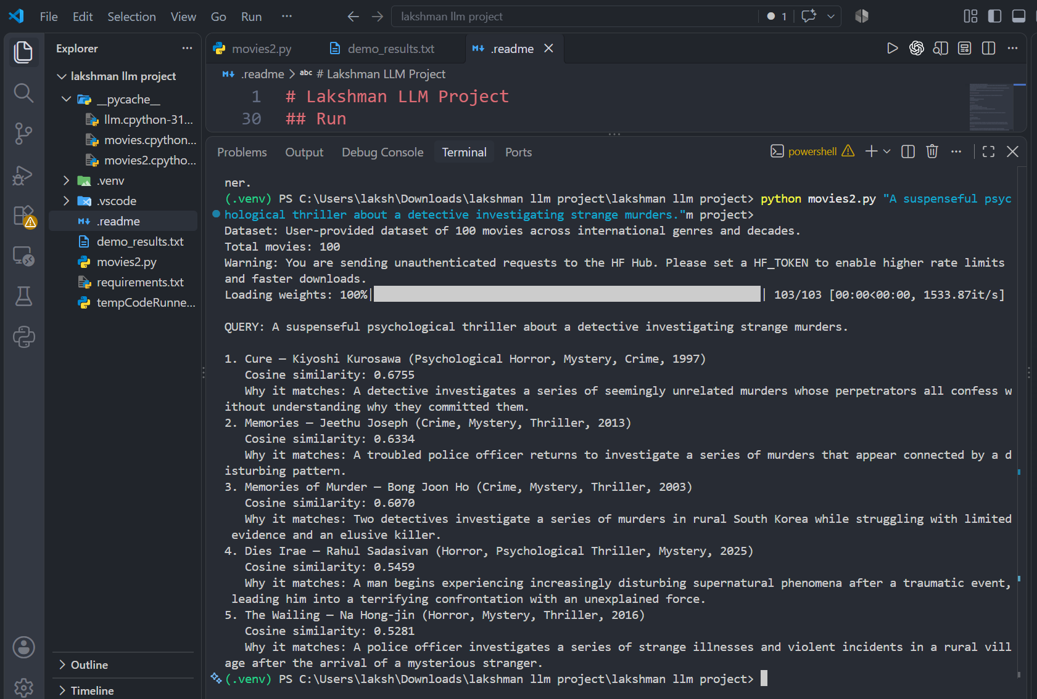

7.3 Query 3
Input: A heartwarming Indian sports drama about a parent training his daughters to become wrestlers.
Rank | Movie | Cosine Similarity | Manual Assessment
1 | Dangal | 0.5877 | Highly relevant: directly matches parent, daughters, wrestling and sports drama.
2 | Chhichhore | 0.4938 | Partially relevant: father/son relationship and overcoming failure, but not wrestling.
3 | Munna Bhai M.B.B.S. | 0.4213 | Weak/partial: family expectations and personal growth overlap, but not sports.
4 | Aavesham | 0.4201 | Weak: Indian setting and mentorship/young people overlap, but not the requested story.
5 | Aattam | 0.4131 | Weak/partial: Indian drama and social themes, but not sports or parent/daughters.
Assessment: Dangal is the clearest match because the query contains distinctive plot and relationship details.

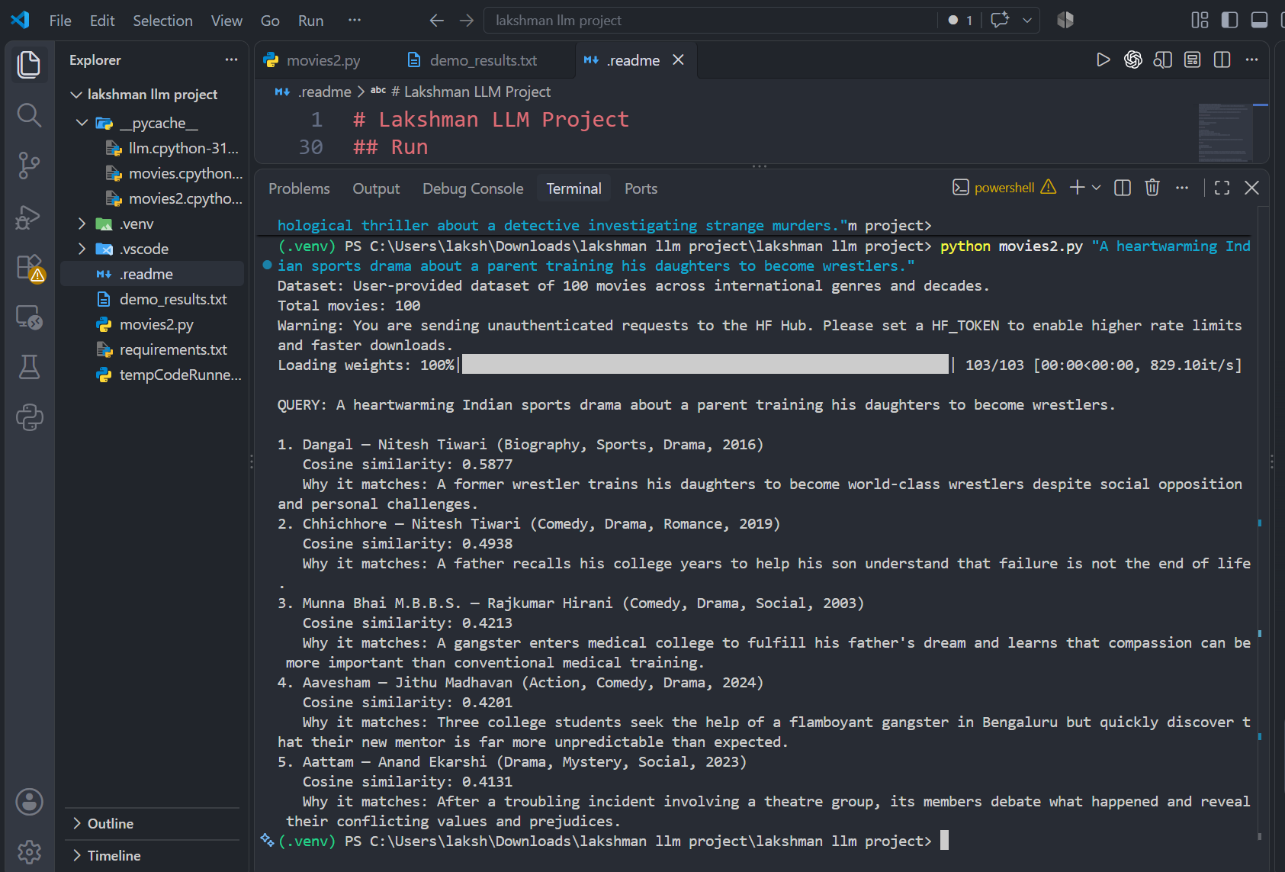

7.4 Query 4
Input: A surreal science-fiction adventure about alternate universes and family relationships.
Rank | Movie | Cosine Similarity | Manual Assessment
1 | Everything Everywhere All at Once | 0.4309 | Highly relevant: directly matches multiverse/alternate versions and family relationships.
2 | Incendies | 0.3977 | Partially relevant: strong family relationship and hidden-history themes, but not science fiction.
3 | Lokah: Chapter 1 – Chandra | 0.3695 | Partially relevant: supernatural/fantasy and hidden identity, but not alternate universes.
4 | Meiyazhagan | 0.3610 | Partially relevant: family reconnection and memories, but not science fiction.
5 | Forgotten | 0.3500 | Partially relevant: family relationship and altered/misleading memories, but not multiverse.
Assessment: Everything Everywhere All at Once is the strongest match. Other results capture only parts of the query.
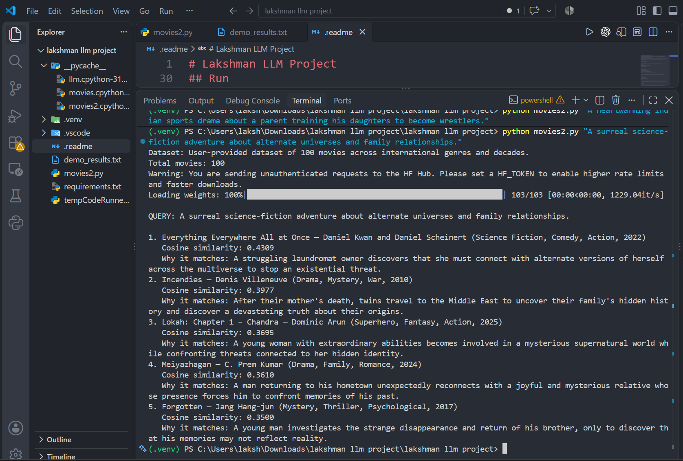

7.5 Query 5
Input: Recommend a good movie for tonight.
Rank | Movie | Cosine Similarity | Manual Assessment
1 | The Dark Knight | 0.4271 | Plausible general recommendation; the query gives no specific preference.
2 | Midnight in Paris | 0.4149 | Plausible general recommendation; no genre or theme is specified.
3 | The Shining | 0.3971 | Plausible movie, but horror is not requested.
4 | The Hangover | 0.3969 | Plausible entertainment choice, but no preference is specified.
5 | Incendies | 0.3969 | A valid movie but demonstrates the ambiguity of the broad query.
Assessment: This is deliberately broad. The varied genres show that the system has little basis for inferring what the user personally wants.

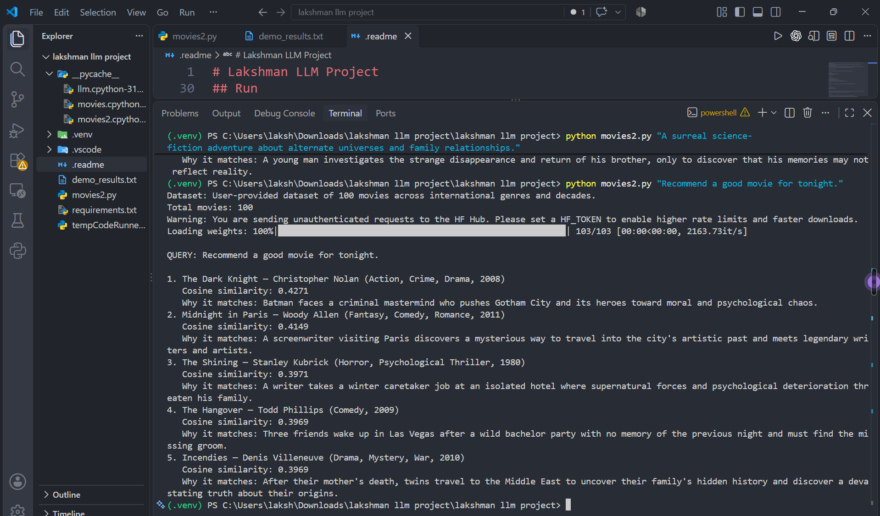

8. Analysis

8.1 Queries that worked well
The specific queries produced the clearest results. The prisoner/friendship query returned The Shawshank Redemption first; the detective/murder query returned Cure first; the wrestling query returned Dangal first; and the multiverse/family query returned Everything Everywhere All at Once first. These queries contained distinctive semantic clues.

8.2 Poor or ambiguous query
Recommend a good movie for tonight is deliberately broad. It contains no genre, mood, plot, setting or other preference, so the retrieved movies span several genres.

8.3 Related-but-not-intended results
Some movies share only part of the intended meaning. Oldboy shares prison/release concepts with the first query without being a hopeful friendship story. Incendies shares family themes with the multiverse query without being science fiction. This demonstrates that semantic similarity does not guarantee exact intent matching.

8.4 Semantic relationships captured
- Prison, friendship, resilience and hope.
- Detective investigation, murders, crime and psychological suspense.
- Parent-child relationships, sports, determination and social opposition.
- Alternate universes, identity, family relationships and existential threats.

8.5 Limitations
- The catalog contains only 100 movies.
- Retrieval quality depends on the manually prepared descriptions.
- Ambiguous queries provide weak retrieval signals.
- Semantic similarity is not identical to exact user intent.
- The embedding model influences the retrieved results.
- Cosine similarity does not measure movie quality or personal taste.

9. Input and Output Evidence
The final program accepts a natural-language query and supports a --demo mode for five evaluation queries. The terminal displays each query, five ranked movies, cosine similarity scores, explanations and manual relevance assessments.
Insert these screenshots before submission:
- VS Code project folder.
- Final movies2.py imports and model name.
- Embedding and cosine similarity code.
- Top-five ranking logic.
- Complete five-query terminal output.

10. Dependencies and Execution
requirements.txt contains:
numpy
sentence-transformers
scikit-learn
Run commands:
py -3.12 -m venv .venv
.venv\Scripts\Activate.ps1
pip install -r requirements.txt
python movies2.py --demo

11. Conclusion
The project successfully implements semantic movie retrieval using pretrained Sentence Transformer embeddings and cosine similarity. A dataset of 100 movies is embedded, the natural-language query is embedded using the same model, and the movies are ranked by cosine similarity to retrieve the top five. The evaluation shows that specific queries can retrieve semantically appropriate movies, while broad queries can produce less targeted results.

