

ASSESSMENT DECLARATION COVER SHEET

Please complete this cover sheet for each assessment submission. For group assessments, each group member must individually complete and submit a cover sheet.

STUDENT REGISTRATION NUMBER: 40596285
MODULE TITLE: LS002996 - SOC10101 - Honours Project
DATE OF SUBMISSION: 22/04/2026
I declare that, except where explicitly acknowledged*, this assessment is my own work and has not been submitted for any other module or degree programme at Edinburgh Napier University or any other institution. This declaration is made in compliance with Edinburgh Napier University’s Academic Integrity Regulations.
*IMPORTANT: Contributions from other sources include incorrectly cited quotations or content generated by Generative Artificial Intelligence (Gen AI) tools, such as ChatGPT. See Artificial Intelligence Tools and Your Learning for more information.
Note: It is also important to check the associated Assessment Brief to understand what is permissible. Unless stated in the Assessment Brief, use of Grammarly for checking spelling and grammar is allowable in this assessment, but it cannot be used to generate content.
Please declare here your use of such tools in this assessment submission:
(Select one of the two options below)
☐ | Yes, I have used Gen AI tools for this submission, and I have described how below.
☑ | No, I have not used Gen AI tools for this submission.
If you selected Yes, briefly describe (in less than 100 words) how you used these tools:

A Mobile Geolocation System for Exploration Using Fog-of-War Map Visualisation and Collaborative Data Sharing

  - Jack Millar

Submitted in partial fulfilment of
the requirements of Edinburgh Napier University
for the Degree of
BENG (HONS) SOFTWARE ENGINEERING

School of Computing, Engineering & The Built Environment
May 2026
Authorship Declaration
I, Jack Millar, confirm that this dissertation and the work presented in it are my own achievement.
Where I have consulted the published work of others this is always clearly attributed;
Where I have quoted from the work of others the source is always given. With the exception of such quotations this dissertation is entirely my own work;
I have acknowledged all main sources of help;
If my research follows on from previous work or is part of a larger collaborative research project I have made clear exactly what was done by others and what I have contributed myself;
I have read and understand the penalties associated with Academic Misconduct.
I also confirm that I have obtained informed consent from all people I have involved in the work in this dissertation following the School's ethical guidelines

Signed: Jack Millar

Date: 22/04/2026

Matriculation no: 40596285

General Data Protection Regulation Declaration
Under the General Data Protection Regulation (GDPR) (EU) 2016/679, the University cannot disclose your grade to an unauthorised person. However, other students benefit from studying dissertations that have their grades attached.

Please sign your name below one of the options below to state your preference.

The University may make this dissertation, with indicative grade, available to others.
JACK MILLAR

The University may make this dissertation available to others, but the grade may not be disclosed.

The University may not make this dissertation available to others.

Abstract
This dissertation presents the design, implementation, and evaluation of a mobile geolocation application that encourages real-world exploration through a fog-of-war map visualisation and collaborative data sharing. While modern navigation systems prioritise efficiency by guiding users along optimal routes, this project explores an alternative approach that promotes curiosity, spatial awareness, and user-driven exploration.
The developed system is an Android-based prototype that integrates GPS location tracking, OpenStreetMap visualisation, and local data persistence. The application dynamically reveals map areas as users physically explore their environment, using a fog-of-war mechanic to obscure unexplored regions. In addition, a QR-based sharing system enables users to exchange exploration data, supporting collaborative discovery without requiring a centralised backend.
A mixed-method evaluation was conducted, combining functional system testing with a four-week longitudinal user study. Quantitative metrics, including session frequency, distance travelled, and session duration, were collected to assess engagement, alongside qualitative feedback gathered through questionnaires and the System Usability Scale (SUS).
Results indicate that the system successfully promotes sustained engagement and exploratory behaviour, with participants demonstrating consistent usage and reporting increased motivation to explore and deviate from familiar routes. The application achieved high usability scores, with SUS results of 91% and 92.5% at midpoint and final evaluation respectively.
However, limitations were identified, including a small sample size, inflated session duration due to background tracking, and limited use of collaborative features. Future work will focus on improving scalability through backend integration, enhancing social features, and conducting larger-scale evaluations.
Overall, the findings suggest that exploration-focused design, supported by fog-of-war visualisation and lightweight gamification, can effectively encourage real-world exploration while maintaining a privacy-aware approach to location data.

Table of Contents
Abstract 5
List Of Tables 8
List Of Figures 8
1. Introduction 9
1.1 Project Aim 9
1.2 Project Objectives 9
1.3 Overview of the System 10
1.4 Dissertation Structure 10
2. Literature Review 10
2.1 Geolocation and Location-Based Systems 10
2.2. Exploration, Spatial Cognition, and the Role of Wandering 13
2.3 Gamification and Motivation 14
2.4 Existing Applications and Identified Gap 16
2.5 Summary and Link to Project 18
3. Methodology 19
3.1 Overview 19
3.2 Requirements Analysis 19
3.2.1 Functional Requirements 19
3.2.2 Non-Functional Requirements 20
3.2.3 Traceability Plan 20
3.3 System Design and Architecture 21
3.3.1 Design Rationale 21
3.3.2 Use Case Design 21
3.3.3 Data Flow Design 22
3.3.4 Class Design 22
3.3.5 Data Model Design 23
3.3.6 Deployment Architecture 24
3.3.7 User Interface Design 25
3.4 Software Development Methodology 26
3.4.1 Development Approach 26
3.4.2 Tools, Libraries, and Frameworks 26
3.4.3 Version Control and Project Management 26
3.4.4 Technology Justification and Alternatives 27
3.5 Evaluation Methodology 29
3.5.1 Evaluation Goals 29
3.5.2 Evaluation Design Overview 29
3.5.3 Requirements-based system evaluation 29
3.5.4 Longitudinal study methodology 30
3.5.5 Logging and privacy-aware instrumentation 30
3.5.6 Success Criteria 30
3.5.7 Procedure 31
4. Implementation, Testing and Evaluation 31
4.1 System Implementation 31
4.1.1 Map Integration 32
4.1.2 Location Tracking and Path Recording 33
4.1.3 Fog-Of-War Rendering 33
4.1.4. Exploration Data Persistence 34
4.1.5 Exploration Data Sharing 34
4.1.6 Settings and User Controls 35
4.1.7 Summary of Implementation 35
4.2 Testing Strategy 36
4.2.1 Functional Feature Testing 36
4.2.2 Testing Results and Observations 38
4.2.3 Limitation: QR Code Data Capacity 39
4.3 Evaluation Results 39
4.3.1 Study Objectives 39
4.3.2 Participants 40
4.3.3 Evaluation metrics 40
4.3.4 Logging and Data Collection 40
4.3.5 Quantitative Results 41
4.3.6 Qualitative feedback 42
Overall, the qualitative feedback suggests that the application positively influences user motivation and exploratory behaviour. However, these findings are influenced by the study context, limited sample size, and reliance on self-reported data. As such, while the fog-of-war mechanic appears effective, further large-scale and controlled studies would be required to confirm its long-term impact. 43
5. Conclusion 43
5.1 Overview of the Project 43
5.2 Achievement of Objectives 43
5.3 Evaluation Summary 43
5.4 Limitations 43
5.5 Future Work 44
5.6 Final Reflection 45
References 45
APPENDIX 1 Personal Appraisal 48
APPENDIX 2 Initial Project Overview 49
APPENDIX 3 Interim Feedback 52
APPENDIX 4 Diary Sheets 52
APPENDIX 5 – Participant Information Sheet + Informed Consent Forms 54

List Of Tables
Table 1 - Advantages/Disadvantages of Mobile Platforms 26
Table 2 – Evaluation Checklist 34
Table 3 - Application Logging Data Fields 38

List Of Figures
Figure 1. Tracks Obtained Using AGPS, GPS and Cellular Triangulation 13
Figure 2. The Heidelberg GPS Track 13
Figure 3. Overview of Mobile Application “MapUncover” 15
Figure 4. The perceived positive and negative effects on exercise motivation and behaviour from using the exercise application 16
Figure 5. A screenshot from the main Pokémon capture minigame of Pokémon GO 17
Figure 6. Use Case Diagram 21
Figure 7. Data Flow Design 22
Figure 8. Class Design 22
Figure 9. Data Model Design 23
Figure 10. Deployment Architecture 24
Figure 11. UI Design: Map 24
Figure 12. UI Design: Settings 25
Figure 13. Main Map Interface 30
Figure 14. Distance (km) travelled per Participant 38

1. Introduction
Digital mapping technologies have fundamentally changed how people interact with physical environments. Modern smartphones integrate GPS, mobile connectivity, and mapping platforms to provide real-time navigation and location-based services. While these systems offer clear benefits, they are typically designed to optimise efficiency by guiding users along the fastest or most direct routes.
Although efficient navigation is valuable, it can reduce opportunities for exploration and discovery. Heavy reliance on turn-by-turn guidance may limit spatial awareness and discourage users from deviating from suggested paths, reducing exposure to new locations and experiences.
This project explores an alternative approach by designing a system that encourages exploration rather than efficiency. It applies a fog-of-war mechanic, where unexplored areas of a map remain hidden and are gradually revealed through Physical movement. This approach aims to promote curiosity, engagement, and spatial awareness.
To address gaps in existing systems, this project develops a mobile geolocation prototype that combines fog-of-war visualisation with collaborative data sharing. The system reveals map areas based on real-world exploration and enables users to exchange exploration data via QR codes, supporting collaborative discovery without requiring a centralised backend.

Project Aim
The aim of the project is to design, implement, and evaluate a prototype mobile geolocation application that encourages real-world exploration through a fog-of-war map mechanic and collaborative map sharing.

Project Objectives
To achieve this aim, the project pursues the following objectives:
- Investigate existing research on geolocation systems, spatial exploration, and gamification.
- Design a mobile application architecture capable of supporting fog-of-war map exploration.
- Implement a prototype application that records user movement and dynamically reveals explored map regions.
- Provide features that support collaborative exploration through QR-based data sharing.
- Evaluate the usability and engagement of the prototype through structured testing and user feedback

Overview of the System
The developed system is a mobile Android application that allows users to explore their physical environment while gradually revealing areas of a digital map. The application uses GPS location data to track user movement and record path points. These path points are used to determine which regions of the map should be revealed.
The application provides several key features:
- A fog-of-war exploration layer that reveals areas as users move
- Integration with OpenStreetMap for map rendering
- Points of Interest (POIs) that users can discover while exploring
- A settings interface allowing users to customise map layer colour and manage data
- QR-code based sharing that allows users to combine exploration data with friends
The system architecture uses a modular design that separates user interface components, domain logic, and data persistence.

Dissertation Structure
This dissertation is organised as follows:

Chapter 2 – Literature Review
Reviews research on geolocation technologies, spatial exploration behaviour, and gamification system. Existing applications are analysed to identify gaps that motivate the project.

Chapter 3 – Methodology
Describes the requirements analysis, system architecture, software development approach, and evaluation methodology used during the project

Chapter 4 – Implementation, Testing and Evaluation
Presents the implemented system, demonstrating how the prototype satisfies the project requirements. The chapter also details the testing strategy and results from system evaluation and user testing.

Chapter 5 – Conclusion
Summarises the outcomes of the project, reflects on how effectively the aims and objectives were achieved, and outlines potential directions for future development.

2. Literature Review

2.1 Geolocation and Location-Based Systems
The invention and development of geolocation technologies have fundamentally changed how people move through and interpret their surroundings. Modern location-based services (LBS) use real-time geodata from smartphones and other connected devices to provide navigation, information, entertainment and security services (Freedman, 2023).
From a cartographic perspective, the way spatial information is presented can significantly influence user behaviour and interpretation. MacEachren (1995) debates that maps are not neutral representations but interactive tools that shape how users explore and understand space. Design choices such as visibility, abstraction, and layering can therefore directly influence how users engage with geographic environments.
At the core of many of these systems is the Global Positioning System (GPS), which offers continuous, worldwide, three-dimensional position and velocity information to any user with suitable receiving equipment (Kaplan & Lewis, 1997). GPS receivers operate passively, allowing an unlimited number of users to access the system without affecting its performance, which has made GPS a dominant global standard.
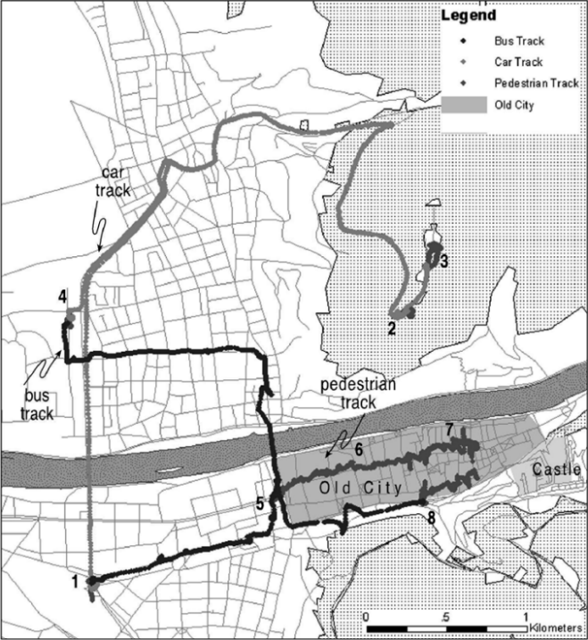
Historically, GPS was developed for military and only later opened to civilian use. The system became fully operational in the mid-1990s, and selective availability (a system that artificially degraded accuracy for civilian devices) was disabled in 2000. This enabled much more precise location fixes for non-military uses (Kaplan & Lewis, 1997). As access improved, GPS became so pervasive that the term itself is often used generically for satellite-based positioning.
Shoval and Isaacson (2007) provide an early empirical investigation into the viability of different LBS technologies for tracking people in real-world environments. In their Heidelberg experiment (Figure 1) a participant followed a predefined route through narrow streets and alleyways while carrying a GPS receiver. Despite the dense urban environment and changes in mode of transport (walking, bus, car), the receiver remained fully functional and was able to determine position with a high degree of accuracy. An interesting side effect was that the pattern of recorded points varied depending on the type of transportation, enabling the researchers to infer whether the subject was travelling on foot or by vehicle.
Figure 2. The Heidelberg GPS Track
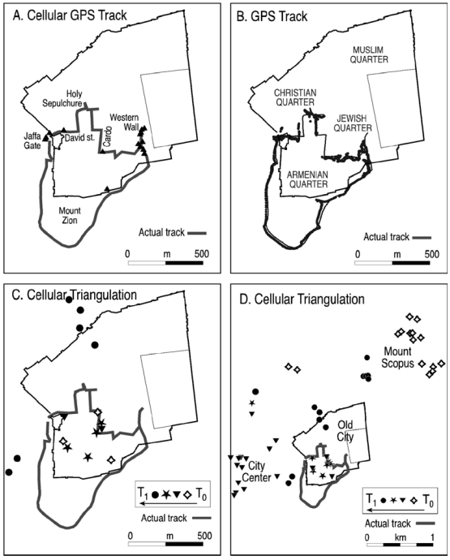
In a follow-up experiment in Jerusalem, Shoval and Isaacson (2007) compared three approaches along the same track: GPS, Assisted GPS (A-GPS) and cellular triangulation - as seen in Figure 2. A-GPS, constrained by the cellular network, sampled location at a lower frequency (e.g. every 30 seconds) but still produced a coherent and reasonably accurate path, except in some vehicular conditions where it struggled to keep up. Cellular triangulation was far less precise; it generated sparse, coarse points that could only identify the general area (such as being “within the Old City”) and were insufficient to reconstruct the actual route. By contrast, GPS provided relatively dense and accurate data, albeit with some degradation under covered streets. These results highlight that while multiple technologies can support location tracking, they differ substantially in accuracy, sampling rate and suitability for detailed behavioural analysis.
Figure 1. Tracks Obtained Using AGPS, GPS and Cellular Triangulation
At the same time, the increasing precision and ubiquity of tracking raise ethical and social concerns. Curry (2000) discusses how remote surveillance systems and GPS, especially when tied to geographic information systems, contribute to a world in which every location can be mapped, cross referenced and compared with other events. He argues that such technologies challenge traditional norms of privacy and can erode spatial boundaries and aspects of the self. Regulatory bodies echo these concerns: UK guidance treats location and geolocation data as forms of personal data that can reveal sensitive information about an individual’s movements and routines, and therefore must be collected and processed transparently and proportionately (Information Commissioner's Office , 2020).
Overall, geolocation technologies and LBS provide a technical foundation for robust systems that track movement and support navigation, but the choice of technology (GPS, A-GPS, cellular), environmental conditions and sampling strategy all influence data quality. At the same time, the ability to continuously collect and store location traces brings privacy and ethical responsibilities that must be considered in the design of any exploration-focused application. The system developed in this project builds on the strengths of GPS-based LBS while aiming to minimise unnecessary data collection and to keep tracking at an appropriate level for a prototype.
More recent work highlights how LBS have evolved beyond navigation into context-aware systems that adapt to user behaviour and environment, further expanding their role in everyday decision-making (Raper et al, 2007) (Steiniger et al. 2006).

2.2. Exploration, Spatial Cognition, and the Role of Wandering
Although geolocation technologies can make it easy for users to find places, they can subtly change how people learn and experience their environments. Barkhuus (2019) examines how newcomers use mobile location technologies when exploring a new city and finds that these tools often turn exploration into a digital search task. Participants relied on maps and search functions to locate specific destinations, but described offline wandering (defined as; moving without a strict plan) as a kind of “premium” activity
This distinction between guided navigation and open-ended exploration reflects broader theoretical perspectives on movement through space. de Certeau (1984) describes walking as a form of spatial practice, where individuals actively construct meaning through their movement rather than simply following predefined routes. From this perspective, wandering is not inefficient behaviour but a meaningful process that allows individuals to engage with and interpret their environment in a more personal and exploratory way.
Exploration behaviour has also been studied in the context of spatial learning, where active movement through an environment improves Cognitive mapping and spatial understanding. Early foundational work by Tolman (1948) introduced the concept of Cognitive maps, suggesting that individuals build internal representations of their environment through experience. Building on this, Montello (1998) argues that direct navigation experience plays a key role in forming accurate mental representations of space, particularly in large-scale environments. This supports the idea that systems encouraging Physical exploration, rather than passive navigation, can enhance spatial awareness and engagement.
In addition, exploration has been linked to intrinsic curiosity and information-seeking behaviour, Berlyne (1960) conceptualises curiosity as a response to novelty and uncertainty, while Loewenstein (1994) further explains that individuals are motivated to seek information in order to reduce knowledge gaps. More recent work by Litman (2010) distinguishes between different types of curiosity, including interest-based curiosity and deprivation-based curiosity, both of which can drive exploratory behaviour in different ways.
Spatial cognition research helps explain why this matters. Weisberg and Newcombe (2018) argue that some individuals readily form detailed cognitive maps to integrate different routes into a coherent representation of space, whereas others struggle to connect locations and rely more heavily on landmark-based or route-based strategies. They also discuss spatial anxiety: people who feel anxious tend to perform worse on spatial tasks, though it is unclear whether anxiety causes poor performance or whether repeated difficulties lead to anxiety, Either way, high spatial anxiety can discourage individuals from exploring unfamiliar environments, reinforcing reliance on external guidance.
He (2020) examines how GPS use relates to exploration behaviour and navigation ability. The study reports that individuals with lower spatial activity tend to explore their surroundings more actively and depend less on GPS for guidance, whereas frequent GPS users perform worse on several navigation measures, including travel efficiency, number of stops, direction estimation and sketch map accuracy. The widespread availability of GPS means that users can navigate it primarily by following turn-by-turn instructions, which reduces the cognitive effort involved in wayfinding but also limits the opportunities to build and refine internal representations of the environment.
These findings are further supported by experimental studies comparing navigation methods. Ishikawa et al. (2008) found that participants who relied on GPS navigation systems performed significantly worse in spatial knowledge tasks compared to those using maps or direct navigation experience. GPS users were less able to estimate directions, recall routes, and construct accurate sketch maps, suggesting that reliance on automated navigation can reduce engagement with the environment and hinder the development of spatial understanding.
These sources suggest that systems designed purely around efficiency may contribute to weaker cognitive maps and an over-reliance on external aids. In response, researchers have begun to explore ways of designing digital tools that actively support exploration and spatial learning. Schade et al. (2023) introduced MapUncover, a mobile map application that employs a “fog-of-war” mechanic: unexplored areas of the map are obscured and gradually revealed as users move through the environment (Figure 3). In their study, the fog-of-war design led to a significant increase in participants’ familiarity with the environment and encouraged a variety of exploration patterns. Participants reported discovering alternative routes and new meaningful places, and qualitative feedback suggested that the process of uncovering hidden map regions felt engaging rather than burdensome.
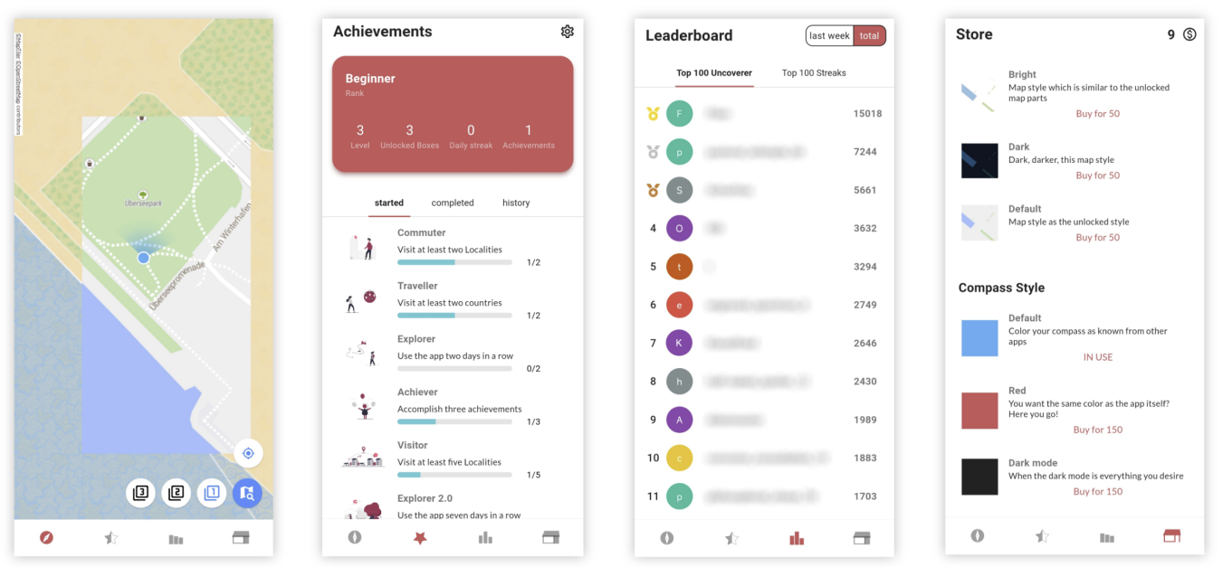
Figure 3. Overview of Mobile Application “MapUncover”
Taken together, this literature indicates that exploration is not just a by-product of navigation but a valuable activity that supports richer spatial knowledge and more satisfying relationships with place. Wandering and self-directed route choice allow users to encounter new environments, while designs that withhold complete information—such as fog-of-war—can gently encourage exploration without forcing it (Barkhuus, 2019) (He, 2020) (Weisberg & Newcombe, 2018) (Schade et al, 2023). For the project at hand, this implies that an effective exploration-focused system should limit full map foresight, make exploration progress visible and rewarding, and avoid simply providing optimal routes from A to B.

2.3 Gamification and Motivation
Gamification has emerged as a popular strategy for increasing engagement in digital systems by incorporating game-like elements into non-game contexts. Deterding et al (2011) defines gamification as the use of game design elements in non-game contexts, distinguishing it from “serious games”, which are full games designed for purposes beyond entertainment. Industry perspectives such as Bunchball (2010) similarly describe gamification as the application of game dynamics to encourage participation, sharing and interaction within websites, services or communities. This can be done through various mechanics, such as points, badges, or leaderboards, as again seen in Figure 3.
Within mobile applications, gamification is often used as a strategy to boost user motivation. Self-Determination Theory (SDT) suggests that intrinsic motivation is nurtured when individuals feel competent, autonomous and connected to others (Ryan & Deci, 2000). Features such as progress tracking, challenges and social elements can help satisfy these needs by making users feel effective and in control of their choices, as well as make them feel part of a community.
This aligns with the concept of flow, introduced by Csikszentmihalyi (1990), which describes a state of deep engagement and immersion that occurs when individuals are fully absorbed in an activity. Flow is most likely to occur when there is a balance between challenge and skill, suggesting that systems which gradually reveal progress and provide continuous feedback (such as fog-of-war exploration) can promote sustained engagement and enjoyment.
However, the relationship between extrinsic rewards and intrinsic motivation is complex. A analysis by Deci et al. (1999) found that excessive reliance on external rewards can undermine intrinsic motivation, particularly when rewards are perceived as controlling rather than supportive. This reinforces the importance of designing gamification systems that support Autonomy and engagement, rather than simply incentivising behaviour through points or rewards.
Similarly, Wells et al. (2014) demonstrate that gamification can influence real-world travel behaviour through structured rewards and challenges. However, such systems are typically designed to promote predefined outcomes, such as sustainable travel, rather than open-ended exploration. This highlights a distinction between behaviour-driven gamification and exploration-driven systems, reinforcing the gap addressed by this project.
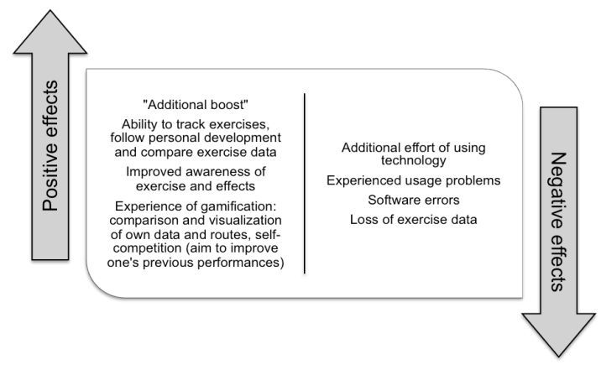
Studies on gamified exercise and wellness applications show that, when designed carefully, game elements can enhance motivation. Piippo and Kari (2016) found that tracking one’s own exercise was a key motivating factor for almost all participants in their study of a exercise application (Figure 4). Many of the participants noted that being able to follow their personal development positively affected their motivation to be physically active. Sharing exercise data within an online service was seen as a positive, and about half of the participants did mention that seeing other people’s exercise data created a form of peer pressure that encouraged them to increase their own activity.
Figure 4. The perceived positive and negative effects on exercise motivation and behaviour from using the exercise application
Giannakis and Jaccheri (2013) similarly highlight that augmented feedback from mobile self-tracking devices can promote working out by making progress more visible and tangible. Ahtinen et al. (2009) investigated social features in mobile wellbeing applications and found that social interaction: which can include peer support, cooperation, competition, and a sense of belonging to a group, can increase perceived community and act as a clear motivator for wellness activities such as physical exercise. These findings align with broader evidence that well-designed gamification can positively influence user behaviour, particularly when feedback, rewards, and social mechanisms are aligned with user goals (Hamari, Koivisto, & Sarsa, 2014)
At the same time, other scholars caution against relying solely on extrinsic rewards. In his work on meaningful gamification, Nicholson (2015) argues that if the goal is long-term change, rewards should be used sparingly and gradually replaced by more meaningful ways of engaging with the underlying activity but value should diminish over time, as users find intrinsic reasons to continue. Otherwise, behaviour is likely to stop when the rewards stop.
Location-based games provide concrete example so of how gamification can be applied to physical exploration. Examples include Pokémon Go, where you explore the real-world locations to collect creatures and capture gyms, as well as limited time events. A report on Pokémon Go by Laato (2020) notes that playing can increase users physical activity levels, social interaction and awareness of their local area, although these effects are often strongest in the short term. Gamified map applications such as MapUncover also explores this idea by directly tying game elements to spatial exploration: revealing fogged map regions becomes a form of progress, and participants in Schade et al’s (2023) study reported that this mechanic encouraged them to explore alternative routes and discover new meaningful places.
For the proposed project, these insights suggest that gamification should be used to support, rather than replace, intrinsic motivation to explore. Features such as fog-of-war, progress visualisation (percentage of area uncovered) and simple social features (e.g. sharing coverage with friends) can support feelings of competence, autonomy and relatedness with others ( (Ryan & Deci, 2000); (Ahtinen, et al., 2009); (Piippo & Kari, 2016)). At the same time, following Nicholson’s (2015) guidance, the system should avoid over-emphasising external rewards; the aim is to make exploration itself engaging and satisfying, rather than to trap users in a cycle of points collection.

2.4 Existing Applications and Identified Gap
A range of existing applications and systems already relate to the to idea of geolocation exploration and gamification, however they only focus typically on part of the design space. Commercial navigation apps such as Google Maps or Apple Maps are optimised for efficiency: they show fully detailed maps by default and guide users along optimal routes, offering little incentive to deviate or wander. Fitness and tracking apps use GPS to record movement histories and present as static maps or heatmaps, which can motivate activity but generally treat exploration as incidental rather than central.
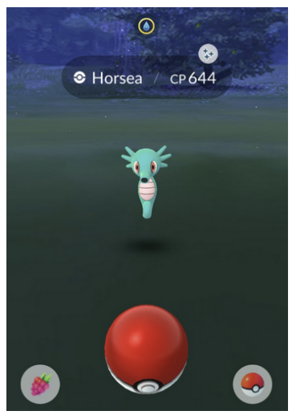
Location-based games like Pokémon Go demonstrate that game mechanics can integrate with real world scenarios to successfully motivate physical activity and local exploration (Laato, Hyrynsalmi, Rauti, & Sutinen, 2020). However, exploration in such systems is often driven by discrete in-game goals (e.g. visiting Pokéstops or capturing Pokémon (Figure 5)) rather than by a continuous sense of discovery. Fog-of-war style applications such as Fog of World focus more directly on exploration by obscuring unexplored and revealing them as users travel, but they typically emphasise individual progress and are not always designed with collaborative map sharing in mind.
Further research supports these findings, with Kamel Boulos et al. (2017) highlighting that augmented reality games such as Pokémon Go can significantly increase Physical activity, social interaction, and engagement with local environments. However, these effects are often dependent on sustained motivation and meaningful interaction design, reinforcing the importance of carefully balancing game mechanics with intrinsic engagement.
Figure 5. A screenshot from the main Pokémon capture minigame of Pokémon GO
Research prototypes such as MapUncover (Schade, Savino, Niess, & Schoning, 2023) come closer to the aims of this project. MapUncover introduces a fog-of-war mechanic into a mobile map app and demonstrates that this design can promote spatial exploration, greater familiarity with the environment and the discovery of new routes and places. However the emphasis is on individual exploration and evaluation, so there is less focus on how multiple users can collaborate to build a shared picture of their environment or how long-term engagement could be supported through meaningful gamification.
The literature and existing systems therefore suggest a gap at the intersection of three areas:
- Exploration-centred design, where wandering and discovery are treated as core goals rather than side effects;
- Fog-of-war and layered visibility, where unexplored and partially explored areas are visually distinguished; and
- Collaborative geolocation experiences, where multiple users can share and combine their exploration journey to construct a richer representation place.
Additionally, while many location-based games and apps collect large amounts of location data, few explicitly prioritise privacy-aware design or restrict data collection to what is strictly necessary for exploration. So the concerns raised by Curry (2000) and current regulatory guidance paint a clear picture for the scope of a new system that support collaborative, gamified exploration while taking a cautious and proportionate approach to handling location data.
Despite the availability of navigation and location-based applications, existing systems primarily prioritise efficiency over exploration and rarely integrate collaborative exploration features with privacy-aware design. As such, there is a need for a system that encourages exploration, visualises progress, and supports lightweight collaboration without reliance on centralised data storage. No existing system effectively combines exploration-driven design, fog-of-war visualisation, and privacy-aware collaborative sharing in a lightweight mobile application.
The project described in this dissertation aims to address this gap by designing and implementing a prototype geolocation system that places exploration at the centre of the user experience, uses fog-of-war and layered visibility to make exploration progress visible, and includes basic collaborative features that allow friends to share their coverage and jointly reveal more of the map.

2.5 Summary and Link to Project
This chapter has reviewed relevant literature on geolocation and LBS, spatial cognition and exploration, and gamification and motivation, as well as related applications. Geolocation technologies such as GPS provide the technical basis for continuous, worldwide positioning ( (Kaplan & Lewis, 1997); (Shoval & Isaacson, 2007) ), but their use raises ethical concerns around privacy and surveillance ( (Curry, 2000); (Information Commissioner's Office , 2020)). Studies on spatial cognition and GPS use indicate that heavy reliance on turn-by-turn navigation can limit exploration and hinder the development of robust cognitive maps, particularly for individuals with higher spatial anxiety ( (Weisberg & Newcombe, 2018); (He, 2020); (Barkhuus, 2019)). At the same time, research on fog-of-war style systems such as MapUncover suggests that obscuring unexplored areas and revealing them through movement can promote exploration and environmental familiarity (Schade, Savino, Niess, & Schoning, 2023).
The gamification literature shows that integrating game elements—such as progress tracking, feedback and social interaction—into non-game contexts can enhance motivation and engagement when these elements support basic psychological needs for competence, autonomy and relatedness ( (Ryan & Deci, 2000); (Piippo & Kari, 2016); (Ahtinen, et al., 2009); (Hamari, Koivisto, & Sarsa, 2014) ). However, meaningful gamification requires careful design to avoid over-reliance on extrinsic rewards and to encourage users to find intrinsic value in the underlying activity (Nicholson, 2015).
Taken together, these insights inform several key requirements for the proposed system:
- It should support and visualise exploration rather than only providing efficient routes.
- It should use fog-of-war or layered visibility to represent what has been explored, both individually and collaboratively.
- It should incorporate lightweight gamification and social features that support competence, autonomy and relatedness without relying solely on external rewards.
- It should handle location data cautiously, collecting and storing only what is necessary for exploration and evaluation and acknowledging the privacy implications of tracking.
These requirements shape the design and implementation described in the next chapter, which outlines the methodology used to develop and evaluate the prototype exploration-focused geolocation application.

3. Methodology

3.1 Overview
This chapter describes the approach used to design, develop, and evaluate a prototype mobile application that encourages real-world exploration through a fog-of-war mechanic. The methodology covers:
- Requirements, analysis and prioritisation
- System design and architecture
- Development process and tooling
- Evaluation and testing
The project is implemented as a mobile application that displays an OpenStreetMap map, tracking the user’s location using device GPS, records exploration paths to a local JSON-based store, and reveals map regions as the user moves. The persistence layer was initially designed around SQLite, but JSON was used in the implemented prototype to support rapid iteration.

3.2 Requirements Analysis

3.2.1 Functional Requirements
Requirements were derived using a structured, elicitation analysis approach based on:
- Findings from the literature review on exploration, spatial cognition, fog-of-war systems, and privacy-aware handling of geolocation;
- Feature decomposition from the proposed user experience (map exploration, settings, POIs, sharing); and
- Iterative refinement using early diagrams and UI mock-ups to validate feasibility and user flow.
Because the prototype was conducted as a single-student honours project with a limited development timeframe, functional requirements were prioritised using the MoSCoW method (Must-have, Should-have, Could-have, Won’t-have). This prioritisation ensured that the core exploration functionality could be implemented first while additional features were considered optional extensions.
Must Have
FR1 | Display a map using OpenStreetMap tiles
FR2 | Obtain the user’s position using GPS services
FR3 | Record user location points during movement
FR4 | Reveal explored areas using a fog-of-war mechanic
FR5 | Generate a QR code containing shareable exploration data
FR6 | Import exploration data by scanning a QR code
FR7 | Display imported exploration data as an overlay layer
Should Have
FR8 | Provide a “Centre on user location” map function
FR9 | Provide a clear-cache function to remove exploration data
FR10 | Display various exploration states using layered visibility
FR11 | Provide a function to export study logging data
Could Have
FR12 | Store points of interest
FR13 | Display POI markers on the map
FR14 | Detect when a POI has been discovered
FR15 | Display clear exploration state around discovered POI
Won’t Have
FR16 | Customisation of exploration layer colours

The MoSCoW prioritisation ensured that the core mechanics (GPS tracking, fog-of-war rendering, and collaborative sharing) were implemented first. Features such as Points of Interest (POIs) and map customisation were classified as lower priority enhancements and were therefore not implemented in the final prototype due to time constraints. However, the system architecture was designed to support these extensions in future development.
These requirements listed here and in the following section were later mapped to system design components and testing procedures to ensure that the implemented prototype satisfied the core functional goals of the project.

3.2.2 Non-Functional Requirements
These requirements focus on performance, privacy, and usability, but are not crucial to the running of the application. Nevertheless they are important due to the sensitivity and resource costs incurred by having a location-based system.
ID | Requirement
NFR1 | Minimise stored location data and only record information necessary for exploration visualisation and evaluation.
NFR2 | Provide clear indication when location data is being used and allow users to clear stored data.
NFR3 | Render exploration overlays smoothly without excessive battery usage.
NFR4 | Persist exploration data locally across application restarts
NFR5 | Maintain map interaction behaviour consistent with common mobile map interfaces

3.2.3 Traceability Plan
A simple traceability approach was used to ensure that requirements were reflected in the design, implementation, and testing of the prototype. Each core requirement was linked to one or more system components and to corresponding system tests.
For example, GPS-related requirements were linked to the location service and map management logic, while sharing requirements were linked to the QR management component. Likewise, non-functional requirements such as persistence and privacy were reflected in the local JSON storage approach, cache-clearing functionality, and lifecycle testing. This traceability helped maintain alignment between the original project objectives, the implemented features, and the final evaluation.

3.3 System Design and Architecture

3.3.1 Design Rationale
The system was designed to support a mobile exploration experience centred around a fog-of-war map mechanic. The design needed to address several challenges, including the separation of user interface components from application logic, efficient handling of location data, privacy-aware storage of exploration information, and the ability to share exploration progress between users without requiring a central server.
To support these goals, the system was designed using a modular architecture in which responsibilities are divided between distinct components responsible for map rendering, exploration tracking, data persistence, and sharing functionality. This modular approach improves maintainability and allows individual components to evolve independently as the project progresses.
It is important to note that the design described in this section represents the intended system architecture developed during the design phase of the project. As the project progressed through iterative development, some elements of the design were simplified or modified during implementation. These changes are discussed in Chapter 4.

3.3.2 Use Case Design
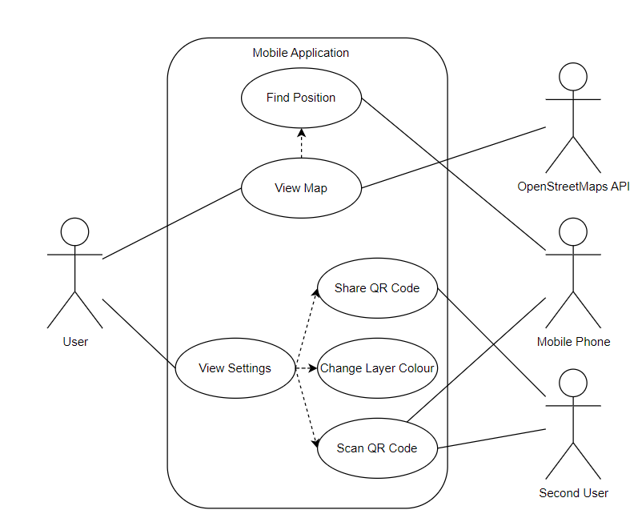
The system’s primary user interactions are represented in the use case diagram (Figure 6).
Figure 6. Use Case Diagram
The diagram illustrates the interaction between the user and the mobile application, as well as external actors such as the OpenStreetMap API and a second user who may share exploration data. The main user interactions include viewing the map, locating the user’s position, accessing the settings interface, sharing exploration data through QR codes, and importing exploration data from another user.
These use cases define the primary functional behaviour expected from the system. The View Map use case acts as the central interaction, with additional functionality such as Find Position, Share QR Code, Scan QR Code, and Change Layer Colour extending the core functionality. The diagram also illustrates how map data is retrieved from the OpenStreetMap API and how exploration information can be exchanged between devices.
This use case model helped define the scope of the system and guided the identification of functional requirements during the requirements analysis stage.

3.3.3 Data Flow Design
To better understand how information moves through the system, a data flow diagram was created (Figure 7). This diagram illustrates the movement of location data, map interactions, and user actions within the system.
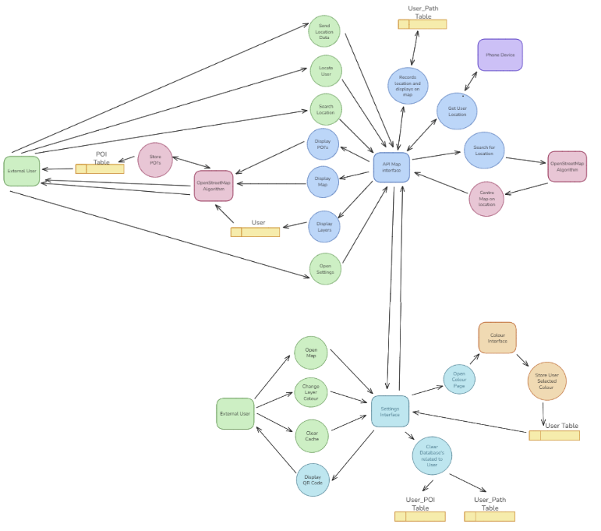
The external user interacts with the application through the map interface, performing actions such as sending location data, searching for locations, and viewing the map. These actions are processed through the map interface layer, which communicates with the OpenStreetMap algorithm to retrieve map tiles and render map content.
Figure 7. Data Flow Design
Location information is obtained from the mobile device and recorded within the user path table. This path data is used to determine which areas of the map should be revealed through the fog-of-war system. The diagram also illustrates the storage of POI data and the display of map layers representing exploration progress.
The settings interface is represented as a separate interaction point where the user can modify system settings, clear stored data, and share exploration information.
This data flow model helped clarify how different parts of the system communicate and ensured that data processing responsibilities were clearly separated between components.

3.3.4 Class Design
The class diagram (Figure 8) represents the object-oriented design of the system. It identifies the key entities and services used to manage exploration data, user interactions, and sharing functionality.
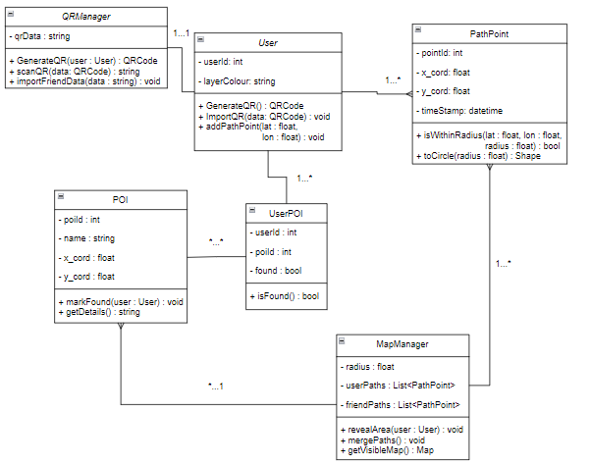
The User class represents an individual user of the system and stores user-specific settings such as the selected map layer colour. The class also contains methods for generating QR codes and importing shared exploration data.
Figure 8. Class Design
The PathPoint class represents a recorded location coordinate with an associated timestamp. These objects are created whenever a user moves through the environment and are used to track exploration progress. PathPoint objects include methods for determining whether a point falls within a reveal radius and for converting coordinates into geometric shapes used in map rendering.
The MapManager class manages the fog-of-war exploration logic. It stores lists of recorded user paths and shared paths from other users. Its responsibilities include revealing explored areas, merging paths received from other users, and generating the visible map overlay displayed in the application.
The QRManager class handles the generation and scanning of QR codes used to share exploration data between users. This approach enables collaborative exploration without requiring a centralised backend server.
The design also includes POI and UserPOI classes to support potential Points of Interest functionality. POI objects store static location definitions, while UserPOI objects track whether a user has discovered a particular location. Although this functionality was included in the design phase, it was considered an optional extension to the core exploration system.

3.3.5 Data Model Design
The system’s data structure was further defined using an entity-relationship diagram (Figure 9). The ER diagram defines four primary entities:
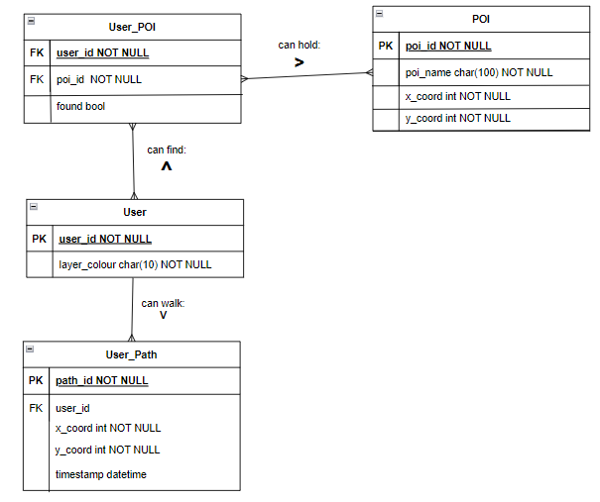
User
Figure 9. Data Model Design
Represents an individual application user. Each user has a unique identifier and may store configuration information such as the preferred exploration layer colour.
User_Path
Stores the path points recorded as a user moves through their environment. Each path entry includes geographic coordinates and a timestamp representing when the location was recorded.
POI
Represents a predefined point of interest within the map. Each POI includes a name and geographic coordinates
User_POI
This table links users and POIs and records whether a particular user has discovered a given point of interest.

This relational model supports efficient querying of exploration data and enables features such as tracking visited locations, identifying POI discoveries, and maintaining user-specific exploration progress.

3.3.6 Deployment Architecture
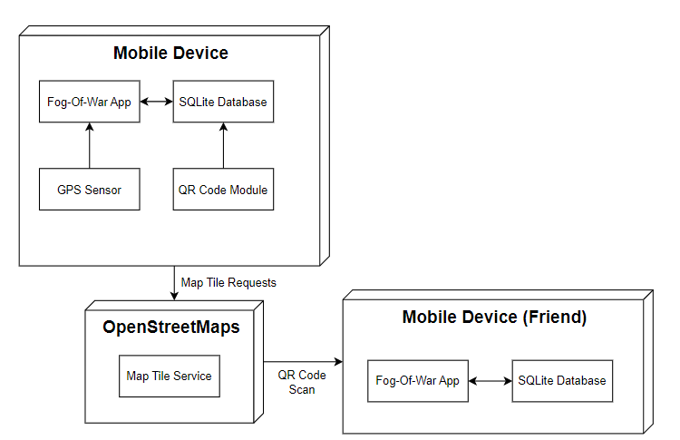
The deployment diagram (Figure 10) illustrates the Physical architecture of the system.
Figure 10. Deployment Architecture
The mobile device hosts the fog-of-war application, which communicates with several internal and external components. The application interacts with the device’s GPS sensor to obtain location data and with the QR code module to generate and scan QR codes used for sharing exploration information.
Map tiles are retrieved from the OpenStreetMap tile service via HTTP requests. This allows the application to display map data without maintaining its own map infrastructure.
Exploration data is stored locally within the mobile device using a database layer. When users choose to share exploration progress, the application generates a QR code containing exploration data. Another device running the application can scan this QR code to import the shared exploration paths.
This architecture supports collaborative exploration while maintaining a lightweight system that does not require centralised servers or cloud infrastructure.

3.3.7 User Interface Design
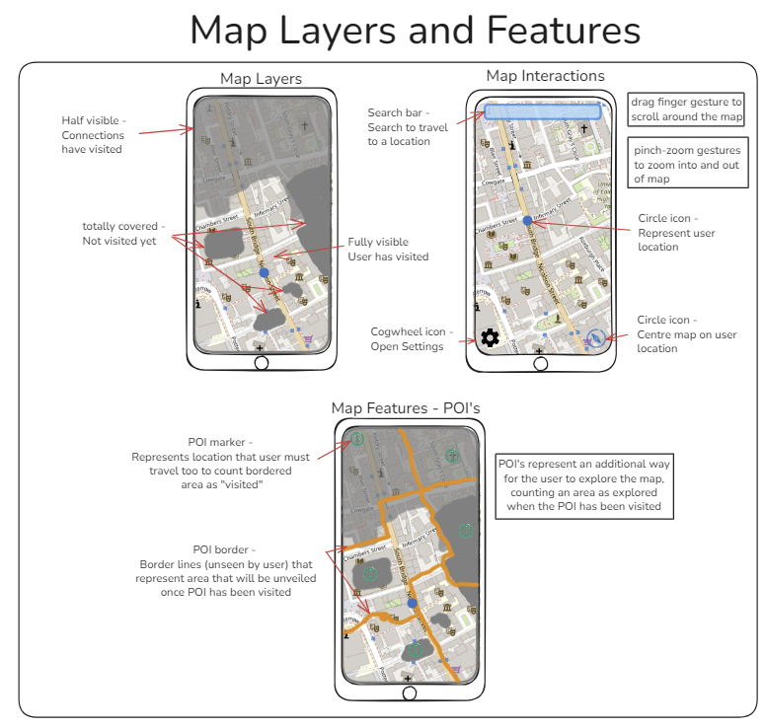
The user interface design was developed through a series of wireframes and interface diagrams (Figure 11 and Figure 12).
Figure 11. UI Design: Map
The Map Interface acts as the central interaction point of the application. It displays the map, user position, and exploration layers. Unexplored areas are covered by a fog layer, while visited areas are revealed. The interface supports common mobile map gestures such as panning and zooming.
Exploration progress is visualised using layered map overlays. Areas that have been visited by the user are displayed as fully visible regions, while unexplored areas remain obscured. However, when a User imports map data from another, that imported explored data will show as half transparent
The Settings Interface provides access to configuration and sharing functionality. From this interface users can generate QR codes to share their exploration progress, scan QR codes to import exploration data from another user, clear locally stored exploration data, and modify map display settings.
These interface designs were created to maintain familiarity with common mobile mapping applications while introducing new exploration-focused mechanics. 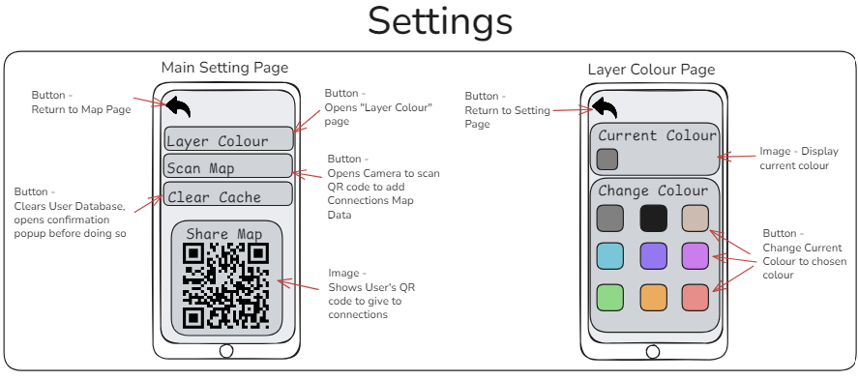
Figure 12. UI Design: Settings

3.4 Software Development Methodology

3.4.1 Development Approach
An iterative, incremental approach was adopted to reduce risk and accommodate tuning of the fog-of-war mechanic (e.g. reveal radius, rendering, and sampling). Development progressed through small vertical slices that each produced a testable feature.
The core iteration plan was:
- Baseline map display and finding user location
- Persistence of user’s path points
- Fog-of-war style reveal overlay
- QR generation, scanning, and friend overlay rendering
- POI storage, and display
- Cache clearing, and settings personalisation
This order front-loads the technical risks (importing map, GPS permissions, overlay rendering) and ensures that core exploration features are implemented before secondary features.

3.4.2 Tools, Libraries, and Frameworks
The prototype was implemented with a primary focus on Android to minimise the additional complexity introduced by multi-platform development and to ensure completion within the project timeframe. Development was undertaken using Android Studio, with Java used for application logic and Android XML layouts used to implement the user interface.
The system then integrates the following technologies:
- OpenStreetMap as the external map tile provider for map visualisation;
- Local JSON storage for offline persistence of user settings, exploration paths, and POI progress (prototype implementation);
- Android device APIs for GPS location access and camera scanning to support QR-based sharing and real time exploration updates.
This technology stack supports rapid prototyping with offline storage and minimal infrastructure overhead, while still enabling the implementation and evaluation of the core research functionality: an exploration-focused map application using a fog-of-war mechanic.
Android was selected as the initial target platform because it enabled more efficient development and testing than iOS within the available resources, and because prior experience with Android development reduced the learning curve. This allowed the project effort to be directed towards implementing and evaluating exploration mechanics rather than resolving iOS-specific tooling and platform constraints.

3.4.3 Version Control and Project Management
Version control for the project was managed using GitHub, which provided a central repository for tracking development progress and maintaining a history of code changes. The use of version control allowed incremental updates to be recorded, enabled rollback to previous versions when necessary, and preserved evidence of development activity throughout the project.
GitHub’s project management features were also used to maintain a lightweight task board and development roadmap. Tasks were organised according to the planned development iterations, allowing features to be tracked as they progressed through the development lifecycle. This structure helped manage the project timeline and supported reflective evaluation of the development process later in the dissertation.

3.4.4 Technology Justification and Alternatives

3.4.4.2 Overview
The selection of technologies for this project was guided by the need to balance development efficiency with system performance and achievement of the prototypes objectives. Several alternative approaches were considered for key components of the system, including platform choice, data persistence, and data sharing mechanisms.

3.4.4.2 Mobile Platform Selection
The application was developed natively for Android using Android Studio and Java. This design was influenced by prior development experience, availability of development tools, and the ability to efficiently access device-level features such as GPS and background services
Table 1 - Advantages/Disadvantages of Mobile Platforms
Option | Advantages | Disadvantages
Android (Java) | Full access to device APIs, efficient background services, strong tooling, Hardware available to test | Platform-specific
Cross-platform (MAUI) | Singe codebase for multiple platforms | Increased complexity, potential performance overhead, additional learning curve
IOS (Swift) | Strong ecosystem | Requires separate development environment, purchase of hardware to test on, additional learning curve.

Android was selected as it allowed rapid development of a stable prototype while minimising implementation complexity. Given the project’s time constraints, a cross-platform solution would have introduced unnecessary overhead without directly contributing to the research objectives.

3.4.4.3 Data Storage / Persistence
The system uses local JSON-based storage for persisting exploration data and application state. While this differs from the originally planned SQLite implementation, the decision was made to prioritise simplicity and rapid iteration.
Table 2 - Advantages/Disadvantages of Mobile Platforms
Option | Advantages | Disadvantages
JSON | Lightweight, easy to debug, flexible structure | Limited scalability, inefficient querying for large datasets
SQLite | Structured queries, efficient data handling, scalable | Increased implementation complexity, slower development
Cloud Storage | Scalable, real-time sync and collaboration | Requires infrastructure, introduces privacy concerns and network dependency.

JSON was selected as it supports a lightweight prototype while aligning with the projects privacy-aware design goals. However, it is recognised that SQLite or Cloud Storage would be more appropriate for a production system.

3.4.4.4 Data Sharing Mechanism
Exploration data was implemented using QR codes, enabling direct transfer between devices without requiring a central server.
Table 3 - Advantages/Disadvantages of Data Sharing Mechanisms
Option | Advantages | Disadvantages
QR Code Sharing | No backend required, privacy-preserving, simpler to implement | Limited data capacity, requires Physical proximity
Cloud API | Scalable, supports real-time collaboration, no size limitations. | Requires server infrastructure, raises privacy and security concerns.
Bluetooth / Transfer | Works offline, no internet required. | Device compatibility issues, more complex implementation.

The QR-based approach aligns with the prototypes goal of minimising infrastructure and maintaining user control over data. However, testing revealed limitations in data capacity, indicating that a backend-supported approach would be necessary for scaling the system.

3.4.4.5 Mapping Technology
The application integrates OpenStreetMap (OSM) for map visualisation
Table 4 - Advantages/Disadvantages of various Mapping Technologies
Option | Advantages | Disadvantages
OpenStreetMap | Free, open-source, no API costs, flexible integration | Less polished than commercial alternatives
Google Maps API | High-quality maps, extensive features | API costs, usage restrictions, dependency on external service.
MapBox | Customisable styling, Modern features | Usage limits, dependency on external service

OpenStreetMap was selected due to its open nature, cost-effectiveness, and suitability for prototype development without licensing constraints.

3.4.4.6 Summary of Technology Choices
Overall, the selected technologies prioritise:
- rapid prototyping and development efficiency
- privacy-aware data handling
- minimal reliance on external infrastructure
While these decisions support the goals of the prototype, several limitations were identified, particularly in scalability and data sharing. Future iterations of the system would likely adopt a hybrid approach incorporating backend services and structured data storage to support long-term usage and collaborative functionality.

3.5 Evaluation Methodology

3.5.1 Evaluation Goals
The evaluation aims to determine whether the prototype:
- Functions reliably in realistic mobile usage conditions (foreground/background/resume);
- Correctly persists and visualises exploration progress using the fog-of-war mechanic;
- Supports collaborative sharing via QR import/export without compromising stability;
- Provides acceptable usability and sustained motivation for users beyond an initial session.

3.5.2 Evaluation Design Overview
A mixed-method approach was adopted where structured system tests would check for requirements-based functional validation, and a user-focused evaluation through a longitudinal study: measuring engagement and perceived motivation over time.
The combination of system testing and a longitudinal user study was selected to provide both a technical verification and behavioural evaluation of the system. System testing ensures that the application satisfies its functional and non-functional requirements, while the longitudinal study provides insight into how the exploration mechanic influences user behaviour over time. This mixed-method approach is appropriate for exploratory mobile applications where both system reliability and user engagement are critical to the success of the design.

3.5.3 Requirements-based system evaluation
System evaluation was conducted using a checklist of repeatable test cases designed to validate the most important reliability and safety-critical behaviours of a location-based mobile application. Specifically, the checklist verifies correct behaviour across common Android lifecycle states (foreground, background/minimised, closed and reopened), the correct persistence and restoration of exploration progress across app restarts, robust permission handling for location and camera access (including denial and acceptance paths), and the correctness and fault tolerance of QR-based data exchange for importing and overlaying shared exploration coverage. The checklist structure records test steps, expected results, observed results, pass/fail outcomes, and implementation notes, supporting traceability back to the project’s functional and non-functional requirements.

3.5.4 Longitudinal study methodology
To evaluate sustained engagement and real-world exploratory impact, a four-week longitudinal study was planned, Participants were asked to install the APK and use the application naturally while travelling, ensuring background tracking remained enabled where appropriate
The target number of Participants for this study was 6, with 4 being seen as a acceptable minimum.
The Quantitative measures for this study were:
- Distance that user travelled
- Number of sessions
- Time spent per session
- Number of times exploration data was shared
During the Midpoint check-in, the data that was planned to be collected was:
- Perceived motivation: “How much has the app motivated you to explore over the past X weeks?”
- “Did the app make you deviate from your normal route?”
During the midpoint check-in and final debrief, the System Usability Scale (SUS) would be administered to provide a standardised usability score.
The focus on engagement measures is directly informed by the literature on exploration behaviour and spatial cognition discussed in Chapter 2. Prior studies suggest that exploration-oriented systems may influence how users move their environment and whether they tend to deviate from familiar routes. Measuring these behaviours therefore provides an indirect indicator of whether the fog-of-war mechanic successfully encourages exploration.

3.5.5 Logging and privacy-aware instrumentation
To avoid unnecessary collection of sensitive location histories, logging was designed to capture behavioural engagement system operation without storing raw coordinate beyond what is required for the study.
Planned logged fields include:
- Timestamps (session start/end, session duration)
- Session distance travelled
- Number of sessions
- Count of Map Shares
This approach supports the reports evaluation while also aligning with privacy-by-design principles by limiting collected data to what is necessary for analysis.

3.5.6 Success Criteria
Success Criteria were defined prior to evaluation:
- Retention: at least 60% of participants complete >= 5 sessions
- Exploration activity trend: average distance travelled per week increases over time (or at least remains stable after week 1), indicating sustained use during real-world movement.
- Usability: SUS score > 65 (this would put it above a basic acceptable threshold)
- Motivation stability: engagement does not collapse after day 3 (session and tracking logs remain relatively stable).
Distance travelled was used as a proxy measure for exploration activity, since the prototype logging focused on behavioural engagement rather than storing detailed spatial coverage data.

3.5.7 Procedure
The evaluation study followed a structured procedure designed to ensure that participants understood the purpose of the study and provided informed consent before taking part.

Day 0 – onboarding
Participants were provided with a participant information sheet outlining the purpose of the study and how their data would be used. Participants were then asked to sign an informed consent form confirming their voluntary participation.
Following this, participants were assisted with installing the application APK on their mobile device and granting the necessary permissions for location access and QR scanning. A short baseline questionnaire was then administered to collect information regarding the participant’s typical navigation behaviour, frequency of exploration activities, and confidence in navigating unfamiliar environments.

Study Period
Participants were asked to use the application naturally during their everyday movement over the four-week study period. They were encouraged to keep background tracking enabled when appropriate in order to allow exploration progress to be recorded.
A midpoint check-in was conducted during the study period to collect preliminary feedback regarding usability and motivation.

End-of-Study debrief
At the end of the study period, participants completed the System Usability Scale (SUS) questionnaire and provided additional qualitative feedback regarding their experience using the application, as well as sending recorded data that their device captured during the study. This feedback was used to evaluate the usability and perceived effectiveness of the exploration-focused design

4. Implementation, Testing and Evaluation

4.1 System Implementation
This section describes the implementation of the exploration-focused geolocation prototype outlined in the methodology chapter. The system was developed as a mobile Android application designed to support exploration through a fog-of-war map visualisation mechanic and collaborative sharing of exploration data.
The prototype was implemented using Android Studio, with Java used for application logic and Android XML layouts used to construct the user interface. The system integrates several platform services and external technologies, including device GPS services, OpenStreetMap map tiles, and QR code functionality for sharing exploration data between users.
The implementation follows the modular architecture described in Chapter 3. Responsibilities are divided between several components responsible for user interaction, location tracking, exploration visualisation, data persistence, and sharing functionality. This separation allows individual parts of the system to be developed and tested independently while maintaining a clear structure for the application.
The application consists of the following major components
- MainActivity, which provides the primary map interface and user interaction layer.
- LocationFogService, which retrieves location updates and records exploration paths.
- FogOverlay, which renders the fog-of-war exploration paths.
- JsonDb, which manages local persistence of exploration data and settings.
- SettingsActivity, which provides user controls for managing data and sharing features
- StudyLogger and StudyExport, which support logging and exporting of evaluation data.
The interaction between these components enables the application to track user movement, reveal explored areas of the map, persist exploration data locally, and allow exploration progress to be shared with other users.

4.1.1 Map Integration
The central user interface of the application is the map view, which is implemented within the MainActivity class. This activity serves as the entry point for the application and provides the primary interaction environment for users.
The map interface integrates with OpenStreetMap, which supplies the map tiles used to display geographic information. OpenStreetMap was selected as the map provider because it offers open and freely accessible geographic data that can be integrated into mobile applications without requiring proprietary APIs or licensing restrictions.
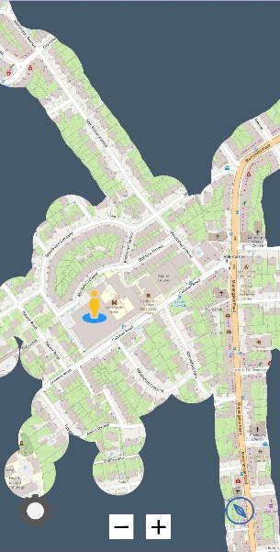
When the application launches, the map view is initialised and configured to display map tiles retrieved dynamically from the OpenStreetMap tile service. The map interface supports standard mobile map interactions, including panning and zooming gestures. These interactions allow users to explore their environment while observing how their exploration progress is reflected in the fog-of-war overlay.
Figure 13. Main Map Interface
The map interface also displays several visual elements representing exploration progress and shared exploration coverage. These elements include:
- The user’s current location marker
- The fog-of-war overlay layer
- Revealed exploration areas
- Shared exploration paths imported from other users
This interface serves as the primary visualisation layer of the application and acts as the container for several dynamic elements generated by other components of the system.
Figure 13 illustrates the implemented map interface and the fog-of-war overlay displayed during exploration

4.1.2 Location Tracking and Path Recording
Tracking user movement is a fundamental requirement of the exploration system. This functionality is implemented through the LocationFogService, which is responsible for retrieving location updates from the device and recording exploration paths.
The Android Location API is used to obtain GPS location updates while the application is running. Each location update provides the device’s current geographic coordinates, including latitude and longitude. These coordinates are used to generate exploration path points representing the user’s movement through the environment.
Each recorded path point contains the following information:
- Latitude
- Longitude
- Timestamp indicating when the location was recorded
Location updates are not recorded continuously at every possible interval. Instead, the system applies a distance-based threshold to determine when a new path point should be recorded. This approach ensures that path points are only stored when the user has moved a meaningful distance from their previous location.
Using this distance threshold helps reduce unnecessary location sampling, which provides several benefits:
- Reduces storage requirements
- Improves performance when rendering exploration overlays
- Minimises battery consumption on the mobile device
The recorded path points are then passed to the exploration rendering system, which determines which areas of the map should be revealed.

4.1.3 Fog-Of-War Rendering
The fog-of-war visualisation is the core feature of the exploration system. This mechanic is implemented through the FogOverlay component, which is responsible for generating the visual representation of explored and unexplored areas on the map.
At the start of the application, the map is covered by a semi-opaque fog layer representing unexplored regions. As the user moves through the environment and path points are recorded, the system generates “reveal regions” around each recorded coordinate.
Each reveal region is defined as the circular area centred on the recorded path point. The radius of the circle represents the exploration radius and determines how much of the map becomes visible around that location.
When a new path is recorded, the FogOverlay component recalculates the visible exploration region by combining the circular reveal areas associated with each path points. The resulting geometry is used to update the fog overlay displayed on the map.
This approach produces a visual effect in which unexplored areas remain obscured while visited areas gradually become visible as the user moves through the environment.
The fog-of-war visualisation provides several benefits:
- It encourages users to physically explore their environment.
- It provides immediate visual feedback regarding exploration progress.
- It creates a game-like mechanic that supports motivation and engagement.
The fog overlay is updated dynamically whenever new exploration data becomes available or when exploration data from other users is imported.

4.1.4. Exploration Data Persistence
Exploration data and user configuration information are stored locally on the device using a JSON-based persistence mechanism. This storage system is implemented through the JsonDB component.
The JSON database stores several types of application data, including:
- Recorded exploration path points
- Shared exploration paths imported from other users
- Logging information used for evaluation
Storing exploration data locally allows the application to operate without requiring a remote server or cloud database. This simplifies the system architecture and ensures that the application can function offline.
JSON was selected as the persistence format for the prototype because it offers a lightweight and flexible structure for storing hierarchical data. During development, JSON storage made it much easier to inspect and debug stored data.
Although the original system design included a relational database model use SQLite, the JSON approach proved sufficient for the prototype implementation and allowed development to progress more quickly.

4.1.5 Exploration Data Sharing
Collaborative exploration is supported through a QR-code–based sharing mechanism. This feature allows users to exchange exploration progress with other users without requiring a central server.
The sharing functionality is implemented through the StudyExport component and the QR scanning functionality of the application. When a user chooses to share their exploration data, the application encodes the relevant path information into a compact data format. This encoded data is then embedded within a generated QR code that can be displayed on the user’s device.
Another user running the application can scan this QR code using the device camera. Once scanned, the encoded exploration data is decoded and imported into the receiving user’s application. The imported exploration paths are then merged with the local exploration data and rendered as an additional overlay on the map. This allows users to visualise areas explored by other users while continuing to discover new regions themselves.
In the prototype implementation, exploration data is stored entirely on the device using local JSON storage. As a result, the full exploration dataset must be encoded directly within the generated QR codes. When a user has accumulated a large amount of exploration data, multiple QR codes may therefore be generated to transfer the complete dataset.
In a production-ready system, this limitation would likely be addressed by introducing a backend database or cloud storage service. Instead of encoding the entire dataset within the QR code, the code would simply contain a link or identifier referencing exploration data stored on a remote server. This would allow exploration data to be synchronised more efficiently and would significantly reduce the amount of data that must be transferred through QR codes.
This serverless sharing approach provides several advantages for the prototype system:
- it avoids the need for backend infrastructure
- it keeps exploration data under the control of the users
- it simplifies privacy management by limiting external data storage

4.1.6 Settings and User Controls
The application includes a settings interface implemented through the SettingsActivity class. This interface provides users with control over application behaviour and stored exploration data.
The settings interface includes the following functions:
- clearing locally stored exploration data
- exporting study data for evaluation purposes
- generating QR codes for exploration sharing
- scanning QR codes to import exploration data
Providing users with the ability to clear stored exploration data supports privacy-aware system design. Because location data can reveal sensitive information about a user’s movement patterns, the system ensures that users retain control over the data stored on their device.
The settings interface also supports evaluation functionality through the export of study data used during the user evaluation phase.

4.1.7 Summary of Implementation
The implemented system successfully integrates location tracking, map visualisation, exploration rendering, and collaborative sharing into a single mobile application.
The modular architecture adopted during the design phase proved effective during implementation, allowing individual components such as the map interface, exploration rendering system, and persistence layer to be developed independently.
The combination of fog-of-war visualisation and collaborative sharing provides a novel exploration-focused interaction model that encourages users to explore their environment while visualising their progress in real time.
The following sections evaluate the reliability and usability of the system through structured testing and user evaluation.

4.2 Testing Strategy
The testing strategy was designed to verify that the implemented prototype satisfied the functional and non-functional requirements defined in Chapter 3. Testing focused on validating the reliability of the mobile application, the correctness of the fog-of-war exploration mechanic, and the functionality of the collaborative sharing features.
Because the system is a mobile application that relies on device sensors and external services, testing was conducted primarily through manual functional testing supported by structured test cases. This approach was selected because many behaviours of the system such as GPS movement tracking, map interaction, and QR scanning, require Physical device interaction and cannot be easily simulated through automated unit testing.
The testing process therefore consisted of three main stages:
- Functional feature testing, verifying that the core system features behaved as expected.
- Lifecycle and permission testing, ensuring that the application handled Android lifecycle events and system permissions correctly.
- Data sharing and persistence testing, verifying that exploration data could be stored, restored, and shared between devices.
Each test case recorded the test steps, expected behaviour, observed outcome, and pass/fail result. This structured approach allows the results of testing to be clearly linked back to the system requirements defined earlier in the project.

4.2.1 Functional Feature Testing
To verify that the implemented prototype satisfies the functional and non-functional requirements defined in Chapter 3, a structured evaluation checklist was used. The checklist consisted of a series of repeatable test cases designed to validate the reliability of the mobile application under realistic usage conditions.
Testing focused on several critical aspects of the system:
- reliability of background location tracking
- persistence of exploration data across application restarts
- correct operation of the fog-of-war exploration mechanic
- functionality of the QR-based data sharing system
- robustness of Android permission handling for location and camera access
Each test case recorded the test steps, expected behaviour, observed behaviour, and pass/fail outcome. The checklist approach ensures that system behaviour can be directly traced to the functional requirements identified earlier in the project.
Table 1 presents a summary of the evaluation checklist used to validate the prototype.
Table 5 - Evaluation Checklist
Test ID | Test Steps | Expected Result | Actual Result | Pass/Fail
1 (background tracking works when minimised) | - Launch App,  - Wait until current location is shown,  - Press Home to minimise the app (do not force-close)  - Walk ~20 metres while app remains minimised  - Re-open the app  - Observe the revealed fog area | - The app does not crash  - Foreground service notification remains present while minimised  - Newly travelled area is revealed on the map after reopening | Same as Expected Result | Pass
2 (background tracking works when destroyed) | - Launch App,  - Wait until current location is shown,  - Close the App normally  - Walk ~20 metres while app remains minimised  - Re-open the app  Observe the revealed fog area | - The app does not crash  - Foreground service notification remains present while minimised  - Newly travelled area is revealed on the map after reopening | Same as Expected Result | Pass
3 (Doesn’t crash on close / resume) | - Launch App  - Press Home to background the app for ~10 seconds  - Return to the app  - Repeat steps 2-3 three times.  - Close the App normally  - Re-open the app from the launcher  - Repeat steps 5-6 three times | - No crash during background/foreground transitions  - No crash when closing and reopening  - Location/fog functionality resumes normally after reopening | Same as Expected Result | Pass
4  (Fog reveals correctly and persists after restart) | - Launch the app and open the map  - Move around until you reveal a clearly visible patch of fog  - Close the App normally  - Re-open the app | - Previously revealed fog remains revealed after restart.  - No “reset” to a fully fogged map unless the cache was cleared  - New exploration continues from the saved state | Same as Expected Result | Pass
5  (Export QR code) | - On Device A, explore and reveal some fog.  - Open Settings/Share screen  - Generate the QR code  - Confirm the QR code displays | - QR code is generated without error  - QR encoded non-empty progress data | - Works correctly, so long as location data to store is minimal | Pass
6  (Import QR code and merge) | - On Device A, explore and reveal some fog  - On Device B, explore a different area  - Open Settings on Device A & B  - Open Scan on Device B  - Scan Device A’s QR code  - Return to map on Device B and check coverage | - App confirms import success  - Device B now shows original revealed area and a less transparent imported revealed area.  - No crash if scanning invalid QR code | - Same as Expected Result | Pass
7a ( Location Permission handled correctly when denied) | - Launch the app  - When prompted for location permission, tap “Deny”  - Attempt to use map tracking features  - Minimise the app and reopen it | - App does not crash  - App does not allow the user to interact with application  - No background service starts for location without permission | - Same as Expected Result | Pass
7b  (Location Permission handled correctly when accepted) | - Launch the app  - When prompted for location permission, tap “Accept”  - Verify location updates and fog reveal works | - Location updates begin  - Fog reveals as you move  - No crash | - Same as Expected Result | Pass
7c  (Camera Permission handled correctly when denied) | - Launch the app  - When prompted for Camera permission, tap “Accept”  - Open Settings | - Pressing “Scan” button should not open the Camera | - Same as Expected Result | Pass
7d  (Camera Permission handled correctly when Accepted) | - Launch the app  - When prompted for Camera permission, tap “Accept”  - Open Settings | - Pressing “Scan” button should open the QR Scanner Camera | - Same as Expected Result | Pass

4.2.2 Testing Results and Observations
The evaluation checklist confirmed that the prototype operates reliably across the tested scenarios. All test cases passed successfully, demonstrating that the core exploration functionality and supporting features behave as intended.
In particular, testing confirmed that background location tracking continues correctly while the application is minimised or reopened. This behaviour is enabled using a foreground service, which allows the application to continue receiving location updates even when the user is not actively interacting with the interface.
Testing also verified that exploration progress persists correctly across application restarts. Previously revealed fog areas remain visible when the application is reopened, allowing exploration progress to accumulate over time without requiring continuous application usage.
The fog-of-war rendering system was observed to update correctly as the user moves, with new exploration regions being revealed around recorded path points.
The QR-based data sharing functionality also operated as expected. Exploration data could be successfully exported as a QR code on one device and imported on another device. The imported exploration paths were merged with the local user’s data and displayed as a secondary overlay on the map.
Permission handling for both GPS location and camera access was tested under both acceptance and denial conditions. The application correctly prevented location tracking or QR scanning when permissions were denied and did not crash when permission requests were rejected by the user.
Overall, the results of the evaluation checklist indicate that the implemented prototype satisfies the core functional requirements of the system and operates reliably under common mobile usage scenarios.

4.2.3 Limitation: QR Code Data Capacity
One limitation identified during testing relates to the QR code sharing mechanism.
The test case evaluating QR code export functionality revealed that QR code generation may fail when the exploration dataset becomes too large. Because the prototype stores all exploration data locally, the full dataset must be encoded directly into the generated QR code. When a user has accumulated many exploration path points, the encoded data may exceed the capacity of a single QR code.
As a result, the QR export test occasionally failed when the dataset exceeded the size supported by the QR encoding method used in the prototype.
This limitation highlights an important design consideration. In a production implementation, QR codes would likely contain only a reference identifier or URL linking to exploration data stored on a remote server, rather than embedding the full dataset within the code itself. This approach would significantly reduce the amount of encoded data and eliminate the QR size limitation observed during testing.
Despite this limitation, QR sharing worked correctly when the exploration dataset was within manageable size limits, allowing users to successfully exchange exploration coverage between devices.

4.3 Evaluation Results

4.3.1 Study Objectives
In addition to system reliability testing, a longitudinal user study was designed to evaluate whether the exploration-focused design encourages sustained engagement over time.
The primary objective of the study was to determine whether the fog-of-war exploration mechanic motivates users to explore their environment beyond initial use.
The study was designed to run over a four-week period, during which participants were asked to install the application and use it naturally during everyday walking or travel activities. Participants were encouraged to keep the application running in the background to allow exploration progress to be recorded.

4.3.2 Participants
The ideal number of participants for the study was 6, although four was considered as the minimum acceptable sample size for obtaining meaningful behavioural observations for this study. Participants were recruited from Napier Universities student population and alumni, which were asked to use the application as part of their normal movement activities.

4.3.3 Evaluation metrics
Several quantitative metrics were used to measure engagement with the application:
- Distance travelled while tracking, used as a proxy GDPR-compliant measure of exploration activity
- Number of sessions, representing how often the application was used
- Time spent per session, indicating sustained interaction with the application
- Number of exploration data sharing events, representing collaborative engagement
In addition to behavioural metrics, qualitative feedback was collected through midpoint and end-of-study questionnaires.
During the midpoint check-in, participants were asked questions such as:
- “How much has the app motivated you to explore over the past weeks?” (scale 1–5)
- “Did the app encourage you to deviate from your normal route?” (Yes/No)
The System Usability Scale (SUS) questionnaire was also administered during the midpoint check-in and final evaluation in order to obtain a standardised usability score.

4.3.4 Logging and Data Collection
To minimise the collection of sensitive location data, the logging system was designed to capture behavioural metrics without storing detailed location histories.
Instead of storing full GPS tracks, the system records aggregated session data through the logging component implemented in the StudyLogger class. Each session is recorded as a structured log entry containing summary information describing user interaction with the application.
Table 2 is used to show the applications logged fields
Table 6 - Application Logging Data Fields
Field | Description
sessionId | Unique identifier for the session
startTs | Timestamp when the session began
endTs | Timestamp when the session ended
durationMs | Total duration of the session
sessionNumber | Sequential session number
sessionDistanceM | Total distance travelled during the session
mapShareCount | Number of times exploration data was shared
participantId | Identifier for the participant

4.3.5 Quantitative Results
Study log data was collected from 4 participants over the four-week evaluation period. The dataset recorded session frequency, session duration, distance travelled, and map sharing activity. These metrics were used to evaluate user engagement and exploration behaviour.
Across all participants, a total of 110 sessions were recorded. The average number of sessions per participant was 27, with total distances (as seen in Figure 14) ranging from 88 km to 1301 km. Duration per participant varied between 803 and 911 hours, indicating differences in usage patterns.
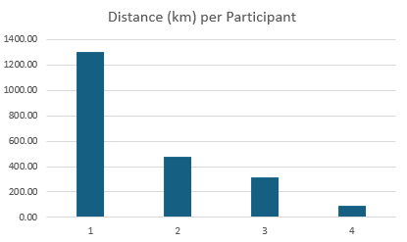
Most participants demonstrated consistent engagement throughout the study period, with multiple sessions recorded across different days. This suggests that the application was used beyond its initial novelty and integrated into regular movement behaviour.
While distance travelled was used as a proxy for exploration activity, this measure does not distinguish between intentional exploration and routine travel. For example, long-distance travel (e.g. commuting or transport use) may inflate distance metrics without reflecting meaningful exploratory behaviour. As a result, distance should be interpreted as an indicator of engagement rather than a direct measure of exploration.
Figure 14. Distance (km) travelled per Participant
Similarly, session duration proved to be a less reliable metric due to background tracking behaviour. In many cases, the application continued running while users were not actively interacting with it, leading to inflated session lengths. This limits the validity of duration as a measure of user engagement. Additionally, a small number of sessions recorded minimal or zero distance, which may reflect stationary use or logging artefacts. These factors were considered when interpreting overall engagement.
Map sharing activity was minimal across participants, indicating that the collaborative features were not widely utilised during the study period. This was expected, due to limited awareness of other participants in the study, as well as the feature being optional for use.
Most participants met the predefined retention criteria, completing more than five sessions. Distance travelled remained relatively stable across the study period, suggesting sustained engagement. These results indicate that the system achieved its core objective of encouraging continued exploration. These findings are broadly consistent with prior work by Schade et al. (2023), which suggests that fog-of-war visualisation can encourage exploration and increase familiarity with environments. However, unlike controlled studies, the real-world setting of this project introduces additional variability, making direct comparison more complex.
Overall, the study logs provide evidence that the application supports sustained user engagement and promotes exploratory behaviour, although collaborative features were less frequently used.

4.3.6 Qualitative feedback
In addition to quantitative behavioural data, qualitative feedback was collected through midpoint and end-of-study questionnaires. This feedback aimed to assess user motivation, exploration behaviour, and perceived usability of the application.
Participants generally reported that the application had a positive effect on their motivation to explore. Many responses fell within the “Much” and “Very much” categories, indicating that the system was effective in encouraging exploration behaviour. A smaller number of participants reported moderate or low motivation (“Some” or “A little”), suggesting variability depending on individual usage patterns.
When asked whether the application encouraged deviation from normal routes, most participants indicated that it had. This suggests that users were willing to alter their typical navigation behaviour in order to uncover new areas of the map. This finding directly supports the project’s objective of promoting exploration rather than efficiency-based navigation.
However, these findings should be interpreted with caution. Self-reported measures of motivation and behaviour are subject to bias, including social desirability bias and the influence of participating in a study. As a result, participants may over-report positive experiences or changes in behaviour.
These findings are consistent with the quantitative results, where increased session counts and recorded travel distances suggest that users actively engaged with the exploration mechanic during real-world movement. But while this alignment between qualitative and quantitative data strengthens the validity of the findings, it does not fully eliminate alternative explanations. For example, increased activity may be influenced by external factors such as daily routines or environmental context, rather than solely the application itself.
The System Usability Scale (SUS) results indicate that the application achieved a high level of usability. The system obtained a SUS score of 91% at the midpoint and 92.5% at the end of the study, which places it well above the standard benchmark for acceptable usability. The slight increase in SUS score between the midpoint and final evaluation suggests that usability perceptions improved over time as participants became more familiar with the system. This is supported by participant responses, which indicated that the system was easy to use and that users felt confident interacting with it. Most users also indicated that they would be able to learn the system quickly without external assistance. Negative responses to statements relating to complexity and inconsistency were low, suggesting that the interface was relatively intuitive and well-integrated.
Although the System Usability Scale results indicate a high level of usability, the small sample size and time limits the generalisability of these findings. Additionally, participants may have become more comfortable with the system over time, which could contribute to improved scores.
However, some limitations were observed. While usability was generally rated positively, engagement with certain features, such as map sharing, remained limited. This suggests that some aspects of the system may require clearer presentation or stronger incentives to encourage use.

Overall, the qualitative feedback suggests that the application positively influences user motivation and exploratory behaviour. However, these findings are influenced by the study context, limited sample size, and reliance on self-reported data. As such, while the fog-of-war mechanic appears effective, further large-scale and controlled studies would be required to confirm its long-term impact.

5. Conclusion

5.1 Overview of the Project
This project aimed to design, implement, and evaluate a mobile geolocation application that encourages real-world exploration through a fog-of-war map mechanic and collaborative map sharing. The system was developed as a prototype Android application integrating GPS tracking, OpenStreetMap visualisation, and local data persistence.

5.2 Achievement of Objectives
The project successfully achieved its core objectives. The system was able to:
- Record user movement using GPS location tracking
- Dynamically reveal explored areas using a fog-of-war mechanic
- Persist exploration data locally across sessions
- Support collaborative sharing of exploration data using QR codes.
- Provide a usable and intuitive mobile interface
Evaluation results demonstrated that the system functioned reliably and met the functional and non-functional requirements defined in Chapter 3.

5.3 Evaluation Summary
The evaluation combined structured system testing with a four-week longitudinal user study. Functional testing confirmed that the application operates reliably across common mobile scenarios, including background tracking, lifecycle handling, and data persistence.
Quantitative results showed sustained engagement across participants, with multiple sessions recorded and significant distances travelled. These findings indicate that the application was used beyond initial novelty and integrated into real-world movement.
Qualitative feedback further supported these findings, with participants reporting increased motivation to explore and a willingness to deviate from their normal routes. The application achieved high usability scores, with SUS results of 91% at midpoint and 92.5% at the end of the study, indicating a highly usable system.

5.4 Limitations
Despite these positive results, several limitations were identified during the development and evaluation of the system.
First, the sample size of participants was relatively small, limiting the generalisability of the findings. While the study provided useful insights into user behaviour and system performance, the results cannot be assumed to represent a wider population. Participant behaviour may also have been influenced by familiarity with the developer or awareness of the study’s objectives. A larger and more diverse participant group would provide more robust and representative conclusions, particularly in assessing long-term engagement patterns.
Second, session duration data was affected by background tracking behaviour, which resulted in inflated duration values. In several cases, the application remained active while users were not actively engaging with it, leading to session lengths that do not accurately reflect meaningful interaction. As a result, this reduces reliability of duration as a metric for measuring engagement compared to session frequency or distance travelled. This limitation highlights the challenge of accurately capturing user interaction in mobile systems that operate in the background.
Third, the QR-based sharing mechanism was constrained by data size limitations, reducing its effectiveness for larger exploration datasets. As exploration data increased over time, the amount of information that could be encoded within a single QR code became insufficient, requiring either truncation or segmentation of data. This introduces friction into the sharing process and limits the practicality of the feature for long-term use. Additionally, QR-based sharing requires Physical proximity between users, which further restricts its usability in real-world scenarios.
Finally, collaborative features were underutilised during the evaluation period, suggesting that further design work is required to better integrate and incentivise social interaction. While the system technically supports data sharing, the lack of engagement with this feature indicates that it may not have been sufficiently visible, intuitive, or rewarding for users. This highlights a broader limitation in the current design, where exploration is primarily an individual activity rather than a socially driven experience. Enhancing the visibility and value of collaborative features would be necessary to fully realise the intended social aspects of the system.

5.5 Future Work
Several areas for future work have been identified based on the limitations observed during development and evaluation.
One key area for improvement is the implementation of a backend system to support scalable data sharing. In the current prototype, exploration data is encoded directly into QR codes, which introduces limitations when handling large datasets. A server-based approach would allow exploration data to be stored remotely and referenced through lightweight identifiers, significantly improving scalability and enabling more seamless data exchange between users.
The collaborative features of the system also present opportunities for further development. Although QR-based sharing demonstrates the feasibility of collaborative exploration, it was not widely utilised by participants during the study. Enhancing these features through mechanisms such as persistent friend connections, live data synchronisation, or shared exploration goals could improve user awareness and encourage more meaningful interaction between users.
In addition, the integration of Points of Interest (POIs) represents a natural extension of the exploration-focused design. While POI functionality was considered during the design phase, it was not fully implemented in the final prototype. Incorporating POIs could provide users with additional incentives to explore specific locations, adding structure and purpose to the exploration experience while maintaining the core fog-of-war mechanic.
From a technical perspective, expanding the system to support multiple platforms would also increase its accessibility. The current implementation focuses on Android to reduce development complexity within the project timeframe. However, extending the application to other platforms, such as iOS, would allow for a broader user base and more comprehensive evaluation in future studies.
Finally, the evaluation itself could be extended in future work. The current study involved a relatively small number of participants over a four-week period, which was sufficient to observe initial engagement patterns but limits the generalisability of the findings. A larger-scale study conducted over a longer duration would provide deeper insight into long-term behavioural change, retention, and the sustained impact of exploration-based design on user behaviour.

5.6 Final Reflection
From a project management perspective, the iterative development approach proved effective in reducing technical risk and enabling continuous validation of core features. By implementing the system in incremental stages, key challenges such as GPS tracking, fog-of-war rendering, and data persistence were addressed early in the development process.
However, time constraints limited the implementation of lower-priority features such as Points of Interest (POIs) and more advanced collaborative functionality. This highlights the importance of more aggressive scope control and prioritisation in future projects, particularly when balancing development, evaluation, and dissertation writing within a fixed timeframe.
Overall, this project demonstrates that exploration-focused design, supported by fog-of-war visualisation and lightweight gamification, can positively influence user behaviour. The prototype successfully encourages exploration and engagement while maintaining a privacy-aware approach to data collection. These findings contribute to the broader understanding of how geolocation systems can move beyond efficiency-based navigation to support richer and more meaningful interactions with physical environments.

References
Ahtinen, A., Isomursu, M., Mukhtar, M., Mantyjarvi, J., Hakkila, J., & Blom, J. (2009). Designing social features for mobile and ubiquitous wellness applications. 8th International Conference on Mobile and Ubiquitous Multimedia (pp. 1-9). Cambridge: ACM.
Barkhuus, L. (2019). Making the city my own: uses and practices of mobile location technologies for exploration of a new city. Pers Ubiquit Comput, p. 269–278. doi:https://doi.org/10.1007/s00779-018-01191-z
Berlyne, D. (1960). Conflict, arousal, and curiosity. McGRAW-HILL SERIES IN PSYCHOLOGY.
Boulos, K., Lu, Z., Guerrero, P., Jennett, C., & Steed, A. (2017). From urban planning and emergency training to Pokémon Go: applications of virtual reality GIS (VRGIS) and augmented reality GIS (ARGIS) in personal, public and environmental health. International Journal of Health Geographics, 16. doi:10.1186/s12942-017-0081-0
Bunchball Inc. (2010). Gamification 101: An introduction to the use of game dynamics to influence behaviour. Retrieved from https://jndglobal.com/wp-content/uploads/2011/05/gamification1011.pdf
Certeau, M. (1984). The Practice of Everyday Life. Los Angeles.
Curry, M. (2000). The power to be silent: Testimony: Identity, and the place of place. Historical Geography, 28, p. 13-24. Retrieved from https://www.sscnet.ucla.edu/geog/faculty/curry/Curry--Silent.pdf
Czikszentmihalyi, M. (1990). Flow – The Psychology of optimal experience. Harper & Row. Retrieved from https://www.researchgate.net/publication/224927532_Flow_The_Psychology_of_Optimal_Experience
Deci, E., Koestner, R., & Ryan, R. (1999). A meta-analytic review of experiments examining the effects of extrinsic rewards on intrinsic motivation. Psychological Bulletin, 125(6), 627-668. doi:10.1037/0033-2909.125.6.627
Deterding, S., Dixon, D., Khaled, R., & Nacke, L. (2011). Gamification: Toward a definition. CHI Conference, (pp. 12–15). Retrieved from https://gamification-research.org/wp-content/uploads/2011/04/02-Deterding-Khaled-Nacke-Dixon.pdf
Freedman, M. (2023, October 27). Location-Based Services: Definition and Examples. Retrieved from Business News Daily: https://www.businessnewsdaily.com/5386-location-based-services.html
Giannakis, K., Konstantinos, C., & Jaccheri, L. (2013). User requirements for gamifying sports software. 3rd International Workshop on Games and Software Engineering: Engineering Computer Games to Enable Positive, Progressive Change (pp. 22-26). San Francisco: IEEE.
Hamari, J., Koivisto, J., & Sarsa, H. (2014). Does Gamification Work? — A Literature Review of Empirical Studies on Gamification. the 47th Hawaii International Conference on System Sciences. Hawaii: IEEE Computer Society. doi:10.1109/HICSS.2014.377
He, C. (2020). How anxiety and growth mindset are linked to navigation ability: Impacts of exploration and GPS use. Journal of Environmental Psychology, 71. doi:https://doi.org/10.1016/j.jenvp.2020.101475
Information Commissioner's Office . (2020). Age appropiate design: A code of practice for online services. Retrieved from https://ico.org.uk/for-organisations/uk-gdpr-guidance-and-resources/childrens-information/childrens-code-guidance-and-resources/age-appropriate-design-a-code-of-practice-for-online-services/
Ishikawa, T., Fujiwara, H., Imai, O., & Okabe, A. (2008). Wayfinding with a GPS-based mobile navigation system: A comparison with maps and direct experience. Journal of Environmental Psychology, 28(1), 74-82. Retrieved from https://www.sciencedirect.com/science/article/pii/S0272494407000734
Kaplan, E., & Lewis, S. (1997, January). Understanding GPS principles and applications. Journal of Electronic Defense, 20(1), S81+. Retrieved from https://link-gale-com.napier.idm.oclc.org/apps/doc/A19161412/AONE?u=napier&sid=bookmark-AONE&xid=ea24d894
Laato, S., Hyrynsalmi, S., Rauti, S., & Sutinen, E. (2020). The Effects Playing Pokemon GO has on Physical Activity - A Systematic Literature Review. 53rd Hawaii International Conference on System Sciences. Manoa: University of Hawaii.
Litman, J. (2010). Curiosity and the pleasures of learning: Wanting and liking new information. Cognition and Emotion, 793–814. Retrieved from https://doi.org/10.1080/02699930541000101
Loewenstein, G. (1994). The psychology of curiosity: A review and reinterpretation. Psychological Bulletin, 116, 75-98. doi:https://doi.org/10.1037/0033-2909.116.1.75
MacEachren, A. (1995). How Maps Work: Representation, Visualization and Design. Guilford Press. Retrieved from https://www.researchgate.net/publication/307855254_How_maps_work_Representation_Visualization_Design
Montello, D. (1998). A New Framework for Understanding the Acquisition of Spatial Knowledge in Large-Scale Environments. In M. Egenhofer, & R. Golledge, Spatial and temporal reasoning in geographic information systems (pp. 143-154). Oxford University Press.
Nicholson, S. (2015). A RECIPE for Meaningful Gamification. In T. Reiners, & L. Wood (Eds.), Gamification in Education and Business (pp. 1-20). Cham: Springer. doi:10.1007/978-3-319-10208-5
Piippo, J., & Kari, T. (2016). To Gamify or Not to Gamify? Gamification in Exercise Applications and Its Role in Impacting Exercise Motivation. 29th Bled eConference (p. 13). Bled: University of Maribor.
Raper, J., Gartner, G., Karimi, H., & Rizos, C. (2007, March). A critical evaluation of location based services and their potential. Journal of Location Based Services, 1, 5-45. Retrieved from https://doi.org/10.1080/17489720701584069
Ryan, R., & Deci, E. (2000). Self-determination theory and the facilitation of intrinsic motivation, social development, and well-being. American Psychologist, 55(1), p. 68-78. doi:https://doi.org/10.1037/0003-066X.55.1.68
Schade, E., Savino, G., Niess, J., & Schoning, J. (2023). MapUncover: Fostering spatial exploration through gamification in mobile map apps. CHI Conference on Human Factors in Computing Systems, (pp. p. 1-13). doi:https://doi.org/10.1145/3544548.3581428
Shoval, N., & Isaacson, M. (2007). Tracking tourists in the digital age. Annals of tourism research, 34(1), p. 141-159. doi:https://doi.org/10.1016/j.annals.2006.07.007
Steiniger, S., Neun, M., & Edwardes, A. (2006). Foundations of Location Based Services. Retrieved from https://faculty.kfupm.edu.sa/: https://faculty.kfupm.edu.sa/crp/bramadan/crp514/readings/6%20-%20Foundations_of_LBS_LectureNotes_by_Steinigeretal_2006_28Pages.pdf
Tolman, E. (1948). Cogntivie Maps in Rats and Men. The Psychological Review, 55, 189-208. doi:10.1037/h0061626
Weisberg, S., & Newcombe, N. (2018). Cognitive Maps: Some People Make Them, Some People Struggle. Current Directions in Psychological Science(27(4)), 220-226. doi:https://doi.org/10.1177/0963721417744521
Wells, S., Kotkanen, H., Schlafli, M., Gabrielli, S., Masthoff, J., Jylhä, A., & Forbes, P. (2014). Towards an Applied Gamification Model for Tracking, Managing, & Encouraging Sustainable Travel Behaviours. EAI Endorsed Transactions on Ambient Systems, 1(4).

APPENDIX 1 Personal Appraisal
This project required the design, development, and evaluation of a complete software system, and provided an opportunity to apply both technical and non-technical skills developed throughout the course. Reflecting on the original aims and objectives, I believe that I successfully delivered a functional prototype that meets the core goal of encouraging real-world exploration through a fog-of-war map mechanic and collaborative features.
From a technical perspective, one of the most significant skills developed during this project was mobile application development using Android. While I had prior programming experience, working with Android-specific concepts such as activity lifecycles, background services, and permission handling presented new challenges. In particular, implementing reliable background GPS tracking required a deeper understanding of how mobile operating systems manage resources and application states. Overcoming these challenges improved my ability to design systems that operate in real-world conditions rather than controlled environments.
Another key area of development was system design and architecture. The use of modular design principles allowed the system to be structured into separate components for map rendering, location tracking, data persistence, and sharing functionality. This separation improved maintainability and made it easier to debug and extend the system. Additionally, creating UML diagrams and data flow models helped translate abstract ideas into a structured design, reinforcing the importance of planning before implementation.
The project also strengthened my problem-solving skills. Several challenges were encountered during development, including handling inconsistent GPS updates, managing data persistence, and addressing limitations in QR code data capacity. These issues required iterative debugging, testing, and refinement. For example, the limitation of QR code size led to the realisation that a production system would require a backend solution, highlighting the importance of considering scalability early in the design process.
In terms of project management, I applied an iterative development approach, breaking the system into manageable components and implementing features incrementally. The use of GitHub for version control allowed me to track progress and maintain a clear history of changes. However, time management was a challenge at certain stages, particularly when balancing development with evaluation and dissertation writing. In hindsight, allocating more time earlier in the project for evaluation planning would have improved the overall workflow.
The evaluation phase provided valuable experience in conducting user studies and analysing both quantitative and qualitative data. Designing a longitudinal study and collecting real-world usage data required careful consideration of ethics, privacy, and data collection methods. This reinforced the importance of GDPR-compliant design and minimising the collection of sensitive data. Analysing the results also highlighted the complexity of interpreting behavioural data, particularly when metrics such as session duration were affected by background application behaviour.
From a personal development perspective, this project improved my confidence in independently managing a large-scale software project. It required sustained effort over an extended period, as well as the ability to adapt when initial design assumptions did not fully translate into implementation. I also developed stronger communication skills through documenting the system, structuring the dissertation, and presenting technical work in a clear and organised manner.
Overall, this project has been a valuable learning experience that has strengthened both my technical abilities and my approach to software engineering as a discipline. It has highlighted the importance of balancing system design, user experience, and evaluation, and has provided a strong foundation for future work in software development.

APPENDIX 2 Initial Project Overview
Initial Project Overview

Development of a Geolocation System Featuring Layered Map Visibility and Collaborative Exploration

- Overview of Project Content and Milestones
The focus of this project is to design, develop and evaluate the prototype of a geolocation-based software product, applying software engineering principles in its implementation of dynamic map visibility and collaborative features. The product aims to encourage discovery by hiding unexplored areas of the map until visited, while enabling users to share progress and content with friends.
Proposed Milestones:
Week 3 | Initial Project Overview Form Hand-in
Week 4 | Initial System Design
Week 7 | Development of the fog-of-war mechanic with basic geolocation integration
Week 9 | Implementation of collaborative map sharing and map layers
Week 10 | Interim Report/Meeting
Week 12 | Development of POI’s, UI polish
Week 15 (End of Trimester 1) | Finish main development features/deliverables
Week 1 | User Testing, survey distribution, feedback analysis
Week 5 | Feedback implementation, documentation, Project ready to deliver
Week 12 | Poster presentation, dissertation submission

- Main Deliverables
Mobile Prototype | A functional mobile application with the layered map visibility and collaborative features.
Project Documentation | Documentation related to the project:  - Design diagrams  - Requirements (MOSCOW diagram)  - Technical documentation  - Testing procedures  - GitHub/Notepad ReadMe file  - User Manual
Demo Video | A short video showcasing the main features and workflow of the system
Evaluation Report | Evaluation of the final product, analysing the prototypes useability, efficiency, and feedback gathered from users.

- The Target audience for the deliverables
This project is aimed at those who enjoy exploration and discovery, who are looking at gamifying their journeys and finding new routes they have not covered before. It also allows social groups to share their experiences and travels, creating opportunities for collaborative exploration and collective achievement.
- Work to be undertaken
- Requirements engineering
  - Gathering and prioritising functional and non-functional requirements
- Data collection
  - Collecting app feedback from students using surveys to inform project decisions
- Analysis
  - Reviewing collected data and refining system features accordingly
- Evaluation
  - Measuring useability, efficiency, and overall user satisfaction through structured testing, analysis, and data collection
- Testing
  - Implementation of Unit tests, functional testings, and battery/efficiency assessments.
- Implementation
  - Building the prototype with map API’s (OpenStreetMaps), fog of war logic, and collaborative features.
- System Design (architecture, stacks, UI/UX wireframes)
  - Defining the architecture, selecting technology stacks, producing UI/UX wireframes for refinement.
- Review of existing apps
  - Analyse current applications (e.g. Fog of World, Bump, FOWIRL, Pokemon Go) to identify strengths and weaknesses, and opportunities for innovation

- Additional Information / Knowledge Required
This project will be developed using Android Studio, the Java programming language, and OpenStreetMap as the mapping platform. It will extend my existing skills by providing experience with geolocation APIs, dynamic map rendering, and efficient data handling within a mobile environment.
In addition, I will be acquiring new knowledge in several key areas:
- Optimising accuracy and battery life to ensure efficient mobile performance.
- Privacy-preserving techniques for handling sensitive data responsibly
- Usability testing methods tailored for mobile applications to gather meaningful user feedback and improve design

- Information Sources that provide context for the project (similar projects)

Fog of World | A mobile app where users uncover fog on maps by physically visiting areas  https://play.google.com/store/apps/details?id=com.ollix.fogofworld
Bump | A social app concept that connects users when they physically encounter one another  https://play.google.com/store/apps/details?id=co.amo.android.location&hl=en_GB
Fowirl | A soon to be released mobile app where users uncover fog on maps by physically visiting areas  https://apps.apple.com/tr/app/fowirl/id6742189650
Assassins Creed: Valhalla | A video game by Ubisoft which contains examples of uncovering areas of a map by visiting POI locations.

- The importance of the project
While mapping and fitness apps are widely available, most provide complete information upfront, which diminishes the sense of discovery. Few systems integrate dynamic map visibility with meaningful collaborative interaction. This project aims to fill that gap by:
- Encouraging exploration and outdoor activity
- Supporting social interaction through collaborative map sharing
- Offering a user-centric approach that balances engagement with privacy.

- Key Challenges to be overcome
- Efficiency
  - Ensuring the system runs smoothly on mobile devices without lag or excessive memory usage.
- Battery life
  - GPS tracking and map rendering are resource-intensive, strategies should be devised to limit the cost.
- User testing/feedback
  - Recruiting users and gathering meaningful feedback within the project timeframe
- Privacy
  - Handling sensitive data responsibly, limiting unnecessary data storage
IPO FEEDBACK
“Usually better to upload a PDF for any document where the recipient doesn't need to edit it. Especially given that turnitin choked on your supplied docx. Otherwise a nice creative idea for a software development project. I'd consider how you can root this in the wider research landscape however. One way might be through the work done on gamification of exercise. I am sure that work has also been done on similar question related to shifting between detail levels in digital cartographic maps to match the users activities.”

APPENDIX 3 Interim Feedback
Feedback discussed in the meeting. Think about the evaluation and make the icon size smaller!

APPENDIX 4 Diary Sheets
The following table provides a summary of meetings held with the project supervisor throughout the duration of the project. These meetings were used to review progress, refine project scope, and receive feedback on development and evaluation:
Date | Attendees | Topics Discussed | Actions / Outcomes
10/09/2025 | Me, Supervisor | Project Idea Discussion and initial scope | Refine project idea and identify core concept
16/09/2025 | Me, Supervisor | Further Project Idea Discussion | Begin IPO form
22/09/2025 | Me, Supervisor | Definition of problem area and project scope | Finalise IPO form and begin initial system design
29/09/2025 | Me, Supervisor | System design discussion and literature direction | Finalise aims and objectives and select technology stack
06/10/2025 | Me, Supervisor | Literature direction and related research topics | Begin development and collect relevant references
13/10/2025 | Me, Supervisor | Literature review discussion and development progress | Continue application development and expand literature review
28/10/2025 | Me, Supervisor | Application development and literature review progress | Refine system features and continue implementation
05/11/2025 | Me, Supervisor | Progress check and development discussion | Address implementation issues and continue development
12/11/2025 | Me, Supervisor | Pre-interim meeting discussion | Prepare resources for interim and refine content
21/11/2025 | Me, Supervisor, Second Marker | Interim project review and feedback | Revise project based on feedback, continue development, and complete literature review
11/12/2025 | Me, Supervisor | Discussion of plans over winter period | Finish main development deliverables and refine literature review.
26/01/2026 | Me, Supervisor | Post-winter break meeting and planning for the term | Review project progress, identify remaining development tasks, and plan evaluation phase
03/02/2026 | Me, Supervisor | Evaluation planning and study design discussion | Define evaluation methodology and outline user study structure
17/02/2026 | Me, Supervisor | Study preparation and questionnaire design | Finalise questionnaires and prepare for participant recruitment
03/03/2026 | Me, Supervisor | Evaluation progress and data collection discussion, gain permission for use of Napier’s Survey Site | Begin study and start initial data collection
17/03/2026 | Me, Supervisor | Ongoing study monitoring and methodology discussion | Review study progress and refine evaluation approach based on initial findings, begin writing dissertation sections
31/03/2026 | Me, Supervisor | Ongoing study monitoring and dissertation discussion | Continue data collection and continue dissertation writings.

APPENDIX 5 – Participant Information Sheet + Informed Consent Forms

