Literature Review

2.1 Geolocation and Location-Based Systems
The invention and development of geolocation technologies have fundamentally changed how people move through and interpret their surroundings. Modern location-based services (LBS) use real-time geodata from smartphones and other connected devices to provide navigation, information, entertainment and security services (Freedman, 2023). At the core of many of these systems is the Global Positioning System (GPS), which offers continuous, worldwide, three-dimensional position and velocity information to any user with suitable receiving equipment (Kaplan & Lewis, 1997). GPS receivers operate passively, allowing an unlimited number of users to access the system without affecting its performance, which has made GPS a dominant global standard.
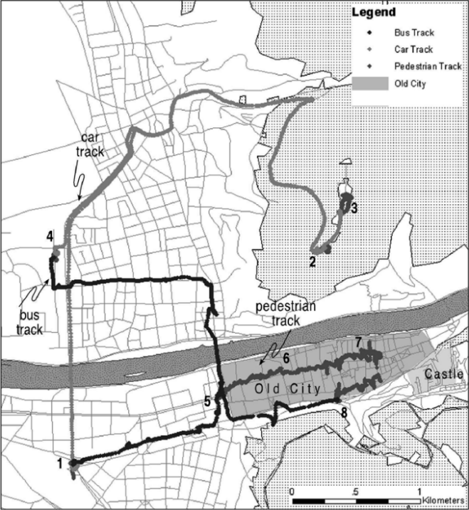
Historically, GPS was developed for military and only later opened to civilian use. The system became fully operational in the mid-1990s, and selective availability (a system that artificially degraded accuracy for civilian devices) was disabled in 2000. This enabled much more precise location fixes for non-military uses (Kaplan & Lewis, 1997). As access improved, GPS became so pervasive that the term itself is often used generically for satellite-based positioning.
Shoval and Isaacson (2007) provide an early empirical investigation into the viability of different LBS technologies for tracking people in real-world environments. In their Heidelberg experiment (Figure 1) a participant followed a predefined route through narrow streets and alleyways while carrying a GPS receiver. Despite the dense urban environment and changes in mode of transport (walking, bus, car), the receiver remained fully functional and was able to determine position with a high degree of accuracy. An interesting side effect was that the pattern of recorded points varied depending on the type of transportation, enabling the researchers to infer whether the subject was travelling on foot or by vehicle.
Figure 1. The Heidelberg GPS Track
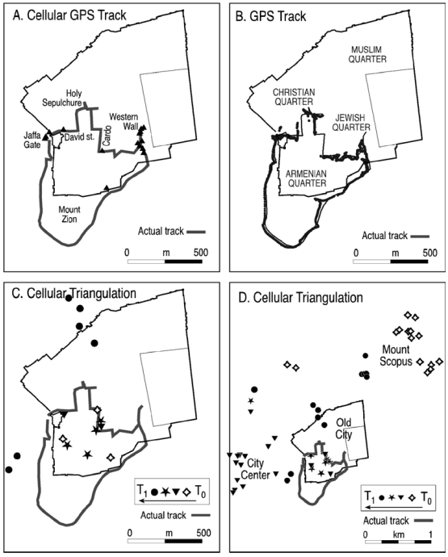
In a follow-up experiment in Jerusalem, Shoval and Isaacson (2007) compared three approaches along the same track: GPS, Assisted GPS (A-GPS) and cellular triangulation - as seen in Figure 2. A-GPS, constrained by the cellular network, sampled location at a lower frequency (e.g. every 30 seconds) but still produced a coherent and reasonably accurate path, except in some vehicular conditions where it struggled to keep up. Cellular triangulation was far less precise; it generated sparse, coarse points that could only identify the general area (such as being “within the Old City”) and were insufficient to reconstruct the actual route. By contrast, GPS provided relatively dense and accurate data, albeit with some degradation under covered streets. These results highlight that while multiple technologies can support location tracking, they differ substantially in accuracy, sampling rate and suitability for detailed behavioural analysis.
At the same time, the increasing precision and ubiquity of tracking raise ethical and social concerns. Curry (2000) discusses how remote surveillance systems and GPS, especially when tied to geographic information systems, contribute to a world in which every location can be mapped, cross referenced and compared with other events. He argues that such technologies challenge traditional norms of privacy and can erode spatial boundaries and aspects of the self. Regulatory bodies echo these concerns: UK guidance treats location and geolocation data as forms of personal data that can reveal sensitive information about an individual’s movements and routines, and therefore must be collected and processed transparently and proportionately (Information Commissioner's Office , 2020).
Figure 2. Tracks Obtained Using AGPS, GPS and Cellular Triangulation
Overall, geolocation technologies and LBS provide a technical foundation for robust systems that track movement and support navigation, but the choice of technology (GPS, A-GPS, cellular), environmental conditions and sampling strategy all influence data quality. At the same time, the ability to continuously collect and store location traces brings privacy and ethical responsibilities that must be considered in the design of any exploration-focused application. The system developed in this project builds on the strengths of GPS-based LBS while aiming to minimise unnecessary data collection and to keep tracking at an appropriate level for a prototype.

2.2. Exploration, Spatial Cognition, and the Role of Wandering
Although geolocation technologies can make it easy for users to find places, they can subtly change how people learn and experience their environments. Barkhuus (2019) examines how newcomers use mobile location technologies when exploring a new city and finds that these tools often turn exploration into a digital search task. Participants relied on maps and search functions to locate specific destinations, but described offline wandering (defined as; moving without a strict plan) as a kind of “premium” activity. Wandering took more time but resulted in more meaningful discoveries and a stronger sense of connection to the places they found, suggesting that purely efficiency-oriented navigation may undermine some of the experiential value of getting to know a place.
Spatial cognition research helps explain why this matters. Weisberg and Newcombe (2018) argue that some individuals readily form detailed cognitive maps to integrate different routes into a coherent representation of space, whereas others struggle to connect locations and rely more heavily on landmark-based or route-based strategies. They also discuss spatial anxiety: people who feel anxious tend to perform worse on spatial tasks, though it is unclear whether anxiety causes poor performance or whether repeated difficulties lead to anxiety, Either way, high spatial anxiety can discourage individuals from exploring unfamiliar environments, reinforcing reliance on external guidance.
He (2020) examines how GPS use relates to exploration behaviour and navigation ability. The study reports that individuals with lower spatial activity tend to explore their surroundings more actively and depend less on GPS for guidance, whereas frequent GPS users perform worse on several navigation measures, including travel efficiency, number of stops, direction estimation and sketch map accuracy. The widespread availability of GPS means that users can navigate it primarily by following turn-by-turn instructions, which reduces the cognitive effort involved in wayfinding but also limits the opportunities to build and refine internal representations of the environment.
These findings suggest that systems designed purely around efficiency may contribute to weaker cognitive maps and an over-reliance on external aids. In response, researchers have begun to explore ways of designing digital tools that actively support exploration and spatial learning. Schade et al. (2023) introduced MapUncover, a mobile map application that employs a “fog-of-war” mechanic: unexplored areas of the map are obscured and gradually revealed as users move through the environment (Figure 3). In their study, the fog-of-war design led to a significant increase in participants’ familiarity with the environment and encouraged a variety of exploration patterns. Participants reported discovering alternative routes and new meaningful places, and qualitative feedback suggested that the process of uncovering hidden map regions felt engaging rather than burdensome.
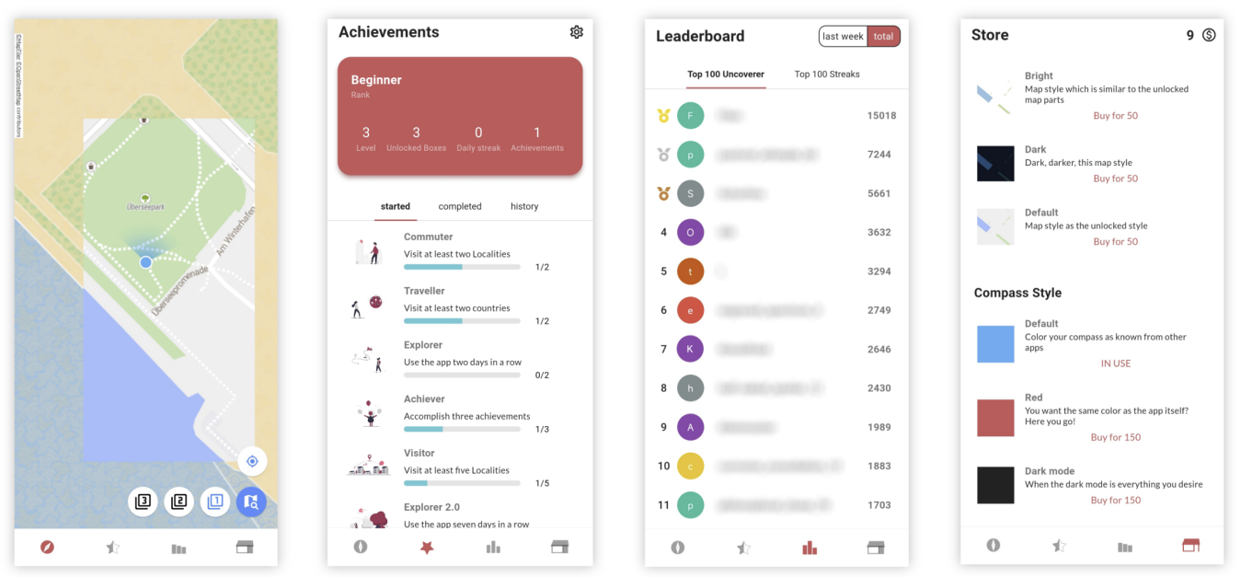
Figure 3. Overview of Mobile Application “MapUncover”
Taken together, this literature indicates that exploration is not just a by-product of navigation but a valuable activity that supports richer spatial knowledge and more satisfying relationships with place. Wandering and self-directed route choice allow users to encounter new environments, while designs that withhold complete information—such as fog-of-war—can gently encourage exploration without forcing it (Barkhuus, 2019) (He, 2020) (Weisberg & Newcombe, 2018) (Schade et al, 2023). For the project at hand, this implies that an effective exploration-focused system should limit full map foresight, make exploration progress visible and rewarding, and avoid simply providing optimal routes from A to B.

2.3 Gamification and Motivation
Gamification has emerged as a popular strategy for increasing engagement in digital systems by incorporating game-like elements into non-game contexts. Deterding et al (2011) defines gamification as the use of game design elements in non-game contexts, distinguishing it from “serious games”, which are full games designed for purposes beyond entertainment. Industry perspectives such as Bunchball (2010) similarly describe gamification as the application of game dynamics to encourage participation, sharing and interaction within websites, services or communities. This can be done through various mechanics, such as points, badges, or leaderboards, as again seen in Figure 3.
Within mobile applications, gamification is often used as a strategy to boost user motivation. Self-Determination Theory (SDT) suggests that intrinsic motivation is nurtured when individuals feel competent, autonomous and connected to others (Ryan & Deci, 2000). Features such as progress tracking, challenges and social elements can help satisfy these needs by making users feel effective and in control of their choices, as well as make them feel part of a community. However, it is to note that SDT cautions about placing too much emphasis on external rewards as they can undermine intrinsic motivation if users become more focused on collecting points or badges than on engaging with the underlying activity itself.
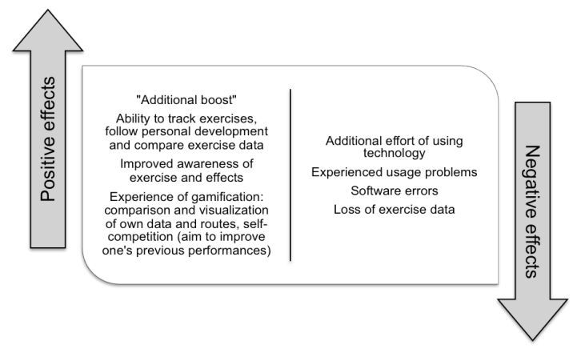
Studies on gamified exercise and wellness applications show that, when designed carefully, game elements can enhance motivation. Kari and Piippo (2016) found that tracking one’s own exercise was a key motivating factor for almost all participants in their study of an exercise application (Figure 4). Many of the participants noted that being able to follow their personal development positively affected their motivation to be physically active. Sharing exercise data within an online service was seen as a positive, and about half of the participants did mention that seeing other people’s exercise data created a form of peer pressure that encouraged them to increase their own activity.
Figure 4. The perceived positive and negative effects on exercise motivation and behaviour from using the exercise application
Giannakis and Jaccheri (2013) similarly highlight that augmented feedback from mobile self-tracking devices can promote working out by making progress more visible and tangible. Ahtinen et al. (2009) investigated social features in mobile wellbeing applications and found that social interaction: which can include peer support, cooperation, competition, and a sense of belonging to a group, can increase perceived community and act as a clear motivator for wellness activities such as physical exercise. These findings align with broader evidence that well-designed gamification can positively influence user behaviour, particularly when feedback, rewards, and social mechanisms are aligned with user goals (Hamari, Koivisto, & Sarsa, 2014)
At the same time, other scholars caution against relying solely on extrinsic rewards. In his work on meaningful gamification, Nicholson (2015) argues that if the goal is long-term change, rewards should be used sparingly and gradually replaced by more meaningful ways of engaging with the underlying activity. But their value should diminish over time as users find intrinsic reasons to continue. Otherwise, behaviour is likely to stop when the rewards stop.
Location-based games provide concrete example so of how gamification can be applied to physical exploration. Some examples would include Pokémon Go, where you explore the real-world locations to collect creatures and capture gyms, as well as limited time events. A report on Pokémon Go by Laato (2020) notes that playing can increase users physical activity levels, social interaction and awareness of their local area, although these effects are often strongest in the short term. Gamified map applications such as MapUncover also explores this idea by directly tying game elements to spatial exploration: revealing fogged map regions becomes a form of progress, and participants in Schade et al’s (2023) study reported that this mechanic encouraged them to explore alternative routes and discover new meaningful places.
For the proposed project, these insights suggest that gamification should be used to support, rather than replace, intrinsic motivation to explore. Features such as fog-of-war, progress visualisation (This would be understood in the project by the percentage of area uncovered) and simple social features (e.g. sharing coverage with friends) can support feelings of competence, autonomy and relatedness with others ( (Ryan & Deci, 2000); (Ahtinen, et al., 2009); (Piippo & Kari, 2016)). At the same time, following Nicholson’s (2015) guidance, the system should avoid over-emphasising external rewards; the aim is to make exploration itself engaging and satisfying, rather than to trap users in a cycle of points collection.

2.4 Existing Applications and Identified Gap
A range of existing applications and systems already relate to the to idea of geolocation exploration and gamification, however they only focus typically on part of the design space. Commercial navigation apps such as Google Maps or Apple Maps are optimised for efficiency: they show fully detailed maps by default and guide users along optimal routes, offering little incentive to deviate or wander. Fitness and tracking apps use GPS to record movement histories and present as static maps or heatmaps, which can motivate activity but generally treat exploration as incidental rather than central.

Location-based games like Pokémon Go demonstrate that game mechanics can integrate with real world scenarios to successfully motivate physical activity and local exploration (Laato, Hyrynsalmi, Rauti, & Sutinen, 2020). However, exploration in such systems is often driven by discrete in-game goals (e.g. visiting Pokéstops or capturing Pokémon (Figure 5)) rather than by a continuous sense of discovery. Fog-of-war style applications such as Fog of World focus more directly on exploration by obscuring unexplored and revealing them as users travel, but they typically emphasise individual progress and are not always designed with collaborative map sharing in mind.
Research prototypes such as MapUncover (Schade, Savino, Niess, & Schoning, 2023) come closer to the aims of this project. MapUncover introduces a fog-of-war mechanic into a mobile map app and demonstrates that this design can promote spatial exploration, greater familiarity with the environment and the discovery of new routes and places. However the emphasis is on individual exploration and evaluation, so there is less focus on how multiple users can collaborate to build a shared picture of their environment or how long-term engagement could be supported through meaningful gamification.
Figure 5. A screenshot from the main Pokémon capture minigame of Pokémon GO
The literature and existing systems therefore suggest a gap at the intersection of three areas:
- Exploration-centred design, where wandering and discovery are treated as core goals rather than side effects;
- Fog-of-war and layered visibility, where unexplored and partially explored areas are visually distinguished; and
- Collaborative geolocation experiences, where multiple users can share and combine their exploration journey to construct a richer representation place.
Additionally, while many location-based games and apps collect large amounts of location data, few explicitly prioritise privacy-aware design or restrict data collection to what is strictly necessary for exploration. So the concerns raised by Curry (2000) and current regulatory guidance paint a clear picture for the scope of a new system that support collaborative, gamified exploration while taking a cautious and proportionate approach to handling location data.
The project described in this dissertation aims to address this gap by designing and implementing a prototype geolocation system that places exploration at the centre of the user experience, uses fog-of-war and layered visibility to make exploration progress visible, and includes basic collaborative features that allow friends to share their coverage and jointly reveal more of the map.

2.5 Summary and Link to Project
This chapter has reviewed relevant literature on geolocation and LBS, spatial cognition and exploration, and gamification and motivation, as well as related applications. Geolocation technologies such as GPS provide the technical basis for continuous, worldwide positioning ( (Kaplan & Lewis, 1997); (Shoval & Isaacson, 2007) ), but their use raises ethical concerns around privacy and surveillance ( (Curry, 2000); (Information Commissioner's Office , 2020)). Studies on spatial cognition and GPS use indicate that heavy reliance on turn-by-turn navigation can limit exploration and hinder the development of robust cognitive maps, particularly for individuals with higher spatial anxiety ( (Weisberg & Newcombe, 2018); (He, 2020); (Barkhuus, 2019)). At the same time, research on fog-of-war style systems such as MapUncover suggests that obscuring unexplored areas and revealing them through movement can promote exploration and environmental familiarity (Schade, Savino, Niess, & Schoning, 2023).
The gamification literature shows that integrating game elements—such as progress tracking, feedback and social interaction—into non-game contexts can enhance motivation and engagement when these elements support basic psychological needs for competence, autonomy and relatedness ( (Ryan & Deci, 2000); (Piippo & Kari, 2016); (Ahtinen, et al., 2009); (Hamari, Koivisto, & Sarsa, 2014) ). However, meaningful gamification requires careful design to avoid over-reliance on extrinsic rewards and to encourage users to find intrinsic value in the underlying activity (Nicholson, 2015).
Taken together, these insights inform several key requirements for the proposed system:
- It should support and visualise exploration rather than only providing efficient routes.
- It should use fog-of-war or layered visibility to represent what has been explored, both individually and collaboratively.
- It should incorporate lightweight gamification and social features that support competence, autonomy and relatedness without relying solely on external rewards.
- It should handle location data cautiously, collecting and storing only what is necessary for exploration and evaluation and acknowledging the privacy implications of tracking.
These requirements shape the design and implementation described in the next chapter, which outlines the methodology used to develop and evaluate the prototype exploration-focused geolocation application.

References
Ahtinen, A., Isomursu, M., Mukhtar, M., Mantyjarvi, J., Hakkila, J., & Blom, J. (2009). Designing social features for mobile and ubiquitous wellness applications. 8th International Conference on Mobile and Ubiquitous Multimedia (pp. 1-9). Cambridge: ACM.
Barkhuus, L. (2019). Making the city my own: uses and practices of mobile location technologies for exploration of a new city. Pers Ubiquit Comput, p. 269–278. doi:https://doi.org/10.1007/s00779-018-01191-z
Bunchball inc. (2010). Gamification 101: An introduction to the use of game dynamics to influence behaviour. Retrieved from https://jndglobal.com/wp-content/uploads/2011/05/gamification1011.pdf
Curry, M. (2000). The power to be silent: Testimony: Identity, and the place of place. Historical Geography, 28, p. 13-24. Retrieved from https://www.sscnet.ucla.edu/geog/faculty/curry/Curry--Silent.pdf
Deterding, S., Dixon, D., Khaled, R., & Nacke, L. (2011). Gamification: Toward a definition. CHI Conference, (pp. 12–15). Retrieved from https://gamification-research.org/wp-content/uploads/2011/04/02-Deterding-Khaled-Nacke-Dixon.pdf
Freedman, M. (2023, October 27). Location-Based Services: Definition and Examples. Retrieved from Business News Daily: https://www.businessnewsdaily.com/5386-location-based-services.html
Giannakis, K., Konstantinos, C., & Jaccheri, L. (2013). User requirements for gamifying sports software. 3rd International Workshop on Games and Software Engineering: Engineering Computer Games to Enable Positive, Progressive Change (pp. 22-26). San Francisco: IEEE.
Hamari, J., Koivisto, J., & Sarsa, H. (2014). Does Gamification Work? — A Literature Review of Empirical Studies on Gamification. the 47th Hawaii International Conference on System Sciences. Hawaii: IEEE Computer Society. doi:10.1109/HICSS.2014.377
He, C. (2020). How anxiety and growth mindset are linked to navigation ability: Impacts of exploration and GPS use. Journal of Environmental Psychology, 71. doi:https://doi.org/10.1016/j.jenvp.2020.101475
Information Commissioner's Office . (2020). Age appropiate design: A code of practice for online services. Retrieved from https://ico.org.uk/for-organisations/uk-gdpr-guidance-and-resources/childrens-information/childrens-code-guidance-and-resources/age-appropriate-design-a-code-of-practice-for-online-services/
Kaplan, E., & Lewis, S. (1997, January). Understanding GPS principles and applications. Journal of Electronic Defense, 20(1), S81+. Retrieved from https://link-gale-com.napier.idm.oclc.org/apps/doc/A19161412/AONE?u=napier&sid=bookmark-AONE&xid=ea24d894
Laato, S., Hyrynsalmi, S., Rauti, S., & Sutinen, E. (2020). The Effects Playing Pokemon GO has on Physical Activity - A Systematic Literature Review. 53rd Hawaii International Conference on System Sciences. Manoa: University of Hawaii.
Nicholson, S. (2015). A RECIPE for Meaningful Gamification. In T. Reiners, & L. Wood (Eds.), Gamification in Education and Business (pp. 1-20). Cham: Springer. doi:10.1007/978-3-319-10208-5
Piippo, J., & Kari, T. (2016). To Gamify or Not to Gamify? Gamification in Exercise Applications and Its Role in Impacting Exercise Motivation. 29th Bled eConference (p. 13). Bled: University of Maribor.
Ryan, R., & Deci, E. (2000). Self-determination theory and the facilitation of intrinsic motivation, social development, and well-being. American Psychologist, 55(1), p. 68-78. doi:https://doi.org/10.1037/0003-066X.55.1.68
Schade, E., Savino, G., Niess, J., & Schoning, J. (2023). MapUncover: Fostering spatial exploration through gamification in mobile map apps. CHI Conference on Human Factors in Computing Systems, (pp. p. 1-13). doi:https://doi.org/10.1145/3544548.3581428
Shoval, N., & Isaacson, M. (2007). Tracking tourists in the digital age. Annals of tourism research, 34(1), p. 141-159. doi:https://doi.org/10.1016/j.annals.2006.07.007
Weisberg, S., & Newcombe, N. (2018). Cognitive Maps: Some People Make Them, Some People Struggle. Current Directions in Psychological Science(27(4)), 220-226. doi:https://doi.org/10.1177/0963721417744521

