Jackson Webster

Assignment 5.2

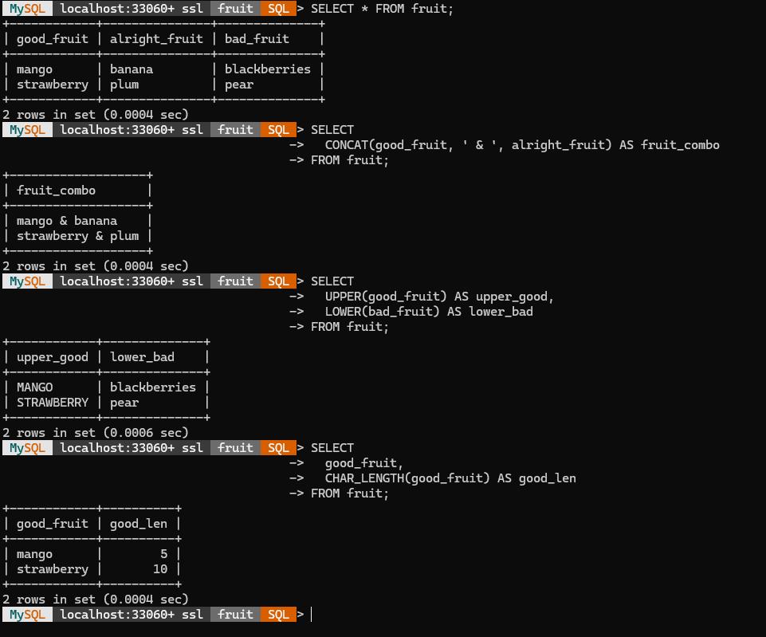

Function: CONCAT()  
 When it might be used: The CONCAT() function combines two or more text fields into one string. It can be used to join names, titles, or words together in a single column.  
 Alias for the column: fruit_combo  
 SQL Statement:  
 SELECT CONCAT(good_fruit, ' & ', alright_fruit) AS fruit_combo FROM fruit;

Function: UPPER() and LOWER()  
 When it might be used: These functions change the text case. UPPER() makes text all uppercase and LOWER() makes text all lowercase. This helps standardize data for comparisons or display formatting.  
 Alias for the columns: upper_good, lower_bad  
 SQL Statement:  
 SELECT UPPER(good_fruit) AS upper_good, LOWER(bad_fruit) AS lower_bad FROM fruit;

Function: CHAR_LENGTH()  
 When it might be used: The CHAR_LENGTH() function returns the number of characters in a text value. It’s useful for checking data length, enforcing formatting rules, or analyzing text size.  
 Alias for the column: good_len  
 SQL Statement:  
 SELECT good_fruit, CHAR_LENGTH(good_fruit) AS good_len FROM fruit;