Jackson Webster

10/16/2025

Assignment 6.2

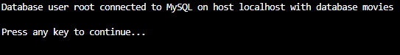

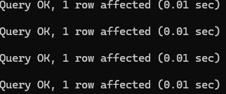

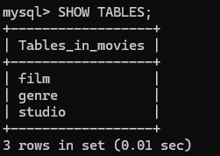  
  
I had to rename the .env file to config.env and use the absolute path in the Python script because Python was not recognizing the .env file using a relative path. This made sure the script could read my database credentials and connect successfully.