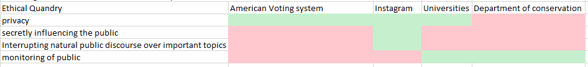

Green is a “check mark” and red is a “not checkmark” …inverse checkmark? …anti-checkmark?

I chose the Cambridge fake social media influence on the 2016 presedential vote as my scenario. The ethical quandry’s that I found to be the most important to consider were that of privacy, secretly influencing the public, interference of public discourse, and monitoring of the public. My four systems I am considering are the American voting system (as a whole), Instagram, universities in general, and the department of conservation.

For what ethical dilemmas affected what system and for what system in turn has issues with this dilemma I found that for privacy the American voting system, Instagram, and universities are all involved in the issue of privacy. I think that keeping these systems information private along with the people that use it (in the case of Instagram you can choose to reveal some information) is very important and violating that privacy can be a huge issue. Public influence I can only really see being all that applicable to Instagram as it can be a serious outlet for information exchange and since the algorithms that Instagram has in place shows people what Instagram wants them to see then I can see that as being able to influence the public. For interference of discourse I can see Instagram being the only real contender here as it has the ability to limit what people can say with bans and removing posts and filtering what people see. Finally monitoring of public is something that universities and the DOC both have in common. Universities must monitor their students closely and those that are on their campus and the department of conservation must ensure wildlife and wild areas are protected and maintained despite people using and traveling these areas constantly.