


BlastPro Complete User Manual
  - Using the web application and Android field notebook
INSY7315 Work Integrated Learning | Task 3 | 2026
Client Xploma BlastPro Team ARC group 16

Team member | Student number
Nicholas Farquhar | ST10439055
Zain Labuschagne | ST10442835
Matthew Jackson | ST10445830
Jaco Smit | ST10439052
Ethan Chipps | ST10330209
Jarred Blamire | ST10452547

Version 1.1 | Updated 30 October 2026 | Web and Android application manual

Contents
1 About this manual 4
How to use the guide 4
2 Access and accounts 5
Open the hosted web application 5
Sign in and sign out 5
Create a company 6
Forgotten passwords 8
3 Roles and navigation 8
Web navigation 9
Android navigation 9
4 Company administration 9
Review and edit company details 9
Create a Blaster account 10
Update access and passwords 10
Manage products and prices 11
Manage your profile 12
5 Project management 13
Create and find a project 13
Edit or delete a project 14
6 Pattern design 14
Bench and hole layout 14
Rock and site details 15
Timing plan 16
Site calibration and limits 16
Edit individual holes 17
Save the draft or calculate 18
7 Results and warnings 19
Read the result state 19
Understand the figures 20
Respond to warnings 20
Compare previous calculations 21
8 Reports and PDF output 21
9 Shared web notes and photos 22
Create and edit notes 23
Attach and view photos 23
Add a comment 23
10 Install and access the Android app 24
Requirements 24
Install the supplied build 24
Sign in on Android 25
11 Android field notebook 26
Find and refresh notes 26
Create a project on Android 27
Create or edit a note 28
Take select and remove photos 29
Comments and deletion 30
Settings and sign out 31
12 Troubleshooting 31
Information to give support 32
13 Guided training exercise 32
14 Technical access and local setup 33
15 Glossary and support 34
Support responsibility 35

1 About this manual
This manual explains how authorised Xploma users use BlastPro to prepare and store blast design records, review calculated planning results, produce reports, and share project notes and photos. It covers both the browser application and the Android field notebook, including the Main Company User administration screens.
The instructions describe source revision 62b02d2. The web workflow was reviewed on 28 October 2026 and the Android screen walkthrough was captured on 30 October 2026 from that source. Both applications share one API and database; a change saved successfully becomes available to an authorised user in the other application after it reloads the relevant information.
BlastPro provides planning estimates for qualified blasting professionals. Site measurements, product suitability, loading, initiation plans, calibration coefficients and operating limits must be checked through the organisation’s approved engineering process. A result marked complete, or a report without warnings, does not approve a blast or establish a safe exclusion distance.

How to use the guide
Start with access and roles, then follow the web workflow from the Dashboard through Pattern Design, Results and Reports. Main Company Users should also read company administration. Android users should read installation and the field notebook sections. The final chapters provide troubleshooting, a training exercise, and a glossary.
Bold interface names in the steps identify the control to select. “Saved draft” means data stored on the server. “Live summary” means the provisional figures shown while editing. “Not available” means the saved result lacks the information needed for that metric; it is not a zero value.
Table 1 Where each task is completed
Application | Use it for | Connection
Web application | Company and user administration, products and prices, projects, pattern design, calculations, reports and shared notes | A browser with internet access to the hosted web application
Android application | Creating projects and capturing, finding, editing and commenting on project notes and photos | Android 8 or later and internet access to the same hosted API

Current release boundary. Android does not calculate blast designs, export calculation reports, or provide an AI chat assistant. Its current screens call the live API; offline note capture and queued synchronisation are not operational. Do not rely on older screenshots or the Settings description that mentions offline use.

2 Access and accounts

Open the hosted web application
1. Open BlastPro. Use the link below in a current browser. Keep JavaScript enabled because the pattern preview and editable hole table depend on it.
2. Check the address. Use the team’s hosted address or an address supplied by the company administrator. A local development address works only while the developer’s web application and API are running.
3. Choose the correct account. Use an existing Main Company User or Blaster account. A local development account and a hosted account may belong to different databases.
Open the hosted BlastPro web application
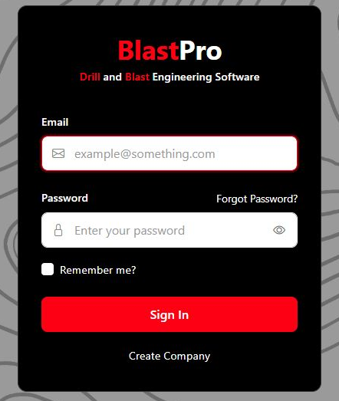
Figure 1 Web sign in page
1. Enter the email address for the account you intend to use.
2. Enter the password and select Sign In. The eye control shows or hides the typed password.
3. Create Company sets up a new company and its first Main Company User; it is not the Blaster registration route.

Sign in and sign out
1. Enter Email and Password. Select Sign In. Successful authentication opens the Dashboard, or the authorised page you were opening.
2. Use Remember me only on a trusted device. The option can preserve the browser sign in across restarts until the API session expires. It does not prevent expiry, deactivation or password changes from ending the session.
3. Read an error before trying again. Correct empty or invalid fields. Repeated incorrect passwords may lock the account for 15 minutes after five failed attempts. Ask the Main Company User if the account is inactive.
4. End the session. Select Logout in the web navigation when finished, particularly on shared computers. Reopen Sign In before another person uses the browser.
The normal web session lasts up to 60 minutes and cannot outlive its API token. Android keeps its token in memory; closing or restarting the process requires another sign in. If the applications return to the sign in screen, authenticate again before continuing.

Create a company
Use Create Company once for a new organisation. An existing Blaster should ask the Main Company User for an account instead. Company setup creates the company and its first Main Company User together and signs that user in immediately; the current setup does not wait for an email confirmation.
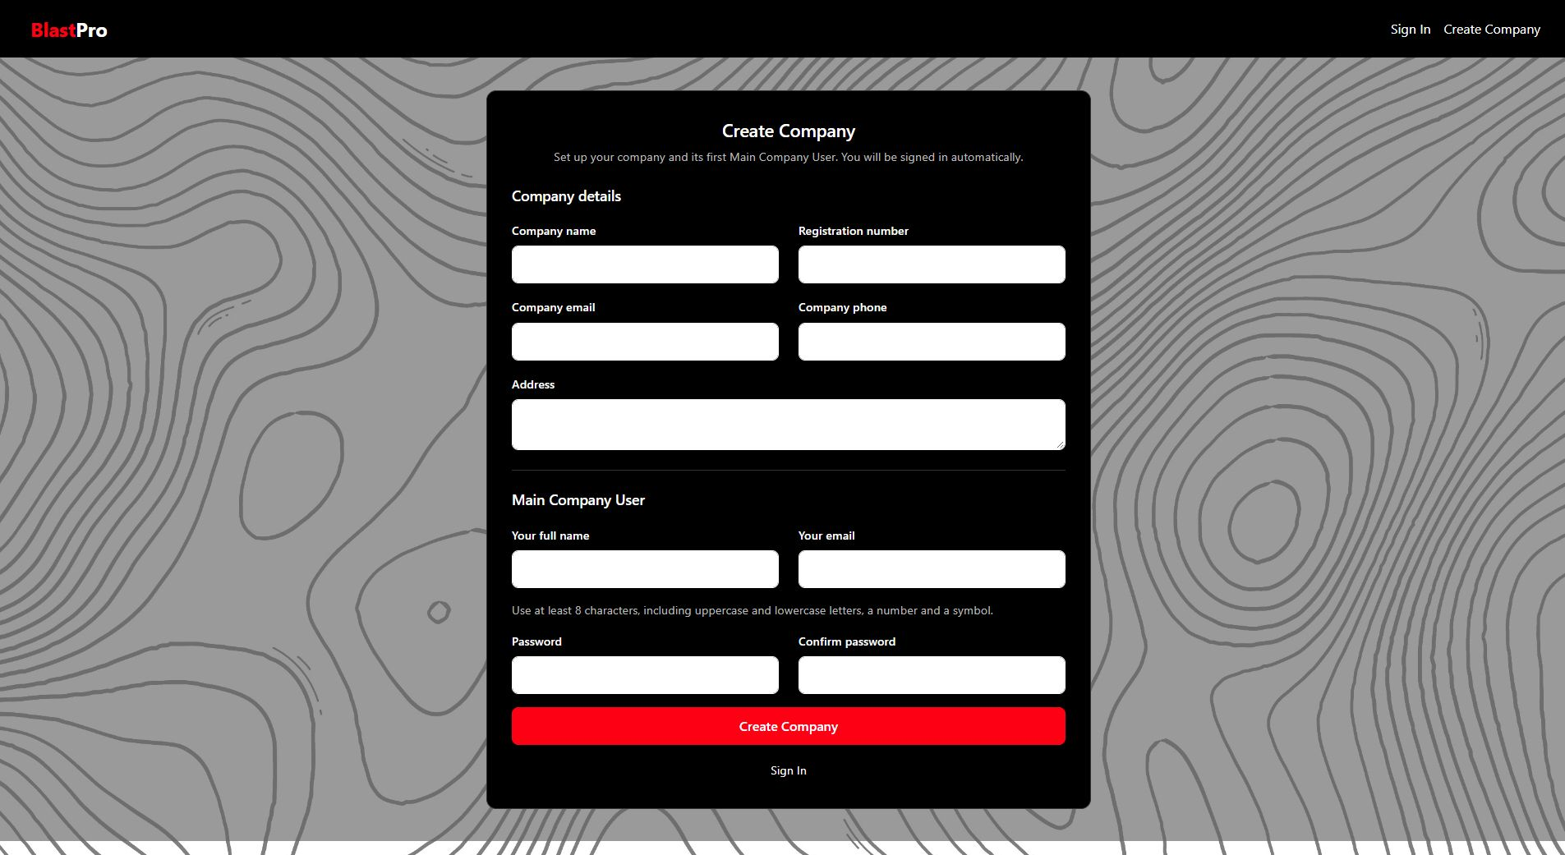
Figure 2 Company setup form organisation details
Figure 3 Company setup form first Main Company User
1. Complete Company details first. Company email and Your email are separate fields.
2. Enter the first Main Company User’s name, email and matching password fields.
3. Field validation appears beside the affected field; complete the correction before submitting again.
Table 2 Company setup fields
Field | What to enter | Limit
Company name | The organisation’s name | Required; maximum 150 characters
Registration number | The company registration reference | Required; maximum 80 characters; must be unique
Company email | The company contact email | Required valid email; maximum 254 characters
Company phone | The company contact number | Required phone number; maximum 30 characters
Address | The company contact address | Optional; maximum 300 characters
Your full name | Name of the first Main Company User | Required; maximum 150 characters
Your email | The first user’s sign in email | Required valid and unique email; maximum 254 characters
Password and Confirm password | The same password in both fields | 8 to 100 characters; include uppercase and lowercase letters, a number and a symbol

1. Select Create Company. Complete both sections and select the Create Company button once.
2. Correct validation messages. A duplicate registration number or email must be resolved. Do not create another company to work around a forgotten account.
3. Confirm the result. The Dashboard opens for the new Main Company User. Open Company to review the record, then create Blaster accounts as described in chapter 4.

Forgotten passwords
1. Select Forgot Password. Enter the account email and submit the request. BlastPro shows the same acknowledgement whether or not an eligible account exists.
2. Follow the supported recovery route. In the current hosted demonstration environment, outgoing reset email is not configured. A Blaster should ask the Main Company User to use Set password. The Main Company User should contact the project support team for account recovery.
3. For local development only. The reset message is written in the API project’s App_Data/PasswordReset folder. A developer can open the latest message for the requested address and use the link while it remains valid.
4. Choose a new password. On a valid reset page, enter the new password and its confirmation. Reset links expire after one hour and cannot be reused after a successful reset. Sign in again afterwards.
Changing or resetting a password invalidates earlier sessions. Never include a password or reset link in a support screenshot.

3 Roles and navigation
Table 3 Role permissions
Task | Blaster | Main Company User
Sign in and edit permitted personal profile details | Yes | Yes
Create projects and work on patterns and results | Own projects | All accessible company projects
View reports and project notes | Own projects | Company projects
Add comments to an accessible note | Yes | Yes
Edit or delete a note and its photos | Notes they authored within an accessible project | Company notes
Manage company contact details | No | Yes
Create Blasters and set their account status or password | No | Yes; up to five active Blasters
Manage company products and prices | No | Yes
Access another company’s data | No | No

A company is a data record; its people sign in with their own accounts. A Blaster sees their own projects. The Main Company User can oversee projects within the same company. A missing item may therefore be an access restriction rather than a failed save.

Web navigation
Dashboard opens the project list. Reports lists accessible project reports. Main Company Users also see Company and Products and prices. Select your name to open Profile and select Logout to end the session. Pattern Design and Results are reached from the relevant project’s buttons on the Dashboard, so the selected project remains clear.

Android navigation
After sign in, Notes is the main screen. The bottom bar contains Notes, the central plus button for a new note, and Settings. The back arrow returns from the editor or New Project. The bottom bar is hidden while the keyboard is open and on editing screens. Search and the project filter narrow the visible notes; they do not delete records.

4 Company administration
Only a Main Company User can open Company and Products and prices. Use these screens before onboarding Blasters and before relying on explosive cost figures in new calculations.

Review and edit company details
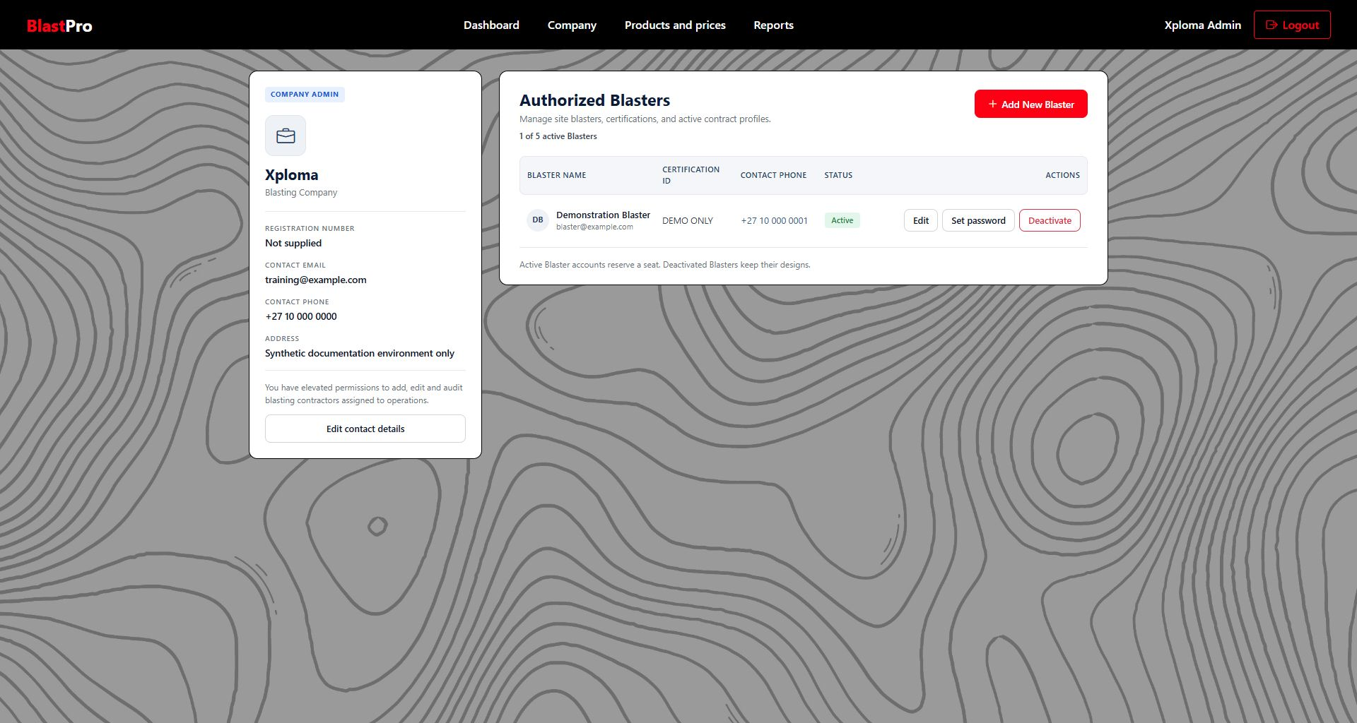
Figure 4 Company details and authorised Blasters
1. The company card contains its registration and contact information.
2. The seat count shows active Blasters out of the five available places.
3. Each Blaster has Edit, Set password and Deactivate or Reactivate actions.
1. Open Company. Check the company name, registration number, contact email, contact phone and address.
2. Select Edit contact details. Update Contact email, Contact phone and Address. The company name and registration number are displayed as company identity information and are not changed by this form.
3. Select Save details. Review the returned company page and confirmation. Cancel returns without submitting the form.

Create a Blaster account
1. Check the seat count. A company may have one Main Company User and no more than five active Blasters. If all seats are used, deactivate an appropriate account before adding another.
2. Select Add New Blaster. Enter the Blaster’s unique Email, Password and Confirm password. The current implementation creates the account immediately; it does not send an invitation email.
3. Select Create account. Resolve any duplicate email or password validation messages. Share access through the organisation’s approved confidential method.
4. Complete the person’s details. From the company list select Edit, then enter Full name, Certification ID and Contact phone. Save changes. These fields are required when saving this details form.
Do not use team members’ real passwords in screenshots or training materials. The accounts shown in this manual belong to an isolated synthetic documentation environment.

Update access and passwords
1. Edit a Blaster. Use Edit beside the intended person and check the email shown before saving their name, certification and contact details.
2. Set a password. Use Set password, enter New password and Confirm new password, and select Save password. The password must satisfy the account policy. Existing sessions are revoked.
3. Deactivate an account. Select Deactivate for a person who should no longer sign in. The account’s designs are retained, existing sessions are invalidated, and the active seat is released.
4. Reactivate an account. Select Reactivate when access is required again. A free seat must be available. The person must sign in again; an older session does not become valid automatically.

Manage products and prices
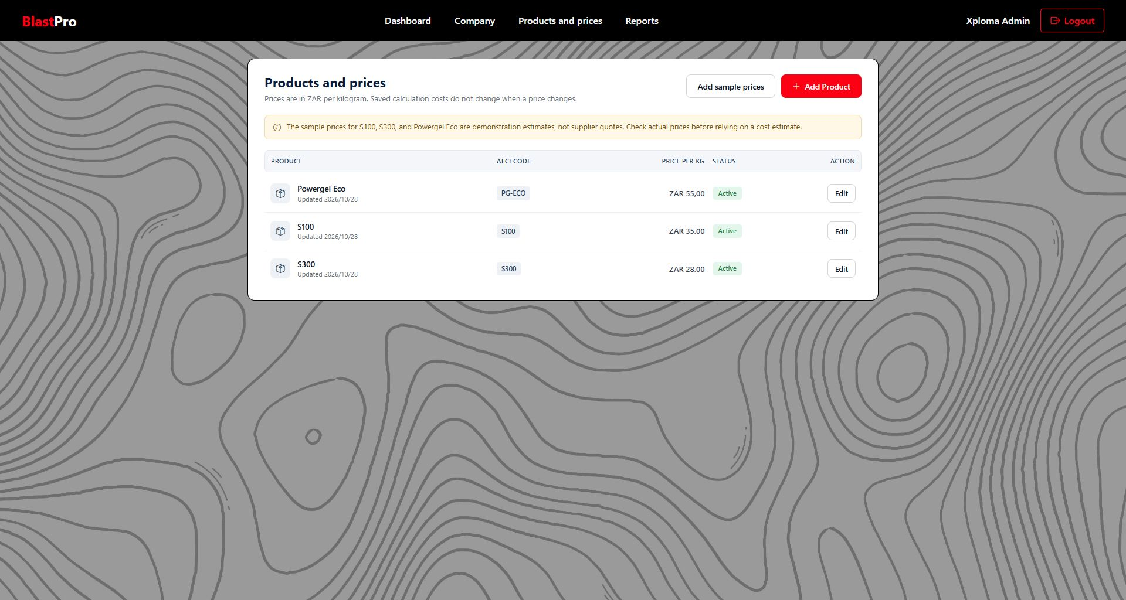
Figure 5 Company product and price list
1. Add Product opens a new company price record.
2. Edit changes a product’s name, catalogue mapping, price or availability.
3. Add sample prices creates editable demonstration prices; these are not supplier quotations.
Table 4 Product administration controls
Field or action | Meaning
Product name | A clear company label; 2 to 150 characters. Duplicate company names are rejected.
AECI catalogue product | Maps the company price to the selected product used by current pattern designs. Only one company price may map to the same catalogue code.
Price per kilogram | ZAR per kg, from 0.01 to 1,000,000. Obtain a current approved price from the supplier or company pricing process.
Available for new designs | Tick for an active product. Untick to stop offering it for new designs.
Custom product for older designs only | Supports legacy designs; current patterns should use the matching AECI catalogue product.
Add sample prices | Loads S100, S300 and Powergel Eco demonstration estimates. Existing mapped entries are not replaced with a new supplier quote.

1. Open Products and prices. Select Add Product or Edit beside an existing product.
2. Set the product mapping and price. Choose the matching catalogue item, enter the ZAR price per kg, and set availability.
3. Select Save product. Check the returned list. A changed price applies to new calculations. An existing saved result keeps its original calculated cost.
4. Recalculate when required. If a design needs the revised price, review its saved pattern and run a new calculation. Keep the older calculation for comparison.
A cost is available only when every hole resolves to an active company product price and the prices use one currency. Selecting an AECI product for engineering reference does not itself establish a company price.

Manage your profile
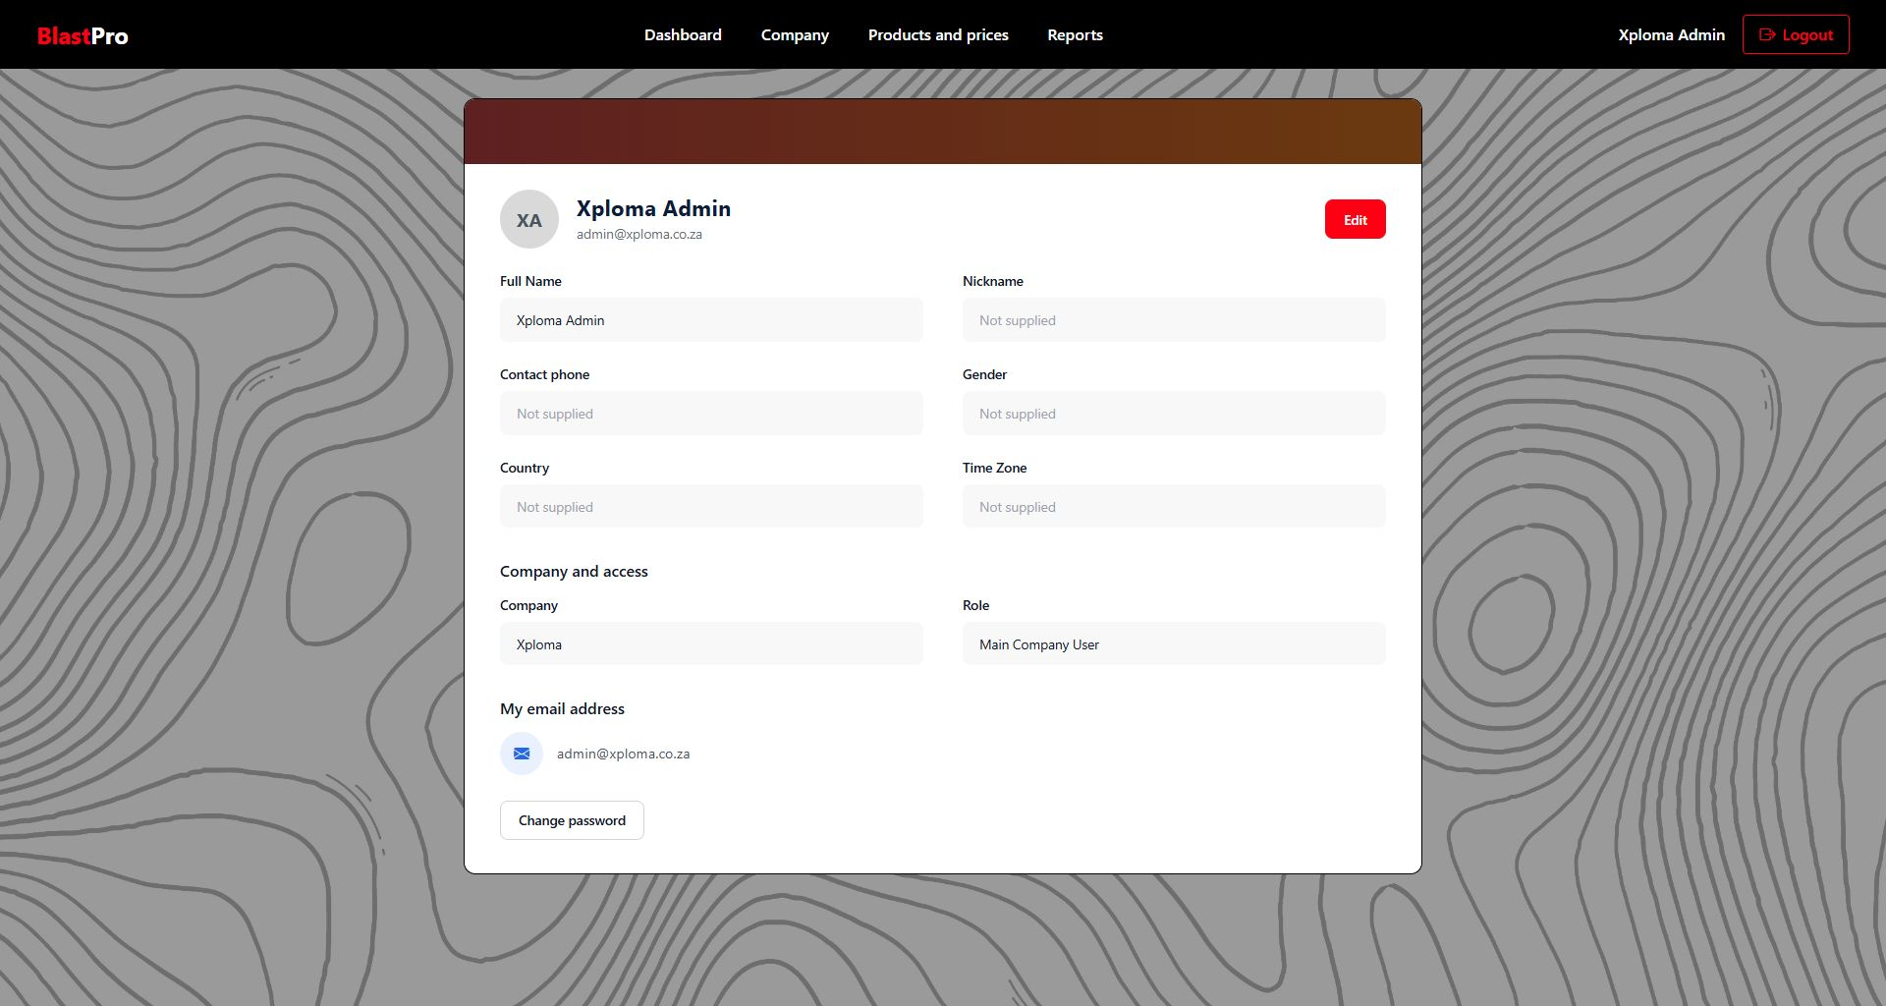
Figure 6 Personal profile
1. Edit changes permitted personal details.
2. Company and Role explain the account’s current access.
3. Change password uses the password recovery route described in chapter 2.
1. Open your profile. Select your name in the web navigation.
2. Select Edit. Update Full name, Nickname, Contact phone, Gender, Country and Time zone as appropriate. Full name is required. The other fields are optional and validate their format or maximum length.
3. Select Save profile. Review the updated profile. The form does not change your email, company, role or active status. Ask the Main Company User or support team if those details are wrong.

5 Project management
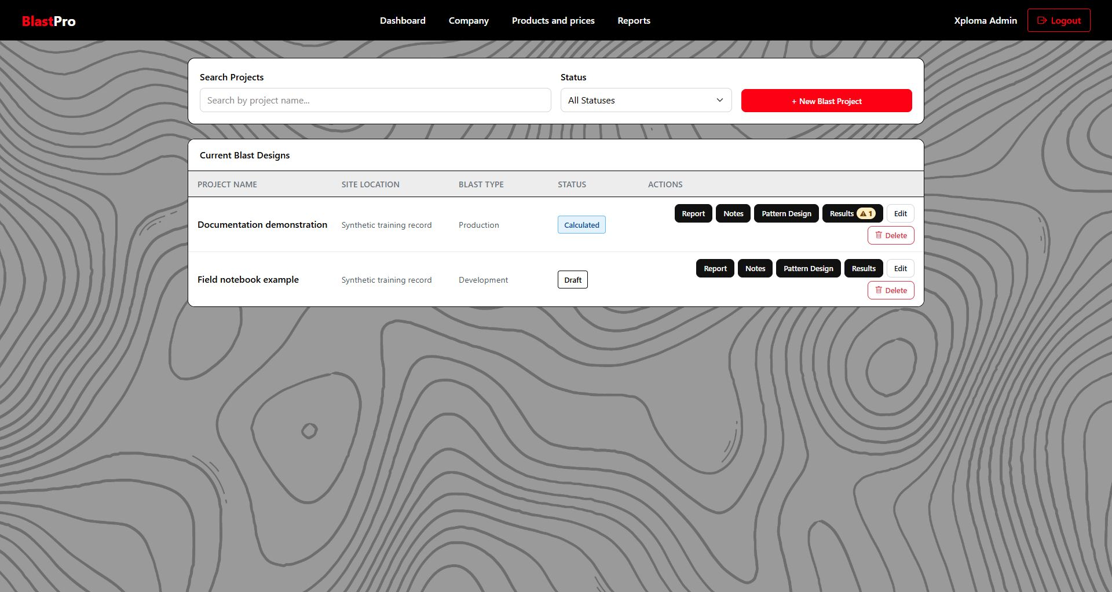
Figure 7 Dashboard project list
1. Search Projects filters by project name. Status restricts the list further.
2. New Blast Project creates a record.
3. Each row has Report, Notes, Pattern Design, Results, Edit and Delete actions. A Results badge shows the warning count and highest severity.

Create and find a project
1. Select New Blast Project. Enter Project Name, Site Location and Blast Type. Use a descriptive name so the project can be found later.
2. Choose a blast type. The available labels are Production, Pre-split, Trim, Development and Trench. These describe the project; they do not approve a method.
3. Select Create Project. The project is saved and its Pattern Design screen opens. Cancel returns to the Dashboard.
4. Find the record again. On Dashboard type part of its name into Search Projects. Choose All Statuses to remove a status restriction. Clear the search if no matching records appear.
Table 5 Project details
Field | Requirement
Project Name | Required; maximum 100 characters
Site Location | Required; maximum 150 characters
Blast Type | Required; choose one of the supplied options

Edit or delete a project
1. Edit the project. Select Edit on its Dashboard row, update the name, location or type, and select Save Changes.
2. Check results after changing a design. A change to calculation-relevant design data can mark the earlier result outdated. Review the design and run a new calculation before using current figures.
3. Delete only the intended record. Select Delete on the project row and read the confirmation. Confirming removes the project from the normal working list. Cancel leaves it available.
Deletion uses a soft delete in the server data model. The current application does not provide a normal restore button. Ask the support team before assuming a deleted record can be recovered.

6 Pattern design
Open Pattern Design for the intended Dashboard project. Work through the five sections in order and inspect the plan as you edit. The visible summary is provisional; use Save Draft or Save and Review Results to store the work. Closing the page without saving can lose edits.
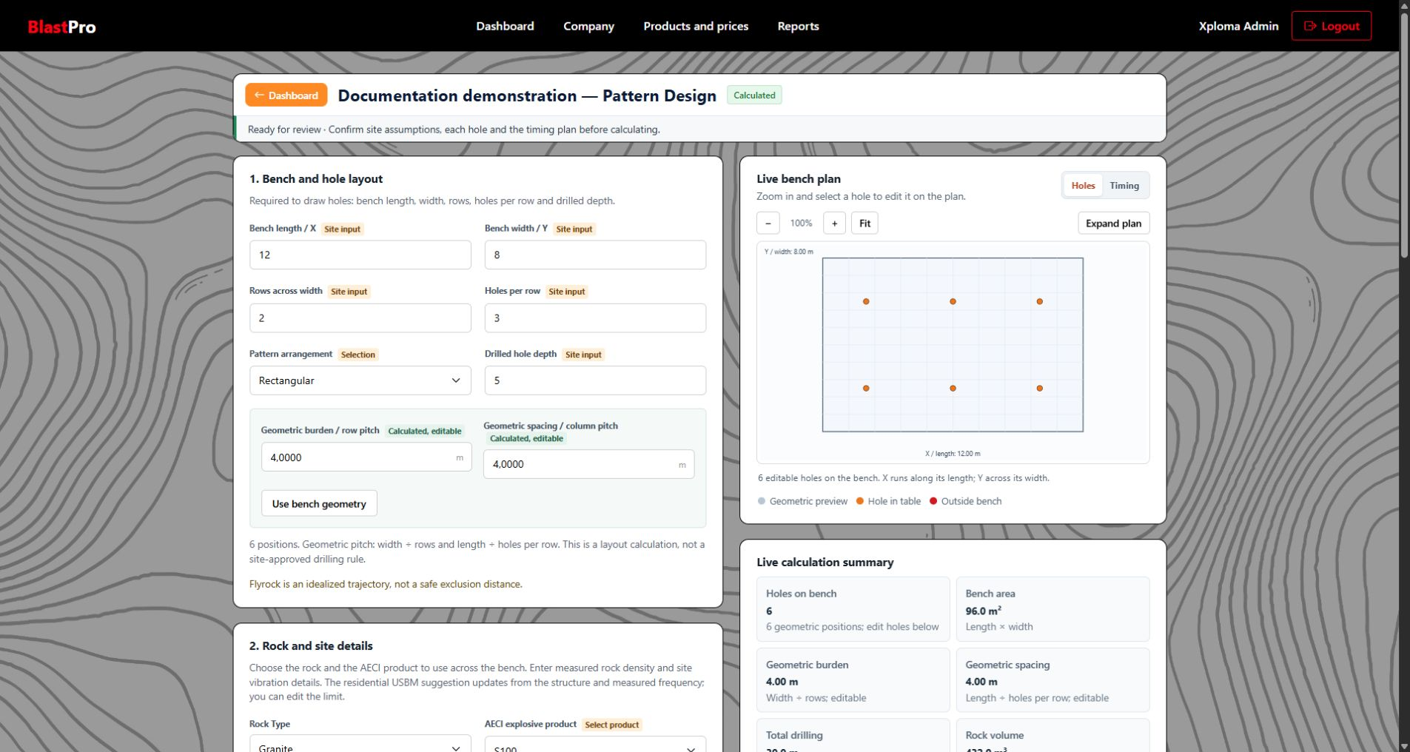
Figure 8 Pattern Design workspace
1. The left column contains bench, rock, timing and site inputs.
2. The Live bench plan supports Holes and Timing views, zoom, pan, Fit and Expand plan.
3. The editable hole table and save actions are further down the page.

Bench and hole layout
1. Enter measured bench dimensions. Bench length is the X direction and bench width is the Y direction, in metres. The current editor uses a rectangular bench planning area.
2. Set the layout. Enter Rows across width and Holes per row, choose Rectangular or Staggered, and enter Drilled hole depth in metres.
3. Review geometric pitch. The app divides bench width by row count for burden and bench length by holes per row for spacing. Both values remain editable. Use bench geometry restores the derived geometric values.
4. Apply the layout. Select Apply current layout to holes. If the current rows contain manual edits, choose Replace holes to regenerate them or Keep edits to preserve them.
5. Inspect all generated holes. Check the plan and table. Geometry generation is a starting arrangement; the blaster remains responsible for the actual site pattern.
Table 6 Bench layout field reference
Input | Unit or choice | Interface limit
Bench length and width | Metres | Greater than zero; up to 10,000 m each
Rows and holes per row | Whole numbers | At least one each; their product cannot exceed 500 holes
Drilled hole depth | Metres | Positive value
Geometric burden and spacing | Metres | Positive, editable pitch values
Pattern arrangement | Rectangular or Staggered | Select the required starting arrangement

Replacing a layout replaces current hole edits. The application asks for confirmation when it detects manually adjusted values. Use Keep edits when uncertain and review the existing table first. Add Hole and Add 10 Holes can add rows without replacing the full layout.

Rock and site details
1. Choose Rock Type. Select Granite, Limestone, Sandstone, Shale or Other. Enter measured Rock density in tonnes per cubic metre; do not treat a rock name as a measured density.
2. Choose the AECI explosive product. Select a suitable catalogue entry approved through your organisation’s engineering process. New holes use the selected product and its reference information.
3. Review the vibration limit. Enter the approved limit in mm/s. Nearby structure and Measured frequency can produce a residential USBM suggestion. A manually entered site limit remains a separate decision.
4. Use a suggestion only when applicable. Use USBM suggestion restores the app’s reference value where the selected residential structure and frequency support it. Other structures and local requirements require a site-approved manual limit.
5. Check each hole’s loading. Catalogue density is an editable starting value. A charge estimate can update from diameter, loaded length and density. Review the measured product and loading information for every exception.
The USBM reference is US residential guidance from RI 8507. It is not a South African legal limit, a general rule for every structure, or proof that a blast is safe. The manual’s purpose is to explain the interface; a qualified person must establish the correct local and site requirements.

Timing plan
Select a Sequence order, review Interval in milliseconds, and inspect the Timing view of the plan. The interval shown from the burden is a preliminary software estimate, not an approved initiation plan. Individual hole delays remain editable.
Table 7 Available timing sequence labels
Sequence order | Displayed behaviour
Sequential by hole number | Follows the numbered hole list
Sequential across rows | Progresses along rows
Sequential down columns | Progresses along columns
Serpentine across rows | Alternates direction between rows
Chevron | Arranges a V pattern from the centre
Echelon | Uses a diagonal order from the right
Interleaved rows | Starts rows with a half-row overlap
One time per row | Groups the holes in each row at one time
One time per column | Groups the holes in each column at one time

1. Choose the sequence. Select the intended order and review Interval in ms.
2. Apply to edited delays when needed. Select Apply sequence to edited delays. If prompted, Replace delays overwrites the manual delays; Keep delays preserves them.
3. Review the result. Switch the plan to Timing and compare the order with the hole table. Timing labels are shown on the plan only when there are 45 holes or fewer; the table retains the numeric delays.

Site calibration and limits
Enter measured calibration data and approved limits. The software stores these inputs with the draft. Missing optional estimate inputs can leave a related metric unavailable, while missing essential readiness inputs prevent the combined save and calculate action.
Table 8 Calibration and limit fields
Field | Unit | Purpose
Charge grouping window | ms | Defines which nearby initiation times contribute to the maximum charge calculation
Distance to receptor | m | Distance used by the PPV estimate
PPV site coefficient | Site calibrated coefficient | Site-specific input to the scaled-distance PPV model
PPV decay exponent | Site calibrated exponent | Site-specific decay input to the PPV model
Flyrock launch speed | m/s | Evidence-based input to the idealised trajectory screen
Trajectory angle | Degrees from 0 to 90 | Editable trajectory assumption
Trajectory height | m | Editable launch-height estimate
Approved exclusion radius | m | Site limit against which the idealised trajectory result is screened

Do not enter invented values merely to remove a missing-input message. Record approved information through the site process. The idealised trajectory excludes many physical effects and cannot determine the safe area for a real blast.
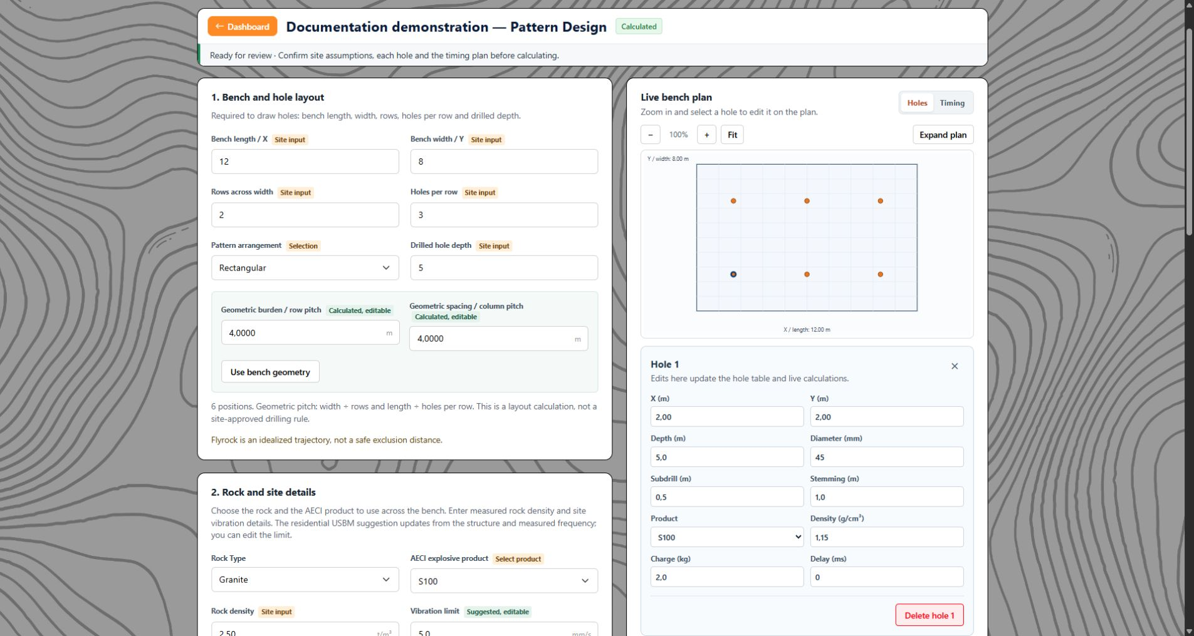
Figure 9 Selected hole editor on the web
The selected-hole editor changes the same row shown in the hole table. Check the hole number, position, depth, product, loading and timing fields before saving. The surrounding plan remains available for checking where the selected hole lies.

Edit individual holes
1. Select the hole. Click a plotted hole to open the selected-hole editor, or edit its row in the hole table.
2. Review the row fields. X, Y, Depth, Diameter, Subdrill, AECI product, Density, Charge, Stemming and Delay describe that hole. The plan and row refer to the same draft record.
3. Change a site exception. Enter the verified value in the editor or table. Manual overrides are retained when supported by the control; review the live summary after changing product, loading or timing.
4. Add or remove rows. Use Add Hole or Add 10 Holes. Tick row checkboxes and select Delete Selected to remove selected rows. Select all holes controls the full table. The selected-hole editor also has Delete hole.
5. Inspect position and limits. An outside-bench indication identifies a point that requires review. Use plus or minus to zoom, drag to pan, Fit to reset the view, and Expand plan for a larger view.
Table 9 Hole table field reference
Hole field | Unit | Meaning
X and Y | m | Position in the bench coordinate system
Depth | m | Drilled hole depth
Diameter | mm | Hole diameter; interface accepts positive values up to 1,000 mm
Subdrill | m | Length below the intended bench level
AECI product | Catalogue selection | Product reference for that hole
Density | g/cm³ | Loading density; the editor accepts 0.01 to 5
Charge | kg | Explosive mass assigned to that hole
Stemming | m | Stemming length
Delay | ms | Initiation time as a non-negative whole number

The application accepts decimal inputs with a decimal point. Review field messages when a number is rejected. Table-row validation may appear in the summary as “Hole 1”, “Hole 2” and so on because those cells do not have individual message areas.

Save the draft or calculate
1. Use Save Draft while preparing the design. This stores the current pattern without creating a new result and returns to Dashboard. Check the “Pattern draft saved” message.
2. Use Save and Review Results when ready. The button labelled Save & Review Results saves the draft, runs the calculation against that saved version, and opens Results.
3. Complete required readiness inputs. The combined action needs at least one hole; positive charge and stemming for every hole; a site charge grouping window; rock density, burden and spacing; and positive vibration and exclusion limits.
4. Resolve an interrupted save. Read the field or summary message. If the data changed in another window, reload the latest version, compare it with your intended edits, and save again. Do not repeatedly submit an old version.
A successful draft save can be followed by a calculation-readiness message. In that case, the draft is stored but the new result has not been created. Return to the indicated fields and try Save & Review Results again after correction.

7 Results and warnings
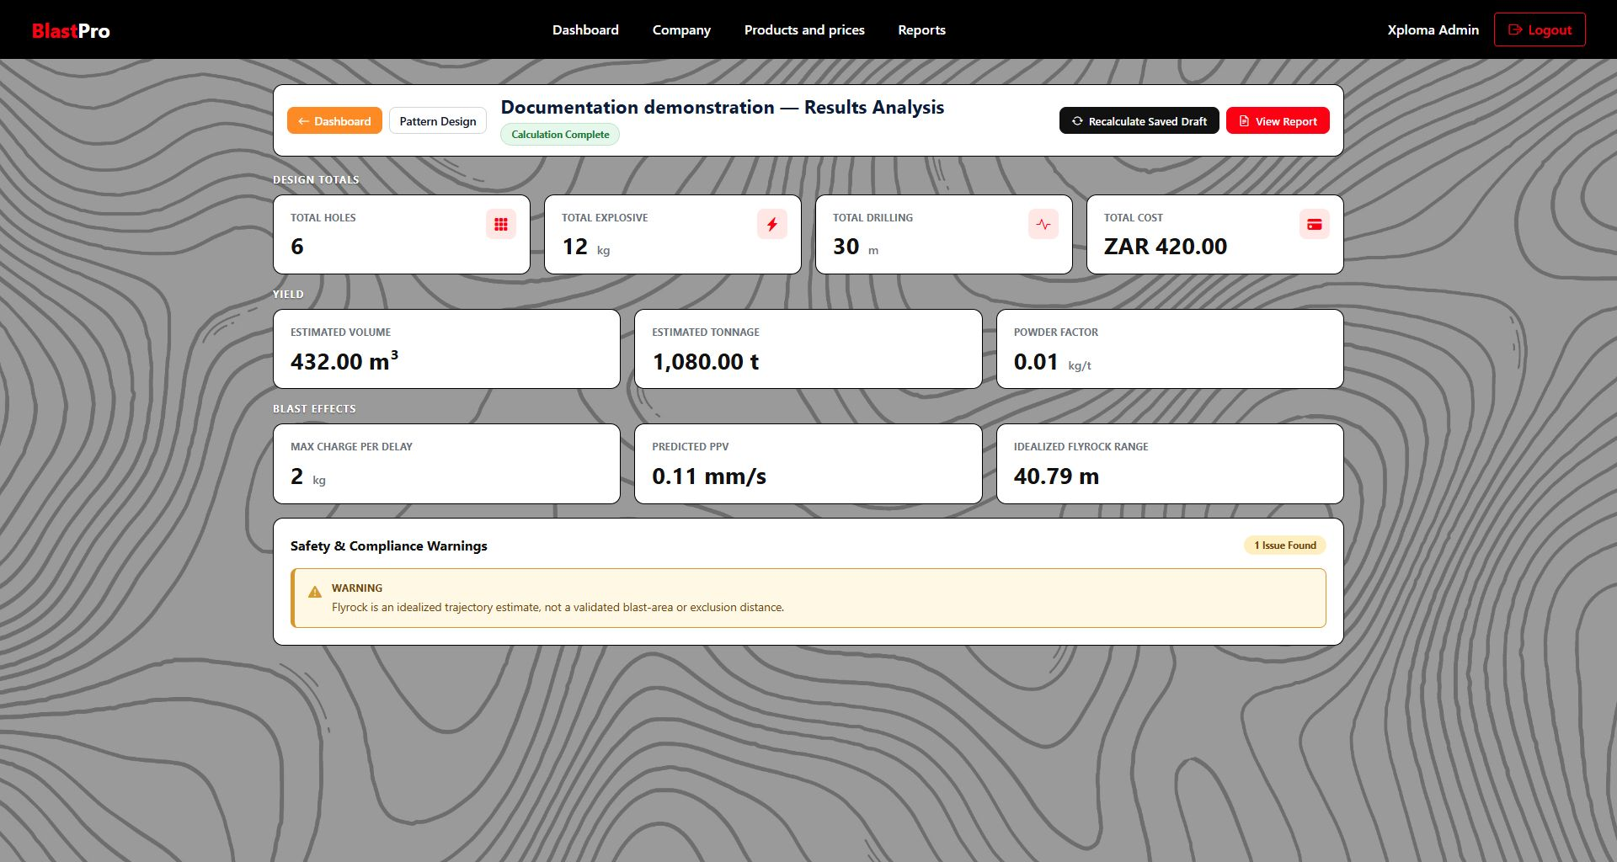
Figure 10 Saved calculation results
1. Check the calculation state and date before reading the figures.
2. Recalculate Saved Draft uses the server’s stored pattern. View Report follows the selected result.
3. Read all warning messages, including informational ones, and inspect Previous Calculations when present.

Read the result state
Table 10 Result states
State | Meaning and next action
Not Calculated or No results yet | The project has no saved calculation. Open Pattern Design and use Save & Review Results.
Calculation Complete | A saved calculation is available for the current saved design. This describes software processing, not engineering approval.
Outdated Calculation | The design changed after the displayed calculation. Review Pattern Design and recalculate the saved draft.
Previous Calculation | You opened a historical result. Use View latest result to return to the current result.

Understand the figures
Table 11 Result metrics
Metric | Displayed unit | What to check
Total Holes | Count | Matches the intended saved hole list
Total Explosive | kg | Sum of hole charges in the saved pattern
Total Drilling | m | Sum of drilled depths
Total Cost | Currency | Calculated only when all hole prices are active and complete in one currency
Estimated Volume | m³ | Planning volume from the supported saved dimensions and effective depth inputs
Estimated Tonnage | t | Volume multiplied by rock density
Powder Factor | kg/t | Explosive quantity relative to estimated tonnage
Max Charge Per Delay | kg | Largest grouped charge under the site delay window
Predicted PPV | mm/s | Site-calibrated screening estimate; requires all related inputs
Idealized Flyrock Range | m | Simplified trajectory screen; not a safe-distance determination

Not available indicates insufficient or unsuitable input for that figure. Correct the relevant saved pattern, calibration or price information and create a new calculation. A saved older result is not rewritten when the design or product prices change.

Respond to warnings
The Dashboard Results badge gives a count and uses the highest severity. Results, report preview and the downloaded PDF display the actual messages. Severity is also written as text so users do not have to rely on colour alone.
Table 12 Warning interpretation
Severity | Response
Information | Read the limitation or missing-data explanation and decide what supporting information is required.
Warning | Investigate the stated design condition, assumption or incomplete input before relying on the output.
Critical | Escalate the stated condition for qualified review and resolve it before considering operational use.

1. Read every message. Use the full text rather than the count alone.
2. Return to the source input. Open Pattern Design or ask the Main Company User to correct company product pricing as applicable.
3. Save and calculate again. Review the new result and compare it with the earlier one. Do not assume a warning disappeared from an older PDF.
4. Retain the reviewed record. Download the report for the intended calculation only after the appropriate professional review process.

Compare previous calculations
1. Find Previous Calculations. The list includes calculation date, cost, powder factor and warning count when available.
2. Select Open for the intended record. The page shows Previous Calculation. Check its date and calculated-by name.
3. Open its report if required. View Report follows the selected result rather than silently switching to the latest one.
4. Return to current information. Use View latest result. Recalculate Saved Draft creates a new result from the present saved pattern.

8 Reports and PDF output
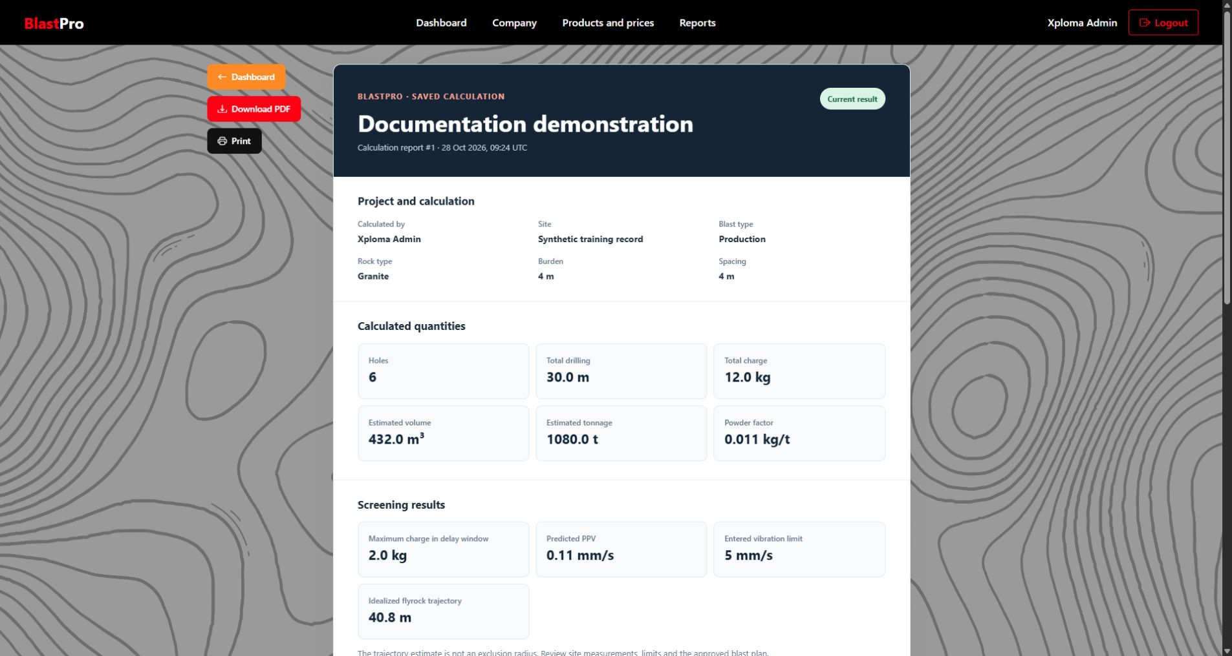
Figure 11 Calculation report preview
1. Check the project identity, selected calculation date and result data.
2. Review the saved hole plan, schedule and warnings.
3. Download PDF and Print are separate actions.
1. Open a report. Use Report on Dashboard, View Report on Results, or Reports in the main navigation followed by Open Report for the project.
2. Check the selected calculation. Reports opened directly from Dashboard normally show the project’s latest saved calculation. A report opened from a historical result follows that selected result.
3. Review all pages. Check project facts, metrics, warnings, hole plan and hole schedule. A new saved calculation retains the pattern snapshot used for that result.
4. Download a PDF. Select Download PDF and save the generated file in the appropriate project records location. Open the downloaded file and check that it represents the intended calculation.
5. Print when needed. Select Print and use the browser print dialog. Check paper size, scaling, page range and destination before completing the print action.
If there is no saved calculation, the report page presents an empty state and an Open Results route. Return to Pattern Design, complete the draft and use Save & Review Results. Calculations created before pattern snapshots were introduced cannot reconstruct their historical hole plan; do not assume a missing historical plan represents the current design.
The downloaded PDF is a calculation record. It does not perform permitting, give a formal design approval, or replace the organisation’s signed operational documents.

9 Shared web notes and photos
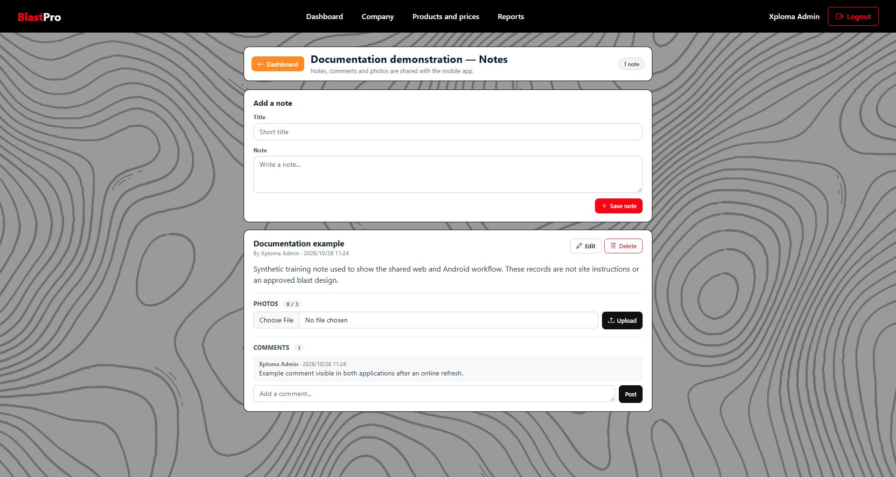
Figure 12 Project notes on the web
1. Add a note creates a record for the selected project.
2. Edit and Delete act on the intended note; editing other authors’ notes requires the Main Company User role.
3. Photos and comments are attached to the note and are shared with Android through the API.

Create and edit notes
1. Open Notes for a project. Select Notes on the intended Dashboard row. Check the project name in the page heading.
2. Enter a Title or Note. At least one must contain text. Title has a maximum of 150 characters; Note has a maximum of 10,000.
3. Select Save note. The note appears with author and date information. A blank title displays as Untitled note.
4. Edit an existing note. Select Edit, change the title or body, and select Save changes. A Blaster may edit their own note; a Main Company User may edit company notes.
5. Delete when appropriate. Select Delete on the intended note and read the confirmation. Confirming removes the note, its comments and photos from the shared system.

Attach and view photos
1. Save the note first. The web upload control belongs to an existing note.
2. Choose a supported file. Use the file selector under Photos, select a JPEG, PNG or WebP image smaller than 5 MB, and select Upload.
3. Review the attachment. A thumbnail appears. Select it to open the image in another browser tab. A note can contain at most three photos.
4. Remove a photo if needed. Select its remove control. The deletion affects the shared server record, so it disappears from Android after refresh. Only the note author or Main Company User can manage the attachments.

Add a comment
1. Open the intended note card. Check its title, author and project context.
2. Enter the comment. Use Add a comment, up to 2,000 characters, and select Post.
3. Review the thread. The new comment appears with its author and timestamp. The current interface provides no normal comment editing or deletion action.
Shared notes are visible only through an accessible project. A Main Company User can see company project notes; a Blaster is restricted to projects they own. A Blaster cannot edit or attach photos to a note authored by another user simply because it appears in an accessible project.

10 Install and access the Android app
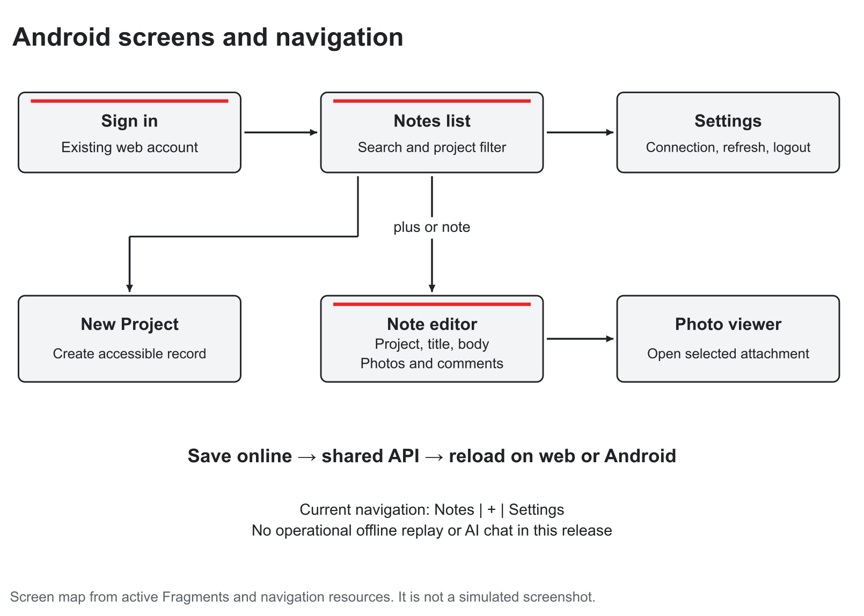
Figure 13 Current Android screen map and navigation paths

Requirements
Use an Android phone or emulator running Android 8 or later. The project targets Android API 35 and the current app version is 1.0. A network connection is required for sign in, project loading, note saves, photo upload and refreshing shared records. An iPhone application is not supplied in this release.
The compiled current Android build normally points to the hosted HTTPS API. The phone does not need the developer’s laptop or Visual Studio to stay running when it uses that build. A separately compiled development build may use another API address; Settings does not provide an address editor.

Install the supplied build
1. Obtain the team’s APK. Use the current APK supplied by the project team or the build artifact from the repository’s successful GitHub Actions run. Check that it is the build intended for the hosted environment.
2. Install through the device’s normal process. Open the APK and follow Android’s prompts. If Android asks to allow installation from the chosen source, use the organisation’s authorised device procedure.
3. Open BlastPro. The sign in screen should appear. Installation does not create an account.
4. Use an existing account. Create a company in the web application or obtain a Blaster account from the Main Company User, then sign in on Android with that account.
Open the GitHub repository and build artifacts
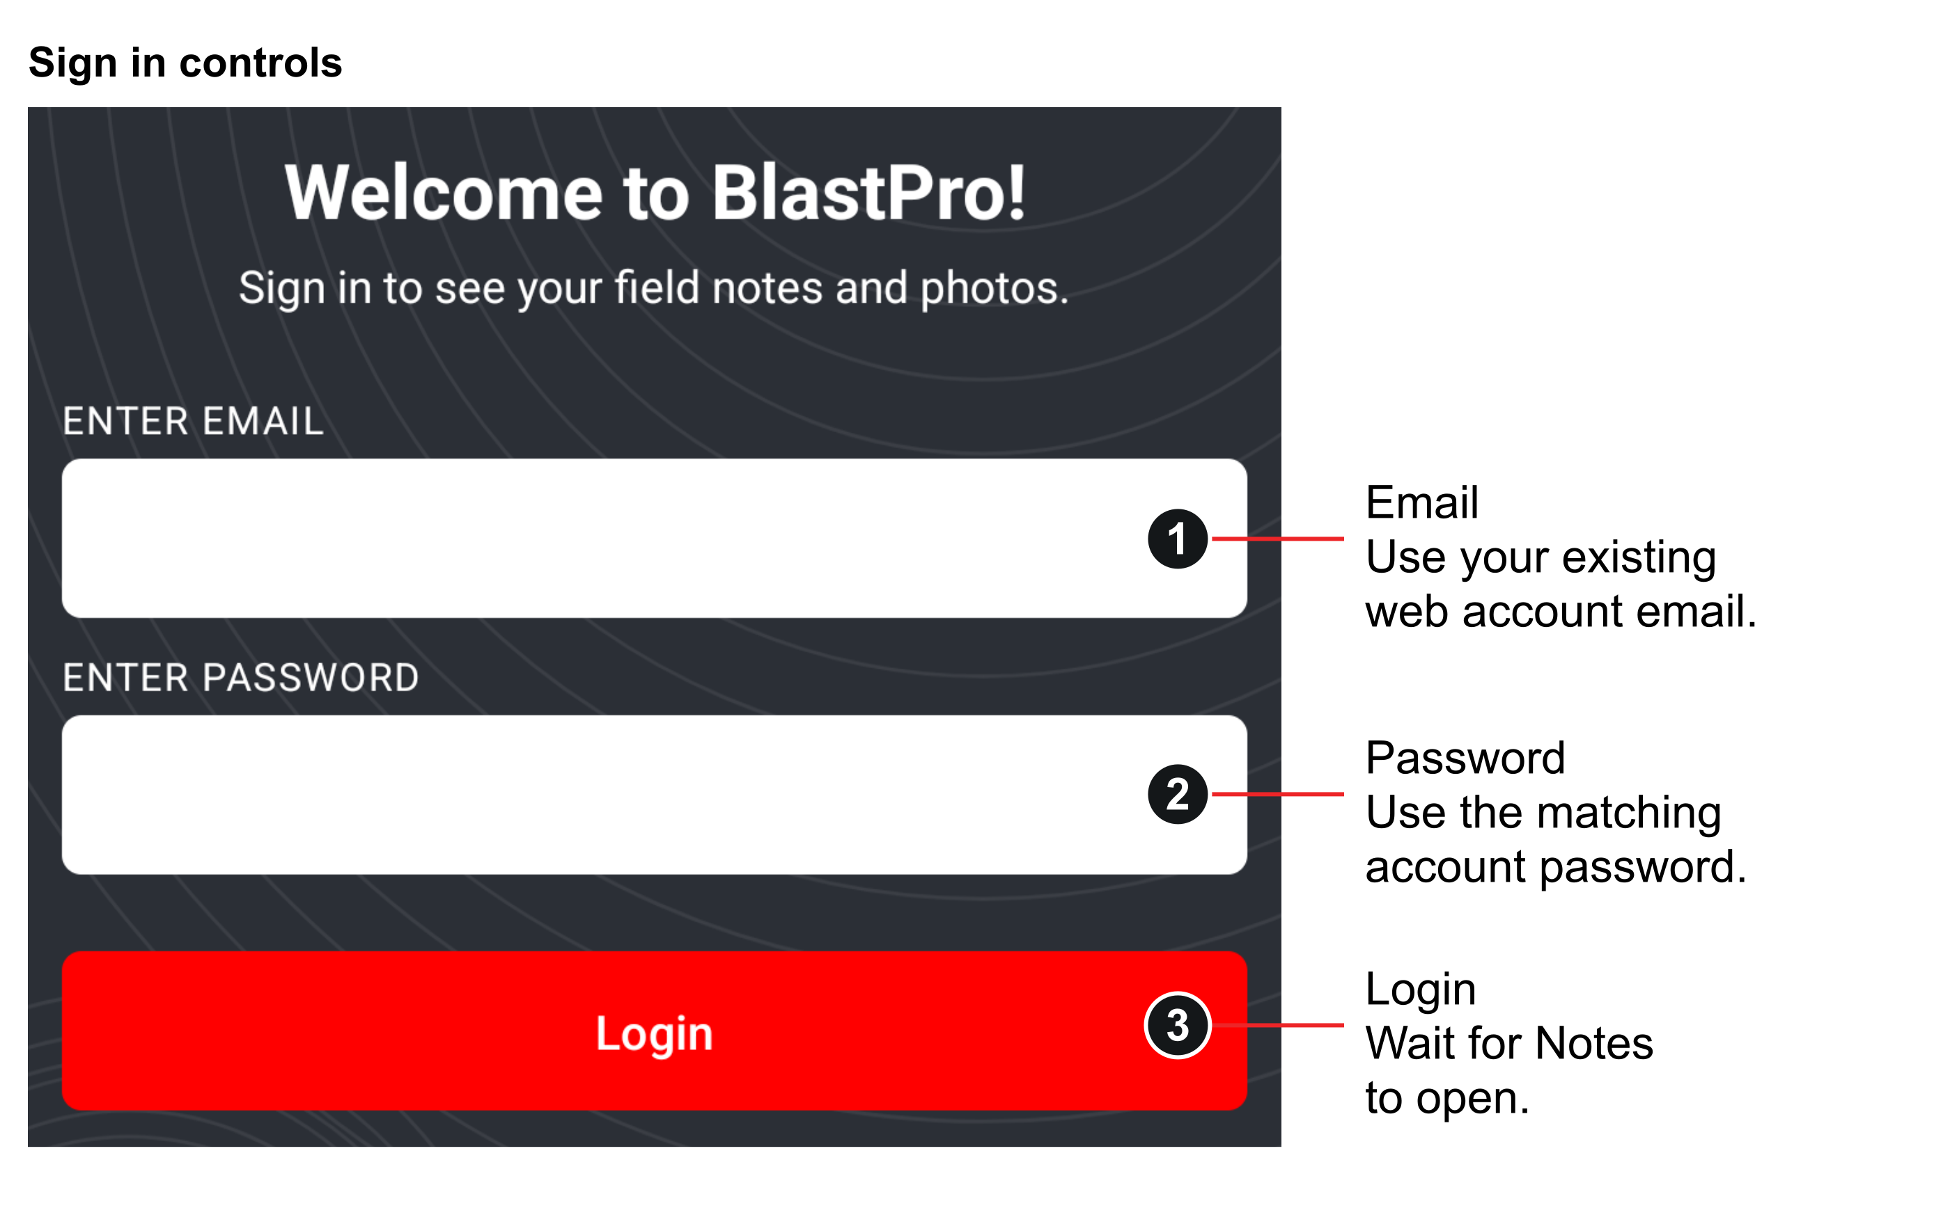
Figure 14 Android sign in controls
The numbered labels identify the current sign-in controls. Use an account from the same API environment; the screenshot uses a separate documentation build.

Sign in on Android
1. Enter email and password. Both are required. The app displays “Enter email and password” when either is empty.
2. Select Login. The button shows Signing in while the request runs. A successful sign in opens Notes.
3. Confirm the available projects. The project filter and editor contain only the projects accessible to this account. A Blaster does not gain access to another Blaster’s projects by using the mobile app.
4. Sign in again after expiry. The API can reject an expired or revoked session. Closing the app process also clears the memory-only session, so sign in again when prompted.
Screenshot key. Numbered labels explain the actual Android controls. Cropped regions omit empty background and system status bars for readability; the controls and example content are unchanged. The screens were captured against a synthetic local documentation database, without changing hosted client data.

11 Android field notebook
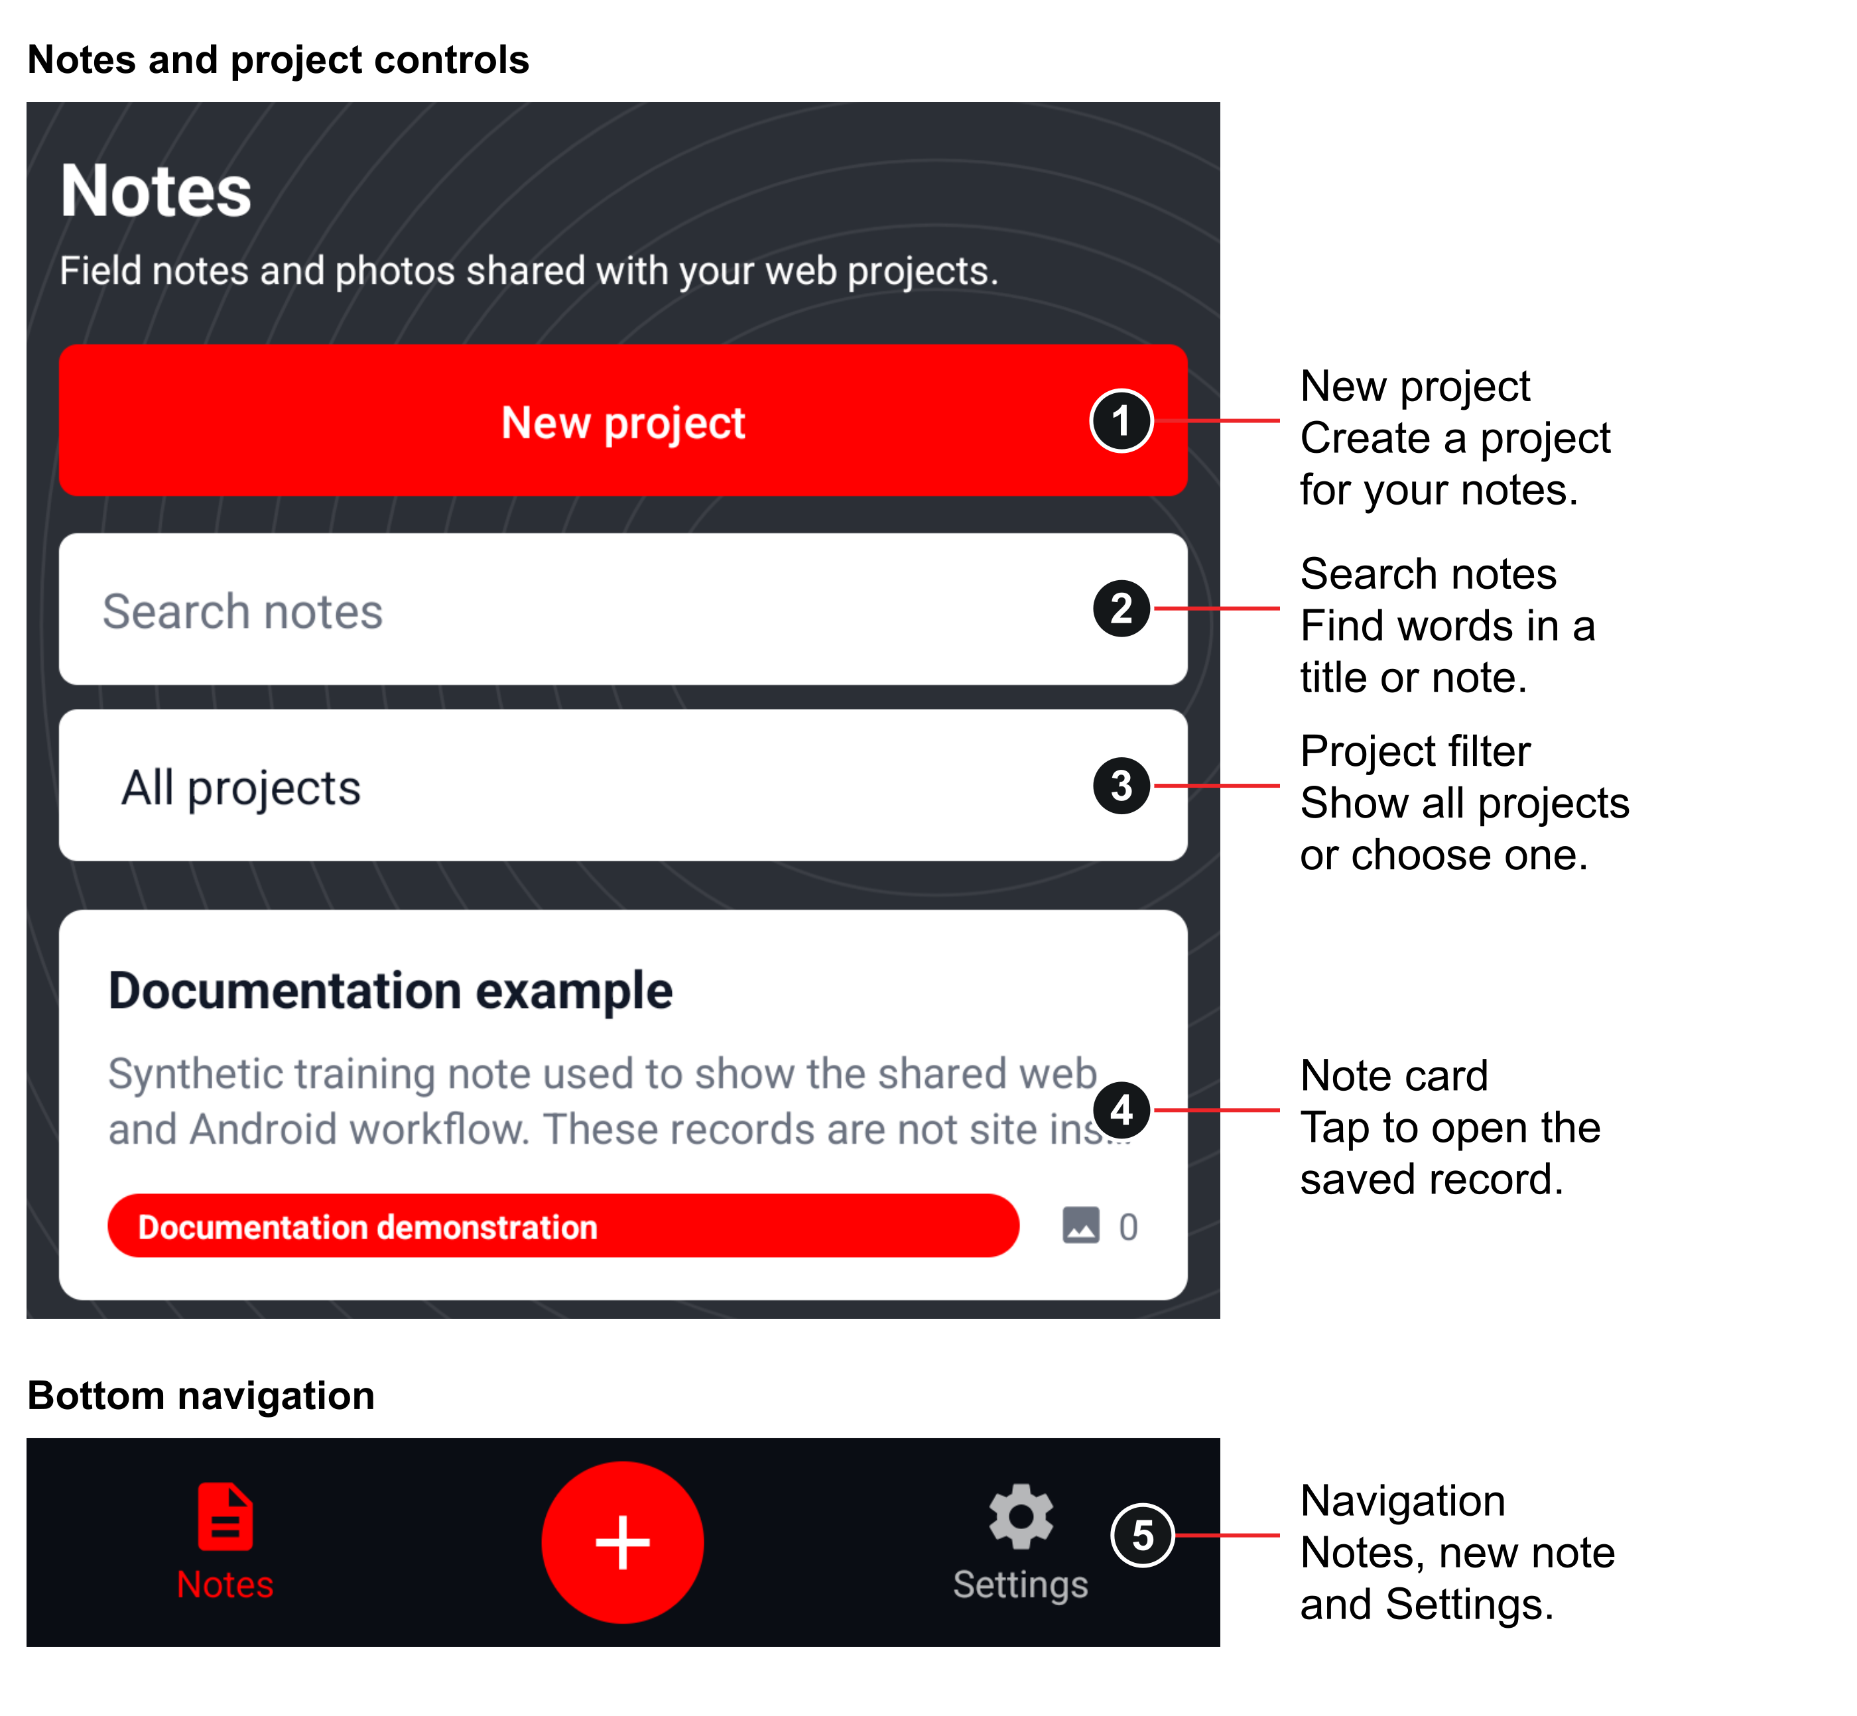
Figure 15 Android notes search filter and navigation
The upper controls and bottom navigation are separate cropped regions from the same screen. The note shown is a synthetic training record.

Find and refresh notes
1. Open Notes. After sign in the app loads accessible projects and their notes, with recently updated notes first.
2. Search. Type words from a note’s title or body into Search notes. Clear the search to show all matches again.
3. Filter by project. Select All projects or a specific project. Search and project filter work together.
4. Open a note. Tap its card to view or edit it. The card displays title, text preview, project, date and photo count.
5. Refresh shared changes. Return to Notes to trigger a reload. If a change made on the web is missing, return to the screen after checking the network and current account.
No notes yet may mean the selected project has no notes, the search has no matches, or the account has no accessible projects. Clear the filters before creating a duplicate note.
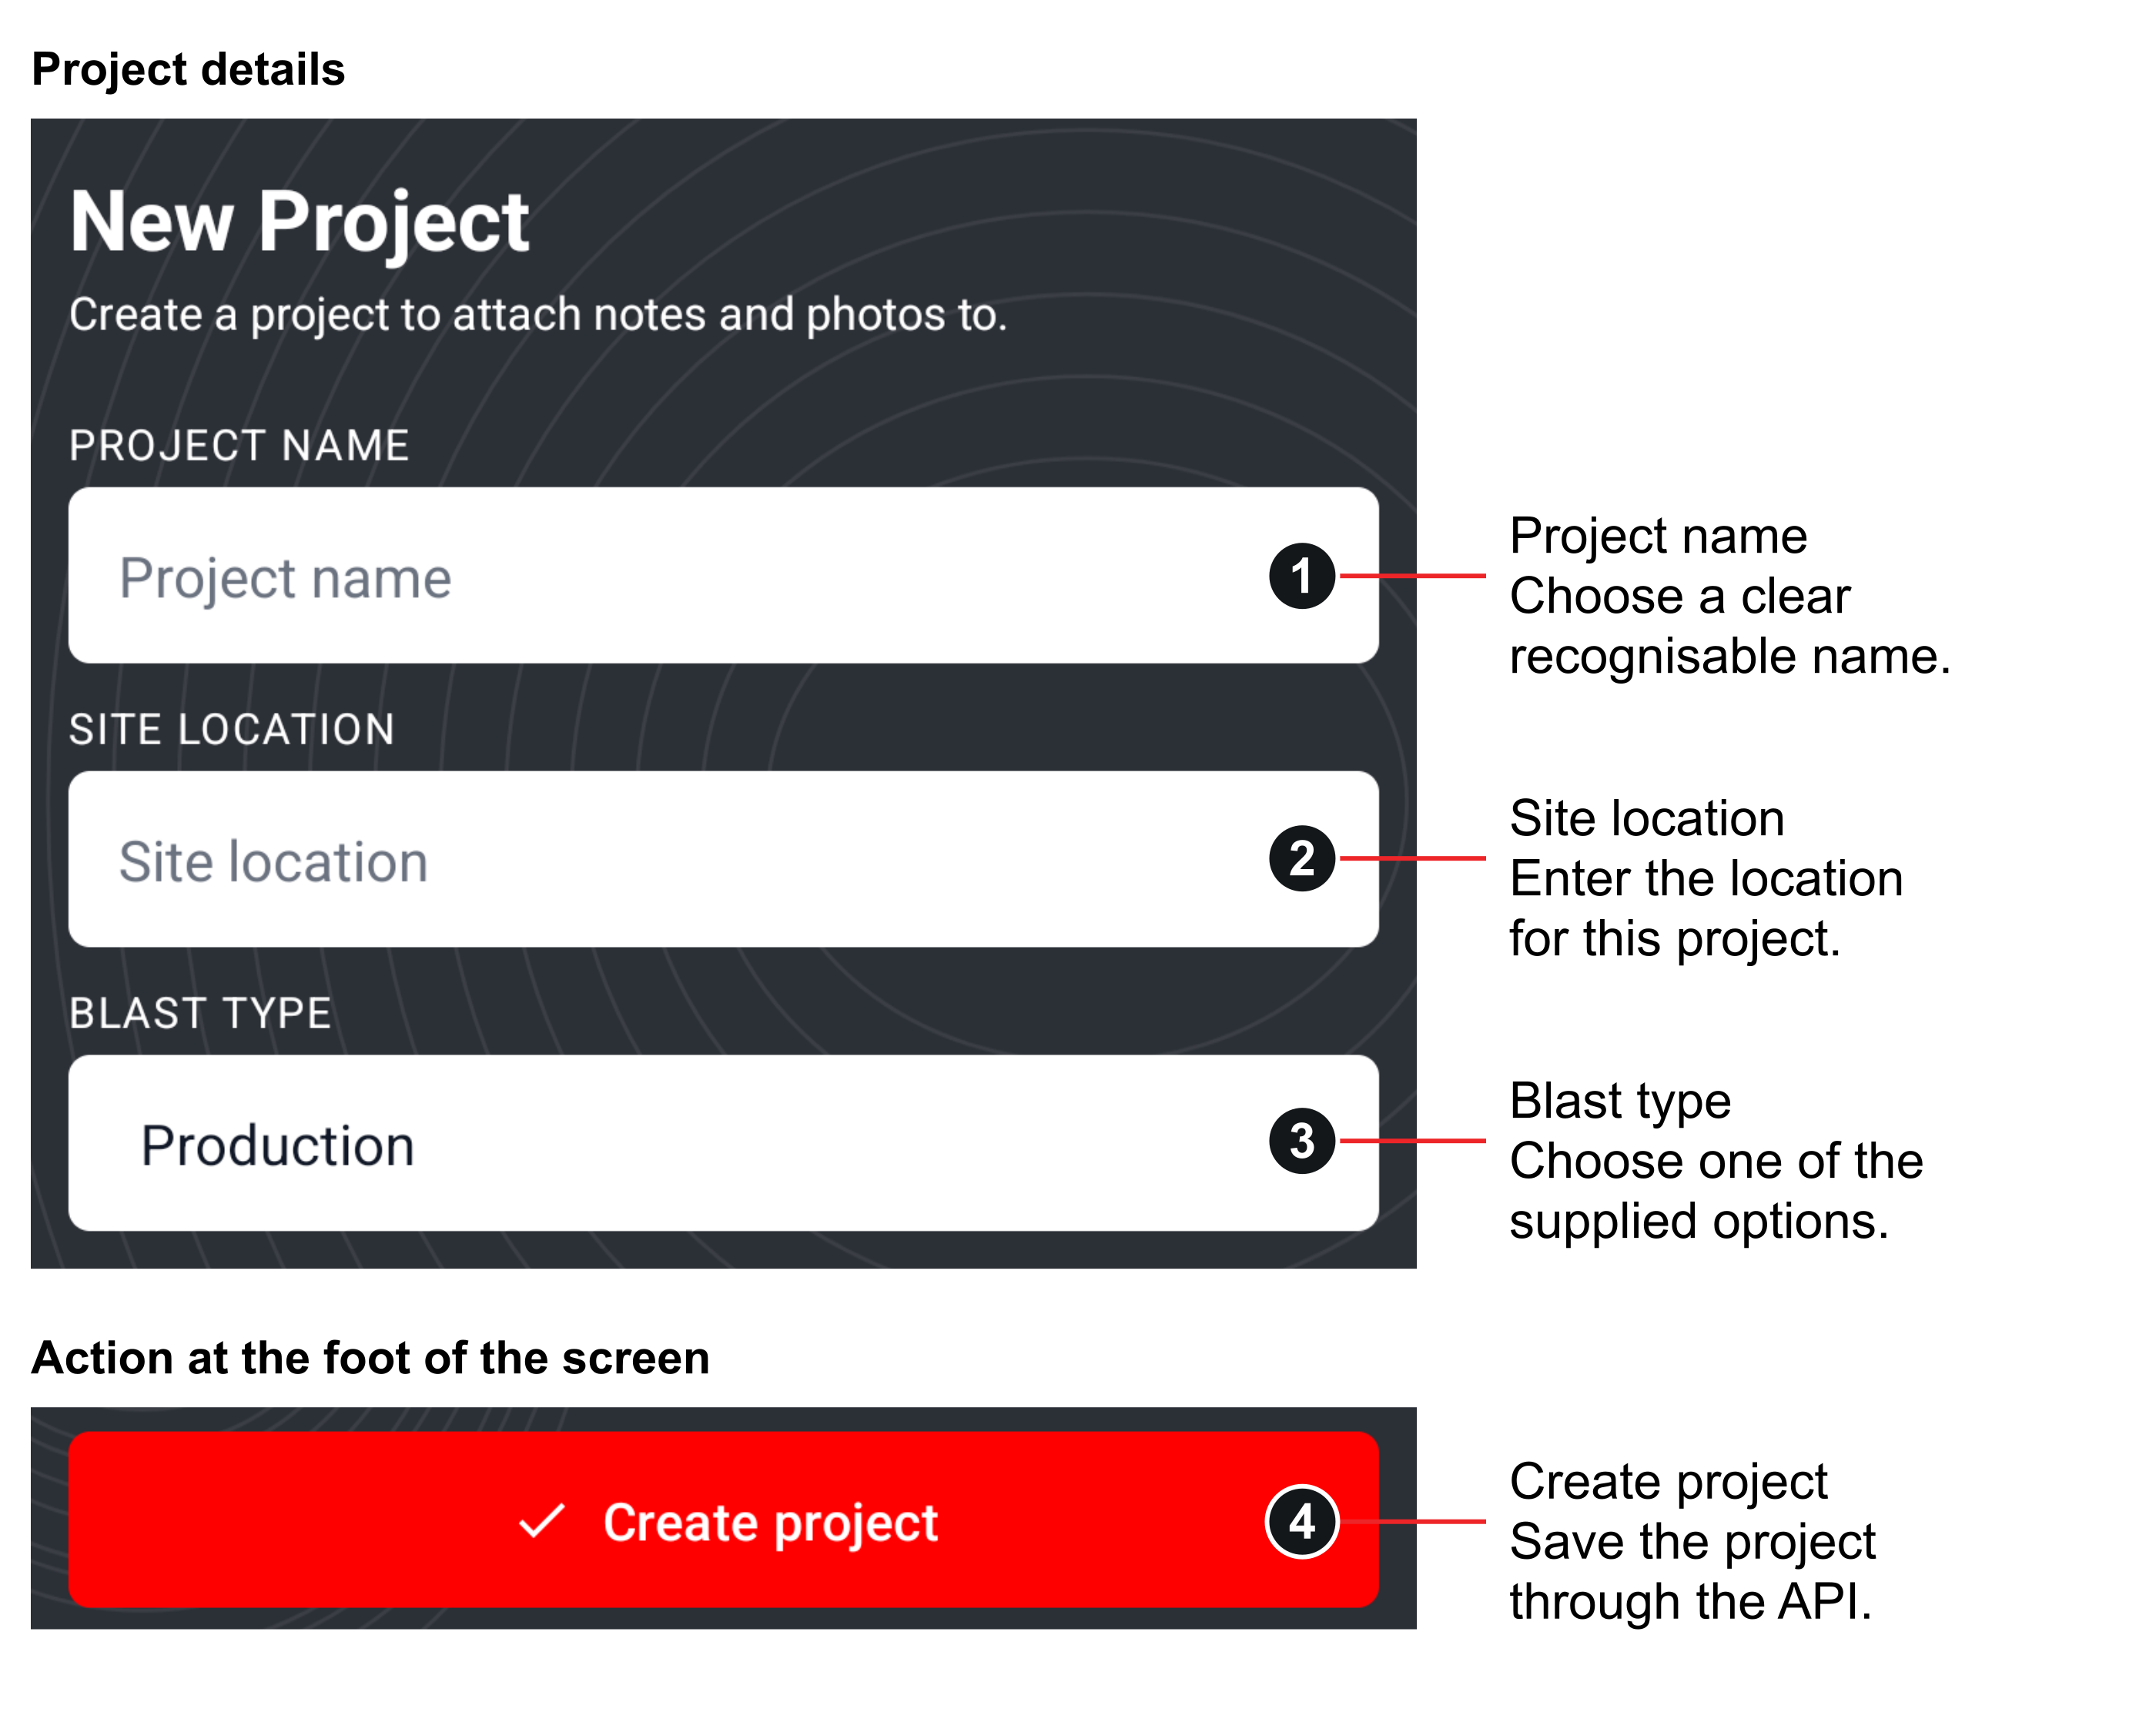
Figure 16 Android project fields and create action
The form and the action at the foot of the screen are shown as separate regions. Creating a project does not create its web blast pattern.

Create a project on Android
1. Select New project. Enter Project name and Site location.
2. Choose Blast type. Choose Production, Pre-split, Trim, Development or Trench.
3. Select Create project. The app saves the project through the API and returns to the preceding screen. Empty name or location produces “Enter a name and site location”.
4. Use the new project. It becomes available in the mobile note project selector and in the authorised user’s web Dashboard after a reload. Complete its blast pattern on the web.
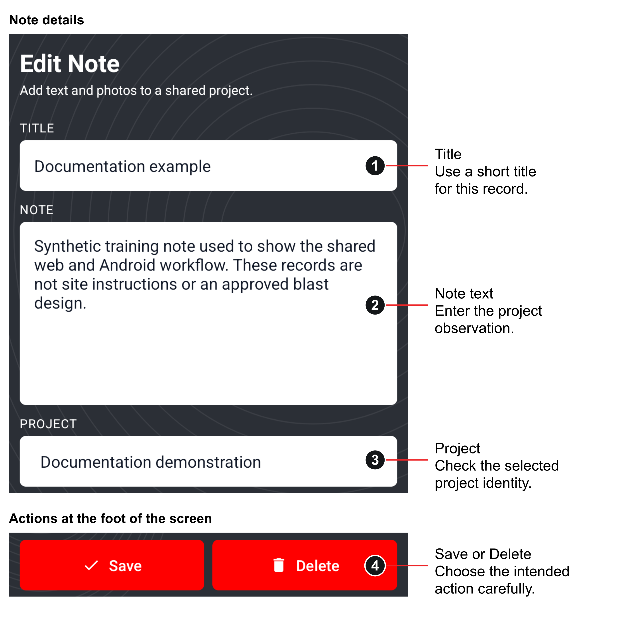
Figure 17 Android note details and save actions
A saved note stays associated with its original project. Use Save to retain edits; Delete removes the shared record after confirmation.

Create or edit a note
1. Select the central plus button. The New Note editor opens. If no project is available, create one first.
2. Enter the title and note. At least a title, note text or selected photo is needed. A photo-only new note receives the title Field photo when its title is blank.
3. Choose the project. A note must belong to a project. Once saved, the project selector for that note is disabled; the current interface does not move an existing note to another project.
4. Add photos if required. Use Take Photo or Gallery as described below. Review the selected files.
5. Select Save. The button shows Saving while the API creates or updates the note and uploads pending photos. Successful completion returns to Notes.
6. Verify the save. Reopen the note or reload the project’s Notes page on the web. If an upload failed after the note itself saved, inspect the existing record before retrying to avoid duplicates.
A failed network request does not queue a complete offline save in this release. Keep the editor open while resolving a connection problem and verify the server record after a retry. Unsaved editor changes can be lost when leaving the screen or closing the app.
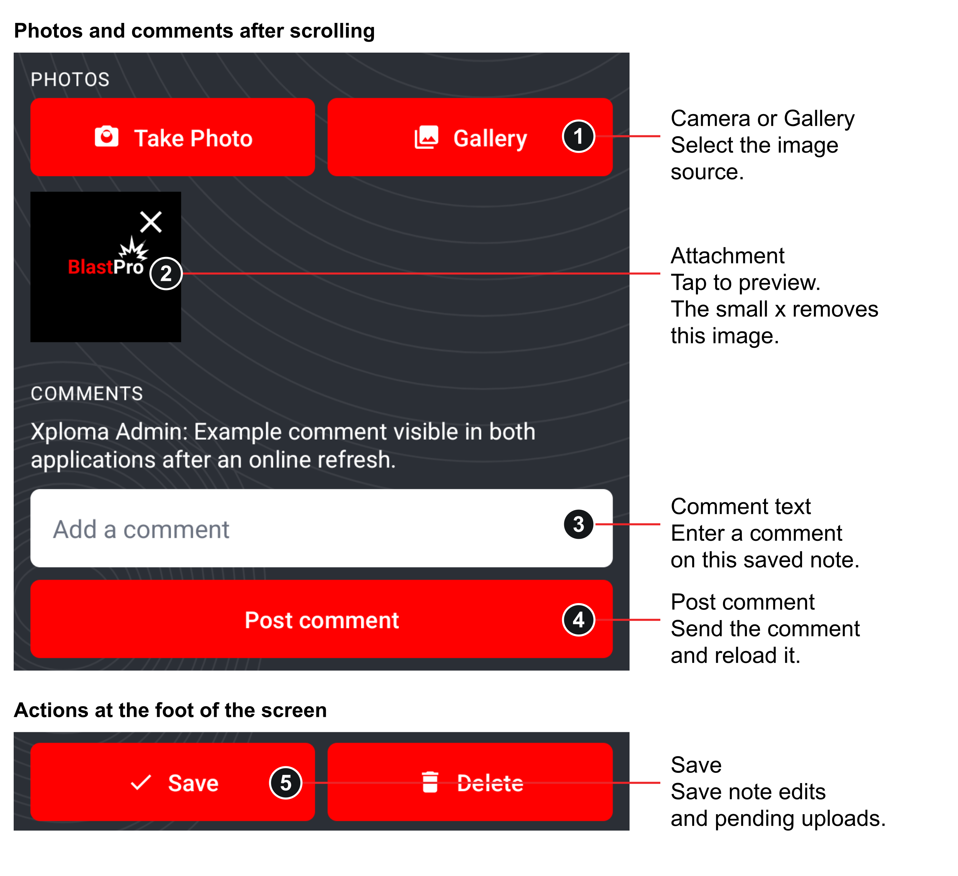
Figure 18 Android photo attachments and comments
Scroll the note editor to see the lower controls. The attachment is the BlastPro icon used as a demonstration image; it is not a site photograph. The small x removes an attachment, while the preview close control only closes its enlarged view.

Take select and remove photos
1. Take a photo. Select Take Photo. Allow the camera permission when you intend to use it, take the photo, and accept it in the camera interface. If permission is denied, the app explains that camera permission is needed.
2. Choose from the gallery. Select Gallery and choose an image. Supported uploaded content is JPEG, PNG or WebP and must be smaller than 5 MB.
3. Review the selection. Up to three photos may belong to one note, counting existing and pending images together. Tap a thumbnail to open the preview and close it with the cross control.
4. Remove the correct image. Use the small remove control for that thumbnail. Removing a pending image cancels that attachment. Removing an existing photo deletes it from the shared server immediately.
5. Save pending attachments. Select Save to upload newly selected photos. Reopen the note to verify the result.

Comments and deletion
1. Open an existing note. The Comments section is shown after the note has been saved.
2. Add a comment. Enter text and select Post comment. Empty input produces Enter a comment. After a successful post the comment thread reloads.
3. Delete a note when required. Select Delete. Read the message explaining that the note, comments and photos will be removed from the web and mobile app.
4. Confirm or cancel. Select Delete to complete the removal or Cancel to retain it. A permission error means the account is not allowed to change that author’s note.
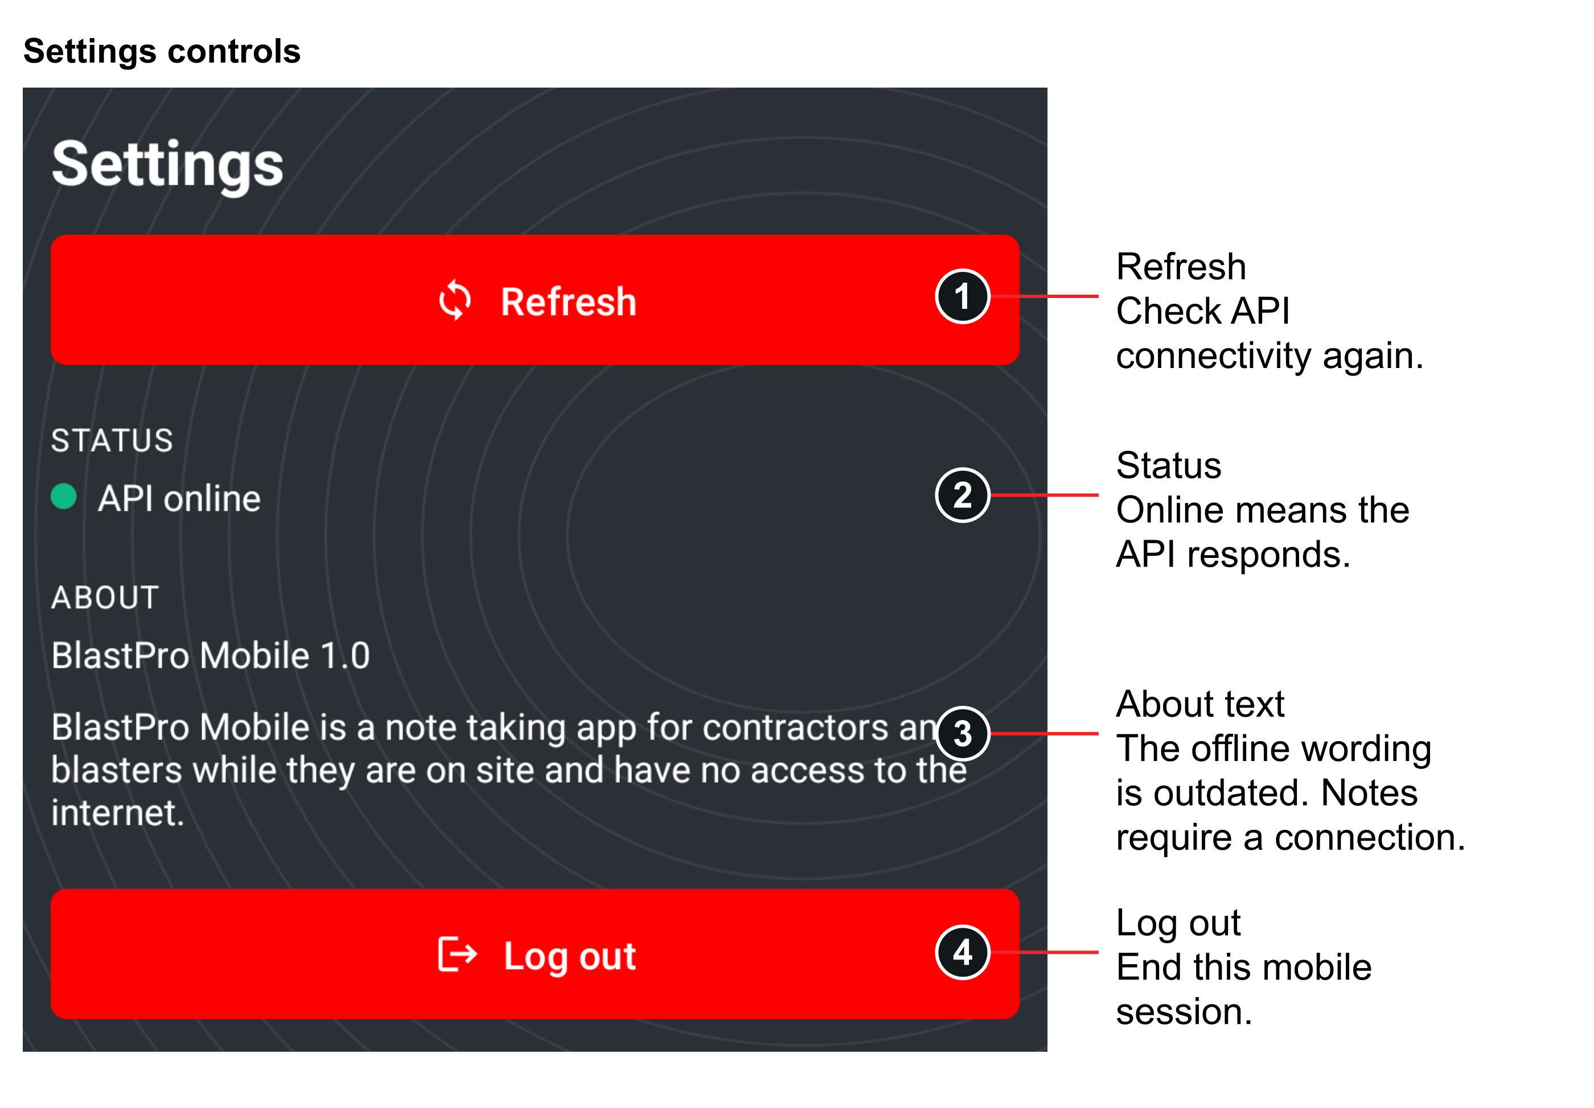
Figure 19 Android connection status and logout
The screenshot retains the application’s existing About wording. As explained in this manual, the current note and photo flow requires an online API connection.

Settings and sign out
1. Open Settings. The app checks API connectivity and displays API online or API offline.
2. Select Refresh. The status shows Checking API while it tries the configured endpoint. This check confirms that the server answers; it does not save or synchronise an unsaved note.
3. Select Log out. The session token is removed and the sign in screen opens. Save and verify pending note work before signing out.
The About text identifies BlastPro Mobile 1.0. The old description mentioning use without internet does not reflect the current remote save flow. This version requires a connection for its working note and photo features. The AI chat feature is not available in the current navigation.

12 Troubleshooting
Start by checking the environment, account and saved record. Avoid creating a replacement company or duplicate project until the underlying problem is clear. Never share an account password, bearer token, database connection string or password reset link in a support request.
Table 13 Problems and recovery actions
Problem | What to check and do
Web or Android sign in fails | Check spelling and password, internet, and that the account belongs to the selected hosted or local environment. Inactive or locked accounts need administrator assistance. After five failed attempts, allow the lockout period to expire.
The website opens but project actions fail | The web page and API are separate services. Retry after checking connectivity. Report the exact action and time to the support team if the API fails.
Android says API offline | Check Wi-Fi or mobile data, then open Settings and Refresh. A local-only development API cannot normally be reached from a physical phone.
Android project or note is missing | Confirm the account, selected project filter and search text. Return to Notes to reload. Local and hosted databases are separate.
Create Company reports duplicate data | The company registration number and account email must be unique. Ask for access to the existing company rather than entering false identity details.
Cannot add or reactivate a Blaster | Check the five active Blaster seat limit. Deactivate an appropriate account before retrying.
Save and Review Results returns to Pattern Design | Read the readiness message and provide the missing saved input. Ensure all holes have positive charge and stemming and the required density, pitch, delay window and limits are present.
Pattern generation fails | Provide positive bench dimensions, row count, holes per row and depth. The total layout must be at most 500 holes. Check field messages.
Manual hole values disappeared | Replacing the hole layout regenerates its rows. Review the confirmation before choosing Replace holes; use Keep edits when preserving exceptions.
Delay edits changed | Applying a timing sequence can replace manual delays after confirmation. Use Keep delays when retaining a checked timing plan.
Saved design version conflict | Another save changed the record after this page loaded. Reload the current design, compare the intended edits and save again.
Cost is Not available | Ask the Main Company User to check every hole’s active company product price and catalogue mapping. Recalculate after correcting the saved draft or pricing.
PPV or flyrock is Not available | Read the related warning. The estimate needs the corresponding site inputs. Supply approved values, save and calculate again.
Results are marked outdated | Review the saved pattern and select Recalculate Saved Draft or Save & Review Results to create a new result.
Report has no calculation | Open Pattern Design and create a saved calculation. A draft alone does not create a report result.
Older report has no hole plan | That historical result may predate stored pattern snapshots. It cannot reconstruct the old pattern from the current design.
Photo upload fails | Check JPEG, PNG or WebP format, size below 5 MB, a saved note, fewer than three attachments, network and note edit permissions.
Android camera does not open | Grant camera permission through the device’s authorised settings process or use Gallery. The app cannot take a photo after permission is denied.
Android note save or upload partly failed | Reopen the existing server note after restoring connectivity. Confirm which photos were uploaded before retrying. There is no offline replay queue.
Cannot edit another person’s note | Only the author or Main Company User may edit, delete or manage its photos. Having access to read the project does not grant every edit action.
Password reset email does not arrive | Hosted outbound recovery email is not configured. Blasters should contact the Main Company User for Set password; Main Company Users should contact project support.

Information to give support
Record the application used, account role, project name or ID, action taken, exact visible message, date and time, device and browser or Android version, network type, and whether the issue also occurs in the other app. Include a redacted screenshot when it helps. Describe whether the record is hosted or local, and whether the attempted change appears after a reload.

13 Guided training exercise
Use a separate training environment and synthetic records for this exercise. The screenshots in this document were captured from an isolated documentation database. Their measurements and prices are software examples, not field recommendations or approved design data. Do not copy them into a real project.
1. Establish access. Sign in as the supplied training Main Company User. Open Company and confirm the demonstration record. Review the Blaster list and five-seat indicator.
2. Create a project. Select New Blast Project, use a name such as Training exercise, enter Synthetic training record as the location and choose a type.
3. Prepare the pattern. In a training environment only, use values supplied by the trainer. Follow the bench, rock, product, timing and calibration sections, then inspect the hole plan and table.
4. Save a draft. Select Save Draft and confirm that the project returns on Dashboard. Reopen Pattern Design and verify the saved inputs.
5. Create a result. Complete the required inputs and select Save & Review Results. Identify the result state, quantities, unavailable values and warning text.
6. Test result history. Change one trainer-approved input, save and calculate again, and open the earlier calculation from Previous Calculations. Identify which report belongs to which result.
7. Export. Open the selected report, download its PDF and check project identity, date, metrics, warnings and hole schedule.
8. Create a shared note. Add a web note labelled Training observation and post a comment. If authorised, attach a small demonstration image.
9. Use Android. Sign in to the same environment with an authorised account, find the project note, edit your own note or create a new one, and save. Reload the web Notes page to verify the shared record.
10. Close the session. Check that all work is saved. Log out from Android and the web application.
An exercise is complete when the user can find the saved project, distinguish draft from calculated and historical results, explain warning and unavailable states, open the intended PDF, and verify the same authorised note through both applications.

14 Technical access and local setup
This chapter is for the project team and assessors reproducing the application. Ordinary hosted users can continue to use the website and supplied Android APK without installing these developer tools.
Source repository
Table 14 Developer setup reference
Component | Requirement or path
Web and API | Windows, .NET 10 SDK, SQL Server LocalDB and Visual Studio with ASP.NET support or two terminals
Solution | BlastPro/BlastPro.slnx
Visual Studio startup | Choose the shared BlastPro API + Web startup profile to start both applications
Development web address | https://localhost:7001/Account/Login
Development API and Swagger | https://localhost:7002/ and https://localhost:7002/swagger in Development only
Android project | BlastPro.Android opened in Android Studio, SDK 35 and JDK 21 selected as the Gradle JDK
Android API setting | The compiled blastProApiUrl value. Default current build uses the hosted HTTPS API. Settings cannot change it.

1. Open the correct solution. Load the outer BlastPro.slnx and select BlastPro API + Web. Starting only the web project causes API-dependent actions to fail.
2. Keep configuration private. Configure the development database and any required signing key through the supported configuration process. Use a separate test database when demonstrating. Do not store production credentials in the repository.
3. Start both services. The default development ports are 7001 for web and 7002 for API. Wait for the listening messages before opening Sign In.
4. Create a local company. Local startup applies migrations and creates roles. Use Create Company for a local account; hosted accounts are not copied to LocalDB.
5. Build Android if required. In BlastPro.Android run gradlew.bat :app:assembleDebug. The debug APK is in app/build/outputs/apk/debug/app-debug.apk.
6. Choose the right mobile API. Use the default hosted HTTPS API for the normal supplied build. The current Gradle configuration requires the blastProApiUrl property to start with HTTPS during configuration, including an assembleDebug invocation. Passing an HTTP emulator URL directly to that property therefore fails. A developer reproducing a local HTTP test must use a separate debug-only build override and an isolated local database; this does not change the hosted release configuration.
Swagger is intended for local Development and protected endpoints require a valid user token. The normal user interface should be used for everyday work. A green API connectivity status alone does not demonstrate that authentication, permissions and database actions work.

15 Glossary and support
Table 15 Glossary
Term | Meaning in BlastPro
API | The service that validates requests, applies access rules, calculates results and stores shared data
Bench | The rectangular planning area represented by length and width in the current editor
Blaster | A company user whose project access is restricted to their own records
Burden and spacing | Editable row and column pitch values used by the supported layout and volume calculations
Calculation snapshot | The saved pattern information associated with a particular result for later reporting
Charge grouping window | The time interval used when finding a grouped maximum charge
Current and outdated | Whether a calculation corresponds to the present saved design
Density | Rock density is entered in t/m³; product loading density is entered in g/cm³
Draft | A saved pattern that can be edited without creating a new calculation result
Main Company User | The account role that manages company contacts, Blasters and prices and oversees company projects
PPV | Peak particle velocity, displayed in mm/s as a site-calibrated screening estimate
Powder factor | Explosive quantity per estimated tonne, shown in kg/t
Receptor | The structure or other location used when entering a distance and vibration limit
Stemming | The stemming length recorded for a hole
Subdrill | The drilled length below the intended bench level
Synchronisation | In the current release, loading and saving shared records online through the API; not an offline replay queue

Support responsibility
The Main Company User is the first contact for Blaster accounts, seat availability and company prices. The project team handles deployment, unavailable services, Main Company User recovery and defects. Xploma’s authorised professional process remains responsible for the technical interpretation and operational use of blast designs. This document does not invent a support phone number, service-level agreement or supplier commitment.

