


BlastPro Final Project Report
  - Web blast design workspace and Android field notebook for Xploma
INSY7315 Work Integrated Learning | Task 3 | 2026
Client Xploma ARC group 16

Team member | Student number
Nicholas Farquhar | ST10439055
Zain Labuschagne | ST10442835
Matthew Jackson | ST10445830
Jaco Smit | ST10439052
Ethan Chipps | ST10330209
Jarred Blamire | ST10452547

Contents
1 Executive overview 4
2 Client context and project analysis 5
2 1 Organisation and existing process 5
2 2 Research method and evidence register 6
2 3 Risks and analysis decisions 7
3 Final Report Updates and Refinement 7
3 1 Delivered scope 7
3 2 Scope changes from the initial design 7
3 3 Lecturer feedback and refinement evidence 8
3 4 Project Completion and Polishing 9
4 Requirements and acceptance approach 9
5 User roles and experience journeys 10
5 1 Prototype lineage 12
6 Work breakdown and team organisation 12
6 1 Coordination and dependencies 13
7 Non functional requirements and quality targets 13
8 Architecture and design decisions 14
8 1 Cloud topology and transport 15
9 Implementation and critical flows 16
9 1 Implementation components 16
9 2 Sign in and access enforcement 17
9 3 Save calculate and retrieve a report 18
9 4 Project and result state 18
9 5 Shared note flow 19
10 Data schema and storage design 19
10 1 Snapshot schema and historical meaning 20
10 2 Retention backup and recovery 21
11 Calculation logic and numerical interpretation 21
11 1 Quantities and conditional metrics 21
11 2 Charge grouping and vibration 21
11 3 Idealised trajectory and warnings 22
11 4 Reproducible software example 22
12 API contracts and data flow 23
12 1 Error handling and concurrency 24
12 2 Data movement and consistency 24
13 Security and threat mitigation 25
13 1 XSS prevention 25
13 2 Session and authority details 26
13 3 Security work before production handover 26
14 Deployment and CI CD Final Status 27
14 1 Test coverage and honest limits 28
14 2 Deployment and rollback procedure 28
15 Running costs and two year planning scenario 29
15 1 Scale comparison 29
15 2 Two year growth illustration 30
16 Change management training and handover 30
16 1 Role based training 31
16 2 Handover contents and acceptance gates 31
17 Evaluation limitations and next release priorities 32
18 References and evidence sources 33
18 1 Source code evidence map 34
Annexure A Declaration of Authenticity 35
Assistance and review record 35
Appendix C Functional requirements traceability 36
Appendix D User stories 41
Appendix E Non functional requirements 44
Appendix F Work breakdown structure 48

1 Executive overview
BlastPro gives Xploma a shared workspace for recording surface blast designs and the information used to calculate them. The delivered web application combines company accounts, project management, measured bench inputs, editable hole layouts, saved calculations, warnings, history and PDF reports. Its Android companion captures online project notes, comments and photographs through the same API and SQL database. The Main Company User oversees company projects, Blaster access and company product prices; a Blaster works within their own project records.
This final report consolidates the Task 1 analysis baseline with the implemented Task 2 and Task 3 software. It explains the final architecture, data schema, API contracts, security controls, calculations, GitHub workflow and delivery evidence. The complete original requirement and user story identifiers are retained, so the reader can see which parts were delivered and which remain partial or deferred. The accompanying BlastPro Complete User Manual provides the detailed operational instructions for both applications.
The final assessment build supports a complete saved web workflow from a project and pattern to calculated results and an exported report. It also supports shared web and Android notes. The latest reviewed GitHub Actions run passed the .NET and JavaScript checks, built the Android APK and deployed both Azure applications. The hosted sign in page was accessible during the review on 28 October 2026. These observations establish a working assessment release; they do not establish specialist engineering approval, a production service level, full original-scope completion or client acceptance.
Important limitations remain visible throughout this report. The current editor uses a rectangular bench with rectangular or staggered layouts. Freehand boundaries, linked side profiles, a formal reviewer approval process and a general audit ledger are not delivered. Android note capture depends on an online API connection; its unused local persistence scaffold does not provide an operational offline queue. AI chat is disabled. The calculations are planning estimates based on entered site information, and the idealised flyrock trajectory cannot determine a safe blast exclusion distance. [P1; C1]
Table 1 Document control
Release record | Value
Client and team | Xploma | ARC Group 16
Module and assessment | INSY7315 Work Integrated Learning | Task 3
Report date | 30 October 2026
Reviewed source revision | 62b02d242751b12ac5fe73f65f2e8394e3646a28
Submitting student | Nicholas Farquhar | ST10439055
Companion document | BlastPro_Complete_User_Manual.docx
Evidence boundary | Code review, supplied project material, current demonstration screenshots and visible GitHub/hosted evidence; no invented interviews, signatures, peer scores or client acceptance

Source repository
Reviewed release commit
Hosted web application
Latest reviewed successful pipeline
Personal completion before submission. Annexure A requires the submitting student’s own declaration and signature. Contribution and attendance percentages are supplied in the separate BlastPro_Confidential_Peer_Evaluations.docx. The selected presentation and demonstration recording accompany the repository submission.
Submission media. The retained presentation and team-selected demonstration recording accompany the final submission. The video link below opens the supplied 19 minute 59 second recording. [P7]
Watch the supplied BlastPro demonstration

2 Client context and project analysis

2 1 Organisation and existing process
The team’s supplied presentation describes Xploma as a small specialist rock breaking contractor working in construction, infrastructure and quarry contexts. Examples include pipe jacking and other infrastructure work, mining or quarry activity and large building projects. The original project material describes a team of three professionals. These descriptions come from the supplied client background, rather than independently verified company research. [P2]
The documented operational process begins with an external client request, a licensed Blaster’s site visit and measurement of the rock and surrounding conditions. Design and quotation preparation precede external approval, permit arrangements, drilling, charging, site preparation, the blast and the post blast inspection. BlastPro supports the design and calculation record and related field notes within that wider process. Client requests, commercial quotations, permit applications, blast execution and operational site controls remain outside the software.
The initial problem is fragmented design information. Manual drawings and spreadsheets can make it difficult to reproduce the exact inputs behind a result, locate prior work or review another authorised person’s design. The application therefore gives each project a stored input set, explicit units, repeatable calculation functions, warnings and a retrievable result. The company and ownership model also gives users a defined boundary for discovering and changing records. [P1]
Table 2 Problem and solution analysis
Need identified in project material | Response in the delivered release | Evidence or evaluation boundary
Retain reusable design records | Saved projects, pattern inputs, holes and calculation history | Project and calculation entities; no full revision approval ledger
Reduce disconnected calculations | One API calculation service and Results page | Repeatable software arithmetic; field accuracy still depends on specialist supplied inputs
Review design effects | PPV and trajectory screens with warnings | Not a blast approval or validated exclusion radius
Give the company oversight | Company-scoped Main Company User role | API access controls; no cross-company administration
Capture field observations | Online Android and web notes, comments and photos | No operational offline queue or AI assistant
Produce a readable design record | HTML preview, print and PDF from a selected saved result | New result snapshots retain hole plan; older results may lack snapshots

2 2 Research method and evidence register
The analysis used the supplied revised feature specification, original Task 1 report, prototype, work allocation documents and team presentation to establish the problem and intended scope. The final assessment review then compared that baseline with the repository entities, controllers, services, views, Android screens, tests and pipeline. Current documentation screenshots were captured from a separate synthetic demonstration database to avoid presenting test records as client operating data.
The original report expressly records that interview transcripts and an independent client profile were not supplied. This report preserves that limitation. It does not claim that research interviews, usability sessions, specialist formula approval or signed user acceptance were conducted. Expected benefits such as faster preparation, fewer transcription errors and more consistent records remain objectives for a controlled pilot until measured. [P1]
Table 3 Analysis evidence register
Evidence | What it supports | Limit
P1 Original Task 1 documentation | 44 functional requirements, 35 stories, 28 NFRs, 32 planned tasks and initial diagrams | A design baseline; proposed services are not proof of deployment
P2 Client presentation material | Client background and business process | Team-supplied description; no independent commercial verification
P3 Revised feature specification and Task 2 scope | Scope evolution and intended application behaviour | Contains broader future functions
P4 Work Split | Six documentation workstream owners | Does not prove the author of every code change
C1 Current release source | Actual persistence, business rules, interfaces and controls | Source review does not prove field acceptance or every runtime case
E1 Successful Actions run | Automated checks, Android build and two Azure deployments | CI excludes LocalDB-tagged checks and does not exercise full mobile UI
E2 Current UI captures | Visible web interface with synthetic example records | Training data and screenshots are not client measurements
A1 Module manual and ARC guidance | Report, user guide, declaration, peer and EXPO requirements | Individual forms must be completed personally

2 3 Risks and analysis decisions
Table 4 Project risk analysis
Risk | Consequence | Response
Incorrect site inputs or model use | Misleading planning estimates | Explicit units, missing-input states, visible warnings and specialist verification before operational reliance
Cross-company or owner leakage | Exposure of another company’s designs or notes | Validated company/role context and API resource checks
Mobile connection loss | A user may assume an unsaved observation was retained | Online-only instructions; verify server save; offline queue remains a documented gap
Old report described as current | A design may be used after inputs change | Current/outdated result flags and result-specific report snapshots
Unproven adoption or capacity | Overstated project benefit and hosting sizing | Label targets and cost scenarios; pilot and load testing required
Shared account or careless screenshots | Exposure of credentials or private site information | Individual users; private credential transfer; synthetic training data

3 Final Report Updates and Refinement

3 1 Delivered scope
- Company setup and immediate sign in, Identity authentication and two server-assigned roles.
- Company-scoped projects and ownership restrictions, search, filtering, editing and soft deletion.
- Rectangular bench inputs, rectangular or staggered hole generation, editable holes, timing sequences and an interactive plan.
- Saved drafts, server calculations, warning severity, current and outdated result states, calculation history and stored pattern snapshots.
- Result-specific report preview, printing and generated PDF download.
- Main Company User control over company contacts, Blaster accounts and active seats, products and prices, plus personal profile editing.
- Shared web and Android project notes, comments and up to three supported image attachments per note.
- Hosted MVC and API applications with Azure SQL and a working GitHub Actions build, test, Android and deployment workflow.

3 2 Scope changes from the initial design
The original baseline envisaged a substantially broader product than the assessed release. Task 2 planning narrowed the immediate implementation to a working project, pattern, calculation and report flow, after which the Android notes companion was integrated. The final implementation evidence takes precedence over future diagrams or feature descriptions in earlier documents. The baseline remains visible in Appendix C rather than being silently rewritten as complete.
The delivered release does not include client self-service requests, permit or quotation management, surveying or 3D scanning. The broader original design functions for irregular boundaries, exclusion polygons, linked profiles, immutable review/revision governance, a complete audit log and offline note replay remain outside the working release. There is no functioning AI assistant. These items require a recorded scope decision or further implementation before they can be treated as fulfilled requirements. [P1; P3; C1]

3 3 Lecturer feedback and refinement evidence
Table 5 Feedback response matrix
Feedback or earlier issue | Final report response | Software evidence
Task 2 APIs add to documentation | Section 12 explains endpoint contracts, errors, authority and data exchange | Concrete controller routes and role/resource checks
Task 2 Security add to documentation | Section 13 discusses authentication, authorisation, XSS, CSRF, uploads, transport and remaining risks | Identity/JWT, encoded output and negative access tests
Task 2 Data Flow and Logic add to documentation | Sections 9 and 12 explain save/calculate/report and shared-note flows | Stored draft reload, result transaction and snapshot
Task 2 GitHub Branching and Workflow add to documentation | Section 14 documents feature branches, pull requests, main and check triggers | Actual workflow and release history
Task 2 CI CD and Pipelines add to documentation | Section 14 includes pipeline diagram and successful final deployment evidence | Actions run 39554429674 passed all four jobs
Task 1 documentation feedback | Original baseline retained, consolidated and reconciled with actual code | Detailed Task 1 rubric comments were referred to the group through Ethan; unavailable comments are not invented
Earlier stale manuals and prototype claims | Current manual and this report describe actual online Android and account behaviour | Immediate company sign in, direct Blaster passwords, hidden AI, online remote notes

Table 6 Documented refinement history
Date | Visible refinement | Evidence
4 to 5 October 2026 | CI workflow, hosting/setup and README work integrated | Git history and successful workflow lineage
16 October 2026 | Warning displays and Save and Review Results flow improved | Commits 175a43a and a845292
20 October 2026 | UI styling unified across pages | Commit 1f58d24
21 October 2026 | Latest reviewed main release built and deployed | Commit 62b02d2 and Actions run 9
28 October 2026 | Final report and complete current user manual prepared | This document and accompanying manual

3 4 Project Completion and Polishing
The final release supports the complete delivered web workflow: company sign in, role-scoped projects, pattern inputs and hole editing, saved calculations and warnings, result history, selected-result reports and PDF output. The Android field notebook uses the same API for project creation and shared notes, comments and images. Sections 9 to 13 explain these working paths; the accompanying manual shows their current screens and controls. [C1; E2]
Polishing includes clearer warning severity and result-state cues, the Save and Review Results path, consistent page styling and reproducible report snapshots. The dated refinement evidence above identifies the relevant changes. Section 14 records the successful automated checks, Android build and Azure deployment. The full original requirements remain mapped in Appendices C to E so that partial and deferred capabilities are visible; the report does not describe the broader original scope as fully delivered.

4 Requirements and acceptance approach
The original Task 1 identifiers are the traceability baseline: FR 01 to FR 44, 35 user stories and NFR 01 to NFR 28. Appendix C retains every functional requirement, priority, acceptance expectation and delivered status. Appendix D retains every story. Appendix E retains all non-functional targets and distinguishes implemented controls from unmeasured or deferred expectations.
A requirement is Implemented when the delivered code supports its stated core behaviour. Partial means a working subset exists but the full original wording or its governance/evidence is missing. Deferred means the original capability is not delivered. Not evidenced means the requested measurement, approval or verification is unavailable. These labels do not substitute for client or specialist acceptance. A broad requirement that bundles geometry, governance and auditing may remain Partial even though its basic user workflow works. No completion percentage is inferred from the labels.
Table 7 Acceptance scenarios and evidence
Release acceptance scenario | Expected observable outcome | Available evidence
Account and access boundaries | Valid users enter their role; other-company and non-owner records are denied | Auth and access tests; role-scoped API code
Saved design | Measured inputs and editable holes reopen after save; invalid records are rejected | Pattern/project API and web-flow tests; E2
Calculation and history | A calculation uses persisted inputs, creates warnings and snapshot, and retains older results | Calculation tests and result entities; E2
Selected report | Preview and PDF represent the selected stored result and its warnings | Report controller/builder and tests; E2
Shared note | An authorised online save is visible when the other client reloads | Common note API and Android RemoteRepository; manual workflow
Delivery | Checks and Android build finish before main deploys API and web | Successful Actions run E1
Client and specialist acceptance | Representative user and numerical cases are signed off by the appropriate people | Not supplied; remains a handover gate

Future acceptance records should name the scenario, release commit, environment, inputs, expected result, actual result, evaluator, date and outcome. A synthetic screenshot or passing unit test should not be described as a signed client acceptance record.

5 User roles and experience journeys
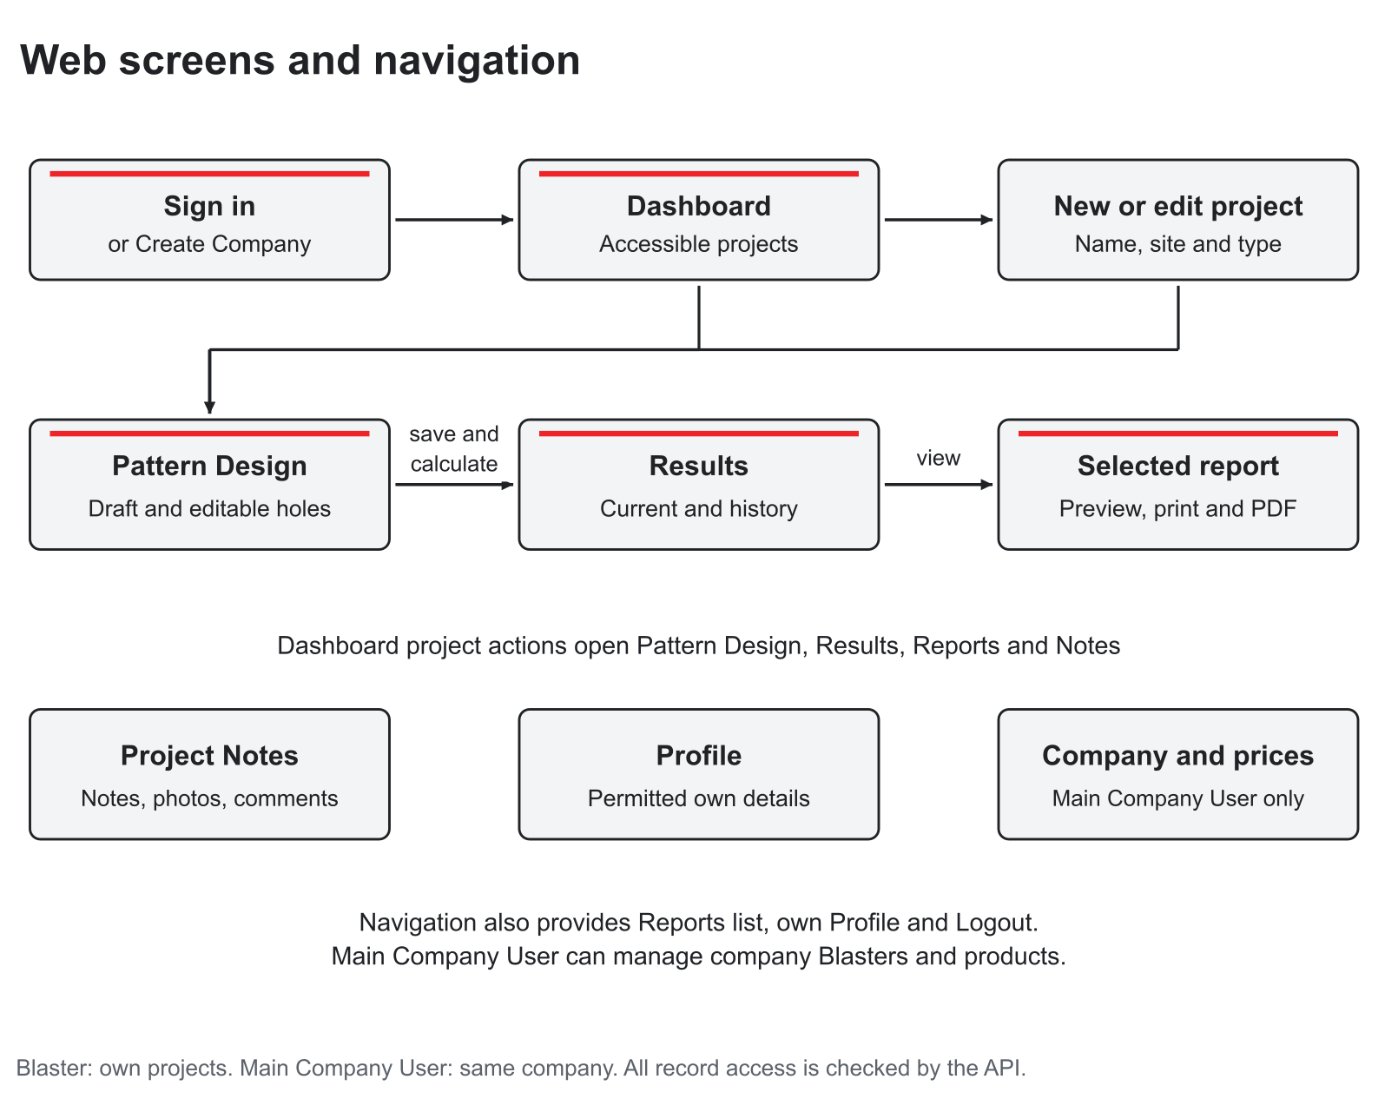
Figure 1 Current web screen journey and role-specific branches
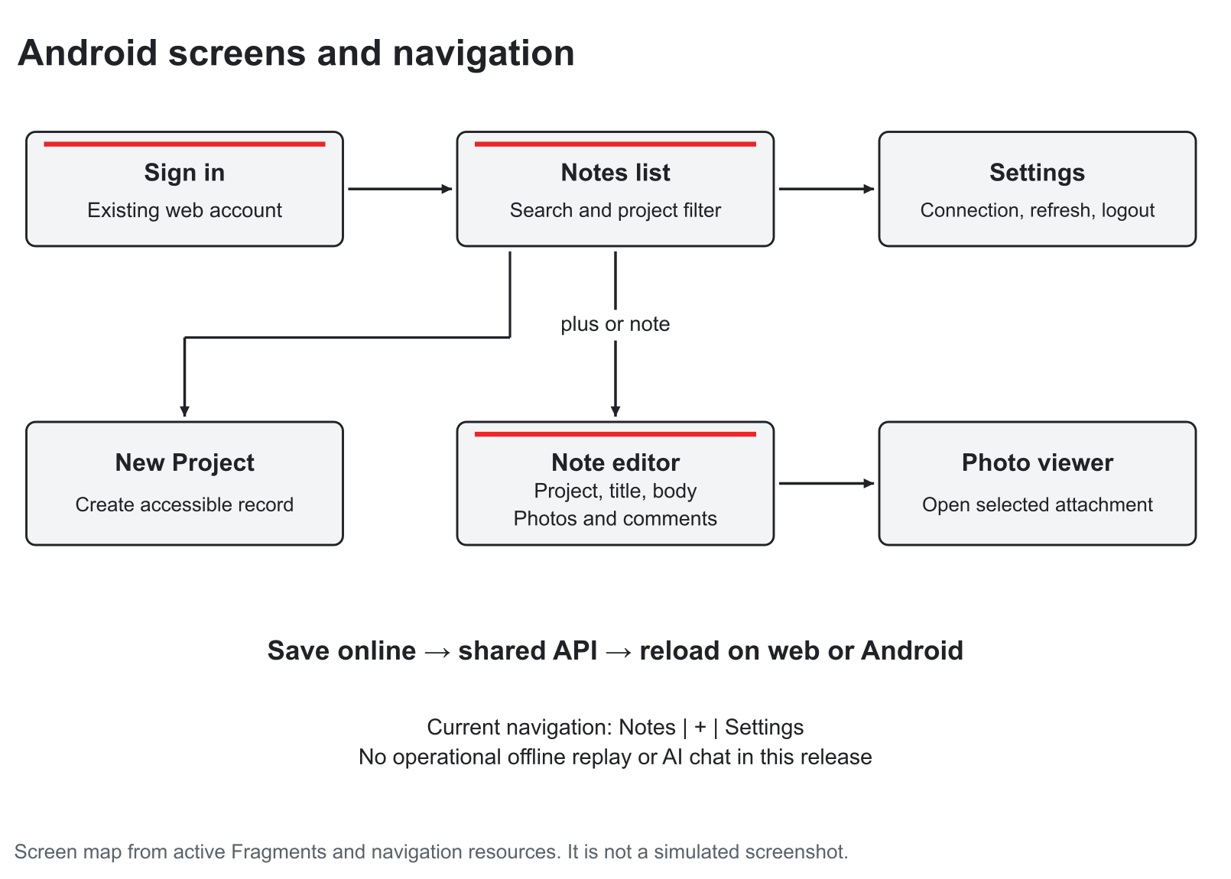
Figure 2 Current Android screen journey and shared online notebook
Table 8 Permissions by role
Operation | Blaster | Main Company User
Project, pattern, results and reports | Own accessible projects | Projects in the same company
Read notes and add comments | Accessible own projects | Accessible company projects
Edit or delete notes and photos | Their own note in an accessible project | Authorised company notes
Company contacts and Blaster administration | No | Yes
Company products and prices | No | Yes
Personal profile | Permitted own fields | Permitted own fields
Another company’s records | No | No

The company itself is a data record, not a shared login. The first Main Company User is created during company setup and signs in immediately. That user can create up to five active Blasters, set their passwords, edit permitted details and deactivate or reactivate accounts. Deactivation frees a seat and preserves designs. The server rechecks the seat limit during reactivation and invalidates previous sessions when account access changes. A role or company cannot be selected through the personal profile form. [C1]
The Blaster’s web journey is Sign In, Dashboard, New Project or an existing Pattern Design, save or Save and Review Results, Results and selected Report. Project Notes branches from the project row. Results provides history and links to the selected saved report. Editing input data can invalidate a previously current calculation. The Main Company User follows the same project journey and additionally opens Company, Products and prices and their own Profile through the navigation.
The Android journey begins with sign in to the same API environment and then Notes. Search and a project filter narrow the list. A user can create a project, use the central plus action to create a note for an accessible project, edit notes, add comments and attach supported photos. The photo viewer opens a selected attachment. Settings shows connection information, refresh and logout. The current active flow calls the API directly; there is no background offline replay service. Closing the process clears the in-memory session, so a later launch may require another sign in.
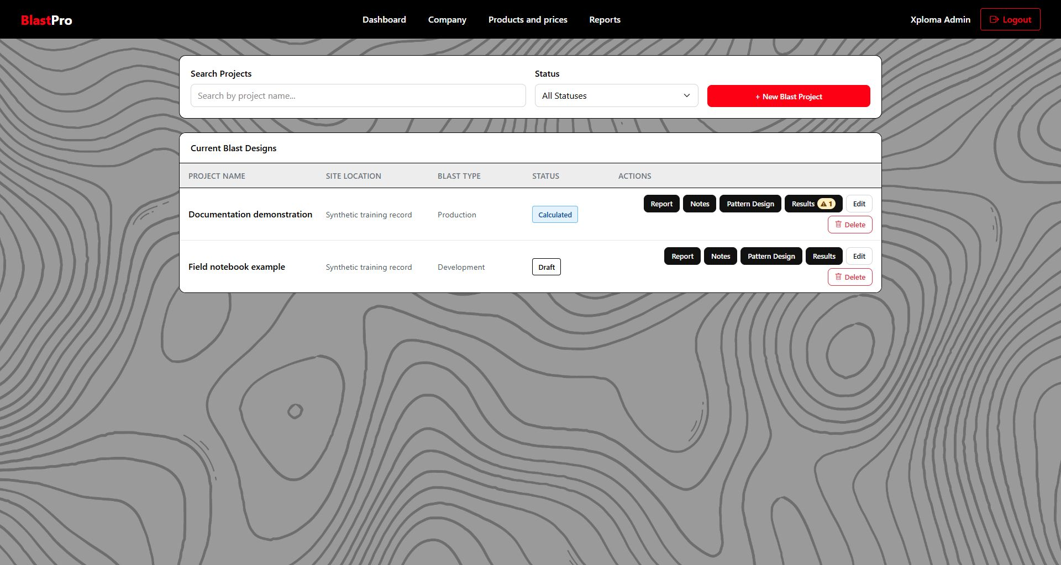
Figure 3 Current web Dashboard and project action paths using synthetic documentation records

5 1 Prototype lineage
Task 1 supplied mobile and web Figma prototypes. They are historical design evidence, while the current manual and implementation determine the delivered behaviour. The prototype showed the intended login to Dashboard, pattern, results and report progression; later work added hosted API integration, company setup and online shared notes. [P5]
Original web prototype
Original mobile prototype

6 Work breakdown and team organisation
The original work breakdown contains 32 planned tasks, with durations, predecessors and resources. Appendix F preserves that planning information. The estimates are historical planning assumptions, not reconstructed timesheets. The original four placeholder role labels have been replaced by workstreams and the six documented section owners where the supplied allocation supports them. This does not assign authorship of every implementation change.
The documented Task 1 allocation gave Nicholas requirements, roles, stories, UX journeys, WBS and NFRs; Ethan analysis artifacts and costs; Jaco data schema and architecture; Jarred implementation and DevOps; Zain introduction, security, change management and appendices; and Matthew the prototype. The team’s subsequent source history shows integrated code and merges. Contribution evaluation must combine the actual work records and each student’s explanation rather than infer all contribution from commit author names alone. [P4; C1]
Table 9 Six member documentation allocation
Member | Documented workstream
Nicholas Farquhar | Requirements, roles, stories, UX journeys, WBS and non-functional requirements
Zain Labuschagne | Introduction, security, change management and appendices
Matthew Jackson | Prototype
Jaco Smit | Data schema and architecture
Ethan Chipps | Analysis artifacts and running costs
Jarred Blamire | Implementation and DevOps

6 1 Coordination and dependencies
Requirements define the access rules and required records. The data and API work must establish those records before the clients can save real designs. Calculations rely on validated saved hole and site inputs; reports rely on stored results and their snapshots. Shared mobile notes rely on the same accessible projects and API. Tests and the pipeline run before the deployed release is updated. A defect in one boundary can therefore affect several screens, which is why end to end scenarios complement unit checks.

7 Non functional requirements and quality targets
The quality baseline covers security, accuracy and traceability, performance, reliability, usability, accessibility, interoperability, maintainability and operational recovery. Appendix E retains the exact 28 original targets and verification approaches. Targets are not presented as achieved measurements. For example, database indexes do not establish a user capacity, and a successful hosted page load does not prove long term uptime.
Delivered controls include server-side company and owner enforcement, validation, explicit units, warning text, repeatable calculation functions, saved snapshots, concurrency checks and an automated pipeline. The remaining verification work includes representative load tests, a complete keyboard and screen reader review, measured performance under the intended workload, restoration exercises and client usability acceptance. WCAG 2.2 is a design and evaluation reference; this report does not certify accessibility conformance. [C1; R4]
Table 10 Quality targets and current verification boundary
Quality concern | Current design response | Evidence still required
Security and isolation | Role and resource checks in API; Identity and JWT; encoded output | Independent security review and deployment configuration audit
Calculation correctness | Pure calculation functions, explicit units and automated numerical cases | Specialist approval with representative field data
Responsiveness | Responsive web layout and native Android screens | Documented device and accessibility matrix
Consistency and traceability | Persisted input reload, selected result history and snapshot | Full audit/review governance if required by client
Performance and capacity | EF queries, relational constraints and indexes | Measured response distribution and concurrency tests
Availability and recovery | Hosted apps and migrations; local reproducibility | Actual backup retention, restore drill, support ownership and uptime record

8 Architecture and design decisions
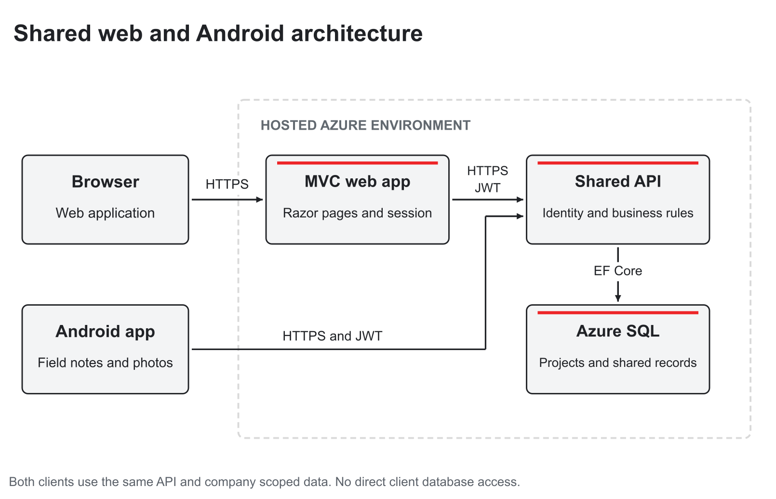
Figure 4 Implemented shared API architecture and logical service boundaries
The browser communicates with the ASP.NET Core MVC application. Razor views, CSS and JavaScript provide the user interface, and an API client handles server-to-server JSON requests. The MVC application does not query SQL directly. The API validates the authenticated account, company, role and project ownership before applying business rules and EF Core persistence. Android uses Kotlin Fragments, XML layouts, Navigation and RecyclerView, and calls the same API through RemoteRepository. Its active implementation is not Jetpack Compose. [C1]
The separation keeps a single authority for account access, company data, project validation and calculations. Web and mobile clients can share records without separately implementing a database access policy. Its cost is a dependency on an available API and correct environment configuration. The current online Android behaviour follows directly from that dependency. A future offline capability would need a local source of truth, queued writes and conflict handling; the unused Room classes alone do not provide it.
Table 11 Architecture and design rationale
Decision or pattern | How it is applied | Reason and tradeoff
MVC presentation separation | Controllers prepare view models; Razor renders user screens | Keeps display concerns separate from API persistence; requires mapping and error handling
API and DTO boundary | Clients exchange constrained request and response objects | Prevents unrestricted binding of entity security fields and centralises validation
Dependency injection and API client abstraction | Controllers receive framework services and IApiClient | Enables controlled dependencies and web-flow tests
Pure calculation service | Static functions calculate from supplied records/settings | Deterministic numerical testing; persistence stays in the calculation controller
EF Core data mapping | DbContext, relationships, migrations and query filters | Relational integrity with reproducible schema evolution
Snapshot for historical result rendering | PatternSnapshotJson saved alongside each new calculation | Reports can reproduce the pattern used then; not a complete audit/version platform

8 1 Cloud topology and transport
The demonstrated deployment contains two Azure App Service applications, one for MVC and one for the API, and Azure SQL. Hosted client traffic uses HTTPS and authenticated API operations use JWT bearer tokens. EF Core submits SQL operations from the API. The logical boundary shown in the figure is supported by the repository and deployed endpoints. No private subnet, VNet integration, private endpoint, managed identity, Key Vault, Blob report store or deployment slot is asserted as an implemented fact.
Those services appeared in earlier proposed diagrams but are not established by the delivered source and reviewed evidence. Network restrictions, database firewall rules, TLS database settings, backup retention and cloud administrator access must be checked in the actual Azure configuration before production handover. Photo bytes currently reside in SQL. PDF documents are generated from result data by MVC, rather than being retrieved from a configured Blob archive. [C1]
Hosted API base address

9 Implementation and critical flows

9 1 Implementation components
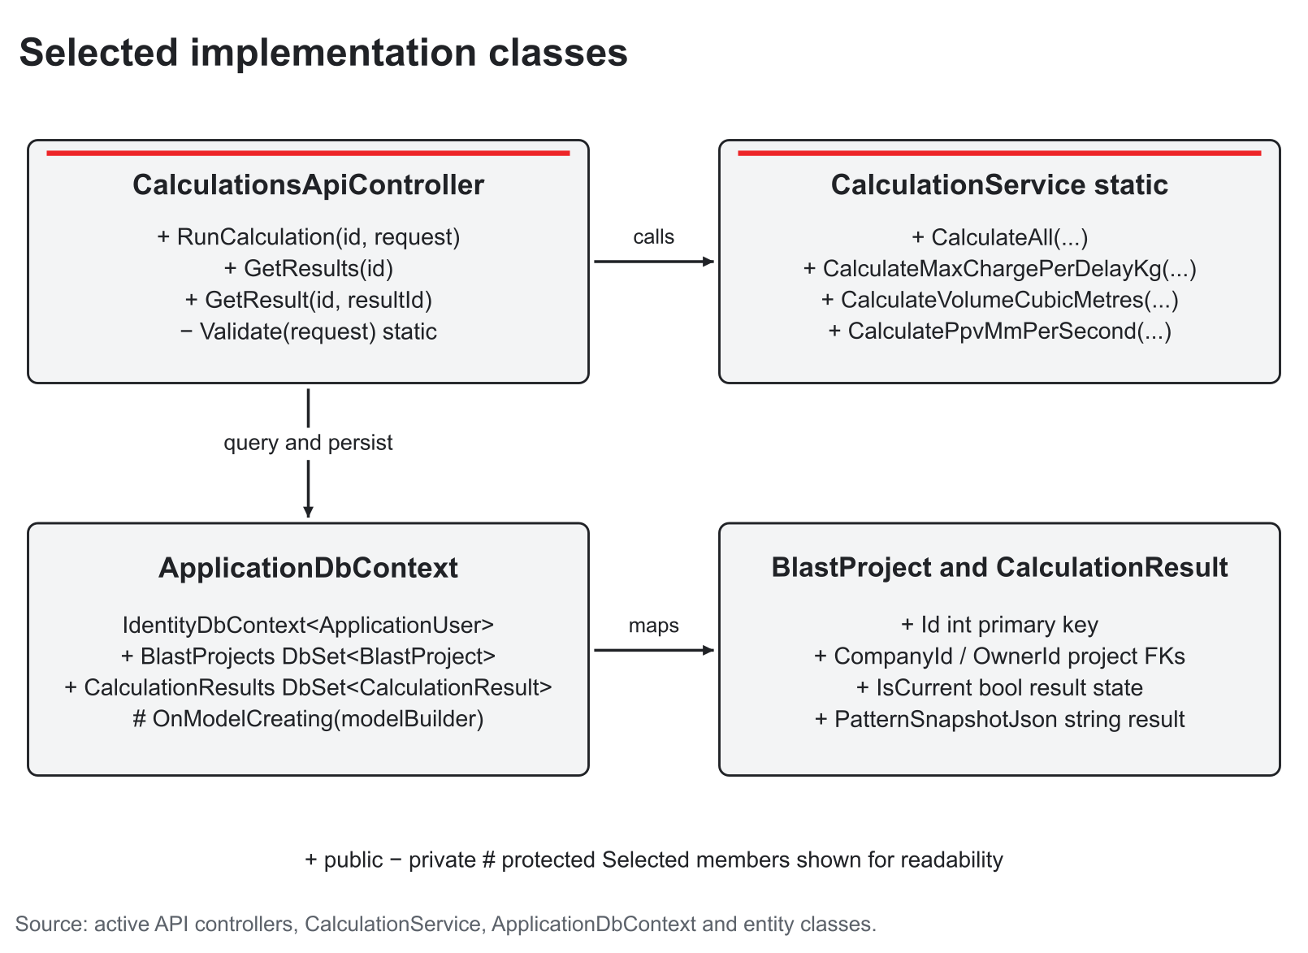
Figure 5 Selected implementation classes and dependency relationships with member visibility
Table 12 Implementation class responsibilities and public operations
Class or component | Key attributes or operations | Relationship
ApplicationDbContext | IdentityDbContext<ApplicationUser>; business DbSets; OnModelCreating | Maps keys, FKs, indexes, constraints and query filters
ProjectsController API | Project list/detail/create/update/delete; pattern load/save | Uses company/owner context, DbContext and DTO mapping
CalculationsApiController | + RunCalculation; + GetResults; + GetResult; private validation/mapping | Calls CalculationService and persists result, warnings and snapshot
CalculationService | + CalculateAll; + CalculateVolumeCubicMetres; + CalculatePpvMmPerSecond; + EstimateIdealizedFlyrockRangeMetres | Pure static calculation logic uses project, holes, products and settings
SavedDraftCalculator | + CalculateAsync(IApiClient api, int projectId) | MVC reloads persisted pattern, checks readiness, requests calculation
ReportsController and ReportPdfBuilder | Selected saved result to report model; + Build(ReportViewModel) returns bytes | MVC HTML and PDF output from saved snapshot
AccountTransactions | BeginAsync and company seat locking | Serialises account and active-seat changes
Android RemoteRepository and MobileSession | HTTP JSON/photo requests; in-memory user token | Native client of the same project and note APIs

A plus sign denotes a public operation. Entity keys and relationships are shown in section 10. The implementation table and diagrams describe the active classes and interaction boundaries; empty scaffold controllers are excluded. [C1]

9 2 Sign in and access enforcement
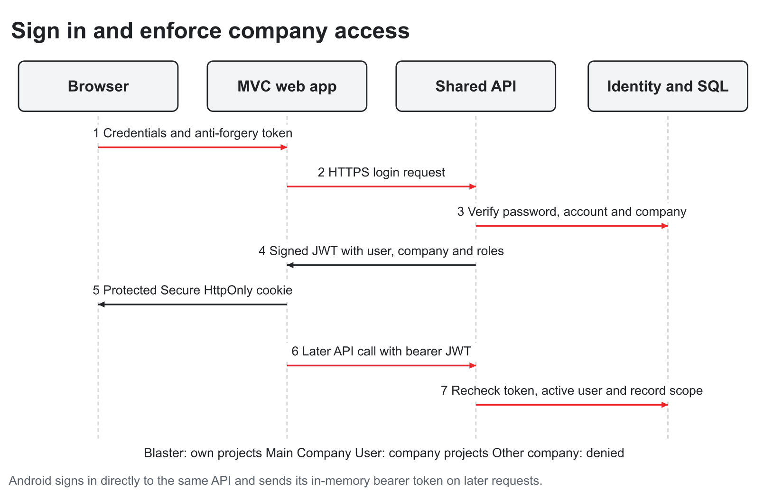
Figure 6 Sign in and resource authority checks at the API
A browser sign in posts an antiforgery-protected MVC form. MVC calls the login endpoint. Identity verifies the password, lockout, account status and active company; the token service signs the account’s user, company, role and security information into a JWT. MVC carries that JWT as a claim inside its protected authentication cookie. Each later API request attaches the token explicitly.
Android authenticates directly against the same API and holds its token in MobileSession memory. Account deactivation or password changes can invalidate previous sessions through security-stamp checks. A user-controlled project ID does not grant access: the API must still match company membership and, for a Blaster, ownership. Main Company User endpoints also enforce their role independently of visible navigation. [C1]

9 3 Save calculate and retrieve a report
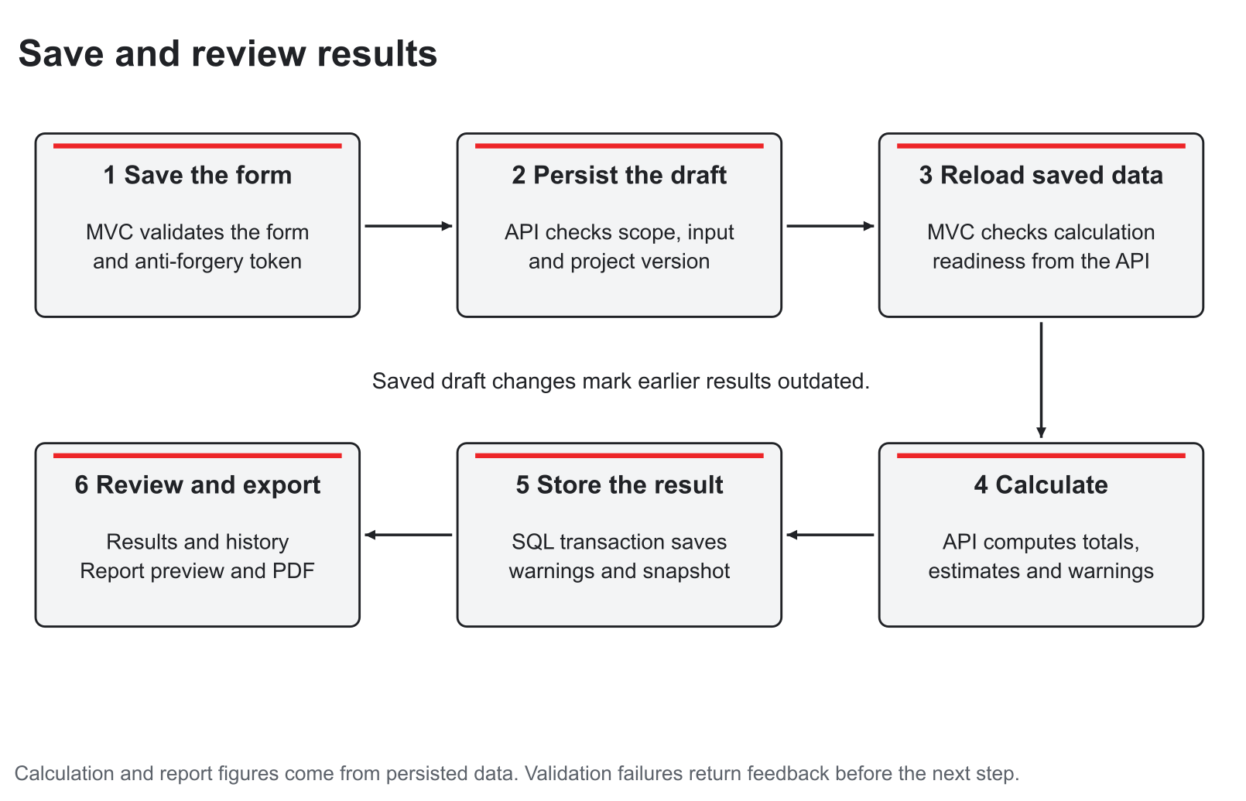
Figure 7 Persisted design to calculation history and result-specific report
The browser builds a draft with a live plan and provisional summary. Saving posts the complete pattern through MVC to the API. The API validates values and reference codes, checks concurrency, and saves project and hole data. A relevant edit marks earlier results noncurrent. Save and Review Results then reloads the saved design and checks calculation readiness before asking the API to calculate it. Unsaved browser values are not treated as the persisted numerical evidence.
The calculation endpoint computes a result, warnings and the pattern snapshot and saves them transactionally. It retains previous results while selecting a current result. Results can retrieve an older result explicitly; the report route follows that selected result identifier. PDF generation uses the corresponding view model and snapshot. Earlier results created before snapshot support cannot reconstruct the exact old hole plan. [C1]

9 4 Project and result state
A new project is Draft. A successful calculation produces a Calculated project and a current result. Changing calculation-relevant design inputs marks the existing result outdated and returns the design to Draft until recalculated. The status enumeration also contains Active, Reviewed and Archived labels; their existence does not establish a formal reviewer approval or immutable revision process. Project deletion hides the project and subordinate records through soft-delete filters. Note deletion removes the note and its photos/comments; there is no normal recycle-bin screen.

9 5 Shared note flow
Both clients use the same authorised project notes endpoint. An online save writes a note directly to SQL, and a later reload in the other client retrieves that server record. Author and Main Company User checks apply to editing/deleting a note and its photos. A note can have up to three JPEG, PNG or WebP photos of at most 5,000,000 bytes each. Multiple mobile photo uploads are individual requests: if an upload partly fails, the user must reopen the saved note and verify which attachments reached the server before retrying. This is shared online data, without a working offline conflict-resolution queue.

10 Data schema and storage design
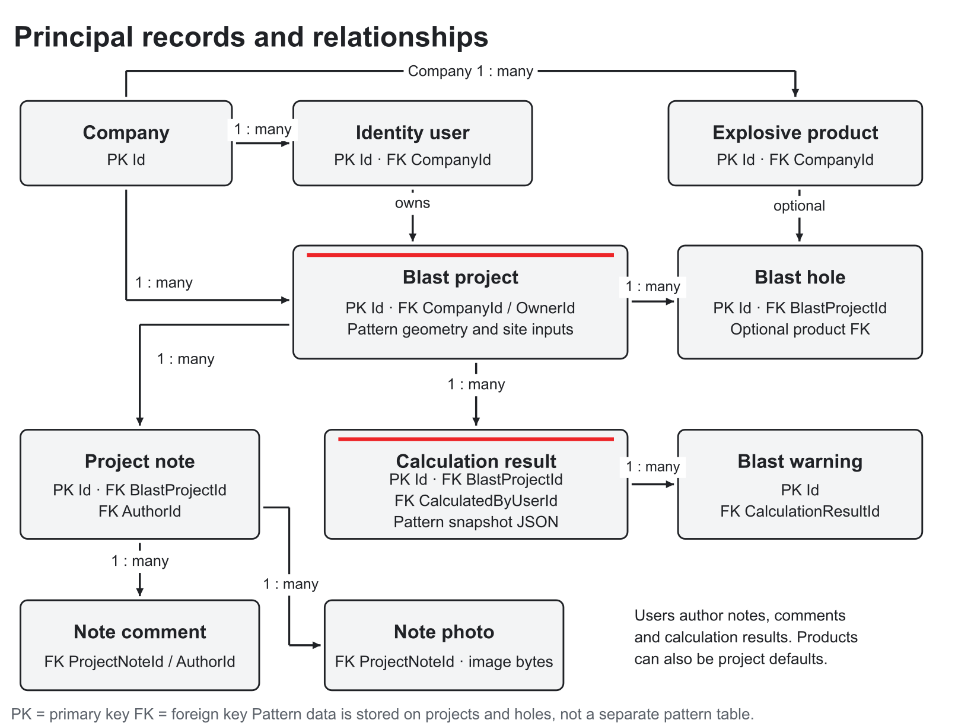
Figure 8 Principal implemented entities with keys and relationships
SQL Server provides the relational store in Development through LocalDB and in the demonstrated cloud through Azure SQL. ApplicationDbContext extends IdentityDbContext so account, role and token framework tables coexist with the business entities. Company is the tenant boundary. BlastProject references its company and owner; holes and calculations belong to a project. Notes belong to a project and an author, with child comments and photos. Company products can provide prices for hole or project product mappings. [C1]
The data model uses foreign keys, unique indexes, selected positive/nonnegative check constraints and decimal precision. SQL rowversion supports concurrent project editing. A unique filtered index permits one current calculation per project. Query filters hide soft-deleted projects and subordinate records. Company, referenced users and products use restricted deletion relationships to protect historical records. These constraints improve integrity but are not evidence of measured query speed or production capacity.
Table 13 Implemented business data dictionary
Record | Principal attributes | Integrity and storage
Company | Id integer PK; Name(150); RegistrationNumber(80); contacts; IsActive; UTC timestamps | Unique non-null registration; contact limits; company is parent of users, projects and products
ApplicationUser | Identity string PK; CompanyId FK; FullName(150); Email; profile fields; CertificationId; IsActive | Unique normalised email; unique company/non-null certification; company delete restricted
BlastProject | Id PK; CompanyId/OwnerId FKs; optional product FK; name/site/type; geometry; rock/site/timing settings; Status; IsDeleted; RowVersion | Indexed company/owner/status; SQL rowversion; positive constraints; decimal inputs mostly 18,4
BlastHole | Id PK; BlastProjectId FK; HoleNumber; X/Y; Depth; Diameter; Subdrill; Stemming; Charge; Delay; AECI code/density; product FK | Unique project/hole number; positive depth; nonnegative charge/stemming/delay; decimals 18,4
ExplosiveProduct | Id PK; CompanyId FK; Name; AECI code; PricePerKg; CurrencyCode; IsActive; timestamps | Unique company/name and non-null catalogue mapping; nonnegative price; 3-character currency
CalculationResult | Id PK; project/user FKs; calculated quantities; cost/currency; IsCurrent; CalculatedAtUtc; PatternSnapshotJson | One current result per project; money 18,2; powder factor 18,6; snapshot nvarchar(max)
BlastWarning | Id PK; CalculationResultId FK; Severity; Code(80); Message(600); CreatedAtUtc | Result/severity index; warning belongs to its saved result
ProjectNote | Id PK; project/author FKs; Title(150); Body(10000); UTC timestamps | Project/update index; project access and author rules checked in API
ProjectNoteComment | Id PK; note/author FKs; Body(2000); CreatedAtUtc | Cascade with note; author delete restricted
ProjectNotePhoto | Id PK; ProjectNoteId FK; FileName(200); ContentType(50); binary Data; CreatedAtUtc | Photo bytes in SQL; cascade with note; API enforces count/type/size

10 1 Snapshot schema and historical meaning
PatternSnapshotJson stores the pattern information used for a specific saved calculation. It captures bench dimensions and hole schedule values used by the report, including coordinates, depth, diameter, product, density, charge, stemming, subdrill and delay where available. It is an application serialisation inside a relational record, not a deployed document database. The shape is defined by the snapshot DTO in source; a complete business revision schema or externally governed JSON schema is not implemented. A snapshot records the calculation inputs at that time; it does not certify that the site measurements were approved.

10 2 Retention backup and recovery
Retention periods and operational restore objectives require a client decision. The release contains soft project deletion and real note/photo/comment deletion, but no user-facing restore workflow. Database backup and Azure retention are infrastructure settings outside the inspected source. Handover must therefore record the actual backup policy, exercise a restore into an isolated database, verify users/projects/results/photo bytes, and document the responsible owner before operational use. No successful restoration test is claimed here.

11 Calculation logic and numerical interpretation
CalculationService separates numerical operations from database access. It receives a saved project, its holes, company products and settings, and returns quantities and warning records. The calculation controller handles persistence. This makes the arithmetic repeatable for a fixed input set and supports focused numerical tests. Clear units are necessary: lengths use metres, charge uses kilograms, rock density uses tonnes per cubic metre, product density uses grams per cubic centimetre, delays use milliseconds, prices use currency per kilogram and PPV uses millimetres per second. [C1]

11 1 Quantities and conditional metrics
$$Total charge = Σ charge per hole Total drilling = Σ drilled depth per hole$$
$$Estimated volume = Σ burden × spacing × (drilled depth - subdrill)$$
$$Estimated tonnage = estimated volume × rock density$$
$$Powder factor = total charge ÷ positive estimated tonnage$$
The nominal volume uses hole coverage and effective depth. Per-hole subdrill is preferred, with a legacy common value as a fallback. It is not a surveyed irregular solid calculation. Nominal coverage can exceed entered bench area; the service emits a warning for that condition. Powder factor is unavailable when a positive tonnage cannot be calculated, rather than being silently reported as zero.
Cost sums each hole’s charge multiplied by its active company price. Every hole must resolve to a usable company-owned priced product and all prices must use the same currency. Missing, inactive, unmapped or mixed-currency prices leave cost unavailable. Demonstration sample prices are not supplier quotations. A saved result retains its computed cost when prices change; recalculation creates a new value rather than rewriting the old result.

11 2 Charge grouping and vibration
Maximum charge per delay is computed using a sorted sliding interval. Holes are grouped while the difference between the right and left delay is strictly less than the entered positive window; a difference equal to the window starts outside that group. The largest group sum becomes W for the PPV screen. The user must supply an appropriate site window and review the actual initiation plan; the interval is not a universal safety constant.
$$Predicted PPV = K × (D ÷ √W)⁻ⁿ$$
K and n are site calibration values in the application’s units, D is receptor distance and W is the maximum grouped charge. Missing required values make PPV unavailable; an estimate exceeding the entered vibration limit creates a Critical warning. The UI can suggest a USBM RI 8507 Appendix B residential reference using structure type and measured frequency. It is US research guidance and cannot be presented as an automatic South African legal limit or blast approval. The entered limit remains subject to the site’s approved professional process. [C1; R5]

11 3 Idealised trajectory and warnings
The flyrock screen uses a projectile trajectory with gravity 9.80665 m/s², an entered launch speed, angle and height. It omits drag, irregular fragment shape and uncertain field launch conditions. The app always records a trajectory-screening warning, and creates a Critical warning if the estimate exceeds the entered approved radius. The trajectory does not establish that radius. A missing metric is a data/assumption state, and a warning-free display would still not constitute operational approval.

11 4 Reproducible software example
The documentation environment contains a synthetic six-hole example: a 12 m by 8 m bench, two rows of three holes, burden and spacing 4 m, drilled depth 5 m, subdrill 0.5 m per hole, charge 2 kg per hole, rock density 2.5 t/m³ and delays 0, 25, 50, 75, 100 and 125 ms. With an 8 ms grouping window, maximum grouped charge is 2 kg. These figures demonstrate software arithmetic only; they are not recommended site or product loading values.
Table 14 Synthetic numerical example
Metric | Arithmetic or assumption | Result
Total drilling | 6 × 5 m | 30 m
Total charge | 6 × 2 kg | 12 kg
Nominal volume | 6 × 4 × 4 × (5 − 0.5) | 432 m³
Tonnage | 432 × 2.5 | 1,080 t
Powder factor | 12 ÷ 1,080 | 0.011111 kg/t before display rounding
Demonstration cost | 12 kg × ZAR 35/kg sample price | ZAR 420.00
Predicted PPV | K 100, n 1.6, D 100 m, W 2 kg | About 0.11 mm/s
Trajectory screen | 20 m/s, 45 degrees, height 0 | About 40.79 m; screening warning retained

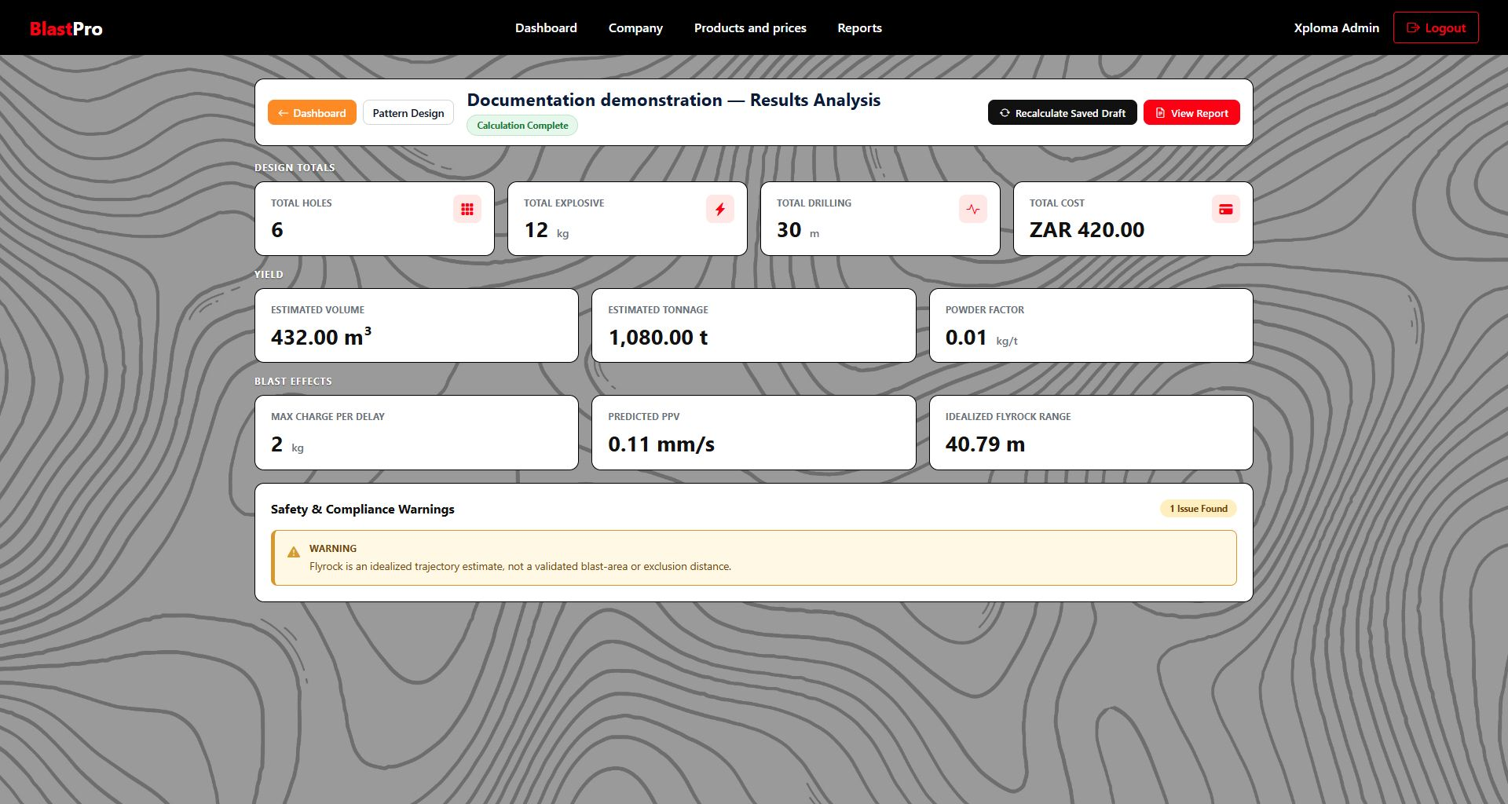
Figure 9 Saved results for the isolated numerical example with its visible warning

12 API contracts and data flow
The API is the shared authority for web and Android. Authenticated routes require an explicit bearer token; company and user scope come from the validated principal, not a caller-selected company identifier. JSON DTOs carry inputs and outputs, with multipart requests for photo upload and binary image responses for photo retrieval. MVC creates the report HTML/PDF from API result data, so an additional API report endpoint is not required. [C1]
The table groups concrete active routes by resource. A list or detail request returns only records the caller can access. Creation returns a new identifier and a 201 response where defined; invalid input, conflicting records and inaccessible resources are handled through the controller contract. Empty legacy scaffold files are not counted as working endpoints.
Table 15 Working API surface
Resource | Active method and route | Contract and rules
Account setup | POST /api/companies | Create company and main user together; 201 login response; duplicate email/registration can return 409
Authentication | POST /api/auth/login; GET /api/auth/me | Login response contains JWT/account context; invalid credentials return generic 401
Password recovery | POST /api/auth/forgot-password; POST /api/auth/reset-password | Development delivery; hosted recovery unavailable; invalid/expired reset returns 400
Projects | GET/POST /api/projects; GET/PUT/DELETE /api/projects/{id} | Accessible summaries/detail, create/edit and soft delete; unavailable or concealed record commonly returns 404
Pattern | GET/PUT /api/projects/{id}/pattern-design | Read/save project inputs and complete hole collection; validate bounds and rowversion concurrency
Calculations | POST /api/projects/{id}/calculations | Compute saved design and persist result, warnings and snapshot; return 201
Results | GET /api/projects/{id}/results; GET /api/projects/{id}/results/{resultId} | Displayed result and history; selected saved result and snapshot
Company | GET/PUT /api/company | Main Company User company contacts and Blaster/seat information
Blasters | POST /api/company/blasters; GET/PUT /api/company/blasters/{id} | Read/create/edit same-company Blaster; server seat/identity rules
Blaster access | PUT /api/company/blasters/{id}/status; PUT .../{id}/password | Activate/deactivate or set password; role gate and session invalidation
Products | GET /api/company/products/catalog; GET/POST /api/company/products; PUT .../{id}; POST .../samples | Catalogue and company price administration; samples are demonstration estimates
Profile | GET/PUT /api/profile | Own permitted profile fields; excludes company/role/active state
Notes | GET/POST /api/projects/{projectId}/notes; GET/PUT/DELETE .../notes/{noteId} | Accessible project notes; author or Main Company User edit/delete
Comments | POST .../notes/{noteId}/comments | Comment on an accessible note; body validation
Photos | POST .../notes/{noteId}/photos; GET/DELETE .../photos/{photoId} | Access-checked multipart upload/binary download; max three supported images, 5,000,000 bytes each

12 1 Error handling and concurrency
Clients display validation close to the relevant field where supported, and report connection, timeout or server failures. Inaccessible records are not exposed merely because an ID can be guessed. Project rowversion prevents one editor silently overwriting a conflicting saved version. The API also validates product mapping, hole uniqueness, numeric bounds and account status. A conflict should prompt the user to reload and review the current record. An HTTP connectivity check is useful but does not prove authentication, permissions or a complete database workflow.

12 2 Data movement and consistency
For design work the authoritative sequence is validated input, saved project/holes, reloaded persisted design, calculation and stored result/snapshot, then rendered output. For notes it is authorised client request, direct API save to SQL, then another authorised client reload. The first sequence protects the relationship between a report and the calculation it represents. The second gives shared online visibility without promising offline reconciliation. Passwords, bearer tokens, connection strings and publish profiles are excluded from report examples and screenshots.

13 Security and threat mitigation
Security is enforced at both presentation and API boundaries. MVC forms use antiforgery validation, while API operations authenticate explicit bearer tokens and recheck active account/company and resource authority. ASP.NET Core Identity stores password hashes and provides password policy and lockout. The default inspected policy requires at least eight characters including upper and lower case, a digit and a symbol, and locks after five failed attempts for fifteen minutes. These are implementation controls, not a claim of independent penetration testing. [C1]

13 1 XSS prevention
User-controlled project, note and comment values must be rendered as text. Current Razor views use normal encoded expressions, and relevant JavaScript uses textContent for dynamic labels and messages. This follows Microsoft’s output-encoding guidance: data should be encoded for its output context, rather than trusted merely because it came from the database. Raw HTML must not be introduced for arbitrary user text. [R1]
The report’s generated numeric/SVG paths are a restricted use case and must remain separated from untrusted HTML content. Validation constrains numeric and text inputs, but does not replace output encoding. A configured Content Security Policy was not found, and the report does not claim every future screen is protected automatically. Any rich-text feature or new dynamic rendering path requires a fresh review. [C1]
Table 16 Security threat and control matrix
Threat | Implemented control and evidence | Remaining boundary
Account compromise | Identity password hashes, policy and lockout; generic login failures | No verified MFA; hosted recovery email unavailable
Invalid or stale token | HMAC SHA256 JWT issuer/audience/signature/lifetime checks; active user/company/security stamp validation | Deployed token settings can override committed defaults
Cross-company or non-owner access | Company/owner-scoped controller queries and role gates; negative tests | Hidden menu items are not an access control
Cross site request forgery | MVC mutating forms validate antiforgery tokens, including logout | API uses explicit bearer authentication rather than automatic browser cookie auth
Cross site scripting | Razor output encoding and text-only dynamic rendering | No CSP configuration found; preserve restrictions on Html.Raw/generated SVG
SQL injection | EF LINQ and parameterised operations including interpolated SQL through EF | Future raw SQL must remain parameterised
Malicious or oversized upload | JPEG/PNG/WebP signature checks, count limit, safe basename and 5,000,000 byte maximum | No malware scanner or image re-encoding established
Session exposure | Secure HttpOnly MVC cookie; JWT not placed in browser localStorage by this flow | Remember me can persist to token expiry; shared devices require logout
Mobile session theft | Password field cleared and token retained in memory only | No claim of encrypted offline notebook; app cache may hold images
Insecure transport | Hosted HTTPS, MVC redirect/HSTS and HTTPS-only release API setting | Debug emulator HTTP is development-only; Azure firewall/TLS settings require configuration evidence
Concurrent changes | Rowversion, unique/FK/check constraints and transactional seat/result changes | No complete audit ledger or business approval engine
Secret disclosure | Configuration/user secrets and Actions publish-profile secrets | Do not publish cloud keys, private reset links or real passwords

13 2 Session and authority details
The MVC authentication cookie is Secure and HttpOnly with no sliding extension. Without Remember me its expiry is the earlier of token expiry or sixty minutes; with Remember me it follows token expiry. The committed JWT lifetime is 480 minutes, subject to deployment configuration. Android keeps the token in memory and clears it on logout. Main Company User power remains limited to the same company. Account and active-seat mutations use a serializable transaction and company row locking, so two concurrent requests cannot simply count the same free seat. [C1]

13 3 Security work before production handover
The handover gate should verify actual cloud firewall and administrator access, backup/restore, HTTPS data paths, log redaction, dependency status and a tested account recovery method. A targeted assessment should exercise direct ID access, inactive accounts, token revocation, upload spoofing, malicious text and antiforgery rejection. OWASP’s authorisation guidance supports checking permission for every request and granting access explicitly; it is used here as a review reference, not as a certification. [R2; R3]

14 Deployment and CI CD Final Status
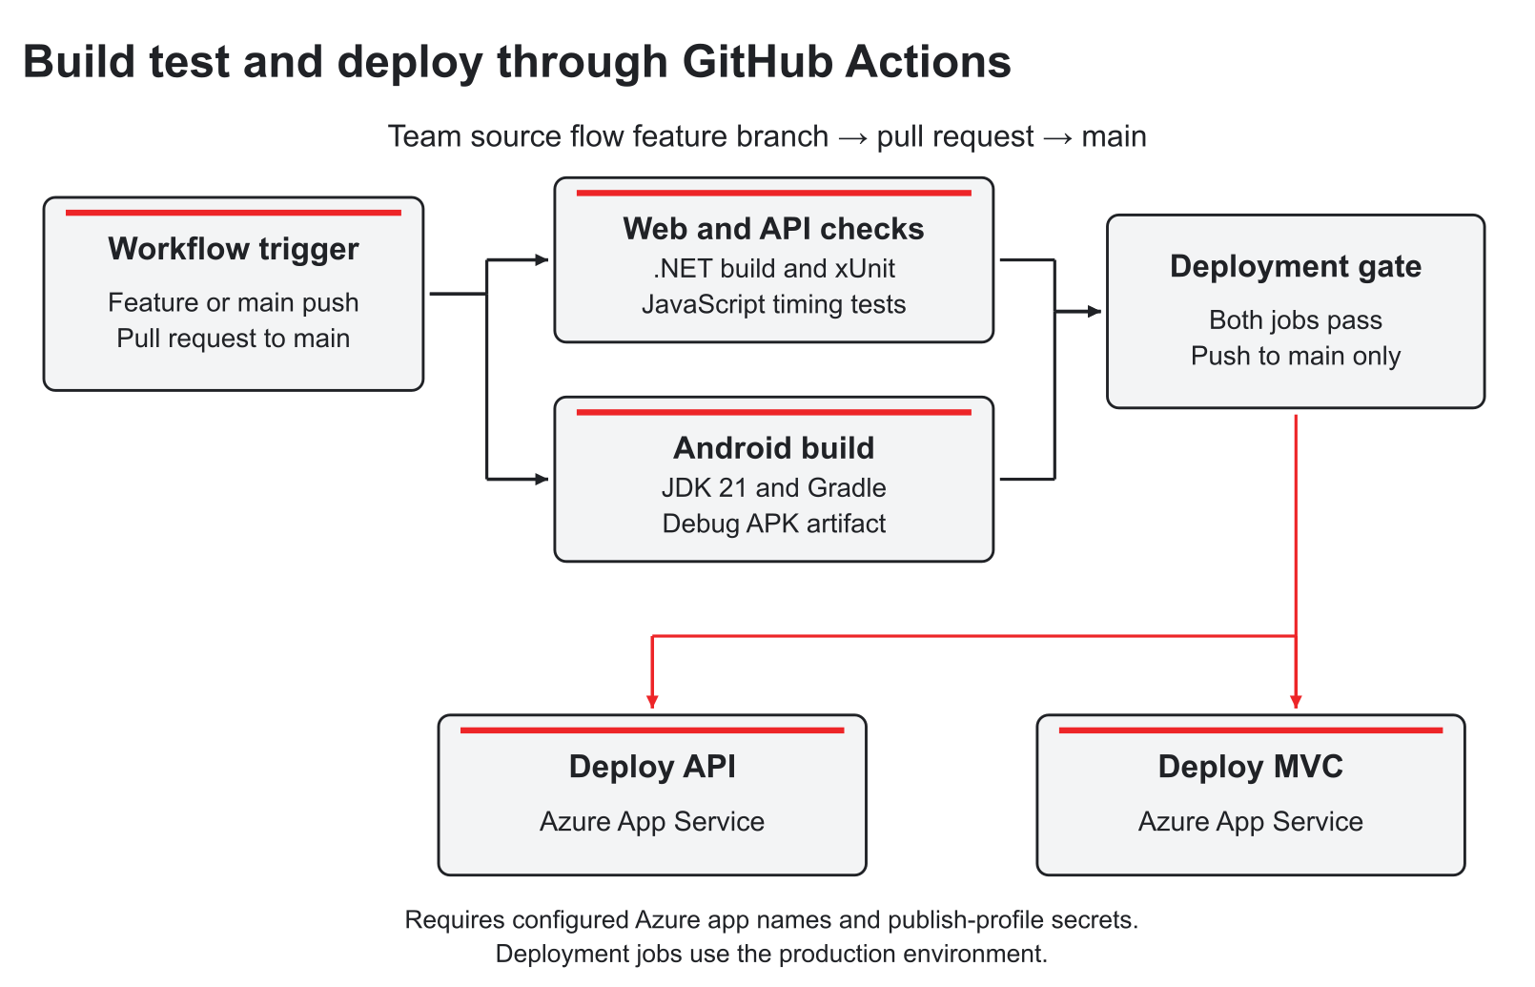
Figure 10 Actual feature branch and main pipeline with parallel quality jobs and Azure deployments
The repository workflow triggers on pushes to main and feature branches, and on pull requests into main. The intended collaboration flow is a focused feature branch, descriptive commits and a pull request for integration. Tests and build checks run before the main push can reach the deployment jobs. This report describes the configured pipeline and reviewed run, rather than claiming that every historical change followed a protected-branch policy. [C1]
The Windows quality job sets up .NET 10 and Node 22, builds the test project in Release, runs xUnit checks excluding Category LocalDb, runs JavaScript timing tests and uploads TRX results. In parallel the Ubuntu Android job uses JDK 21 and Gradle to assemble a debug APK and upload it. After both succeed, a push to main can publish and deploy the API and MVC applications through separate Azure jobs using repository variables and publish-profile secrets. Each deployment has its own production environment/concurrency setting.
Table 17 Final delivery evidence
Reviewed evidence | Observed result | Interpretation
Actions run 9 on 21 October 2026 | Overall Success, commit 62b02d2 | Same revision as reviewed local and remote main
Build and test NET and JavaScript | Succeeded | Automated software checks passed for the configured suite
Build Android app | Succeeded; APK artifact available | Build evidence, not complete mobile user acceptance
Deploy API to Azure | Succeeded | API deployment job executed rather than being skipped
Deploy web app to Azure | Succeeded | MVC deployment job executed
Hosted web sign in on 28 October 2026 | Page loaded and displayed sign in/company setup controls | A point-in-time availability observation
Current documentation environment | Project, pattern, stored result/report and shared-note pages captured | Synthetic isolated example, not client data

Review the successful release pipeline and its jobs

14 1 Test coverage and honest limits
The active tests cover authentication, lockout, password recovery and token revocation; company transaction, seat and access rules; project ownership and tenant boundaries; product administration; notes and uploads; calculation totals, validation, history and snapshots; key MVC flows; residential vibration guidance; and JavaScript timing sequences. Source test methods and historical totals are not reported as a fresh executed case count, because parameterised cases and later changes make that inference unreliable.
LocalDB-tagged relational concurrency and database constraint tests are excluded in the hosted CI command. The Android pipeline builds the APK but does not execute a full phone UI regression suite. No representative load benchmark, independent security test, restore drill or signed field user acceptance record was found. These omissions remain visible in the quality and handover sections. A green pipeline is important release evidence but does not prove all original requirements or operational engineering suitability.

14 2 Deployment and rollback procedure
1. Identify the release. Record commit, successful run, app addresses, schema migrations and known limitations.
2. Configure the environment privately. Supply the API database connection and JWT signing key in Azure configuration, set the web ApiBaseUrl and keep publish profiles in Actions secrets.
3. Deploy after checks. The main workflow publishes both apps only after quality and Android jobs pass. Verify their logs and expected URLs.
4. Perform a smoke review. Use an authorised demonstration account to verify sign in, saved project retrieval, calculations/report and cross-client notes in the intended environment.
5. Handle a failed release. Restore a known working app artifact or redeploy a known commit. Review database migration compatibility separately; do not assume deploying older binaries reverses schema or data changes.
6. Record the result. Capture date, commit, run, verifier and defects without exposing secrets. Escalate any database recovery to the responsible operator.

15 Running costs and two year planning scenario
The supplied hosting guide selected one shared Windows App Service F1 plan for the MVC and API applications and an eligible Azure SQL free offer. That is a demonstration cost strategy, not proof of a zero invoice or a production availability commitment. The SQL free allowance is based on compute and storage consumption, not a number of free users. The selected exhaustion behaviour can pause the database when its allowance is spent. Actual Azure configuration, eligibility and invoices must be verified by the subscription owner. [P6; R6]
The paid comparison below uses public Microsoft South Africa North retail consumption rates retrieved on 28 October 2026 in USD. It assumes one plan shared by the two web applications, 730 compute hours and 365 divided by 12 SQL billing days per month. It does not double-count two apps as two plans. The rates are indicative before taxes, currency conversion, discounts and agreement terms. [R7; R8]
Table 18 Verified retail inputs to the planning estimate
Component | Retail rate USD | Monthly basis | Indicative USD per month
Windows App Service B1 | 0.110 per hour | 730 hours | 80.30
Windows App Service B2 | 0.219 per hour | 730 hours | 159.87
Windows App Service B3 | 0.438 per hour | 730 hours | 319.74
Azure SQL Standard S0 | 0.707 per day | 365 / 12 days | 21.50
Azure SQL Standard S1 | 1.413 per day | 365 / 12 days | 42.98
Azure SQL Standard S3 | 7.066 per day | 365 / 12 days | 214.92

15 1 Scale comparison
Table 19 Illustrative scale budgets with explicit sizing assumptions
Registered user scenario | Candidate sizing assumption | Base USD per month | Variable use budget | Total planning USD per month
100 | One B1 plan + SQL S0 | 101.80 | 10.00 | 111.80
1,000 | One B2 plan + SQL S1 | 202.85 | 30.00 | 232.85
10,000 | One B3 plan + SQL S3 | 534.66 | 100.00 | 634.66

The registered user counts are planning scenarios required for comparison, not demonstrated capacities or vendor entitlements. Concurrent users, calculation frequency, query response and note-photo volume determine actual sizing. Load tests must validate the candidate tier before a capacity promise is made. The variable-use figures are team-assumed contingencies for transfer, additional database/photo/backup volume and monitoring, not quoted bundles.
Table 20 Full running cost assumptions and exclusions
Running cost area | Treatment in this estimate
Compute and database | Included once at the selected shared App Service and SQL tiers
Photos and retention | Stored in SQL; consumption and backup volume require monitoring and may exhaust the contingency
Outbound transfer and monitoring | Variable-use planning allowance only; actual metered usage governs billing
Provider hostname and certificate | Current Azure provider addresses; no paid custom-domain cost assumed
Email and AI | No functioning paid provider in this release; an approved future service needs a new quote/budget
Additional backup retention or storage | Not assumed free indefinitely; select policy and price actual consumption
Development and team fees | Excluded from infrastructure running costs as required by the assessment
Taxes exchange rates and contracts | Excluded from USD retail illustration; apply actual subscription billing conditions

15 2 Two year growth illustration
No client-supplied two year adoption forecast or actual invoice was supplied. The following is therefore an explicit planning assumption awaiting client validation: use the 100-user/B1/S0 scenario during months 1 to 12, then move to the 1,000-user/B2/S1 scenario during months 13 to 24 after measurements justify it. It is not a forecast attributed to Xploma.
Table 21 Transparent two year budget calculation
Period | Scenario and monthly budget USD | Months | Period total USD
Year 1 | 100 registered users; 111.80 | 12 | 1,341.60
Year 2 | 1,000 registered users; 232.85 | 12 | 2,794.20
Two year total | Illustrative retail plus assumed usage budgets | 24 | 4,135.80

Review actual usage after the first representative month, set subscription budgets and alerts, and revise the forecast with the client. Retention, photograph frequency and real concurrency should drive the decision to increase capacity. An abrupt need for more storage or throughput can exceed the assumed contingency. [R9]

16 Change management training and handover
Adoption should begin with a controlled pilot that preserves the existing manual process as a fallback. The organisation benefits when authorised designs, saved inputs, results and notes can be found consistently; individual users benefit when the interface makes their current task and stored result clear. Those are adoption objectives, rather than a claim that the organisation has already changed its operations.
The Main Company User should act as the company’s operational contact. That person verifies contacts, Blaster access and active prices before the pilot. A small number of Blasters then practise a complete project and online mobile-note scenario. Feedback should be logged with the release, steps, expected/actual outcome and screenshots. No signed client pilot, training attendance, acceptance or handover was supplied, so the timetable below is a proposed relative sequence. [P1; P4]
Table 22 Proposed transition from development to use
Phase | Activity and deliverable | Owner or approval
Readiness week | Freeze release commit, addresses, APK, manual, known issues, test evidence and private configuration record | Project team; client nominates operational owner
Pilot week | Use authorised synthetic or approved data; test role access, saved patterns, warnings, PDF and notes across apps | Selected Blasters and Main Company User
Training and parallel run | Short role sessions; keep manual/spreadsheet process available while recording defects | Team trainer and company contact
Acceptance decision | Record each scenario outcome; specialist separately evaluates numerical model applicability | Client representative and qualified specialist
Cutover and handover | Transfer source, deployment/migrations, recovery procedure and private credentials; agree support | Client owner and project team
Initial support review | Proposed two week support period; prioritise failures and update instructions | Period and response expectations require agreement

16 1 Role based training
Table 23 Training plan
Audience | Practice | Completion evidence
Blaster web users | Create/find project, enter units, inspect holes, save draft, review warnings/history and export chosen result | User reproduces saved record and explains current versus outdated results
Main Company User | Company contacts, seats, Blaster password/status, products and prices, company project oversight | Correct account/price changes and denied cross-company access
Android users | Online sign in, project selection, note/photo/comment save, search/filter, reload and logout | Saved server note seen in the other client; connection failure understood
Operational maintainer | Configuration, migrations, pipeline artifacts, logs and restore procedure | Private runbook plus isolated restore/smoke evidence

16 2 Handover contents and acceptance gates
- Repository, precise release commit, build artifacts/APK and accessible demonstration link.
- This final report, complete user manual, requirements status register and known issue list.
- Actual hosting/subscription owner, approved configuration locations, migration history and recovery runbook.
- Current test/pipeline evidence plus outstanding device, load, security, restore and client acceptance checks.
- Private transfer of credentials through an agreed confidential route, with ownership and access reviewed.
- A client-approved retention, support and adoption plan; no invented signature or service contract.
The absence of offline capture is material for remote sites. The pilot must confirm that available connectivity supports the current notebook flow; a required offline workflow cannot be replaced by a promise that the unused local scaffold will synchronise later. Any production rollout dependent on offline work must wait for that capability or an explicitly agreed alternative process.

17 Evaluation limitations and next release priorities
The project demonstrates integration of a web workspace, native Android client, shared API, relational data model, calculation service, generated reports and automated cloud deployment. Its strongest evidenced outcome is the continuity of a saved record: authorised inputs can be stored, calculated, revisited and rendered together with their warnings. Shared online notes add a field companion without duplicating calculation logic on the phone.
The initial design remains broader than that outcome. The final report therefore treats documentation refinement and successful delivery as evidenced achievements while retaining unfinished functions and unverified operational targets. It does not assert measured productivity gains, specialist certification, signed client acceptance, production resilience or complete original-scope fulfilment. The next work should follow client priorities and evidence, rather than adding undocumented claims to a final presentation.
Table 24 Prioritised remaining work
Priority area | Reason | Next evidence or change
Client and specialist acceptance | Business fit and model applicability remain unapproved | Recorded representative scenarios and signed decisions
Offline notes | Earlier scope identified unreliable site connectivity | Local persistence, queued writes, conflict policy and loss/retry tests
Account recovery | Hosted reset email not operational | Configured provider and verified end to end recovery
Original geometry and governance gaps | Baseline includes irregular geometry, profiles, audit and review | Client scope decision followed by targeted implementation and tests
Mobile reliability and usability | CI only establishes APK build | Phone/device matrix, interruption/upload cases and accessibility review
Operational readiness | No verified restoration/capacity record | Restore drill, actual retention, load tests and measured budgets
Documentation and delivery packaging | README contains stale/missing documentation links; selected slides and video must be linked in the submitted repository | Package the reviewed documents, retained slide deck and selected demo video, then check marker access

18 References and evidence sources
Project references are supplied team materials. Code references use the reviewed repository revision shown in section 1. External sources provide technical guidance or retail pricing; they are not substitutes for project-specific validation. Access date for the online evidence and external references is 28 October 2026.
Table 25 Project source register
ID | Author or source | Document or evidence | Use
P1 | Group 16 | Task 1 documentation | Original requirements, analysis, 32 task WBS, diagrams, costs and change plan. Supplied project file.
P2 | Group 16 | Presentation Information.docx and INSY7315 GROUP 16 Presentation.pptx | Supplied client background and business process.
P3 | Group 16 | Revised Product Feature Specification and Task 2 Work Split and Tips | Scope baseline and development planning material.
P4 | Group 16 | Work Split.docx | Original six member documentation allocation.
P5 | Group 16 | Task 1 prototype | Historical mobile and web Figma prototypes.
P6 | BlastPro team | BlastPro_Azure_Free_Hosting_Step_by_Step.md | Documented demonstration hosting approach.
C1 | BlastPro team | FullStackDev Wil source commit 62b02d2 | Active MVC/API/Android source, EF schema, tests and workflow.
E1 | GitHub Actions | CI CD run 39554429674 | Successful four-job release evidence, 21 October 2026.
E2 | BlastPro documentation review | Current screenshots captured 28 October 2026 | Isolated synthetic database; no real client site data.
A1 | The Independent Institute of Education | INSY7315 Module Manual 2026 and ARC Task 3 guide | Assessment structure, declaration and confidential peer form.
F1 | INSY7315 lecturer feedback | Task 2 rubric released 23 October 2026 | Requests to add API/security/data flow/branching/pipeline explanation to documentation.
P7 | BlastPro Team | INSY7315_Task2_WIL.docx and BlastPro_Task2_Hosted_Final.pptx | Supplied demonstration link and retained slide deck selected for the final submission; video playback checked 30 October 2026.

R1 Microsoft Learn Prevent Cross Site Scripting in ASP NET Core
Open source
R2 Microsoft Learn Antiforgery in ASP NET Core
Open source
R3 OWASP Authorization Cheat Sheet
Open source
R4 W3C Web Content Accessibility Guidelines 2 2
Open source
R5 US Bureau of Mines via CDC RI 8507 Structure Response and Damage Produced by Ground Vibration From Surface Mine Blasting
Open source
R6 Microsoft Learn Azure SQL Database free offer
Open source
R7 Microsoft Learn Azure Retail Prices API
Open source
R8 Microsoft Learn Azure App Service plans
Open source
R9 Microsoft Learn Plan and manage App Service costs
Open source
Retail pricing data was queried from prices.azure.com/api/retail/prices using USD Consumption filters for southafricanorth and Azure App Service or SQL Database. Monthly totals use the explicitly stated hours/days, rounded to cents. No actual customer invoice or client adoption forecast was supplied.

18 1 Source code evidence map
Table 26 Reproducible implementation evidence
Area | Repository path at reviewed revision
Identity and authentication | BlastPro/BlastPro.Api/Controllers/AuthController.cs; Services/JwtTokenService.cs; API and MVC Program.cs
Projects and saved pattern | BlastPro/BlastPro.Api/Controllers/ProjectsController.cs; MVC Views/Projects/PatternDesign.cshtml
Calculation and history | BlastPro/BlastPro.Api/Controllers/CalculationsApiController.cs; Services/CalculationService.cs
Storage and constraints | BlastPro/BlastPro.Api/Data/ApplicationDbContext.cs; Models/Entities; Data/Migrations
Company and Blaster rules | BlastPro/BlastPro.Api/Controllers/CompanyRegistrationController.cs; BlastersController.cs; Services/AccountTransactions.cs
Reports | BlastPro/BlastPro/Controllers/ReportsController.cs; Services/ReportPdfBuilder.cs
Notes and uploads | BlastPro/BlastPro.Api/Controllers/ProjectNotesController.cs; Models/Entities/ProjectNote.cs
Android | BlastPro.Android/app/src/main/java; data/RemoteRepository.kt and MobileSession; UI Fragments and XML resources
Automation | Root .github/workflows/ci-cd.yml; BlastPro/BlastPro.Tests

Annexure A Declaration of Authenticity
Individual declaration for the submitting student. Complete the identification, signature and date personally after reviewing the final work. The declaration text follows the INSY7315 module manual. No signature or identification number has been generated.
I, ______________________________________ ID Number, ______________________________________ hereby declare that this portfolio, and any evidence included therein, contains my own independent work and that I have not received help from other groups.
I confirm that we have not committed plagiarism in the accomplishment of this work, nor have I falsified and/or invented experimental data.
I accept the academic penalties that may be imposed for violations of the above.
STUDENT NUMBER ST10439055
STUDENT NAME Nicholas Farquhar
STUDENT SIGNATURE ______________________________________
DATE ______________________________________

Assistance and review record
AI tools assisted with consolidating the supplied project material, explaining and checking source behaviour, drafting this report and the manual, and document formatting. The software history also contains AI-supported development and debugging work described in the team’s Task 2 declaration. The submitting students must review the work, check claims and references, and take responsibility for the submitted content. No client interviews, numerical field observations, signatures, evaluation ratings or approvals have been invented in this document.

Appendix C Functional requirements traceability
All 44 original functional requirements are retained below. The acceptance text is the original baseline expectation, not an assertion that the test or approval has been completed. Status evaluates the complete requirement wording. Source P1; implementation review C1.
Table 27 Complete original functional baseline
ID and priority | Original requirement and acceptance expectation | Delivered status and evidence
FR-01  Must | The system shall authenticate users and establish a company and role context for every session.  Acceptance expectation: Unauthenticated access is rejected; successful login loads the correct role home. | Implemented  Identity login, JWT company/role claims and MVC cookie establish account context.
FR-02  Must | The system shall enforce company isolation on every read, write, calculation, search and report operation.  Acceptance expectation: Cross-company API and UI tests return no data and no indirect identifiers. | Implemented  Delivered project, note, result and administration routes scope access to the validated company; negative tests exist.
FR-03  Must | The system shall allow a Blaster to discover and operate only on designs they own.  Acceptance expectation: Owner and non-owner tests cover list, direct URL, API, copy, report and download. | Implemented  Project API ownership checks restrict Blasters while Main Company Users can access same-company projects.
FR-04  Must | The Main Company User shall create, disable, reactivate and manage Blaster accounts in the same company.  Acceptance expectation: Account-state changes take effect and are audited. | Partial  Create, edit, disable, reactivate and password reset are present with five active seats; no general audit ledger records account changes.
FR-05  Must | The system shall audit login, account, design, calculation, override, review, report and archive events.  Acceptance expectation: Each event records actor, company, time, action and affected record/revision. | Deferred  No general append-only AuditLog entity or event catalogue is implemented. Timestamps and calculation history provide narrower evidence.
FR-06  Must | The Blaster dashboard shall display only the signed-in Blaster's designs and their state, warnings and stale status.  Acceptance expectation: Seeded multi-user test shows no other owner's design. | Implemented  Authorised dashboard project summaries include statuses and warning count/severity; saved results become outdated after design edits.
FR-07  Must | The Main Company User dashboard shall summarise all Blasters and designs inside the company.  Acceptance expectation: Counts and lists reconcile with company test data. | Partial  Company project oversight and a Company page with Blaster/seat information are present; the original full dashboard/audit summary is narrower in the delivered UI.
FR-08  Must | Users shall search and filter authorised designs by reference, owner where allowed, rock, explosive, pattern, date and review state.  Acceptance expectation: Each filter returns only authorised matching records and can be cleared. | Partial  Dashboard searches project name and filters status; the full proposed owner/rock/product/pattern/date filter set is not delivered.
FR-09  Must | A Blaster shall create, save, continue and archive a Draft design with optional internal job references.  Acceptance expectation: A draft can be closed and reopened without loss. | Partial  Project CRUD, persisted pattern drafts and soft deletion are delivered. A separate archive/restore lifecycle and complete internal-reference workflow are not established.
FR-10  Must | A Blaster shall copy an authorised design or create a new revision without changing the source.  Acceptance expectation: Source identifiers, revision and snapshots remain unchanged. | Deferred  There is no dedicated copy or formal design revision lineage operation. Historical calculation results are a different feature.
FR-11  Must | A Blaster shall draw and close a point-by-point irregular boundary on a blank canvas.  Acceptance expectation: Polygon points persist and reopen in the same order and scale state. | Deferred  Bench dimensions define a rectangle; no editable point-by-point polygon boundary is stored.
FR-12  Must | The system shall offer editable quick-start shapes that become ordinary editable geometry.  Acceptance expectation: Every generated point and edge can be modified or deleted. | Partial  Numeric bench dimensions and rectangular/staggered hole layouts provide a starting design, but boundary points/edges cannot be edited as general geometry.
FR-13  Should | The system should support freehand tracing and simplify the trace into editable control points.  Acceptance expectation: Trace output is editable and does not bypass geometry validation. | Deferred  No freehand boundary tracing or control-point simplification tool is implemented.
FR-14  Must | The geometry editor shall add, insert, move and delete points; zoom, pan and fit; and provide undo/redo and grid snapping controls.  Acceptance expectation: Each tool changes only the intended geometry and supports undo/redo. | Partial  The live plan supports hole selection, hole editing, zoom, pan and fit. Boundary-point editing, geometry undo/redo and grid snapping are not delivered.
FR-15  Must | The system shall require Metric or Imperial units and scale geometry from at least one known edge before calculations run.  Acceptance expectation: Unscaled designs cannot calculate; a known length establishes a visible scale. | Partial  Inputs carry explicit SI units and measured bench dimensions; Metric/Imperial switching and known-edge geometric scaling are not implemented.
FR-16  Must | The system shall link the top view with one or more side profiles or height zones.  Acceptance expectation: Changing linked height/profile data makes dependent results stale. | Deferred  There is no linked side-profile or height-zone model. Hole depths and numeric bench parameters do not implement the original profile requirement.
FR-17  Must | A Blaster shall mark free faces, blast direction, rock/height/water/void zones and internal exclusions.  Acceptance expectation: Each item persists, is labelled and is available as a visual layer. | Partial  Rock/site fields and bench layout exist; free-face, water/void/height zones and internal exclusion geometry are absent.
FR-18  Must | The server shall detect open/self-crossing boundaries, short invalid edges and other invalid geometry.  Acceptance expectation: Invalid geometry produces a specific corrective message and blocks dependent work. | Partial  The delivered pattern validates positive dimensions and hole input bounds. Open/self-crossing polygon validation is not applicable to the current rectangular model and is not implemented.
FR-19  Must | The system shall generate square, rectangular and staggered patterns from burden, spacing, orientation and free-face offsets.  Acceptance expectation: Reference cases produce expected row orientation, positions and counts. | Partial  Rectangular and staggered layouts use measured bench dimensions and editable burden/spacing. Arbitrary orientation and free-face offsets are not delivered.
FR-20  Must | Automatic pattern generation shall exclude holes outside the boundary and inside exclusions.  Acceptance expectation: Generated patterns contain zero prohibited holes in boundary test cases. | Partial  Rectangular bench generation and outside-bench checks exist; polygon clipping and internal exclusion regions are not implemented.
FR-21  Must | A Blaster shall add, remove, move, exclude, restore and edit an individual hole and its design properties.  Acceptance expectation: Per-hole changes persist and recalculate or mark dependent results stale. | Partial  Add, remove, select, move and edit individual holes is delivered. A separate exclude/restore flag workflow is not established.
FR-22  Must | The system shall warn about edge, neighbour and exclusion conflicts after manual hole changes.  Acceptance expectation: Controlled conflict cases identify the affected hole and violated rule. | Partial  Input validation and nominal coverage/outside-bench warnings exist. Full edge, neighbour and exclusion conflict rules from the polygon design are not delivered.
FR-23  Must | The Main Company User shall manage effective-dated, versioned company rock definitions and properties.  Acceptance expectation: Historical designs retain the selected rock snapshot. | Deferred  Rock input/reference selection exists, but no Main Company User managed effective-dated/versioned rock catalogue is implemented.
FR-24  Must | The Main Company User shall manage explosive products, applicability data, prices, currency, dates and supplier references.  Acceptance expectation: Historical designs retain the product and price snapshot. | Partial  Company-owned products, price, currency, AECI reference and active state are implemented. Effective-date history, supplier metadata and governed versions are not.
FR-25  Must | A Blaster shall assign an explosive product to all holes, a row, a zone or an individual hole.  Acceptance expectation: Bulk assignment and controlled exceptions produce the expected final assignments. | Partial  Project/default and individual-hole product choices exist. Explicit row/zone bulk assignment is not established.
FR-26  Must | A Blaster shall define charge length/column, mass, stemming, decks and primer position where applicable.  Acceptance expectation: Invalid charge geometry is rejected or clearly warned. | Partial  Charge mass, drilled depth, diameter, subdrill, stemming and density fields exist; multi-deck charges and primer-position modelling are not implemented.
FR-27  Must | A Blaster shall assign initiation type, starting point and delays by hole, row or group; the system shall calculate maximum charge per delay.  Acceptance expectation: Timing summary and reference cases produce the approved maximum charge per delay. | Partial  Delay patterns/individual milliseconds and moving-window maximum charge per delay exist; the full proposed initiation type/group governance is narrower.
FR-28  Must | Every controlled calculation shall store its inputs, outputs, units, formula/model name, version, coefficients, limits and effective date.  Acceptance expectation: A reviewed result can be reproduced from its snapshot. | Partial  Saved totals, warnings and PatternSnapshotJson preserve run inputs/hole layout for new results. A formal governed formula version/effective-date catalogue is absent.
FR-29  Must | The system shall calculate area, perimeter, volume, tonnage, rows, hole counts, depths and total drilling metres.  Acceptance expectation: Approved golden cases pass within the agreed numeric tolerance. | Partial  Hole count, drilling, nominal burden-spacing volume and tonnage are calculated. This is not an irregular surveyed solid model and does not deliver every original perimeter/profile measure.
FR-30  Must | The system shall calculate explosive quantity per hole/product/total, powder factor, volume/tonnage per hole and charge per delay.  Acceptance expectation: Approved golden cases pass within the agreed numeric tolerance. | Partial  Total explosive, powder factor and maximum charge per delay are calculated. The complete original per-product/per-hole volume and tonnage output catalogue is narrower.
FR-31  Must | The system shall capture receptors and predict PPV using an approved vibration model and threshold.  Acceptance expectation: Approved model, coefficients, units and golden cases are versioned and pass. | Partial  PPV uses user-supplied distance, K, exponent and grouped charge and compares the threshold. Specialist approval/governed models and a receptor collection are not evidenced.
FR-32  Must | The system shall estimate flyrock distance using an approved model and compare it with receptors/boundaries.  Acceptance expectation: Approved model and golden cases pass; assumptions and limitations display. | Partial  An idealised projectile range is compared with a user-entered exclusion radius and clearly warned. It is not an approved site flyrock model or geometric receptor/boundary analysis.
FR-33  Must | The system shall estimate explosive-product cost using the effective quantity and price snapshot only.  Acceptance expectation: Totals reconcile by product; missing/stale prices warn; excluded costs never appear. | Partial  Charge times active company product prices yields one-currency explosive cost; missing prices warn and saved totals persist. Full effective-dated price provenance is absent.
FR-34  Must | The system shall mark dependent results stale after relevant geometry, hole, product, timing, model or reference changes.  Acceptance expectation: Dependency tests show stale state before review/report finalisation. | Partial  Saving changed design inputs marks current calculation results outdated. Complete dependency invalidation for later reference/model/price governance is not delivered.
FR-35  Must | The system shall classify and display critical errors, blast-effect warnings, design warnings, missing information and information messages.  Acceptance expectation: Messages identify field/value/rule/correction and remain visible at review. | Partial  Critical, Warning and Info messages are stored and shown with text/severity; full original classification, override/review correction workflow is narrower.
FR-36  Must | Where permitted, an authorised user shall override a value or warning with the original value, final value, actor, time and reason retained.  Acceptance expectation: Override is visible in later review, history and report. | Deferred  No warning/value override ledger with original/final value, actor and reason is implemented.
FR-37  Must | Critical errors shall block review; a successful review shall freeze the exact design, calculation, warning, model and price snapshot.  Acceptance expectation: A reviewed snapshot cannot be edited in place. | Deferred  Status values do not create a formal review/approval gate or immutable reviewed revision. Calculation readiness validation is a narrower control.
FR-38  Must | The system shall preserve revision creator, reason, geometry, holes, results, warnings, reports and review evidence.  Acceptance expectation: Earlier revisions remain readable after later changes. | Partial  Saved calculation runs, warnings and new pattern snapshots survive design changes. Formal design revision creator/reason/review lineage is absent.
FR-39  Should | Users should compare key dimensions, hole counts, quantities, effects and cost between revisions/alternatives.  Acceptance expectation: Comparison identifies old/new values and revision references. | Deferred  Historical results can be opened, but there is no dedicated side-by-side revision/alternative comparison or formal revision reference.
FR-40  Must | The system shall generate one stable PDF blast-design and calculation report from a saved revision.  Acceptance expectation: Report contains all specified sections, status and exact source revision. | Partial  MVC HTML preview, print and PDF use a selected stored calculation and available pattern snapshot. Formal revision/model/template governance fields are not all delivered.
FR-41  Must | The Main Company User shall manage approved ranges, units, thresholds, coefficients, review periods and report branding.  Acceptance expectation: Changes are authorised, effective-dated where applicable and audited. | Deferred  Company contact/product administration exists; no complete approved coefficient/range/unit/review-period/report-branding settings manager is implemented.
FR-42  Must | The Main Company User shall view authorised company design activity and revision history.  Acceptance expectation: Audit search returns all and only company events. | Partial  Main Company Users see authorised company projects and saved results. A general activity/audit search with revision event details is absent.
FR-43  Must | The design workspace shall provide switchable layers for geometry, context, holes, loading, initiation and blast effects.  Acceptance expectation: Layer visibility changes presentation without deleting underlying data. | Partial  Plan/timing/charge views and plan controls are available; the full independent geometry/context/loading/blast-effect layer model is not implemented.
FR-44  Must | Changing display units shall not change the represented physical design or calculation result.  Acceptance expectation: Round-trip Metric/Imperial tests remain within approved tolerance. | Deferred  The delivered interface uses labelled SI inputs; no Metric/Imperial conversion and round-trip behaviour is implemented.

Appendix D User stories
The original 35 stories remain in their role and goal format for traceability. Their acceptance summaries describe intended evidence. They must be read with the delivery status register, since some stories require deferred governance or geometry. Source P1.
Table 28 Complete original story register
ID and priority | Role and original story | Acceptance expectation
US-B01  Must | Blaster  As a Blaster, I want to sign in securely, so that I can access only my authorised company workspace. | Correct role home; invalid access rejected.
US-B02  Must | Blaster  As a Blaster, I want to see only my own designs and their status, so that I can find the work I am permitted to continue. | No other owner's record appears.
US-B03  Must | Blaster  As a Blaster, I want to create a design with an internal reference and units, so that I can identify and measure the proposed design correctly. | Draft persists with company/owner/units.
US-B04  Must | Blaster  As a Blaster, I want to draw an irregular boundary from a blank canvas, so that I can represent the rock or bench as it exists on site. | Closed polygon saves and reopens.
US-B05  Must | Blaster  As a Blaster, I want to start from an editable quick shape, so that I can create simple geometry faster without being restricted by the template. | All generated points/edges remain editable.
US-B06  Should | Blaster  As a Blaster, I want to trace a freehand outline, so that I can sketch an irregular boundary quickly and refine its control points. | Simplified trace passes normal geometry validation.
US-B07  Must | Blaster  As a Blaster, I want to scale the drawing from a known length, so that all geometry and calculations use real measurements. | Calculation blocked until valid scale exists.
US-B08  Must | Blaster  As a Blaster, I want to define top and side representations with height information, so that volume and hole depth reflect the rock profile. | Linked changes mark results stale.
US-B09  Must | Blaster  As a Blaster, I want to mark free faces, blast direction, zones and exclusions, so that the pattern reflects design context and prohibited areas. | Items persist and can be shown/hidden.
US-B10  Must | Blaster  As a Blaster, I want to generate a square, rectangular or staggered pattern, so that I can establish an initial hole layout efficiently. | Pattern uses burden, spacing, orientation and offsets.
US-B11  Must | Blaster  As a Blaster, I want to generate holes only inside permitted geometry, so that prohibited holes are not proposed. | Zero generated holes outside/inside exclusions.
US-B12  Must | Blaster  As a Blaster, I want to move, add, remove and edit individual holes, so that I can adapt the generated pattern to actual conditions. | Changes persist and conflicts are identified.
US-B13  Must | Blaster  As a Blaster, I want to assign explosive products and charge geometry by design, row, zone or hole, so that loading reflects the proposed design. | Bulk values and exceptions reconcile.
US-B14  Must | Blaster  As a Blaster, I want to assign initiation types, starting points and delays, so that the system can summarise timing and maximum charge per delay. | Timing and maximum charge match approved cases.
US-B15  Must | Blaster  As a Blaster, I want to calculate geometry, drilling, explosive quantity, tonnage and powder factor, so that I can evaluate the proposed design consistently. | Approved golden cases pass.
US-B16  Must | Blaster  As a Blaster, I want to enter sensitive receptors and calculate vibration and flyrock predictions, so that I can identify design-related blast-effect concerns. | Approved models, thresholds, warnings and limitations display.
US-B17  Must | Blaster  As a Blaster, I want to receive clear validation messages and visible warnings, so that I know what is wrong, why it matters and how to correct it. | Message identifies value, rule and corrective action.
US-B18  Must | Blaster  As a Blaster, I want to see dependent results marked stale after an input change, so that I do not review an outdated calculation. | Stale state blocks review where necessary.
US-B19  Must | Blaster  As a Blaster, I want to record an authorised override reason, so that an exceptional design decision remains transparent. | Original/final values, actor, time and reason remain visible.
US-B20  Must | Blaster  As a Blaster, I want to see explosive-product cost only, so that I can compare the approximate product requirement without creating a client quotation. | Quantity, price snapshot and product total reconcile.
US-B21  Must | Blaster  As a Blaster, I want to review and freeze my design when it has no critical errors, so that I can preserve a trustworthy revision. | Reviewed snapshot is immutable.
US-B22  Must | Blaster  As a Blaster, I want to create a new revision or copy a previous design, so that I can explore changes without overwriting history. | Source remains unchanged; lineage is retained.
US-B23  Should | Blaster  As a Blaster, I want to compare important values between revisions, so that I can understand the effect of a design change. | Old/new values and revision references display.
US-B24  Must | Blaster  As a Blaster, I want to generate a complete PDF design report, so that I can communicate the exact saved revision and its assumptions, warnings and results. | Report traces to one revision and contains all required sections.
US-M01  Must | Main Company User  As a Main Company User, I want to see all Blasters and designs in my company, so that I can oversee company design activity. | Company counts and lists reconcile.
US-M02  Must | Main Company User  As a Main Company User, I want to search and filter designs by owner and design attributes, so that I can find work requiring review or attention. | Authorised filters return correct results.
US-M03  Must | Main Company User  As a Main Company User, I want to create, disable and reactivate Blaster accounts, so that only authorised staff can use the system. | Account state is enforced and audited.
US-M04  Must | Main Company User  As a Main Company User, I want to open and review any company design, so that I can verify its geometry, calculations, warnings and history. | Same-company design opens; other company does not.
US-M05  Must | Main Company User  As a Main Company User, I want to manage rock definitions and properties, so that Blasters use controlled company reference data. | Effective versions and historical snapshots persist.
US-M06  Must | Main Company User  As a Main Company User, I want to manage explosive products and prices, so that quantity and cost estimates use current approved data. | Product/price versions are effective-dated and audited.
US-M07  Must | Main Company User  As a Main Company User, I want to manage approved ranges, thresholds and model coefficients, so that design checks use company-approved controls. | Only specialist-approved models enter production.
US-M08  Must | Main Company User  As a Main Company User, I want to set units, review periods and report branding, so that company designs and reports are consistent. | Settings apply to new work without rewriting reviewed history.
US-M09  Must | Main Company User  As a Main Company User, I want to see warnings, overrides and revision activity, so that exceptional decisions remain accountable. | Actor, time, reason and affected revision are visible.
US-M10  Must | Main Company User  As a Main Company User, I want to generate a report from an authorised saved revision, so that I can verify the exact company design output. | Report uses selected revision snapshot.
US-M11  Must | Main Company User  As a Main Company User, I want to rely on automatic company and ownership boundary enforcement, so that confidential design data is not exposed to unauthorised users. | Negative authorisation suite passes.

Appendix E Non functional requirements
Original targets and verification methods are preserved. The delivered evidence column reports current support and measurement gaps; the original status label alone was not treated as proof. Source P1; implementation review C1.
Table 29 Complete original quality baseline
ID and category | Original target and verification | Current status and evidence
NFR-01  Security | Every request shall revalidate authenticated company, role and ownership authority on the server; hiding UI controls alone is insufficient.  Verification: Automated negative authorisation suite for list, direct URL, API, copy, report and download. | Implemented  Company/role/owner checks are in delivered controllers and negative authorisation test classes. No copy feature exists to verify.
NFR-02  Security | All production traffic shall use HTTPS; passwords shall use the framework's approved adaptive password hashing and secrets shall not be stored in source control.  Verification: Configuration review, TLS scan, credential-storage inspection. | Partial  Identity hashing, HTTPS controls, Secure cookies and external configuration are present. Hosted sign-in loaded over HTTPS; no independent TLS scan or full secret audit is evidenced.
NFR-03  Security | Session controls shall expire inactive sessions and revoke access promptly after an account is disabled.  Verification: Timed session test and disabled-account test. | Partial  Token expiry and security-stamp/active-account validation support session revocation. The original inactivity policy is not established by fixed token/cookie expiry alone.
NFR-04  Security | Client and server shall validate all geometry, calculation, price, settings, review and report inputs; server validation is authoritative.  Verification: Tampered-request and invalid-boundary tests. | Partial  Client/server validation covers delivered dimensions, holes, products and account operations. Planned polygon/review/settings modules do not exist.
NFR-05  Security | Security design and verification shall use an agreed OWASP ASVS 5.0 control baseline and document exceptions.  Verification: Threat model and mapped ASVS verification report. | Not evidenced  No completed ASVS control baseline, exception register or mapped verification report was found.
NFR-06  Privacy | The system shall collect only identity, company, audit and optional internal reference data required by scope, and shall restrict export/download to authorised users.  Verification: Data inventory, access review and export tests. | Partial  Data inventory and authorised project/note/photo access can be inspected; no approved privacy jurisdiction, retention or export policy is evidenced.
NFR-07  Auditability | Audit events shall be append-only to ordinary users and record actor, company, UTC time, action, entity/revision and outcome.  Verification: Attempted edit/delete tests and event-field inspection. | Deferred  No append-only general AuditLog record or complete audit event API is implemented.
NFR-08  Integrity | Reviewed revisions, calculation/model snapshots, price snapshots and generated-report source references shall be immutable.  Verification: Database/API mutation tests and revision lineage inspection. | Partial  Saved calculation results and new pattern snapshots retain past run evidence; formal immutable reviewed revisions and governed model/price snapshots are incomplete.
NFR-09  Calculation accuracy | All formulas and unit conversions shall pass specialist-approved golden cases within a documented numeric tolerance before production use.  Verification: Automated golden-case suite signed off by qualified specialist. | Not evidenced  Automated calculation tests exist, but specialist-signed golden cases and agreed production tolerances were not found.
NFR-10  Unit consistency | Changing Metric/Imperial display units and converting back shall not materially change the physical design or controlled result.  Verification: Round-trip property tests across representative inputs. | Deferred  No display unit conversion workflow or Metric/Imperial round-trip test is implemented.
NFR-11  Performance | For an agreed representative design, 95% of ordinary page/navigation/search/save requests should complete within 2 seconds and controlled save actions within 3 seconds, excluding large report generation.  Verification: Instrumented staging load test. | Not evidenced  No instrumented staging load results establish the proposed p95 page/save targets. CI success is not a latency measurement.
NFR-12  Performance | Geometry pan, zoom, selection and point/hole movement should remain visibly responsive, targeting at least 30 frames per second on the agreed standard workstation and design size.  Verification: Browser performance recording on representative geometry/hole counts. | Not evidenced  SVG plan interactions exist; no frame-rate recording on an agreed workstation/design size was found.
NFR-13  Performance | Core calculation and report generation should complete within client-approved limits and show progress when an operation exceeds 2 seconds.  Verification: Timed golden-case and representative-report tests. | Partial  Calculation/report flows and user feedback exist, but no client-approved time limits or repeatable representative timing results are evidenced.
NFR-14  Capacity | The application shall meet response targets at the agreed peak concurrent-user count without cross-tenant data leakage or failed saves.  Verification: Concurrent load and tenancy-isolation test. | Not evidenced  Authorisation tests exist but no agreed concurrency target or load-test evidence establishes capacity and save reliability at peak load.
NFR-15  Availability | The production service should achieve at least 99.5% monthly availability excluding approved maintenance.  Verification: Monitoring report and incident log. | Not evidenced  Live login and successful deployment are observed snapshots, not a monthly availability report; the documented F1 demo plan offers no dependable production SLA.
NFR-16  Recovery | Backups shall cover company, user, geometry, design, reference, audit and report data; restore procedures shall be tested at least quarterly.  Verification: Quarterly restore evidence and integrity reconciliation. | Not evidenced  Managed SQL backup capability depends on actual service configuration; no quarterly restore exercise or full data reconciliation evidence was supplied.
NFR-17  Recovery | A proposed recovery point objective of 24 hours and recovery time objective of 4 hours shall be validated against client risk and hosting capability.  Verification: Timed recovery exercise and data-loss measurement. | Not evidenced  No client approval or timed restore exercise validates the proposed 24 hour RPO and 4 hour RTO.
NFR-18  Usability | A representative Blaster should complete the first-release happy path without assistance after training, with no unresolved critical error and no loss of entered data.  Verification: Observed task-based usability/UAT session. | Not evidenced  A full user guide and automated happy-path tests support training, but no observed client UAT/signoff session was supplied.
NFR-19  Accessibility | The web application should conform to WCAG 2.2 Level AA for the complete supported workflows, including keyboard operation, visible focus, contrast, labels, errors and status messages.  Verification: Automated checks plus manual keyboard/screen-reader review of complete processes. | Partial  Responsive controls, labels, focus/error text and warning labels exist; no complete WCAG 2.2 AA process audit or supported screen-reader matrix was found.
NFR-20  Accessibility | Critical errors, warning levels, selection and state shall not be communicated by colour alone.  Verification: Visual inspection, high-contrast/grayscale review and accessible-name checks. | Implemented  Warnings show severity words and messages alongside colours; result warning badges also display counts. Full accessibility conformance is a separate unverified target.
NFR-21  Compatibility | The release shall support client-approved current versions of Microsoft Edge and major Chromium-based browsers on the agreed desktop display sizes.  Verification: Published browser matrix and end-to-end regression run. | Partial  Web UI is built for current browsers and responsive widths; no signed/published exact browser/device support matrix or cross-browser run was supplied.
NFR-22  Maintainability | The solution shall use separable services for geometry, calculations, security, reporting and data access with dependency injection and automated unit/integration tests.  Verification: Architecture review and CI test results. | Partial  MVC/API separation, injected services, deterministic CalculationService, report builder and automated tests are present. The larger planned geometry/governance services are not delivered.
NFR-23  Maintainability | The application shall use an actively supported ASP.NET Core/.NET release; framework and third-party dependencies shall be inventoried and reviewed for updates/vulnerabilities.  Verification: Support-policy check, dependency inventory and scan. | Partial  .NET 10, EF Core 10 and package references are inventoried in project files. Ongoing vulnerability scanning and a maintenance review record were not found.
NFR-24  Testability | Each controlled formula, business rule, authorisation boundary, stale dependency and report section shall trace to one or more automated or manual tests.  Verification: Requirements-to-test traceability audit. | Partial  Unit/integration/web tests cover many delivered rules, permissions, results and report flows. No complete original 44 FR/28 NFR test traceability audit or missing-module coverage exists.
NFR-25  Observability | The service shall emit structured logs with correlation identifiers, health status and actionable failure details without exposing secrets or unnecessary personal data.  Verification: Log review, health-check test and failure injection. | Partial  ASP.NET logging and actionable client connection errors exist; a complete documented correlation/health/alert scheme and failure-injection evidence were not found.
NFR-26  Deployability | Database migrations and environment configuration shall be version-controlled; deployment shall have a tested rollback or forward-fix plan.  Verification: Staging deployment/redeployment and rollback rehearsal. | Partial  EF migrations and CI/CD configuration are version controlled and deployment run succeeded. A tested rollback/forward-fix rehearsal and formal release runbook signoff are not evidenced.
NFR-27  Report quality | The same saved revision and report template version shall produce stable content and preserve the exact source revision, units, models, warnings and overrides.  Verification: Repeat-generation content comparison and source-revision check. | Partial  Reports use a selected stored calculation and new pattern snapshot, preserving saved quantities/warnings. No formal report template/model/revision version catalogue or override evidence is implemented.
NFR-28  Data lifecycle | Archive/soft deletion shall protect design history from ordinary destructive actions; retention and permanent deletion authority shall follow approved company policy.  Verification: Archive/restore tests and policy review. | Partial  Project soft deletion and query filters preserve subordinate records; a user restore screen, approved retention period and permanent deletion authority policy are not evidenced.

Appendix F Work breakdown structure
The 32 task estimates and dependencies come from the original Task 1 plan. Days are planning estimates, not actual elapsed effort. Named responsibility refers only to the related documentation section allocation from P4, rather than an invented record of implementation authorship. Team workstream means the supplied evidence does not establish one individual developer.
Table 30 Complete historical work plan
Task | Name and description | Estimate and dependency | Related owners and resources
1.1 | Confirm charter and scope  Agree objective, deliverables, exclusions, decision owners and acceptance process. | 2 d  Predecessors: - | Nicholas Farquhar, Zain Labuschagne  Resources: Client brief, feature specification, meeting
1.2 | Stakeholder and workflow validation  Walk through current drawing/calculation process with Main User and representative Blasters. | 3 d  Predecessors: 1.1 | Nicholas Farquhar  Resources: Interview guide, screen-share/site access, notes
1.3 | Requirements baseline  Validate FRs, stories, NFR targets, rules, assumptions, exclusions and traceability. | 4 d  Predecessors: 1.2 | Nicholas Farquhar  Resources: This chapter, traceability matrix, client review
1.4 | Engineering model confirmation  Obtain approved equations, coefficients, units, limits and golden test cases. | 5 d  Predecessors: 1.1 | Team workstream  Resources: Engineering references, golden-case workbook
2.1 | Information architecture  Confirm screen inventory, navigation, states and role-specific flows. | 3 d  Predecessors: 1.3 | Nicholas Farquhar  Resources: Journey maps, whiteboard/wireframe tool
2.2 | Wireframes and prototype  Design dashboards, geometry workflow, review, administration and report preview. | 5 d  Predecessors: 2.1 | Matthew Jackson  Resources: Prototype tool, WCAG checklist, client feedback
2.3 | Usability review  Run task walkthroughs with both roles and revise the prototype. | 3 d  Predecessors: 2.2 | Matthew Jackson  Resources: Prototype, scripts, observation notes
3.1 | Solution and security architecture  Define MVC/services/data boundaries, tenancy, authorisation, audit, reporting and deployment design. | 4 d  Predecessors: 1.3 | Jaco Smit, Zain Labuschagne  Resources: Architecture diagrams, OWASP ASVS, threat model
3.2 | Development environment and CI  Create repository, branching rules, solution, automated build/test and configuration handling. | 2 d  Predecessors: 3.1 | Jarred Blamire  Resources: Visual Studio, Git, CI runner, package feeds
3.3 | Data model and migrations  Implement company, user, design, geometry, holes, catalogues, calculations, revisions and audit entities. | 5 d  Predecessors: 3.1, 3.2 | Jaco Smit  Resources: EF Core, agreed relational DB, ERD
4.1 | Authentication and tenancy  Implement secure login, sessions, role/ownership policies and company isolation. | 5 d  Predecessors: 3.2, 3.3 | Team workstream  Resources: ASP.NET identity/security services, test data
4.2 | Dashboards and design library  Implement role dashboards, search/filter, create/save/continue/copy/revise/archive. | 5 d  Predecessors: 2.3, 4.1 | Team workstream  Resources: MVC UI, database, design test records
4.3 | Geometry editor foundation  Implement canvas/SVG boundary editing, point tools, undo/redo, zoom/pan/grid and persistence. | 8 d  Predecessors: 2.3, 4.1 | Team workstream  Resources: SVG/canvas library, geometry library, browser dev tools
4.4 | Scale, profile, zones and exclusions  Implement units, known-edge scaling, side profile/heights, free face, direction, zones and exclusions. | 7 d  Predecessors: 4.3 | Team workstream  Resources: Geometry service, validation cases, UX prototype
4.5 | Hole-pattern design  Generate three pattern types, enforce boundaries/exclusions and support individual-hole editing/conflicts. | 7 d  Predecessors: 4.4 | Team workstream  Resources: Pattern algorithms, geometry cases, golden layouts
4.6 | Reference catalogues and admin  Implement rock, explosive, price, ranges, thresholds, model and branding administration. | 5 d  Predecessors: 4.1, 3.3 | Team workstream  Resources: Validated seed data, admin UI, audit service
4.7 | Loading and initiation  Implement product assignment, charge geometry, delays, timing summary and charge per delay. | 6 d  Predecessors: 4.5, 4.6 | Team workstream  Resources: Explosive data, loading/timing golden cases
5.1 | Core calculation service  Implement geometry, volume, tonnage, drilling, quantities and powder-factor calculations. | 8 d  Predecessors: 3.3, 4.4, 4.6 | Team workstream  Resources: Approved formulas, unit library, golden tests
5.2 | Vibration and flyrock  Integrate approved models, receptors, thresholds, assumptions, limitations and warnings. | 6 d  Predecessors: 1.4, 5.1, 4.7 | Team workstream  Resources: Approved models, test cases, visual overlay support
5.3 | Explosive cost estimate  Calculate product quantities, effective price snapshots, stale-price warnings and comparisons. | 3 d  Predecessors: 4.6, 4.7 | Team workstream  Resources: Price seed data, currency rules, test cases
5.4 | Validation and stale-state engine  Implement server/client validation, dependencies, warning levels and corrective messages. | 6 d  Predecessors: 4.4, 4.5, 4.7, 5.1 | Team workstream  Resources: Rules catalogue, dependency map, automated tests
5.5 | Review, overrides and revisions  Implement review gate, reasons, immutable snapshots, revision history and comparison. | 7 d  Predecessors: 5.2, 5.3, 5.4 | Team workstream  Resources: Audit service, snapshot design, comparison UI
5.6 | PDF report  Generate complete design/calculation report from an exact saved revision. | 5 d  Predecessors: 5.5 | Team workstream  Resources: PDF library, branding, approved report sample
6.1 | Accessibility and browser pass  Verify keyboard focus, contrast, non-colour warnings, responsive layout and browser matrix. | 4 d  Predecessors: 4.2-5.6 | Team workstream  Resources: WCAG tools, Edge/Chromium browsers, keyboard
6.2 | Integration and system testing  Run end-to-end, negative, unit conversion, stale-state, revision and report tests. | 7 d  Predecessors: 6.1 | Team workstream  Resources: Test plan, representative dataset, CI reports
6.3 | Security verification  Test authentication, tenant/owner isolation, input handling, session, audit and dependency risks. | 4 d  Predecessors: 4.1, 6.2 | Zain Labuschagne  Resources: OWASP ASVS checklist, security test tools
6.4 | Performance and recovery tests  Test agreed representative designs, concurrency, backup and restore targets. | 4 d  Predecessors: 6.2 | Team workstream  Resources: Load scripts, monitoring, backup environment
7.1 | User acceptance testing  Run role-based scenarios and obtain recorded client decisions and defects. | 4 d  Predecessors: 6.3, 6.4 | Team workstream  Resources: UAT plan, staging environment, sign-off log
7.2 | Defect correction and regression  Resolve accepted defects and rerun impacted automated/manual tests. | 5 d  Predecessors: 7.1 | Team workstream  Resources: Defect tracker, CI, regression suite
7.3 | Deployment preparation  Finalise migrations, seed data, configuration, monitoring, backup, release and rollback plan. | 3 d  Predecessors: 7.2 | Jarred Blamire  Resources: Hosting environment, secrets, runbook
7.4 | Pilot deployment  Deploy approved release, run smoke tests and verify monitoring/backup. | 2 d  Predecessors: 7.3 | Team workstream  Resources: Production/pilot environment, release package
7.5 | Training and handover  Train both roles and hand over user guide, technical notes, test evidence and support process. | 2 d  Predecessors: 7.4 | Zain Labuschagne  Resources: Training environment, manuals, source and runbook

