Jack Kapino

Project 2:

**Part 1: 1 bit alu for bits (0 to 2)**

**Description:**

One bit alu circuit receives two 1-bit inputs A,B. Opcode input tells the mux which operation will be connected to the output. This 1-bit alu can perform and, or, addition, subtraction operations. For the subtraction operation the input of b must be inverted this is done with binvert 2:1 multiplexer. The inverted result is sent to the adder where an additional 1 from the carryin is added. (a + binverted)+1. The output depends on the opcode given to the multiplexer. Opcodes { 00 = And, 01 = Or, 010 = addition, 110 = Subtraction}. Depending on the opcode given, output will be connected to one of the three gates producing result wire.

**Diagram:**

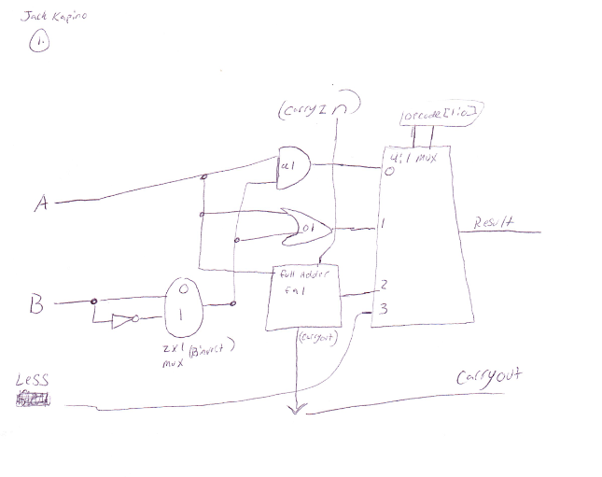

**Part 2: 1-Bit Alu Most Significant bit:**

**Description:** This circuit has inputs (a,b, less ). Outputs are result, overflow, set. This circuit is similar to part 1 but includes overflow detection and a fifth operation SLT “Set on Less than” is included in the multiplexer. If A<B slt results in a 1 otherwise value = 0.

**Diagram:**

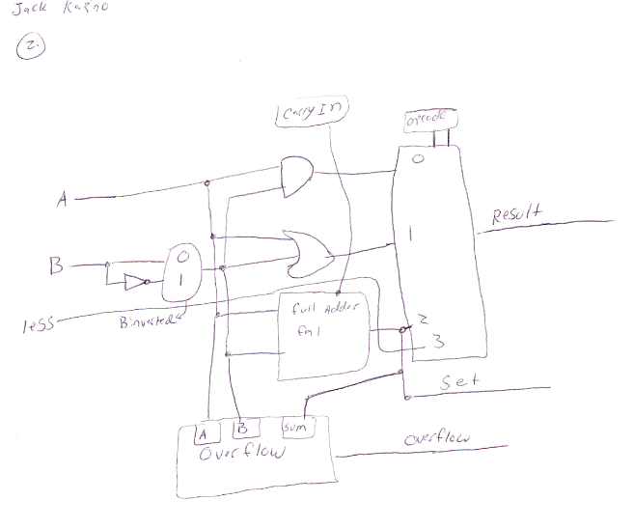

**Part 3: 4-bit alu:**

**Description:**

4 bit Alu inputs include A,B and an opcode to select the corresponding operation. The result output gives you the result of the selected 4:1 mux operation. Zero output gives 1 when arithmetic operation is zero, and gives 0 for non-zero results and logic operations. Overflow output determines if overflow has occurred. Overflow is detected when the sign of the operands doesn’t match that of the output. Overflow detection only for arithmetic operations can be accomplished by using an And Gate with the second bit of the opcode, which will always be 1 for an arithmetic operation.

4 bit Alu opcodes:

000 =And, 001 = or, 010 = Addition, 110 = Subtraction, 111 = SLT

**Diagram:**

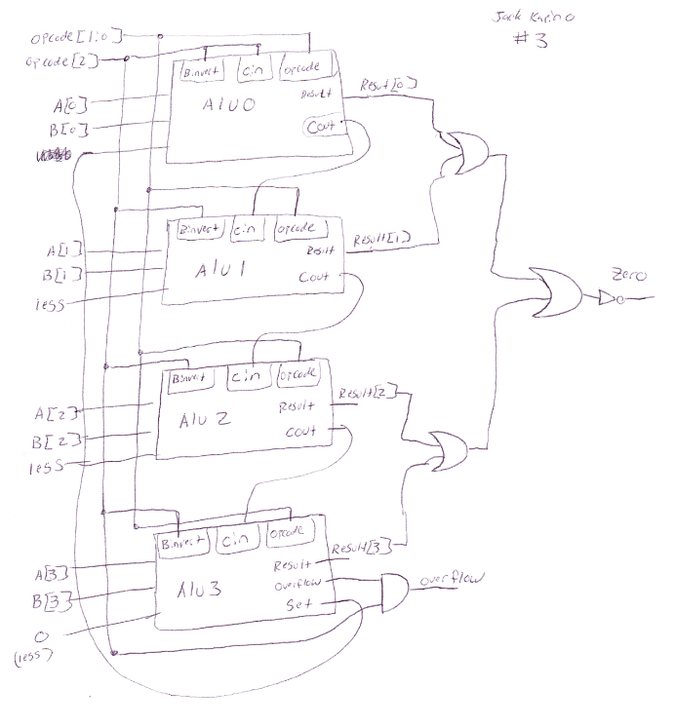

**Part 4: Test Module + Verilog Code:**

**Verilog Code:**

**//Half adder**

**module half_adder(x,y,S,C);**

**input x,y;**

**output S, C;**

**xor x1(S,x,y);**

**and a1(C,x,y);**

**endmodule**

**//Full adder**

**module full_adder(x,y,z,S,C);**

**input x,y,z;**

**output S, C;**

**half_adder ha1(x,y,u,v);**

**half_adder ha2(u,z,S,w);**

**or o1(C,v,w);**

**endmodule**

**//2:1 Mux**

**module two_oneMux(sel,op,out);**

**input sel;**

**input [1:0] op;**

**output out;**

**not n1(inverted, sel);**

**and a1(and1, op[0], inverted);**

**and a2(and2, op[1], sel);**

**or o1(out, and1, and2);**

**endmodule**

**//4:1 Mux**

**module muxFour_One(sel,operation,out);**

**input [1:0] sel;**

**input [3:0] operation;**

**output out;**

**two_oneMux muxOne(sel[0], {operation[0], operation[1]}, one);**

**two_oneMux muxTwo(sel[0], {operation[2], operation[3]}, two);**

**two_oneMux muxThree(sel[1], {one, two}, out);**

**endmodule**

**//Part 1**

**module One_Bit_Alu(a,b,cin,opcode,binvert,less,result,cout);**

**input a,b,cin;**

**input [1:0] opcode;**

**input binvert,less;**

**output result,cout;**

**not notb(bbar, b);**

**two_oneMux mux2_1(binvert, {bbar, b}, binverted);**

**muxFour_One mux(opcode, {and0, or1, sum2, less}, result);**

**full_adder fa1( a,binverted, cin, sum2, cout);**

**and a1( and0, a, binverted);**

**or o1( or1, a, binverted);**

**endmodule**

**module Overflow(a,b,total,overflow);**

**input a, b, total;**

**output overflow;**

**not n1(aprime, a);**

**not n2(bprime, b);**

**not n3(totalprime, total);**

**and a1(and1, aprime, bprime);**

**and a2(negative_sum, and1, total);**

**and a3(and2, a,b);**

**and a4(positive_sum, and2, totalprime);**

**or o1(overflow, negative_sum, positive_sum);**

**endmodule**

**//Part 2**

**module Msb_Alu(a,b,cin,opcode,binvert,less,set,result,overflow);**

**input a,b, cin;**

**input [1:0] opcode;**

**input binvert,less;**

**output set,result,overflow;**

**not n1(bbar, b);**

**two_oneMux inverter(binvert, {bbar, b}, binverted);**

**muxFour_One mux(opcode, {out1, out2, sum3, less}, result);**

**full_adder fa1(a, binverted, cin, sum3, cout);**

**or or_msb(out2, a, binverted);**

**and and_msb(out1, a, binverted);**

**not n2(outpt,sum3);**

**not n3(set,outpt);**

**Overflow over1(a, binverted, sum3, overflow);**

**endmodule**

**//Part 3**

**module Four_bitAlu(a,b,opcode,result,overflow,zero);**

**input [3:0] a,b;**

**input [2:0] opcode;**

**output [3:0] result;**

**output overflow,zero;**

**One_Bit_Alu alu0(a[0],b[0],opcode[2],opcode[1:0],opcode[2],set,result[0],carry1);**

**One_Bit_Alu alu1(a[1],b[1],carry1,opcode[1:0],opcode[2],1'b0,result[1],carry2);**

**One_Bit_Alu alu2(a[2],b[2],carry2,opcode[1:0],opcode[2],1'b0,result[2],carry3);**

**Msb_Alu alu3(a[3],b[3],carry3, opcode[1:0],opcode[2], 1'b0 , set, result[3], overflow_out);**

**and a1(overflow, overflow_out, opcode[1]);**

**or o1(left, result[0], result[1]);**

**or o2(right, result[2], result[3]);**

**or o3(notzero, left, right);**

**not n1(zero, notzero);**

**endmodule**

**//Part 4 Testing ALu and output**

**module test_Alu;**

**reg signed [3:0] a,b;**

**reg [2:0] opcode;**

**wire signed [3:0] result;**

**wire overflow,zero;**

**Four_bitAlu fba1( a, b,opcode, result, overflow, zero);**

**initial**

**begin**

**$display(" Opcode A B Result Overflow Zero ");**

**$monitor(" %b %d %b %d %b %d %b %d %d", opcode, a, a, b, b, result, result, overflow, zero);**

**opcode = 0; a = 1; b = 2;**

**#10; opcode = 0; a = -3; b = 7;**

**#10; opcode = 0; a = -1; b = 3;**

**#10; opcode = 1; a = 2; b = 5;**

**#10; opcode = 1; a = -1; b = -1;**

**#10; opcode = 1; a = -4; b = 3;**

**#10; opcode = 2; a = 2; b = 1;**

**#10; opcode = 2; a = 5; b = 5;**

**#10; opcode = 2; a = 4; b = 4;**

**#10; opcode = 2; a = 7; b = -7;**

**#10; opcode = 6; a = 6; b = 2;**

**#10; opcode = 6; a = 5; b = 7;**

**#10; opcode = 6; a = -2; b = -2;**

**#10; opcode = 6; a = -3; b = 3;**

**#10; opcode = 6; a = 1; b = -1;**

**#10; opcode = 7; a = 2; b = 3;**

**#10; opcode = 7; a = 3; b = 2;**

**#10; opcode = 7; a = 1; b = 2;**

**//#10; opcode = 7; a = 1; b = 9;**

**#10; opcode = 7; a = -2; b =5;**

**end**

**endmodule**

**Program output:**

