**Create a dockerfile, docker-compose file which when executed must display your basic details in the website.**

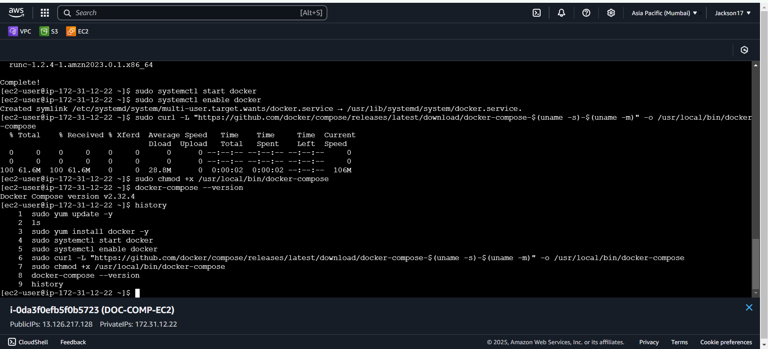

**Creating app.py**

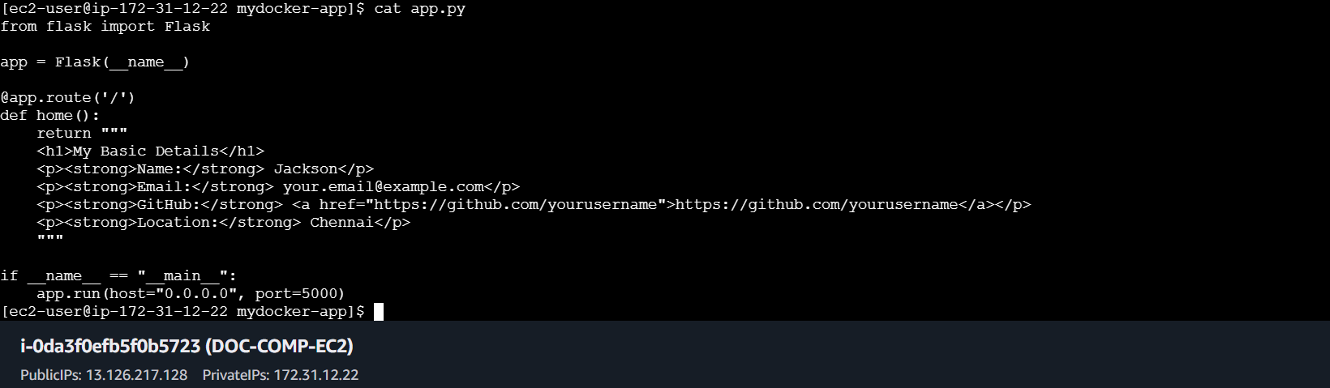

**Creating dockerfile**

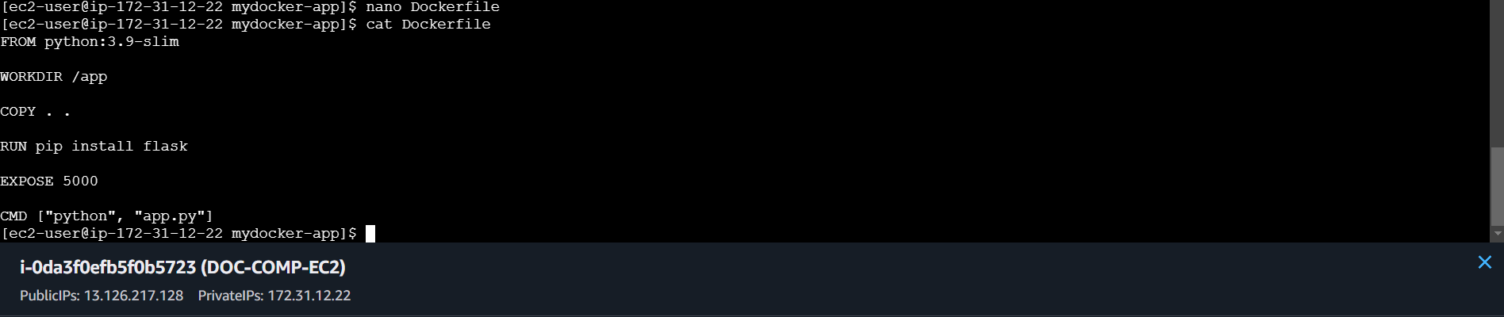

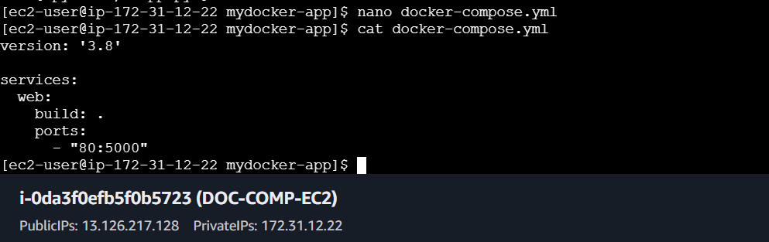

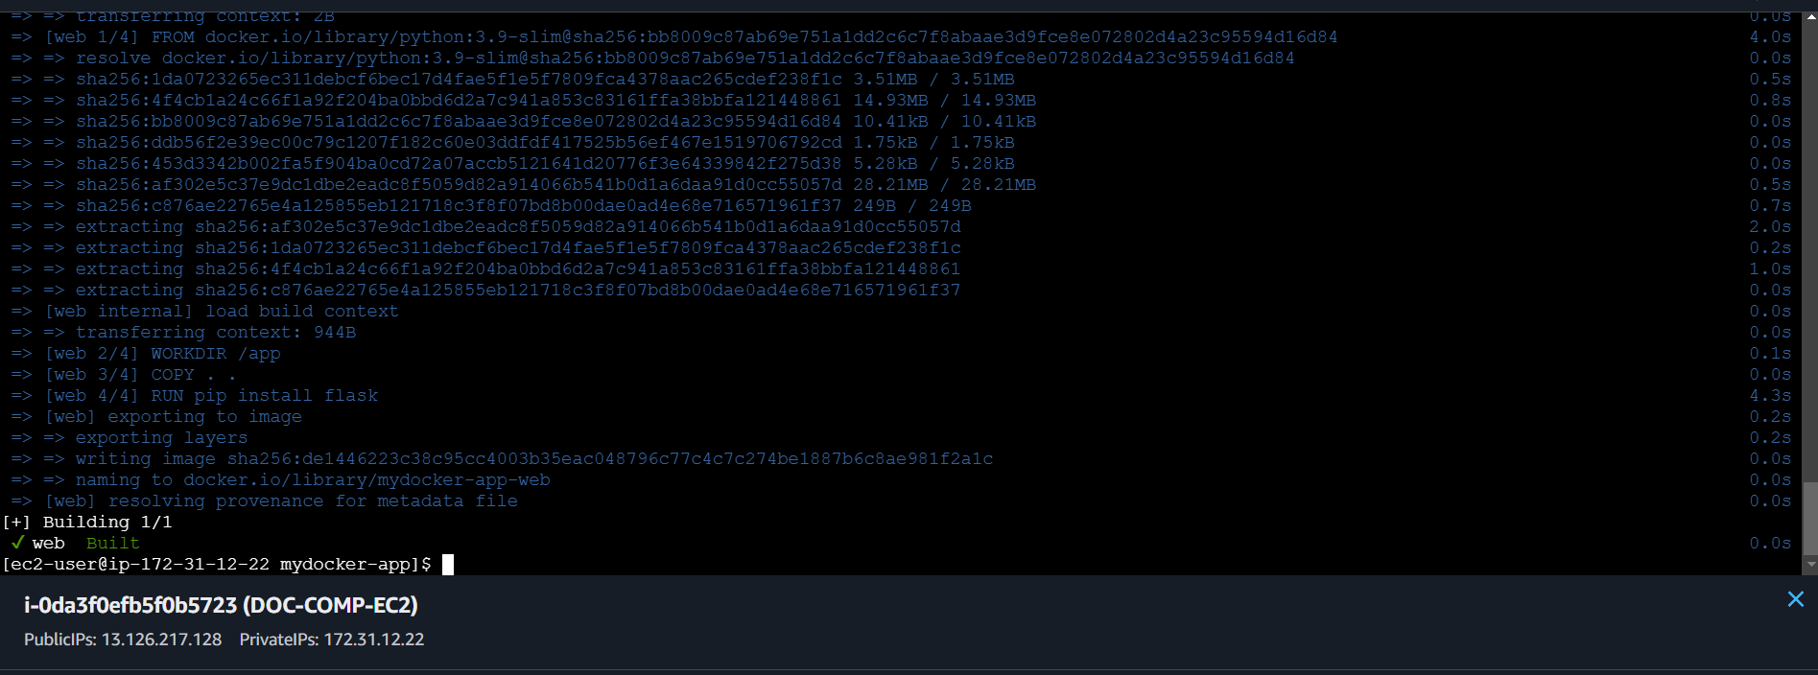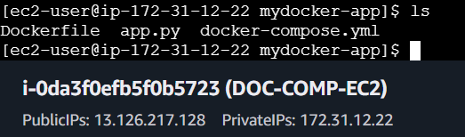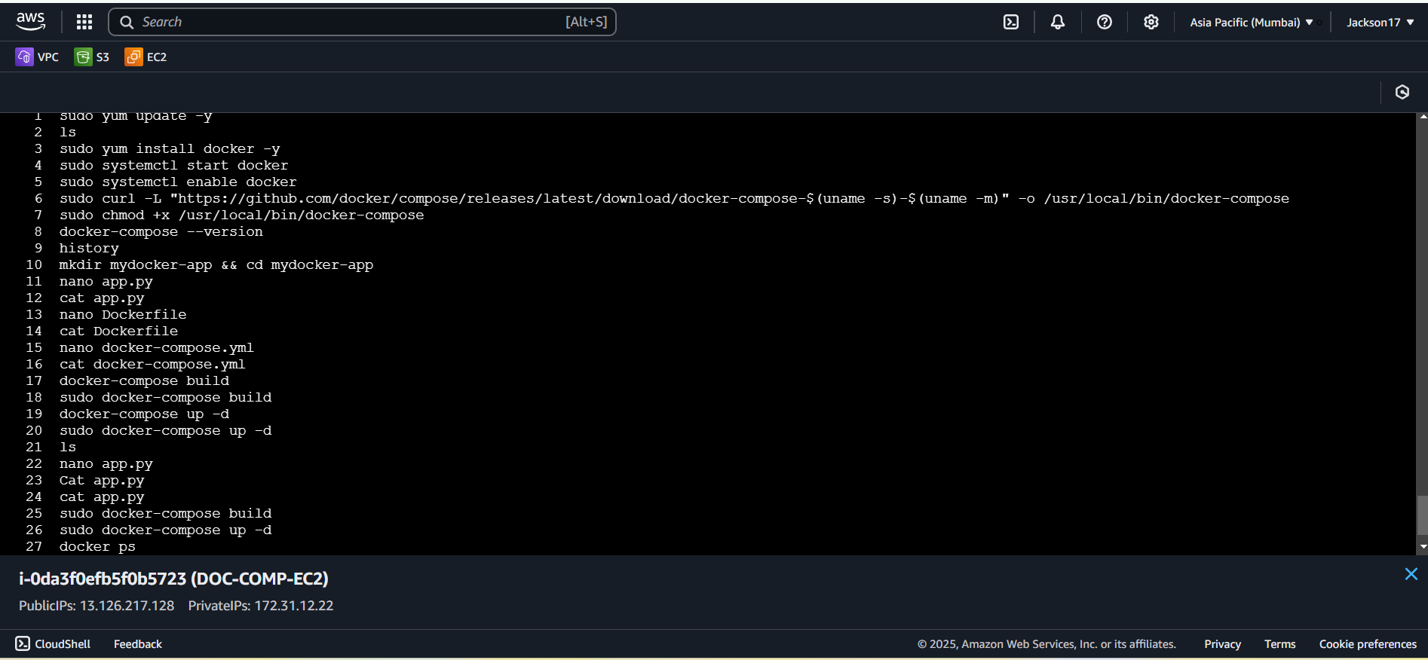

**Output:**

