**MZUMBE UNIVERSITY**



**FACULTY OF SCIENCE AND TECHNOLOGY**

**(FST)**

**DEPARTMENT OF COMPUTING SCIENCE STUDIES**

**A PROJECT REPORT**

**ON**

**A WEB BASED APPLICATION FOR NETWROK MONITORING AND MANAGEMENT AT MZUMBE UNIVERSITY**

**BY**

**RASHIDI MANENO KILAZA**

**14323028/T.21**

**PROGRAMME: BSc ICTB 3**

**(BACHELOR OF SCIENCE IN INFORMATION AND COMMUNICATION TECHNOLOGY WITH BUSINESS)**

**SUPERVISED BY**

**DR. MERCY KOMBA**

**A Project Report submitted to Department of Computing Science Studies in Partial Fulfillment of the Requirements for the award of Bachelor Degree of Science in Information and Communication Technology with Business (Bsc ICTB) at Mzumbe University 2024**

# CERTIFICATION

We, the undersigned, certify that we have read and hereby recommend for acceptance by the Mzumbe University, a project report entitled “A WEB BASED APPLICATION FOR NETWORK MONITORING AND MANAGEMENT AT MZUMBE UNIVERSITY” in a partial fulfilment of the requirements for awards of the degree of Bachelor of Science in Information Communication Technology with Business (BSc. ICTB).

Major Supervisor Name: …………………………………………………………

Major Supervisor Signature Date

__________________________ ____________________________

Internal Examiner Name: ………………………………………………………………

Internal Examiner Signature Date

__________________________ ____________________________

Accepted for the Board of the Faculty of Science and Technology

_____________________________________________________

DEAN, FACULTY OF SCIENCE & TECHNOLOGY

# DECLARATION

I am RASHIDI MANENO KILAZA, with registration number 14323028/T.21 hereby declare that the work contained in the project report for my final year project, entitled: “A WEB BASED APPLICATION FOR NETWORK MONITORING AND MANAGEMENT AT MZUMBE UNIVERSITY”, is my own original work and has never been submitted to any university or higher learning institutions for any academic rewards where other people work has been used.

Signature: _____________________________ Date: ____________________

# 

# ACKNOWLEDGEMENT

First I would like to express my deep gratitude and thanks to almighty God for keeping me Healthy throughout the entire project duration.

I would like to express my sincere gratitude to my supervisor DR. MERCY KOMBA, for her invaluable guidance, support, and encouragement throughout the completion of this project. Dr. Mercy's expertise, mentorship, and constructive feedback have been a success instrumental in shaping the direction and positive outcomes of this research endeavor.

I am truthfully grateful for her dedication and assistance, which have significantly contributed to the success of this project.

# TABLE OF CONTENT

**CERTIFICATION ii**

**DECLARATION iii**

**ACKNOWLEDGEMENT iv**

**TABLE OF CONTENT v**

**LIST OF ABBREVIATIONS: viii**

**ABSTRACT ix**

**CHAPTER ONE 1**

**INTRODUCTION AND PROBLEM DESCRIPTION 1**

BACKGROUND OF THE PROJECT: 1

1.2. PROBLEM STATEMENT: 2

PROJECT OBJECTIVES: 2

1.3.1. GENERAL OBJECTIVE OF THE PROJECT: 2

1.3.2. SPECIFIC OBJECTIVES OF THE PROJECT: 2

SIGNIFICANCE AND SCOPE OF THE PROJECT: 2

1.3.1. SIGNIFICANCE OF THE PROJECT 2

SCOPE OF THE PROJECT 3

CHAPTER TWO 3

LITERATURE REVIEW 4

2.1. Introduction 4

2.2. Overview of Network Monitoring 4

2.3. Web-Based Network Monitoring and Management Tools 4

2.4. Advantages of Web-based Network Monitoring and Management 5

CHAPTER THREE 6

REQUIREMENTS ELICITATION AND SYSTEM ANALYSIS 6

3.1. Introduction to Requirement Elicitation 6

3.2. Requirements Elicitation and Classification 6

3.2.1. Functional Requirements of the system 7

3.2.2. Non-Functional Requirements 8

3.2.3. METHODOLOGY AND TECHNOLOGY OF SYSTEM IMPLEMENTATION 8

3.2.4. Use Case 9

CHAPTER FOUR: 11

SYSTEM DESIGN 11

4.1. Introduction to System Design 11

4.2. Types of System Design 11

4.2.1 Logical System Design 11

4.2.2 Physical System Design 12

4.2.3 Architectural System Design 12

4.3.1. Methodology review for a Web-based Application for Network Monitoring and Management at Mzumbe University: 12

4.3.2 Dynamic Systems Development Method model 12

4.3.3 System Technologies 13

4.4. Database Design 13

4.4.1. Conceptual Database design 14

4.3.2. Logical Database design 14

4.3.3 Physical Database design 14

4.4 User interface design 15

4.5 Summary 15

CHAPTER FIVE: 16

SYSTEM IMPLEMENTATION 16

5.1. Introduction 16

5.2 Functionalities Implementation 16

5.3. Database Implementation 19

5.4. User Interface Implementation 19

Figure 9. User Login Page 20

Figure 10. User Interface 20

5.5. System Testing and Evaluation 21

CHAPTER SIX 23

CONCLUSION AND RECOMMENDATION 23

6.1. Introduction 23

6.2. Summary 23

6.3. Conclusion 24

6.4. Recommendations 24

REFERENCES 25

# LIST 0F FIGURE

Figure 2 : Database design for Network Monitoring System 21

Figure 3. Network Administrator Page 24

Figure 4. Network Admin report generation site 25

Figure 5. Network Admin Page for Alert mechanisms 25

Figure 6. Network Admin site for Device Status Information and Control 25

Figure 7. User Access Page 26

Figure 8. Database Implementation 27

# LIST OF ABBREVIATIONS:

PRTG Paessler Router Traffic Grapher

FQDN Fully Qualified Domain Name

TAP Test Access Point

SNMP Simple Network Management Protocol

XSS Cross-site Scripting

SQL Structured Query Language

# ABSTRACT

In response to the growing complexity and importance of network infrastructure at Mzumbe University, this project proposes the development of a web based application for network monitoring and management tailored to the university’s specific requirements. The application aims to provide administrators with a comprehensive and a user-friendly platform to monitor, manage and optimize the university’s network infrastructure effectively.

The key features of the proposed web-based application include, Real-time monitoring dashboard, automated alerting and notification system, device inventory and configuration management, historical performance analysis, Role-based Access control.

The proposed web based application seeks to empower administrators with the tools and insights needed to maintain a resilience in network infrastructure that supports the university’s academic and administrative activities effectively, proactive alerting and centralized management capabilities, the application aims to enhance the overall performance and reliability of the university’s network environment.

CHAPTER ONE

# INTRODUCTION AND PROBLEM DESCRIPTION

**TITLE OF THE PROJECT:** A WEB-BASED APPLICATION FOR NETWORK MONITORING AND MANAGEMENT AT MZUMBE UNIVERSITY

# BACKGROUND OF THE PROJECT:

Network Monitoring is the term used to describe the process of detecting and reporting the failures occurring via network. These failures can be either caused by devices in network or connection issues. Despite the troubleshooting property to most of network facilities such as servers and other hardware devices, then there is also a need to have a web-based application which will facilitate efficient evaluation of the hardware devices status via network.

According to Adekunle Matthew, Hasan Khan and Neelam Abdullah, managing network is a very big functional area along with performance, monitoring, device maintenance and plan of change. It explains how difficult it is in monitoring network hardware devices with no assistance of any monitoring tool. Also in this book there is no clear description on how network packets forwarded from their source to destination can be tracked so as to measure the network bandwidth instead it explains about the existence of a network monitoring tool called PRTG which can aid in critical system downtime by providing early notification of outages, so network administrator can’t wait for users to complain for network failure.

Similarly to Daniel Hein, who explained about how network can be monitored in large institutions or organization. But in this paper it describes the way network can be monitored but in Nagios. In this paper it only describes how network can be monitored through a web based software called Nagios which can be easily accessed from browser using Fully Qualified Domain Name (FQDN) by visiting the web page at <http://FDQN/nagios3>. But one among the weakness or deficiency of this website is that it lacks the site responsible for displaying the packets forwarded from the source to destination visa network.

From these two publications when relating them, we can recognize that network was not efficiently monitored through an easily accessible web – based application but also the publications do not justify how the bandwidth was maximized and tracked via the system when packets are forwarded from their source to destination.

It has been a custom that most of the network signals are transmitted via network copper wire but through this transmission means there are some of the demerits which can into rise and cause several network irregularities like inefficient network packets transmission. Most of the higher learning institutions (A case study in Mzumbe University) nowadays do use advanced means of network packets transmission which is the use of fiber cable in network signals transmission. This is more efficient since it may bring about small or no packet loss via network when the network packets are transmitted from their source to destination. But still there is some inefficiency in packet transmission leading to poor network connectivity.

# 1.2. PROBLEM STATEMENT:

At Mzumbe University, the popular means of network communication is the use of wired and wireless networks. Whereby in both networks becomes difficulty in identifying security breaches or attacks in a simplified technological manner during their occurrence, therefore leading to easy systems attacks with external adversaries and also delays in network communication. This also slows down the capabilities of the students and other University staffs in easy access of several academic resources through university’s online portals. Therefore, there is a need of efficient network monitoring and management at Mzumbe University.

1.3 **PROJECT OBJECTIVES:**

1.3.1. GENERAL OBJECTIVE OF THE PROJECT:

To develop and implement a web-based application for network monitoring and management at Mzumbe University which is aimed at enhancing reliability, security and efficiency of the university’s network infrastructure.

# 1.3.2. SPECIFIC OBJECTIVES OF THE PROJECT:

* To design a simplified user interface for favoring the clients who will be directly linked to the system, this may enable users or clients in interacting with the system.
* To improve network performance by decreasing the average network response time.
* To enhance security by ensuring that the web-based application identifies and alerts the system administrator of any potential security breaches within its occurrence.
* To develop an administrators management system which will be mostly used by the system administrator for troubleshooting purposes and network status checkup.

1.3.3 **SIGNIFICANCE AND SCOPE OF THE PROJECT:**

* + 1. SIGNIFICANCE OF THE PROJECT;

The significance of this project is in its functioning to favor efficient network connection and notification of any security breach through alerts linked to the system. And also ensuring there is the prevention of excess packet loss during packet transmission together with monitoring and controlling of the network status in the server. Also, may aid improving network performance so as to allow several users linked within the network to communicate easily and exchange several network resources such as files and others.

# SCOPE OF THE PROJECT

I have decided to conduct this project so as to simplify the connectivity and other network operations and assist in efficient network performance. Also, this application which will be developed or designed will also favor fiber optics implementation to facilitate efficient routing of network packets from their source to destination. And also, will aid in provision of knowledge on how fiber optic can be implemented through wireless network connection. And then the server status will be maintained thoroughly as the users or clients do access internet service from it.

Also, this project will involve user login site, security and monitoring site where the administrator can undertake all of the troubleshooting tasks so as to control and maintain the network status. Then some of the product deliverables such as the instructions for using the application, user requests features and project benefit measurement plan.

My goal is to make sure that there is an easy access of wireless network with no irregularities or deficiencies and also to make sure that the project becomes a source of earning if it will be sold outside Mzumbe University Main Campus. To meet this financial goal, the system must have strong user inputs. Also, there must be benefits capturing system from which all of the earnings can be recognized in such a system. Then if this project takes a little longer to complete or cost a little more than planned, then it will be beneficiary and if it has a good payback, then it will help in promoting a good view or image of Mzumbe University as an excellent consulting higher learning institution.

CHAPTER TWO**:**

# LITERATURE REVIEW

# 2.1. Introduction

Literature review is an essential component of this project, acting as an essential exploration of existing knowledge and studies related to network monitoring and management.

This chapter derives into relevant literature, examining key themes, methodologies and findings. It not only building the foundation for the current or existing project but also identifies the gaps and areas where the innovations and improvements are guaranteed. It normally involves systematic and critical review on scholarly work or publication so as to discover knowledge and generate ideas.

This project addresses the increasing importance of robust network oversight in contemporary technological landscapes. The literature review highlights the evolution of network monitoring tools, emphasizing the shift toward web-based applications for their accessibility and scalability.

# 2.2. Overview of Network Monitoring

Historically, network monitoring involved standalone tools with limited capabilities. As networks because more complex, the demand for centralized and user-friendly solutions grew. Web-based applications emerged as a solution, providing real-time monitoring, intuitive interfaces, and remote accessibility. This trend aligns with the paradigm shift towards cloud computing and the need for efficient management of distributed systems.

Research indicates that effective network management is crucial for optimizing performance, identifying potential issues, and ensuring security. Web-based applications offer advantages such as cross-platform compatibility and ease of deployment to their widespread adoption.

Network monitoring involves the continuous surveillance of network components to identify and address issues such as downtown, congestion and security breaches. Network management encompasses the activities involved in configuring, maintaining and optimizing network resources to ensure optimal performance and reliability. Traditional network monitoring and management systems have relied on proprietary software installed on local servers or dedicated hardware appliances. However, the advent of web-based applications has revolutionized the way organizations approach network monitoring and management.

# 2.3. Web-Based Network Monitoring and Management Tools

Several web-based applications have been developed to provide comprehensive solutions for network monitoring and management. One prominent example is Nagios, anopen-source monitoring tool that offers a web-based interface for monitoring network services, host resources and system metrics. Nagios allows administrators to set up alerts, notifications and automated responses to network events, enhancing proactive management and troubleshooting capabilities.

Another notable example is Zabbix, a web-based network monitoring solution that provides real-time monitoring, alerting and visualization features. Zabbix supports a wide range of network devices and protocols, allowing administrators to monitor network performance and identify potential issues before they escalate. The web-based interface of Zabbix enables remote access and management, facilitating centralized control of distributed network infrastructure.

# 2.4. Advantages of Web-based Network Monitoring and Management

Web-based applications offer several advantages over traditional network monitoring and management systems. Firstly, web-based interfaces provide accessibility from any location with an internet connection, enabling administrators to monitor and manage networks remotely. This is particularly beneficial for organizations with geographically dispersed network assets or remote office locations.

Secondly, web-based applications typically offer scalability and flexibility allowing organizations to adapt their monitoring and management systems to evolving network requirements. With web-based tools, administrators can easily add new devices, sensors and monitoring parameters without the need for extensive hardware upgrades or software installations.

Finally, web-based applications often feature intuitive user interfaces and customizable dashboards, making it easier for administrators to visualize network performance metrics and interpret monitoring data effectively. This enhances decision-making and enables proactive network management strategies to improve overall network reliability and performance.

In conclusion, the literature reviewed highlights the importance of web-based applications in network monitoring and management. By leveraging the capabilities of web technologies, organizations can achieve greater flexibility, accessibility and scalability in monitoring and managing their network infrastructures. Moving forward, further research and development in this area will continue to drive innovation and advancement in network monitoring and management practices, ultimately enhancing the resilience and efficiency of modern network environments.

CHAPTER THREE**:**

# REQUIREMENTS ELICITATION AND SYSTEM ANALYSIS

# 3.1. Introduction to Requirement Elicitation

Requirement elicitation is the process of seeking, uncovering, acquiring and elaborating requirements for the system. It’s generally understood that requirements are elicited rather than just captured or collected. It is a complex process involving many activities with a variety of available techniques, approaches and tools for performing them. They are mostly collected from users, customers and other stakeholders of the system (Sommerville, I 2010).

In today’s interconnected world, the efficient management and monitoring of networks are crucial for the smooth operation of businesses and organizations. As such, the development of a web-based application for network monitoring and management presents an opportunity to streamline these processes, enhance security and optimize network performance. This outlines the requirements elicitation and system analysis for such an application.

# 3.2. Requirements Elicitation and Classification

Requirements Elicitation is a crucial phase in the development process, where the needs and expectations of stakeholders are gathered and analyzed to define the scope of the project. For a web-based application for network monitoring and management, the following stakeholders and their requirements need to be considered;

i) End Users: These are individuals responsible for overseeing network operations and troubleshooting issues. Their requirements may include:

* User-friendly interface for real-time monitoring of network traffic, devices and performance metrics.
* Customizable dashboards and reports to visualize data according to specific needs.
* Alerts and notifications for critical events or anomalies detected in the network.
* Ability to remotely access and manage network devices securely.

ii) Network Administrators: These professionals are tasked with configuring and maintaining network infrastructure. Their requirements may include:

* Centralized management console for configuring network devices such as routers, switches and firewalls.
* Automated provisioning and deployment of network resources.
* Integration with existing network management tools and protocols such as SNMP (Simple Network Management Protocol) and Syslog.

iii) Security Analyst: Given the increasing threat landscape, security is paramount in network management applications. Their requirements may include:

* Intrusion detection and prevention capabilities to identify and mitigate security breaches.
* Role-based access control to restrict privileges and ensure data confidentiality.
* Encryption of sensitive data transmitted over the network.

iv) Business Stakeholders: These individuals or groups may have overarching requirements related to budget, scalability and compliance:

* Cost-effective solution without compromising on functionality or security.
* Scalability to accommodate growth in network infrastructure and user base.

# 3.2.1. Functional Requirements of the system

These are requirements which define the important functions of the system or its components. The functional requirements of this system include;

1. Database

This will store user profiles securely including personal information, details of emergency events including location, timestamp and nature of the incident. Also implementing regular database backups to prevent data loss. But implementing a well-designed database system will play a vital role of ensuring the effectiveness and reliability of my application.

1. Real-Time Monitoring

The system should provide real-time monitoring of network traffic, device status and performance metrics such as bandwidth utilization, packet loss and latency.

1. Dashboard

The system should feature customizable dashboards that allow users to view key metrics and data visualizations relevant to their specific needs and responsibilities.

1. Configuration Management

Network administrators should be able to configure and manage network devices (e.g. routers, switches, firewalls) through the system, including device provisioning, firmware updates and policy enforcement.

1. Security Management

The system should offer features for managing network security, including user authentication, access control, encryption and integration with security information and event management systems.

# 3.2.2. Non-Functional Requirements

These are the services offered by the system. The following are non-functional requirements for my system;

1. Performance

The system should be highly responsive and capable of handling large volumes of data without significant latency, even during peak usage periods.

1. Scalability

The system should be designed to scale horizontally to accommodate increase in data volume, user traffic and network complexity without sacrificing performance or functionality.

1. Reliability

The system should be highly reliable, with minimal downtime or service interruptions to ensure continuous monitoring and management of the network.

1. Security

Data transmitted between the system and network devices should be encrypted to ensure confidentiality and integrity. The system itself should be protected against common security threats such as SQL injection and cross-site scripting (XSS).

1. Usability

The user interface should be intuitive and user-friendly with features such as drag-and-drop customization, contextual help, and responsive design for use on various devices and screen sizes.

1. Compliance

The system should comply with relevant industry standards and regulations governing network security and data privacy, such as GDPR, HIPAA and PCI DSS.

1. Interoperability

The system should be compatible with a wide range of browsers, operating systems and network devices to ensure interoperability and ease of deployment in heterogeneous environment.

3.2.3. METHODOLOGY AND TECHNOLOGY OF SYSTEM IMPLEMENTATION**:**

Methodology to be used in development of this project is waterfall model which involves requirements analysis, system design, implementation, testing, deployment and maintenance. It’s sequential and linear in nature with which each stage building upon the results of the previous stage.

Technology to be used is Java for performing complex network operations, PHP for data manipulation on the server side processing, HTML (HyperText Markup Language) for user interface development.

# 3.2.4. Use Case

Is a description of the steps taken by an actor (user or system) to accomplish a specific goal within a system (as defined by Osterwalder and Pigneur, 2018) (p 138). In software engineering and system design, use cases are frequently employed to recognize and comprehend the interaction between users and the system. In this project, the use case assists in defining the features and needs of the system by assisting in the identification and documentation of the interactions between actors (users and the system). It also aids in making sure the system satisfies the requirements and expectations of the end users. Use cases are used to represent the functionalities of the system from the user’s perspective, defining how the system will respond.

Creation of a use case diagram typically involves identifying actors (users or external systems) and use cases (specific functionalities or actions). After identifying the actors, we categorize them according to the expected functions or the user needs from the system. Some of the functions require the users to login into the system, and for the user to login must be in the system and the information must be stored in the database of the system.

A use case diagram typically includes the following elements;

* **Actors;** Represented by stick figures, these are the external entities that interact with the system.
* **Use cases;** Represented by oval shapes, these are the specific actions or tasks that the system can perform for the actors.
* **Association;** Represented by lines connecting actors and use cases, these indicate the relationships between actors the use cases they are associated with.

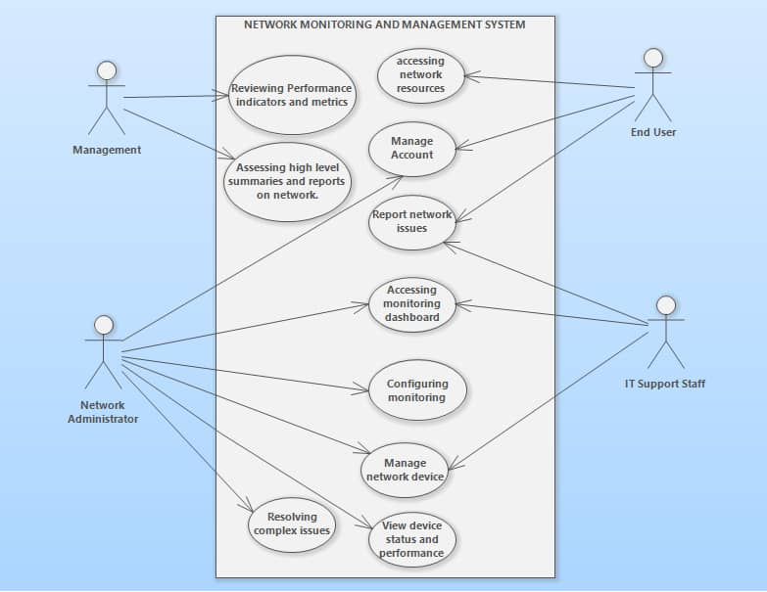

# CHAPTER FOUR:

# SYSTEM DESIGN

# 4.1. Introduction to System Design

System design is the process of defining the elements of a system such as the architecture, modules and components, the different interfaces of those components and the data that goes through that system. It is meant to satisfy specific needs and requirements of a business or organization through the engineering of a coherent and well-running system. Also, System design is the process of describing the components, modules, interfaces, and data for a system to accomplish specified requirements. Once the requirements have been analyzed then it is necessary to identify in details how an application will be constructed to perform a specified task. System design also, is focused on what information will be processed in the developed applications and how will the application be constructed? How the system will look like. All of these questions are defined within this phase of system design. In system design, developer may use unified modeling languages to show how the users (actors) will interact with the application or system.

# 4.2. Types of System Design

# 4.2.1 Logical System Design

Logical design pertains to an abstract representation of the data flow, inputs, and outputs of the system. It describes the inputs (sources), outputs (destinations), databases (data stores), procedures (data flows) all in a format that meets the user requirements. While preparing the logical design of a system, the system analyst specifies the user needs at level of detail that virtually determines the information flow into and out of the system and the required data sources. Data flow diagram, E-R diagram modeling are used.

# 4.2.2 Physical System Design

Physical design relates to the actual input and output processes of the system. It focuses on how data is entered into a system, verified, processed, and displayed as output. It produces the working system by defining the design specification that specifies exactly what the candidate system does. It is concerned with user interface design, process design, and data design.

# 4.2.3 Architectural System Design

It is also known as high level design that focuses on the design of system architecture. It describes the structure and behavior of the system. It defines the structure and relationship between various modules of system development process.

# 4.3.1. Methodology review for a Web-based Application for Network Monitoring and Management at Mzumbe University:

During the design of system and its implementation there are several challenges which I have encountered, one among the challenges I had faced is the need of specifying the methodological approach to be used in designing and implementation. System design methodology is among the ways of managing system development project which typically addresses issues like deciding which functionalities have to be implemented in a system, who works on, and what testing is done. This is mainly used in planning, designing and controls the overall process of developing the information system. The approach used in the design of a Web-based Application for Network Monitoring and Management at Mzumbe University is Agile Methodology**.**

# 4.3.2 Dynamic Systems Development Method model

DSDM is an agile software development methodology. It is an iterative, incremental approach that is largely based on the Rapid Application Development (RAD) methodology. The method provides a four-phase framework consisting of Feasibility and business study, Functional model / prototype iteration, Design and build iteration and Implementation.

Within each phase, DSDM relies on several different activities and techniques based on these principles. Projects evolve best through direct and co-located collaboration between the developers and the users. Self-managed and empowered teams must have the authority to make time sensitive and critical project-level decisions., Design and development is incremental and evolutionary in nature and is largely driven by regular and iterative user feedback. Working software deliverables are defined as systems that address the critical, current business needs versus systems that address less critical future needs. Frequent and incremental delivery of working software is valued over infrequent delivery of perfectly working software. All changes introduced during development must be reversible. Continuous integration and quality assurance testing is conducted in-line, throughout the project lifecycle. Visibility and transparency is encouraged through regular communication and collaboration amongst all project stakeholders.

# 4.3.3 System Technologies

The system is going to be implemented using PHP(laravel) as a programming language under the use of the following structure MYSQL Database server;

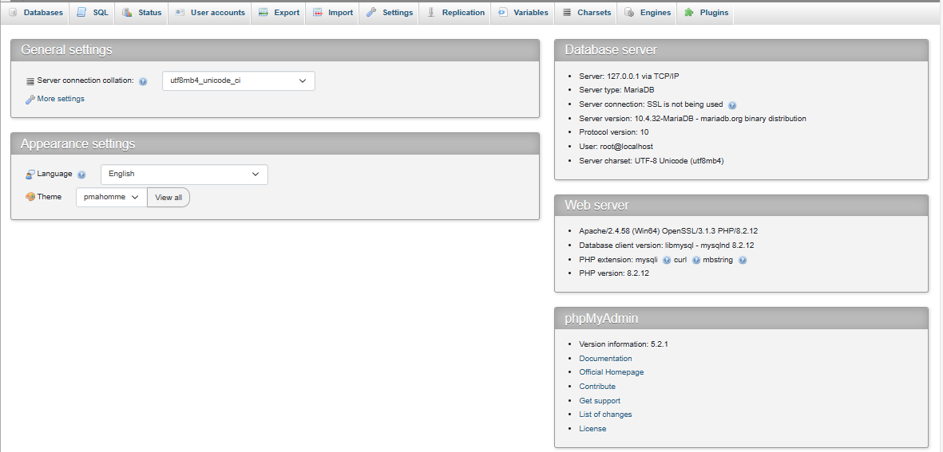

***Figure 1 : MYSQL Database Server for Network Monitoring System***

# 4.4. Database Design

A database is a collection of interrelated data stored with a minimum redundancy to serve the users quickly and effectively.

Database design is the collection and organization of processes that facilitate the designing, development, implementation, and maintenance of database management systems. Properly designed database is easy to maintain, improves data consistency and are cost effective in terms of disk storage space. in database design a designer decides how the data elements correlate. The following is the illustration of a database design;

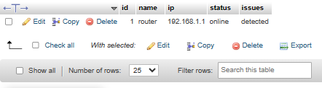

## Figure 2 : Database design for Network Monitoring System

# 4.4.1. Conceptual Database design

This is the organized view of database entity, attributes, and their relationships. The aim of having the conceptual model design is to establish entities, their attributes, and their relationships. Entity is a real word thing, attributes is a property of an entity, and relationship is dependency or association between two or more entities. A commonly used conceptual model is entity relationship mode (ER-model). The diagram entity relationship below shows the relationship between those entities and their attributes.

# 4.3.2. Logical Database design

In this design we define the structure of data elements and to set relationship between them. The logical models add further information to the conceptual model elements. The aim of logical is to provide basic for the physical model. In this design we just need to verify and adjust the connector details that were set earlier for relationships. The logical model focuses mostly on the data requirements and the data to be stored independent of physical considerations. It does not concern itself with how the data will be stored or where it will be stored physically.

# 4.3.3 Physical Database design

The design describes the specific implementation of the data model. It contains the relationships between tables, developed for DBMS, location, data storage. The column has exact data types, lengths assigned and default values, primary keys and foreign keys, views, indexes are defined in this design

# 4.4 User interface design

User interface design is the design of user interface for secondary school activities monitoring system the user interface is implemented by using, HTML where all system users (students, network admin, IT support staff, university management) have a single main menu which requires their login credentials (username, email and password) so as they can interact with the system.

# 4.5 Summary

This chapter explains system design which is very crucial for the system development and database design which is logical, physical and conceptual database design, interface design, and then followed by the choice of the best and favorable technology to handle the designing of this Web Based Application for Network Monitoring and Management. Apart from that also this chapter describes the types of system design which are Logical system design, Physical system design, User Interface Design and Architectural system design.

Also this chapter describes the system technologies including the language used and database server which is MYSQL Database Server.

# 

# CHAPTER FIVE:

# SYSTEM IMPLEMENTATION

# 5.1. Introduction

System implementation is the process of defining how the information system should be built, ensuring that the information system is operational and used, ensuring that the information system meets quality standard i.e., quality assurance (James Kyle, 2006). Implementation is a process of ensuring that the information system is operational. It generally involves mainly two parts Constructing a new system from scratch and constructing a new system from the existing one. Implementation allows the users to take over its operation for use and evaluation. It involves training the users to handle the system and plan for a smooth conversion.

All system maintenance, coding and testing activities are explained in details and also the user guide document has well been well designed so as to support the user of the system. Implementation is the carrying out, execution, or practice of a plan, a method, or any design, idea, model, specification, standard or policy for doing something. As such, implementation is the action that must follow any preliminary thinking in order for something to actually happen.

# 5.2 Functionalities Implementation

When you login in the system the below interface will appear which needs a user to register. Displays the login information such as username, email and password where the user has to enter so as to allow him or her to interact directly with the system. But if the User will not click the button after filling all of the required information, then won’t be able to interact with the entire system.

But after logging in the user will be taken directly to his or her page based on the roles granted to him or her. For instance if the user is an admin then will be taken to the admin page where he will be able to view and monitor several devices together with performing configurations. Then his page will be as follows;

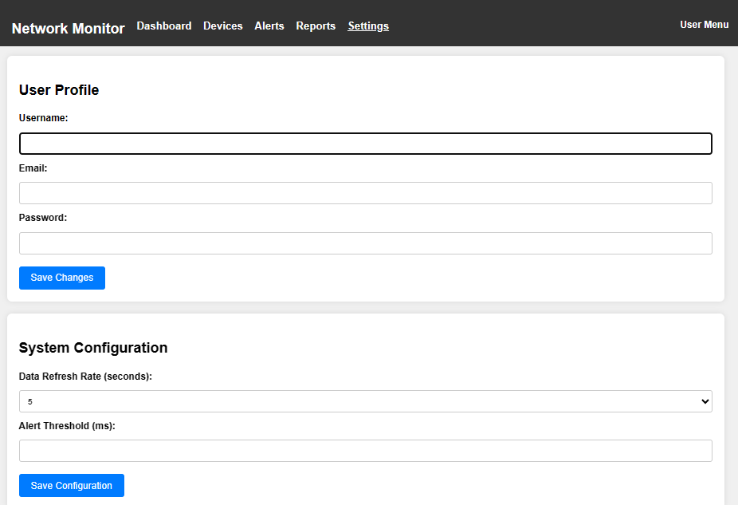

## Figure 3. Network Administrator Page



## Figure 4. Network Admin report generation site

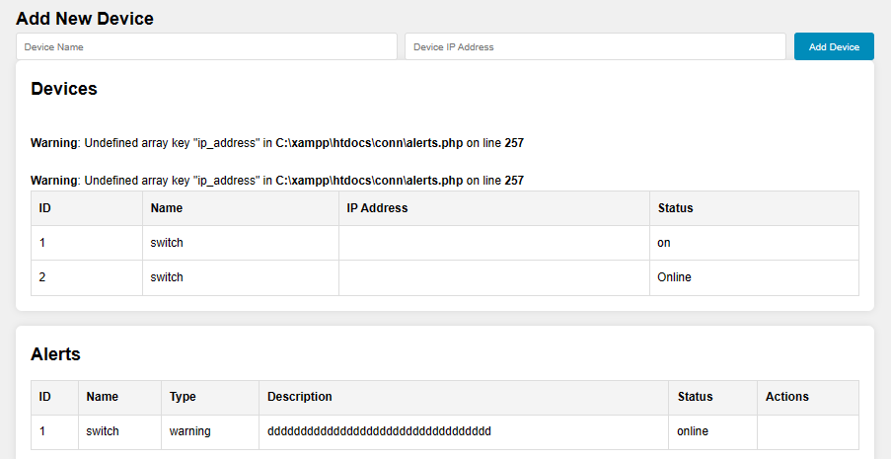

## Figure 5. Network Admin Page for Alert mechanisms

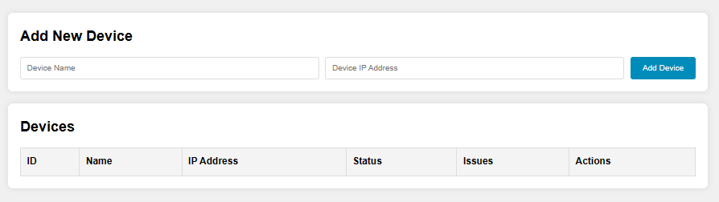

## Figure 6. Network Admin site for Device Status Information and Control

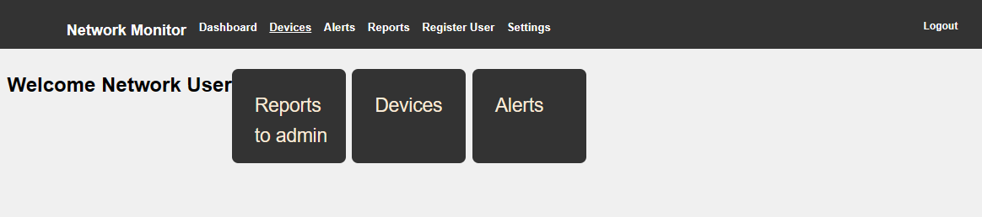

## Figure 7. User Access Page

# 5.3. Database Implementation

Involves several key steps to ensure that the database is well-designed, scalable and meets the needs of the client or user. Requires several steps such as Requirements Analysis, Database Design, Physical Design, Database Creation, Data Loading, Testing, Deployment, Maintenance and Monitoring, Documentation, Training and Support.

In this stage, the database is then accessed by the user of the application or the system rather than the application programming stored in database itself. The application has been implemented with MYSQL Database that used to manage all the data related to Network monitoring and management.

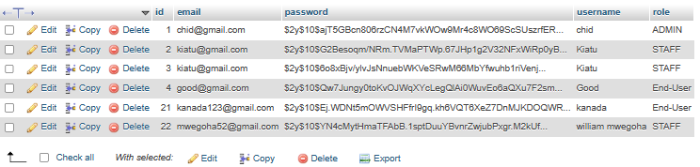

## ***Figure 8. Database Implementation***

# 5.4. User Interface Implementation

Implementation of the user interface is the practice of producing an interface by using web technologies so as a user can see the resources with an abstraction from the sophisticated components of the system. It is the part of the information system that is directly accessed and interacted by the user of the system. The user interface has been implemented using HTML (Hyper Text Markup Language).

***Home page***

This is where a user sees first after accessing the application or the system.

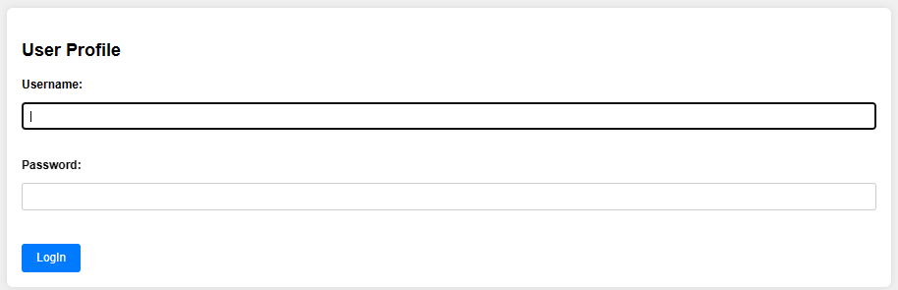

## Figure 9. User Login Page



## Figure 10. User Interface

# 5.5. System Testing and Evaluation

System testing is a process of evaluating the system’s compliance with the specified requirements. It verifies the system to be delivered, meets the specification and its purpose by investigating both functional and non-functional requirements. A WEB BASED APPLICATION FOR NETWORK MONITORING AND MANAGEMENT AT MZUMBE UNIVERSITY has been tested under the following categories;

* **Preliminary Test (Unit testing)**

Refers to the technique by which individual units are tested to determine if it fits for use. It is basically written and executed by a system developer to make sure that the code meets its design perspective. This includes testing every unit piece of code during programming process where each piece of code was tested before moving forward. And in this application all codes are tested and seems to meet its design perspective.

* **Test Plan**

The test plan is basically the way the final product is being tested and how it responds. I tested the application in a way that all input/output are pushed to the application and wait for the response.

* **Test Cases**

The case through testing my Web Based Application for Network Monitoring and Management is that, I have tested my application to different servers so as to detect the weaknesses or flaws but the only weakness I have recognized after this kind of test is the threshold level being varying with time.

* **Integration Testing**

It is the process whereby integration between component and interaction of different part of the application are tested to verify its compatibility. The purpose of integration testing in my WEB BASED APPLICATION FOR NETWORK MONITORING AND MANAGEMENT AT MZUMBE UNIVERSITY is to verify proactive issue detection, security, device status and remote accessibility. Basically, integration testing is done after Unit testing and before validation testing.

* **Validation Testing**

Validation testing is done towards the end of the development process and it is performed so as to see whether the system meets user requirements or expectations. It is used to determine if the system complies the requirement and perform the function as it is intended to meet user needs. After Validation the process which follows is verification where occurs when the system meets the user expectations or requirements.

CHAPTER SIX**:**

# CONCLUSION AND RECOMMENDATION

# 6.1. Introduction

This chapter describes the summary of a WEB-BASED APPLICATION FOR NETWORK MONITORING AND MANAGEMENT AT MZUMBE UNIVERSITY in brief, where it explains the project summary, conclusion with regard of its recommendations. The WEB-BASED APPLICATION FOR NETWORK MONITORING AND MANAGEMENT AT MZUMBE UNIVERSITY is an innovative project aimed at enhancing the resilience of Mzumbe University’s network infrastructure. The project eliminates the need or demand for physical means for monitoring or troubleshooting of the network faults instead they are being monitored and managed using a web-based application with specified Access Control to its stakeholders where the Administrator is the only one responsible for monitoring activities within the system.

# 6.2. Summary

A WEB-BASED-APPLICATION FOR NETWORK MONITORING AND MANAGEMENT AT MZUMBE UNIVERSITY offers a user-friendly and efficient method for monitoring necessary network performance metrics such as bandwidth. By the use of Network Admin Page, we can see the monitoring activities of the system or application. The system retrieves the data from a centralized database and delivers it to its users including students in a clear and concise format. The implementation of this project has several advantages, including proactive issue detection, enhanced security, efficient resource management and device status control. Additionally, the monitoring system ensures data privacy and by implementing appropriate authentication mechanisms together with allowing remote accessibility.

The project involves the development of a secure user registration page, where users can interact directly with the system logging in to have a direct access to the entire system and perform actions that are entitled with. It requires collaboration among several network hardware devices, efficient configuration settings and also report generation mechanisms so as to ensure accurate and timely result retrieval from the centralized database. By leveraging existing network monitoring system, the project aims to reach a wide range of its stakeholders or users, including those in remote areas who may have limited access to internet services.

This Network monitoring system provides several advantages, including instant real-time monitoring, proactive issue detection, enhanced security, enhanced resource management and device status control. Moreover, the system can be easily scaled and used across different regions, enabling its users to benefit from it effectively.

# 6.3. Conclusion

In summary, the WEB-BASED APPLICATION FOR NETWORK MONITORING AND MANAGEMENT AT MZUMBE UNIVERSITY project has the potential to greatly improve the process of Proactive issue detection for ensuring efficient troubleshoot and checking of the network devices status so as to improve the resilience of the university’s network infrastructure. The convenience, accessibility, and cost-effectiveness of this network monitoring system makes it to be a viable solution for educational institutions and students alike.

# 6.4. Recommendations

In developing this Web-Based Application for Network Monitoring and Management at Mzumbe University for improving the remote accessibility and efficient resource management many efforts were done to make sure that the system can solve the problem facing Mzumbe University particulary in Network infrastructure management and control. Although the Information technology (IT) project never end but may continue to change and being modified as user requirements change or additional functionalities increase. Therefore, the same case applies to this monitoring system that all parts have been covered but some additional features can be made as long as user requirements are kept on changing depending on the real situation and growth of science and technology in Mzumbe University Network Technology.

I recommend other developers and researchers to do implementation as follows;

* Implementation of Web-Based Application for Network Monitoring and Management at Mzumbe University. For instance in accessing resources from the system and also to administrators its very essential to use their page for several monitoring tasks and management of resources where they can be able to view the network bandwidth and take control for the availability of a quality network.
* Regular checkup of the device status and configuration settings for ensuring availability of the quality network all the time to its authorized users and also improving user data confidentiality by improving the authentication mechanisms and security in general.

# REFERENCES

Antoniou, P., & Pitsillides, A. (2007). *Network monitoring and management applications. Journal of Network and Systems Management, 15(4), 444-461.*

Barford, P., & Sommers, J. (2004). *Comparing probe- and router-based packet-loss measurement. IEEE Internet Computing, 8(5), 50-56.*

Benabdellah, A. C., & El Ghanami, K. (2019). *An efficient network monitoring system based on flow and log analysis. International Journal of Computer Networks & Communications, 11(3), 45-60.*

Brownlee, N. (2010). *Network and Application Management. Springer Handbook of Network and Systems Administration, 503-528.*

Case, J. D., Fedor, M., Schoffstall, M. L., & Davin, J. (1990). *Simple Network Management Protocol (SNMP). Internet Engineering Task Force (IETF).*

Dainotti, A., Pescape, A., & Ventre, G. (2011). A tool for the generation of realistic network failure events. *Simulation Modelling Practice and Theory, 19(2), 362-374.*

Dong, Y., Wang, H., & Jia, W. (2009). *Network Performance monitoring and diagnosis in cloud computing. Proceedings of the 2009 2nd International Conference on Cloud Computing, 515-520.*

Du, J., Xu, J., & Gao, Y. (2015). *A novel architecture for network monitoring and management. International Journal of Network Management , 25(5), 334-344.*

Gill, P., Arrlitt, M., Li, Z., & Mahanti, A. (2008). *The flattening internet topology: Natural evolution, unsightly barnacles or contrived collapse? Passive and Active Network Measurement, 9(1), 1-10.*

Jiang, Z., Jiang, H., & Xu, L. (2012). *Network monitoring: Present and future. IEEE Communications Surveys & Tutorials, 15(4), 2234-2262.*

Kim, J., Lee, H., & Kim, C. (2004). *A real-time network monitoring system using web technology. IEEE Transactions on Customer Electronics, 50(2), 748-753.*

Medhi, D., & Ramasamy, K. (2010). *Network Routing: Algorithms, Protocols and Architectures.* Morgan Kaufmann.

Moura, M. J., & Azevedo, A. J. (2005). *A Web-based network management system. Proceedings of the 2005 IEEE/IFIP International Conference on Management of Multimedia Networks and Services, 207-217.*

Phaal, R., Farrukh, C. J. P., & Probert, D. R. (2004). *Technology roadmapping –* A planning framework for evolution and revolution. *Technological Forecasting and Social Change, 71(1-2), 5-26.*

Soldani, D., & Li, M. (2004). *Self-handling network technology. IEEE Communications Magazine, 42(7), 72-79.*

<https://www.solarwinds.com>

<https://www.nagios.com/products/nagios-xi/>

<https://www.zabbix.com/>