新增project
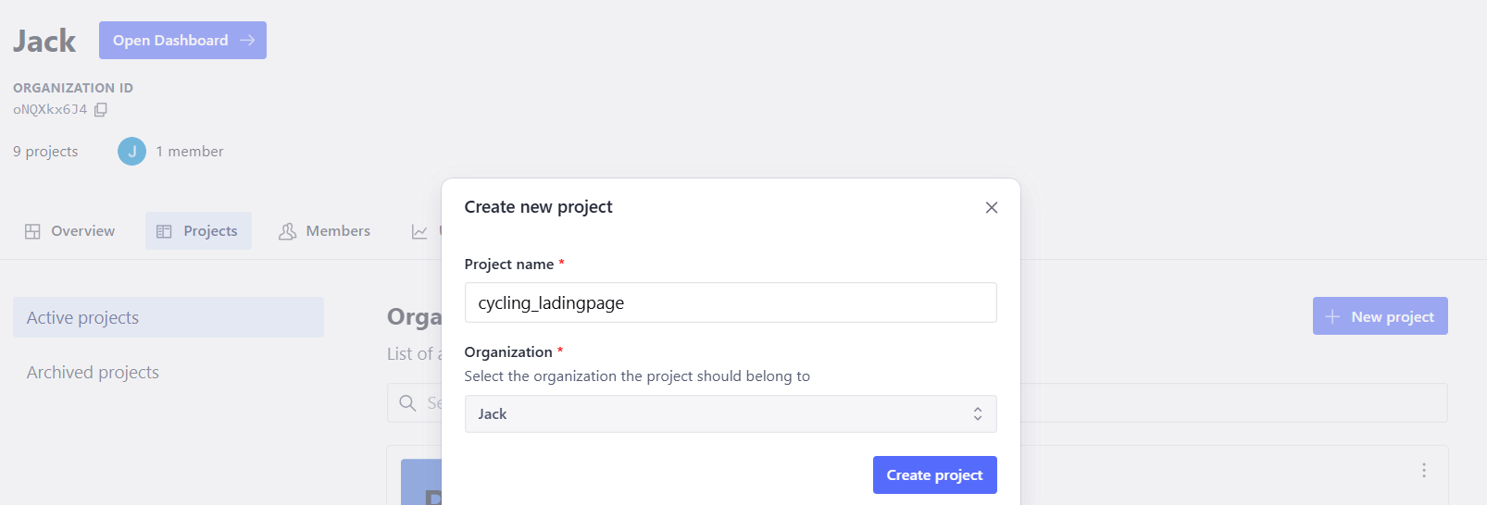
終端機輸入指令: 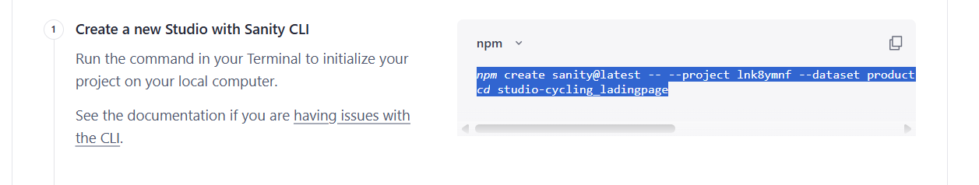
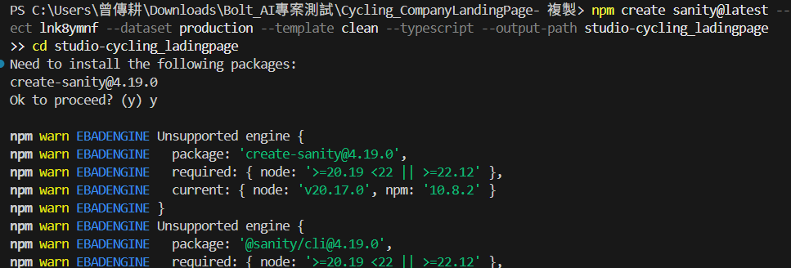
成功安裝之後會新增studio目錄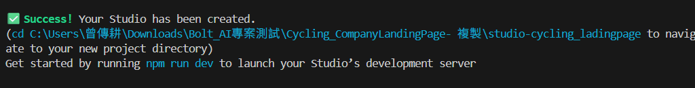
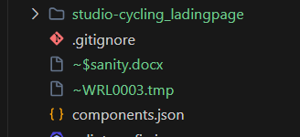

查看sanity內的sanity.cli.ts的projectId是否符合專案的id
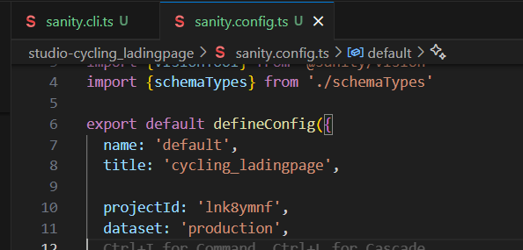

輸入問題:
i already have products.tsx and ProductDetail.tsx compoent , but i want to use sanity cms system which i already installed inside my project ,that use the suitable schemaTypes data can choose name: 'Velocity Pro Carbon', category: 'Road Racing', price: 4999, originalPrice: 5499, image: 'https://images.unsplash.com/photo-1456990493443-0d0ee2a630cc?w=600&auto=format&fit=crop&q=60&ixlib=rb-4.1.0&ixid=M3wxMjA3fDB8MHxzZWFyY2h8NjB8fHJvYWQlMjBiaWtlfGVufDB8fDB8fHww', rating: 4.9, reviews: 127, features: ['Carbon fiber frame', 'Shimano Ultegra Di2', 'Aero wheelset'], isBestseller: true value inside varible instead

建立完成之後: 進入sanity本地端開啟
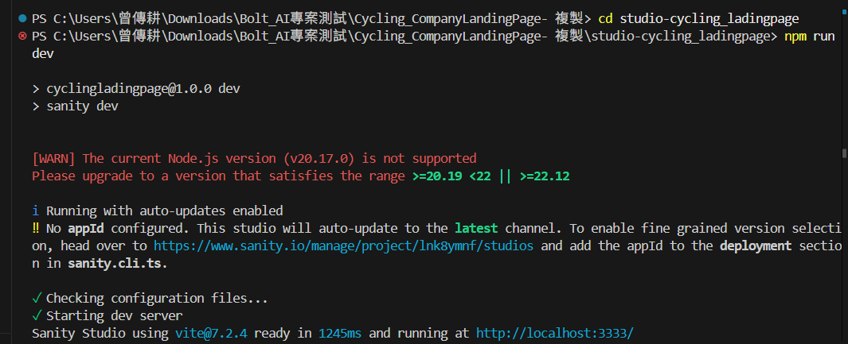
開啟前端網址本地端的CORS權限tab選API進入cors origins
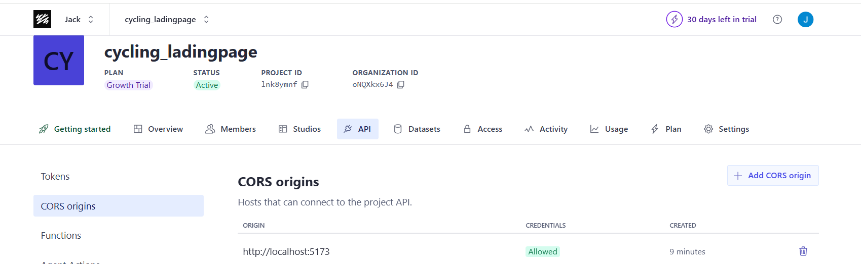

詢問是否允許credentials當新增CORS ORIGIN
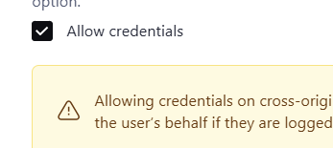
shoud i acceput Allow credentials
Yes, you should allow credentials (--credentials flag). This enables authenticated requests which is needed for:
- Fetching draft/unpublished content
- Using preview mode
- Any authenticated API calls
For a public website fetching published content only, credentials aren't strictly required, but it's generally safe to enable and gives you more flexibility later.
Recommendation: Type Y to accept "Allow credentials" when prompted.
If you already cancelled, run this command again:
測試:
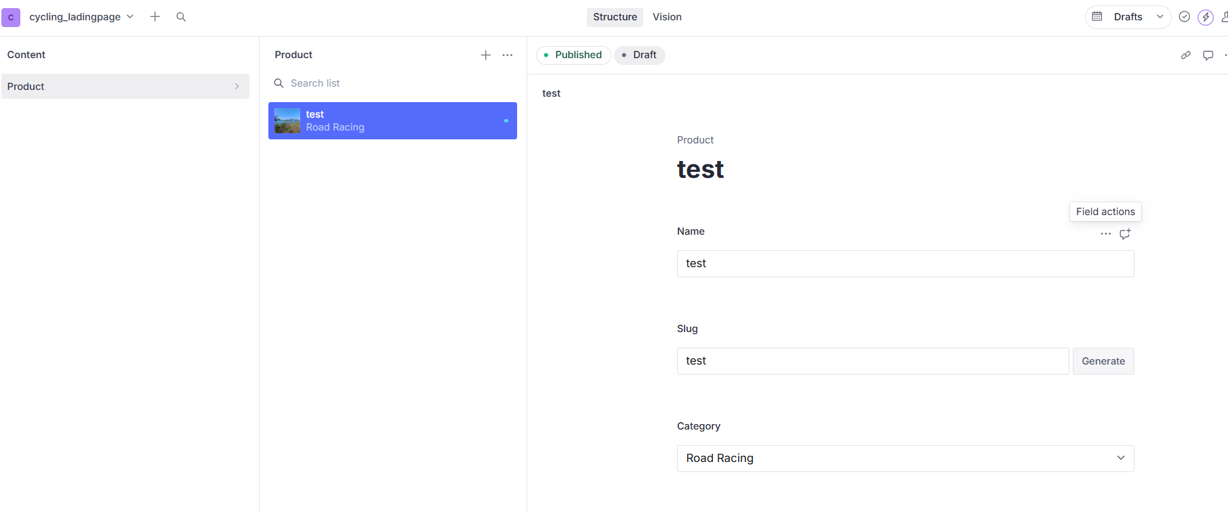
輸出:
本地端測試成功，接下來Deploy到遠端stuido

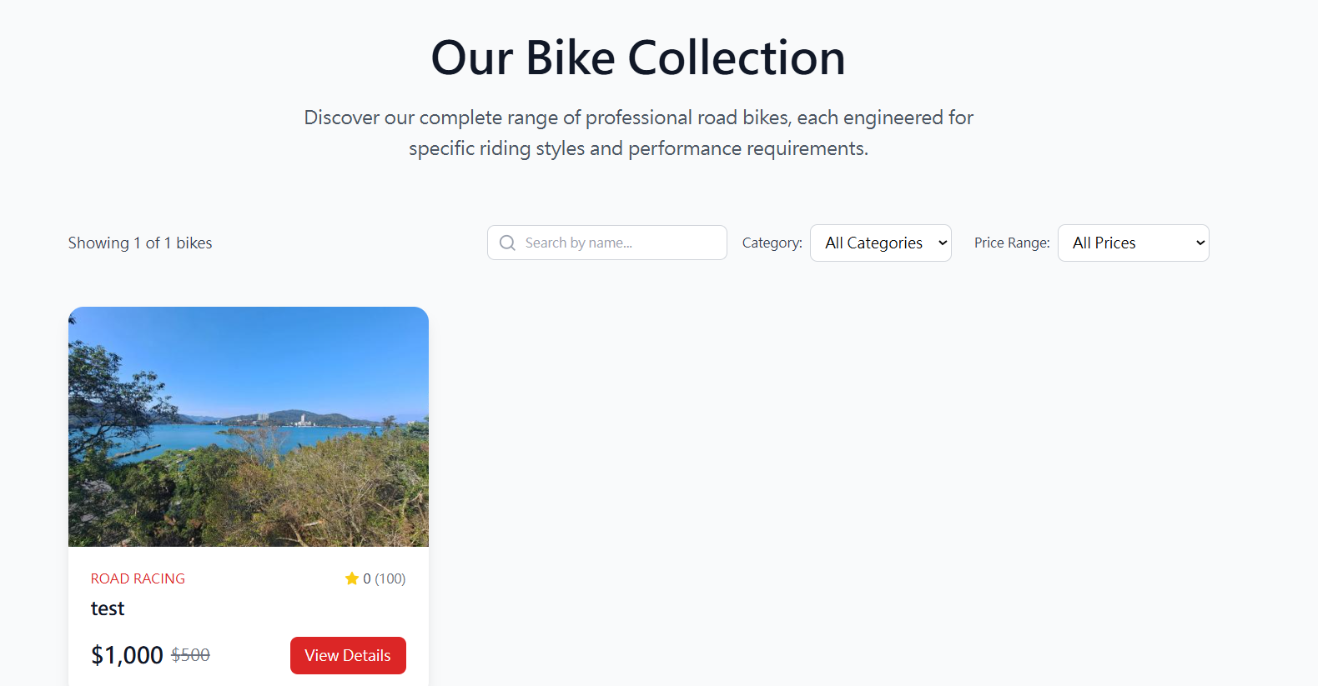
進入sanity的studio目錄輸入指令deploy
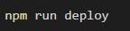
成功deploy之後控制台就會出現open sanity studio的選項
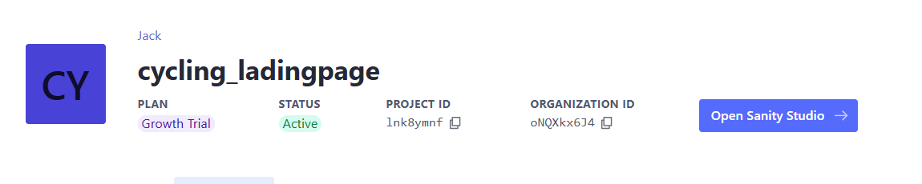
本地端測試成功之後，push到Git同時控制台也允許其他網址的CORS
