新增符合netlify的form section

Netlify Form Features Added
Form Attributes for Netlify Detection
name="contact" - Form identifier
method="POST" - HTTP method
data-netlify="true" - Enables Netlify form detection
netlify-honeypot="bot-field" - Spam protection
Hidden form-name input - Required for Netlify
Form Fields
姓名 (Name) - Required text field
電子郵件 (Email) - Required email field with validation
電話號碼 (Phone) - Optional tel field
主旨 (Subject) - Required text field
訊息內容 (Message) - Required textarea (6 rows)

程式碼:
{/* Contact Section */}
<section id="contact" className="py-20 bg-gradient-to-b from-gray-50 to-white">
<div className="max-w-4xl mx-auto px-4 sm:px-6 lg:px-8">
<div className="text-center mb-12">
<h2 className="text-4xl font-bold text-gray-900 mb-4">聯絡我們</h2>
<p className="text-xl text-gray-600">
有任何問題或建議？歡迎與我們聯繫
</p>
</div>

<div className="bg-white rounded-2xl shadow-xl p-8 md:p-12">
<form
name="contact"
method="POST"
data-netlify="true"
netlify-honeypot="bot-field"
className="space-y-6"
>
{/* Hidden input for Netlify */}
<input type="hidden" name="form-name" value="contact" />

{/* Honeypot field for spam protection */}
<p className="hidden">
<label>
Don't fill this out if you're human: <input name="bot-field" />
</label>
</p>

<div className="grid grid-cols-1 md:grid-cols-2 gap-6">
<div>
<label htmlFor="name" className="block text-sm font-medium text-gray-700 mb-2">
姓名 *
</label>
<input
type="text"
id="name"
name="name"
required
className="w-full px-4 py-3 border border-gray-300 rounded-lg focus:ring-2 focus:ring-amber-500 focus:border-transparent transition-all"
placeholder="請輸入您的姓名"
/>
</div>

<div>
<label htmlFor="email" className="block text-sm font-medium text-gray-700 mb-2">
電子郵件 *
</label>
<input
type="email"
id="email"
name="email"
required
className="w-full px-4 py-3 border border-gray-300 rounded-lg focus:ring-2 focus:ring-amber-500 focus:border-transparent transition-all"
placeholder="your@email.com"
/>
</div>
</div>

<div>
<label htmlFor="phone" className="block text-sm font-medium text-gray-700 mb-2">
電話號碼
</label>
<input
type="tel"
id="phone"
name="phone"
className="w-full px-4 py-3 border border-gray-300 rounded-lg focus:ring-2 focus:ring-amber-500 focus:border-transparent transition-all"
placeholder="0912-345-678"
/>
</div>

<div>
<label htmlFor="subject" className="block text-sm font-medium text-gray-700 mb-2">
主旨 *
</label>
<input
type="text"
id="subject"
name="subject"
required
className="w-full px-4 py-3 border border-gray-300 rounded-lg focus:ring-2 focus:ring-amber-500 focus:border-transparent transition-all"
placeholder="請輸入主旨"
/>
</div>

<div>
<label htmlFor="message" className="block text-sm font-medium text-gray-700 mb-2">
訊息內容 *
</label>
<textarea
id="message"
name="message"
rows={6}
required
className="w-full px-4 py-3 border border-gray-300 rounded-lg focus:ring-2 focus:ring-amber-500 focus:border-transparent transition-all resize-none"
placeholder="請輸入您的訊息..."
></textarea>
</div>

<button
type="submit"
className="w-full bg-amber-600 hover:bg-amber-700 text-white px-8 py-4 rounded-lg font-semibold text-lg transition-all duration-300 transform hover:scale-105 shadow-lg hover:shadow-xl"
>
送出訊息
</button>
</form>
</div>
</div>
</section>
進入專案的forms 開啟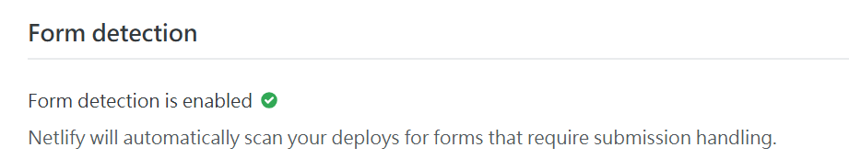

開啟email通知路徑
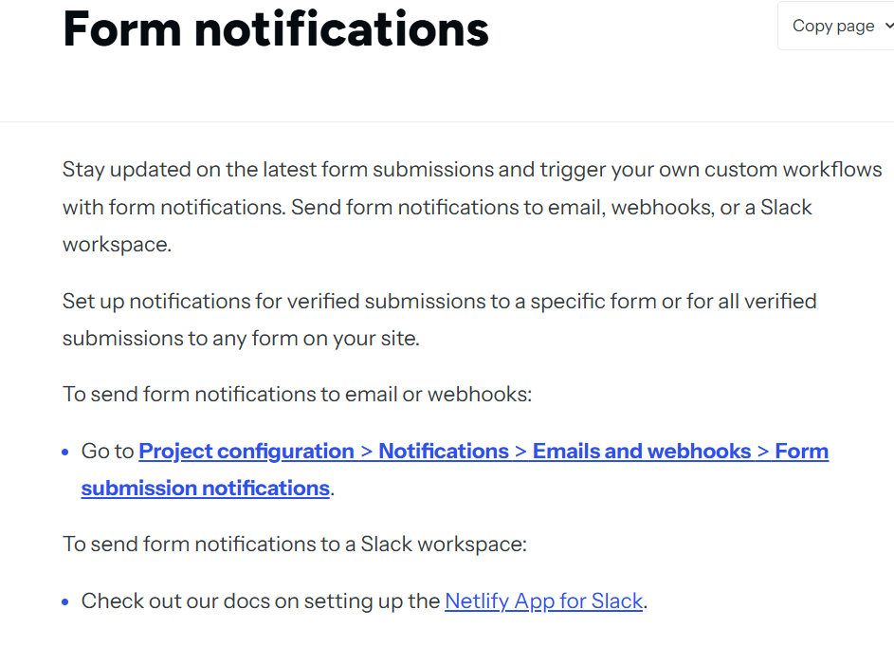點Notifications的email and webooks

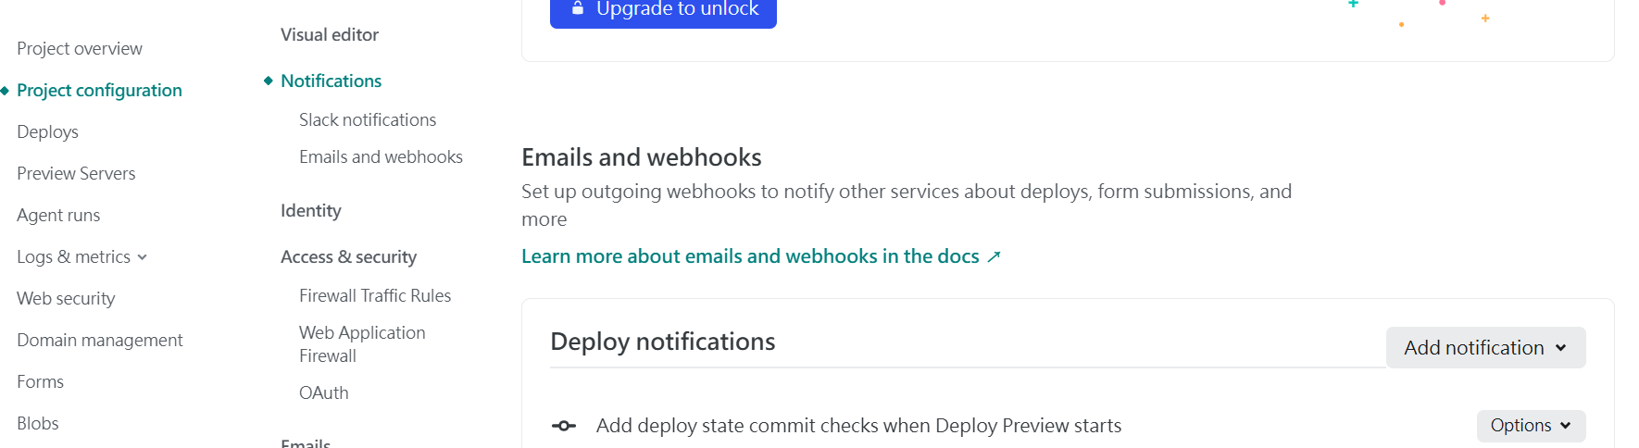
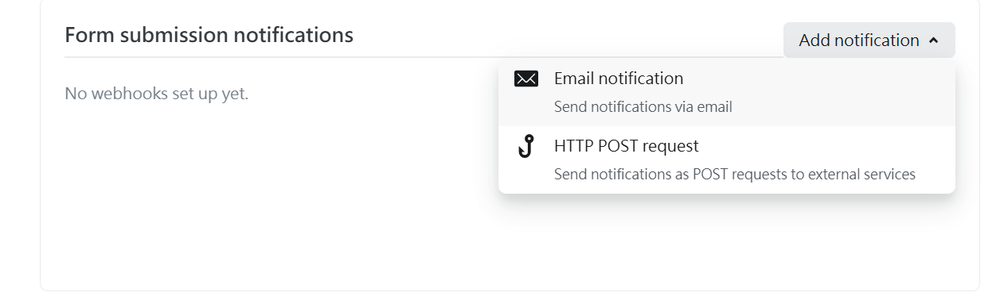

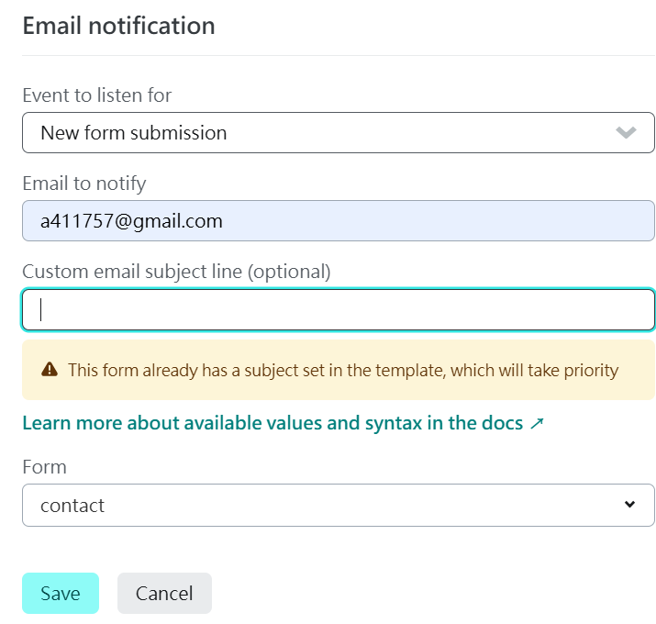
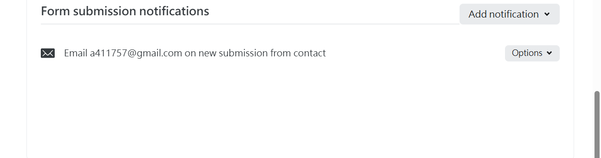
收到測試訊息

詢問: 使用者提交之後會跳出訊息的modal取代導引到netlify的頁面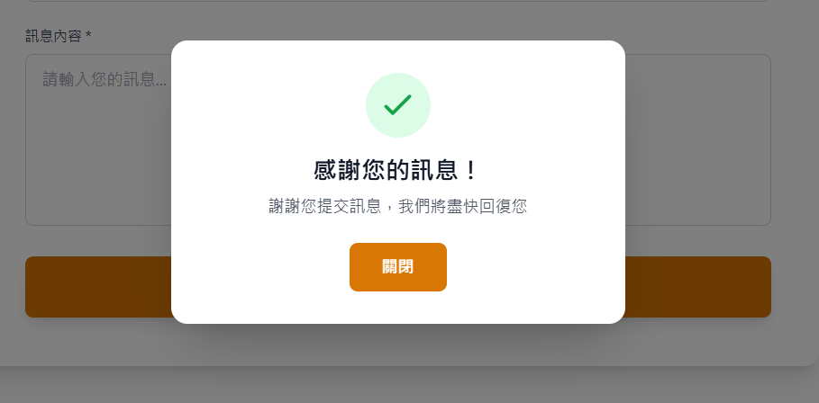
更新程式碼:
{/* Contact Section */}
<section id="contact" className="py-20 bg-gradient-to-b from-gray-50 to-white">
<div className="max-w-4xl mx-auto px-4 sm:px-6 lg:px-8">
<div className="text-center mb-12">
<h2 className="text-4xl font-bold text-gray-900 mb-4">聯絡我們</h2>
<p className="text-xl text-gray-600">
有任何問題或建議？歡迎與我們聯繫
</p>
</div>

<div className="bg-white rounded-2xl shadow-xl p-8 md:p-12">
<form
name="contact"
method="POST"
data-netlify="true"
netlify-honeypot="bot-field"
className="space-y-6"
onSubmit={(e) => {
e.preventDefault();
const form = e.currentTarget;
fetch('/', {
method: 'POST',
headers: { 'Content-Type': 'application/x-www-form-urlencoded' },
body: new URLSearchParams(new FormData(form) as any).toString()
})
.then(() => {
setShowSuccessModal(true);
form.reset();
})
.catch(() => alert('提交失敗，請稍後再試'));
}}
>
{/* Hidden input for Netlify */}
<input type="hidden" name="form-name" value="contact" />

{/* Honeypot field for spam protection */}
<p className="hidden">
<label>
Don't fill this out if you're human: <input name="bot-field" />
</label>
</p>

<div className="grid grid-cols-1 md:grid-cols-2 gap-6">
<div>
<label htmlFor="name" className="block text-sm font-medium text-gray-700 mb-2">
姓名 *
</label>
<input
type="text"
id="name"
name="name"
required
className="w-full px-4 py-3 border border-gray-300 rounded-lg focus:ring-2 focus:ring-amber-500 focus:border-transparent transition-all"
placeholder="請輸入您的姓名"
/>
</div>

<div>
<label htmlFor="email" className="block text-sm font-medium text-gray-700 mb-2">
電子郵件 *
</label>
<input
type="email"
id="email"
name="email"
required
className="w-full px-4 py-3 border border-gray-300 rounded-lg focus:ring-2 focus:ring-amber-500 focus:border-transparent transition-all"
placeholder="your@email.com"
/>
</div>
</div>

<div>
<label htmlFor="phone" className="block text-sm font-medium text-gray-700 mb-2">
電話號碼
</label>
<input
type="tel"
id="phone"
name="phone"
className="w-full px-4 py-3 border border-gray-300 rounded-lg focus:ring-2 focus:ring-amber-500 focus:border-transparent transition-all"
placeholder="0912-345-678"
/>
</div>

<div>
<label htmlFor="subject" className="block text-sm font-medium text-gray-700 mb-2">
主旨 *
</label>
<input
type="text"
id="subject"
name="subject"
required
className="w-full px-4 py-3 border border-gray-300 rounded-lg focus:ring-2 focus:ring-amber-500 focus:border-transparent transition-all"
placeholder="請輸入主旨"
/>
</div>

<div>
<label htmlFor="message" className="block text-sm font-medium text-gray-700 mb-2">
訊息內容 *
</label>
<textarea
id="message"
name="message"
rows={6}
required
className="w-full px-4 py-3 border border-gray-300 rounded-lg focus:ring-2 focus:ring-amber-500 focus:border-transparent transition-all resize-none"
placeholder="請輸入您的訊息..."
></textarea>
</div>

<button
type="submit"
className="w-full bg-amber-600 hover:bg-amber-700 text-white px-8 py-4 rounded-lg font-semibold text-lg transition-all duration-300 transform hover:scale-105 shadow-lg hover:shadow-xl"
>
送出訊息
</button>
</form>
</div>
</div>
</section>

{/* Success Modal */}
{showSuccessModal && (
<div className="fixed inset-0 bg-black bg-opacity-50 flex items-center justify-center z-50 p-4">
<div className="bg-white rounded-2xl shadow-2xl max-w-md w-full p-8 transform transition-all">
<div className="text-center">
<div className="mx-auto flex items-center justify-center h-16 w-16 rounded-full bg-green-100 mb-4">
<svg className="h-10 w-10 text-green-600" fill="none" stroke="currentColor" viewBox="0 0 24 24">
<path strokeLinecap="round" strokeLinejoin="round" strokeWidth="2" d="M5 13l4 4L19 7"></path>
</svg>
</div>
<h3 className="text-2xl font-bold text-gray-900 mb-2">感謝您的訊息！</h3>
<p className="text-gray-600 mb-6">
謝謝您提交訊息，我們將盡快回復您
</p>
<button
onClick={() => setShowSuccessModal(false)}
className="bg-amber-600 hover:bg-amber-700 text-white px-8 py-3 rounded-lg font-semibold transition-colors duration-200"
>
關閉
</button>
</div>
</div>
</div>
)}

提交到Netlify測試
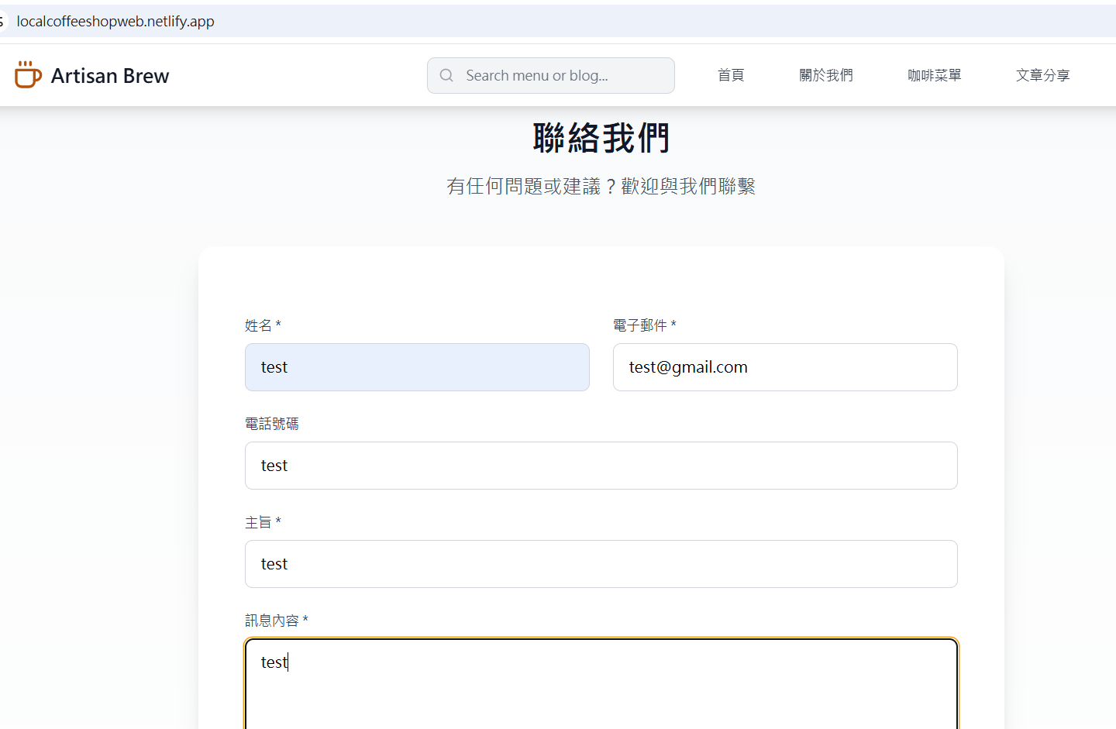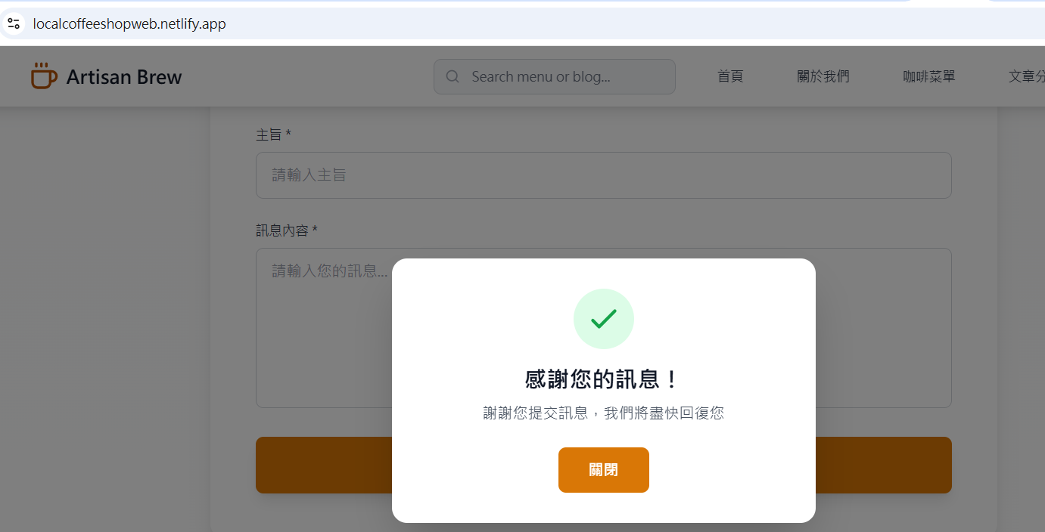
測試成功:

