Churn Analysis
1. Project Overview
The goal of this project is to identify customers who are likely to churn before their renewal date(6 months to 45 days), using datasets given,
- Billing
- Renewal call
- Emails
- Cc_calls
For Billing Dataset
The work is divided into two major stages:
- Billing Data Cleaning & Preparation
- Hypothesis Testing & Feature Validation for Churn Prediction

2. Data Sources
Raw Datasets
- Billing Data
- Renewal Calls Data

3. Stage 1 – Billing Data Cleaning
Prepare a high-quality, analysis-ready billing dataset with:
- One row per customer
- Valid renewal outcomes
- No leakage or extreme noise

3.1 Initial Data Inspection
- Billing dataset size: 122,082 rows × 59 columns
- Customers (Co_Ref) repeat across multiple renewal years
- Missing values found in several fields:
  - Connection metrics
  - Discount fields
  - Last-year payment information
Important observation:
Co_Ref + Renewal_Year is already unique
3.2 Understanding Duplicates
- Same customer appears in multiple years (2023–2026)
- Business rule: Keep the most recent renewal record per customer
- so co_Ref + Renewal_year was considered for understanding duplicates

3.3 Cleaning Strategy
The following steps were applied in sequence:
Step 1: Date Parsing
Converted all relevant date fields into standard datetime format:
- Prospect_Renewal_Date
- Closed_Date
- Proforma_Date
- Registration_Date
- Last_Renewal
Step 2: Remove Invalid Renewal Years
Dropped clearly erroneous data:
- Year 2027
- Year 2050
Retained valid renewal years: 2023–2026
Step 3: Filter Valid Outcomes
Kept only:
- Won
- Churned
- Open
“Open” records are retained temporarily.
Step 4: Remove Extremely Sparse Columns
- Dropped columns with >85% missing values
- Example:
  - Connection quantities
  - Discount amounts
Reason: These add noise and no analytical value.
Step 5: Missing Value Treatment
- Numeric columns
  - Filled using median values
- Categorical columns
  - Filled with "Unknown"
- Special handling:
  - Last_Total_Net_Paid → filled with 0
  - Last_Connections → filled with 0
Step 6: Derived Indicators
Created additional binary signals:
- has_last_renewal
- is_closed
These capture customer lifecycle signals.
Step 7: De-duplication
Final business rule:
One customer = one row
Method:
- Sorted by latest Prospect_Renewal_Date
- Kept most recent record per Co_Ref

3.4 Final Output of Cleaning
Final billing dataset
- 47,825 customers
- 55 clean columns
- Zero duplicate customers
Outcome distribution:
- Won
- Churned
- Open
Saved as: billings_clean.csv
4. Stage 2 – Hypothesis Testing
Validate business assumptions about what drives churn, before applying machine learning.

5. Model Design Framework
Prediction Window
- Focus: 180 to 45 days before renewal date
Target Variable
churn = 1 → Prospect_Outcome = Churned
churn = 0 → Prospect_Outcome = Won

6. Renewal Call Window Filtering
- Join billing + renewal calls using Co_Ref
- Calculate:
days_to_renewal = renewal_date – call_date
- Keep calls where: 45 ≤ days_to_renewal ≤ 180

7. Call Feature Aggregation
Multiple calls per customer were aggregated into one row per customer.
Generated Call Features
- call_count_window
- first_call_date
- last_call_date
- days_to_renewal_min
- days_to_renewal_max
- days_to_renewal_mean
Ensures compatibility with billing data structure.

8. Feature Engineering
New explanatory variables were created:
Feature | Description
tenure_days | Customer age in days
price_change_ratio | Year-over-year price change
days_last_call_to_renewal | How close last call was to renewal
call_freq_per_month | Normalized engagement intensity

9. Leakage Prevention
Removed columns that would not be available at prediction time:
- Prospect_Outcome
- Closed_Date
- Payment totals
- Renewal post-event scores
Prevents data leakage.

10. Hypotheses Tested
H1: Lower tenure increases churn
Confirmed
Churned customers have significantly lower tenure.
H2: Lower revenue bands churn more
Confirmed
Band A/B customers show higher churn rates.
H3: Higher renewal score reduces churn
Confirmed
Higher Total_Renewal_Score is strongly protective.
H4: More calls may indicate escalation
Confirmed
Call volume differences are statistically significant.
H5: Longer tenure in days (tenure_days) is associated with lower churn
Confirmed
There is a significant difference in tenure_days between churned and non-churned customers.
H6: Price change ratio impacts churn
Confirmed
There is a significant difference in price_change_ratio between churned and non-churned customers.
H7: Proximity of last call to renewal (days_last_call_to_renewal) impacts churn
Confirmed
There is a significant difference in days_last_call_to_renewal between churned and non-churned customers.
H8: Call frequency per month (call_freq_per_month) impacts churn
Confirmed
There is a significant difference in call_freq_per_month between churned and non-churned customers.
Additional Validated Drivers
- Tenure (in days)
- Price change shock
- Proximity of last call to renewal
- Call frequency intensity
All hypotheses were validated using t-tests and chi-square tests with p < 0.05.

11. Feature Selection for Modeling
Final features chosen based on hypothesis results:
- Total_Renewal_Score_New
- Tenure_Years
- Band
- Call_count_window
- Tenure_days
- Price_change_ratio
- Days_last_call_to_renewal
- Call_freq_per_month
Categorical fields were label-encoded.

12. Final Outputs
File | Purpose
billings_clean.csv | Clean billing data
billings_processed.csv | Model-ready data

EDA
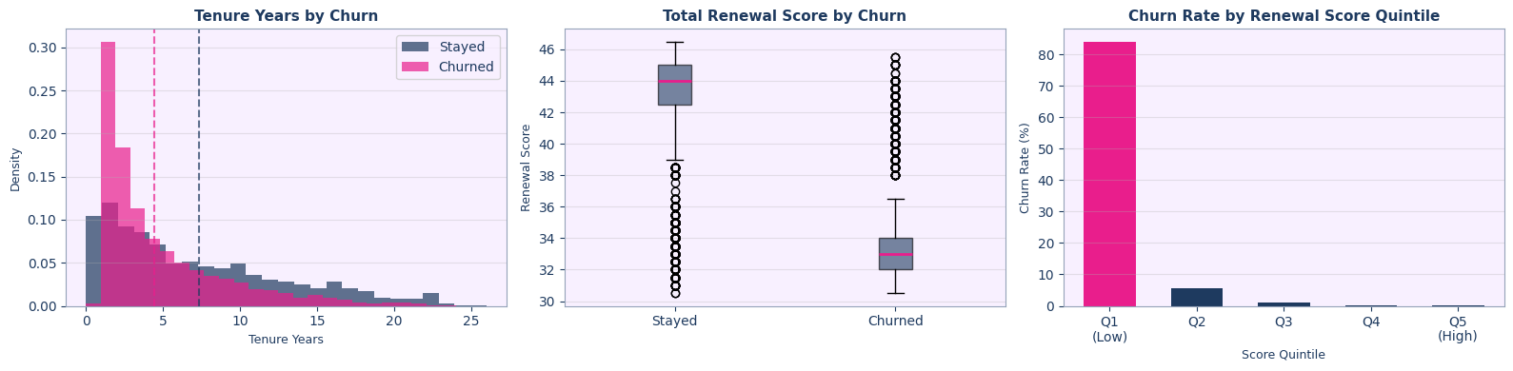
Tenure & Score Analysis



Band & Tenure Group Churn Rates
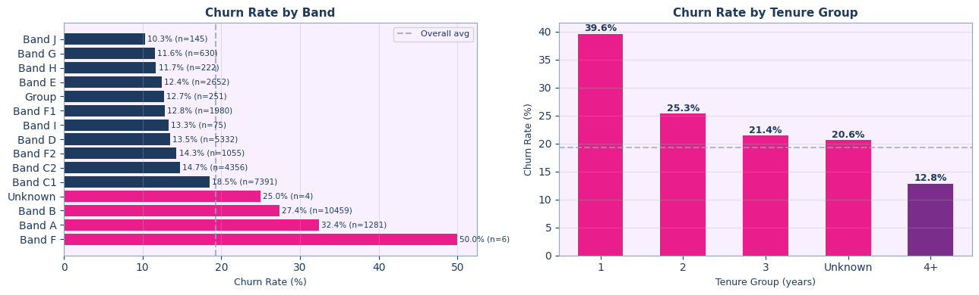

Call Behaviour in the Window
