DORING, Jackson (jdori5)

12IPT Item i Hangman

Contents

Home Page- index.php 2

Sketch 2

Form 2

Settings Page- change.php 3

Sketch 3

Form 3

Credits Page- credit.php 4

Sketch 4

1 Player Hangman- game.php 5

Sketch 5

Form 5

2 Player Hangman- game3.php 6

Sketch 6

Form 6

Rational 7

Function Specification 8

Pseudocode 9

game.php 9

game3.php 13

index.php 16

credits.php 16

change.php 16

Screenshots 17

index.php 17

game.php 17

game3.php 18

change.php 18

credits.php 19

Work Log 20

Evaluation 23

# Home Page- index.php

This will be the first page players will see when they open the website. The page will allow players to input main game options before staring Hangman.

## Sketch

Banner DIV

Navigation DIV

Content DIV

Game Options

Enter name for 1 Player Hangman

Enter 2 names for 2 player Hangman

## Form

|  |  |  |
| --- | --- | --- |
| Input Type | Info on Screen | Name |
| Text | Players Name | Pname |
| SUBMIT | Submit | submit |
| Text | 2 Player | Pname2 |
| Text | Players Name | Pname1 |
| SUBMIT | Submit | submit |

# Settings Page- change.php

This page will allow players to customize the page settings, they can change settings such as: colour of text, background colour and font sizes.

## Sketch

Banner DIV

Navigation DIV

Content DIV

Page Settings

Change background colour

Change text colour

Font size

Apply Changes

## Form

|  |  |  |
| --- | --- | --- |
| Input Type | Info on Screen | Name |
| Text | Background colour | BC |
| Text | Font Colour | FC |
| Text | Text Size | TS |
| SUBMIT | Update Page | submit |

# Credits Page- credit.php

This page will inform the users on what languages were used to develop the website, and will have the name of the developer. It will also include background information on the rules of Hangman.

## Sketch

Banner DIV

Navigation DIV

Content DIV

How to play Hangman

What languages were used to develop the website

Who the website was developed by

# 1 Player Hangman- game.php

Players can navigate to this page to play 1 player hangman.

## Sketch

Banner DIV

Navigation DIV

Content DIV

Game interactions

Hangman images

Category Selection

New word button

Letter inputs

## Form

|  |  |  |
| --- | --- | --- |
| Input Type | Info on Screen | Name |
| Submit | Movies | cat |
| Submit | Countries | cat |
| Submit | Names | cat |
| Submit | New Word | Word |
| Submit | Alphabet letters | Guess |

# 2 Player Hangman- game3.php

Players can navigate to this page to play 2 player Hangman.

## Sketch

Banner DIV

Navigation DIV

Content DIV

Game interactions

Hangman images

Word to guess

Letter inputs

## Form

|  |  |  |
| --- | --- | --- |
| Input Type | Info on Screen | Name |
| Text | Choose a word | Word |
| Submit | Enter | sub |
| Submit | Alphabet letters | Guess |

# Rational

The purpose of the website is to demonstrate my HTML, CSS and PHP skills by creating a web based hangman game that incorporates all these languages. The features that need to be include are, functionalities allowing users to customize the website design, features that incorporate cookies and having a functioning hangman game.

The target audience for the website is going to be young adults and children. The information and features they can expect to see on the page is:

* Rules and instructions on game
* Three style options to customize game functionality and web design. These options will be background colour, font colour and text size.
* Being able to play hangman

The benefits that this website will provide for visitors are, entertainment and knowledge on hangman. It will also be an effective way for visitors to engage and be more social with their friends.

The time frame given for this task is 6-weeks, the planning of the program should be completed within the first week so more time can be allocated to the development of the program. The programming should take 5weeks, which will include the testing and pseudocode. Then the evaluation should then be completed within a week.

# Function Specification

The languages that will be used to create the website are HTML, CSS and PHP. HTML will be used to create the basic template of the website, such as the headers, titles and any inputs. CSS will be used to design an aesthetically pleasing webpage by changing aspects of the page. PHP will be used to make the game function, and be used to create cookies so user inputs can be saved.

The appearance of the webpage will be basic, only having required components. A variety of colours, fonts, images and styles will be used to make the page aesthetically pleasing for the users. The inputs and outputs that will exist within the website are:

* Buttons to enter letter guesses
* Text boxes for changing page styles
* Buttons to draw a random word
* Reset button to set the website style to default
* Outputting different hangman images
* Outputting the underscores
* Outputting guessed letters that were wrong

The website will work by players starting on the index page, here they will enter the player names. Next, they will navigate onto the game page, on this page they can play hangman. Players first have to press “Get Word” to generate a random word, underscores equal to the number of letters in the word will then be displayed. To play hangman, players guess the word by pressing the letter buttons. If the letter exists within the word, then the underscore will be replaced with the letter. If the letter isn’t in the word, then the player will get one section added to the hangman. If all sections of the image appear on the screen, then the player will lose and the game will restart. From any page on the website the users can access the style page, where they can alter the look of the website and change the player name. Users can also access the credits page where all the rules and credits for the website will appear.

Some assumptions that have been made while planning this website are, the users will have a basic understanding of how hangman works and the rules associated with it. Also, the users will be player by themselves and therefore they will be playing against an A.I. An assumption that the users have a functioning computer setup and internet connection has also been made.

# Pseudocode

## game.php

Creating cookie to store selected category

Setting the cookies name and value

Setting category cookies time expiry to 3 days

Setting category cookie to the category the user selects

Selecting a specific set of words depending on the category selected by the user

If the user selects "Movies", then this set of words will be selected

If the user selects "Countries", then this set of words will be selected

If the user selects "Names", then this set of words will be selected

Splitting the letters in the random word into its own array

If the "_array" cookie is set, then the following code will run

Sets $_array to the values of "_array" cookie

If "_array" isn't set, then the following code will run

Setting the _array to nothing

If the user clicks "New Word" then a random word will be selected from the category, then underscores will be generated according to the number of letters in the word, then cookies will be created for the Wrong Letters

If "New Word" button is pressed, then the following code will run

Shuffling the words in the selected category

Selecting and saving the first word from the selected category

Counting how many letters are in the word, then saving it

Setting the $_array to nothing

Setting a counter for the while loop

Loops until the counter is greater than the length of the word

Adding an underscore to the $_array

Adding 1 to the counter

Counting the length of $_array and storing it

Setting the Incorrect letters to nothing

Setting the counter for Incorrect letters to 1

Setting the Incorrect cookie values

Setting the expiry time for Incorrect cookie to 3 days

Setting Incorrect cookie to the value of $Incorrect

Setting values for Incorrect Counter cookie

Setting the expiry time for Incorrect Counter to 3 days

Setting Incorrect Counter cookie to the value of $IncorrectC

If the 'Wrong' cookie is set, then the following code will run

Sets $Wrong to as 'Wrong' cookie

If the 'Wrong' cookie isn't set, then the following code will run

Setting $Wrong to 0

Checks to see if the letter entered is in the word, if it is, then the corresponding underscore will be replaced with the letter, if not, then the wrong letter will be saved, start

Setting a counter

Creating a found counter

Creating a correct counter

Setting IncorrectC as IncorrectC cookie value

Setting Incorrect as Incorrect cookie value

While the $_count value doesn't equal the number of letters in the word, then the following code will run

If the letter inputted by the user is in the word, then the following code will run

Replaces the underscore in $_array with the letter inputted

Setting $found to 1

Adding 1 to the $Correct value

If the letter inputted by the user isn't in the word, then nothing will run

Adding 1 to $_count

If $Correct equals 0, then the following code will run

Adding 1 to $IncorrectC

Adding the wrong letter inputted with a comma to $Incorrect

Setting IncorrectCount cookie as $IncorrectC

Setting Incorrect cookie as $Incorrect

If $found = 0, then the following code will run

Setting $Wrong as its self + 1

If 'New Word' is pressed, then the following code will run

Setting $Wrong to 0

Setting $_count to 0

Setting the 'Wrong' cookie to 0

Saving $Wrong as a cookie, so it can be accessed later

Creating arrays that store each letter of the alphabet $ the hangman images

Storing each letter of the alphabet in an array

Creating an empty array called $Wrong_array

Setting values 06 in $Wrong_array as consecutive hangman images

Converting the values in $_array to one value

Saving $_arrayTemp as a cookie, so it can be accessed later

Linking style sheets

Title with players name

Including navigation bar

Buttons to select category

Hiding the random word

Outputting images based on the number of wrong guesses

If $Wrong is less than 6, then the following code will run

Displays the $Wrong array image that corresponds to the value of $Wrong

Ending the game if there has been 6 wrong guesses

If the user has 6 incorrect guesses, then the following code will run

Displays the last hangman image

Outputting end game comment

If there's no "_" in $_array, then the user wins

If there's a "_", then nothing happens

If there isn't any "_", then the following code runs

Displaying end game comment

Displaying the values within the $_array

Setting $arraylength to the number of values in $_array, so it can be used to run the for loop

Loops through the following code until $n is greater than $arraylength

Displays the $_array value that corresponds to the $n value

Outputting a space in between each value

Outputting buttons for each letter in the alphabet

Creating a count for the amount of buttons created

While $letter_count is less than 26, then the following code will run

Outputting a button with the letter from $letters that corresponds with the value of $letter_count

Inserting a space in between each button

Adding 1 to $letter_count

Displaying the wrong letters the player has guessed

## game3.php

Splitting the letters in the random word into its own array

If the "_array" cookie is set, then the following code will run

Sets $_array to the values of "_array" cookie

If "_array" isn't set, then the following code will run

Setting the _array to nothing

If the user clicks "New Word" then a random word will be selected from the category, then underscores will be generated according to the number of letters in the word, then cookies will be created for the Wrong Letters

If "New Word" button is pressed, then the following code will run

Setting An cookies name and value

Setting An cookies time expiry to 3 days

Counting how many letters are in the word, then saving it

Counting how many letters are in the word, then saving it

Setting the $_array to nothing

Setting a counter for the while loop

Loops until the counter is greater than the length of the word

Adding an underscore to the $_array

Adding 1 to the counter

Counting the length of $_array and storing it

Setting the Incorrect letters to nothing

Setting the counter for Incorrect letters to 1

Setting the Incorrect cookie values

Setting the expiry time for Incorrect cookie to 3 days

Setting Incorrect cookie to the value of $Incorrect

Setting values for Incorrect Counter cookie

Setting the expiry time for Incorrect Counter to 3 days

Setting Incorrect Counter cookie to the value of $IncorrectC

If the 'Wrong' cookie is set, then the following code will run

Sets $Wrong to as 'Wrong' cookie

If the 'Wrong' cookie isn't set, then the following code will run

Setting $Wrong to 0

Checks to see if the letter entered is in the word, if it is, then the corresponding underscore will be replaced with the letter, if not, then the wrong letter will be saved

Setting a counter

Creating a found counter

Creating a correct counter

Setting IncorrectC as IncorrectC cookie value

Setting Incorrect as Incorrect cookie value

While the $_count value doesn't equal the number of letters in the word, then the following code will run

If the letter inputted by the user is in the word, then the following code will run

Replaces the underscore in $_array with the letter inputted

Setting $found to 1

Adding 1 to the $Correct value

Adding 1 to $_count

If $Correct equals 0, then nothing will happen

Adding 1 to $IncorrectC

Adding the wrong letter inputted with a comma to $Incorrect

Setting IncorrectCount cookie as $IncorrectC

Setting Incorrect cookie as $Incorrect

If $found = 0, then the following code will run

Setting $Wrong as its self + 1

If 'New Word' is pressed, then the following code will run

Setting $Wrong to 0

Setting $_count to 0

Setting the 'Wrong' cookie to 0

Saving $Wrong as a cookie, so it can be accessed later

Creating arrays that store each letter of the alphabet $ the hangman images, start

Storing each letter of the alphabet in an array

Creating an empty array called $Wrong_array

Setting values 06 in $Wrong_array as consecutive hangman images

Converting the values in $_array to one value

Saving $_arrayTemp as a cookie, so it can be accessed later

Linking style sheets

Title with the players name

Including Navigation Section

Including Navigation Section

Text input to enter word

Hiding the random word

Hiding the random word

Outputting images based on the number of wrong guesses

If $Wrong is less than 6, then the following code will run

Displays the $Wrong_array image that corresponds to the value of $Wrong

Ending the game if there has been 6 wrong guesses

If the user has 6 incorrect guesses, then the following code will run

Displays the last hangman image

Outputting end game comment

If there's no "_" in $_array, then the user wins

If there's an "_", then nothing happens

If there isn't any "_", then the following code runs

Displaying end game comment

Displaying the values within the $_array

Setting $arraylength to the number of values in $_array, so it can be used to run the for loop

Loops through the folloeing code until $n is greatter than $arraylength

Displays the $_array value that corresponds to the $n value

Outputting a space in between each value

Outputting buttons for each letter in the alphabet

Creating a count for the amount of buttons created

While $letter_count is less than 26, then the following code will run

Creating buttons for each letter in $letters

Inserting a space in between each button

Adding 1 to $letter_count

Displaying the wrong letters the player has guessed

## index.php

Creating a cookie to store the player 2 name

Setting the cookie values

Setting the cookie expiry time to 3 days

Setting the cookie value as $_POST['Pname2']

Creating a cookie to store the player 2 name

Setting the cookie values

Setting the cookie expiry time to 3 days

Setting the cookie value as $_POST['Pname2']

Creating a cookie to store the player 1 name

Setting the cookie values

Setting cookie expiry time to 3 days

Setting the cookie value as $_POST['Pname1']

Linking style sheet

Setting the title to players name

Including navbar page

Text box to input players’ names

## credits.php

Linking style sheets

Title including the players’ name

Including the navigation page

Game rules & credits

## change.php

If the reset button is pressed then the styles will reset

Saving the styles inputted in the text boxes as cookies

Changing the styles to within the css to whatever the corresponding cookie values is

Linking style sheets

Title including the players name

Including the navigation page

Creating text boxes for players to enter desired styles

# Screenshots

## index.php

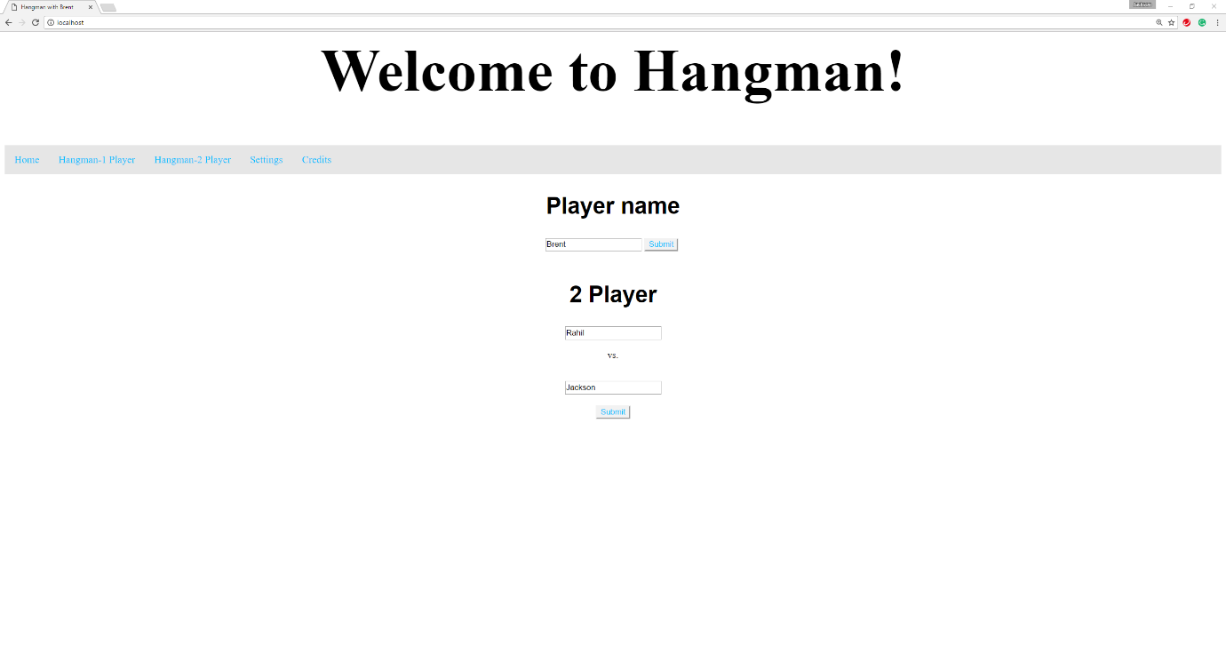

This page will serve as the homepage for when players start the game. Here they will either enter one name if they’re player one player Hangman or two names if they’re player two player Hangman. From here, the names will be sent off to other pages for being stored as titles.

## game.php

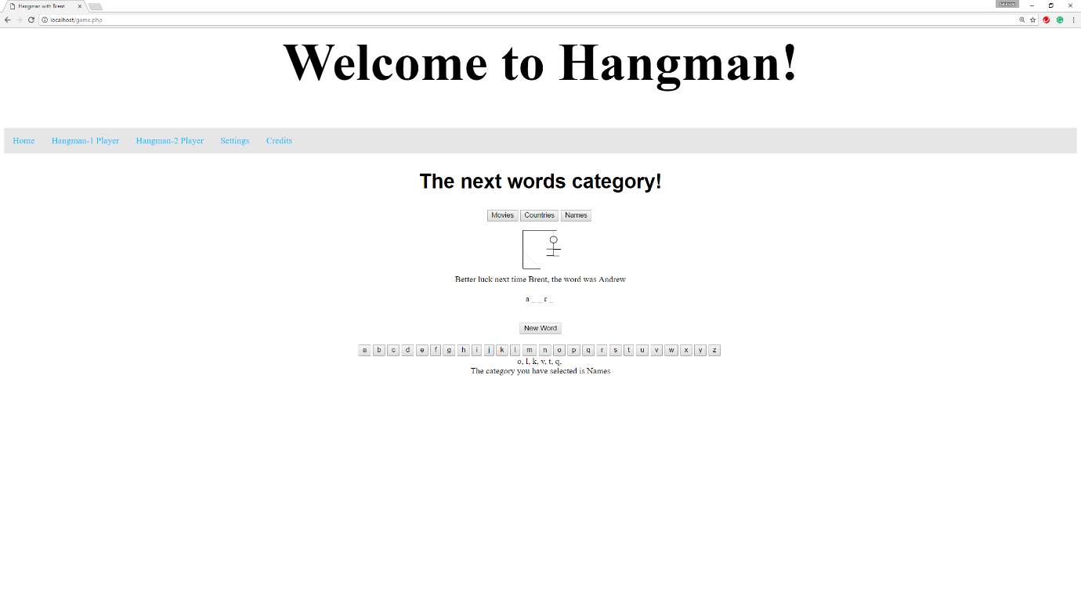

On this page, one player Hangman can be played. When the players first load the page, they’ll have to select one category before continuing, they’ll then need to press “New Word”, from there, a random word will be generated and underscores will be displayed on the screen. The players’ objective then is to guess the random word using the letters on the screen before the man in the image gets hung. A message will appear if the player has won or lost the game.

## game3.php

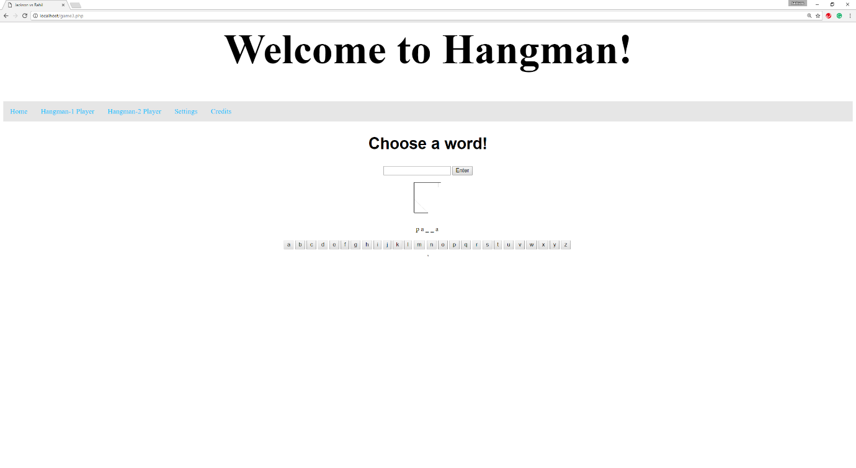

This page is designed for two player Hangman. When the page first loads, one of the players will have to enter a word into the text box. The other player then has to guess the word before the man in the image gets hung. A message will appear if the player wins or loses the game. The players then switch roles once the game has finished.

## change.php

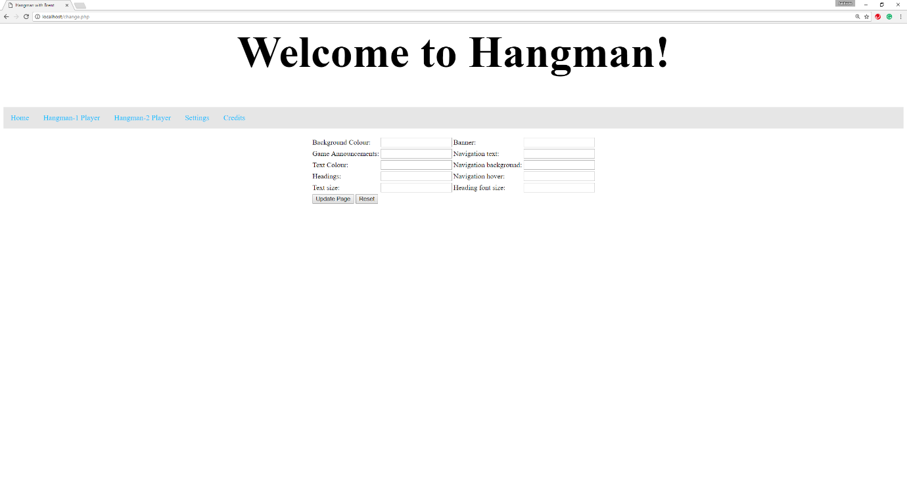

This page will allow players to customise the appearance of the website, it will allow them to customise colours and text.

## credits.php

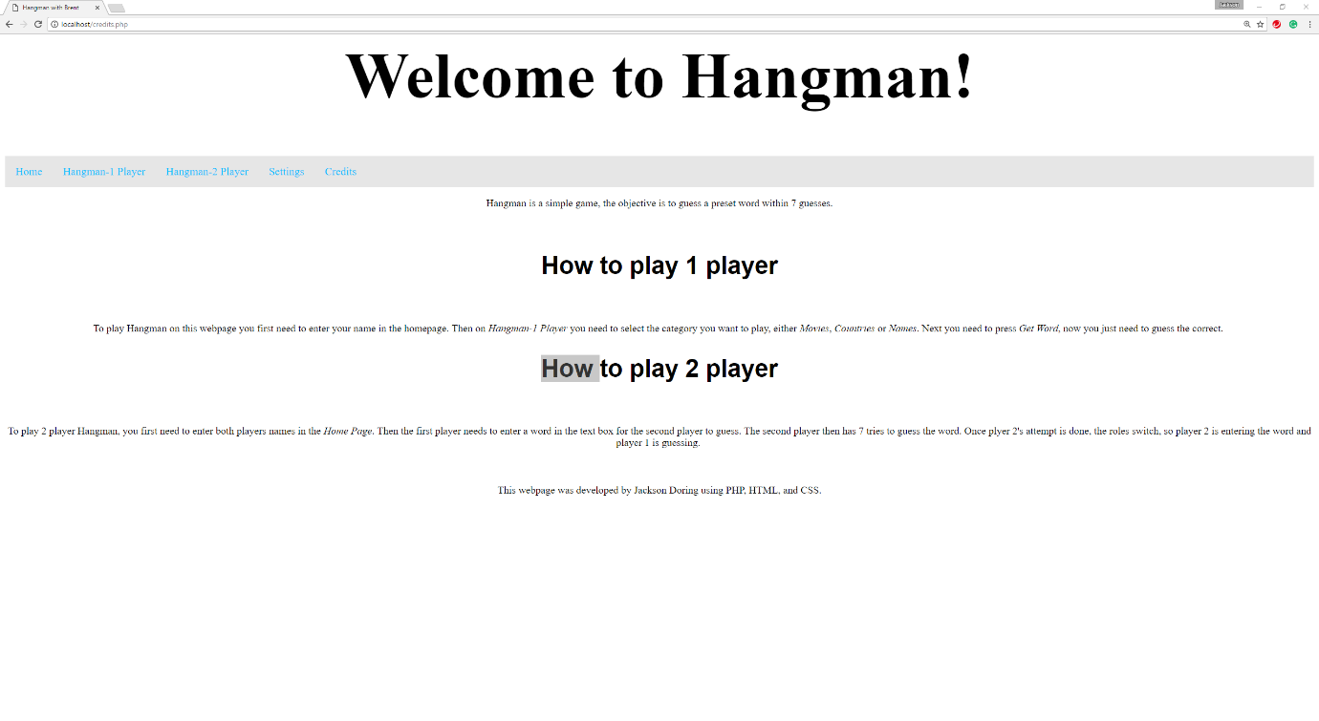

This page informs visitors of the website on how to play one player Hangman and two player Hangman. It also states what languages were used to develop the website and who it was made by.

# Work Log

|  |  |
| --- | --- |
| Date | Current Functionality of Project |
| 15/05 | ***Completed:***   * ***Sketches***   ***Working on:***   * ***Rational***   ***Issues with:*** |
| 16/05 | ***Completed:***   * ***Rational***   ***Working on:***   * ***Function specification***   ***Issues with:*** |
| 18/05 | ***Completed:***   * ***Function specification***   ***Working on:***  ***Issues with:*** |
| 22/05 | ***Completed:***   * ***Flowchart***   ***Working on:***   * ***Creating navigation & header***   ***Issues with:*** |
| 23/05 | ***Completed:***   * ***Navigation bar, header & creating a template for each page***   ***Working on:***   * ***Creating a cookie to store the player name, then output the cookie value as the title for each page***   ***Issues with:***   * ***Creating a cookie to store the player name, then output the cookie value as the title for each page*** |
| 35/05 | ***Completed:***   * ***Creating a cookie to store the player name, then output the cookie value as the title for each page***   ***Working on:***   * ***Selecting different arrays depending on what category the user selects***   ***Issues with:*** |
| 29/05 | ***Completed:***   * ***Selecting different arrays depending on what category the user selects*** * ***Shuffling the selected array, then choses the first value*** * ***Splitting the values from the selected word & putting it in its own array***   ***Working on:***   * ***Outputting underscores based on the string value of the chosen word***   ***Issues with:***   * ***Outputting underscores based on the string value of the chosen word*** |
| 30/05 | ***Completed:***   * ***Outputting underscores based on the string value of the chosen word*** * ***Using a while loop to output buttons for each letter in the alphabet***   ***Working on:***   * ***Saving the chosen word as a cookie***   ***Issues with:*** |
| 31/05 | ***Completed:***   * ***Saving the chosen word as a cookie***   ***Working on:***   * ***If a player clicks a ‘letter’ button, then a loop runs to check if the specified letter is in the array***   ***Issues with:***   * ***If a player clicks a ‘letter’ button, then a loop runs to check if the specified letter is in the array*** |
| 01/06 | ***Completed:***  ***Working on:***   * ***If a player clicks a ‘letter’ button, then a loop runs to check if the specified letter is in the array***   ***Issues with:***   * ***If a player clicks a ‘letter’ button, then a loop runs to check if the specified letter is in the array*** |
| 02/06 | ***Completed:***   * ***If a player clicks a ‘letter’ button, then a loop runs to check if the specified letter is in the array***   ***Working on:***   * ***If the specified letter is in the array, then the corresponding underscore is replaced with that letter***   ***Issues with:***   * ***If the specified letter is in the array, then the corresponding underscore is replaced with that letter*** |
| 03/06 | ***Completed:***   * ***If the specified letter is in the array, then the corresponding underscore is replaced with that letter*** * ***Outputting the array where both the underscores and correct letters are stored***   ***Working on:***  ***Issues with:*** |
| 05/06 | ***Completed:***   * ***Making a reset button for the chosen word, underscore array & letter array*** * ***Creating the change.php page*** * ***Using cookies to save the user input for the background colour, header colour & text colour***   ***Working on:***   * ***Outputting different images depending on the amount of wrong letters that have been guessed*** * ***Ending the game if no underscores exist in the array***   ***Issues with:***   * ***Outputting different images depending on the amount of wrong letters that have been guessed*** * ***Ending the game if no underscores exist in the array*** |
| 06/06 | ***Completed:***   * ***Creating a count for the number of wrong guesses***   ***Working on:***   * ***Outputting images based on the number of wrong guesses***   ***Issues with:***   * ***when the user presses “Get Word” for the first time, the program says the user wins until they guess a letter*** |
| 07/06 | ***Completed:***   * ***Outputting images base on the number of wrong guesses***   ***Working on:***  ***Issues with:*** |
| 08/06 | ***Completed:***   * ***Adding more style options, such as text size & navigation colour***   ***Working on:***   * ***Implementing 2 player***   ***Issues:***   * ***Implementing 2 player*** |
| 12/06 | ***Completed:***   * ***Creating credits page*** * ***Restyling the interface***   ***Working on:***   * ***Implementing 2 player***   ***Issues:***   * ***Implementing 2 player*** |
| 13/06 | ***Completed:***   * ***Adding a reset button to the style page***   ***Working on:***   * ***Implementing 2 player***   ***Issues:***   * ***Implementing 2 player*** |
| 15/06 | ***Completed:***   * ***Implementing 2 player*** * ***Getting other people to test the game to find bugs***   ***Working on:***   * ***Fixing the bugs***   ***Issues:***   * ***Fixing the bugs*** |
| 16/06 | ***Completed:***   * ***Fixing the bugs*** * ***Restyling the interface*** |
| 19/06 | ***Completed:***   * ***Pseudocode*** * ***Screenshots***   ***Working on:***   * ***Evaluation***   ***Issues:*** |
| 20/06 | ***Completed: Evaluation*** |

# Evaluation

I had originally set out to complete a website that allowed users to play Hangman against an A.I. The website was going to work by having the program generate a random word, then the player had to guess the word within seven guesses, otherwise they lose. I also planned to have a style page where users can modify the appearance of the website and a credits page where the rules for hangman, programs used to develop the website and the developer were going to be displayed. The design of the website was planned to be simple, yet aesthetically pleasing, by incorporating simple colours, minimal text and images, and a simple banner.

Some design problems that occurred during the development of the website were, I found it difficult to make the interface aesthetically pleasing. I overcame this problem by asking my fellow peers for opinions and feedback on the interface design. Using the feedback, I then made modifications to the interface accordingly.

During the development of the website, I ran into many difficulties with coding. These difficulties include; struggling to check if the letter inputted by the player matches a letter in the word and changing the style of the website based on the values entered by the players. I overcame these difficulties by consulting with fellow peers and teachers on effective ways to code these components of the website. I also used websites such as W3schools to assistant me throughout the development.

During the development of the website, I found myself finishing the minimum requirements early. With this extra time, I was able to add many other features. These features include; adding two player Hangman, displaying the letters the player guessed wrong, and adding more style options. I was able to complete these extra features because I had gained a greater understanding of PHP throughout the development, making these components easier to code.

The performance of the website is excellent because it allows players to effectively play one player or two player Hangman correctly. It does this by allowing users to enter their names, then having them saved as titles throughout the website. Players can then choose to either generate a random word from a selected category or have a friend enter a word for them to guess, they then try and guess the word within 7 attempts, otherwise they lose. This is an accurate representation of how Hangman works, making the game functional. The website also allows players to modify the appearance of the website. These components help the website to effectively meet the performance requirements of the task.

After testing the website with fellow peers, I received feedback that my website is reliable because it allows players to constantly play the game without bugs and, the website effectively functions how it’s meant to. However, some feedback was that, when players are in the middle of a game and switch to another page. Once they return, either one of the underscores or letters will have disappeared. This is a reliability issues because it doesn’t allow players to complete games when changing in between pages. The website has some minor reliability issues, but overall is a reliable website because it allows users to play the game effectively.

The website is easy to use because it has incorporated well designed, user-friendly features into the interface that allows players to easily navigate, play, and understand the website. These design features include; having a simple, minimalistic interface so players can easily concentrate on specific website components. Having a simple, yet effective navigation bar so players can easily navigate through the website.

If I was to complete another version of the website, I would make modifications to improve the reliability of the website and add more features to make it more engaging. I would do this by saving the underscores and letters displayed as cookies, this will resolve the issue of underscores and letters disappearing when moving between pages, which will improve the reliability of the website. The extra features I would add are; styling options to change the font style, options to change the hangman image, options to increase or decrease the amount of rounds the game lasts for, and adding in difficulty levels for the game. These modifications would help make the website more engaging, user friendly and easier to use.