**Workshop: Services and Error Pages**

Workshop for the ["ASP.NET Advanced" course @ SoftUni](https://softuni.bg/trainings/4107/asp-net-advanced-june-2023)

The "**House** **Renting** **System**" **ASP.NET Core MVC App** is a Web application for **house renting**. **Users** can look at **all** **houses** with their **details**, **rent a house** and look at **their rented houses**. They can also **become** **Agents**. **Agents** can **add houses**, see their **details** and **edit** and **delete** only **houses they added**. The **Admin** has **all privileges** of **Users** and **Agents** and can see **all registrations** in the app and **all made rents**.

We will implement the app during the workshops in the course.

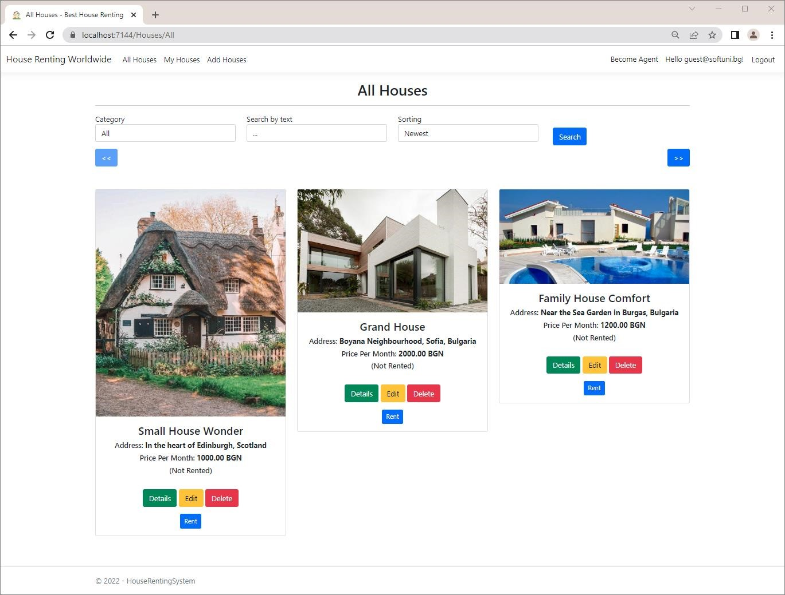

# Implement Custom Error Pages

In this task, we will see how to **implement custom error pages** for "**400** **Bad** **Request**" and "**401** **Unauthorized**" **errors** in "**Production**" **environment**, so that errors look more user-friendly. They will look like this:

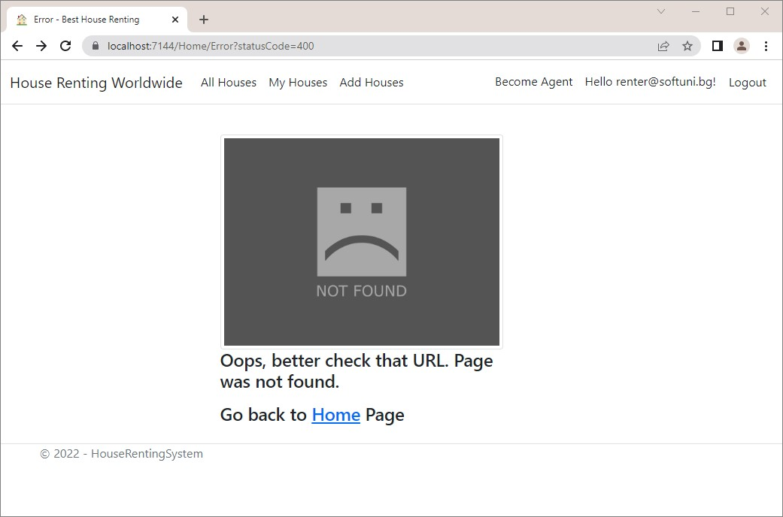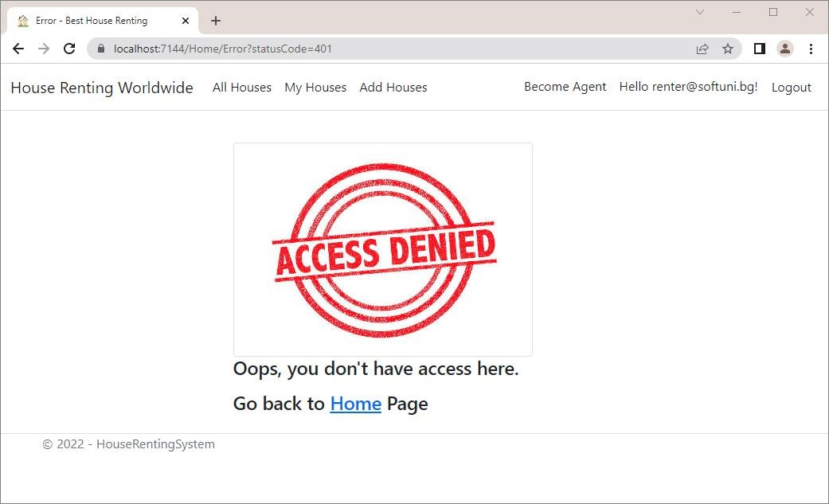

The **error page** for **other status code** will be the following:

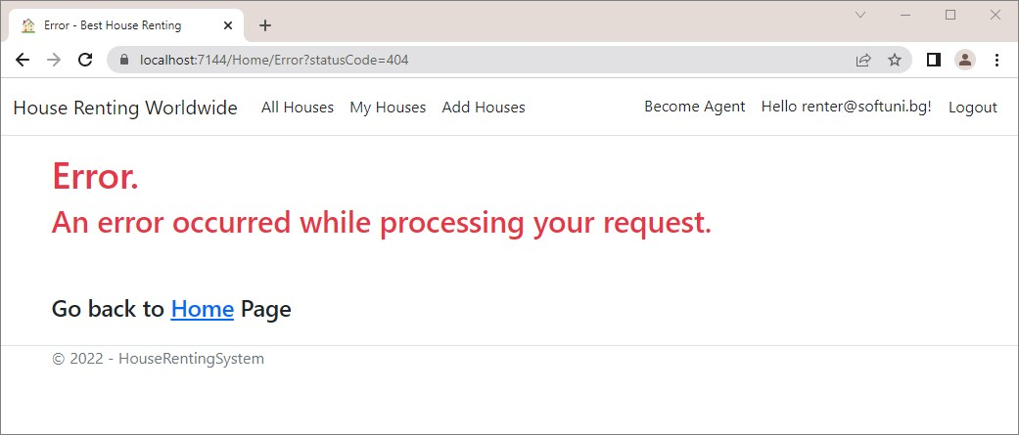

To make **custom error pages**, we should first **modify the app middleware**. Go to the **Program.cs:**

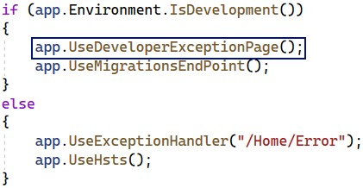

Note that when we are in "**Development**" **environment**, we have a **middleware** for using **developer exception** **pages**. When we are not, we **invoke** the **Error()** **method** of the **HomeController** **class**, which **returns an error view**.

In our case, however, we want to **set custom error pages** when we are not in "**Development**", depending on the **error status code**.

For this reason, we should **change the second middleware**, responsible for **status code pages**. We want to be **redirected** again to "**/Home/Error**" but also to have the **status code as an** **URL query parameter**. Note that the "**500** **Internal** **Server** **Error**" is treated differently than other status code pages, so we should **set a special** **exception handler** for it. Do it like this:

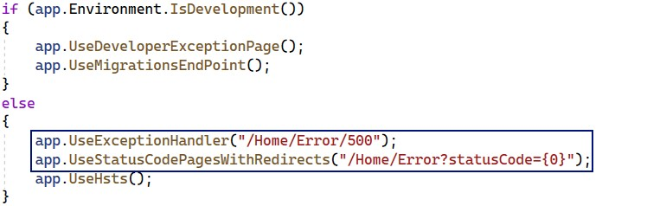

Now our **Error()** **method** in the **HomeController** should accept a **status code** like this:



Then, if we have a **status code** "**400** **Bad** **Request**", we will return the **"Error400.cshtml"** **view** (which we will create later):

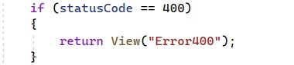

If we have a **status code** "**401** **Unauthorized**", we will return the **"Error401.cshtml"** **view**:

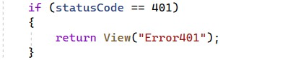

If none of the above cases happen, we should just return the **"Error.cshtml"** **view**:



Now let's **create the view files**. In the "**/Views/Home**" **folder** create the **"Error.cshtml"**, **"Error400.cshtml"** and **"Error401.cshtml"** **views**:

**Remove** the **"Error.cshtml"** file from the "**/Views/Shared**" **folder**, as we won't need it. Also, **remove** the **ErrorViewModel** **class** from the "**/Models**" **folder**:

Write the **"Error.cshtml"** **view** like this

@{

ViewData["Title"] = "Error";

}

<h1 class="text-danger">Error.</h1>

<h2 class="text-danger">An error occurred while processing your request.</h2> <br /><br />

<div class="text-left h4"> Go back to <**a** **asp-controller**="Home" **aspaction**="Index">Home</**a**> Page</div>

The **"Error400.cshtml"** **view** should be the following:

@{

ViewData["Title"] = "Error";

}

<div class="row">

<div class="col-3"></div>

<div class="col-6">

<br>

<div class="row">

<div class="col-10">

<img

src="https://www.publicdomainpictures.net/pictures/280000/velka/not-found-image-

15383864787lu.jpg" alt="Alternative image" class="img-thumbnail">

<div class="text-left h4">

<p>Oops, better check that URL. Page was not found.</p>

</div>

<div class="text-left h4"> Go back to <**a** **asp-controller**="Home" **aspaction**="Index">Home</**a**> Page</div>

</div>

</div>

</div>

<div class="col-3"></div>

</div>

Get the **image URL** from here:

<https://www.publicdomainpictures.net/pictures/280000/velka/not-found-image-15383864787lu.jpg>

The last view is **"Error401.cshtml".** Write it like this:

@{

ViewData["Title"] = "Error";

}

<div class="row">

<div class="col-3"></div>

<div class="col-6">

<br>

<div class="row">

<div class="col-10">

<img src="https://media.istockphoto.com/photos/rubber-stamp-pictureid545992942?k=6&m=545992942&s=612x612&w=0&h=XD1kddQeDrbG9DEQQxGNf6_3snw4gdFZv8GqSFta

6Is=" alt="Alternative image" class="img-thumbnail">

<div class="text-left h4">

<p>Oops, you don't have access here.</p>

</div>

<div class="text-left h4"> Go back to <**a** **asp-controller**="Home" **aspaction**="Index">Home</**a**> Page</div>

</div>

</div>

</div>

<div class="col-3"></div>

</div>

The **image URL** for this page is the following:

[https://media.istockphoto.com/photos/rubber-stamp-pictureid545992942?k=6&m=545992942&s=612x612&w=0&h=XD1kddQeDrbG9DEQQxGNf6_3snw4gdFZv8GqSFta6Is=](https://media.istockphoto.com/photos/rubber-stamp-picture-id545992942?k=6&m=545992942&s=612x612&w=0&h=XD1kddQeDrbG9DEQQxGNf6_3snw4gdFZv8GqSFta6Is=)

Now let's **change the** **environment** to "**Production**", so that we can **test the error pages** we created. To do this, we need to **change** the **ASPNETCORE_ENVIRONMENT** **variable value**.

**Right-click** on the **project** in **Visual** **Studio** and go to **[Properties]**:

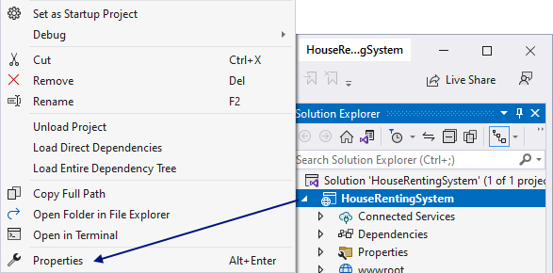

Then, go to the **[Debug]** **menu** and change the **ASPNETCORE_ENVIRONMENT** **variable value** from "**Development**" to "**Production**":

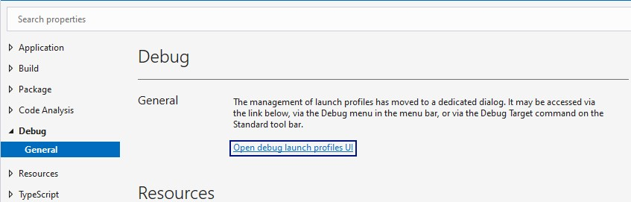

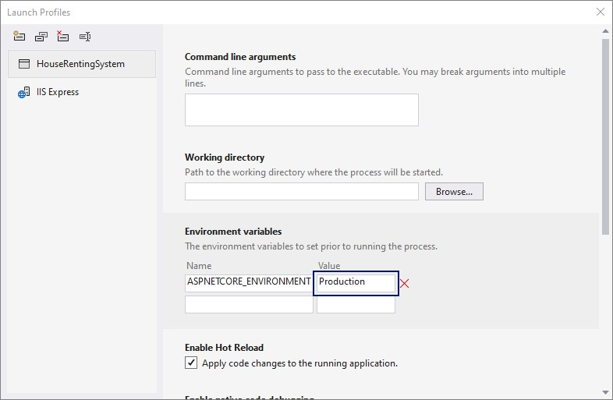

Now **run the app**. Go to a **non-existing page** like <https://localhost:44342/Houses/Details/1000>to see the "**400** **Bad** **Request**" **error page**. You should be **redirected** to [https://localhost:44342/Home/Error?statusCode=400.](https://localhost:44342/Home/Error?statusCode=400)

Test the "**401** **Unauthorized**" **error page** by going t[o https://localhost:44342/Houses/Edit/{id}](https://localhost:44342/Houses/Edit/%7bid%7d) with a **house id** **from the database**, but you **should not be the creator of the house**. You should be **redirected** to [https://localhost:44342/Home/Error?statusCode=401.](https://localhost:44342/Home/Error?statusCode=401)