Jackson Watkins

Professor Andrew Forney

CMSI 387 – Operating Systems

March 2, 2018

Sysiphus Command Report

* $ cd
  + Relative Path:

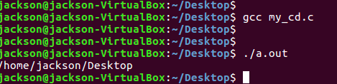

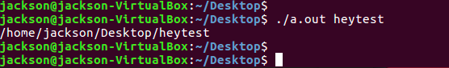

* + Absolute Path:

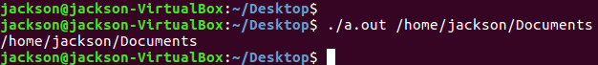

* $ ls
  + Relative Path:

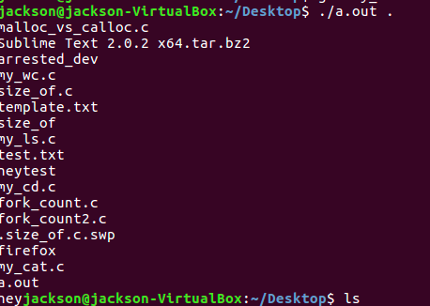

* + Absolute Path:

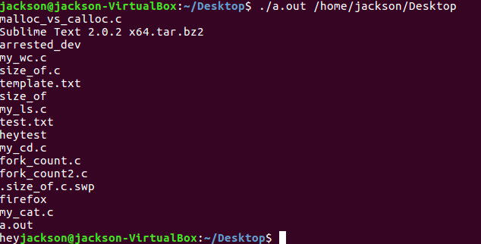

* $ ls -i
  + Relative Path:

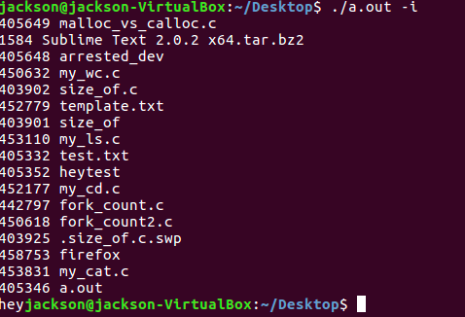



* + Absolute Path:

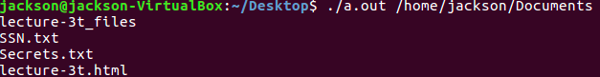

* $ wc
  + Relative Path:



* + Absolute Path:



* $ wc -w
  + Relative Path:



* + Absolute Path:



* $ cat
  + Relative Path:



* + Absolute Path:

