Favorite parts of my website

Jackson M

Link to website: https://jacksonm902.github.io/main/index.html

#1: Title bar logo

LINE OF CODE: <link rel="icon" href="img/title_logo_iNr_icon.ico" type="image/x-icon">

In use:



WHY IS IT ONE OF MY FAVORITE PARTS?

This is one of my favorite parts of the website because it makes my website look unique.

#2: The footer and header of my page

LINE OF CODE:

<footer class="webfooter">

<center>

<p class="p-footer">Contact information:<br>

Email: Company@office.ca<br>

Phone number: 902-449-0007<br>

Address: 2443 office ave, NY<br>

</p>

</center>

</footer>

IN USE:



WHY IS THIS ONE OF MY FAVORITE PARTS OF THE WEBSITE?

This is one of my favorite parts of the website because it helps divide the page and helps bring structure to the page.

#3: My fixed navigation bar

LINE OF CODE:

<nav style="border: 2px solid black;">

    <div class="main" style = "position:absolute; left:920px; top:80px;">

<ul class="ul-top">

<li><a class="active" href="index.html">Home page</a></li>

<li><a href="test dummy.html">Website's siteplan</a></li>

<li><a href="aboutme.html">About me</a></li>

</ul>

</div>

In use:



WHY IS THIS ONE OF MY FAVORITE PARTS OF THE WEBSITE?

This is one of my favorite parts of the website because the navigation bar is fixed to the top of the screen, so the user always has access to the navigation bar without having to scroll to the top.

#4: My best form

LINE OF CODE:

        <div class="main" style = "position:absolute; left:950px; top:410px;">

<table class="Form-table">

<form class="am-form" action="mailto:Stephen.Franks@nscc.ca?subject=form" method="get" enctype="text/plain"style="font-size: larger;">

    <tr style="border: 2px solid black">

        <td style="border-bottom: 2px solid black;">

    <h1 class="h1">About Me!</h1>

    </td>

    </tr>

    <tr>

    <td>

    <label for="First name">First name:</label><br>

<input type="text" name="First name"><br>

<label for="Last name">Last name:</label><br>

<input type="text" name="Last name"><br>

<label for="birthday">Birthday:</label><br>

<input type="date" name="birthday"><br>

<label for="Email">Email address:</label><br>

<input type="email" name="Email address" placeholder="Ex. Company@email.com"><br>

<label for="Province">Province:</label><br>

<select id="Province" name="Province"><br>

<option value="Alberta">Alberta</option>

<option value="British Columbia">British Columbia</option>

<option value="Manitoba">Manitoba</option>

<option value="New Brunswick">New Brunswick</option>

<option value="Newfoundland and labrador">Newfoundland and labrador</option>>

<option value="Nova scotia">Nova Scotia</option>

<option value="Ontario">Ontario</option>

<option value="Prince Edward Island">Prince Edward Island</option>

<option value="Quebec">Quebec</option>

<option value="Saskatchewan">Saskatchewan</option>

</select><br>

<label for="Postal code">Postal code:</label><br>

<input type="text" name="Postal code" min-length="5" placeholder="Ex. B3K-2Z1"><br>

<label for="City">City:</label><br>

<input type="text" name="city"><br>

<label for="What have you learned?">What have you learned?</label><br>

<input type="text" name="what have you learned?" size="50"><br>

<label for="Rate!">How was my form?</label><br>

<input type="range" name="Rate!" size="25"><br>

<input type="submit" value="submit">

<input type="reset" value="reset">

</td>

</tr>

</form>

</table>

</div>

IN USE:

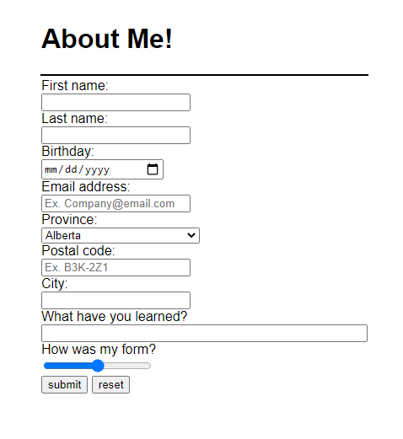

WHY IS IT ONE OF MY FAVORITE PARTS OF MY WEBSITE?

This is one of my favorite parts of my website because it took a long time to make, and it came out looking really nice and organized. I also like that the submit button actually works and emails the results to me.