BUS 387

Alchemy of Innovation: From Concept to Incubator Gold

Jayson R. Margalus

[jmargalus@wlu.edu](mailto:jmargalus@wlu.edu)

Jeff Schatten

[schattenj@wlu.edu](mailto:schattenj@wlu.edu)

Office Hours (by appointment)

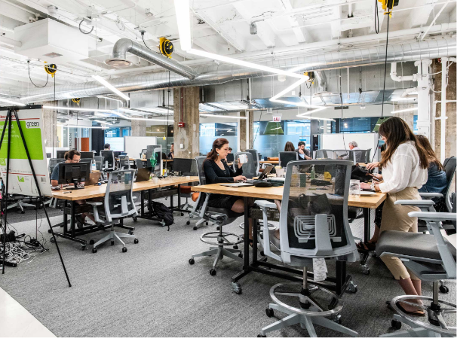

**Course Description**

A four-week Spring Term course that immerses students in an interdisciplinary learning experience in collaboration with a startup incubator(s). Students work with industry professionals on design and prototyping projects, engaging with new technology to develop valuable entrepreneurship, design thinking, and prototyping skills. This hands-on course exposes students to real-world problems and the processes and solutions to go about navigating their solutions.



**What This Course Is**

This course is designed to provide students with an immersive experience in innovation and entrepreneurship, focusing on collaborative design and prototyping. The course aims to foster valuable skills in entrepreneurship, teamwork, and communication, preparing students for future endeavors in various industries.

**What This Course Isn’t**

This course is not a conventional classroom-based learning experience, nor is it a simple networking opportunity. While interactions with industry professionals may lead to connections, the primary focus is on learning and skill-building. The course doesn't promise instant success or a one-size-fits-all formula for innovation. Instead, it provides students with the tools and frameworks to think creatively and critically, enhancing their ability to develop unique solutions to complex challenges in a collaborative and real-world environment. Finally, this course is not an exercise in “how to get an A.” In real life, grades don’t equate to success.

**Learning Outcomes**

* Analyze the entrepreneurial process through active participation in design and prototyping activities.
* Integrate interdisciplinary knowledge to develop viable prototypes using state-of-the-art technology and industry collaboration.
* Collaborate and communicate effectively within interdisciplinary project teams to enhance teamwork skills.
* Evaluate personal growth, professional development, and acquired skills throughout the course through reflection exercises.
* Persuasively present project outcomes to industry professionals and/or the public, demonstrating the ability to articulate innovative solutions effectively.

**Required Texts**

* *Zero to One*, Peter Thiel
* *Sprint: How to Solve Big Problems and Test New Ideas in Just Five Days,* Jake Knapp

**Week 0. Due Before Course Begins**

* Read *Sprint*
* Read *Zero to One*
* Create an X account
  + Share your account and follow all others in the Canvas forum
  + In addition, follow 200 active individuals who are founders, VCs, product folks, researchers in AI, and emerging technology.
* Create a Feedly account
  + Subscribe to 10 tech-related feeds
  + Subscribe to TechCrunch, MIT Technology Review, Wired, Stratechery, The Verge, Andreessen Horowitz’s Future, The Information, Benedict Evans’ blog, CB Insights, and Marginal Revolution.
  + Subscribe to the podcasts:
    - Tier 1: a16z, Acquired, How I Made This, All In, Artificial Intelligence Show, Rework, BG2, Hard Fork, Nickonomics, nVidia AI, Prof G Markets
    - Tier 2: Business Wars, Decoder, Dwarkesh
* Install the following applications on your computer and create an account with your school email address
  + Figma
  + GitHub
  + ChatGPT
  + Claude
  + Claude Code
  + v0 (does not have a local application, just create an account)
  + CrewAI
  + Lindy

**Every day (outside of class)**

* 5 X posts
  + 1-4 things about a tool that you’re using or something you’re creating
  + 1-4 things about something you’ve learned in the space
  + 1-4 pictures of you at a networking event in SF

**Course Schedule, Part I: In Lexington**

| **Day** | **Jay** | **Entrepreneurship** | **Jeff** | **Things Due/ Readings** |
| --- | --- | --- | --- | --- |
| 1 | Game | Zero to One | Team composition | Read: Zero to One ch 1-7 |
| 2 | Notes App | Zero to One | Founders and company culture | Read: Zero to One ch 8-14   * 20 viable business ideas * Game to GitHub * Submit calendar of 5 networking events |
| 3 | To Do App | Sprint | Pitches | Read: Sprint: Set the Stage, Monday, Tuesday   * Notes to GitHub * Competitive Analysis Presentation |
| 4 | Static Website | Sprint | * How to give and take constructive feedback * Mixed group feedback session * Creating a feedback-rich culture | Read: Sprint: Wednesday, Thursday, Friday   * To Do App to GitHub * Present business concept in small groups |
| 5 | Blog | VC | * AI as a collaborator, not a tool * Prompt engineering for product ideation * AI-Augmented Research | * Reading: [Machines of Love and Grace](https://www.darioamodei.com/essay/machines-of-loving-grace) * [A fundraising survival guide](https://www.paulgraham.com/fundraising.html) * [How to raise money](https://open.spotify.com/episode/5B2b3B6coCVY0POAEjY5Ur?autoplay=true) (interview) * Static Website to GitHub * Submit profiles of the alum SF panel |
| 6 | Social Media | VC | * AI and innovation * Start-up ideation in AI era | * Reading: [Three observations](https://blog.samaltman.com/three-observations) * [Reflections](https://blog.samaltman.com/reflections) * [In praise of Failure](https://www.ben-evans.com/benedictevans/2016/4/28/winning-and-losing) * [Start-Up Funding Stages](https://visible.vc/blog/startup-funding-stages/) * Blog to GitHub |
| 7 | Personalized Dashboard |  | * AI agents and autonomous workflows | * [AI 2027](https://ai-2027.com/) (buckle up) * Social Media to GitHub |
| 8 | Teach a Skill to Class |  | TBD | * Reading: TBD * Personalized Dashbaord to GitHub * Proposed SF itinerary, with justification |
| H |  |  |  | * Full Product * Pitch Deck |



**In SF**

| **Day** | **Jay** | **Entrepreneurship** | **Jeff** | **Things Due** |
| --- | --- | --- | --- | --- |
| 1 - May 12 | Travel | | | |
| 2 - May 13 | Site Visits | | | |
| 3 - May 14 | Redwoods | | | |
| 4 - May 15 | 9-12 - Devon McCalister-Rothwell & company visiting | | | |
| 5 - May 19 | TBD | TBD | TBD | TBD |
| 6 - May 20 | Site Visits   * 9am - Plug and Play - Tevin Panchal - 440 N Wolfe Rd, Sunnyvale CA. 650-235-0793 | | | |
| 7 - May 21 | Site Visits | | | |
| 8 - May 22 | Travel | | | |

| **Assignment** | **Grade composition** |
| --- | --- |
| 20 Business Ideas | 2% |
| Competitive Anal. Presentation | 5% |
| Networking | 5% |
| Daily App Post | 8% |
| Twitter Post | 8% |
| TED Talk in SF | 5% |
| TBD SF | 12% |
| Class participation | 25% |
| Final presentation | 10% |
| Final project | 20% |

**Attendance**

A major objective is for you to work with others and generate ideas while taking advantage of this innovative and creative environment, so attendance is required. You are expected to participate actively. The course provides unique opportunities for discussions with startup founders, citizens, and business people. You will learn more and it will be more interesting if you contribute to discussions. See the rubric above related to participation. The professors will post a weekly grade to Canvas. Note that exceeding two absences will by itself lead to a failing grade. (Also see the catalog, “Required Administrative Withdrawal.”)

**Late Policy**

No late submissions will be accepted.

**AI**

You are welcome/expected to use generative AI tools (e.g. ChatGPT, Dall-e, etc.) in this class as doing so aligns with an entrepreneur’s prerogative to leverage relevant technologies to iterate as quickly as possible. You are responsible for the information you submit based on an AI query (for instance, that it does not violate the community of trust, intellectual property laws, or contain misinformation or unethical content). Your use of AI tools must be properly documented and cited in order to stay within university policies on academic integrity. When in doubt about permitted usage, please ask for clarification.

**Academic Integrity**

Academic integrity is a fundamental aspect of our learning community, and all students are expected to adhere to the highest standards of honesty, fairness, and responsibility.

In the context of this course, academic integrity encompasses proper citation of sources, avoiding plagiarism, and ensuring that all submitted work is your own original effort. Any instances of academic dishonesty, including cheating, plagiarism, or other forms of misconduct, may result in course failure. By participating in this course, you commit to upholding the principles of academic integrity and contributing to a culture of trust and respect.

**Students with Disabilities**

I am committed to ensuring access to course content for all students. Reasonable accommodations are available for students with disabilities. Contact Lauren Kozak, Title IX Coordinator and Director of Disability Resources, to confidentially discuss your needs and the accommodation process. More information can be found at: https://www.wlu.edu/disability-accommodations/undergraduate-accommodations

If you have already been approved for accommodations, please meet with me within the first two weeks of the term so we can develop an implementation plan together. It is important to meet as early in the term as possible; this will ensure that your accommodations are implemented early on. If you have accommodations for test-taking, please remember that arrangements must be made at least a week before the date of the test or exam.

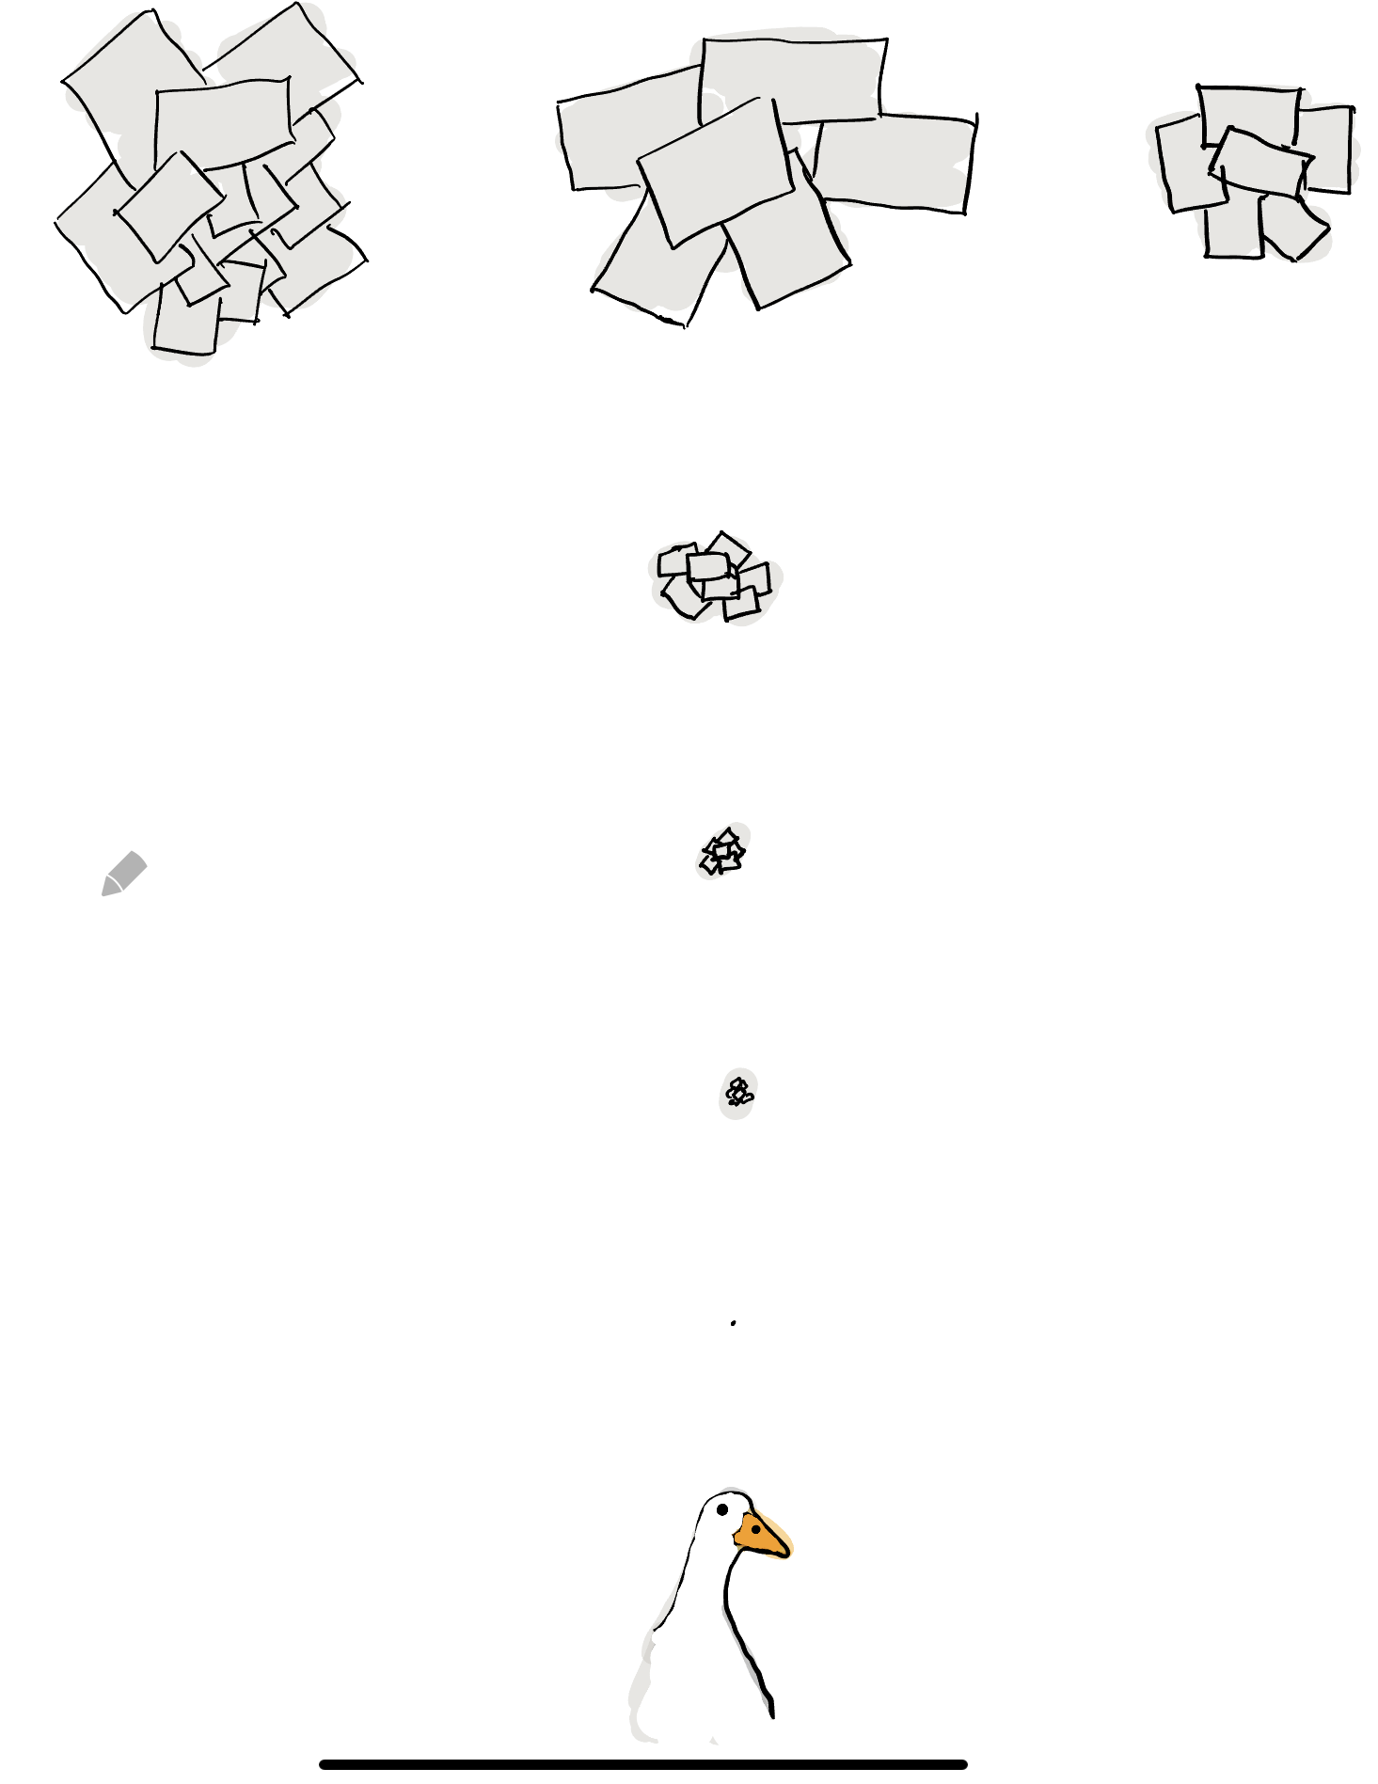

**Faculty NOTES**

**Class Structure**

* Start of class: 30 mins. Post to X based on what you’ve learned on X, RSS, podcasts. We select top 5 per day. We add what’s good news as well.
* Cold call: 10 mins, 2-3 students present on here’s how company X does Y with Z. Market cap under $100m.
* Lecture: 40 minutes
* Build: 60 minutes
* Lecture/Reflect: 40 minutes

**Site Visits**

**Confirmed**

* Drew Denbo
* Devon McCalister Rothwell
* Tevin Panchal - Plug and Play

**Possible**

* Todd Denbo
* Steve Allocca

[Anderson Lunsford ’04](https://nam11.safelinks.protection.outlook.com/?url=https%3A%2F%2Fwww.linkedin.com%2Fin%2Fandersonlunsford%2F&data=05%7C02%7Cjmargalus%40wlu.edu%7C8415cf7e941e40f4820208dd675b552c%7Cd1a80622a99943e58eb67873905e939e%7C1%7C0%7C638780364160872398%7CUnknown%7CTWFpbGZsb3d8eyJFbXB0eU1hcGkiOnRydWUsIlYiOiIwLjAuMDAwMCIsIlAiOiJXaW4zMiIsIkFOIjoiTWFpbCIsIldUIjoyfQ%3D%3D%7C0%7C%7C%7C&sdata=znNbu8j4kvTNH1JRRRXBZiHIdaFs1H3ESr%2B9a%2FiSe5M%3D&reserved=0): CEO, Co-founder @ **BreachRx** – intelligent incident response platform

[Anna Marie Daccache ‘19](https://nam11.safelinks.protection.outlook.com/?url=https%3A%2F%2Fwww.linkedin.com%2Fin%2Fannadaccache%2F&data=05%7C02%7Cjmargalus%40wlu.edu%7C8415cf7e941e40f4820208dd675b552c%7Cd1a80622a99943e58eb67873905e939e%7C1%7C0%7C638780364160897158%7CUnknown%7CTWFpbGZsb3d8eyJFbXB0eU1hcGkiOnRydWUsIlYiOiIwLjAuMDAwMCIsIlAiOiJXaW4zMiIsIkFOIjoiTWFpbCIsIldUIjoyfQ%3D%3D%7C0%7C%7C%7C&sdata=3%2BpqiNKF1gMSeZ8hFEl81FFJq98OabXMAe6FZCrWiFc%3D&reserved=0): Solutions Architect @ **NVIDIA** – in San Jose

[Blair Fletcher Harvey ’08](https://nam11.safelinks.protection.outlook.com/?url=https%3A%2F%2Fwww.linkedin.com%2Fin%2Fblair-fletcher-hardy-79b1a18b%2F&data=05%7C02%7Cjmargalus%40wlu.edu%7C8415cf7e941e40f4820208dd675b552c%7Cd1a80622a99943e58eb67873905e939e%7C1%7C0%7C638780364160910771%7CUnknown%7CTWFpbGZsb3d8eyJFbXB0eU1hcGkiOnRydWUsIlYiOiIwLjAuMDAwMCIsIlAiOiJXaW4zMiIsIkFOIjoiTWFpbCIsIldUIjoyfQ%3D%3D%7C0%7C%7C%7C&sdata=c5Jdsy3YGbKDNB8HY3j55BRNSJiW7TYAaaUK7gC%2F63o%3D&reserved=0): Co-founder @ **Pop & Bottle**

[Calle Ramsey ’17](https://nam11.safelinks.protection.outlook.com/?url=https%3A%2F%2Fwww.linkedin.com%2Fin%2Fcallie-ramsey-122018a0%2F&data=05%7C02%7Cjmargalus%40wlu.edu%7C8415cf7e941e40f4820208dd675b552c%7Cd1a80622a99943e58eb67873905e939e%7C1%7C0%7C638780364160924134%7CUnknown%7CTWFpbGZsb3d8eyJFbXB0eU1hcGkiOnRydWUsIlYiOiIwLjAuMDAwMCIsIlAiOiJXaW4zMiIsIkFOIjoiTWFpbCIsIldUIjoyfQ%3D%3D%7C0%7C%7C%7C&sdata=n9q4dBj%2BC2G8Q%2FiGJJCsfzke9axpkabs%2FmoRGxwgzQQ%3D&reserved=0): Commercial Manager @ **Figure** – AI robotics company/startup building human robots

[Elizabeth McCracken ’05](https://nam11.safelinks.protection.outlook.com/?url=https%3A%2F%2Fwww.linkedin.com%2Fin%2Fsemccracken%2F&data=05%7C02%7Cjmargalus%40wlu.edu%7C8415cf7e941e40f4820208dd675b552c%7Cd1a80622a99943e58eb67873905e939e%7C1%7C0%7C638780364160936813%7CUnknown%7CTWFpbGZsb3d8eyJFbXB0eU1hcGkiOnRydWUsIlYiOiIwLjAuMDAwMCIsIlAiOiJXaW4zMiIsIkFOIjoiTWFpbCIsIldUIjoyfQ%3D%3D%7C0%7C%7C%7C&sdata=dCKA846tqWW9rCveP%2F%2B%2Bgp8bf1KoLEi1Qfw1XmSnpVI%3D&reserved=0): Director of Finance @ **FalconX** – digital asset brokerage

[Gabrey Means ‘95](https://nam11.safelinks.protection.outlook.com/?url=https%3A%2F%2Fwww.linkedin.com%2Fin%2Fgabrey-means-aa922517%2F&data=05%7C02%7Cjmargalus%40wlu.edu%7C8415cf7e941e40f4820208dd675b552c%7Cd1a80622a99943e58eb67873905e939e%7C1%7C0%7C638780364160949171%7CUnknown%7CTWFpbGZsb3d8eyJFbXB0eU1hcGkiOnRydWUsIlYiOiIwLjAuMDAwMCIsIlAiOiJXaW4zMiIsIkFOIjoiTWFpbCIsIldUIjoyfQ%3D%3D%7C0%7C%7C%7C&sdata=GTQ%2BP7KjnwtH1ffIs83Pys4L7pLGuaXidTNVczWZZks%3D&reserved=0)(?): Co-Founder, Creative Director @ **Grow Marketing** – close friends with Devon Rothwell

[**Hilary Grosser Jaschke ‘10**](https://nam11.safelinks.protection.outlook.com/?url=https%3A%2F%2Fwww.linkedin.com%2Fcompany%2Fsnowflake-computing%2F&data=05%7C02%7Cjmargalus%40wlu.edu%7C8415cf7e941e40f4820208dd675b552c%7Cd1a80622a99943e58eb67873905e939e%7C1%7C0%7C638780364160962333%7CUnknown%7CTWFpbGZsb3d8eyJFbXB0eU1hcGkiOnRydWUsIlYiOiIwLjAuMDAwMCIsIlAiOiJXaW4zMiIsIkFOIjoiTWFpbCIsIldUIjoyfQ%3D%3D%7C0%7C%7C%7C&sdata=fVSN5VF1uiKdf4kFZn13AvI6a8a6tWmJ2RmB0hWsBZw%3D&reserved=0)**: Sales Leader @ Snowflake – AI data cloud services**

[Holley Beasley ’15](https://nam11.safelinks.protection.outlook.com/?url=https%3A%2F%2Fwww.linkedin.com%2Fin%2Fholleybeasley%2F&data=05%7C02%7Cjmargalus%40wlu.edu%7C8415cf7e941e40f4820208dd675b552c%7Cd1a80622a99943e58eb67873905e939e%7C1%7C0%7C638780364160974068%7CUnknown%7CTWFpbGZsb3d8eyJFbXB0eU1hcGkiOnRydWUsIlYiOiIwLjAuMDAwMCIsIlAiOiJXaW4zMiIsIkFOIjoiTWFpbCIsIldUIjoyfQ%3D%3D%7C0%7C%7C%7C&sdata=qFQeudqH7bvm8a5Ylvf3hbEtmeRXRpydkFMRvAxolgM%3D&reserved=0): Product lead @ **Power** – healthcare startup; was at Uber

[Katherine Worthington ’18](https://nam11.safelinks.protection.outlook.com/?url=https%3A%2F%2Fwww.linkedin.com%2Fin%2Fkatherine-worthington%2F&data=05%7C02%7Cjmargalus%40wlu.edu%7C8415cf7e941e40f4820208dd675b552c%7Cd1a80622a99943e58eb67873905e939e%7C1%7C0%7C638780364160988532%7CUnknown%7CTWFpbGZsb3d8eyJFbXB0eU1hcGkiOnRydWUsIlYiOiIwLjAuMDAwMCIsIlAiOiJXaW4zMiIsIkFOIjoiTWFpbCIsIldUIjoyfQ%3D%3D%7C0%7C%7C%7C&sdata=x%2ByEfUyCEyl6nwAy4A2%2BOOg%2BnpKAeOncu3ZmXPd0FHY%3D&reserved=0): Brand Partnerships @ **Instacart**

[Kemal Levi ‘04](https://nam11.safelinks.protection.outlook.com/?url=https%3A%2F%2Fwww.linkedin.com%2Fin%2Fkemallevi%2F&data=05%7C02%7Cjmargalus%40wlu.edu%7C8415cf7e941e40f4820208dd675b552c%7Cd1a80622a99943e58eb67873905e939e%7C1%7C0%7C638780364161003692%7CUnknown%7CTWFpbGZsb3d8eyJFbXB0eU1hcGkiOnRydWUsIlYiOiIwLjAuMDAwMCIsIlAiOiJXaW4zMiIsIkFOIjoiTWFpbCIsIldUIjoyfQ%3D%3D%7C0%7C%7C%7C&sdata=zKo503vvIqAXt8XBm7%2FLXQxRHuJO%2BceHY4%2FXz0dKVBQ%3D&reserved=0): Founder and CEO @ **Relimetrics**

[Kerry Cotter Ono ’13](https://nam11.safelinks.protection.outlook.com/?url=https%3A%2F%2Fwww.linkedin.com%2Fin%2Fkerry-cotter-ono%2F&data=05%7C02%7Cjmargalus%40wlu.edu%7C8415cf7e941e40f4820208dd675b552c%7Cd1a80622a99943e58eb67873905e939e%7C1%7C0%7C638780364161016216%7CUnknown%7CTWFpbGZsb3d8eyJFbXB0eU1hcGkiOnRydWUsIlYiOiIwLjAuMDAwMCIsIlAiOiJXaW4zMiIsIkFOIjoiTWFpbCIsIldUIjoyfQ%3D%3D%7C0%7C%7C%7C&sdata=JBhTRGkX7q4R9FUpYZAfDqrLMIz4LH7SlOza1u59lcw%3D&reserved=0): Senior Operations Manager @ **Grindr** – she’s done a few career panels for us

[Lara McKeithan ’10](https://nam11.safelinks.protection.outlook.com/?url=https%3A%2F%2Fwww.linkedin.com%2Fin%2Flaramckeithan%2F&data=05%7C02%7Cjmargalus%40wlu.edu%7C8415cf7e941e40f4820208dd675b552c%7Cd1a80622a99943e58eb67873905e939e%7C1%7C0%7C638780364161028986%7CUnknown%7CTWFpbGZsb3d8eyJFbXB0eU1hcGkiOnRydWUsIlYiOiIwLjAuMDAwMCIsIlAiOiJXaW4zMiIsIkFOIjoiTWFpbCIsIldUIjoyfQ%3D%3D%7C0%7C%7C%7C&sdata=L47yCFaqGjj8WV85Gqi%2FXWBcoY7%2BOV1foov7%2B%2BY3uzA%3D&reserved=0): Founder @ **Pericus Ventures** – growth marketing for seed stage tech startups

[Leland Clemons ‘72](https://nam11.safelinks.protection.outlook.com/?url=https%3A%2F%2Fwww.linkedin.com%2Fin%2Fleland-clemons%2F&data=05%7C02%7Cjmargalus%40wlu.edu%7C8415cf7e941e40f4820208dd675b552c%7Cd1a80622a99943e58eb67873905e939e%7C1%7C0%7C638780364161041150%7CUnknown%7CTWFpbGZsb3d8eyJFbXB0eU1hcGkiOnRydWUsIlYiOiIwLjAuMDAwMCIsIlAiOiJXaW4zMiIsIkFOIjoiTWFpbCIsIldUIjoyfQ%3D%3D%7C0%7C%7C%7C&sdata=H0sIzRU7sxlAI12v3TC4G3eWiuRLd2ivuFnsW8Drxh8%3D&reserved=0): Founder/CEO @ **BondBoxx** – ETF Issuer

[Michael Kronthal ’95](https://nam11.safelinks.protection.outlook.com/?url=https%3A%2F%2Fwww.linkedin.com%2Fin%2Fmkronthal%2F&data=05%7C02%7Cjmargalus%40wlu.edu%7C8415cf7e941e40f4820208dd675b552c%7Cd1a80622a99943e58eb67873905e939e%7C1%7C0%7C638780364161053123%7CUnknown%7CTWFpbGZsb3d8eyJFbXB0eU1hcGkiOnRydWUsIlYiOiIwLjAuMDAwMCIsIlAiOiJXaW4zMiIsIkFOIjoiTWFpbCIsIldUIjoyfQ%3D%3D%7C0%7C%7C%7C&sdata=mwtpZjoSqLaEe%2FI1XFAdQ8Bjpen9NWLbHZ85e8zvA7E%3D&reserved=0): Director of Research @ **Gametime**

[Sam Childress ’19](https://nam11.safelinks.protection.outlook.com/?url=https%3A%2F%2Fwww.linkedin.com%2Fin%2Fsam-childress-617081124%2F&data=05%7C02%7Cjmargalus%40wlu.edu%7C8415cf7e941e40f4820208dd675b552c%7Cd1a80622a99943e58eb67873905e939e%7C1%7C0%7C638780364161065270%7CUnknown%7CTWFpbGZsb3d8eyJFbXB0eU1hcGkiOnRydWUsIlYiOiIwLjAuMDAwMCIsIlAiOiJXaW4zMiIsIkFOIjoiTWFpbCIsIldUIjoyfQ%3D%3D%7C0%7C%7C%7C&sdata=8RajkTwCPYI3P0QmlaJETD5%2FX5YmgoTd38pgSdQIvOM%3D&reserved=0): Strategy and Operations @ **Uber**

[Steven Anderson ’20](https://nam11.safelinks.protection.outlook.com/?url=https%3A%2F%2Fwww.linkedin.com%2Fin%2Fsteven-james-anderson%2Fdetails%2Fexperience%2F&data=05%7C02%7Cjmargalus%40wlu.edu%7C8415cf7e941e40f4820208dd675b552c%7Cd1a80622a99943e58eb67873905e939e%7C1%7C0%7C638780364161077180%7CUnknown%7CTWFpbGZsb3d8eyJFbXB0eU1hcGkiOnRydWUsIlYiOiIwLjAuMDAwMCIsIlAiOiJXaW4zMiIsIkFOIjoiTWFpbCIsIldUIjoyfQ%3D%3D%7C0%7C%7C%7C&sdata=t41i12yua8QQGlLS8HOwjgKiNKZ0y41Qs71A0P0IUFw%3D&reserved=0): Product Specialist @ **Adobe** – former Career Fellow

[Tony Du ‘19](https://nam11.safelinks.protection.outlook.com/?url=https%3A%2F%2Fwww.linkedin.com%2Fin%2Ftonydu2%2F&data=05%7C02%7Cjmargalus%40wlu.edu%7C8415cf7e941e40f4820208dd675b552c%7Cd1a80622a99943e58eb67873905e939e%7C1%7C0%7C638780364161088729%7CUnknown%7CTWFpbGZsb3d8eyJFbXB0eU1hcGkiOnRydWUsIlYiOiIwLjAuMDAwMCIsIlAiOiJXaW4zMiIsIkFOIjoiTWFpbCIsIldUIjoyfQ%3D%3D%7C0%7C%7C%7C&sdata=3NFkvHHSQ6xkmA%2FCZP7%2F6bL4fIy1AeH%2FH4iNCb%2BqVdw%3D&reserved=0): Business Strategy @ **Apple**