CSE 4300/5300 Final Project Spring 2025

Page-Replacement Algorithm implementation

Requirement:
1) Implement Optimal Page Replacement Algorithm (OPT)
2) Implement either FIFO or LRU Page Replacement Algorithm

Project Type:
Undergraduate Students: two students form a team
Graduate Students: individual

Input: Your program read from a text file which include:
1) A choice of a replacement algorithm (FIFO, OPT, and LRU)
2) A number of memory frames,
3) A reference string.

FIFO.txt: F,4,2,3,2,1,5,2,4,5,3,2,5,2
OPT.txt: O,3,1,2,1,3,1,4,1,5,1,6,1,7,1,8
LRU.txt: L,5,2,3,2,1,5,2,4,5,3,2,5,2

The first character in the string means the type of algorithm, e.g.: “F” means FIFO algorithm. The second character in the string means the number of memory frames, e.g.: “4” represents that the number of memory frames is 4. The rest is the reference string. You cannot hard code frame numbers.

Output: Your program should
- Calculate the number of page faults
- Display an output similar to the figure below. When no page fault occurs you may show the column as blank.
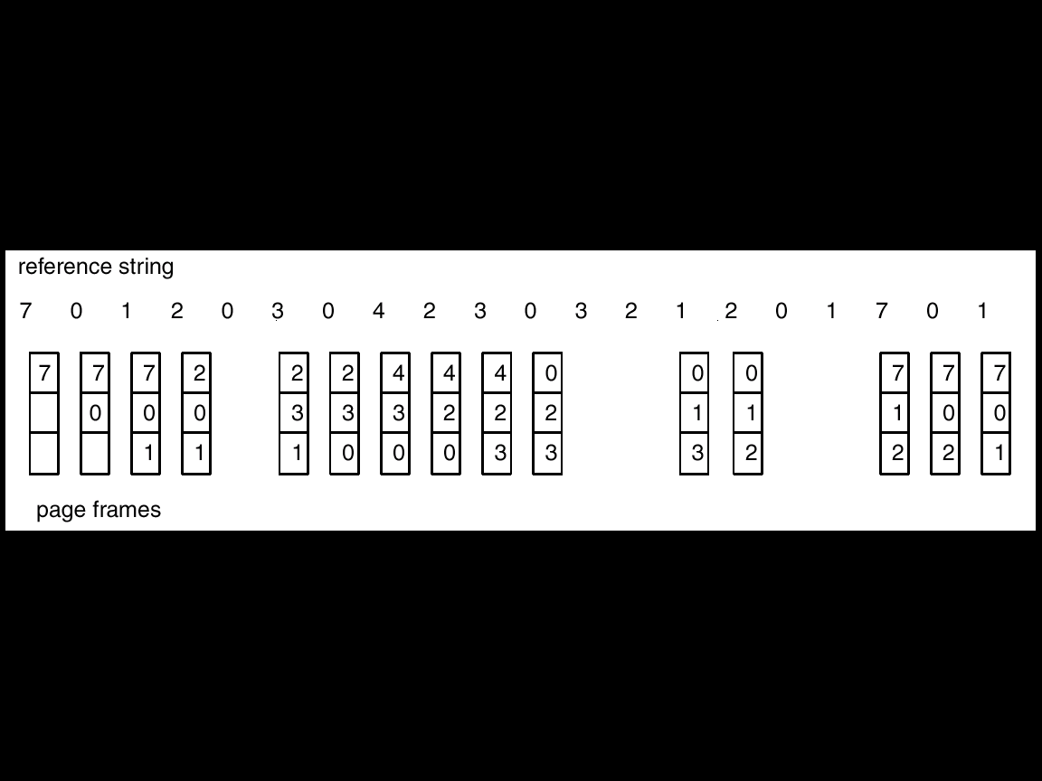

Due Date: 11:59PM, 4/14 (Mon);
Cutoff Date: 11:59PM, 4/16 (Wed). Late penalty -10pts for submitting on 4/15; Late penalty -20pts for submitting on 4/16. No submission will be accepted after 4/16.

Grading: Please see the grading criteria in final project rubrics.docx

Note:
1. In-person Demo is required. If an in-person demo is not conducted, I assume that your project is not working and you will lose -80 points
2. You have to use C++ to implement the algorithms by writing your own source codes. For all the below cases, you will receive a “0” instead:
- Other programming languages (like Python) are NOT accepted
- Cannot use Vector, Queue, and related pre-existing functions/methods in the implementation, e.g.: enqueuer, dequeuer, push and pop are not allowed.
- Calling functions & libraries of FIFO, OPT and LRU are NOT accepted.
- Using existing source codes from the Internet is not acceptable. You will also NOT get any credit for providing URLs to cite where you get the code from.

Requirement for In-Person Demo:
- Run your program using test data, and show results
- Explain the source codes
- Demo time: 4/15 (Tues, 3 bonus point), 4/17 (Thu)

Submission: Submit *.cpp files only to Blackboard

