Winch
Control System Manual

Head Record
Contents
1. Overview - 2 -
2. Control Principles - 2 -
3. Operating Instructions - 2 -
4. Technical parameters of the main motor - 3 -
5. Technical Specifications of the Frequency Converter - 3 -
6. Technical Specifications of the Control Panel - 5 -
7. Common Troubleshooting Guide - 6 -
8. Precautions for sealing - 6 -
9. Electrical Drawings - 6 -

Overview
The winch control system consists of a frequency converter cabinet and an operating console and is suitable for the following working conditions:
( 1 ) Environmental conditions: -10～45℃;
(2) Impacts and vibrations that occur under normal operating conditions;
(3) The periodic tilt is no greater than 22.5° ;
(4) Power supply: 380V / 3P/ 50HZ ; Control power supply : AC220V DC24V ;

Control Principles
- Overview of Control Systems
This control system uses an ABB frequency converter for vector control of the winch's cable winding and unwinding, as well as speed adjustment. It can be controlled from a control panel, which starts and stops the frequency converter to drive the electric winch. The control handle controls the main unit's forward rotation, stop, and reverse rotation. It features frequency converter start/stop, emergency stop, fault alarm, and reset functions, and displays voltage, frequency, and current.
- The control circuit has the following protections
- Air switch QF1 protects the power input line;
- The control circuit is protected by circuit breakers F1 , F2, and F3;
- Brake and fan motor protectors Q1 and Q2 provide protection;
- The frequency converter cabinet is equipped with space heating to ensure that the space inside the frequency converter cabinet is dry and the operating temperature is suitable.
- The frequency converter has comprehensive motor protection functions, including power phase loss, motor overload, and output grounding protection.

Operating Instructions
  - When the main switch QF1 and motor protectors Q1 and Q2 are closed, and circuit breakers F1 , F2, and F3 are activated, the power indicator lights of the frequency converter cabinet will illuminate; the power indicator light on the control panel will also illuminate, and the voltmeter will display the current incoming power voltage.
  - Press the inverter start button SB3, the contactor KM0 is energized and engaged, the inverter power supply is connected and ready, and the cooling fan turns on.
  - After the inverter starts, wait 5 seconds, press the mechanical lock on the handle (zero position protection), pull the handle in the direction of cable retraction, and the motor will run forward at a frequency of 2~50HZ; push the push rod back to the zero position and the motor will stop; conversely, push the push rod in the opposite direction and the motor will run in reverse at a frequency of 2~50HZ. Return to the zero position and the motor will stop working.
  - Press the emergency stop button to stop the entire machine from working.
  - When the motor frequency reaches the predetermined value, the inverter RO1B/RO1C contact K3 is energized, KM1 is energized, and the brake is opened.
  - When the inverter fault buzzer alarm sounds on the control panel, the inverter RO3B/RO3C contacts close. After the fault is cleared, press the fault reset button SB4.
  - When a combined fault occurs, the Q1 or Q2 motor protector will trip. It is necessary to check whether the corresponding motor in the frequency converter cabinet is abnormal. Only after the fault is eliminated can the motor be operated normally .

Technical parameters of the main motor
Motor model: YZP315S1-6-90KW
Motor power: 90KW
Electric motor power: 380V 50Hz
Variable frequency motor: 1 unit, brake 380V.

Technical Specifications of Frequency Converter
- Inverter power: 110KW ;
- The cabinet is made of carbon steel with an IP44 protection rating .
- Braking resistor model: 90KW 5.5Ω ;
- The panel features a power indicator light and an internal cabinet light. The top of the cabinet has lifting rings, providing sufficient overall rigidity. The bottom has mounting holes and a grounding copper busbar. Sufficient space must be considered for terminal block wiring to ensure standardized wiring .
- The control cable connection from the frequency converter cabinet to the control panel is a quick-connect aviation plug.

- Variable frequency cabinet schematic diagram
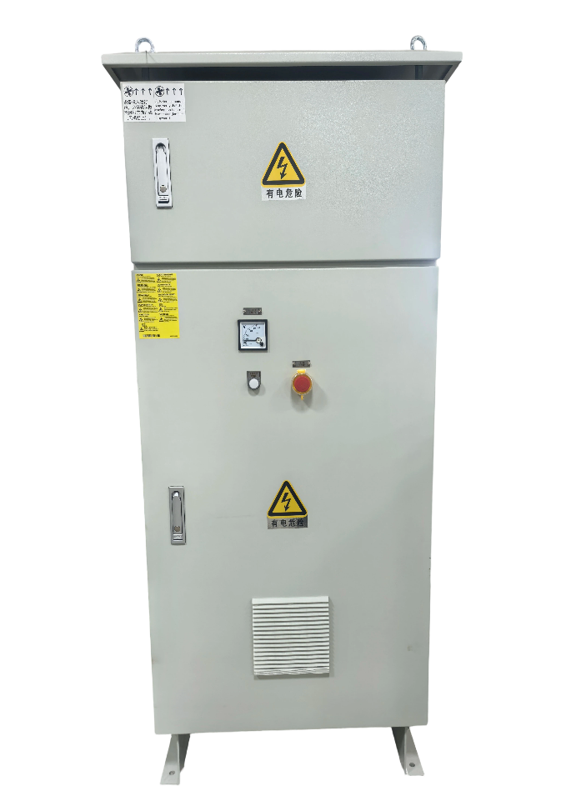 | 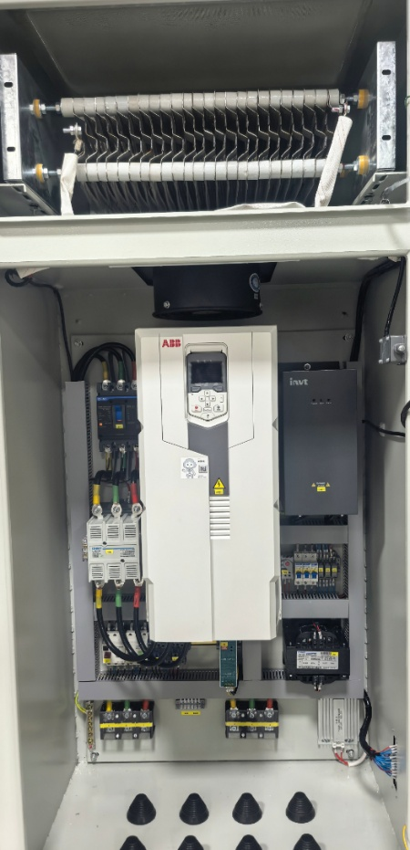

Technical specifications of the control panel
- Control panel diagram
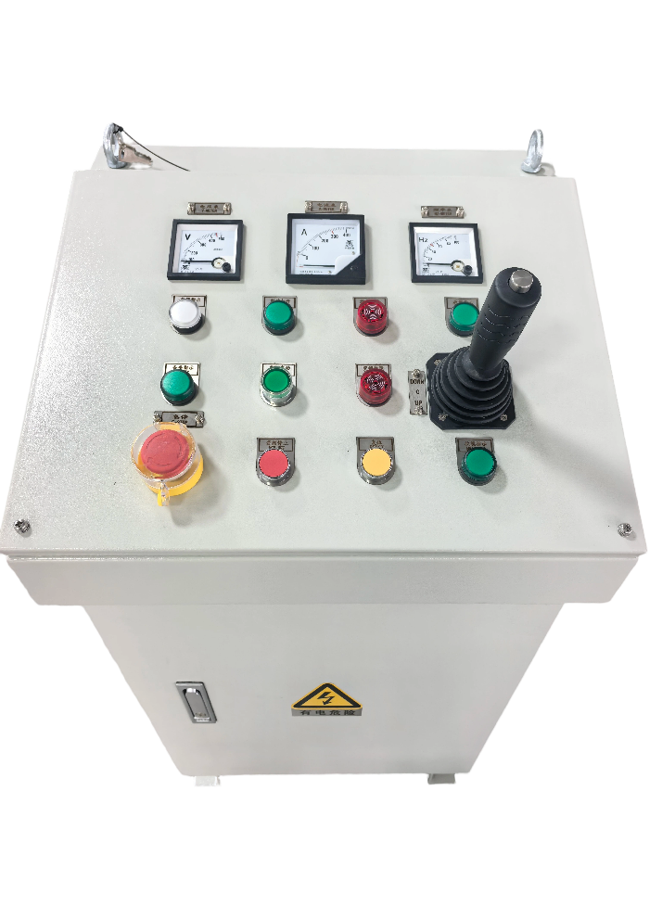 | 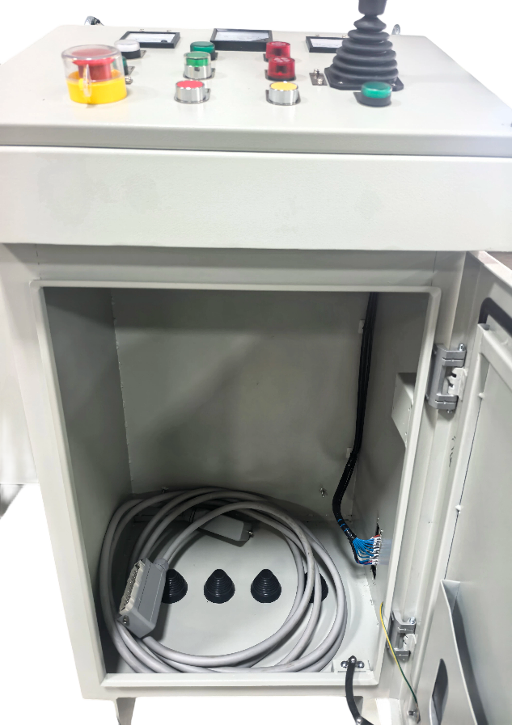

Common Troubleshooting Guide
- The brake fails to disengage when the handle is used to reel in or unleash the cable! The following points should be checked:
- Check if the K3 relay inside the frequency converter cabinet is engaged properly.
- Check if the KM1 contactor inside the frequency converter cabinet is engaging properly.
- Check if the voltage between the three phases (UVW) of the brake terminals is 380V ± 10%.
- Check if the brake is stuck to the brake wheel.
- The main motor does not run when the control handle is used to reel in or unelevate the cable! The following are the key points to check:
- Check if the KM0 contactor inside the frequency converter cabinet is engaging normally.
- Check if the frequency converter starts normally and if the power supply is normal.
- Check if the inverter panel is in remote mode.

Precautions for sealing
- Remove dust and dirt from inside and outside the cabinet.
- To prevent dust accumulation, the control box should be covered with a waterproof tarpaulin.
- The warehouse where the control cabinet is stored should be kept clean and dry. The temperature of the warehouse should be maintained between 0 and 35°C, and the relative humidity should be maintained between 55% and 70%. There should be no corrosive gases in the warehouse.
- During the storage period, the control cabinet must be inspected regularly (at least once every six months). If no improper storage, corrosion or other problems are found, it should be cleaned up immediately, and a new oil seal should be applied after the inspection.

Electrical drawings
See attachment!

