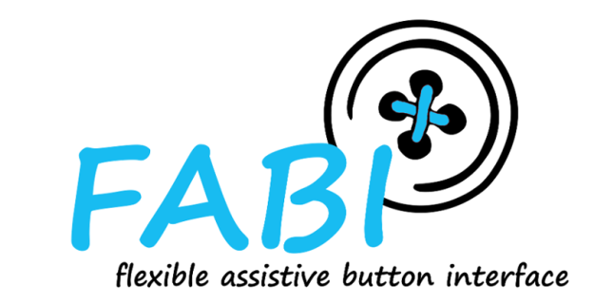

FABI - Flexible Assistive Button Interface

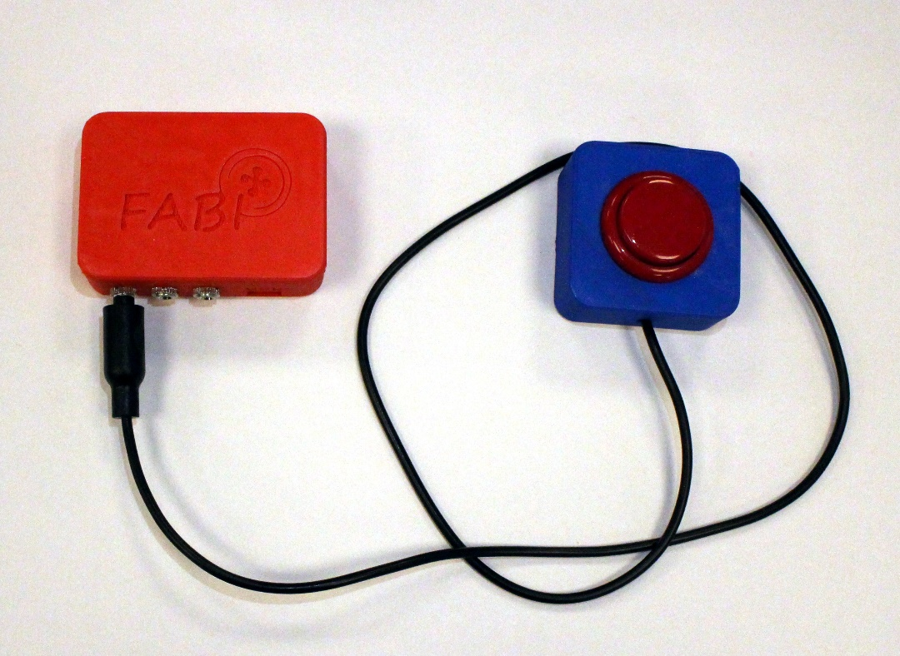

User Manual

AsTeRICS Foundation

# Table of Contents

contents 2

Welcome to FABI 3

About this guide 3

Introduction 4

Download and install the software 4

Connect the USB micro cable 4

Using the FABI-GUI application 5

Assignment of the button functions 9

Use of a pressure sensor (sip / puff) 12

Further options: Settings 12

Use of the "Long Press" functions 13

Use of the "anti-tremor" functions 13

List of supported macro commands 14

List of abbreviations for keyboard keys 15

Further links and software recommendations 16

AsTeRICS and AsTeRICS Grid 16

SpecialEffect.org 16

BLTT.org 16

OneSwitch.org 16

Contact information 17

Disclaimer of liability 17

Acknowledgement 17

# Welcome to FABI

FABI - the "Flexible Assistive Button Interface" - makes it possible to connect several momentary switches (buttons) to a computer or a tablet / smartphone via a USB socket. Pressing a button can trigger desired keys on the keyboard or carry out other mouse cursor actions. A configured FABI module can be used with any computer (Windows, Linux or Mac) without installing special software, because the FABI module behaves like a normal computer mouse or keyboard when it is connected to the computer. People for whom conventional input devices are not suitable can play computer games, surf the Internet, write e-mails and much more.

The FABI interface can be used with arcade buttons, assistive switches or self-made electrical contacts. FABI consists of a hardware module (an inexpensive microcontroller that functions as a computer mouse or keyboard) and a graphical configuration interface ("FABI-GUI") for setting the desired functions.

FABI is available as an open source kit (including the corresponding assembly instructions for the hardware) and was developed as part of the AsTeRICS Academy project at the UAS Technikum Wien. In 2017, the non-profit organization AsTeRICS Foundation was founded in order to further develop such technologies and systems and make them available to the public, see:  
 [www.asterics-foundation.org](http://www.asterics-foundation.org/).

All software modules, the hardware design files and the documents for the instructions are available under free and open source licenses and can be used and modified free of charge. We have tried to select the most cost-effective components for the desired functions - which makes FABI the most cost-effective push button interface in the currently known universe!

### About this guide

These instructions serve to explain the configuration interface and the possible settings and functions. The assembly instructions can be found in a separate document.

In order to set the desired functions through the FABI-GUI, it may be necessary to install a driver (the driver installation is explained in this manual).

## Introduction

The "FABI-GUI" configuration software is required in order to be able to define the functions of the buttons. After a configuration has been saved in the FABI system, it is retained there and the FABI system can be used to control various devices (e.g. Windows PC, Mac computer, tablet or smart phone with USB connection.)  
The configuration software is only required again when settings are to be changed.

### Download and install the software

The executable file FabiGUI.exe can be downloaded from the AsTeRICS GitHub directory: <https://github.com/asterics/FABI/releases/latest>

Save this file in a desired directory on a Windows PC or laptop.

In principle, the FABI-GUI software can also be started under macOS or Linux, with the help of the "mono" software, which can be found here: [https://www.mono-project.com/download/stable](https://www.mono-project.com/download/stable/)

After the FabiGUI.exe file has been downloaded from the above-mentioned source, start the application by double-clicking it. If an error message appears, the "Microsoft.Net Framework" is probably not installed on your computer. In this case, download the framework from the following website:  
<http://www.microsoft.com/en-us/download/confirmation.aspx?id=17718>

### Connect the USB micro cable

Connect the USB plug to the computer. Smartphones / tablets can be connected via a USB-OTG adapter.

Connect this end to the FABI module. Be careful when plugging in, the socket on the microcontroller is not very stable.

In case you have problems or

Then a COM port with a certain number (e.g. COM4) should be selectable in the FabiGUI software in the selection box "FABI Port" (see Figure 2). After unplugging the FABI module, the COM port should disappear again. If no new COM port is created by plugging in the FABI module, please install the Arduino software from the following source and then try again: <https://www.arduino.cc/en/software>

If you have any questions about the download or problems installing the software, please send us an email to: office@asterics-foundation.org

## Using the FABI-GUI application

After the FabiGUI.exe application has been started, the following window should open:

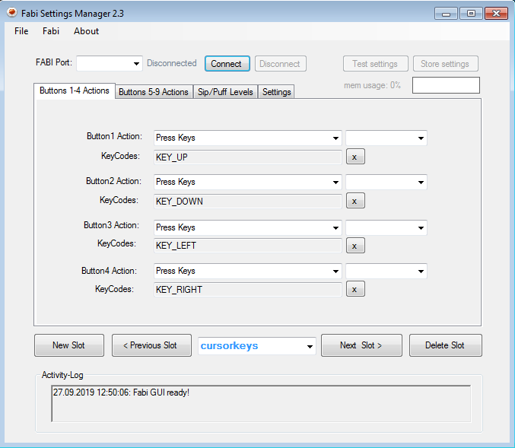

Figure 1: FabiGUI user interface

#### Connect the FABI device:

To use the functions of the configuration software, follow the steps below:

1. Make sure that the device is connected to the computer with a USB cable.
2. Select the appropriate COM port (Communication Port) in the selection field at the top of the application window. If the selection box does not show a COM port number that corresponds to the FABI module, unplug the device and plug it in again, and then click on the selection box to update the COM port list
3. As soon as the COM port is selected, click on the “Connect” button on the right-hand side of the selection field. When the device is connected, a confirmation appears in the activity log in the lower area of ​​the application window.
4. If the connection is successful, existing settings can be loaded from the device - if you want to do this, click on "Yes" in the selection dialog (see Figure 2).

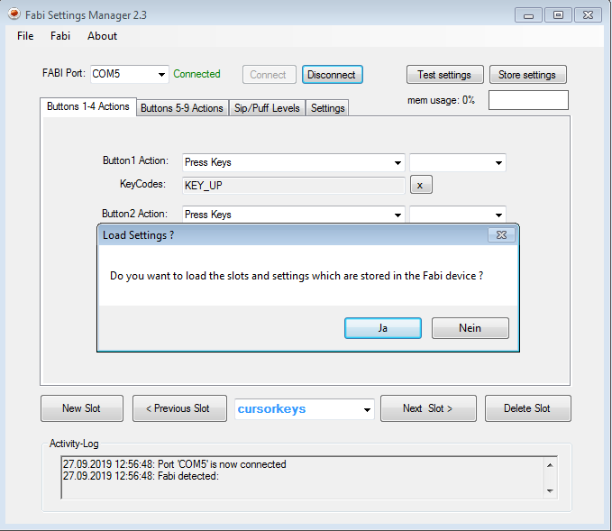

Figure 2: The program has been successfully connected to the microcontroller port

#### Port status

The port status next to the selection box for the FABI port (top left) shows whether the device is currently connected to the application or not. The selected functions of the push button can only be transferred to the device if the port status "Connected" is shown.

#### Activity log

The Activity Log area is displayed in the lower section of ​​the application window and shows the current error and status messages of the application.

#### Test settings

The selected functions for up to 9 buttons are activated when you click on “**Test settings**”. It is then possible to test the functions on your FABI device. This does not permanently save the settings.

#### Save settings

To save the changes permanently in the device, please press "**Store settings**"!

As soon as settings are saved or activated, you will receive a message in the  
*Activity log*.

#### Use of the storage spaces (memory slots)

Function settings can be saved in up to 10 memory slots of the microcontroller. These memory locations can also be changed during operation (e.g. via a specific button). The configurations of the memory slots are retained when the microcontroller is disconnected from the USB cable / power supply. As soon as the FABI device is supplied with power again via the USB cable, the first slot is automatically loaded and activated.

A new storage space is created by clicking on "**New Slot**". Any name can be assigned with a subsequent click in the text field. If you click on the arrow on the right-hand side of the text field, a drop-down menu opens that shows slots that have already been saved and where they can be selected. By clicking on "**Previous Slot**" or "**Next Slot**" you can switch „step by step“ between the existing memory locations.

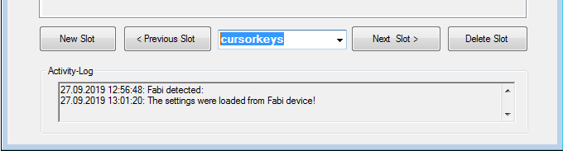

Figure 3: Creating, changing and deleting storage locations

Changes are always made in the currently selected configuration. The current configuration can be tried out on the device using "**Test settings**".

Click “**Delete slot**” to delete the current slot.

#### Loading, saving and transferring configurations

The File menu allows the entire configuration to be saved as a file (.set) on the computer. This settings file can then be transferred to the same or to a different FABI device. This means that several setups (e.g. for different users or use cases) can be saved on one computer and activated with one click. A data selection window enables the selection of a desired file name for saving (**Save Settings**) or loading (**Load Settings**) configuration settings.

**Attention**: When transferring the settings from a saved file to the FABI device, the current configuration settings are overwritten.

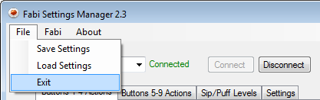

Figure 4: Loading and saving configuration settings

## Assignment of the button functions

With the FabiGUI applications, up to 9 buttons can be assigned different functions. Such functions include various mouse clicks, mouse movements, scrolling or pressing keyboard keys.

Please note that with the 3D-printed FABI housing only 8 of the 9 possible buttons also have recesses for the connections (jack sockets). Usually, fewer buttons are used anyway. If more than 8 buttons are required, several FABI modules can be operated in parallel.

The following chapter explains the selection of the functions for the buttons.

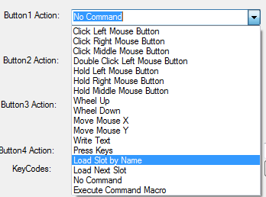

Figure 5: Selection of possible functions for buttons

#### Click Left / Right / Middle Mouse Button

These functions can be used to issue left, right or middle mouse clicks by pressing the button. Note: a click consists of pressing & releasing the corresponding mouse button, both happen in quick succession after pressing the user-operated switch!

#### Double click left mouse button

A double click of the left mouse button is necessary, for example, to open a file. However, performing quick mouse clicks can be difficult for some users. By assigning the “Double Click Left Mouse Button” function, a double click can be carried out by simply pressing the button.

#### Hold Left / Right / Middle Mouse Button

With these functions, the left, right or middle mouse button remains pressed as long as the button is held down (for example, to move a file, it is necessary to keep the left mouse button pressed).

#### Wheel Up / down - Scroll up / down

The functions “wheel up” and “wheel down” generate activities with the scroll wheel of the computer mouse. Triggering the “Wheel Up” function results in scrolling upwards, with the “Wheel down” function scrolling downwards (useful for reading documents or websites, for example).

#### Mouse Move X / Y - mouse movement in X or Y direction

The "Move Mouse X" and "Move Mouse Y" functions generate computer mouse movements along the selected axes. Speed ​​parameters can be set for these functions. When the button is pressed, the mouse pointer is accelerated up to this maximum speed.

A positive value for the X direction moves the mouse pointer to the right.

A negative value for the X direction moves the mouse pointer to the left.

A positive value for the Y direction moves the mouse pointer down.

A negative value for the Y direction moves the mouse pointer up.

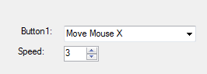

Figure 6: Screenshot of the "Mouse X" function or speed setting

#### Write text

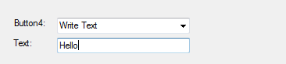The "Write Text" function allows to write a certain text every time the buttons is pressed. If you select Write Text, a blank text box will appear under the drop-down menu, then click the text box and enter the desired text:

Figure 7: Screenshot of the "Write Text" function

#### Press Keys - Press keyboard keys

The "Press Keys" function enables certain keys on the computer keyboard to be triggered as soon as the button is pressed. The keyboard keys are pressed as long as the button is held. The desired key can be selected from a selection box that is displayed on the left:

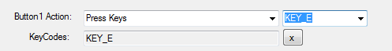

Figure 8: Screenshot of the "Press Key" function

The example in Figure 8 shows the use of the keyboard key “KEY_E” - a small “e” is written every time the key is pressed. It is also possible to select several keys for key combinations, which are then pressed / held at the same time. Keys that have already been assigned can be removed by clicking "X".

**Annotation:** Capital letters can be created in combination with "KEY_SHIFT". All other supported keyboard shortcuts can be found in the appendix.

#### Load Slot by Name - switch to configuration with a specific name

As soon as the button is pressed, the configuration with the specified name is activated. (This action is only relevant if you have saved configurations in several memory locations.)

#### Load Next Slot - switch to the next configuration

As soon as the button is pressed, the next configuration (the next memory location) is activated. After the last configuration, the first configuration is automatically activated. (This action is only relevant if you have saved configurations in several memory locations.)

#### No Command - no action

If “No Command” is selected in the function menu, no action will be taken when the button is pressed.

#### Execute Command Macro - execute macro commands

This action enables several commands to be executed using appropriate command abbreviations, which are entered in the text field separated by semicolons.

Example: The macro command MX 10; WA 500; KP KEY_A; moves the mouse cursor 10 points to the right, then waits 500 milliseconds and then presses the keyboard key "A".

**Note:** A list of the possible command and keyboard shortcuts can be found in the appendix.

## Use of a pressure sensor (sip / puff)

The FABI device enables the use of an optional pressure sensor (sip / puff or suction-blow sensor). Analog pressure sensors such as the sensor type [MPXV7007GP](https://www.digikey.at/product-detail/de/nxp-usa-inc/MPXV7007GP/MPXV7007GP-ND/1168441) can be used. The analog voltage is connected to the solder contact A0 on the microcontroller board. The sensor must also be supplied with operating voltage (correctly connect 5V and GND).

Then, in the tab "Sip / Puff Levels", corresponding threshold values ​​for the strength of the sip or puff activity can be set. These activities can trigger additional functions. The rest value of the sensor (when neither sipping of puffing) is in the middle of the value range, at approx. 512.

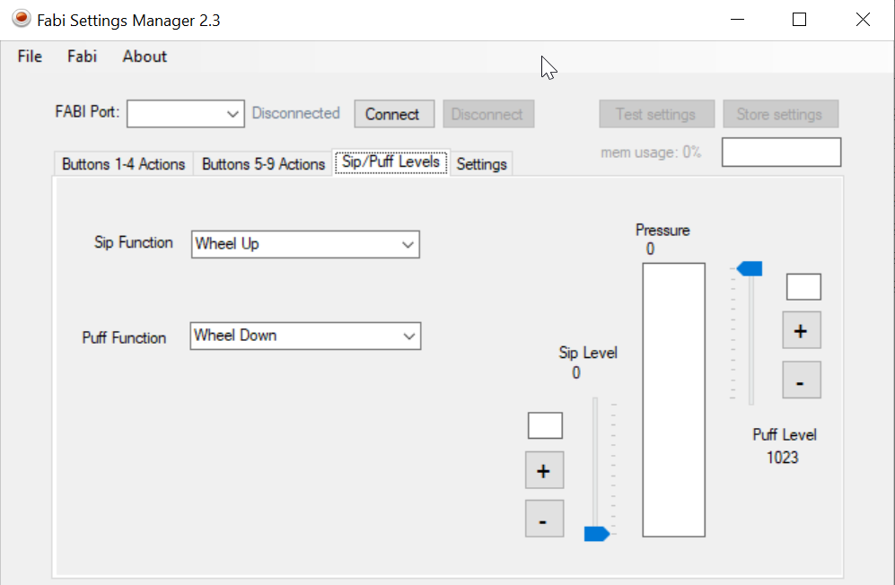

Figure 9: Screenshot of the settings for Sip and Puff

## Further options: Settings

Via the “Settings” tab, additional parameters for the operation of the FABI system can be set, including the use of “**Long Press**” functions when the button is pressed for a particularly long time, and the setting of **anti-tremor** filters for minimal periods of time when pressing buttons to avoid accidental activation - see Figure 10.

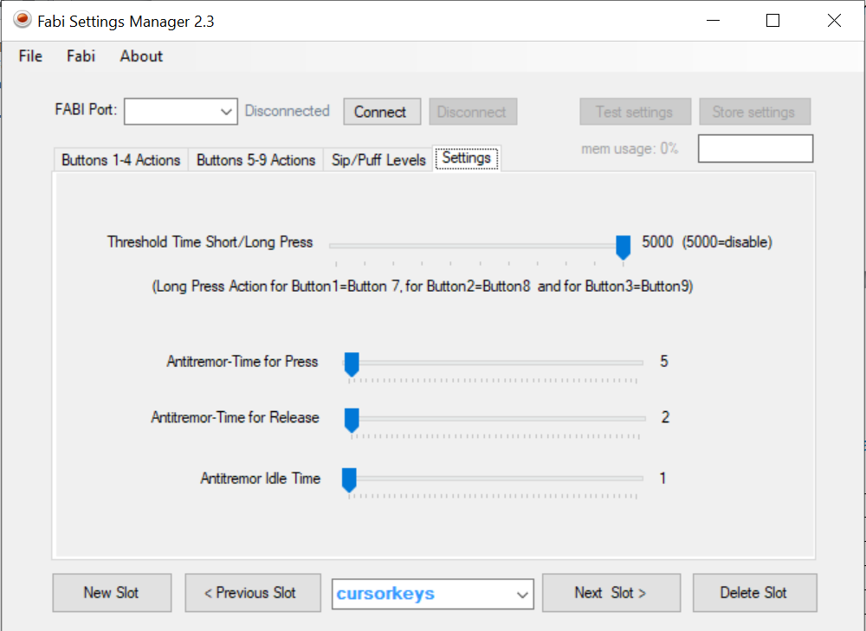

Figure 10: Screenshot of the settings menu

### Use of the "Long Press" functions

The value "**Threshold Time Short / Long Press**" defines the minimum duration of a "long button press" in milliseconds. Consequently, an alternative action can be carried out when performing a long-press. This is particularly useful when a person can only use a small number of buttons. An alternative function or switching of the whole configuration can then be carried out via a long-press.

Currently, only buttons that are plugged into ports 1, 2 or 3 support the long-press function:  
If Button1 is held down, the function set for Button7 is carried out. If Button2 is held down, the function set for Button8 is carried out. If Button3 is held down, the function set for Button9 is carried out.

### Use of the "anti-tremor" functions

The **anti-tremor** parameters can be used to define different time spans that are checked by the FABI system when a button is triggered. In this way, the involuntary triggering of buttons in the event of tremors or problems with fine motor skills can be minimized:

* "Antitremor Time for Press" defines the minimum time span that a button must be pressed for the action to be carried out.
* "Antitremor Time for Release" defines the minimum period of time that a button must be released so that the release is recognized.
* "Antitremor Idle Time" defines the minimum period of time that must elapse between successive presses of a button.

## List of supported macro commands

|  |  |  |
| --- | --- | --- |
| **Abbreviation** | **function** | **example** |
| CL | click left mouse button |  |
| CR | click right mouse button |  |
| CM | click middle mouse button |  |
| CD | click double with left mouse button |  |
| PL | press / hold the left mouse button |  |
| PR | press / hold the right mouse button |  |
| PM | press / hold the middle mouse button |  |
| RL | release the left mouse button |  |
| RR | release the right mouse button |  |
| RM | release the middle mouse button |  |
| WU | move mouse wheel up |  |
| WD | move mouse wheel down |  |
| MX <int> | move mouse in x direction | MX 4  moves cursor 4 pixels to the right |
| MY <int> | move mouse in y direction | MY -10  moves cursor 10 pixels up |
| KW <string> | keyboard write string | KW Hello!  writes "Hello!" on the keyboard |
| KP <string> | key press:  Press keyboard keys (hold) Keys are identified by keyboard shortcuts (see list below) | KP KEY_UP  presses the "Cursor-Up" key  KP KEY_CTRL KEY_ALT KEY_DELETE presses all 3 keys |
| KR <string> | Key release  Keys are identified by keyboard shortcuts (see list below) | KR KEY_UP  releases the "Cursor-Up" key |
| RA | releases all  Release all currently pressed keys and mouse button |  |
| WA <int> | wait  wait a certain number of milliseconds | WA 100  waits 100 milliseconds |

## List of abbreviations for keyboard keys

|  |
| --- |
| Letters |
| KEY_A KEY_B KEY_C KEY_D KEY_E KEY_F KEY_G KEY_H KEY_I KEY_J KEY_K KEY_L KEY_M KEY_N KEY_O KEY_P KEY_Q KEY_R KEY_S KEY_T KEY_U KEY_V KEY_W KEY_X |
| Digits |
| KEY_1 KEY_2 KEY_3 KEY_4 KEY_5 KEY_6 KEY_7 KEY_8 KEY_9 KEY_0 |
| Function keys |
| KEY_F1 KEY_F2 KEY_F3 KEY_F4 KEY_F5 KEY_F6 KEY_F7 KEY_F8 KEY_F9 KEY_F10  KEY_F11 KEY_F12 KEY_F13 KEY_F14 KEY_F15 KEY_F16 KEY_F17 KEY_F18 KEY_F19 KEY_F20 KEY_F21 KEY_F22 KEY_F23 KEY_F24 |
| Navigation buttons |
| KEY_UP KEY_DOWN KEY_LEFT KEY_RIGHT KEY_TAB KEY_PAGE_UP KEY_PAGE_DOWN  KEY_HOME KEY_END |
| Special buttons |
| KEY_ENTER KEY_SPACE KEY_BACKSPACE KEY_DELETE KEY_INSERT  KEY_ESC KEY_NUM_LOCK KEY_SCROLL_LOCK KEY_CAPS_LOCK KEY_PAUSE |
| Alternate function buttons |
| KEY_SHIFT KEY_CTRL KEY_ALT KEY_RIGHT_ALT KEY_GUI KEY_RIGHT_GUI |

## 

## Further links and software recommendations

The FABI Button Interface is suitable as an alternative input system for a wide variety of purposes - from computer / smartphone control to the use of games and learning software. Depending on the number of buttons that can be used, standard programs which rely on mouse / keyboard interaction can be operated without further adjustment.

If the motor skills or the number of usable button functions are very limited, specially adapted applications also offer options for use with just one button. Here are some interesting resources:

### AsTeRICS and AsTeRICS Grid

The further open source developments of the AsTeRICS Foundation allow a versatile use of button interfaces. The [AsTeRICS system](https://www.asterics-foundation.org/projekte-2/das-asterics-framework/) is a construction kit for assistive technologies with which 1-button strategies for computer control can be created. [AsTeRICS Grid](https://www.asterics-foundation.org/projekte-2/asterics-ergo-grid-2/) is a flexible system for Augmentative and Alternative Communication (AAC), which can be operated via a single switch.

### SpecialEffect.org

The non-profit organization SpecialEffect (<https://www.specialeffect.org.uk> ) is dedicated to promoting accessible games in the UK and making specific adaptations for people with disabilities.

### BLTT.org

The Better Living Through Technology website (<https://bltt.org/introduction-to-switch-access> ) provides useful information for key-based computer use and links to many software tools.

### OneSwitch.org

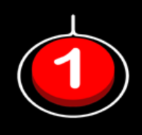Under the address [https://www.oneswitch.org.uk](https://www.oneswitch.org.uk/) Barrie Ellis has collected a wealth of tips and information for single switch gaming and special adaptations for key control of computer games. The games library, the One-Switch-Pulse System and the use of game consoles with controller adapters such as the "Titan-Two" are particularly interesting.

# Contact information

#### AsTeRICS Foundation

Webpage: [https://www.asterics-foundation.org](https://www.asterics-foundation.org/)

E-mail: office[@ asterics-foundation.org](mailto:mailing@asterics-foundation.org)

# 

# Disclaimer of liability

The University of Applied Sciences Technikum Wien and the AsTeRICS Foundation assume no guarantee or liability for the functionality of the hardware / software modules or the correctness of the documentation.

Furthermore, the UAS Technikum Wien and the AsTeRICS Foundation are not liable for any damage to health caused by the use of the hardware / software modules provided.  
The modules and information provided are used at your own risk!

# 

# Acknowledgement

We would like to thank Miriam Brenner, Fabian Schiegl and Fanny Peternell for their support in creating these instructions.

This project was financially supported by the City of Vienna (Municipal Department 23 for Economy, Labor and Statistics, MA 23) (project number 14-02, 18-04).

