1. Use the calculator on your computer to do the following conversions.
   1. 5510 to base 2 1101112
   2. 1008 to base 2
   3. 7F6116 to base 2
   4. 1000000002 to base 10 256
   5. 111001001102 to base 16 72616
   6. 751238 to base 16 7A5316
2. Use the calculator to calculate the following.
   1. 1C816 + 35F16 52716
   2. 1000112 - 1011 2 110002
   3. 101110112 / 10112 100012
   4. CC16 + 178 3338
3. When you click the 'Oct' radio button on the calculator, the numbers 8 and 9, and the letters A, B, C, D, E, and F are disabled.  Why is this?
   1. Oct only uses 8 symbols (0-7) because Oct is base 8.
4. (Computer programming application)  In a Java program, what is the output of the following?
   1. -10048
5. (Computer application)  The Windows registry will allow you to hide computer drive letters.  Each drive letter is assigned a power of 2 based on its place in the alphabet.  For example, to hide the k drive the 'NoDrives' entry would be assigned 1024.  This is calculated by taking k's place in the alphabet (k is the 11th letter), subtracting 1 (11 - 1 = 10) and using that value as the power of 2 (210 = 1024).
   1. What number needs to be assigned to the NoDrives entry in the registry in order to hide the D drive (assume the 'Decimal' radio button is checked meaning the number must be entered in base 10)? 8
   2. What number needs to be assigned to the NoDrives entry in the registry in order to simultaneously hide the A, C, and Q drives (assume the 'Hexadecimal' radio button is checked)?    
      Note:  to hide multiple drives the corresponding powers of 2 are added. 65541
6. (Computer application)  The size of the address bus in a computer dictates the amount of memory that can be addressed by the computer.  For example, a 16-bit address bus would be able to utilize 216 bits of memory which is equivalent to 8 KB (since 1 KB = 1024 bytes and 1 byte = 8 bits).  For conversion information, use the table below.   
   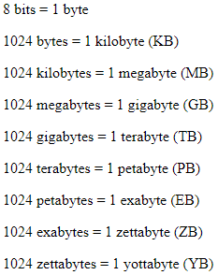  
   Note:  This is a bit of an oversimplification of the situation (no pun intended!).
   1. How many memory locations can be accessed by a system with a 32-bit address bus?  Express your answer in GB. 4 GB
   2. How many memory locations can be accessed by a system with a 64-bit address bus?  Express your answer in GB. 17179869184 GB