System Analysis and Design Documentation

# 1. Introduction

This document provides the system analysis and design (S.A.D) for the proposed Bookshop Management System with Blockchain integration for Uchumi Bookshop. The aim is to automate operations, ensure data integrity, enhance customer experience, and improve efficiency in sales, inventory management, and supplier tracking.

# 2. System Overview

The Bookshop Management System (BMS) is a centralized platform designed to manage book sales, customer orders, inventory, procurement, and financial reporting. Blockchain technology is integrated to secure transactions, ensure immutability, and increase transparency.

# 3. Problem Statement

Uchumi Bookshop currently relies on manual sales ledgers and physical stock-tally methods, which are inefficient, prone to errors, and difficult to audit. These processes lead to delays in serving customers, mismanagement of stock, and lack of reliable financial accountability.

# 4. Proposed Solution

The proposed solution is to implement a Bookshop Management System with blockchain integration to:

- Automate sales and payment processing.  
- Provide real-time inventory management.  
- Introduce bulk order and procurement management modules.  
- Ensure data integrity through blockchain-based immutable records.  
- Provide role-based access for security and accountability.  
- Generate automatic reports for management and auditing.

# 5. Objectives

The objectives of the Bookshop Management System include:  
1. Improve operational efficiency by automating manual processes.  
2. Enhance security and trust through blockchain integration.  
3. Improve customer service with faster transactions and loyalty rewards.  
4. Provide accurate reporting and analytics for decision-making.  
5. Scale to support future growth and online integrations.

# 6. Justification

The system addresses inefficiencies, improves accountability, and positions Uchumi Bookshop competitively. Blockchain ensures trust and transparency, while automation reduces workload and errors. Customers benefit from faster services and loyalty rewards, while management gains reliable reports for better decisions.

# 7. System Design

## 7.1 System Architecture

The system follows a client-server architecture, where the frontend (POS terminals, web interface) connects to a backend server that handles business logic, database operations, and blockchain integration.

## 7.2 Database Design

The relational database stores book details, customers, transactions, suppliers, and staff roles. Blockchain records transaction hashes to ensure immutability.

## 7.3 Use Case Diagram

Actors include: Cashier, Manager, Supplier, Customer. Main use cases: Manage Sales, Manage Inventory, Generate Reports, Manage Procurement, Blockchain Verification.

## 7.4 Data Flow Diagram (DFD)

The DFD illustrates how data flows between customers, staff, inventory, payments, and the blockchain ledger.

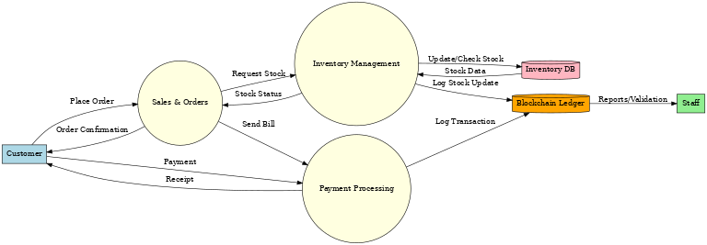

# 8. Test and Validation

The system will undergo the following testing stages:  
- Unit Testing: Testing of POS, inventory, procurement, and blockchain modules.  
- Integration Testing: Ensure modules work seamlessly together.  
- System Testing: Validate system functionality under real conditions.  
- User Acceptance Testing (UAT): Ensure the system meets Uchumi Bookshop’s requirements.

# 9. Conclusion

The Bookshop Management System with blockchain integration will automate daily operations, enhance transparency, and improve customer service. It ensures data security, scalability, and competitiveness in the digital retail space.